***INDEX***

|  |  |  |
| --- | --- | --- |
| S. No. | Program Title | Page No. |
| 1 | Program to check the given number is prime or not | 1 |
| 2 | Program to check the given number is Armstrong | 3 |
| 3 | Program to find the factorial of the given number | 5 |
| 4 | Program to check the number is odd or even | 7 |
| 5 | Program using function | 9 |
| 6 | Program to find largest and smallest element in array | 11 |
| 7 | Sum of numbers in array | 13 |
| 8 | Even / Odd using array | 15 |
| 9 | Sum of 2D array | 17 |
| 10 | Program of Structure | 19 |
| 11 | Program to print table of the given number by user | 21 |
| 12 | Program array passed by reference | 23 |

**S.no: 1**

**Program Title:** Program to check the given number is prime or not

**Source code**

#include <iostream>

#include <cmath>

using namespace std;

int main()

{

    int x;

    cout << "Please enter the no. here : ";

    cin >> x;

    if (x <= 1)

    {

        cout << x << " is not prime";

    }

    else

    {

        int limit = sqrt(x);

        bool isPrime = true;

        for (int i = 2; i <= limit; i++)

        {

            if (x % i == 0)

            {

                cout << x << " is not prime";

                isPrime = false;

                break;

            }

        }

        if (isPrime)

        {

            cout << "The number is prime";

        }

    }

    return 0;

}

**TEST CASES:**

**Case 1;**

Input = 2



**Case 2;**

Input = 10



**Case 3;**

Input = 7



**S.no: 2**

**Program Title:** Program to check the given number is Armstrong

**Source code**

#include <iostream>

#include <cmath>

using namespace std;

bool isArmstrong(int);

int digitCount(int);

int main()

{

    for (int i = 0; i < 100000; i++)

    {

        if (isArmstrong(i))

        {

            cout << i << endl;

        }

    }

    return 0;

}

int digitCount(int x)

{

    if (x == 0)

        return 1;

    int dCount = 0;

    while (x > 0)

    {

        x /= 10;

        dCount++;

    }

    return dCount;

}

bool isArmstrong(int x)

{

    int value = x;

    int digits = digitCount(x);

    int sum = 0;

    while (x > 0)

    {

        sum += pow(x % 10, digits);

        x /= 10;

    }

    return value == sum;

}

**OUTPUT:**

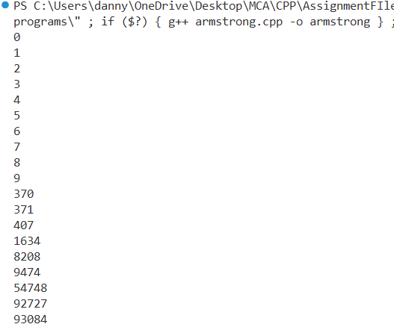

**S.no: 3**

**Program Title:** Program to find the factorial of the given number

**Source code**

#include <iostream>

using namespace std;

int factorial(int n)

{

    return (n <= 1) ? 1 : n * factorial(n - 1);

}

int main()

{

    int n;

    cout << "Enter the number : ";

    cin >> n;

    cout << "Factorial of " << n << " is " << factorial(n);

    return 0;

}

**TEST CASES:**

**Case 1;**

Input = 5



**Case 2;**

Input = 6



**Case 3;**

Input = 0



**S.no: 4**

**Program Title:** Program to check the number is odd or even

**Source code**

#include <iostream>

using namespace std;

bool isEven(int x)

{

    return x % 2 == 0;

}

int main()

{

    int x;

    cout << "Enter the number here : ";

    cin >> x;

    cout << x << " is " << (isEven(x) ? "even" : "odd");

    return 0;

}

**TEST CASES:**

**Case 1;**

Input = 10



**Case 2;**

Input = 5



**Case 3;**

Input = 0

