C++ INDEX

S. No. | Program Title | Page No. | Sign/Remark
1 | Program to check the given number is prime or not | 1
2 | Program to check the given number is Armstrong | 3
3 | Program to find the factorial of the given number | 5
4 | Program to check the number is odd or even | 7
5 | Program using function | 9
6 | Program to find largest and smallest element in an array | 11
7 | Program that finds the sum of numbers in an array | 13
8 | Program that separates even and odd using an array | 15
9 | Program that adds 2D arrays | 17
10 | Program of structure | 19
11 | Program to print table of the given number by user | 21
12 | Program array passed by reference | 23
13 | Program that demonstrates Structures in C++ | 24
14 | Program that creates a class and instantiates an object | 26
15 | Program that uses Access Specifiers | 27
16 | Program to demonstrate single level inheritance | 29
17 | Program that demonstrates multiple inheritance | 30
18 | Program that demonstrates multilevel inheritance | 32
19 | Program that demonstrates Hierarchical inheritance | 33
20 | Program that demonstrates constructor | 35
21 | Program that demonstrates Polymorphism in C++ | 36
22 | Program that demonstrates Function overloading in C++ | 37
23 | Program that demonstrates Class hierarchies in C++ | 38

SQL-INDEX
S. No. | Program Title | Page No. | Sign/Remark
1 | Basic DDL Commands | 43
2 | Write a query to count students based on city | 47
3 | Write a query to find the max marks for each department | 48
4 | Write a query to find the departments having average marks greater than 80. | 49
5 | Write a query to delete all students of the IT department. | 50
6 | Write a query to rename a column | 50
7 | Write a query to show average marks for each department | 51

C++

S.no: 1
Program Title: Program to check the given number is prime or not
Source code
#include <iostream>
#include <cmath>
using namespace std;

int main()
{

int x;
cout << "Please enter the no. here : ";
cin >> x;

if (x <= 1)
{
cout << x << " is not prime";
}
else
{
int limit = sqrt(x);
bool isPrime = true;
for (int i = 2; i <= limit; i++)
{
if (x % i == 0)
{
cout << x << " is not prime";
isPrime = false;
break;
}
}
if (isPrime)
{
cout << "The number is prime";
}
}

return 0;
}

TEST CASES:
Case 1;
Input = 2

Case 2;
Input = 10
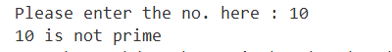

Case 3;
Input = 7

S.no: 2
Program Title: Program to check the given number is Armstrong
Source code
#include <iostream>
#include <cmath>
using namespace std;
bool isArmstrong(int);
int digitCount(int);
int main()
{
for (int i = 0; i < 100000; i++)
{
if (isArmstrong(i))
{
cout << i << endl;
}
}
return 0;
}
int digitCount(int x)
{
if (x == 0)
return 1;
int dCount = 0;
while (x > 0)
{
x /= 10;
dCount++;
}
return dCount;
}
bool isArmstrong(int x)
{
int value = x;
int digits = digitCount(x);

int sum = 0;

while (x > 0)
{
sum += pow(x % 10, digits);
x /= 10;
}
return value == sum;
}

OUTPUT:
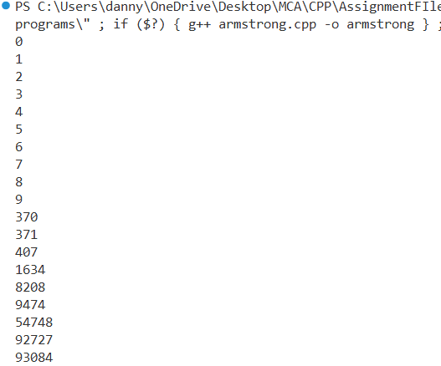

S.no: 3
Program Title: Program to find the factorial of the given number
Source code

#include <iostream>
using namespace std;

int factorial(int n)
{
return (n <= 1) ? 1 : n * factorial(n - 1);
}
int main()
{

int n;
cout << "Enter the number : ";
cin >> n;
cout << "Factorial of " << n << " is " << factorial(n);

return 0;
}

TEST CASES:
Case 1;
Input = 5
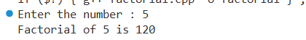

Case 2;
Input = 6
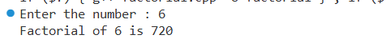

Case 3;
Input = 0

S.no: 4
Program Title: Program to check the number is odd or even

Source code

#include <iostream>
using namespace std;
bool isEven(int x)
{
return x % 2 == 0;
}

int main()
{

int x;
cout << "Enter the number here : ";
cin >> x;
cout << x << " is " << (isEven(x) ? "even" : "odd");
return 0;
}

TEST CASES:
Case 1;
Input = 10
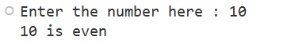

Case 2;
Input = 5
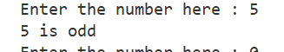

Case 3;
Input = 0
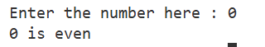

S.no: 5
Program Title: Program using function

Source code

#include <iostream>
using namespace std;

int factorial(int n);

int main()
{

int n;
cout << "Enter the number : ";
cin >> n;
cout << "Factorial of " << n << " is " << factorial(n);

return 0;
}

// Finding factorial using a function
int factorial(int n)
{
if (n <= 1)
{
return 1;
}
else
{
return n * factorial(n - 1);
}
}

TEST CASES:
Case 1;
Input = 6
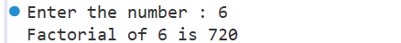

S.no: 6
Program Title: Program to find largest and smallest element in an array

Source code

#include <iostream>
#include "arrayprint.h"
using namespace std;

int min(int[], int);
int max(int[], int);
int main()
{
// array input
int arr[100], n;
cout << "Enter number of elements: ";
cin >> n;
for (int i = 0; i < n; i++)
{
cin >> arr[i];
}
cout << "Min : " << min(arr, n) << endl;
cout << "Min : " << max(arr, n);
return 0;
}
int min(int ar[], int size)
{
int mn = ar[0];
for (int i = 0; i < size; i++)
{
int c = ar[i];
mn = (mn > c) ? c : mn;
}
return mn;
}
int max(int ar[], int size)
{
int mx = ar[0];
for (int i = 0; i < size; i++)
{
mx = (mx < ar[i]) ? ar[i] : mx;
}
return mx;
}

TEST CASES:
Case 1;
Input = [1,2,3]

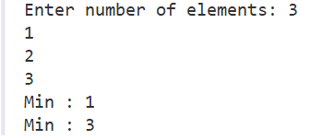

S.no: 7
Program Title: Program that finds the sum of numbers in an array.

Source code

#include <iostream>
using namespace std;
int sum(int ar[], int size)
{
int sm = 0;
for (int i = 0; i < size; i++)
{
sm += ar[i];
}
return sm;
}
int main()
{
// array input
int arr[100], n;
cout << "Enter number of elements: ";
cin >> n;

for (int i = 0; i < n; i++)
{
cin >> arr[i];
}
cout << "Sum of the elements of the array : " << sum(arr, n);
return 0;
}

TEST CASES:
Case 1;
Input = [1,2,3]

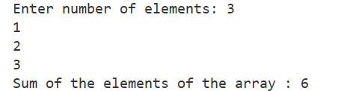

S.no: 8
Program Title: Program that separates even and odd using an array

Source code

#include <iostream>
using namespace std;

void even_fliter(int arr[], int size)
{
cout << "Even numbers are : ";
for (int i = 0; i < size; i++)
{
if (arr[i] % 2 == 0)
{
cout << arr[i] << ",";
}
}
cout << "\n-----------------\n";
}
void odd_fliter(int arr[], int size)
{
cout << "Odd numbers are : ";
for (int i = 0; i < size; i++)
{
if (arr[i] % 2)
{
cout << arr[i] << ",";
}
}
cout << "\n-----------------\n";
}
int main()
{
int arr[10] = {0, 1, 2, 3, 4, 5, 6, 7, 8, 9};

even_fliter(arr, 10);
odd_fliter(arr, 10);
return 0;
}

Output
array = [0, 1, 2, 3, 4, 5, 6, 7, 8, 9]

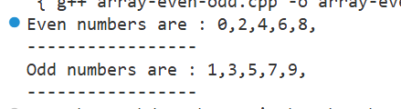

S.no: 9
Program Title: Program that adds 2D arrays.

Source code

#include <iostream>
using namespace std;
void print(int ar[][3])
{
for (int i = 0; i < 3; i++)
{
for (int j = 0; j < 3; j++)
{
cout << ar[i][j] << "|";
}
cout << endl;
}
}
void sum(int ar1[][3], int ar2[][3])
{
int result[3][3];
int range = 9;
for (int i = 0; i < 9; i++)
{
result[i / 3][i % 3] = ar1[i / 3][i % 3] + ar2[i / 3][i % 3];
}
print(result);
}

int main()
{

int ar1[3][3] = {{1, 2, 3}, {2, 3, 4}, {4, 5, 6}};
int ar2[3][3] = {{3, 2, 1}, {4, 3, 2}, {6, 5, 4}};
cout << "Array1" << endl;
print(ar1);
cout << "Array2" << endl;
print(ar2);
cout << "Sum " << endl;
sum(ar1, ar2);
return 0;
}

Output
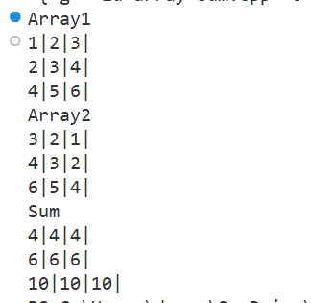

S.no: 10
Program Title: Program of Structure

Source code

#include <iostream>
using namespace std;

struct Person
{
string name;
int age;
void show_details()
{
cout << name << "'s age is " << age;
}
};
int main()
{
struct Person p;
p.name = "John";
p.age = 10;
p.show_details();
return 0;
}

Output

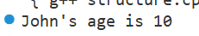

S.no: 11
Program Title: Program to print table of the given number by user.

Source code

#include <iostream>
using namespace std;

void table_print(int number)
{
for (int i = 1; i <= 10; i++)
{
cout << number << " x " << i << " = " << number * i << endl;
}
}

int main()
{
int i;
cout << "Enter the number here: ";
cin >> i;
table_print(i);
return 0;
}

Test Cases

Case 1;
input =1

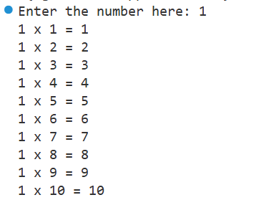

Case 2;
input =16

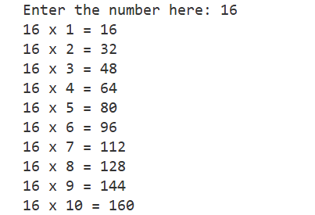

S.no: 12
Program Title: Program array passed by reference.

Source code

#include <iostream>
using namespace std;

int double_elements(int array[], int size)
{
for (int i = 0; i < size; i++)
{
array[i] = array[i] * 2;
}
}
int main()
{
int arr[3] = {1, 2, 3};
cout << "Before the Call\n";
for (int e : arr)
{
cout << e << ",";
}
double_elements(arr, 3);

cout << "\nAfter the Call\n";
// the array is modified here too
for (int e : arr)
{
cout << e << ",";
}
return 0;
}

OUTPUT

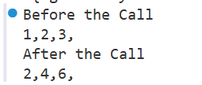

S.no: 13
Program Title: Program that demonstrates Structures in C++

// Structure
#include <iostream>
using namespace std;
struct Person
{
char name[20];
int age;
};

void show_details(Person p)
{
cout << p.name << "'s age is " << p.age << endl;
}

int main()
{
Person people[3];
for (int i = 0; i < 3; i++)
{
Person p;
cout << "Enter name: ";
cin >> p.name;
cout << "Enter age: ";
cin >> p.age;
people[i] = p;
}

for (Person p : people)
{
show_details(p);
}

return 0;
}

OUTPUT

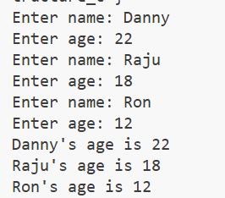

S.no: 14
Program Title: Class and object

// Class and object
#include <iostream>
using namespace std;
class Human
{
public:
int age;
string name;
void introduce()
{
cout << "Age is " << age << endl;
cout << "Name is " << name << endl;
}
};
int main()
{
Human h1;
h1.age = 20;
h1.name = "John";
h1.introduce();
return 0;
}

OUTPUT

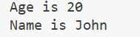

S.no: 15
Program Title: Program that uses Access Specifiers

// Access specifier

#include <iostream>
using namespace std;

class A
{
private:
int pri;

protected:
int pro;

public:
int pub;
void show()
{
cout << "public : " << pub << endl;
cout << "protected : " << pro << endl;
cout << "private : " << pri << endl;
}
};
class B : public A
{
public:
void modify()
{
pub = 1;
pro = 3;
// pri = 2; //not accessible
}
};

int main()
{
A obj;
obj.pub = 1;
// obj.pri = 2; //not accessible
// obj.pro = 3; //not accessible
obj.show();

B obj1;
obj1.modify();
obj1.show();
return 0;
}

OUTPUT

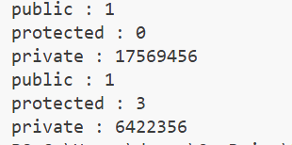

S.no: 16
Program Title: Program to demonstrate single level inheritance

// Single Level Inheritance
#include <iostream>
using namespace std;

class Animal
{
public:
string name;
int age;
void details()
{
cout << "Name: " << name << endl;
cout << "Age: " << age << endl;
}
};
class Cat : public Animal
{
public:
void meow()
{
cout << "Meow" << endl;
}
};

int main()
{
Cat c1;
c1.name = "Tom";
c1.age = 2;
c1.details();
c1.meow();

return 0;
}

OUTPUT

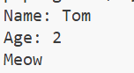

S.no: 17
Program Title: Program that demonstrates multiple inheritance

// Multiple Inheritance
#include <iostream>
using namespace std;

class Human
{
public:
int age;
Human(int age) : age(age) {}
virtual void introduce()
{
cout << "Age is " << age << endl;
}
};
class Employee
{
public:
string name;
float salary;
string company;

Employee(string name, float salary, string company)
: name(name), salary(salary), company(company) {}
void introduce()
{
cout << "Name is " << name << endl;
cout << "Salary is " << salary << endl;
cout << "Company is " << company << endl;
}
};
class Engineer : public Human, public Employee
{
public:
int experience;
Engineer(string name, int age, float salary, string company, int experience) : Human(age), Employee(name, salary, company)
{
this->experience = experience;
}
void introduce() override
{
cout << "Name is " << name << endl;
cout << "Age is " << age << endl;
cout << "Salary is " << salary << endl;
cout << "Company is " << company << endl;
cout << "Experience is " << experience << endl;
}
};

int main()
{
Engineer s1("Danny", 20, 100000, "Google", 5);
s1.introduce();
return 0;
}

OUTPUT

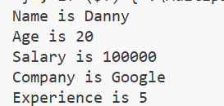

S.no: 18
Program Title: Program that demonstrates multilevel inheritance

// Multilevel inheritance
#include <iostream>
using namespace std;
class Animal
{
public:
void eat()
{
cout << "Eating" << endl;
}
};
class LandAnimal : public Animal
{
public:
void walk()
{
cout << "Walking" << endl;
}
};
class Dog : public LandAnimal
{
public:
void bark()
{
cout << "Barking" << endl;
}
};
int main()
{
Dog d;
d.eat();
d.walk();
d.bark();
return 0;
}

OUTPUT
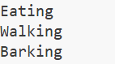

S.no: 19
Program Title: Program that demonstrates Hierarchical inheritance

// Hierarchical Inheritance
#include <iostream>
using namespace std;
class Shape
{
public:
int width, height;
Shape(int w, int h)
{
width = w;
height = h;
}
};
class Rectangle : public Shape
{
public:
Rectangle(int w, int h) : Shape(w, h) {}
int area()
{
return width * height;
}
};
class Triangle : public Shape
{
public:
Triangle(int w, int h) : Shape(w, h) {}
int area()
{
return (width * height) / 2;
}
};

int main()
{
Rectangle r(10, 20);
Triangle t(10, 20);
cout << r.area() << endl;
cout << t.area() << endl;
return 0;
}

OUTPUT

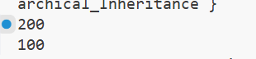

S.no: 20
Program Title: Program that demonstrates constructor

// Constructor
#include <iostream>
using namespace std;

class Person
{
string name;
int age;

public:
Person(string n, int a)
{
cout << "Constructor called" << endl;
name = n;
age = a;
}
void introduce()
{
cout << "Name is " << name << endl;
cout << "Age is " << age << endl;
}
};

int main()
{

Person p1("John", 20); // constructor called
p1.introduce();
return 0;
}

OUTPUT

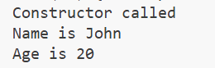

S.no: 21
Program Title: Program that demonstrates Polymorphism in C++

// Polymorphism
#include <iostream>
using namespace std;

class Adder
{
public:
static int add(int a, int b)
{
return a + b;
}
static int add(int a, int b, int c)
{
return a + b + c;
}
static double add(double a, double b)
{
return a + b;
}
};

int main()
{
cout << Adder::add(1, 2) << endl;
cout << Adder::add(1, 2, 3) << endl;
cout << Adder::add(1.0, 2.0) << endl;
return 0;
}

OUTPUT

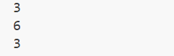

S.no: 22
Program Title: Program that demonstrates Function overloading in C++

// Function overloading
#include <iostream>
using namespace std;

int add(int a, int b)
{
return a + b;
}
int add(int a, int b, int c)
{
return a + b + c;
}
double add(double a, double b)
{
return a + b;
}
int main()
{
cout << add(10, 20) << endl;
cout << add(10, 20, 30) << endl;
cout << add(10.0, 20.0) << endl;
return 0;
}

OUTPUT

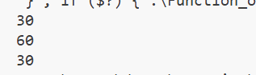

S.no: 23
Program Title: Program that demonstrates Class hierarchies in C++

// Class hierarchies:
// Hybrid inheritance and Dimond problem
#include <iostream>
using namespace std;
class Animal
{
public:
void eat()
{
cout << "Eating" << endl;
}
};

// using virtual inheritance to avoid diamond problem
class LandAnimal : virtual public Animal
{
public:
void walk()
{
cout << "Walking" << endl;
}
};
class Mammal : virtual public Animal
{
public:
void feed()
{
cout << "Feeding" << endl;
}
};

class Cat : public Mammal, public LandAnimal
{
public:
void meow()
{
cout << "Meow" << endl;
}
};

int main()
{
Cat c1;
c1.eat();
c1.walk();
c1.feed();
c1.meow();
return 0;
}

OUTPUT

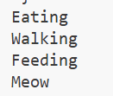

SQL

DDL Commands

-- Create a database
CREATE DATABASE EMPLOYEE;

Logs:
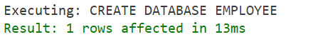

-- Use a database
USE EMPLOYEE;
Logs:
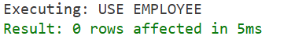

-- Drop a database
DROP DATABASE Employee;
Logs:
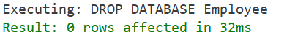

-- Create a table in a database
CREATE TABLE students (
roll_no INT AUTO_INCREMENT PRIMARY KEY,
name VARCHAR(50),
department VARCHAR(50),
city VARCHAR(50),
marks FLOAT
);

-- Display all tables in a database
SHOW TABLES;

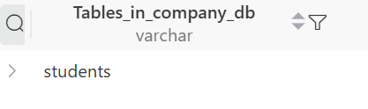
-- Describe a table : Used to display the structure of a table
DESCRIBE students;
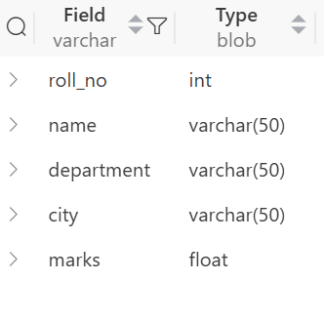
--Drop: Used to delete a table
DROP TABLE students;

-- Turncate: Used to empty a table
TRUNCATE TABLE students;

-- Alter

--Adding a new column
ALTER TABLE students ADD COLUMN phone VARCHAR(20);
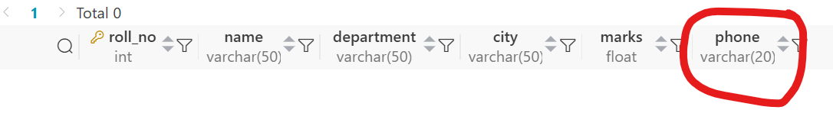

-- Modify a column
ALTER TABLE students MODIFY COLUMN phone VARCHAR(10);
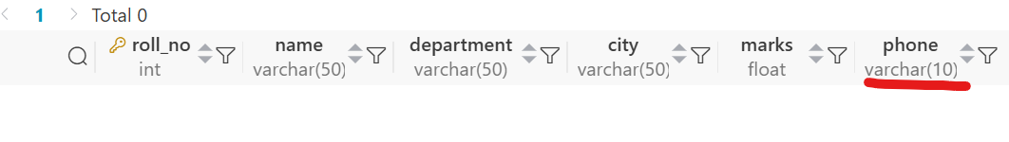

-- rename a column
ALTER TABLE students RENAME COLUMN phone TO phone_no;

-- Drop a column
ALTER TABLE students DROP COLUMN phone_no;
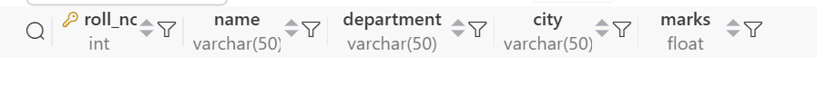

Table to run the following Queries on:
-- Select Data
SELECT * FROM students;

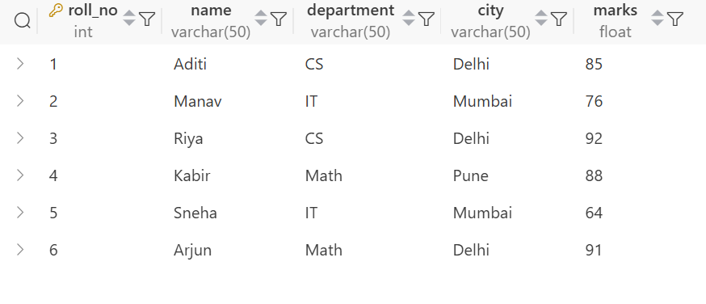

1. Write a query to count students based on city
SELECT city, count(*) as student_count FROM students GROUP BY city;

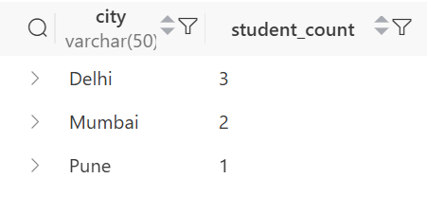

2. Write a query to find the max marks for each department
SELECT department, max(marks) as max_marks
FROM students
GROUP BY
department;
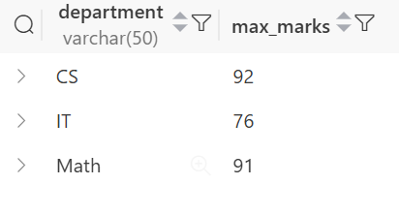

3. Write a query to find the departments having average marks greater than 80.
Select department, avg(marks) as avg_marks
FROM students
GROUP BY
department
HAVING
AVG(marks) > 80;
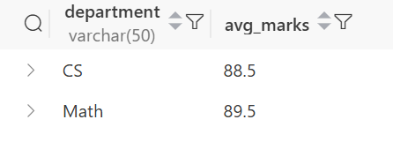

4. Write a query to delete all students of the IT department.
DELETE FROM students WHERE department = 'IT';

5. Write a query to rename a column
Alter TABLE students RENAME COLUMN name TO s_name;

6. Write a query to show average marks for each department
Select department, avg(marks) as avg_marks
FROM students
GROUP BY
department;
