Basic Commands
-- Create a database
CREATE DATABASE EMPLOYEE;

Logs:
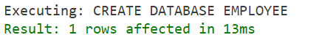

-- Use a database
USE EMPLOYEE;
Logs:
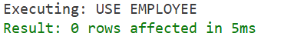

-- Drop a database
DROP DATABASE Employee;
Logs:
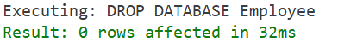

-- Create a table in a database
CREATE TABLE students (
roll_no INT AUTO_INCREMENT PRIMARY KEY,
name VARCHAR(50),
department VARCHAR(50),
city VARCHAR(50),
marks FLOAT
);
-- Display all tables in a database
SHOW TABLES;

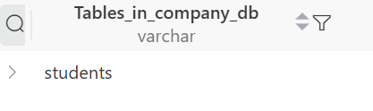
-- Describe a table : Used to display the structure of a table
DESCRIBE students;
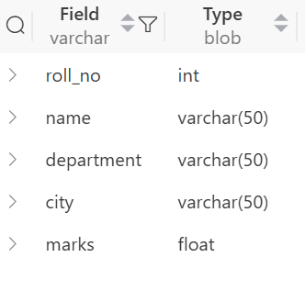
--Drop: Used to delete a table
DROP TABLE students;

-- Turncate: Used to empty a table
TRUNCATE TABLE students;

-- Alter

--Adding a new column
ALTER TABLE students ADD COLUMN phone VARCHAR(20);
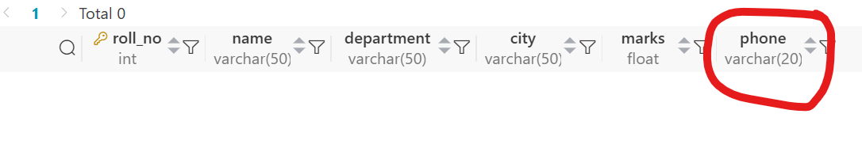

-- Modify a column
ALTER TABLE students MODIFY COLUMN phone VARCHAR(10);
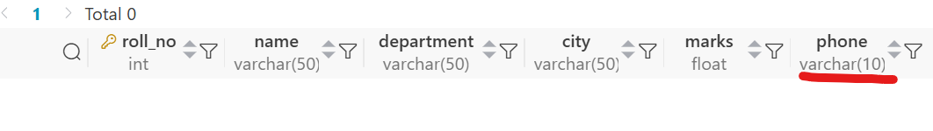

-- rename a column
ALTER TABLE students RENAME COLUMN phone TO phone_no;

-- Drop a column
ALTER TABLE students DROP COLUMN phone_no;


Practical
Student Table:
-- Select Data
SELECT * FROM students;
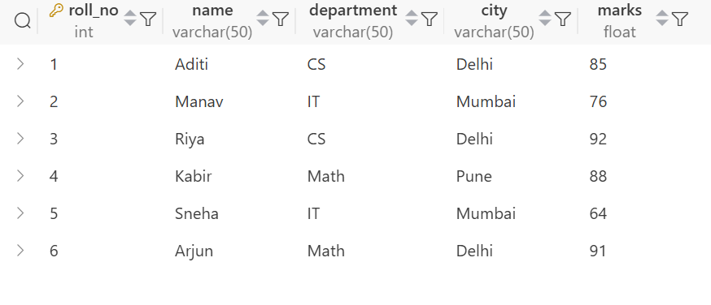

INDEX
S.no. | Title
1 | Write a query to count students based on city
2 | Write a query to find the max marks for each department
3 | Write a query to find the departments having average marks greater than 80.
4 | Write a query to delete all students of the IT department.
5 | Write a query to rename a column
6 | Write a query to show average marks for each department

1. Write a query to count students based on city
SELECT city, count(*) as student_count FROM students GROUP BY city;

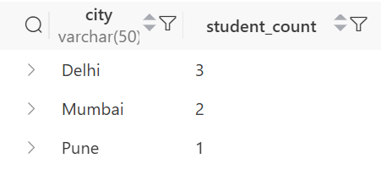

2. Write a query to find the max marks for each department
SELECT department, max(marks) as max_marks
FROM students
GROUP BY
department;
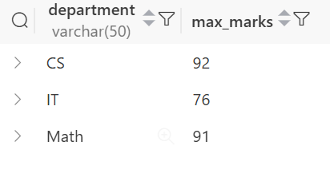

3. Write a query to find the departments having average marks greater than 80.
Select department, avg(marks) as avg_marks
FROM students
GROUP BY
department
HAVING
AVG(marks) > 80;
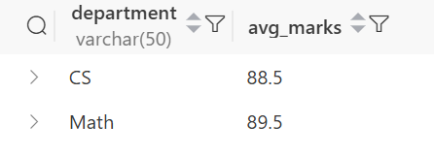

4. Write a query to delete all students of the IT department.
DELETE FROM students WHERE department = 'IT';

5. Write a query to rename a column
Alter TABLE students RENAME COLUMN name TO s_name;

6. Write a query to show average marks for each department
Select department, avg(marks) as avg_marks
FROM students
GROUP BY
department;
