**P1: OUTPUT**

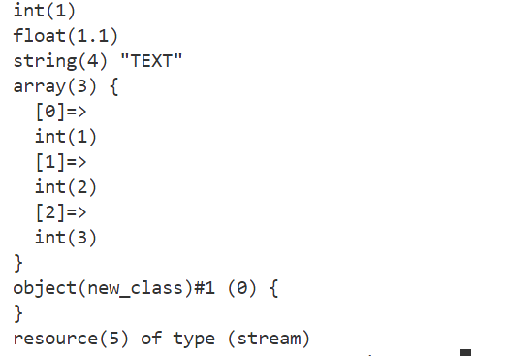

**P2: OUTPUT**



**P3: OUTPUT**



**P4: OUTPUT**



**P5: OUTPUT**

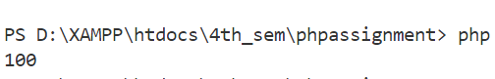

**P6: OUTPUT**

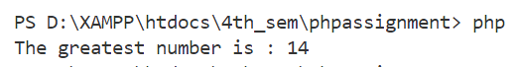

**P7: OUTPUT**

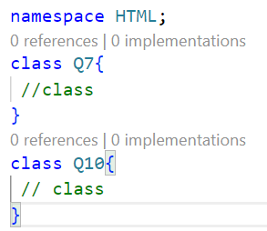

**P9: OUTPUT**

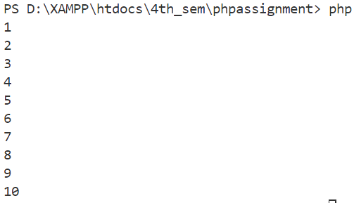

**P8: OUTPUT**

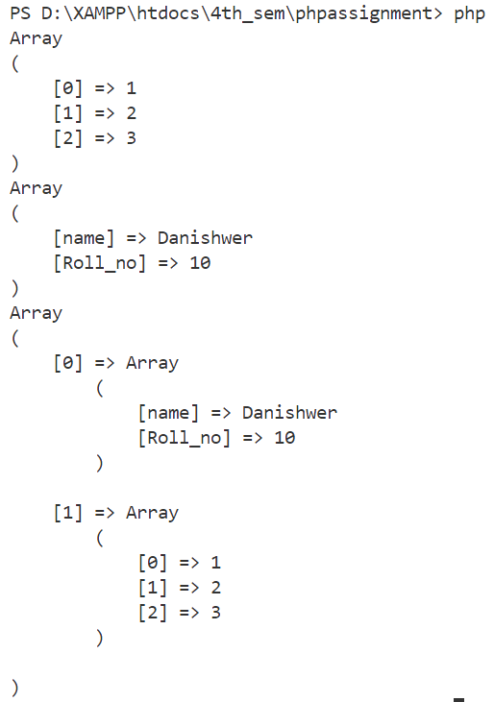

**P10: OUPUT**

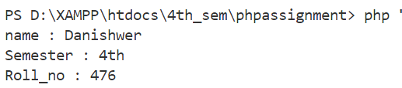

**P11: OUPUT**

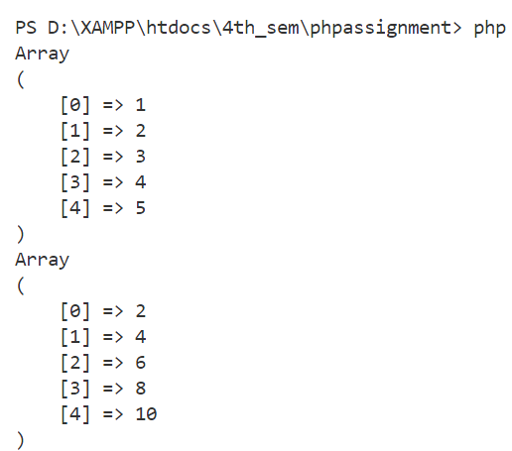

**P12: OUPUT**

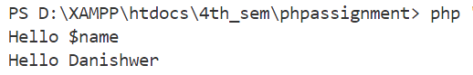

**P13: OUTPUT**

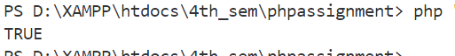

**P14: OUTPUT**

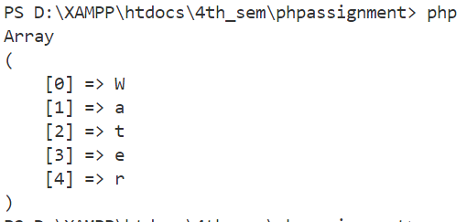

**P15: OUTPUT**

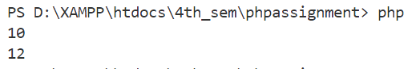

**P16: OUTPUT**

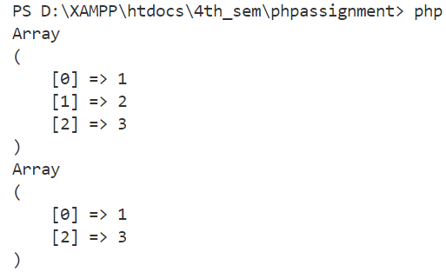

**P17: OUTPUT**

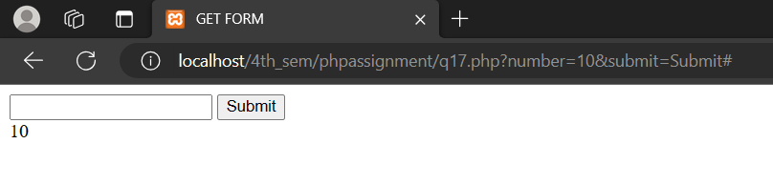

**P18: OUTPUT**

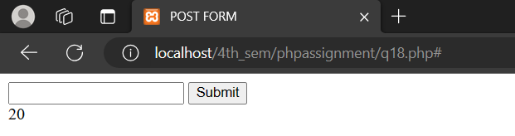

**P19: OUTPUT**

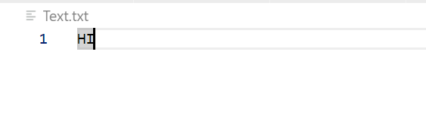

**P20: OUTPUT**

