1

Depth estimation from Lidar measurements

Abderrahim Halimi

# Objectives

* Generate simulated lidar histograms
* Estimate a depth image using a simple matched filter algorithm
* Display results

# Data description

The Lidar system provides a three-dimensional cube of data where two dimensions are related to pixels and the third is related to time-of-flight or range. For each pixel location, the data represents a histogram of number of photon counts with respect to their time of

flight (see Fig. 1).

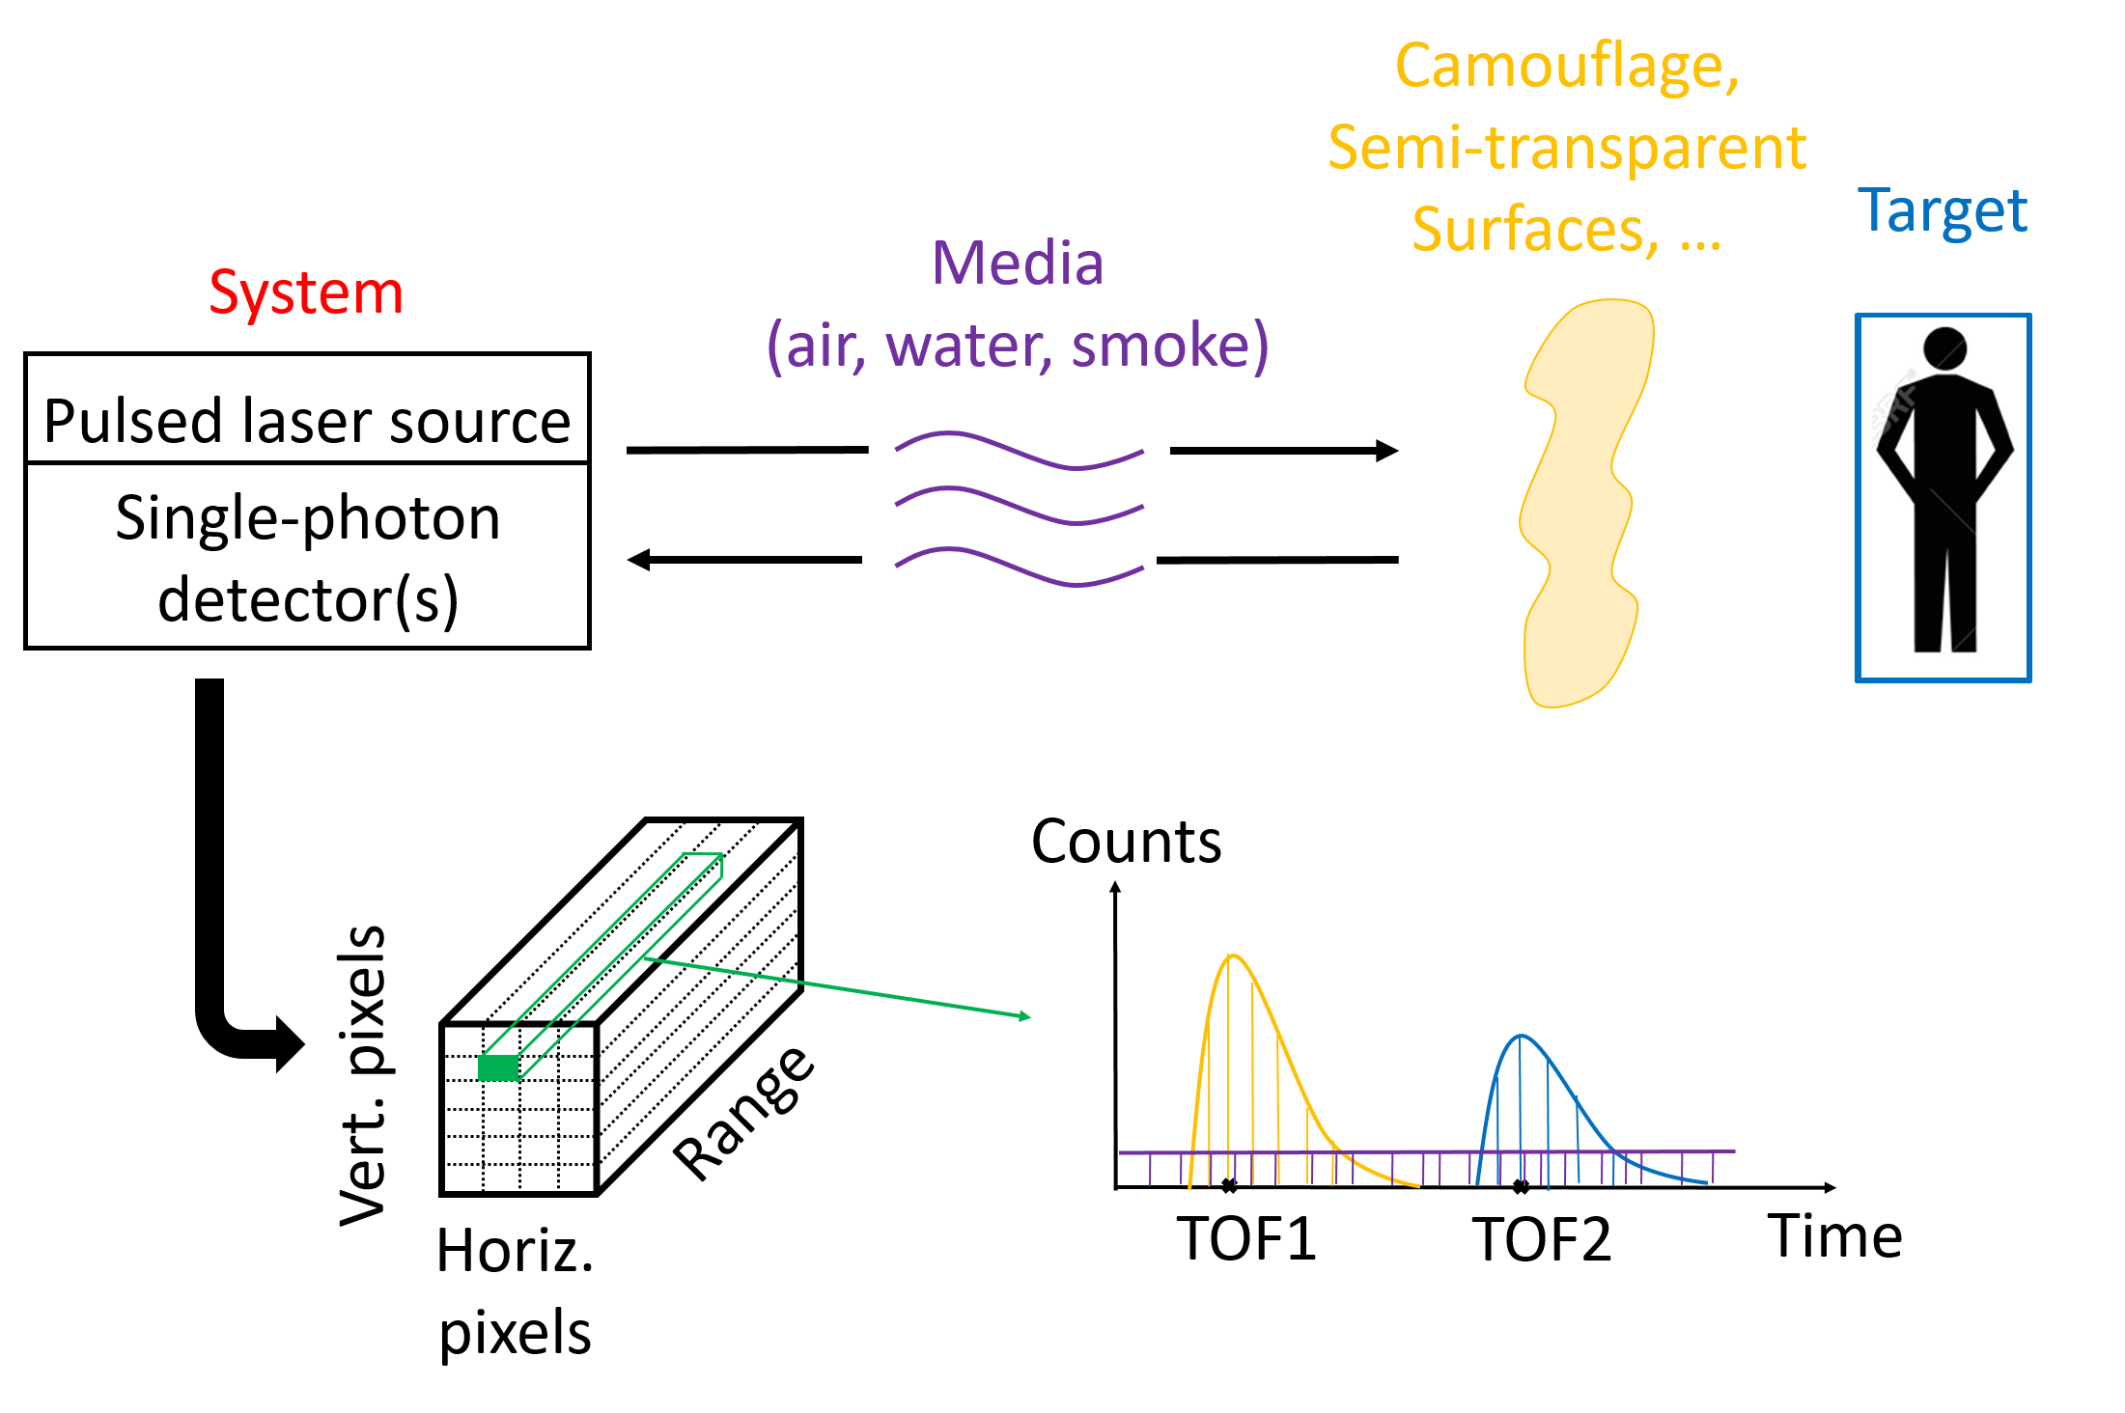

Fig. 1. Schematic description of 3D Lidar imaging in presence of obscurants or camouflages. The data cube is represented in botom left where each pixel is represented by a histogram of counts with respect to time of flight (TOF) (also called

range).

June 8, 2019 DRAFT 2

Denoting the photon counts by *yi,j,t*, where (i,j) are the pixel coordinates and “t” is the

time of flight position, the Lidar equation is given by:

*yi,j,t* ∼P (*si,j,t*) (1)

where

*si,j,t* = *ri,j g* (*t* − *ti,j*) + *bi,j* (2)

and P(*.*) denotes the Poisson distribution, *ti,j* ≥ 0 is the position of an object surface at a given range from the sensor (related to the depth and represented by the peak position TOF2 in Fig. 1), *ri,j* ≥ 0 is the intensity/amplitude of the target (represented by the peak amplitude in Fig. 1), *bi,j* ≥ 0 is a constant denoting the background and dark photon level, and *g* denotes the system impulse response assumed to be known from the calibration step.

# Questions

Q1: Generate a 128x128x300 cube of data (*si,j,t* for *i* ∈ [1*,*128]*,j* ∈ [1*,*128]*,t* ∈ [1*,*300]). Consider the provided Cameraman image as a depth image (the pixels of cameraman are *ti,j* for *i* ∈ [1*,*128]*,j* ∈ [1*,*128]). Consider *bi,j* = 1*,*∀*i,j*, *ri,j* = 5*,*∀*i,j* and use a Gaussian

impulse response $g\left(x\right)=\exp{(\frac{-x^{2}}{3^{2}})}$

Q2: Use the function “poissrnd” to generate *yi,j,t* from *si,j,t*

Q3: For this question, we assume that we do not know the true depth map *ti,j* for *i* ∈ [1*,*128]*,j* ∈ [1*,*128]) and will estimate a new depth map (denoted ${\hat{t}}_{i,j}$*,*∀*i,j*) from the data *yi,j,t* as follows: Use the maximum of matched filtered histograms by the impulse response,

i.e., for pixel (i,j), you need to perform ${\hat{t}}_{i,j} = {argmax}_{x}\sum_{k=1}^{300}{g(x-k)y_{i,j,k}}$.

Q4: Display the clean CameraMan image *ti,j,*∀*i,j* and the estimated one *t*ˆ*i,j,*∀*i,j* using the matlab function “imagesc”, how can we improve the estimated image ?

To improve the estimated depth map, we could try using a different impulse response function, such as a more realistic model for the Lidar system's response. We could also try using more sophisticated algorithms for depth map estimation, such as machine learning techniques.

June 8, 2019 DRAFT