Date: 28-12-19

Name: Dhanur Sharma

1)

SELECT last_name, TRUNC(MONTHS_BETWEEN(sysdate,hire_date)/12) as "YEARS", TRUNC(MOD(MONTHS_BETWEEN(sysdate,hire_date),12),0) months

FROM employees

ORDER BY hire_date;

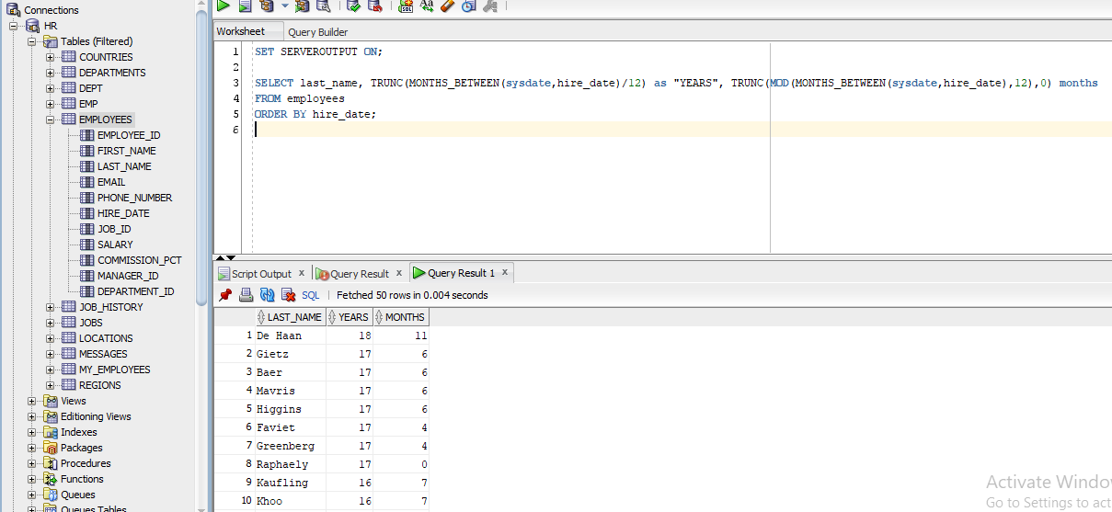

=====================================================================

2)

SELECT d.department_id, d.department_name, d.location_id, COUNT(e.employee_id)

FROM departments d LEFT OUTER JOIN employees e

ON d.department_id = e.department_id

GROUP BY d.department_id, d.department_name, d.location_id;

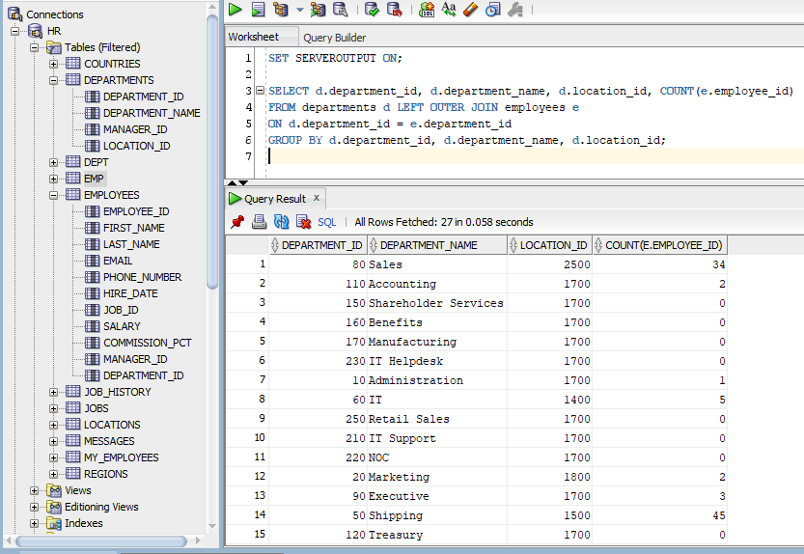

=====================================================================

3)

SELECT last_name, hire_date

FROM employees

WHERE TO_NUMBER(TO_CHAR(hire_date,'DD')) < 16;

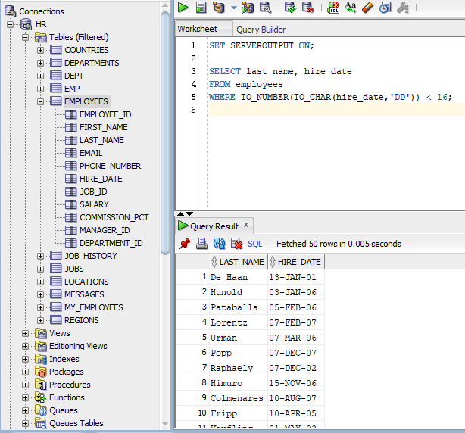

=====================================================================

4)

SELECT last_name, salary, TRUNC(salary/1000) thousands

FROM employees;

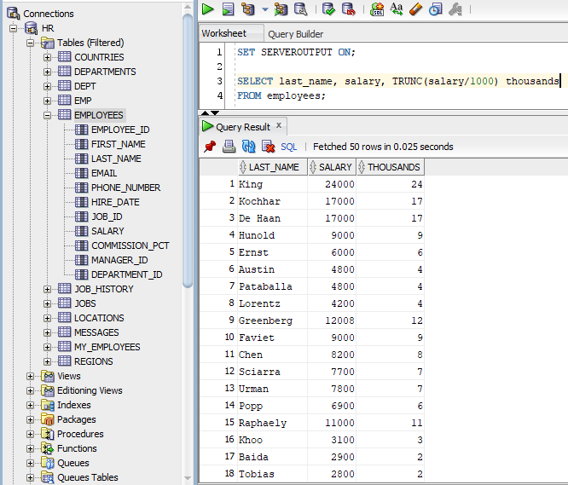

=====================================================================

5)

SELECT *

FROM employees

WHERE salary > ALL (SELECT salary

FROM employees

WHERE department_id = 60);

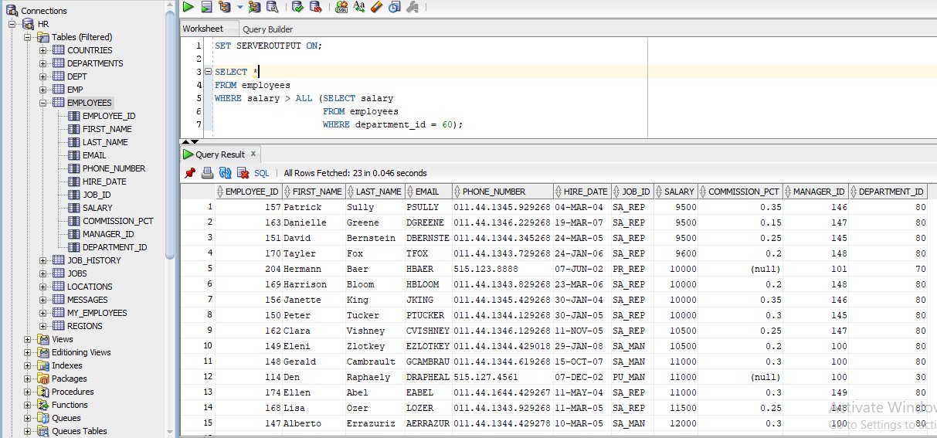

=====================================================================

6)

DECLARE

v_num PLS_INTEGER;

v_dept PLS_INTEGER:=&dep;

BEGIN

SELECT COUNT(*)

INTO v_num

FROM employees

WHERE department_id = v_dept;

DBMS_OUTPUT.PUT_LINE(v_num || ' employee(s) work for department number ' || v_dept);

END;

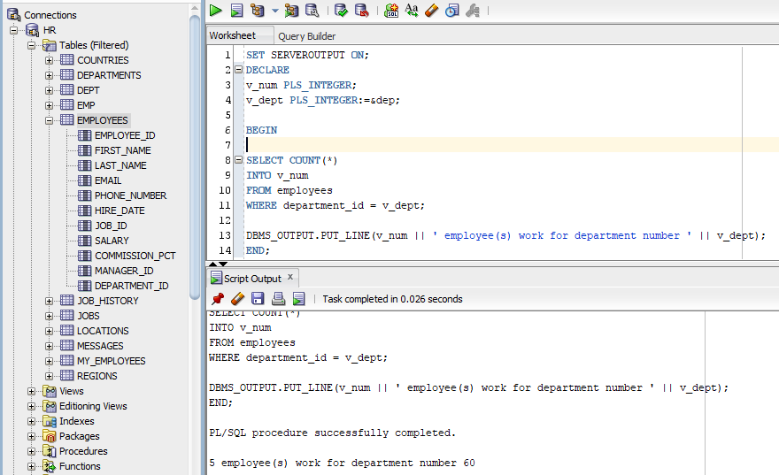

=====================================================================

7)

DECLARE

v_year PLS_INTEGER:=&yr;

BEGIN

IF MOD(v_year,4) = 0 AND MOD(v_year,100) <> 0 THEN

DBMS_OUTPUT.PUT_LINE(v_year || ' is a leap year');

ELSE

DBMS_OUTPUT.PUT_LINE(v_year || ' is not a leap year');

END IF;

END;

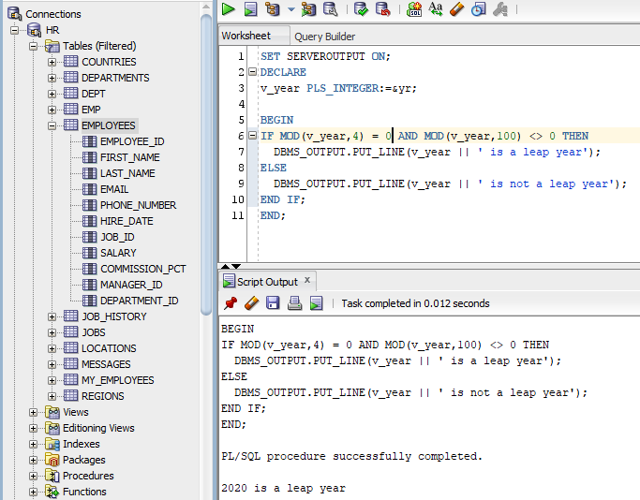

=====================================================================

8)

DECLARE

v_m_salary PLS_INTEGER:=&sal;

v_a_salary PLS_INTEGER;

v_bonus PLS_INTEGER;

BEGIN

v_a_salary := v_m_salary * 12;

IF v_a_salary >= 20000 THEN

v_bonus:= 2000;

ELSIF v_a_salary >=10000 AND v_a_salary<= 19999 THEN

v_bonus:= 1500;

ELSE v_bonus:= 1000;

END IF;

DBMS_OUTPUT.PUT_LINE('The Bonus is $ ' || v_bonus);

END;

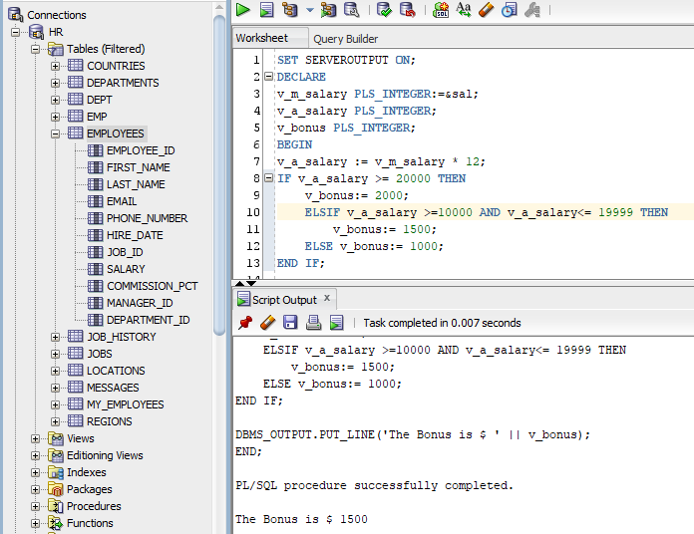

=====================================================================

9)

DECLARE

CURSOR c_emp_cur IS

SELECT last_name, salary, hire_date

FROM employees

WHERE salary > 15000

AND hire_date > '01-FEB-1988';

BEGIN

FOR e_r IN c_emp_cur

LOOP

DBMS_OUTPUT.PUT_LINE(e_r.last_name || 'earns ' || e_r.salary || 'joined the organization on ' || e_r.hire_date);

END LOOP;

END;

/

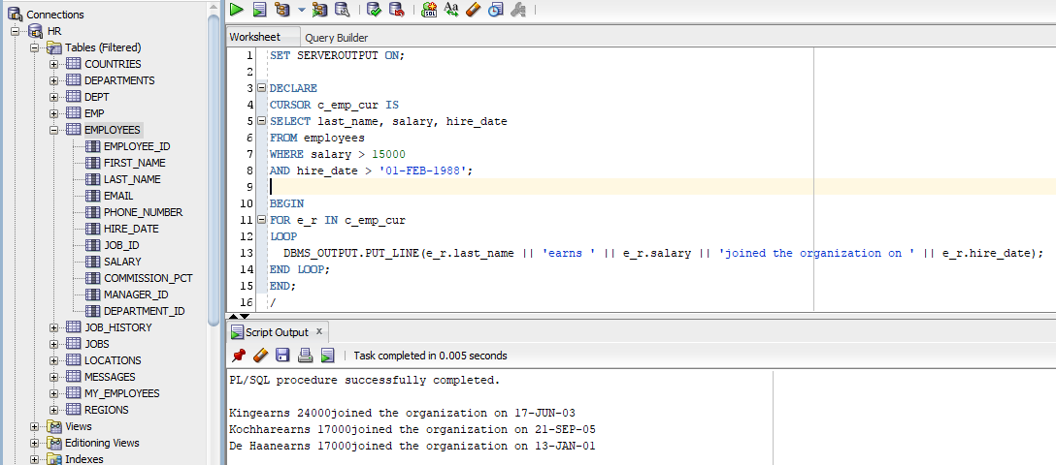

=====================================================================

10)

CREATE TABLE analysis

(ename VARCHAR2(20),

years_ NUMBER(2),

sal NUMBER(8,2));

DECLARE

e_raise_due EXCEPTION;

v_hiredate employees.hire_date%TYPE;

v_name employees.last_name%TYPE := INITCAP( '&b_name');

v_sal employees.salary%TYPE;

v_years NUMBER(2);

BEGIN

SELECT last_name, salary, hire_date

INTO v_name,v_sal,v_hiredate

FROM employees WHERE last_name = v_name;

v_years := MONTHS_BETWEEN(SYSDATE,v_hiredate)/12;

IF v_sal < 3500 AND v_years > 5 THEN

RAISE e_raise_due;

ELSE

DBMS_OUTPUT.PUT_LINE (v_name || ' not due for a raise');

END IF;

EXCEPTION

WHEN e_raise_due THEN

BEGIN

DBMS_OUTPUT.PUT_LINE (v_name || ' is due for a raise');

INSERT INTO analysis(ename,years_,sal)

VALUES (v_name,v_years,v_sal);

END;

END;

/

