DATABASE DESIGN DOCUMENT

Safaricom PLC
Telecommunications Customer and Service Management System
Database schema: safaricom_management
Prepared as an academic database design project

1. INTRODUCTION
The purpose of this project is to design and implement a Safaricom PLC-inspired Telecommunications Customer and Service Management Database System. The system is intended to organise sample information about service centres, employees, customers, service plans, subscriptions and customer-service interactions in a relational database.
The system stores service-centre details and employee job descriptions. Employees are linked to the centres where they work and to their job groups. Employee and customer phone numbers are stored separately so that each person can have more than one phone number without duplicating the main employee or customer record.
Customers can be associated with telecommunications service plans through subscriptions. A subscription records the plan selected, its start date and its status. Customer-service interactions record which employee assisted a customer, when the interaction occurred, and a short description of the issue or enquiry.
The database supports reports such as customer subscription listings, the number of service interactions handled by each employee, and the combined listed price of active subscriptions. These reports are based on the sample data stored in the database and are intended for academic demonstration rather than representing Safaricom PLC's internal systems.
Data note: All employee, customer, telephone, salary and subscription records in this project are fictional. Sample plan prices are illustrative and are not official Safaricom tariffs.

2. ENTITY RELATIONSHIP DIAGRAM
The diagram below summarises the main entities and their foreign-key relationships. A customer may have multiple phone records, subscriptions and service interactions. An employee may have multiple phone records and handle multiple customer interactions.
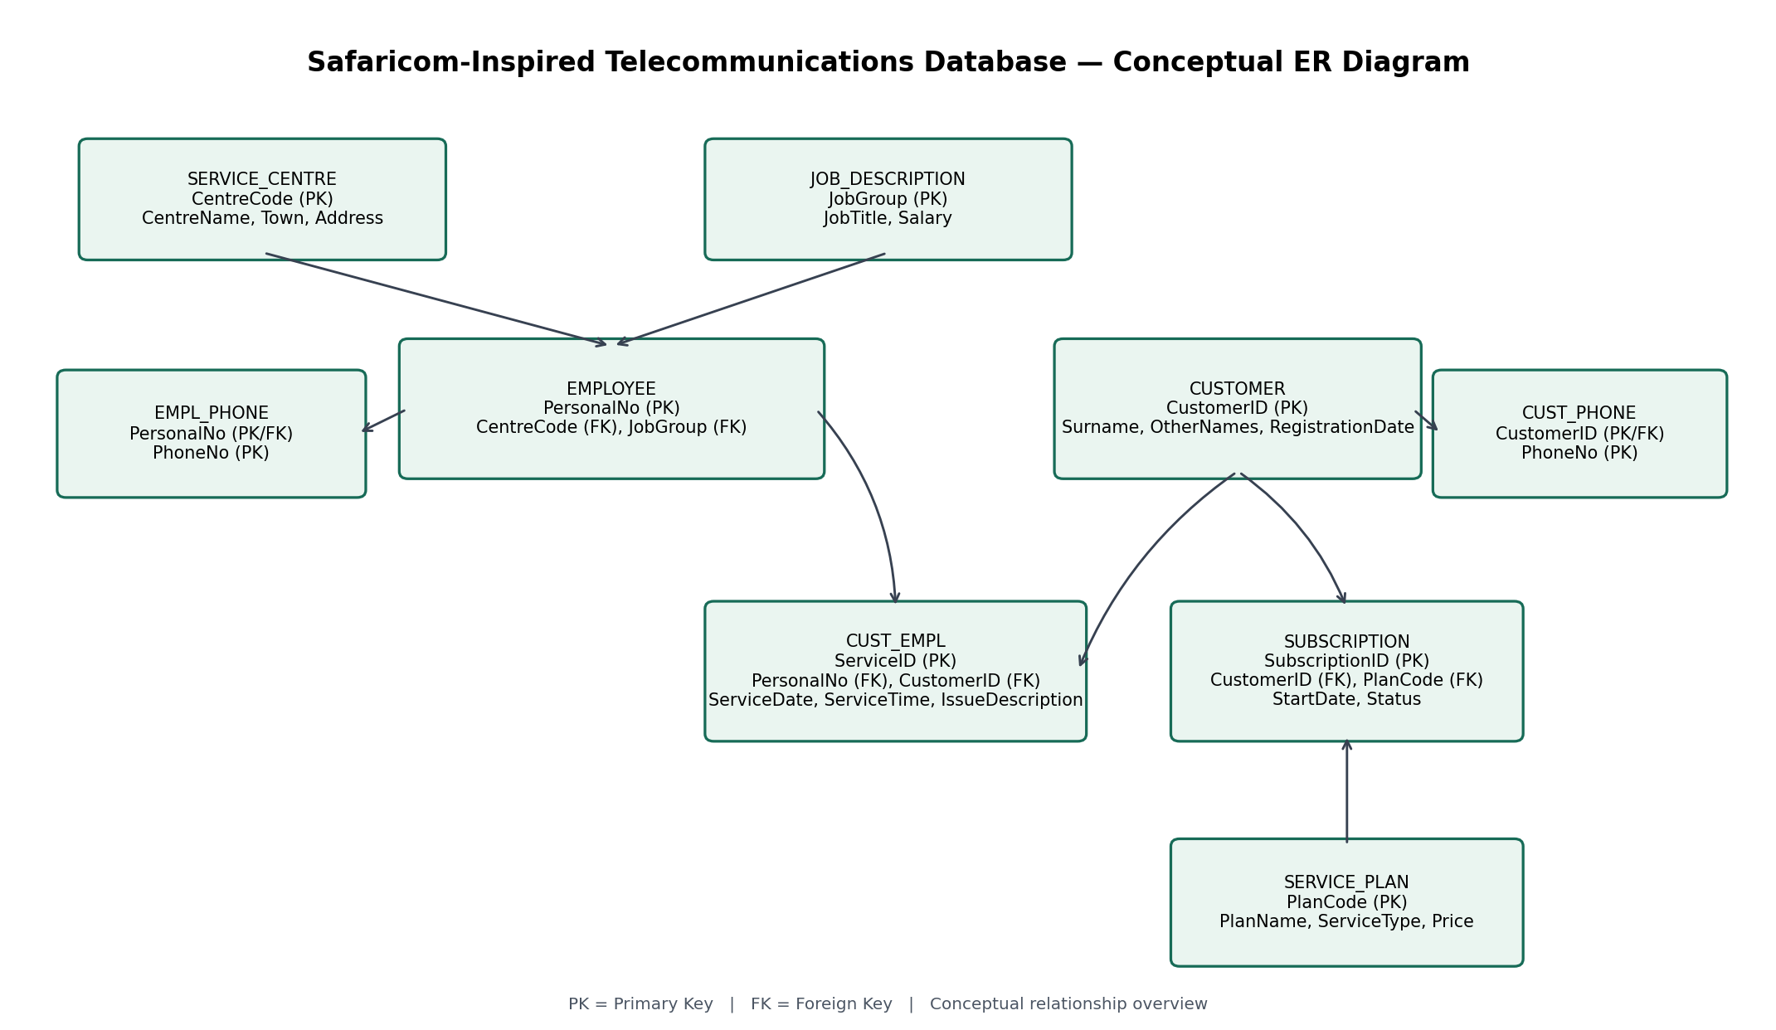

2.1 Relationship summary
Relationship | Description
SERVICE_CENTRE → EMPLOYEE | One service centre can be associated with many employees.
JOB_DESCRIPTION → EMPLOYEE | One job group can be assigned to many employees.
EMPLOYEE → EMPL_PHONE | An employee can have multiple phone-number records.
CUSTOMER → CUST_PHONE | A customer can have multiple phone-number records.
EMPLOYEE → CUST_EMPL | An employee can handle many service interactions.
CUSTOMER → CUST_EMPL | A customer can have many service interactions.
CUSTOMER → SUBSCRIPTION | A customer can hold multiple subscriptions.
SERVICE_PLAN → SUBSCRIPTION | A service plan can be referenced by many subscriptions.

3. MAPPING THE ENTITY RELATIONSHIP DIAGRAM INTO RELATIONS
The conceptual entities are mapped to the following relational tables:
- SERVICE_CENTRE (CentreCode, CentreName, Town, Address)
- JOB_DESCRIPTION (JobGroup, JobTitle, Salary)
- EMPLOYEE (PersonalNo, Surname, OtherNames, Gender, DOB, CentreCode, JobGroup)
- EMPL_PHONE (PersonalNo, PhoneNo)
- CUSTOMER (CustomerID, Surname, OtherNames, RegistrationDate)
- CUST_PHONE (CustomerID, PhoneNo)
- SERVICE_PLAN (PlanCode, PlanName, ServiceType, Price)
- SUBSCRIPTION (SubscriptionID, CustomerID, PlanCode, StartDate, Status)
- CUST_EMPL (ServiceID, PersonalNo, CustomerID, ServiceDate, ServiceTime, IssueDescription)
Primary keys uniquely identify records. Foreign keys connect dependent records to their parent tables and help maintain referential integrity. EMPL_PHONE and CUST_PHONE use composite primary keys. CUST_EMPL uses an auto-increment ServiceID so that the same employee can assist the same customer on multiple occasions.

4. THE PHYSICAL RELATIONAL DESIGN
The following tables show the implemented column names, MySQL data types, key constraints and fictional example values. These definitions reflect the schema created in MySQL Workbench.

SERVICE_CENTRE
SERVICE_CENTRE (CentreCode, CentreName, Town, Address)
ATTRIBUTE | DATA TYPE | EXAMPLE | DESCRIPTION
CentreCode (PK) | CHAR(4) | 0001 | Unique centre identifier
CentreName | VARCHAR(40) | Nairobi CBD Centre | Name of service centre
Town | VARCHAR(30) | Nairobi | Town or city
Address | VARCHAR(80) | Kenyatta Avenue | Centre address

JOB_DESCRIPTION
JOB_DESCRIPTION (JobGroup, JobTitle, Salary)
ATTRIBUTE | DATA TYPE | EXAMPLE | DESCRIPTION
JobGroup (PK) | CHAR(1) | B | Unique job-group code
JobTitle | VARCHAR(30) | Service Manager | Job title
Salary | INT | 150000 | Illustrative salary amount

EMPLOYEE
EMPLOYEE (PersonalNo, Surname, OtherNames, Gender, DOB, CentreCode, JobGroup)
ATTRIBUTE | DATA TYPE | EXAMPLE | DESCRIPTION
PersonalNo (PK) | VARCHAR(6) | 330101 | Unique employee number
Surname | VARCHAR(20) | Wanjiru | Employee surname
OtherNames | VARCHAR(30) | Mary Anne | Employee other names
Gender | CHAR(1) | F | Gender code in sample data
DOB | DATE | 1990-04-12 | Date of birth
CentreCode (FK) | CHAR(4) | 0001 | References SERVICE_CENTRE
JobGroup (FK) | CHAR(1) | B | References JOB_DESCRIPTION

EMPL_PHONE
EMPL_PHONE (PersonalNo, PhoneNo)
ATTRIBUTE | DATA TYPE | EXAMPLE | DESCRIPTION
PersonalNo (PK, FK) | VARCHAR(6) | 330101 | References EMPLOYEE
PhoneNo (PK) | VARCHAR(15) | 0701000001 | Employee phone number

CUSTOMER
CUSTOMER (CustomerID, Surname, OtherNames, RegistrationDate)
ATTRIBUTE | DATA TYPE | EXAMPLE | DESCRIPTION
CustomerID (PK) | VARCHAR(8) | SC100001 | Unique sample customer ID
Surname | VARCHAR(20) | Kamau | Customer surname
OtherNames | VARCHAR(30) | Alice Wanjiku | Customer other names
RegistrationDate | DATE | 2022-03-15 | Registration date

CUST_PHONE
CUST_PHONE (CustomerID, PhoneNo)
ATTRIBUTE | DATA TYPE | EXAMPLE | DESCRIPTION
CustomerID (PK, FK) | VARCHAR(8) | SC100001 | References CUSTOMER
PhoneNo (PK) | VARCHAR(15) | 0712000001 | Customer phone number

SERVICE_PLAN
SERVICE_PLAN (PlanCode, PlanName, ServiceType, Price)
ATTRIBUTE | DATA TYPE | EXAMPLE | DESCRIPTION
PlanCode (PK) | VARCHAR(6) | PL0001 | Unique plan identifier
PlanName | VARCHAR(30) | Daily Data Bundle | Name of service plan
ServiceType | VARCHAR(15) | Data | Type of telecommunications service
Price | DECIMAL(10,2) | 50.00 | Illustrative plan price

SUBSCRIPTION
SUBSCRIPTION (SubscriptionID, CustomerID, PlanCode, StartDate, Status)
ATTRIBUTE | DATA TYPE | EXAMPLE | DESCRIPTION
SubscriptionID (PK) | VARCHAR(8) | SU000001 | Unique subscription identifier
CustomerID (FK) | VARCHAR(8) | SC100001 | References CUSTOMER
PlanCode (FK) | VARCHAR(6) | PL0001 | References SERVICE_PLAN
StartDate | DATE | 2026-01-05 | Subscription start date
Status | VARCHAR(15) | Active | Sample status

CUST_EMPL
CUST_EMPL (ServiceID, PersonalNo, CustomerID, ServiceDate, ServiceTime, IssueDescription)
ATTRIBUTE | DATA TYPE | EXAMPLE | DESCRIPTION
ServiceID (PK) | INT AUTO_INCREMENT | 1 | Unique service-interaction ID
PersonalNo (FK) | VARCHAR(6) | 330101 | References EMPLOYEE
CustomerID (FK) | VARCHAR(8) | SC100001 | References CUSTOMER
ServiceDate | DATE | 2026-10-01 | Date of interaction
ServiceTime | TIME | 09:15:00 | Time of interaction
IssueDescription | VARCHAR(100) | Data bundle activation | Brief description of service issue

5. REPORTS PRODUCED BY THE DATABASE
The implemented SQL queries produce the following reports:
REPORT | PURPOSE | EXPECTED SAMPLE RESULT
Customer subscription report | Lists customer identifiers and names, phone numbers, plan names, service types, plan prices and subscription statuses. | 10 rows expected from the current sample data.
Employee service report | Counts recorded customer-service interactions handled by each employee, including employees with no matching interactions. | 5 rows expected; service counts total 9.
Active subscription value summary | Counts active subscriptions and sums the listed prices of their associated service plans. | One summary row; current sample output shows 8 active subscriptions and a total listed price of KES 4,600.00.

The active-subscription summary is a sum of listed sample plan prices. Since the sample plans do not define consistent billing periods, the result should not be interpreted as actual monthly revenue or official company revenue.

6. KEY TO DATABASE TERMS
TERM | MEANING
PK — Primary Key | A column or set of columns that uniquely identifies a row.
FK — Foreign Key | A column that references a primary key in another table.
VARCHAR(n) | A variable-length character string with a maximum length of n characters.
CHAR(n) | A fixed-length character string.
DECIMAL(10,2) | A numeric type suitable for values with two decimal places.
AUTO_INCREMENT | MySQL automatically generates a new numeric identifier for a row.
JOIN | Combines related rows from two or more tables.

