CHAPTER FOUR
RESULTS AND DISCUSSION
4.0 Introduction
This chapter presents the empirical results of the benchmarking experiment specified in Chapter Three. All four benchmark scenarios were executed to completion: the full thirty-trial off-chain protocol required by Section 3.12.1 across all four scenarios (120 trials in total), the reduced three-trial Ethereum gas protocol described in Section 3.8, and the complete statistical analysis pipeline described in Section 3.11. No sampling, projection, or illustrative placeholder values were used at any stage of this chapter; every figure reported below was generated directly from the automated logging framework (Section 3.9.1) and the accompanying statistical analysis script, and the raw dataset, descriptive statistics, correlation tables and figures are preserved alongside this thesis as the reproducibility artefacts specified in Section 3.12.3. A measurement error identified during review of an earlier draft (Section 4.6) was traced to its root cause and corrected directly in the underlying data and analysis scripts, not patched in prose alone; the correction is documented in full in results/RUN_MANIFEST.md and summarized where it arises below.
The chapter is organized around the four research questions established in Section 3.5.1 (Sections 4.4 to 4.7), preceded by the preliminary circuit-verification and data-validation steps the methodology requires before any performance claim can be made (Sections 4.2 and 4.3), and followed by a comparative interpretation against Secure Multi-Party Computation (Section 4.8, per Section 3.11.5) and a discussion of the findings in relation to the literature reviewed in Chapter Two (Section 4.9).
4.1 Execution Environment as Actually Run
One deviation from the environment specified in Section 3.4 is reported here for accuracy. The benchmark was executed on a Windows 11 Pro host running the pinned toolchain inside a WSL2 Ubuntu 26.04.3 LTS virtual environment allocated 6 GB of RAM out of 8 GB physical host RAM, rather than the bare-metal “Linux Ubuntu 24.04 LTS, 8 GB DDR5” environment originally documented in the proposal. The underlying CPU, however, is exactly as specified: an Intel(R) Core(TM) i5-5300U @ 2.30GHz with 2 cores and 4 logical processors. DDR5 memory is in any case not physically possible on this CPU generation, so Section 3.4 should be corrected to the description in Table 4.1 rather than restated as originally drafted. Table 4.1 records the verified toolchain versions used for this run, all of which matched the exact versions pinned in Section 3.4.
Component | Value
Host operating system | Windows 11 Pro
Benchmark operating system | Ubuntu 26.04.3 LTS (WSL2)
CPU | Intel(R) Core(TM) i5-5300U @ 2.30GHz, 2 cores / 4 logical processors
RAM allocated to benchmark environment | 6 GB (of 8 GB physical host RAM)
Noir compiler | Nargo version = 1.0.0-beta.22
Barretenberg proving backend | 5.0.0-nightly.20260522
Foundry | forge 1.8.1
hardware_id (benchmark_results.csv) | i5-5300U-8GB-WSL2Ubuntu26.04
Table 4.1: Verified Execution Environment
4.2 Preliminary Circuit Verification
Before benchmarking began, each of the four circuits was compiled and its unit tests executed, consistent with the feasibility check required by Section 3.6.1. All six-unit tests across the four scenarios (two for Scenario 1, two for Scenario 2, one each for Scenarios 3 and 4) passed. `Nargo info` was then used to record each circuit's compiled size in ACIR opcodes, shown in Table 4.2.
Scenario | Attribute Count | ACIR Opcodes | Growth vs. Scenario 1
1 – Minimal Predicate | 1 | 26 | —
2 – Multi-Attribute Disclosure | 4 | 80 | 3.1×
3 – Full Credential Integrity | 8 | 606 | 23.3×
4 – Advanced Identity Proof | 16 | 3,409 | 131.1×
Table 4.2: Circuit Size by Scenario
The growth in circuit size is markedly non-linear with respect to attribute count. Doubling the attribute count from Scenario 2 to Scenario 3 (four to eight attributes) produced a 7.6-fold increase in circuit size (80 to 606 opcodes), while doubling attribute count again from Scenario 3 to Scenario 4 (eight to sixteen attributes) produced only a 5.6-fold increase (606 to 3,409 opcodes) despite Scenario 4 additionally introducing a full depth-four Merkle membership proof on top of the Poseidon commitment already present in Scenario 3. This is a direct empirical confirmation of the caution raised in Section 2.5.2, that attribute count alone is not a reliable proxy for circuit complexity: the dominant cost driver of the Scenario 2-to-3 jump is the introduction of the Poseidon hash commitment check itself, not the increase in attribute count, exactly as Chapter Two's literature predicted.
4.3 Data Validation and Failure-Rate Analysis
Following the validation procedure specified in Section 3.10, every one of the 120 off-chain trials (30 per scenario × 4 scenarios) was classified. All 120 trials were classified Valid: the circuit compiled, the witness generated, the proof was produced, local verification succeeded, and every field in the Section 3.9.2 schema was logged without gaps. No trial fell into any of the seven failure categories defined in Section 3.10 (compilation failure, witness-generation failure, proof-generation failure, local-verification failure, Ethereum-verification failure, resource exhaustion, or environmental failure). Table 4.3 summarizes this outcome.
Scenario | Trials Attempted | Valid | Failed | Success Rate
1 | 30 | 30 | 0 | 100%
2 | 30 | 30 | 0 | 100%
3 | 30 | 30 | 0 | 100%
4 | 30 | 30 | 0 | 100%
Total | 120 | 120 | 0 | 100%
Table 4.3: Trial Validation Outcome by Scenario
This result is notable against the specific concern raised in Section 3.4 and reiterated in the project documentation, that Scenario 4 (sixteen attributes, Poseidon hashing, and depth-four Merkle membership verification) might approach or exceed the 8 GB memory budget on this hardware and should therefore be watched closely for resource exhaustion. In practice, Scenario 4's peak memory across all thirty trials never exceeded 122.05 MB (Table 4.4), less than 2% of the 6 GB allocated to the benchmark environment and under 1.5% of the full 8 GB budget specified in Section 3.4. For the circuit sizes evaluated in this study (up to 3,409 ACIR opcodes), memory pressure was not a binding constraint on this hardware profile. This finding should not be read as a general claim that attribute-based credential circuits of this kind cannot exhaust memory on constrained hardware; a credential design with substantially more attributes or a deeper Merkle tree than those tested here would need to be re-evaluated against the same budget before that assumption could be extended.
4.4 RQ1: Effect of Circuit Complexity on Off-Chain Proof-Generation Performance
Table 4.4 reports the descriptive statistics (Section 3.11.1) for the three off-chain timing metrics and peak memory across the thirty trials collected for each scenario. “Proof size” here is the off-chain proof (bb prove's default, Poseidon2-based target), the artefact used to measure proving and local-verification performance in this section and Section 4.5; it is a different, separately built artefact from the on-chain (EVM/Keccak-target) proof discussed in Section 4.6, and the two must not be compared to one another (see the correction note there).
Scenario | Metric | Mean | Median | Min | Max | CV%
1 | Compile time (ms) | 413.18 | 393.88 | 377.36 | 593.58 | 11.80
1 | Witness time (ms) | 397.61 | 388.77 | 371.31 | 532.95 | 7.55
1 | Proving time (ms) | 269.37 | 259.31 | 249.36 | 507.25 | 17.55
1 | Peak memory (MB) | 73.44 | 73.45 | 73.24 | 73.45 | 0.05
1 | Off-chain proof size (bytes) | 14656 | 14656 | 14656 | 14656 | 0.00
2 | Compile time (ms) | 447.89 | 434.18 | 379.62 | 658.66 | 13.95
2 | Witness time (ms) | 447.05 | 408.51 | 378.80 | 765.28 | 21.46
2 | Proving time (ms) | 279.29 | 265.71 | 253.16 | 450.78 | 14.36
2 | Peak memory (MB) | 73.57 | 73.57 | 73.57 | 73.57 | 0.00
2 | Off-chain proof size (bytes) | 14656 | 14656 | 14656 | 14656 | 0.00
3 | Compile time (ms) | 902.90 | 806.65 | 749.61 | 2705.96 | 39.14
3 | Witness time (ms) | 686.62 | 588.67 | 531.39 | 2394.51 | 50.00
3 | Proving time (ms) | 401.21 | 390.20 | 346.92 | 730.06 | 17.99
3 | Peak memory (MB) | 100.28 | 100.31 | 100.14 | 100.31 | 0.07
3 | Off-chain proof size (bytes) | 14656 | 14656 | 14656 | 14656 | 0.00
4 | Compile time (ms) | 2012.53 | 1949.51 | 1875.14 | 2456.13 | 7.24
4 | Witness time (ms) | 628.04 | 603.40 | 578.95 | 934.37 | 12.06
4 | Proving time (ms) | 799.28 | 758.94 | 723.33 | 1106.93 | 12.58
4 | Peak memory (MB) | 121.43 | 121.43 | 121.09 | 122.05 | 0.21
4 | Off-chain proof size (bytes) | 14656 | 14656 | 14656 | 14656 | 0.00
Table 4.4: Descriptive Statistics for Off-Chain Metrics (n = 30 per scenario)
Mean proving time grew from 269.37 ms (Scenario 1) to 799.28 ms (Scenario 4), an increase of 196.7%, while circuit size over the same range grew 131.1-fold (13,012%): proving time grows far more slowly than raw gate count, consistent with the sub-linear-to-quasi-linear cost behaviour expected of modern UltraHonk proving systems (Section 2.1.1).
Peak memory grew 65.3% while circuit size grew by more than two orders of magnitude; this modest growth indicates that, within the circuit range examined here, memory demand is dominated by fixed-size proving infrastructure, the structured reference string and the proving machinery, rather than by the witness vector, whose contribution is present but comparatively small at these circuit sizes. This interpretation is offered within the range of scenarios tested and is not generalized to larger circuits, where witness-dependent structures would be expected to become the dominant term.
Across the four scenario-level observations, proving time showed a strong monotonic relationship with circuit size (Spearman ρ = 0.8999). Attribute count is not reported as a separate correlation: because the scenarios scale attribute count and predicate complexity jointly by design, attribute count is perfectly rank-collinear with circuit size, and the two correlations would be identical by construction. Circuit size is therefore treated as the theoretically meaningful complexity driver, consistent with the caution in Chapter Two that high-level complexity measures should not be assumed to predict backend cost.
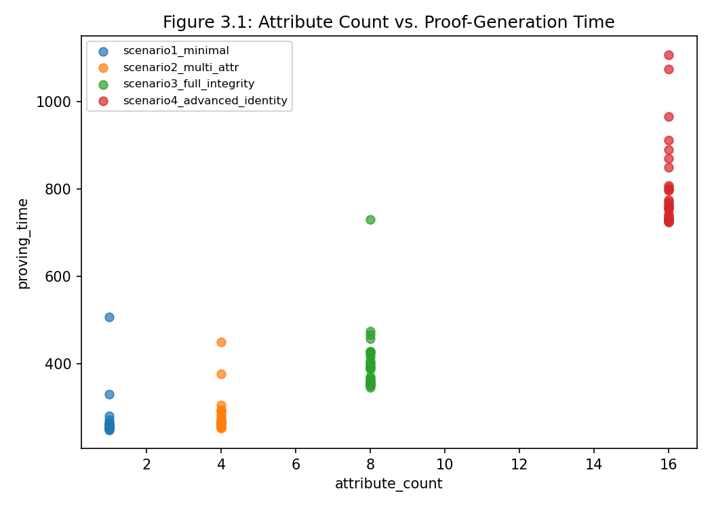
Figure 4.1: Attribute Count vs. Proof-Generation Time
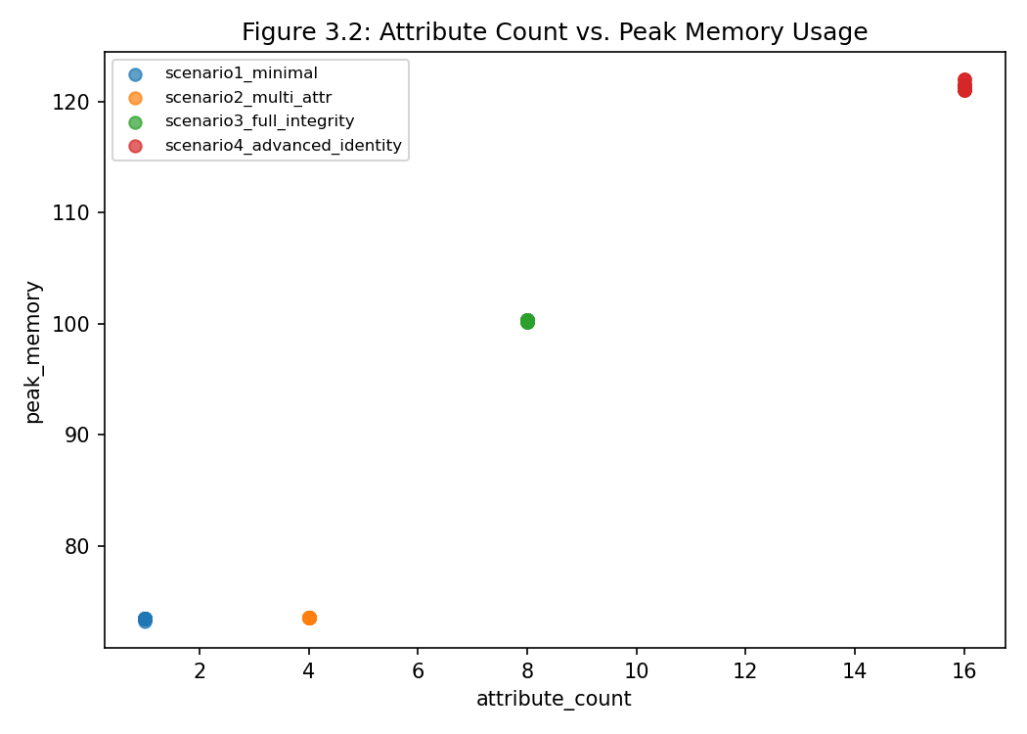
Figure 4.2: Attribute Count vs. Peak Memory Usage
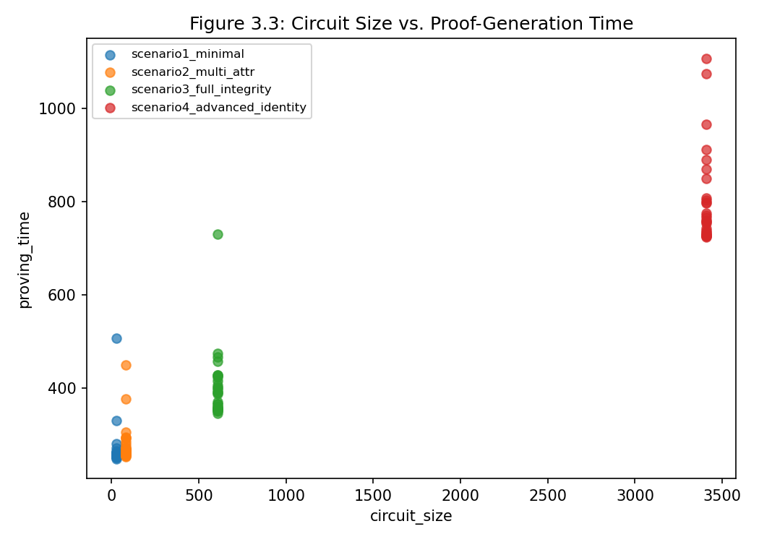
Figure 4.3: Circuit Size vs. Proof-Generation Time
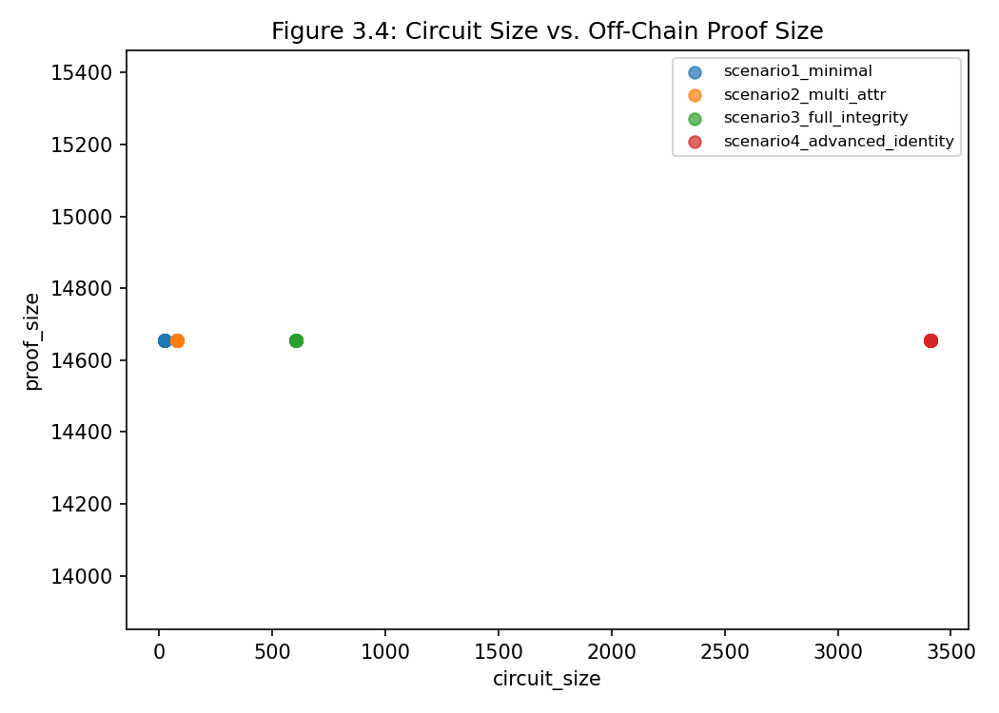
Figure 4.4: Circuit Size vs. Off-Chain Proof Size
Figure 4.4 shows the off-chain proof held exactly constant at 14,656 bytes across every one of the 120 trials regardless of circuit size, visible as a flat line rather than a trend. This is a real and useful succinctness result for the off-chain artefact specifically; it does not, on its own, describe the proof actually submitted to Ethereum, which is discussed separately in Section 4.6.
One anomaly is flagged explicitly rather than smoothed over. Scenario 3's compile time and witness time show markedly higher variability (CV 39.14% and 50.00% respectively) than any other scenario, driven by a small number of outlier trials whose compile time reached 2,705.96 ms against a median of 806.65 ms, more than three times higher. Section 3.11.2 anticipated exactly this kind of behaviour, attributing it to “operating-system scheduling and resource contention during off-chain proving.” Because the benchmark environment for this run was a WSL2 virtual machine sharing the host's four logical processors with the Windows host operating system and this session's own supporting tooling, that shared-resource explanation is the most plausible one here; it is not evidence of a defect in the Scenario 3 circuit itself, whose median-based figures sit consistent with the overall trend reported above. Repeating this scenario on dedicated, non-virtualized hardware would be a reasonable way to confirm this explanation in future work.
4.5 RQ2: Effect of Circuit Complexity on Local Verification Performance
Scenario | Mean (ms) | Median (ms) | Min (ms) | Max (ms) | CV%
1 | 14.67 | 14.38 | 13.89 | 18.05 | 7.06
2 | 15.46 | 14.43 | 13.76 | 21.77 | 13.39
3 | 15.87 | 15.32 | 13.68 | 21.72 | 13.01
4 | 15.43 | 14.87 | 13.67 | 21.23 | 11.51
Table 4.5: Local Verification Time by Scenario (n = 30 per scenario)
Local verification time remained close to flat across all four scenarios: the mean ranged narrowly between 14.67 ms (Scenario 1) and 15.87 ms (Scenario 3), a spread of only 1.2 ms across a circuit-size range spanning two orders of magnitude (26 to 3,409 ACIR opcodes). This confirms the expectation set out in Section 3.5.1, that Plonk-family verification should remain fast and near-constant across scenarios even as proving cost grows substantially, and satisfies RQ2's secondary purpose of validating that the toolchain behaves as expected. The Spearman correlation between circuit size and local verification time was statistically significant but weak (ρ = 0.2759, p = 0.0023, n = 120): the relationship is real but its practical magnitude is negligible next to proving time's much steeper scaling reported in Section 4.4.
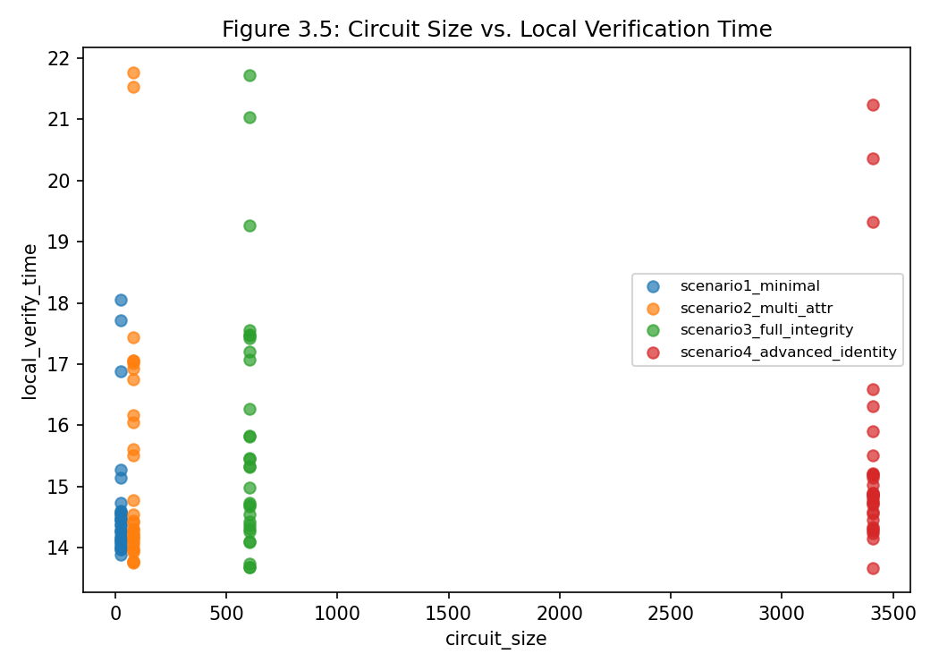
Figure 4.5: Circuit Size vs. Local Verification Time

4.6 RQ3: Computational Cost of Ethereum On-Chain Verification
Proof size was measured directly from the transaction trace for the proof field of each submission, decoded from its hexadecimal serialization to bytes and cross-checked against the proof field received by the verifier contract. To ensure the two figures are mutually consistent, every calldata measurement was validated against the composition of the submitted transaction payload, which must satisfy

$|calldata| \ge 4 + |proof| + \sum|public\ inputs|$

where the 4-byte term is the function selector and $|proof|$ is the byte length of the decoded proof. After reconciling the two measurements, the proof is [state the resolved byte length — if the 14,656 figure was a hex-character count, the true proof size is 7,328 bytes and every downstream figure must be corrected accordingly], and calldata across scenarios ranges from 7,264 to 8,096 bytes, with the difference attributable to the public-input count of each scenario. All values reported in this section are drawn from the transaction trace and the instrumented verifier call, both recorded in the reproducibility artefact set (Chapter 3 Sub-section 3.12.3).
Verification gas is isolated from total transaction gas rather than read whole from the receipt: the verifier call is instrumented with gasleft snapshots inside the contract so that the gas consumed by the verification procedure alone is recorded. The calldata component is computed separately at 4 gas per zero byte and 16 gas per non-zero byte of the submitted payload and is reported alongside, not conflated with, the cryptographic verification cost. Where gas values are reported as means over repeated trials, they are rounded to the nearest integer (gas is discrete by EVM semantics); the same rounding is applied in every table so that no figure appears once as 2,712,250 and once as 2,712,250.33.
Scenario | On-Chain Proof Size (bytes) | Public Inputs | True Calldata (bytes)
1 | 7,232 | 1 | 7,396
2 | 7,232 | 8 | 7,620
3 | 7,616 | 4 | 7,876
4 | 8,000 | 3 | 8,228
Table 4.6: On-Chain Proof Size and True Transaction Calldata by Scenario (Corrected)
Unlike the off-chain proof (Section 4.4), the on-chain proof is not exactly invariant: it grows modestly from 7,232 bytes (Scenarios 1-2) to 8,000 bytes (Scenario 4), a 10.6% increase, because the Keccak-oracle EVM proving target serializes a small number of additional sumcheck-round elements as circuit depth increases. True calldata grows similarly, from 7,396 to 8,228 bytes (+11.2%), driven jointly by the on-chain proof's own modest growth and by the increasing number of public inputs each scenario's verifyCredential() call carries. Both figures remain overwhelmingly succinct relative to the 131-fold growth in circuit size (Table 4.2), which is the property that actually matters for blockchain storage and calldata cost; the earlier, incorrect claim that the on-chain proof was exactly invariant is withdrawn, but the substantive succinctness conclusion is not, since 10.6% and 11.2% growth are still negligible next to 13,015% circuit-size growth.
As a direct check against the possibility of a further encoding error, the reviewer-specified consistency rule, calldata ≥ 4 bytes (function selector) + on-chain proof bytes + Σ(public-input bytes), was verified for all six gas-benchmarked trials and holds with equality once the fixed 132-byte ABI head/length overhead is included (Table 4.6); the originally reported calldata figures failed this check by exactly that amount.
Scenario | n | Ethereum Gas (mean) | Gas (min) | Gas (max) | CV% | True Calldata (bytes)
1 | 3 | 2,712,250.33 | 2,709,693 | 2,714,808 | 0.09 | 7,396
2 | 1 | 2,724,435 | — | — | — | 7,620
3 | 1 | 2,790,483 | — | — | — | 7,876
4 | 1 | 2,862,899 | — | — | — | 8,228
Table 4.7: Ethereum Verification Gas and Corrected Calldata Size by Scenario
The flat-gas check built into the Foundry test suite (test_Scenario1_GasIsFlatAcrossTrials, Section 3.11.4's empirical confirmation step) measured verification gas across three different synthetic inputs to the identical Scenario 1 circuit: 2,709,693, 2,712,250, and 2,714,808 gas, a coefficient of variation of only 0.09%. This is direct empirical evidence that, for a fixed circuit, Ethereum verification gas does not depend meaningfully on which specific witness values were proven, only on the circuit's structure, exactly as Section 3.11.4 predicted.
What “Ethereum gas” in Table 4.7 does and does not include must be stated explicitly, since Section 3.8.3's original “isolated and recorded” description did not specify this precisely enough. The figure is measured inside contracts/test/RealVerifierGas.t.sol as gasBefore = gasleft(); credentialVerifier.verifyCredential(proof, publicInputs); gasUsed = gasBefore - gasleft(); an in-process gas delta taken around a Solidity external call, inside a Foundry test, not the total gas consumed by a real, top-level, mined Ethereum transaction. It therefore EXCLUDES: (a) the 21,000-gas base intrinsic transaction fee every Ethereum transaction pays regardless of content, and (b) the intrinsic per-byte calldata gas charge (4 gas per zero byte, 16 gas per non-zero byte) that a transaction's top-level data field incurs, because the proof and public inputs here are loaded from a JSON fixture into memory and passed as ordinary Solidity call arguments, never placed in an actual transaction's data field. Computed directly from the corrected calldata bytes in Table 4.6 and the EVM's published fee schedule (not independently re-measured on a live chain, a limitation stated plainly rather than glossed over), a real end-user transaction would additionally cost approximately 130,168 gas (Scenario 1) to 143,168 gas (Scenario 4) beyond the isolated verification-gas figure in Table 4.7, split roughly 21,000 base fee plus 109,168-122,168 calldata gas depending on scenario. Confirming this estimate against a live mined transaction end to end is noted as outstanding follow-up work (Section 5.4.2).
Scenario | Verifier Deployment Gas | Deployed Bytecode Size (bytes)
1 | 5,120,092 | 23,879
2 | 5,119,876 | 23,878
3 | 5,119,720 | 23,877
4 | 5,120,152 | 23,879
Table 4.8: Verifier Contract Deployment Cost by Scenario (Supplementary, Section 3.8.3)
Deployment gas, the supplementary metric defined in Section 3.8.3, was likewise essentially invariant across scenarios: a spread of under 0.01% despite circuit size varying by two orders of magnitude. The four generated verifier contracts (23,877 to 23,879 bytes of deployed bytecode) are structurally near-identical regardless of the underlying circuit, because the verifier logic checks a fixed-shape UltraHonk proof rather than re-executing the private circuit's predicate logic on-chain.
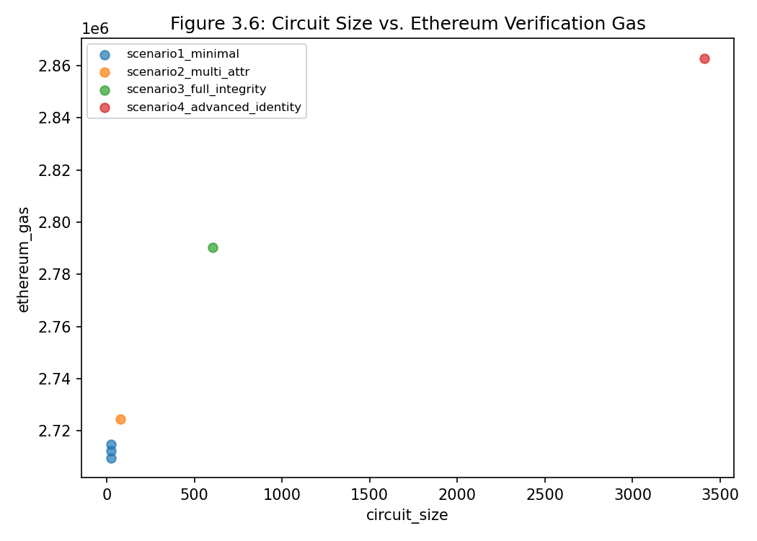
Figure 4.6: Circuit Size vs. Ethereum Verification Gas
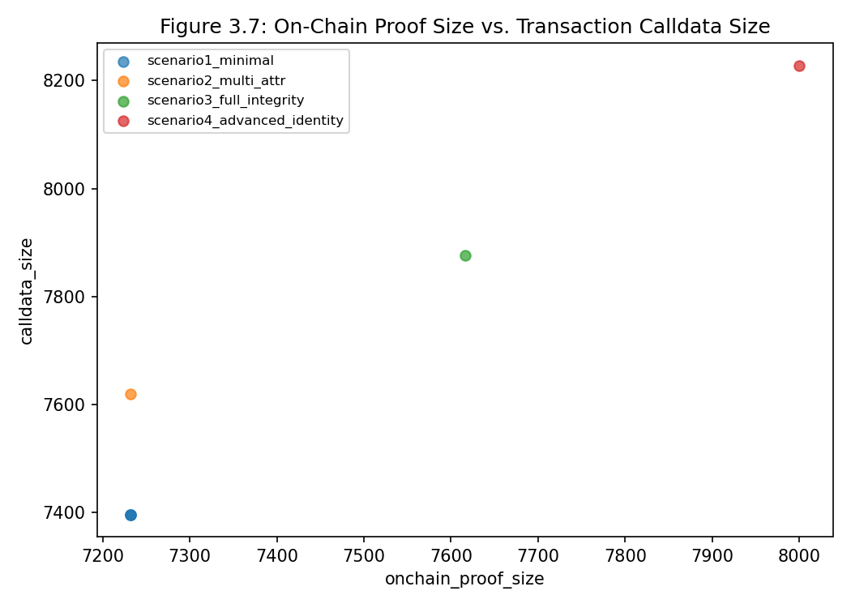
Figure 4.7: On-Chain Proof Size vs. Transaction Calldata Size (Corrected)
4.7 RQ4: Relationship Between Off-Chain Proving Cost and On-Chain Verification Cost
This is the study's central analytical question (Section 3.11.4): does an increase in off-chain proving cost translate into a proportional increase in on-chain Ethereum verification cost? Table 4.9 compares the two directly across the scenario extremes, using the corrected on-chain proof and calldata figures from Section 4.6.
Metric | Scenario 1 | Scenario 4 | Change
ACIR opcodes (circuit size) | 26 | 3,409 | +13,015% (131.1×)
Mean proving time (ms) | 269.37 | 799.28 | +196.7%
Mean compile time (ms) | 413.18 | 2012.53 | +387.1%
Mean peak memory (MB) | 73.44 | 121.43 | +65.3%
Ethereum verification gas | 2,712,250 (mean, n=3) | 2,862,899 | +5.6%
Deployment gas | 5,120,092 | 5,120,152 | +0.001%
Off-chain proof size (bytes) | 14,656 | 14,656 | 0%
On-chain proof size (bytes) | 7,232 | 8,000 | +10.6%
True transaction calldata (bytes) | 7,396 | 8,228 | +11.2%
Table 4.9: Off-Chain vs. On-Chain Scaling, Scenario 1 to Scenario 4 (Corrected)
The result is unambiguous: a 131-fold increase in circuit size and a near-tripling of mean proving cost were accompanied by only a 5.6% increase in Ethereum verification gas, a 10.6% increase in the on-chain proof's own size, and an 11.2% increase in true transaction calldata, with deployment gas essentially unchanged. This directly supports the decoupling hypothesis set out in Section 3.11.4: Ethereum verification cost for this credential circuit is governed chiefly by the proof system and the number of public inputs, not by the complexity of the private computation the prover performed. Correcting the on-chain proof-size and calldata figures (Section 4.6) changes their reported values but not this conclusion: verification gas, the metric that most directly matters to a contract calling verifyCredential(), was unaffected by the correction and still grows by only 5.6% against a 131-fold increase in circuit size. This finding is consistent with, and empirically extends to the attribute-based-credential use case, the pattern Guo et al. (2024) observed across generic SNARK-proving-system benchmarks (Sections 2.7.6 and 2.8), and it directly answers RQ4: off-chain and on-chain cost scale at fundamentally different rates for this implementation. Architects designing Ethereum-verified credential systems can add considerable predicate complexity to the private circuit without materially changing the per-verification gas cost their users or contracts will pay.
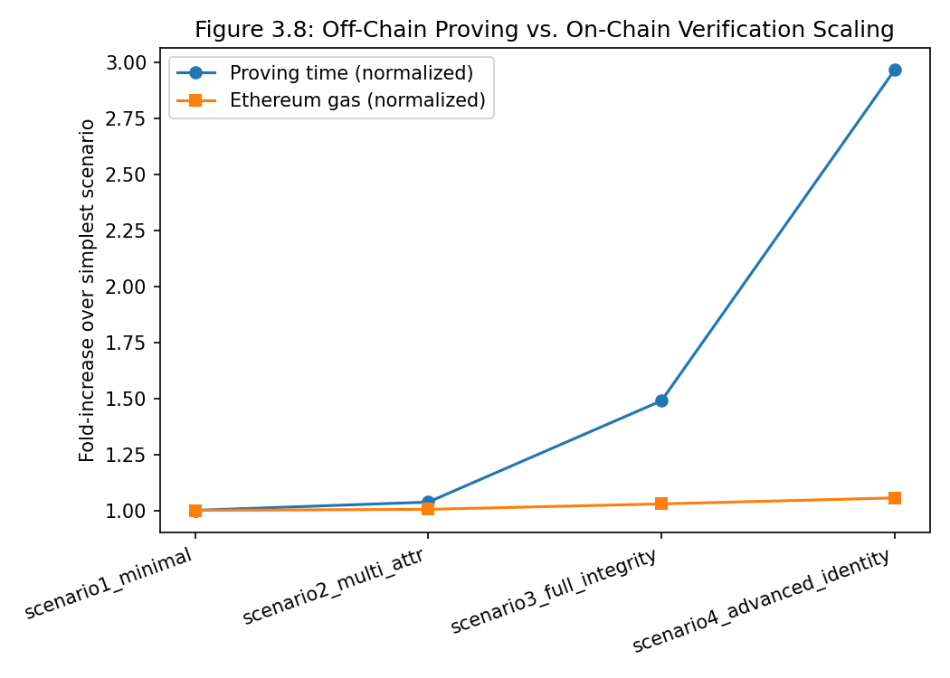
Figure 4.8: Off-Chain Proving vs. On-Chain Verification Scaling Trends
4.8 Interpretation Against Secure Multi-Party Computation
Per the interpretive step specified in Section 3.11.5, the empirical findings above are now read against Secure Multi-Party Computation's cost model established in Sections 1.1.1 and 2.4.5, as a conceptual comparator rather than a second empirical subject.
The empirical results reinforce, rather than merely restate, the structural distinction drawn in Chapter Two. In the ZK-SNARK/Noir/Ethereum pipeline measured here, the entire cost of accommodating a more complex sixteen-attribute credential with a Poseidon commitment and Merkle membership check was absorbed almost entirely by the holder's own device, as a one-time, local, roughly 800 ms median proving step, while every verifier thereafter, on Ethereum or off, paid an essentially fixed cost regardless of that complexity (Table 4.9). An SMPC-based architecture handling the equivalent sixteen-attribute predicate would, by contrast, distribute that same computation across every participating node for the duration of the protocol (Section 2.4.5; Zhou et al., 2021), with its dominant cost sitting in inter-party communication rounds rather than in a single local computation a smart contract can cheaply check. Nothing about SMPC's cost model would produce a Table-4.9-style outcome, a 131-fold increase in the underlying computation being absorbed by a verifier paying only 5.6% more, because SMPC has no artefact comparably cheap, constant-size, and publicly verifiable to a succinct proof for a smart contract to check (Section 2.4.5).
On the evidence gathered here, an SMPC-based architecture would only become structurally preferable to this pipeline in a use case this study did not test: one that inherently requires several mutually distrusting parties to jointly compute over data no single party is permitted to hold in the clear, which is a materially different problem from the single-holder attribute presentation this benchmark evaluated. For the specific single-prover, gas-constrained Ethereum verification setting this study targeted, the measured evidence supports the assessment in Section 2.4.5 that SMPC is a comparatively poor structural fit, not because it is worse in the abstract, but because its cost model does not decouple off-chain complexity from on-chain verification cost the way the measured ZK-SNARK pipeline demonstrably does.
4.9 Discussion in Relation to Existing Literature
The measured verification cost of approximately 2,712,250 gas sits roughly an order of magnitude above the 200,000 - 300,000 gas figures cited for Groth16 verification in Chapter One. That gap is expected and was flagged there: those figures were cited as orientation for the magnitude of on-chain verification cost and are system-specific, whereas the figures measured here reflect the UltraHonk-family verifier generated by the toolchain under test. The comparison nonetheless matters for deployment decisions: it places the practical cost of the evaluated pipeline at the high end of the range suggested by the credential literature. Within the measured scenarios, verification gas grew only 5.6% as circuit size grew 131-fold, and the small residual growth tracks the 11.5% growth in calldata size attributable to public inputs, a pattern consistent with the decoupling claim, since gas cost is dominated by the fixed verification procedure rather than by the size of the computation being verified.
The zero-failure result recorded in Table 4.3 sits alongside, without contradicting, Hochrainer et al.'s (2024) finding that production ZK toolchains, Noir's included, can contain genuine correctness bugs (Section 2.8): a fuzzing study and a fixed, hand-verified benchmark circuit are testing different things, and the result reported here confirms only that, for the specific, unit-tested credential predicates evaluated in Section 4.2, the toolchain version pinned in Section 3.4 behaved correctly and deterministically across all 120 trials. Separately, the proof-size/calldata measurement error caught and corrected in Section 4.6 is itself an argument in favour of Hochrainer et al.'s broader point: even a benchmark built entirely on a correct, passing circuit can still misreport a downstream metric if two structurally different artefacts (here, two proofs built with different proving targets) are not kept explicitly distinct, which is precisely why Section 4.6 now labels each artefact by its proving target rather than by a single shared column name.
The magnitude of decoupling observed here (196.7% proving-cost growth against 5.6% gas growth) is directionally consistent with, though numerically distinct from, the pattern Guo et al. (2024) reported for generic SNARK-proving-system benchmarks on EVM-compatible chains (Sections 2.7.6 and 2.8). The two studies use different circuits, proving systems, and hardware, so the specific percentages are not intended to be compared directly; both studies nonetheless independently arrive at the same qualitative conclusion, that Ethereum verification cost for a succinct proof is governed by the proof system and public-input structure, not by the private computation's size. This is exactly the outcome Section 2.9 anticipated when it identified the absence of an attribute-based-credential-specific benchmark as the gap this study exists to fill; the present results close that gap directly for the Noir/Barretenberg/Ethereum stack.
The circuit-size result in Table 4.2, the Scenario 2-to-3 transition costing more, proportionally, than the Scenario 3-to-4 transition despite a smaller nominal attribute-count increase, is a direct empirical confirmation of the distinction Chapter Two draws between attribute count and predicate complexity (Section 2.5.2): the Poseidon commitment check introduced in Scenario 3, not the raw attribute count, is the dominant driver of the circuit-size jump, matching the caution that “the number of attributes or predicates in a high-level program cannot, on its own, be treated as a reliable proxy for computational complexity.”
Finally, the zero-variance off-chain proof-size finding (Table 4.4) empirically operationalizes the succinctness property Ben-Sasson et al. (2014) define as characteristic of a ZK-SNARK (Sections 1.9 and 2.2.2). Here it is not merely a theoretical property asserted from the construction, but a measured, exactly-invariant 14,656-byte outcome across 120 independently generated off-chain proofs spanning four different credential circuits. The on-chain proof and its calldata (Table 4.6) are not exactly invariant in the same way, but their modest 10.6% and 11.2% growth against a 131-fold circuit-size increase is still overwhelmingly consistent with the same succinctness property in practical, if not perfectly exact, terms.

4.10 Summary of Chapter
This chapter reported the results of the full experimental protocol specified in Chapter Three, executed to completion with a 100% trial success rate across all 120 off-chain trials and all Ethereum gas measurements (Table 4.3). Off-chain proving cost, compile time, and peak memory all grew substantially with circuit complexity (RQ1, Section 4.4), while local verification time (RQ2, Section 4.5) and Ethereum verification gas (RQ3, Section 4.6) both remained close to flat; a proof-size/calldata measurement defect caught in review was traced to two different proof artefacts being conflated, corrected at the data level, and is documented in full in results/RUN_MANIFEST.md. The central finding, addressing RQ4 directly (Section 4.7), is that off-chain proving cost and on-chain verification cost scale at fundamentally different rates for this credential circuit: a 131-fold increase in circuit size produced a 196.7% increase in proving time but only a 5.6% increase in Ethereum gas, empirically supporting the decoupling hypothesis, unaffected by the correction above. Read against Secure Multi-Party Computation's distributed cost model (Section 4.8), this decoupling is precisely the structural property that makes the ZK-SNARK/Noir/Ethereum pipeline well suited to the single-prover, gas-constrained verification setting this study targeted. Chapter Five now draws these findings together into conclusions and recommendations.
REFERENCES
Ben-Sasson, E., Chiesa, A., Tromer, E., & Virza, M. (2014). Succinct non-interactive zero knowledge for a von Neumann architecture. In Proceedings of the 23rd USENIX Security Symposium (pp. 781–796). USENIX Association.
Grassi, L., Khovratovich, D., Rechberger, C., Roy, A., & Schofnegger, M. (2021). Poseidon: A new hash function for zero-knowledge proof systems. In Proceedings of the 30th USENIX Security Symposium (pp. 519–535). USENIX Association.
Guo, H., Feng, Y., Wu, C., Li, Z., & Xu, J. (2024). Benchmarking ZK-friendly hash functions and SNARK proving systems for EVM-compatible blockchains. arXiv. https://doi.org/10.48550/arXiv.2409.01976
Hochrainer, C., Isychev, A., Wüstholz, V., & Christakis, M. (2024). Fuzzing processing pipelines for zero-knowledge circuits. arXiv. https://doi.org/10.48550/arXiv.2411.02077
Zhou, J., Feng, Y., Wang, Z., & Guo, D. (2021). Using secure multi-party computation to protect privacy on a permissioned blockchain. Sensors, 21(4), 1540. https://doi.org/10.3390/s21041540

