# Exercise: React Routing and Architecture Interactive IMDB

This is an exercise for the ["ReactJS Fundamentals Course"](https://softuni.bg/opencourses/reactjs-fundamentals) at [SoftUni.](https://softuni.bg)

## Task Requirements

Using **routing**, create **a ReactJS application** which includes the following **views**:

* **Register** user
* **Login** user
* **Create a movie** (**Admin** only)
* **View all movies** (view **movie trailers** and **story lines** (**Logged-in users** only))

**Hint1:** In order to be able to **display the trailer** of the movie use the [react-player](https://www.npmjs.com/package/react-player).

**Hint2:** Use [react-toastr](https://www.npmjs.com/package/react-toastr) to implement **error-handling (for the forms)**

**Hint3:** Use [react-router-dom](https://www.npmjs.com/package/react-router-dom) to implement the **routing**

## Server

You will be **provided with a server** to fetch data from a database. Run **npm install** before you start and run the server. The server can support the following requests:

* **'http://localhost:9999/feed/movie/create'** – **POST** – add new movie to the database
* **'http://localhost:9999/feed/movies'** – **GET** – get all movies from the database
* **'http://localhost:9999/auth/signup'** – **POST** – register a new user
* **'http://localhost:9999/auth/signin'** – **POST** – login a user

**Explore the code** of the server.

## Database

The database will include the following:

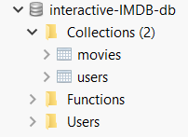

* **User** – has a **username, password, email** and **roles**
* **Movie** – has a **title, storyline, posterUrl, trailerUrl**

## Skeleton

The skeleton provided to you will contain the **server**, the **structure** of the **react application** and the **css files** you will need.

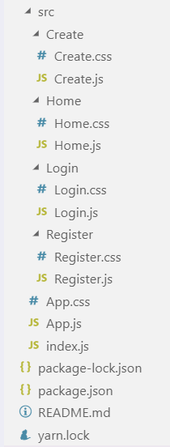

## Views

### Register

### Login

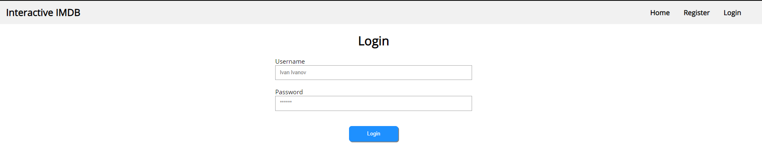

### Home

#### Anonymous

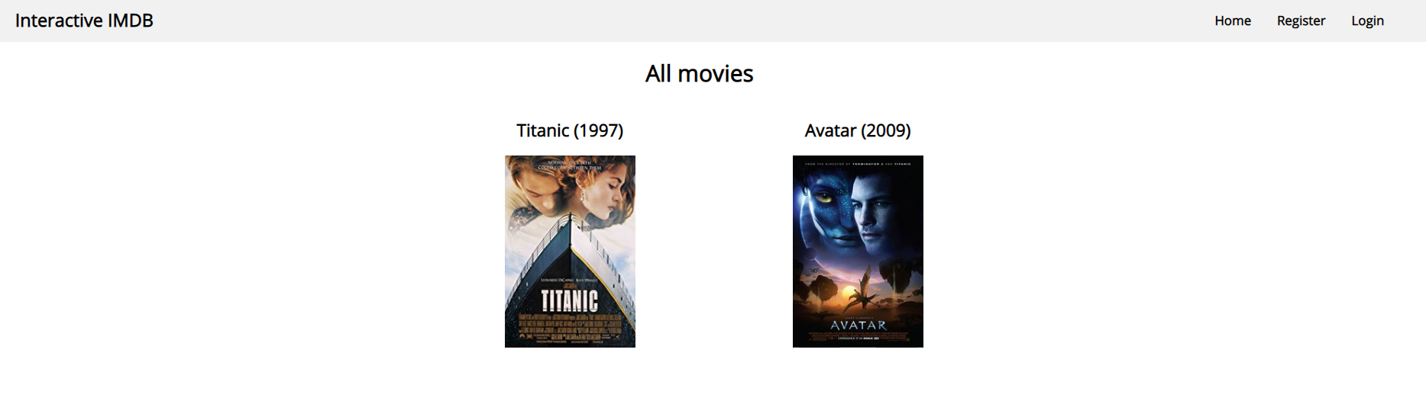

#### Admin

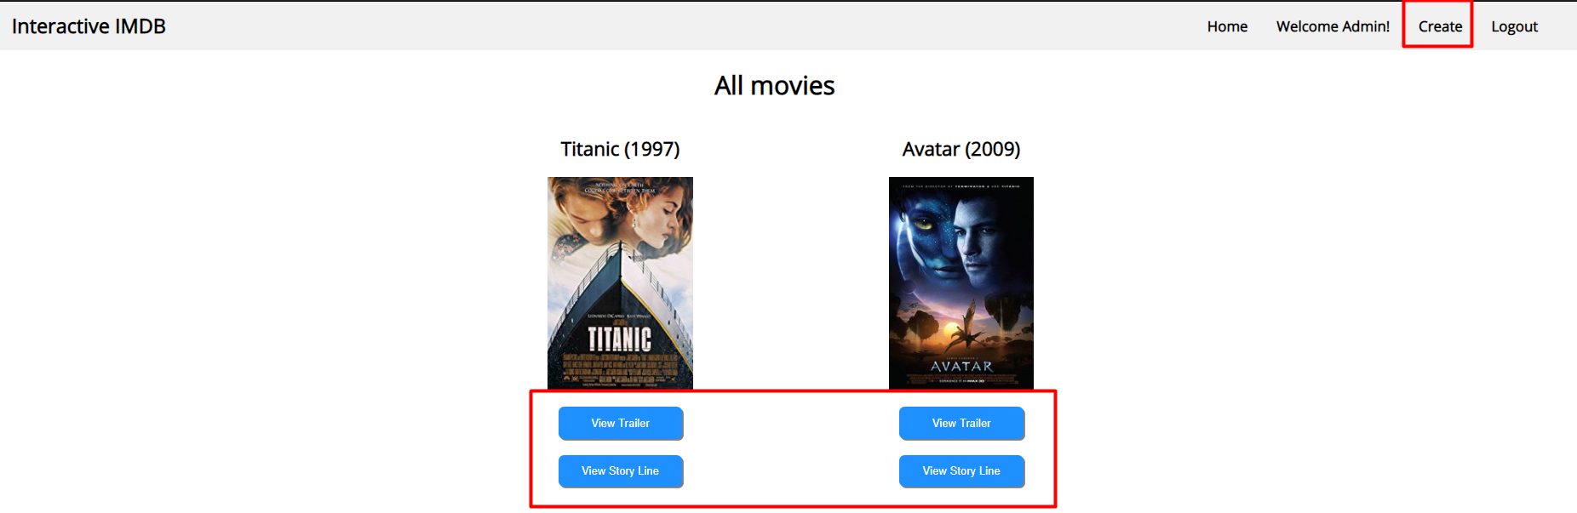

#### User

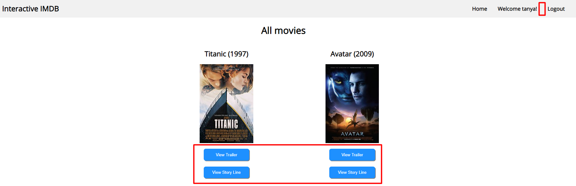

#### View Trailer

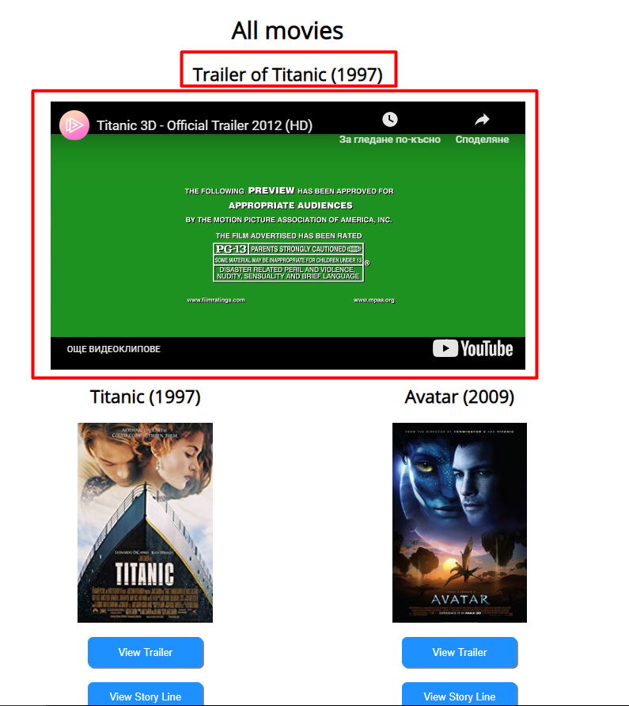

#### View Storyline

