**Wedding-App-React-Project**

This app was created for my project defence @ SoftUni for my React course.

The project was generated with React version 18.2.0.

React web application for reading and creating wishes, TODO:also like and comment on them.

## **Build with:**

### Frontend:

* React 18.2.0
* React Router DOM
* React Swiper
* HTML
* CSS

**The HTML and CSS is written by myself with basic knowledge and lots of documentation searches**

* Font Awesome

### Backend & Database:

* Firebase

**RSVP Wedding App**

### **What Is an RSVP?**

The term "RSVP" comes from the French expression répondez s'il vous plaît, meaning "please respond." If RSVP is written on an invitation, it means the host has requested that the guest respond to say if they plan to attend the party.

This WebApp introduce the unique story of the grooms and gives them opportunity to get responses from their guests .Also the guests can write their wishes at the Book of wishes.

## **Start the app**

To start the application install all dependecies for the client and the rest-api with

**npm install.**

Then start the client with

**npm start**

This will navigate to http://localhost:3000/ in the browser.

**Or you can see live demo here :………………………………………**

### **Home Page**

### Navigation (user)

Картина, която съдържа текст

Описанието е генерирано автоматично

The logout action is available to logged-in users. Upon success, clear any session information and redirect the user to the **Home page**.

### **Navigation (guest)**

Картина, която съдържа текст

Описанието е генерирано автоматично

Invites the user to log in to their account or to register

### **Login Page (logged out user**)

Logging an already registered user with the correct **email** and **password**.

After successful login redirects to the **Home page**, with an already logged-in user.

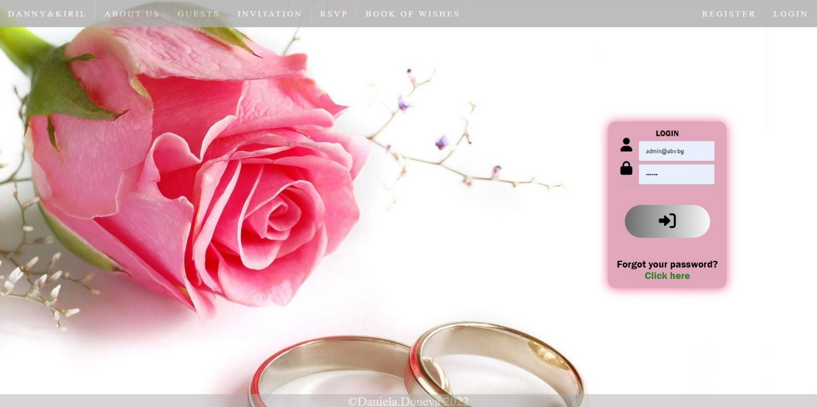

### **Register Page (logged out user)**

Register create user inside the database with **username**, **email** and **password**. Password inside the database is **hashed** and both passwords must match!

**MORE VALIDATIONS YET TO BE MADE**

After successful registration redirects to the **Home page**, with an already logged-in user.

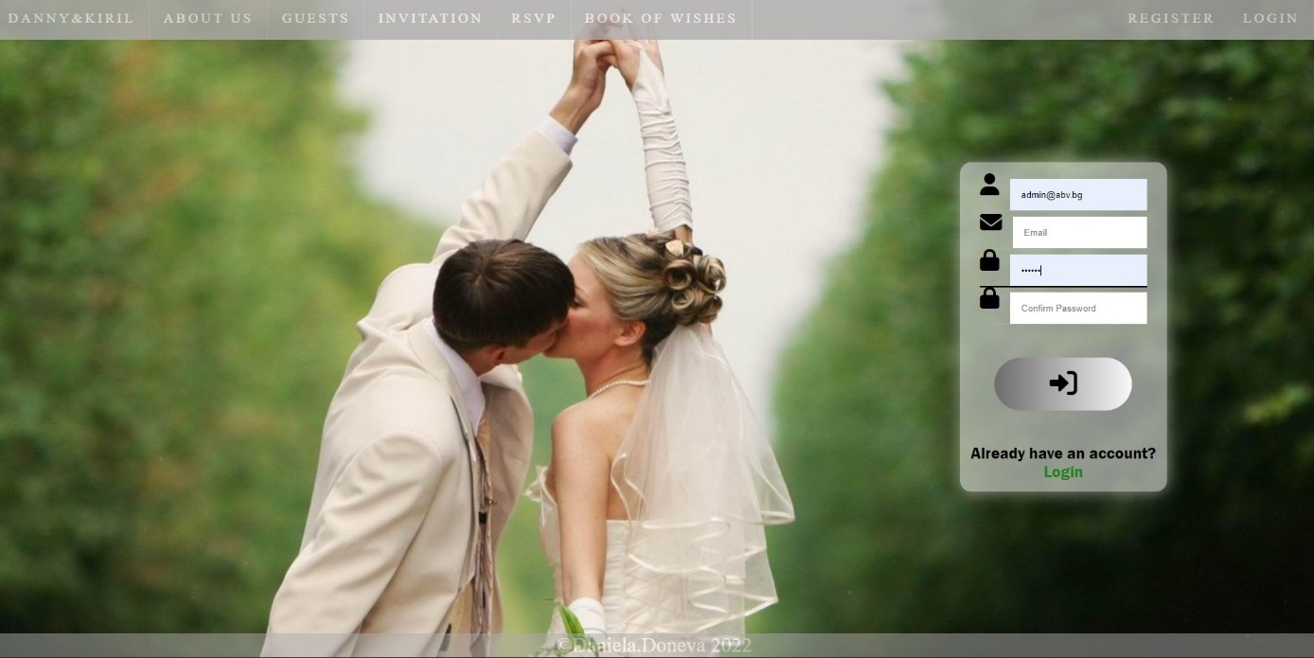

Wishing Book Page (Comment Page)

Here We have Swiper Component with every wish that is saved in our Database .

You can move the cards with click and mouse move.

There is pagination as well.

If there is no wishes -paragraph appears with text “No wishes yet ”

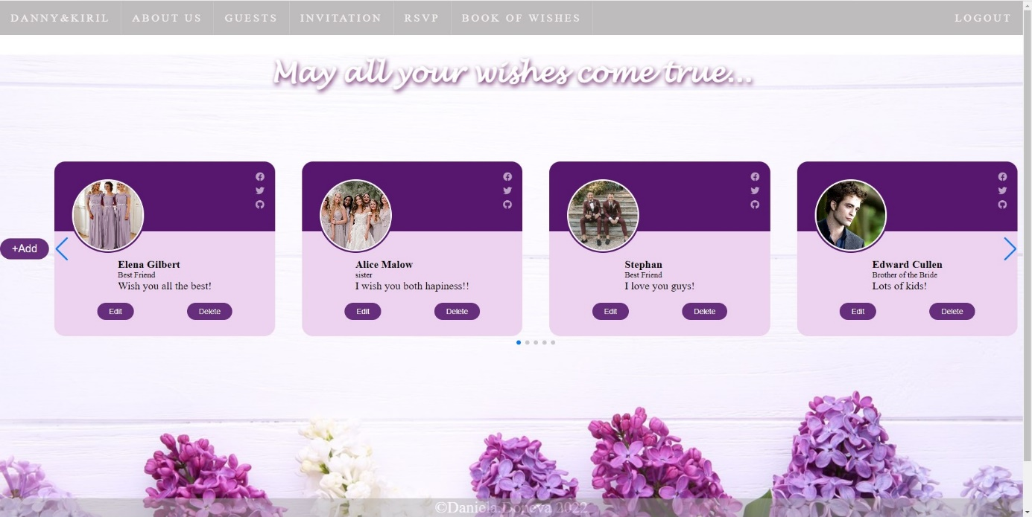

The +ADD Button shows Modal with input fields:

NAME : We expect name here

Photo : Image Url

Related: What is you relationship with the grooms

Message: and you wish

With click on SEND button we create new Wish in this section

We cansel the operation with click on Close or anywhere out of the modal area.

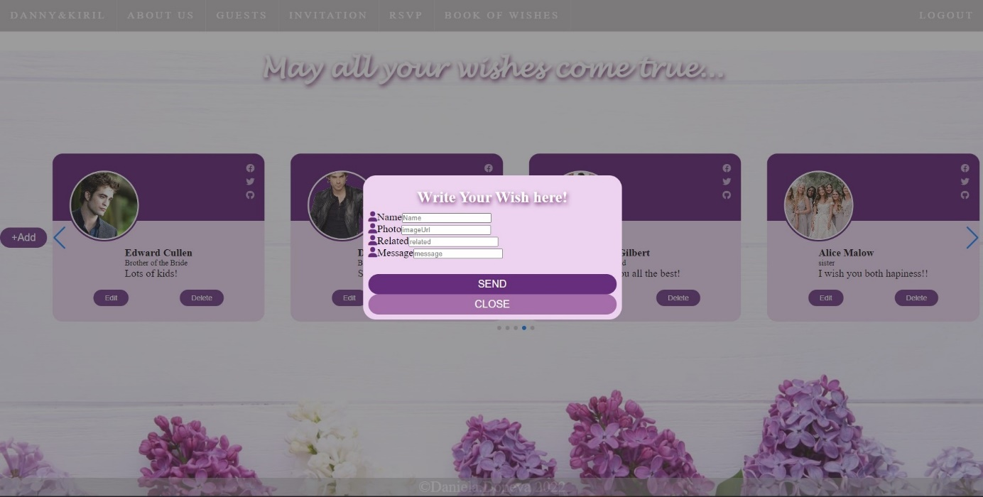

On this photo is clicked on Edit button

It opens another modal only over the card section and gives you the same inputs wich changed the commend .

TODO: That must happen only if is owner

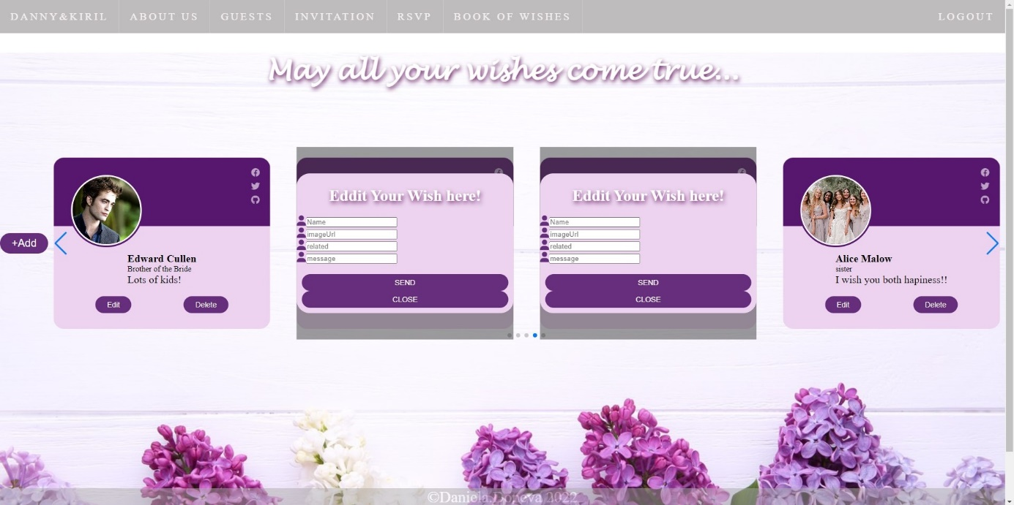

About US

This is static page for now describing grooms unique story !

Картина, която съдържа текст, цвете

Описанието е генерирано автоматично

RSVP Page

Here we have form with input fields ,select options field and textarea.

On Submit this information is saved in our database and is shown in our Guest page.

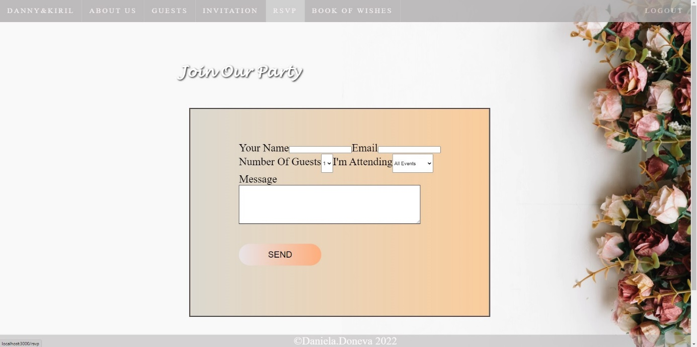

404 page

