Name:- Nariya Darshan A.
En. No.:- E19110403000110036
Subject:- Unix & Shell Programming
Course:- BCA SEM-V
Roll No.:- 36
Practical Assignment

INDEX
Sr.NO | Date | TITLE | Page No. | Sign
1 |  | Study the basic architecture of Unix operating system with all its features. | 5
2 |  | Perform the following basic Unix Shell commands with its options:  ls,mkdir,rmdir,rm,mv,echo,pwd,cd,cat,date,cal,touch, wc | 6
3 |  | Explain chmod command with its options and examples. | 9
4 |  | To study the different modes of vi editor. | 10
5 |  | Write a shell script to display “Hello World”. | 12
6 |  | Write a shell script to read two integer numbers from the user and find sum, product and division of these two numbers. | 12
7 |  | Write a script to find out number of characters, words and lines from a given file. | 13
8 |  | Write a shell script to explain if-then-elif-fi statement with suitable example. | 14
9 |  | Write a shell script display the digits which are at odd positions in a given 5-digit number. | 15
10 |  | Write a shell script to find the factorial value of given input numbers. | 16
11 |  | Write a shell script to generate and display Fibonacci series. | 17
12 |  | Write a shell script to concatenate the contents of two files in a third file. | 18
13 |  | Write a shell script to check whether a given file is readable or not. If it is readable, then display the file contents. | 19
14 |  | Explain input and output redirection in Unix with suitable example. | 19
15 |  | Write a shell script to translate all the contents of a given file into uppercase letters. | 20
16 |  | Explain following commands.  - Cut  - Paste  - Sort. | 21
17 |  | Write a shell script to accept a string in lower case letters from a user, and convert all the characters in the upper-case letters. | 22
18 |  | Write a shell script to read a character from the user and determine whether it is uppercase letter, lower case letter or digit. | 23
19 |  | Write a shell script to determine whether a given number is palindrome or not. | 24
20 |  | Write a shell script to find the lines containing numbers in a file using grep command. | 25
21 |  | Write a shell script to check whether a given number is prime or not. | 26
22 |  | Write a menu driven shell script to perform the following task.  - i)To remove all the vowels from the given file.  - To convert all the vowels from lowercase to uppercase.  - Remove all the digits from the file. | 27
23 |  | Write a shell script to display multiplication table of a given number. | 31
24 |  | Perform following commands using sed:  - Replace or substitute the string of the file f1.  - Replace all the occurrences of the pattern of the file f1.  - Delete the particular lines of the file f1.  - Delete the lines from range x to y. | 31
25 |  | Perform following commands using grep:  - To search for a string case insensitively in the given file.  - To display the count of matches/occurrences of pattern.  - To display only the matched pattern of the file.  - To show the line number of file with the line matched.  - To invert the pattern match of the file.  - To match the lines that starts with a string. | 33
26 |  | Write a command using awk utility:  - To print the lines which matches the given pattern.  - To split a line/record into fields.  - To print the first item along with the row number separated with “:” from each line of the file.  - To find the sum of all the records of the first item of the given file.  - To find the sum of all the records of the second item of the given file. | 34
27 |  | Extras | 36

Ans 1

Unix Architecture

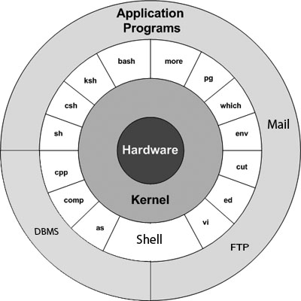

Kernel
The kernel is the heart of the operating system. It interacts with the hardware and most of the tasks like memory management, task scheduling and file management.

Shell
The shell is the utility that processes your requests. When you type in a command at your terminal, the shell interprets the command and calls the program that you want. The shell uses standard syntax for all commands. C Shell, Bourne Shell and Korn Shell are the most famous shells which are available with most of the Unix variants.

Commands and Utilities
There are various commands and utilities which you can make use of in your day to day activities. cp, mv, cat and grep, etc. are few examples of commands and utilities. There are over 250 standard commands plus numerous others provided through 3rd party software. All the commands come along with various options.

Files and Directories
All the data of Unix is organized into files. All files are then organized into directories. These directories are further organized into a tree-like structure called the filesystem.

Ans 2

Ls

ls

ls -l

Ls -a

Mkdir

Mkdir unixstuff
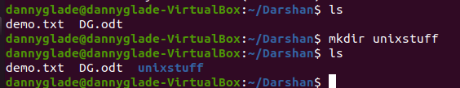

Rm

rm ab*.txt
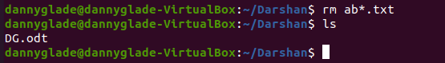

Mv

Mv demo2.txt ~/Darshan/unixstuff/.
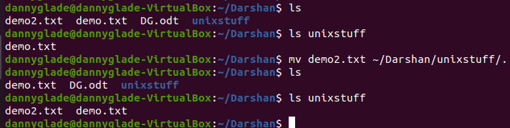

Cp

Cp demo.txt demo2.txt
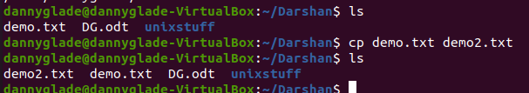

Cp ~/Darshan/demo.txt .
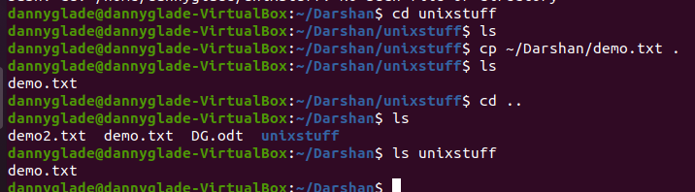

Pwd

Pwd
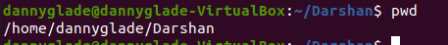

Cd
Cd unixstuff
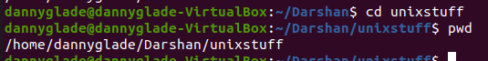

Cd .
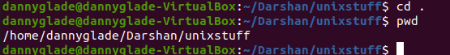

Cd ..
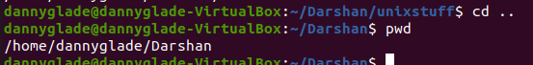

CAT

cat > ab*.txt
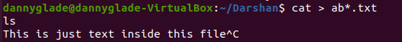

Cat ab*.txt

Wc

Wc demo.txt
Lines/words/charachters

Echo

Echo “My Name is Darshan”

Date

Date +”%d . %m . %y”
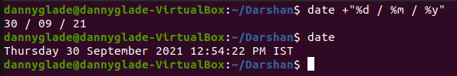

Ans 3

Chmod

Syntax

chmod [reference][operator][mode] file...

Reference Class Description
u owner file's owner

g group users who are members of
the file's group

o others users who are neither the
file's owner nor members of
the file's group

a all All three of the above, same as ugo

Operator Description
+ Adds the specified modes to the
specified classes

- Removes the specified modes from
the specified classes

= The modes specified are to be made
the exact modes for the specified
classes

r Permission to read the file.
w Permission to write (or delete) the file.
x Permission to execute the file, or, in
the case of a directory, search it.

Examples

cat > demo.txt
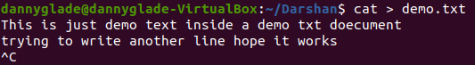

ls -l
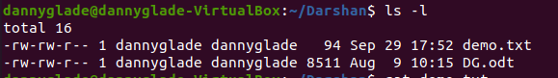

Chmod ugo+w demo.txt
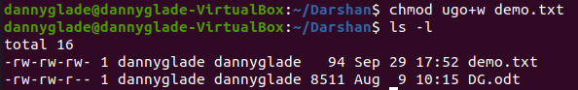

Chmod o-wr demo.txt
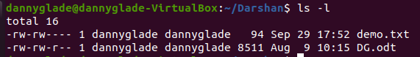

Chmod 666 demo.txt
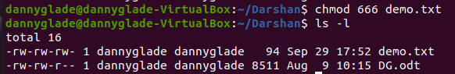

Ans 4

Vi(Vim) Editor

The default editor that comes with the UNIX operating system is called vi (visual editor). Using vi editor, we can edit an existing file or create a new file from scratch. we can also use this editor to just read a text file.

Syntax

vi filename

vi command mode

When you first start editing a file with the vi editor you will be in vi command mode. In this mode you can issue many vi commands, including commands like insert, append, and delete, and other search and navigation commands that let you move around your file.
Possibly the most important thing to know is that when you're in command mode you can't insert text immediately. You first need to issue an insert, append, or open command to insert text.

vi insert mode

Once you issue a vi insert, append, or open command, you will be in vi insert mode. If you're working with a modern vi or vim implementation, your vi editor is typically configured to show the current mode of operation, so when you go into insert mode, you'll see a text string like this on the last line of your vi editor window:
-- INSERT --
At this point you can (a) type text into your file and (b) use the arrow keys to navigate around your file just as you would do with any other text editor. (There may be some complications with older Unix systems, like HP-UX systems, but this statement is generally true.)
A very important concept to know is that when you're in vi insert mode, but you want to switch back to vi command mode, you easily move back to command mode by pressing the [Esc] key. This command is so important, I'll show it again:
[Esc]
This command is very common, and I often see expert vi users press the [Esc] key several times in a row. They usually do this (a) to be sure they hit the key and they're really back in command mode, and (b) to hear the beep from the computer, which happens when you press the [Esc] key when you're already in vi command mode. This seems to serve as a form of feedback which assures them that they're in command mode.

vi last line mode

The last vi mode is known as vi last line mode. You can only get to last line mode from command mode, and you get into last line mode by pressing the colon key, like this:
:

After pressing this key, you'll see a colon character appear at the beginning of the last line of your vi editor window, and your cursor will be moved to that position. This indicates that vi is ready for you to type in a "last line command".
From this vi command prompt you can do all sorts of really amazing things. You can do simple things, like quitting your vi session, like this:
:q
or this:
:q! or this:
:wq

Ans 5

Hello World

Echo “Hello World!!...”

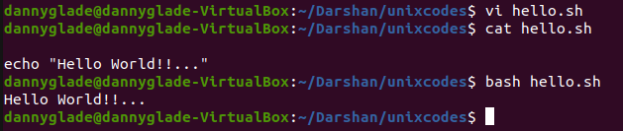

Ans 6

Code
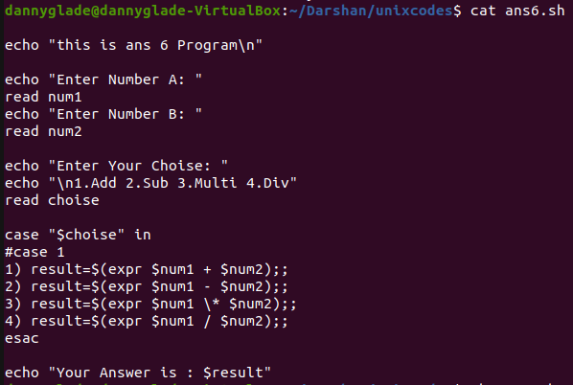

O/P
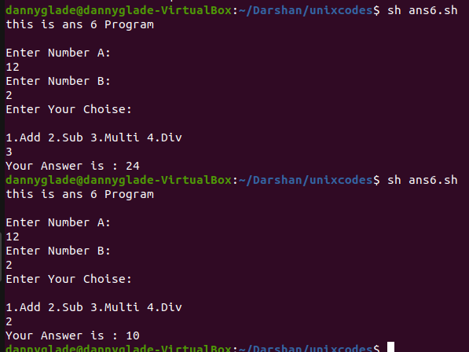

Ans 7

Code

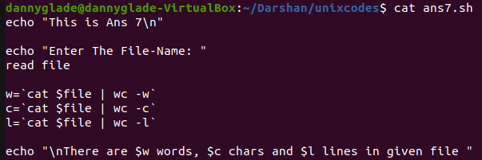

O/P

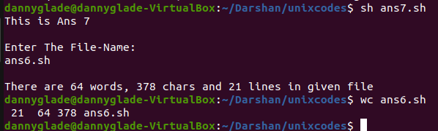

Ans 8

Code

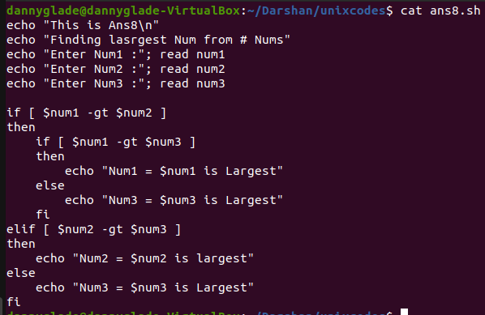

O/P
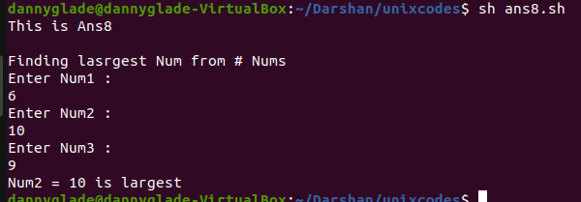

Ans 9

Code

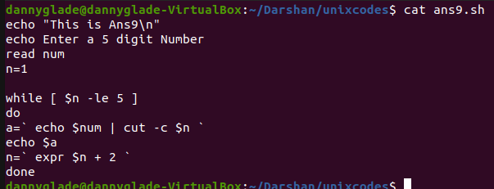

O/P

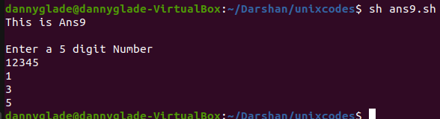

Ans 10

Code
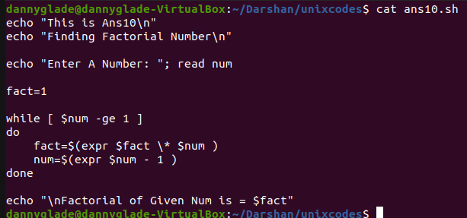

O/P

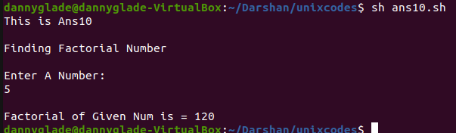

Ans 11

Code
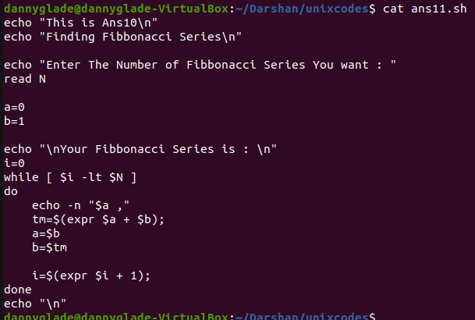

O/P

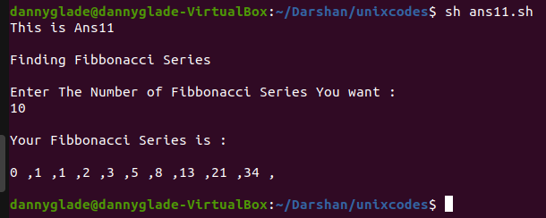

Ans 12

Code
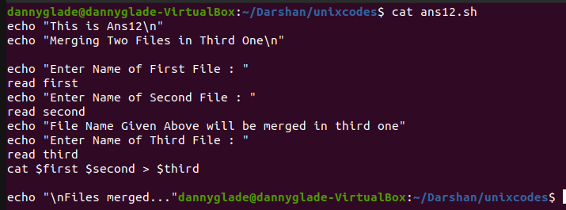

O/P
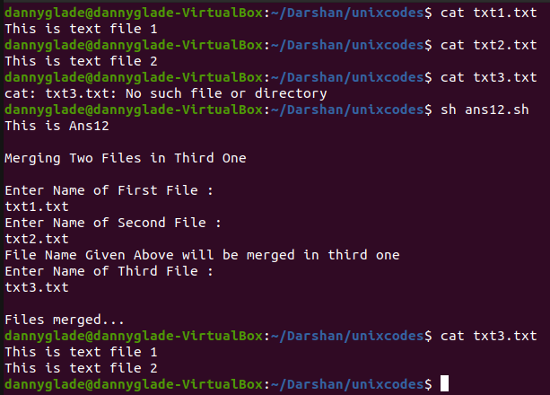

Ans 13

Code
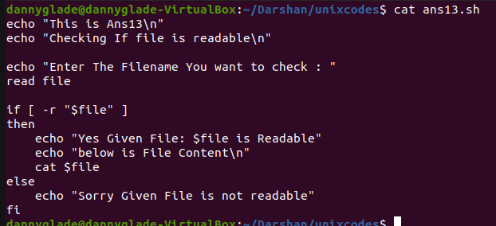

O/P
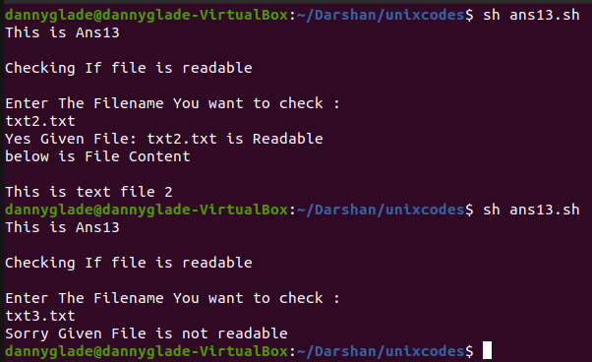

Ans 14

Definition
Redirection is a feature in Linux such that when executing a command, you can change the standard input/output devices. The basic workflow of any Linux command is that it takes an input and give an output.

Output Redirection
The ‘>‘ symbol is used for output (STDOUT) redirection.

E.g.
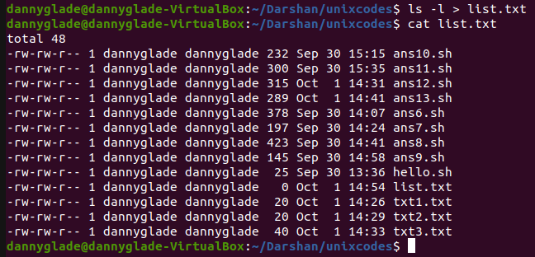

Input Redirection
The ‘<‘ symbol is used for input(STDIN) redirection

E.g.
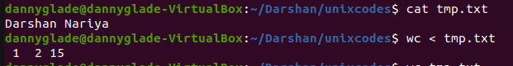

Ans 15

Code
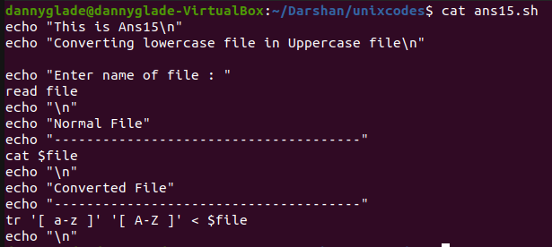

O/P
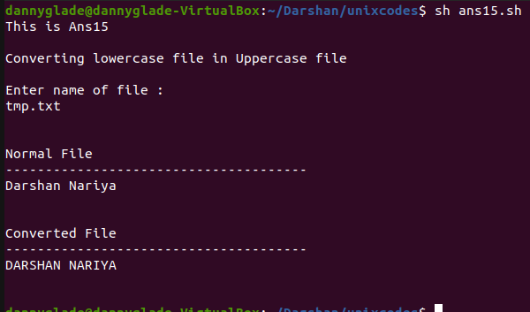

Ans 16

Cut
The cut command extracts a given number of characters or columns from a file. For cutting a certain number of columns it is important to specify the delimiter. A delimiter specifies how the columns are separated in a text file
Syntax:- cut [options] [file]
E.g.
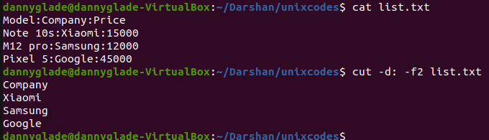

Paste
The main usage of paste command is that it joins the files horizontally by separating the lines from each file with a tab as delimiter to get the required output.
Syntax:- paste [option] [files]
E.g.
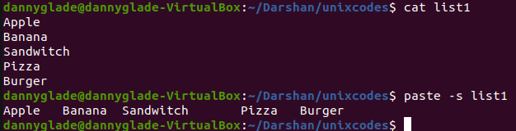

Sort
SORT command is used to sort a file, arranging the records in a particular order. By default, the sort command sorts file assuming the contents are ASCII. Using options in the sort command can also be used to sort numerically
Syntax:- sort [options] [files]
E.g.
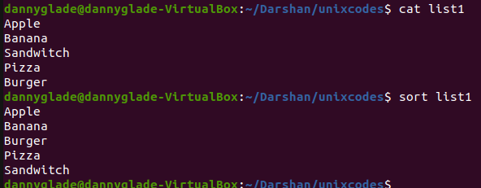

Ans 17

Code
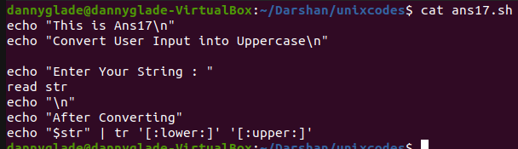

O/P
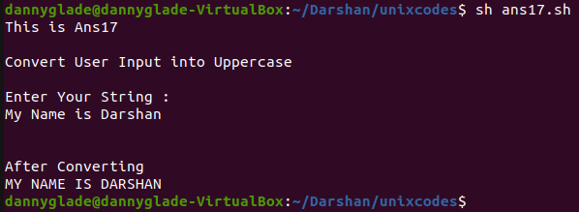

Ans 18

Code
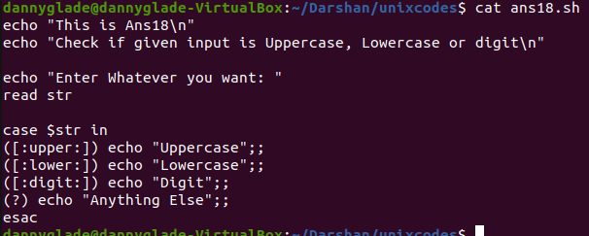

O/P
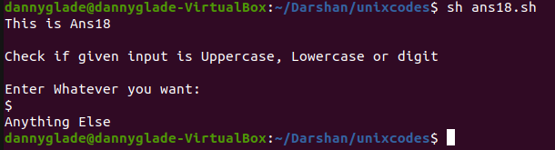

Ans 19

Code
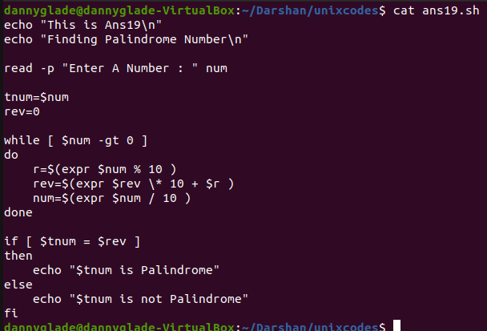

O/P
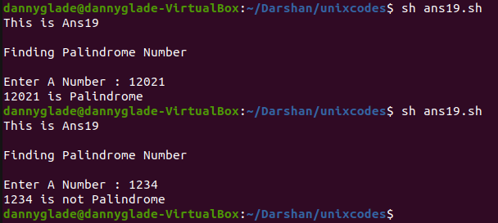

Ans 20

Code
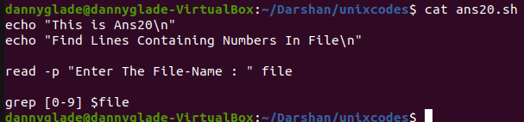

O/P
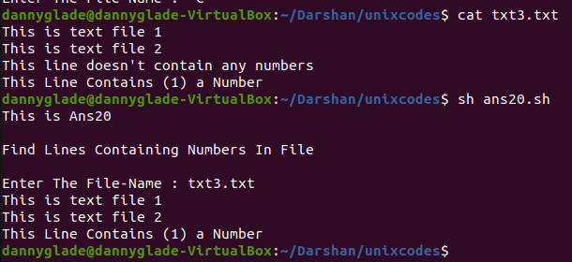

Ans 21

Code
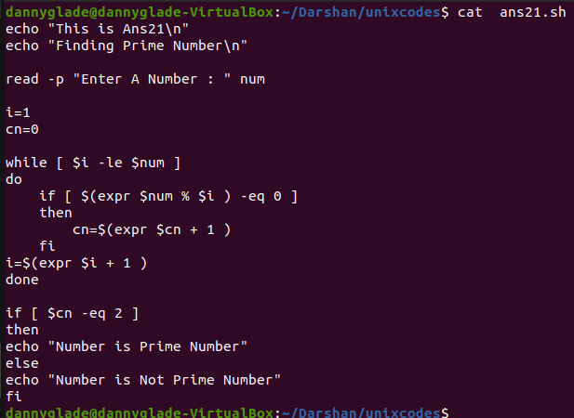

O/P
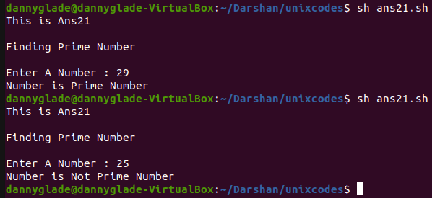

Ans 22

Code

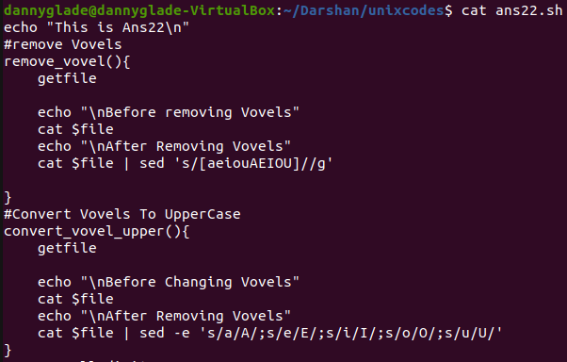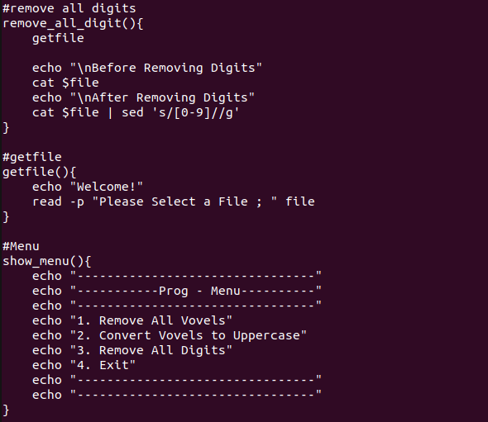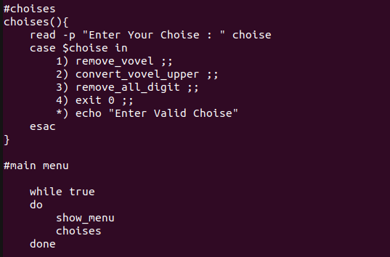

O/P
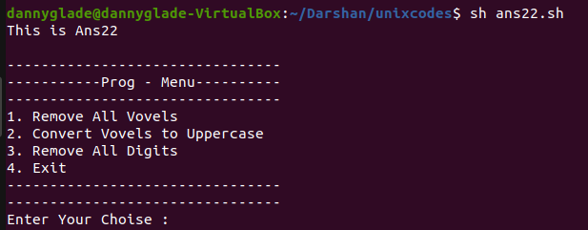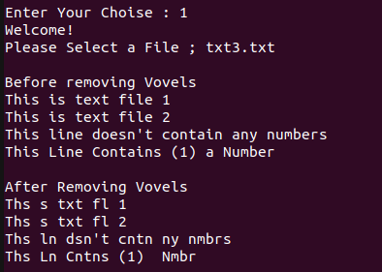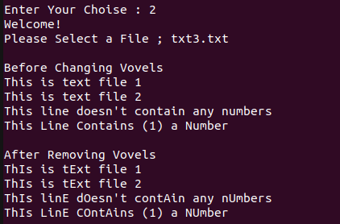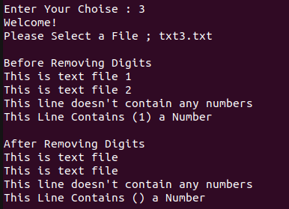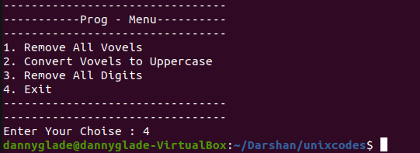

Ans 23

Code
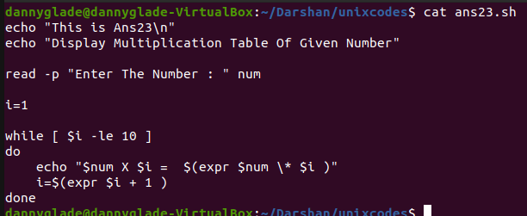

O/P
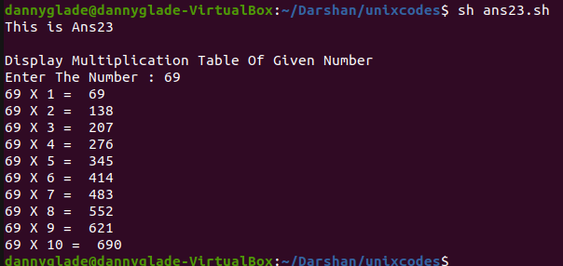

Ans 24

(I)
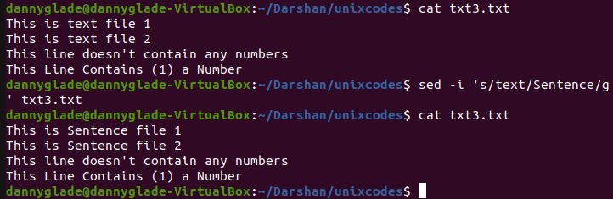

(II)
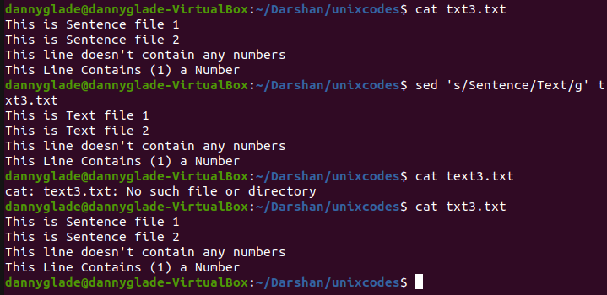

(III)
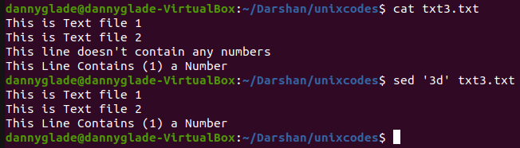

(IV)
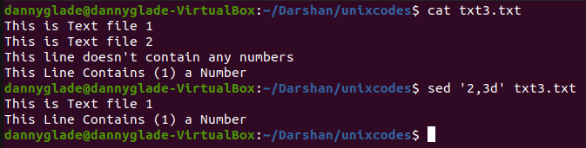

Ans 25

(I)
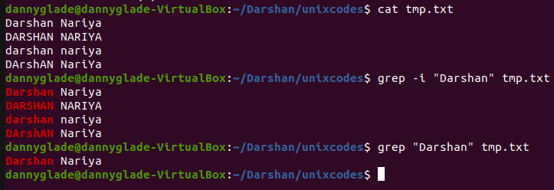

(II)
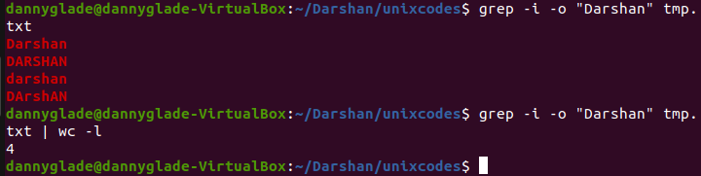

(III)

(IV)

(V)
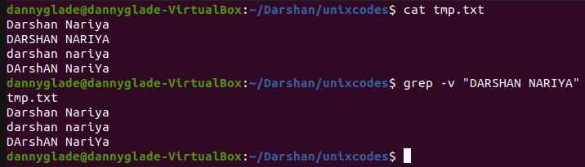

(VI)
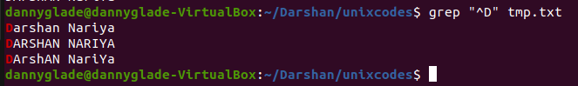

Ans 26

(I)
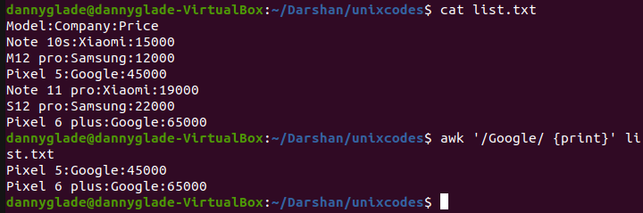

(II)
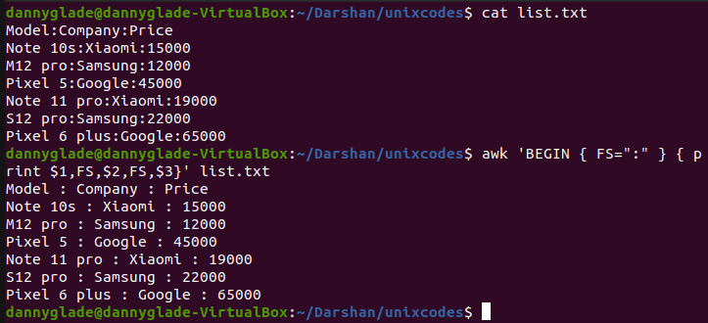

(III)
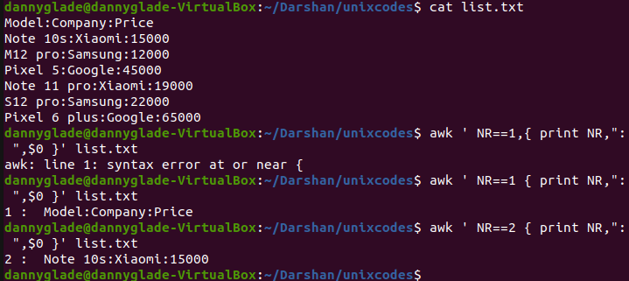

(IV)
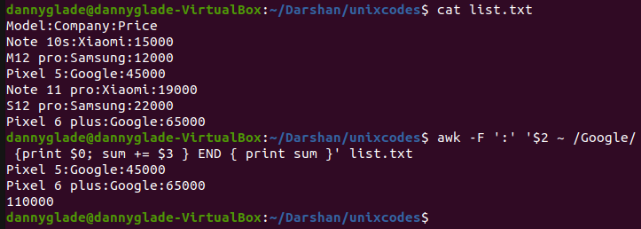

(V)
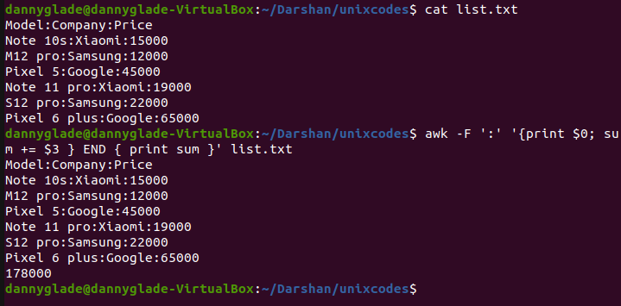

Extras

Df

df -i
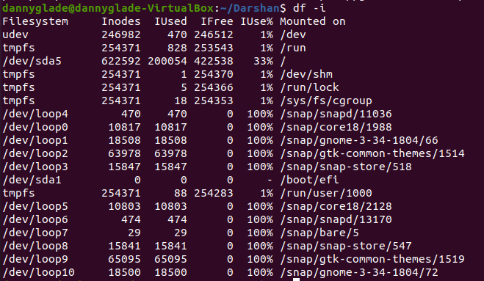

Stat

stat DG.odt
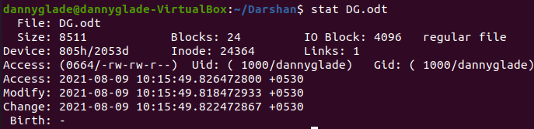

Chmod

cat > demo.txt

ls -l

Chmod ugo+w demo.txt

Chmod o-wr demo.txt

Chmod 666 demo.txt

Grep

Grep demo demo.txt

Redirection

Cat > list1
Apple
Banana
Sandwitch
Pizza
Burger
[Ctrl + D](to stop)
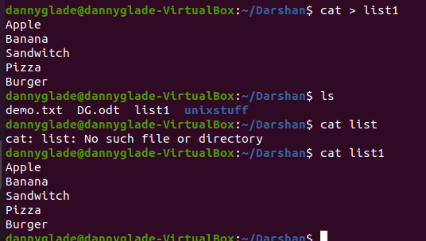

Append

Cat list1 list2 > finallist
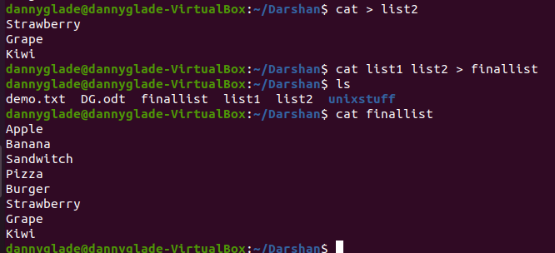

Whatis

Whatis wc

Apropos

Apropos wc
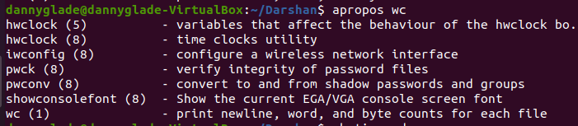

Apropos copy
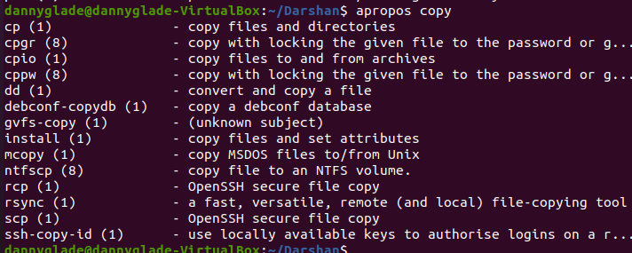

^c

[ctrl + c]
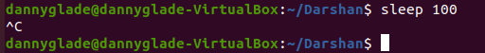

Kill

Sleep 100 & jobs
Kill %1
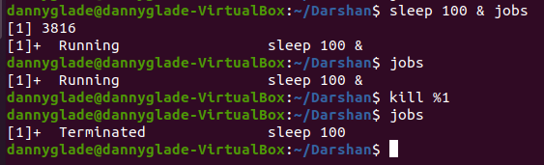

Ps

ps
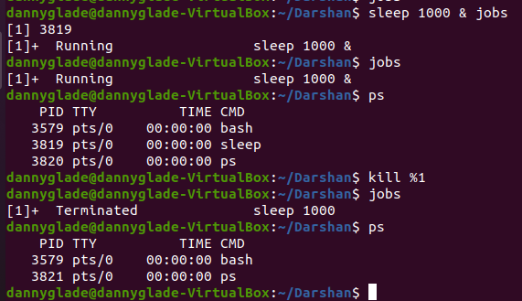

Gzip

Gzip DG.odt
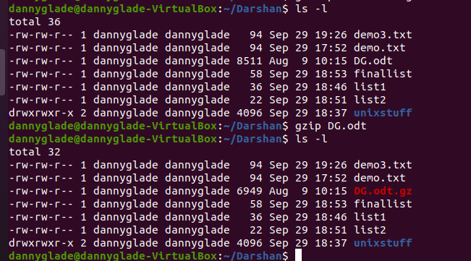

Gunzip

Gunzip DG.odt
