# Question and Answer Management

## Overview

Questions and answers are the core content of your assessment. This section covers creating, editing, and managing questions and their associated answers.

## Understanding Questions

### What Are Questions?

Questions are individual items within a section that collect information from users. Each question has:

* **Label/Text**: The question displayed to users
* **Type**: How the question is answered
* **Voice**: Who asks or answers the question
* **Answers**: Available response options (for select-type questions)
* **Tooltip**: Optional help text for clarification

### Question Types

CareIQ Builder supports five question types:

| Type | Description | User Interface | Use Case |
| --- | --- | --- | --- |
| **Single Select** | Choose one option | Radio buttons | “What is your age range?” |
| **Multiselect** | Choose multiple options | Checkboxes | “Select all symptoms that apply” |
| **Free Text** | Open-ended response | Text input field | “Please describe your symptoms” |
| **Numeric** | Number input | Number field | “How many medications do you take?” |
| **Date** | Date selection | Date picker | “When was your last visit?” |

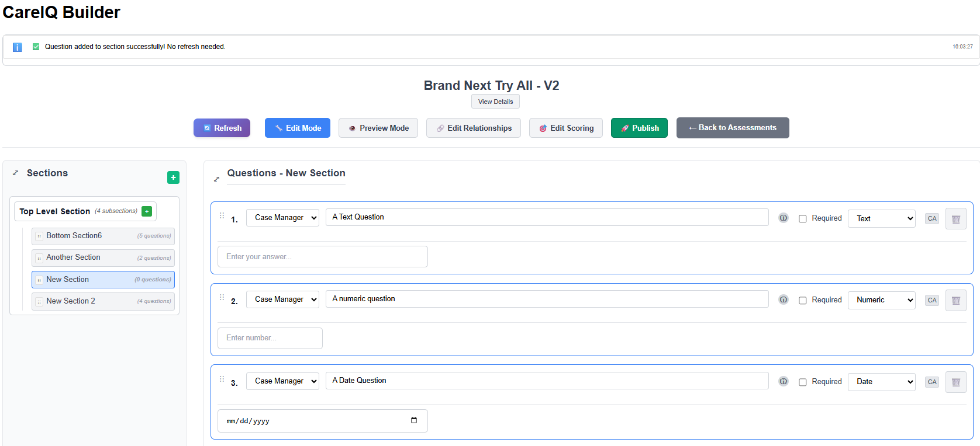

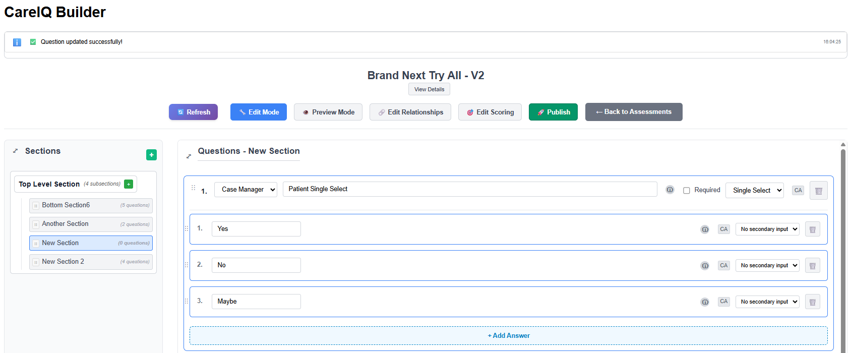

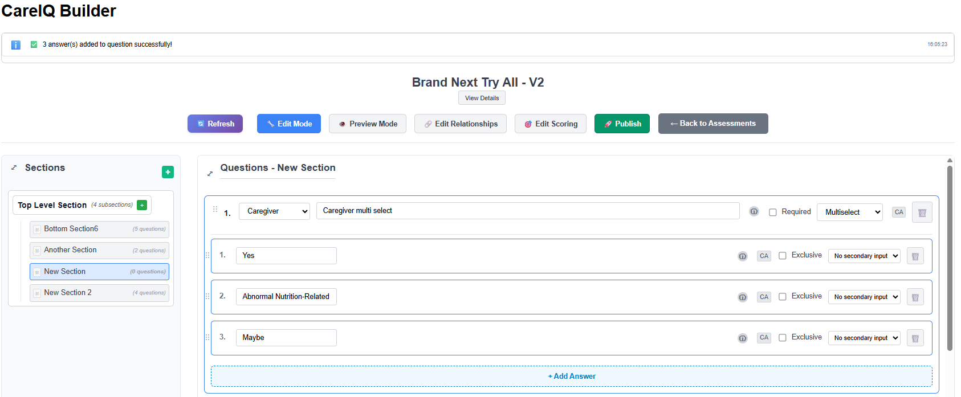

### Question Voice

The voice indicates who asks or answers the question:

* **Case Manager**: Questions asked by care coordinators
* **Caregiver**: Questions directed to family members or caregivers
* **Patient**: Questions answered directly by the patient

## Creating Questions

### Prerequisites

* Assessment must be in Draft status
* Builder must be in Edit mode
* A section must be selected
* You must have appropriate permissions

### Adding a New Question

1. **Select a Section**
   * Click a section in the left panel
   * The section’s questions display in the main area
2. **Click Add Question Button**
   * At the bottom of the questions list
   * Click **“+ Add Question”** button

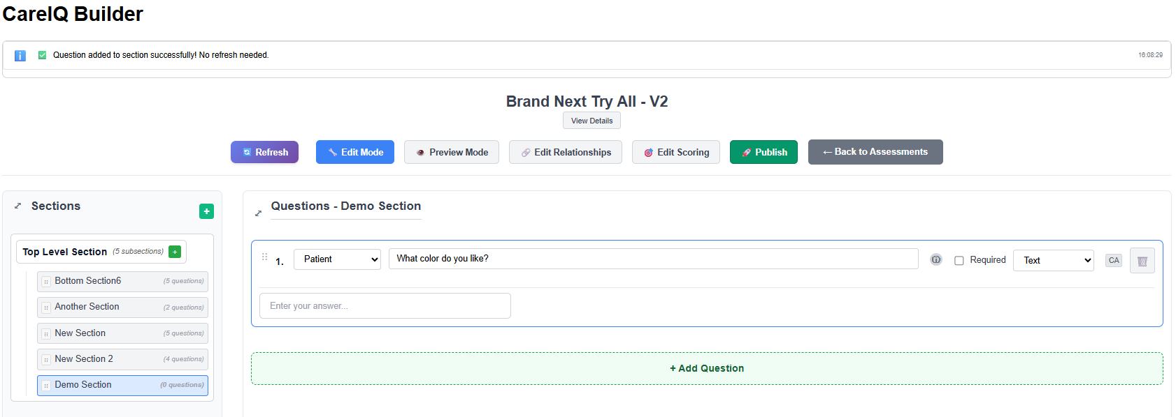

1. **Question Appears**
   * A new question card appears with default values
   * Question label shows placeholder text: “New Question”
   * Default type: Single Select
   * Default voice: Case Manager
2. **Edit the Question Label**
   * Click in the question label field
   * Type your question text
3. **Select Question Type**
   * Click the **Type** dropdown
   * Choose from: Single Select, Multiselect, Free Text, Numeric, Date
   * The answer section updates based on type
4. **Select Question Voice**
   * Click the **Voice** dropdown
   * Choose: Case Manager, Caregiver, or Patient
   * Voice is saved automatically
5. **Add Answers** (for Single Select and Multiselect only)
   * See “Creating Answers” section below
   * Free Text, Numeric, and Date questions don’t have predefined answers

### Using Library Questions

You can search and use pre-built questions from the CareIQ library:

1. **Start Editing Question Label**
   * Click in the question label field
   * A typeahead search activates
2. **Type to Search Library**
   * As you type, matching library questions appear
   * Results show question text and metadata

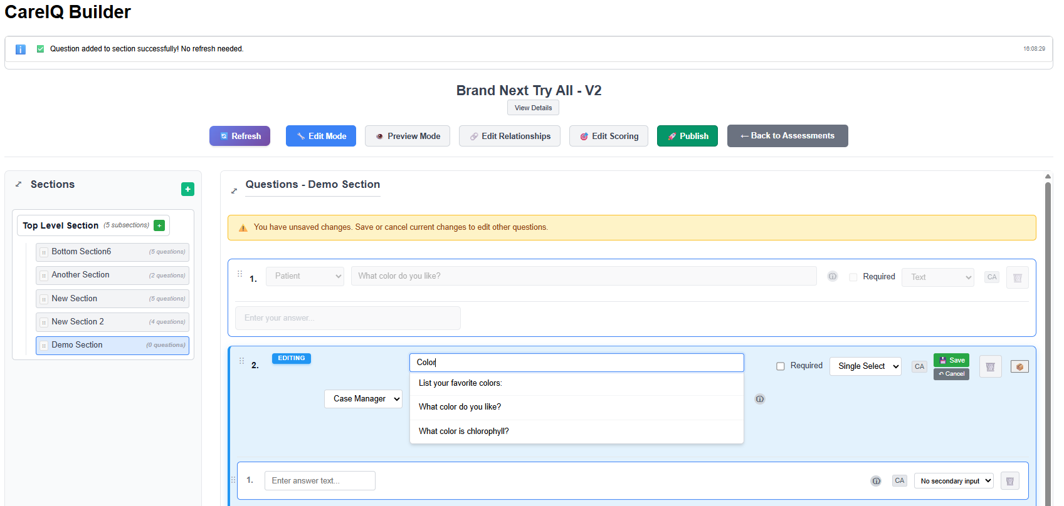

1. **Select from Library**
   * Click a library question from the dropdown
   * The question label, type, and voice populate automatically
   * Answers may also be pre-populated from library
2. **Or Use Custom Question**
   * Continue typing your custom question
   * Press Escape to close the dropdown
   * Enter your own question text

### Adding Tooltips to Questions

Tooltips provide additional help or clarification:

1. **Locate Tooltip Field**
   * Below or beside the question label
   * Click **“Add Tooltip”** or in the tooltip input field
2. **Enter Tooltip Text**
   * Type helpful information
   * Example: “Include prescription and over-the-counter medications”
3. **Save**
   * Tooltip saves automatically or when question is saved
   * Tooltip appears as an info icon (ⓘ) next to question in assessment

## Editing Questions

### Edit Question Label

**Inline Editing** 1. Click in the question label field 2. Edit the text directly 3. Changes are tracked (Save/Cancel buttons appear)

### Change Question Type

1. **Click Type Dropdown**
   * Locate the question type selector
   * Current type is displayed
2. **Select New Type**
   * Choose a different type
   * Warning: Changing type may affect answers
3. **Impact on Answers**
   * Changing from Single Select to Multiselect: Answers remain
   * Changing to Free Text/Numeric/Date: Answers may become inapplicable
   * Confirm the change

### Change Question Voice

1. **Click Voice Dropdown**
   * Locate the voice selector
   * Current voice is displayed
2. **Select New Voice**
   * Choose: Case Manager, Caregiver, or Patient
   * Voice updates immediately

### Save Question Changes

After editing a question:

1. **Changes Are Tracked**
   * An “unsaved” indicator appears
   * **Save** and **Cancel** buttons display

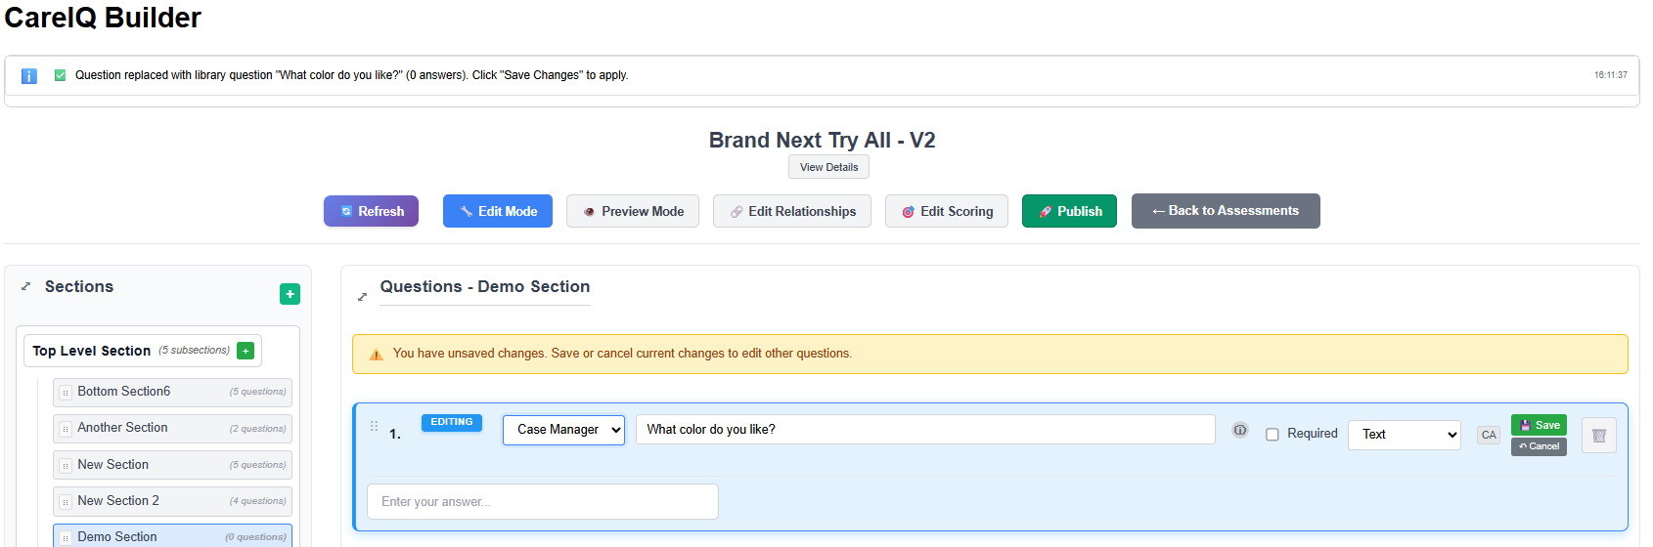

1. **Click Save Button**
   * Saves all changes for this question
   * API call updates the backend
   * Success message appears
   * Save/Cancel buttons disappear
2. **Click Cancel Button**
   * Discards all unsaved changes
   * Question reverts to previous state
   * Save/Cancel buttons disappear

## Deleting Questions

### Delete a Question

1. **Locate Delete Button**
   * Find the question to delete
   * Look for delete button (trash icon or “Delete” text)
2. **Click Delete Button**
   * A confirmation dialog appears

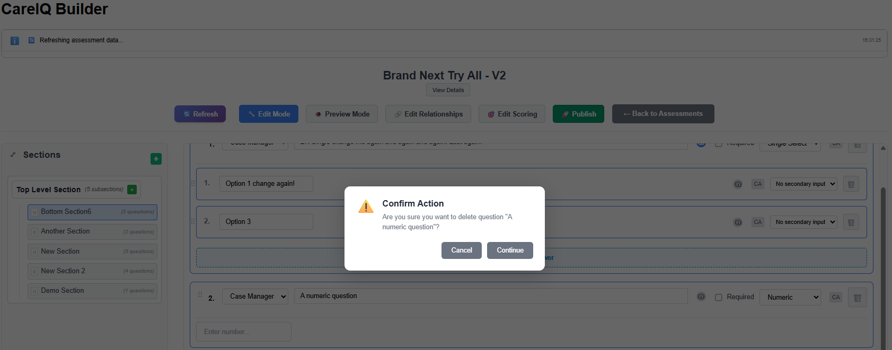

1. **Confirm Deletion**
   * Dialog message: “Are you sure you want to delete this question?”
   * Warns that all answers will also be deleted
   * Click **“Delete”** to proceed or **“Cancel”** to abort
2. **Question Removed**
   * Question and all its answers are deleted from backend
   * Question disappears from the list
   * Success message appears

### What Gets Deleted?

When you delete a question: - The question record is removed - All associated answers are deleted - All relationships for those answers are removed - Any triggered question links are broken - **This action cannot be undone**

## Moving Questions Between Sections

You can move questions from one section to another:

### Move a Question

1. **Locate the Move Button**
   * Find the question to move
   * Click **“Move to Section”** or similar button
2. **Select Target Section**
   * A dropdown or modal appears with available sections
   * Choose the destination section

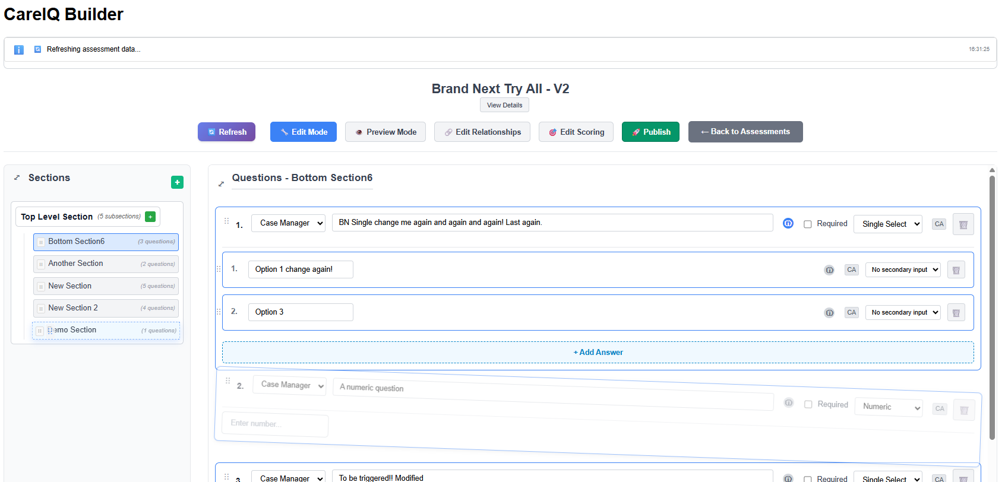

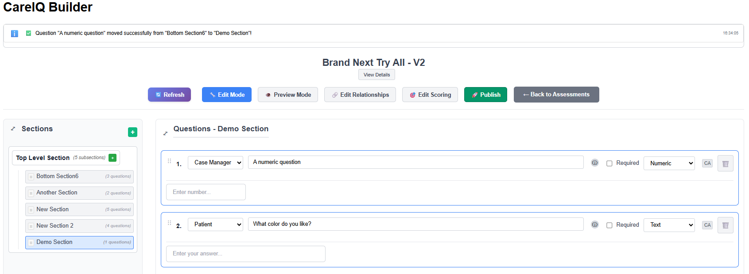

1. **Confirm Move**
   * Click **“Move”** or **“Confirm”**
   * A loading indicator appears
2. **Question Moves**
   * Question is added to the target section
   * Question is removed from the current section
   * Success message appears
3. **Verify Move**
   * Navigate to the target section
   * Confirm the question appears there

## Understanding Answers

### What Are Answers?

Answers are response options for Single Select and Multiselect questions. Each answer has:

* **Label**: The text displayed to the user
* **Alternative Wording**: Optional variations of the answer
* **Tooltip**: Optional help text
* **Mutually Exclusive**: Flag indicating this answer excludes other options
* **Secondary Input**: Additional input required when this answer is selected

### Secondary Input Types

Some answers require additional information:

| Secondary Input Type | Description | Example |
| --- | --- | --- |
| **None** | No additional input | “Yes” or “No” |
| **Text** | Free text input | “Other (please specify)” |
| **Date** | Date picker | “If yes, when?” |
| **Numeric** | Number input | “How many?” |

## Creating Answers

### Prerequisites

* Question must be Single Select or Multiselect type
* Assessment must be in Draft status
* Builder must be in Edit mode

### Adding an Answer

1. **Locate Add Answer Button**
   * Under the question, in the answers area
   * Click **“+ Add Answer”** button

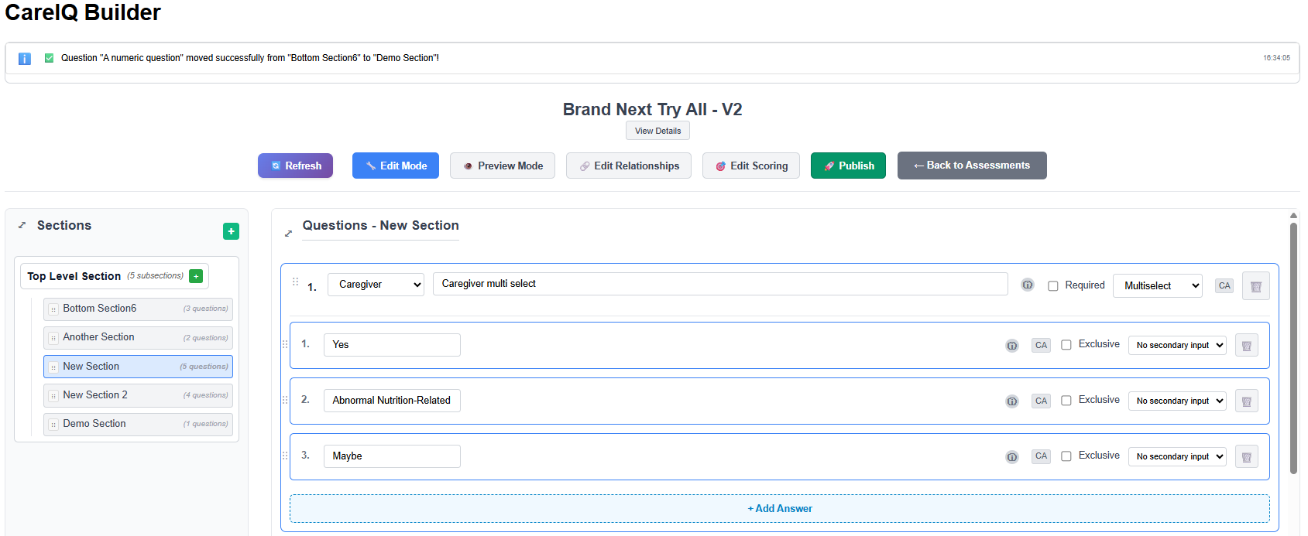

1. **Answer Appears**
   * A new answer card appears
   * Default label: “New Answer” or placeholder text
   * Default settings applied
2. **Edit Answer Label**
   * Click in the answer label field
   * Type your answer text
   * Example: “Yes”, “No”, “18-25 years”, “Diabetes”
3. **Or Use Library Answer**
   * As you type, typeahead search activates
   * Matching library answers appear
   * Click a library answer to use it
   * Or continue with custom text

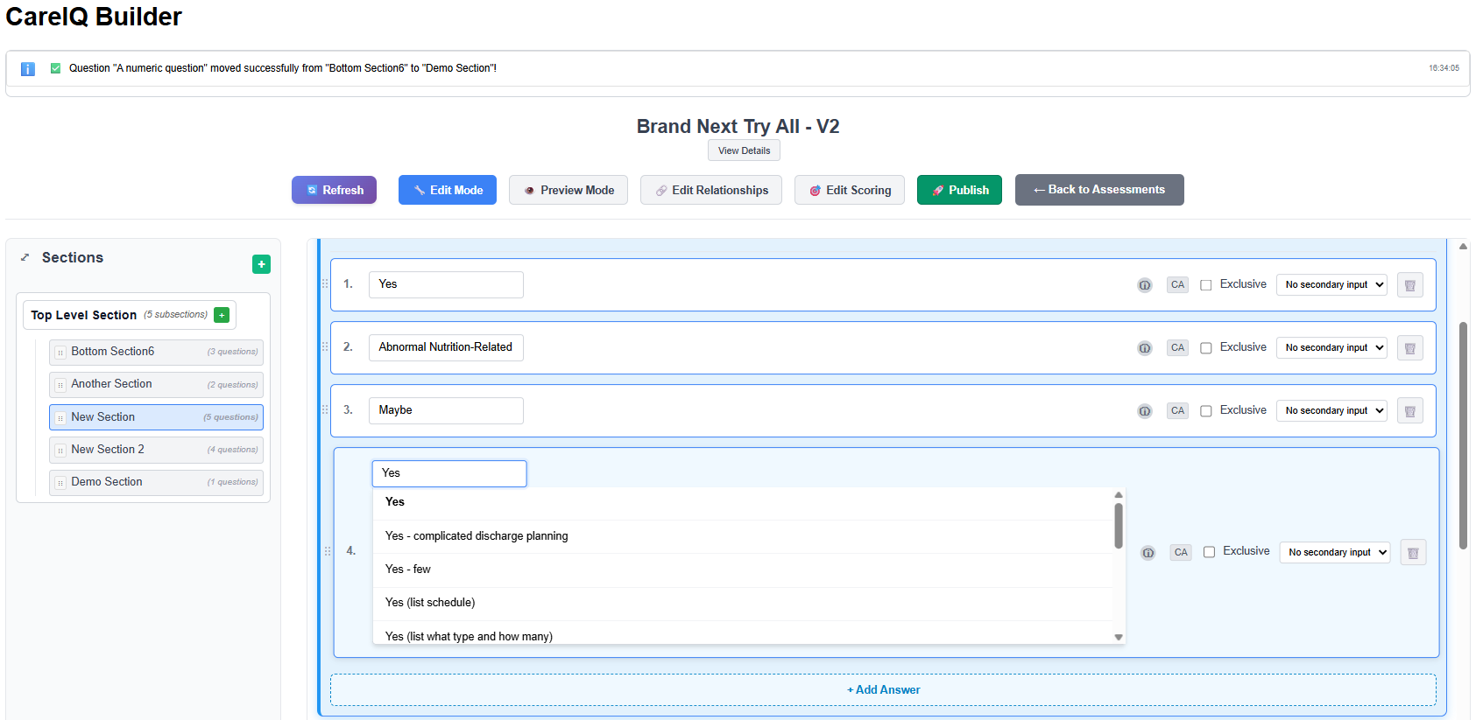

1. **Configure Answer Options**
   * Set secondary input type if needed
   * Mark as mutually exclusive if applicable
   * Add tooltip for clarification

### Setting Secondary Input Type

For answers requiring additional information:

1. **Locate Secondary Input Dropdown**
   * Below or beside the answer label
   * Default: None
2. **Select Input Type**
   * **None**: No additional input required
   * **Text**: User can type additional details
   * **Date**: User must select a date
   * **Numeric**: User must enter a number
3. **Example Use Cases**
   * “Other (please specify)” → Text input
   * “Previous diagnosis (when?)” → Date input
   * “Number of hospitalizations” → Numeric input

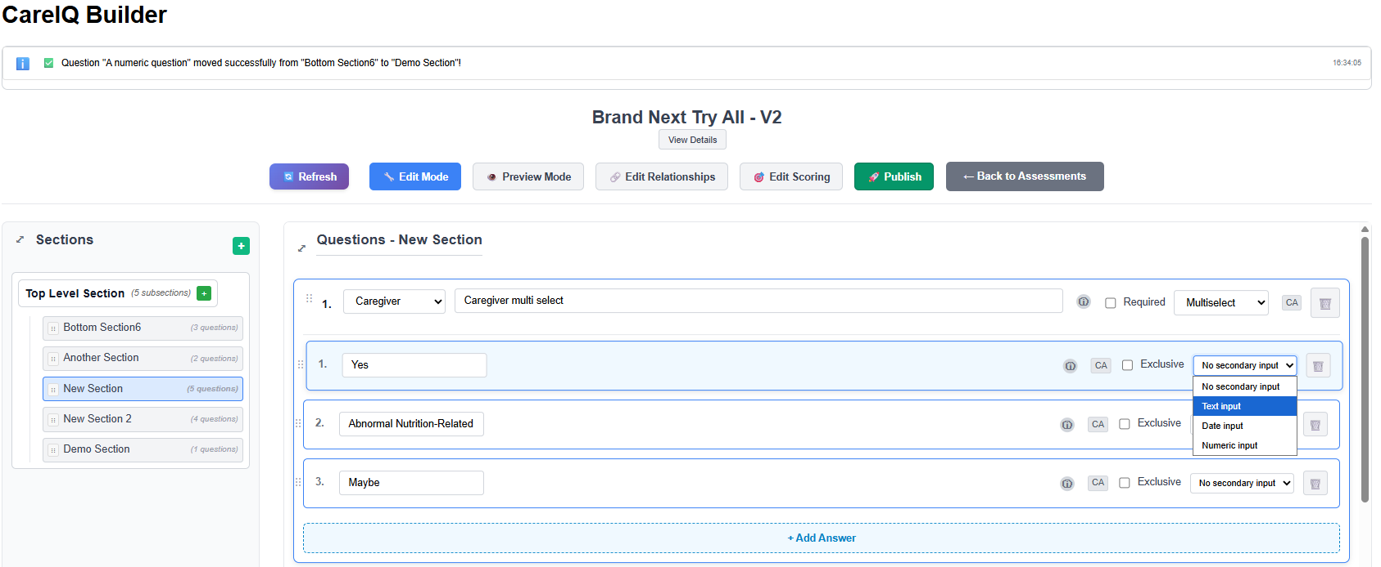

### Marking Mutually Exclusive

Mutually exclusive answers prevent other selections:

1. **Locate Mutually Exclusive Checkbox**
   * In the answer configuration area
   * Label: “Mutually Exclusive” or similar
2. **Check the Box**
   * Indicates this answer excludes all other options
   * Typically used for “None”, “Not Applicable”, “Decline to Answer”
3. **Behavior**
   * When user selects this answer, all other answers are deselected
   * Only applies to Multiselect questions
   * Example: “None of the above” in a symptom list

## Editing Answers

### Edit Answer Label

1. **Click in Answer Label Field**
   * Click to activate inline editing
   * Or use typeahead to search library
2. **Modify Text**
   * Edit the answer text
   * Or select from library results
3. **Save Changes**
   * Changes are tracked automatically
   * Click **Save** button at question level to persist all changes

### Add Alternative Wording

Alternative wording provides variations of the answer for different contexts:

1. **Locate Alternative Wording Field**
   * Below or beside the main answer label
   * May be labeled “Alt Wording” or similar
2. **Enter Alternative Text**
   * Type an alternative phrasing
   * Example: Answer “Yes” could have alt wording “Affirmative”
3. **Use Cases**
   * Report generation with different terminology
   * Multi-language support
   * Clinical vs. patient-friendly language

### Add Answer Tooltip

1. **Locate Tooltip Field**
   * In the answer configuration area
   * Click **“Add Tooltip”** if not visible
2. **Enter Tooltip Text**
   * Provide clarification or examples
   * Example: “Select this if symptoms have lasted more than 3 months”
3. **Tooltip Display**
   * Appears as an info icon next to answer in assessment
   * User hovers or clicks to see tooltip text

## Deleting Answers

### Important: Two-Step Delete Process

Answer deletion uses a **Save & Delete** pattern:

1. **Click Delete Button**
   * Locate the delete button on the answer
   * Click to mark answer for deletion
2. **Answer Marked for Deletion**
   * Answer may show visual indicator (strikethrough, red background, etc.)
   * Answer is NOT yet deleted from backend

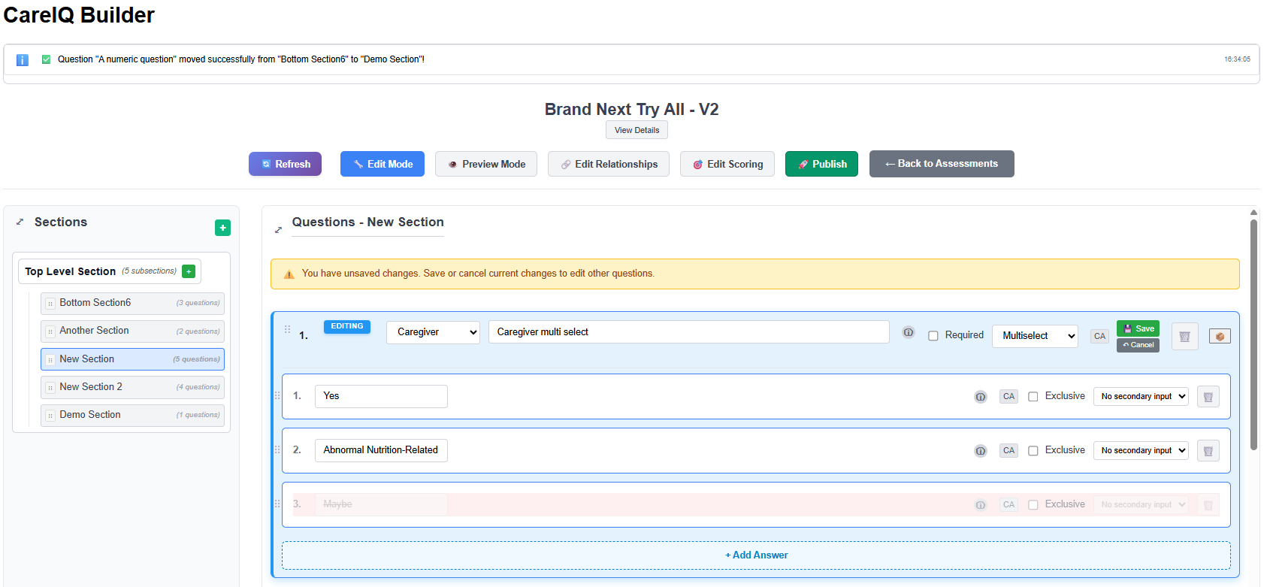

1. **Click Save Button**
   * At the question level, click **“Save”** button
   * Confirms deletion
2. **Or Click Cancel**
   * Click **“Cancel”** to undo the deletion
   * Answer returns to normal state
3. **Deletion Complete**
   * After clicking Save, answer is removed from backend
   * Success message appears
   * Answer disappears from list

### Why Two-Step Deletion?

* Prevents accidental deletions
* Allows multiple changes before saving
* Groups all modifications into one save operation
* Provides clear undo mechanism

## Managing Triggered Questions

### What Are Triggered Questions?

Triggered questions (also called “branch questions”) appear only when specific answers are selected. They enable conditional logic in assessments.

### Viewing Triggered Questions

Answers with triggered questions show an indicator:

1. **Look for Link Icon**
   * Appears on answer cards
   * May show a number (e.g., “2 triggered questions”)

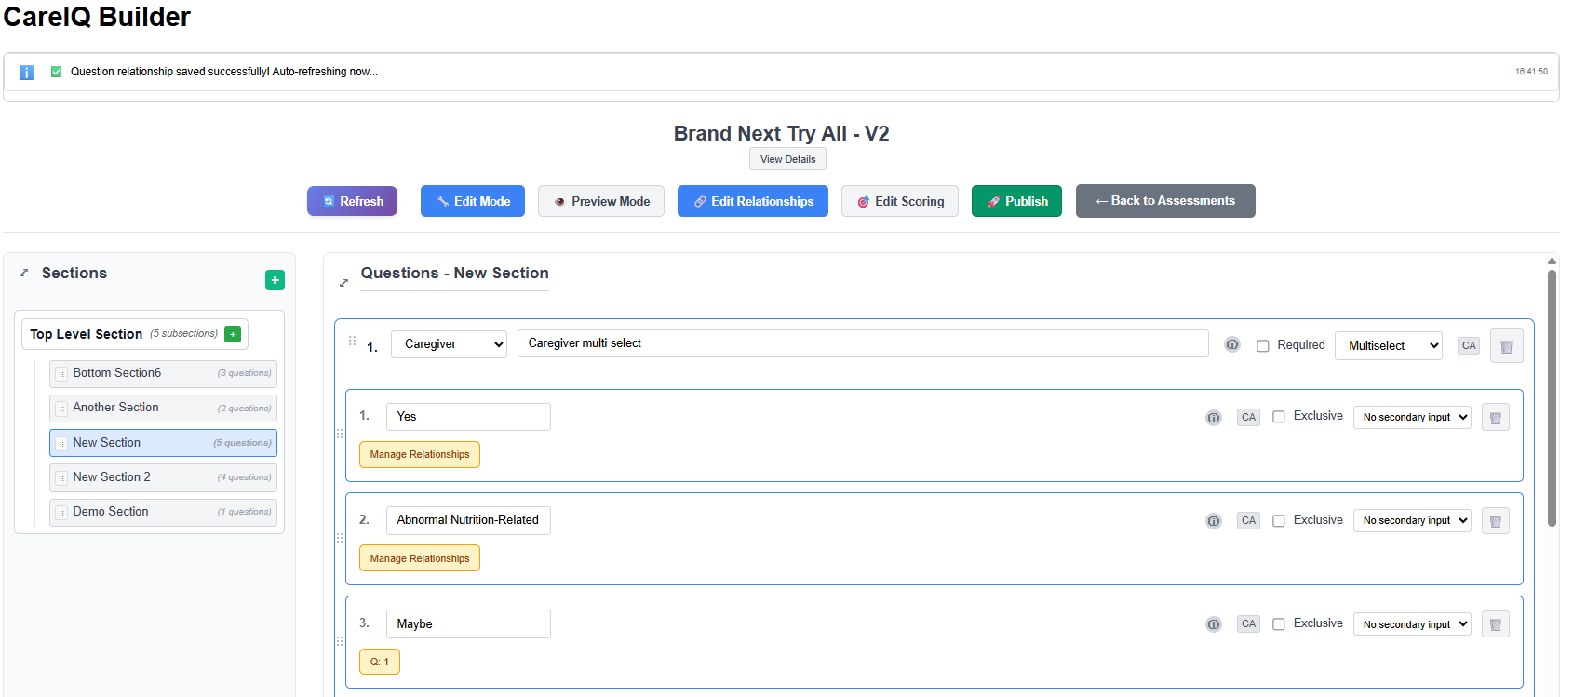

1. **View Triggered Questions**
   * Icon shows how many questions are triggered
   * Questions appear when answer is selected in Preview mode

### Adding Triggered Questions

Adding relationships is covered in the “Relationship Management” section, but here’s a quick overview:

1. Click the relationship button on an answer
2. Navigate to the “Questions” tab
3. Search for questions to trigger
4. Select and confirm

### Removing Triggered Questions

1. **Locate Delete Button**
   * On the triggered question indicator
   * Click the “×” or delete button
2. **Confirm Deletion**
   * Confirmation dialog appears
   * Click **“Delete”** to remove relationship
3. **Relationship Removed**
   * Triggered question link is deleted
   * Question still exists but is no longer triggered by this answer

## Best Practices

### Question Writing

**Be Clear and Concise** - Use simple language - Avoid medical jargon unless appropriate for audience - Example: “Do you have diabetes?” vs. “Have you been diagnosed with diabetes mellitus?”

**One Question, One Concept** - Don’t combine multiple questions - Bad: “Do you smoke or drink alcohol?” - Good: Two separate questions for smoking and alcohol

**Use Appropriate Question Types** - Single Select: When only one answer is valid - Multiselect: When multiple answers apply - Free Text: When you need detailed, open-ended responses - Numeric: When collecting measurements or counts - Date: When timing is important

### Answer Writing

**Provide Complete Options** - Include all reasonable choices - Add “Other (please specify)” with text input for unlisted options - Include “Prefer not to answer” or “Unknown” when appropriate

**Use Parallel Structure** - Keep answer formats consistent - Example: “Daily”, “Weekly”, “Monthly”, “Yearly” (not “Every day”, “Once a week”, etc.)

**Order Answers Logically** - Chronological: “Never”, “Former”, “Current” - Numerical: “0-5”, “6-10”, “11-15”, “16+” - Alphabetical: For long lists of items - Most to least common: For symptom lists

### Voice Selection

**Case Manager Voice** - Questions the care coordinator asks - Administrative or assessment questions - Example: “What is the patient’s primary language?”

**Patient Voice** - Questions answered by the patient - Personal experience and symptoms - Example: “How would you rate your pain level?”

**Caregiver Voice** - Questions directed to family or caregivers - Observations about the patient - Example: “Have you noticed changes in memory or behavior?”

### Secondary Inputs

**When to Use Text Input** - “Other” options: “Other (please specify)” - Additional details: “If yes, please describe”

**When to Use Date Input** - Timing of events: “If yes, when did this occur?” - Historical dates: “Date of diagnosis”

**When to Use Numeric Input** - Counts: “How many medications?” - Measurements: “Weight in pounds” - Ratings: “On a scale of 1-10”

### Mutually Exclusive Answers

**Use for:** - “None of the above” in multiselect lists - “Not applicable” options - “Decline to answer” choices

**Don’t use for:** - Regular answer options - Answers that can logically coexist with others

## Common Tasks

### Creating a Yes/No Question

1. Add question: “Have you been diagnosed with diabetes?”
2. Set type: Single Select
3. Set voice: Case Manager or Patient
4. Add answer: “Yes”
5. Add answer: “No”
6. Save question

### Creating a Symptom Checklist

1. Add question: “Select all symptoms you are currently experiencing”
2. Set type: Multiselect
3. Set voice: Patient
4. Add answers: “Headache”, “Nausea”, “Dizziness”, “Fatigue”, “Other”
5. Set “Other” answer secondary input: Text
6. Add answer: “None of the above”
7. Mark “None of the above” as mutually exclusive
8. Save question

### Creating an Age Range Question

1. Add question: “What is your age?”
2. Set type: Single Select
3. Set voice: Patient
4. Add answers: “Under 18”, “18-25”, “26-35”, “36-45”, “46-55”, “56-65”, “66+”
5. Save question

### Creating a Free Text Question

1. Add question: “Please describe your current symptoms in detail”
2. Set type: Free Text
3. Set voice: Patient
4. Add tooltip: “Include when symptoms started and any patterns you’ve noticed”
5. Save question (no answers needed for Free Text)

### Creating a Numeric Question

1. Add question: “How many medications are you currently taking?”
2. Set type: Numeric
3. Set voice: Patient
4. Add tooltip: “Include prescription and over-the-counter medications”
5. Save question (no answers needed for Numeric)

### Moving a Question to Different Section

1. Locate question to move
2. Click “Move to Section” button
3. Select target section: “Medical History”
4. Confirm move
5. Navigate to “Medical History” section
6. Verify question appears there

## Troubleshooting

### Cannot Add Question

**Possible causes:** - No section selected - Assessment is Published (not Draft) - Builder is in Preview mode - Insufficient permissions

**Solutions:**

1. Click a section in the left panel to select it

2. Verify assessment status is “Draft”

3. Click “Edit Mode” button

4. Contact administrator for permissions

### Cannot Save Question Changes

**Possible causes:** - Network connection issue - Invalid question data - Backend error - Session timeout

**Solutions:**

1. Check system messages for specific errors

2. Verify all required fields are filled

3. Try refreshing the page

4. Check browser console for errors

5. Contact administrator if problem persists

### Question Changes Lost After Refresh

**Possible causes:** - Didn’t click Save button - Save failed silently - Network interruption during save

**Solutions:**

1. Always watch for success message after clicking Save

2. Don’t refresh browser until changes are saved

3. Check system messages for errors 4. Use stable network connection

### Answer Typeahead Not Working

**Possible causes:** - Too few characters typed - No matching library content - Backend search issue

**Solutions:**

1. Type at least 2 characters

2. Try different search terms

3. Check connection status

4. Create custom answer if library search fails

### Cannot Delete Answer

**Possible causes:** - Forgot to click Save button after marking for deletion - Answer has relationships that must be removed first - Insufficient permissions

**Solutions:**

1. Mark answer for deletion, then click Save at question level

2. Remove triggered question relationships first

3. Contact administrator for permissions

### Triggered Questions Not Appearing in Preview

**Possible causes:** - Still in Edit mode (not Preview mode) - Triggering answer not selected - Relationship not properly configured

**Solutions:**

1. Click “Preview Mode” button

2. Select the answer that should trigger questions

3. Verify relationship is configured (see Relationship Management section)

4. Check that triggered question is in same assessment

## Tips and Tricks

### Keyboard Shortcuts

* **Tab**: Move between fields in question editor
* **Enter**: Save changes in some fields
* **Escape**: Cancel editing / close dropdown

### Copy Question Text

To reuse question text:

1. Select and copy question label text

2. Add new question

3. Paste text and modify as needed

### Quick Testing

To quickly test a question:

1. Save your changes

2. Click “Preview Mode”

3. Navigate to the section

4. Answer the question

5. Verify behavior

6. Return to “Edit Mode”

### Bulk Answer Creation

For long lists of answers:

1. Prepare answers in a text editor

2. Copy and paste into each answer field

3. Much faster than typing each individually

## Next Steps

Now that you understand question and answer management: - Learn how to **create relationships** between answers and clinical content - Explore **PGI (Problem-Goal-Intervention)** linking - **Test your assessment** in Preview mode - **Publish** your completed assessment