**How-To**

Build a Game Using SplashKit SDK

# Introduction

In this tutorial we are going demonstrate how to create 2D game using SplashKit SDK. SplashKit is a C++ Software Development Kit. It is a beginner-friendly abstraction over SDL and many other libraries to assist in introductory programming education and can be used to create 2D games.

# Install SplashKit

As a first thing, we need to install SplashKit. Go to [SplashKit website](https://splashkit.io/articles/installation/) follow the instructions. SplashKit website contains detailed instructions on how to install SplashKit on different operating systems.

# Setup SplashKit Project

As a first thing, we need to setup the SplashKit project.

1. **Open mingw64 or mingw32 terminal.**

Go to “msys2” folder. Open the mingw64 or mingw32 terminal.

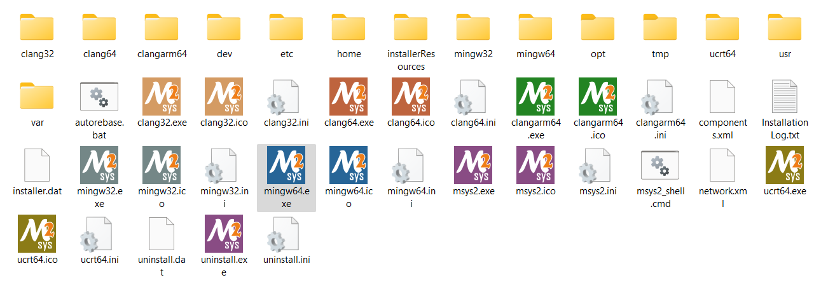

1. **Change directory to game folder**

In the terminal, type cd followed by path of the game folder.

<cd c:/my_game>

1. **Create a C++ project**

When you run the following command, it will create all the basic files inside of the game directory.

<skm new c++>



“include” folder contains header files of SplashKit SDK. “program.cpp” is the main source file where we can write our program.

1. **Add additional SplashKit resources**

To create a more advanced game, we need to access advanced inbuilt resources of the SplashKit SDK. We can you following command to create additional resources.

<skm resources>

