CA

Wa-Tor Speed Up Report

This application was built using Oracle VM VirtualBox in the Ubnunto 22.0.4

Once that has been installed the setting of the VM to run exactly like mine does is :

BaseMemory : 3600MB
BOOT Order : Floppy
Hard Disk

once thos two are the only 2 enabled on boot order theres 4 processors are being used max Those are the only add on setting from the default setting that VM already sets up in order to run the code in the same way I do.

Graphs
this is the results from the code :
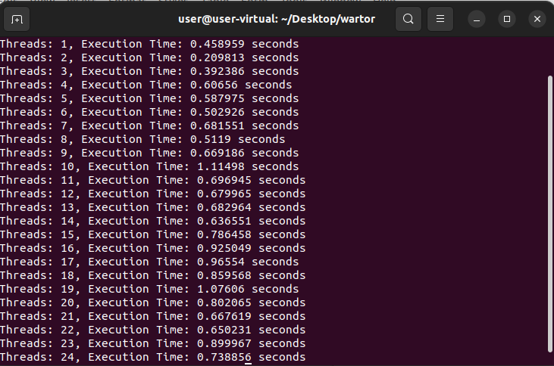
and this is the grid based on the code
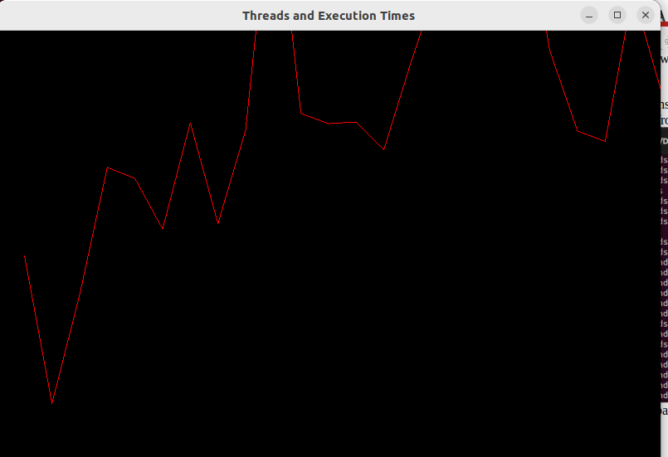
This graph show that when it start the quickest time to complete finishes then speeds up but not all speed up some are slower than the last all the way to completion.

