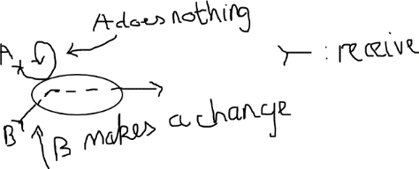The flowchart is based on my understanding of FSM.

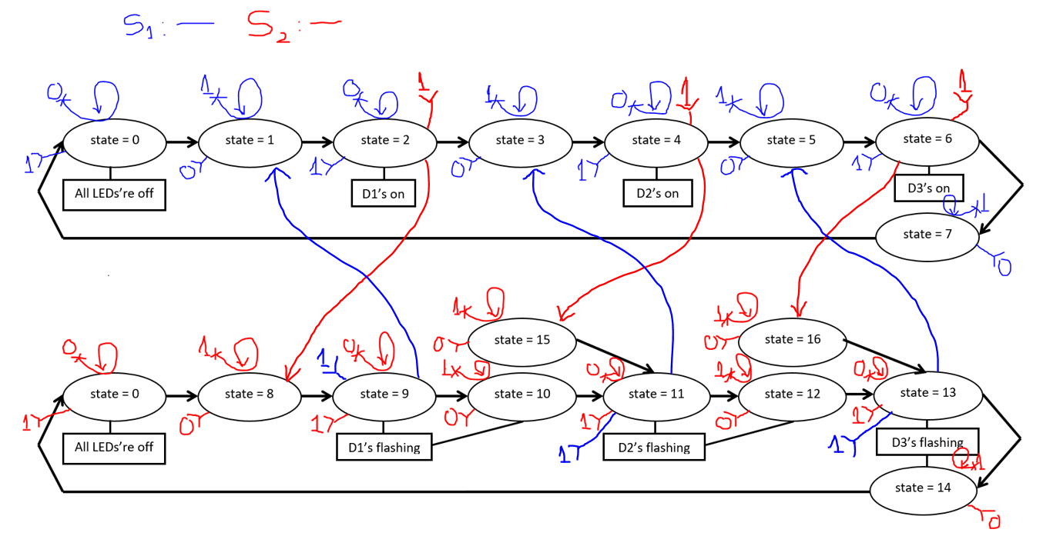Why there are 15th state and 16th state?

There is a case when the D1 is flashing, a person holds the button S2 and intends to make D2 flash, if the 10th state doesn’t continue flashing the D1, it will behave strangely, so 10th state is to make sure whenever the user holds the button when the D1 is flashing, it will continue flashing until the user has stopped holding the button (it toggles to the next LED). This is similar to the rest LEDs.

However, this solution causes a weird behavior when I tried to change from D2’s statically lighting to D2’s flashing motion, due to the working of 10th state, it will flash the D1 before getting D2 into business (I call it “a weird phenomenon”), that is why I created the 15th state and the 16th state to act like a medium transition without any strange flashings.