INSE 6450: AI in Systems Engineering
Milestone 1
Credit Card Fraud Detection System

Student Name | Daniel Adonteng Sarpong
Student ID | 40376356
Instructor | Ali Ayub
Term | Fall 2026
Due Date | October 19, 2026

1. Problem Statement
Credit card fraud detection is a binary classification problem in which a transaction is assessed as either legitimate or potentially fraudulent. The proposed system will use transaction information that is available when a payment is made, including amount, time, merchant category, customer context, and geographic information. Its output will be a fraud prediction together with a risk score that can be used to prioritize suspicious transactions for review.
The intended user is a bank, card issuer, or fraud analyst monitoring payment activity. The system is meant to support a review decision rather than make an irreversible decision by itself. The two main errors have different costs: a false negative can allow fraud to pass through, while a false positive can inconvenience a legitimate customer and create unnecessary investigation work.
Good performance therefore means catching a large share of fraudulent transactions without producing an excessive number of false alarms. Recall and precision will be treated as the main measures, with F1 score and precision-recall AUC used to summarize the trade-off. Accuracy will still be reported, but it will not be used alone because the dataset is highly imbalanced.

Implications for Data Selection
The dataset was selected because it has an explicit fraud label, interpretable transaction fields, a large number of observations, and a chronological train/test split that is practical for this course. The class imbalance means the original class distribution must be preserved in validation and test data. The chronological structure also makes a temporal evaluation more realistic than randomly mixing all transactions. Feature engineering will focus on information that can reasonably be known at transaction time, and direct identifiers or outcome-dependent information will be excluded to reduce leakage.

2. Data Selection

2.1 Dataset Summary and Justification
The selected dataset is the Credit Card Transactions Fraud Detection dataset distributed on Kaggle and generated using the Sparkov simulator. The two uploaded CSV files contain 1,852,394 transactions in total. The supplied training file contains 1,296,675 transactions from January 1, 2019 to June 21, 2020, and the supplied test file contains 555,719 later transactions from June 21, 2020 to December 31, 2020. This chronological separation is useful because it approximates training a model on past activity and evaluating it on future activity.
Split | Transactions | Fraud | Legitimate | Fraud rate | Date range
Training | 1,296,675 | 7,506 | 1,289,169 | 0.579% | 2019-01-01 to 2020-06-21
Test | 555,719 | 2,145 | 553,574 | 0.386% | 2020-06-21 to 2020-12-31
The target is the binary `is_fraud` field. The training set contains 7,506 fraudulent transactions (0.579%) and the test set contains 2,145 (0.386%). This confirms that class imbalance is not a theoretical concern in this project: a classifier that predicts every transaction as legitimate would achieve very high accuracy while detecting no fraud.
The dataset includes transaction time, amount, merchant and category, cardholder demographics and location, merchant coordinates, transaction identifiers, and the fraud label. These fields are useful because they support interpretable feature engineering rather than relying mainly on anonymized components.

Alternatives Considered
The ULB credit-card fraud dataset was considered because it is compact and widely used, but most of its predictive fields are anonymized PCA components. That would make the feature-engineering and explanation parts of the project less meaningful. The IEEE-CIS Fraud Detection dataset was also considered because it contains richer transaction and identity information, but its much larger feature space would add substantial preprocessing complexity that is not necessary for the scope of this project.

2.2 Data Scope, Assumptions, and Limitations
- The fraud label is treated as ground truth for this project, but the transactions are simulated rather than confirmed by real investigators. Performance on this dataset should not be interpreted as production-level banking performance.
- The data represent a simulated U.S. cardholder population. Results may not transfer directly to other countries, institutions, customer populations, or payment channels.
- The training and test fraud rates differ (0.579% versus 0.386%), which is an early sign that class prevalence and behavior may change over time. This supports keeping the later test period separate.
- Names, street addresses, card numbers, and transaction identifiers can identify a customer or individual transaction. They are not automatically useful predictive evidence and may encourage memorization rather than generalizable fraud detection.
- Several demographic and geographic fields may act as proxies for sensitive attributes. Their predictive value will be considered alongside the risk of learning population-specific patterns.
- The raw files contain a CSV index column with no modeling meaning. It will be removed during preprocessing.

2.3 Data Profiling and Exploratory Analysis
Both files were checked directly before any cleaning or feature engineering. Neither file contains missing values, exact duplicate rows, or duplicate transaction numbers. Therefore, no imputation or duplicate removal is required for the current dataset version.
Check | Training set | Test set
Rows | 1,296,675 | 555,719
Missing cells | 0 | 0
Exact duplicate rows | 0 | 0
Duplicate trans_num | 0 | 0
Unique card numbers | 983 | 924
Unique merchants | 693 | 693
Merchant categories | 14 | 14

Transaction amount is strongly right-skewed. In the training set, the mean amount is $70.35, while the median is $47.52. The 99th percentile is $545.99, and the maximum is $28,948.90. Using the standard 1.5×IQR rule, 67,290 transactions (5.19%) fall above the statistical upper fence of $193.38. These records will not be removed automatically because unusually large amounts can be legitimate and can also be important fraud signals.
The amount distribution also differs substantially by class. Fraudulent training transactions have a mean amount of $531.32 and a median of $396.50, compared with $67.67 and $47.28 for legitimate transactions. This supports testing both raw amount and a log-transformed amount rather than treating amount as a simple unscaled feature.
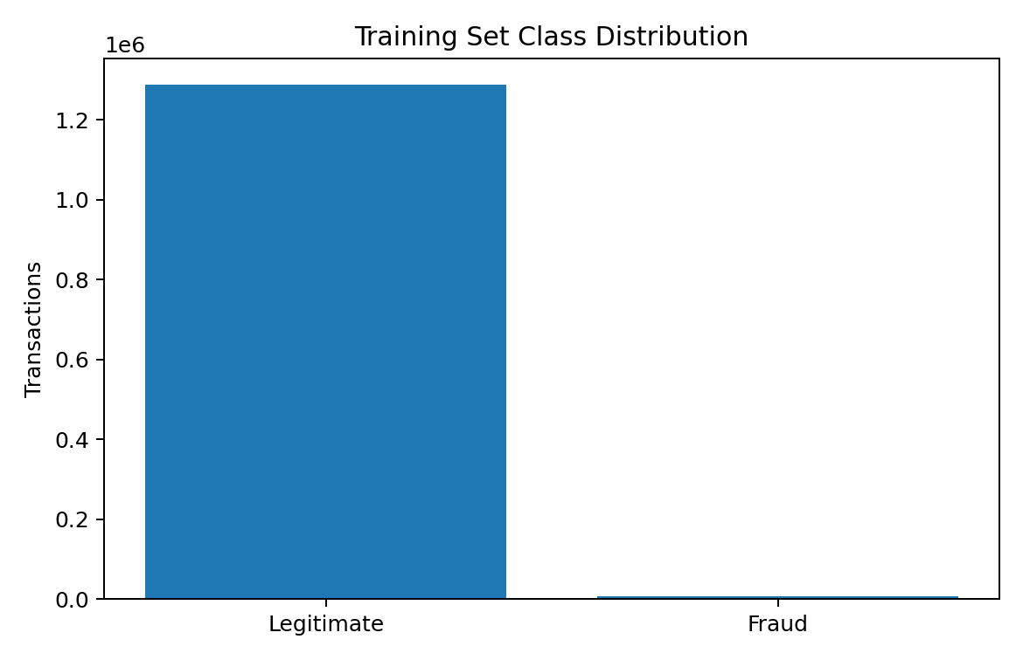
Figure 1. Training-set class distribution.
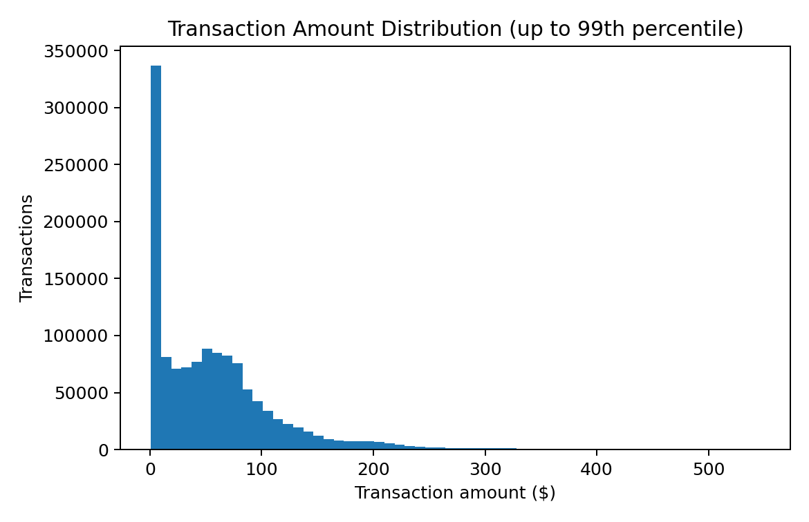
Figure 2. Transaction amount distribution, limited to the 99th percentile for readability.
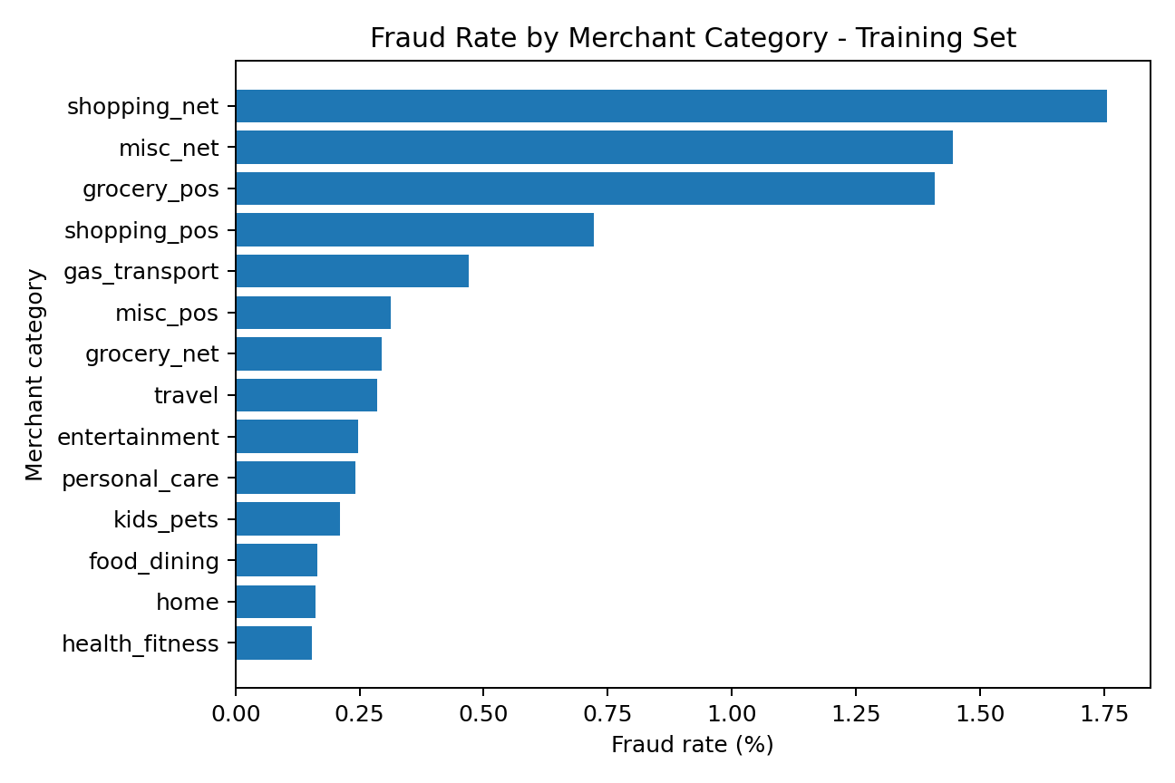
Figure 3. Fraud rate by merchant category in the training set.
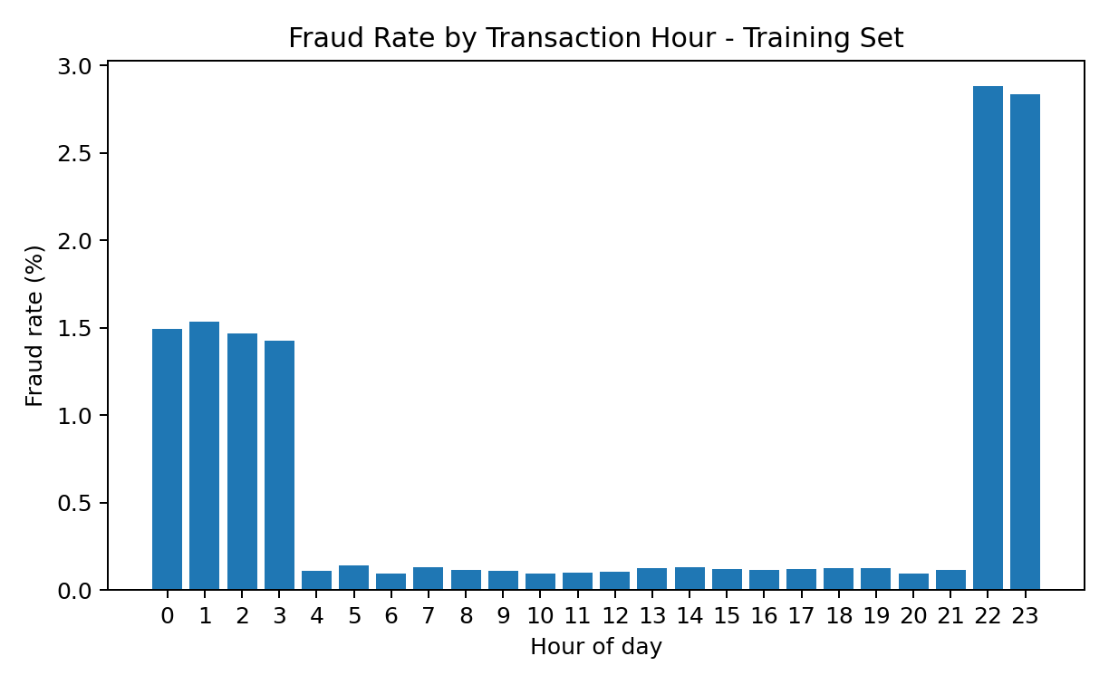
Figure 4. Fraud rate by transaction hour in the training set.
Merchant category and time of day show much stronger differences than geographic distance. In the training data, the highest observed category fraud rates are shopping_net (1.76%), misc_net (1.45%), and grocery_pos (1.41%). Fraud rates are also much higher around 22:00-03:00 than during most daytime hours. These observations justify keeping category and engineered time features as candidate predictors.
Customer-to-merchant distance was also tested because it appeared intuitively useful. However, the mean distance is 76.1 km for legitimate transactions and 76.3 km for fraudulent transactions. The nearly identical averages suggest that this feature may contribute less than expected in this simulated dataset. It will remain a candidate feature, but its usefulness should be judged by model comparison rather than assumed.

2.4 Data Quality Issues and Handling Plan
Issue | Finding / handling plan
Missing values | No missing values were found in either uploaded file. No imputation is required at this stage. If later data introduce missing values, any fitted imputer will use training data only.
Inconsistent formats/units | Transaction timestamps and dates of birth will be parsed as datetime values. Amount is treated as U.S. dollars, and latitude/longitude fields will remain in geographic coordinates until derived distance is calculated.
Label noise / weak labels | The labels are generated by the simulator. They are accepted for this project, but their synthetic origin is a limitation because real fraud labels can be delayed, disputed, or incomplete.
Outliers / erroneous values | Amount has a long right tail and 67,290 training observations exceed the 1.5×IQR upper fence. They will not be removed solely for being statistically unusual. Plausibility checks and transformations will be preferred.
Duplicates | No exact duplicate rows or repeated transaction IDs were found in either file.
Data drift risk | The test data occur later in time and have a lower fraud prevalence than the training data. The supplied chronological split will be preserved so that evaluation reflects later activity.
Class imbalance | Fraud represents only 0.579% of training transactions and 0.386% of test transactions. Accuracy alone is therefore unsuitable. Resampling, if tested later, will be limited to training data; the test distribution will remain untouched.
Labelling if unsupervised | Not applicable to the main task because `is_fraud` provides a supervised binary target. Unsupervised anomaly detection may be considered as an alternative model family later, but it is not required for Milestone 1.

3. Feature Engineering
The feature-engineering plan is intentionally limited to variables that are interpretable and available at transaction time. The goal is not to create a large number of features, but to produce a small set that represents amount, timing, merchant context, customer context, and location without leaking the target.
Feature | Type | Source | Reason
Transaction amount | Numeric | amt | Core transaction magnitude.
Log transaction amount | Numeric | log1p(amt) | Reduces the strong right skew while preserving order.
Hour of day | Numeric / time | timestamp | Fraud rate varies substantially by hour.
Day of week | Categorical / time | timestamp | Tests whether weekly transaction patterns matter.
Night transaction | Binary | timestamp | Simple indicator for 22:00-03:59, where fraud is much more common in this dataset.
Customer age | Numeric | DOB + transaction date | Uses age at transaction rather than raw date of birth.
Merchant category | Categorical | category | Category fraud rates differ materially in the training data.
Customer-to-merchant distance | Numeric | lat/long fields | Interpretable geographic feature; EDA shows weak average separation, so it will be retained only if useful.
City population | Numeric | city_pop | Provides coarse context about the customer location.

3.1 Categorical Variables and Transformations
- Merchant category will be one-hot encoded for classical models because it has only 14 categories in the uploaded files.
- Transaction amount will be retained in raw form and as log1p(amount). Model comparison will determine whether the transformation improves performance.
- Time will be decomposed into hour, day of week, and a night indicator. Cyclical sine/cosine encoding can be tested later if needed.
- Customer-to-merchant distance will be calculated with the Haversine formula rather than treating latitude and longitude as independent linear variables.
- High-cardinality identifiers such as card number and transaction number will not be one-hot encoded. Names and street addresses will also be excluded from the initial model.
- The merchant text contains a constant `fraud_` prefix in this synthetic dataset. The prefix itself is not evidence of the target because it appears on merchants generally; it will be stripped if merchant identity is retained later.
- Image, audio, and free-text processing are not applicable because the selected task uses structured tabular data.

3.2 Leakage Controls
Every feature will be checked against the question: would this information be available when the transaction is scored? The target label will never be used to construct an input feature. Any future customer-history features must use only transactions that occurred before the current transaction. Encoders, scalers, class weighting decisions, and any resampling procedure will be fitted using the training partition only. Direct identifiers will be excluded from the initial feature set because they can encourage memorization of customers or transactions rather than generalizable fraud patterns.

4. Code Submission
The accompanying project folder contains reproducible Python scripts for the exploratory analysis and initial feature engineering. The raw CSV files are not modified. The scripts read from `data/raw/`, save analysis tables and figures under `outputs/`, and write engineered data under `data/processed/`. Relative paths are used so the project can be cloned and run on another machine.
inse6450-fraud-detection/
README.md
requirements.txt
data/
raw/
processed/
src/
eda.py
feature_engineering.py
outputs/
figures/
tables/
analysis_summary.json
reports/
INSE6450_Milestone1_Fraud_Detection.docx

References
Ayub, A. (2026). INSE 6450: AI in Systems Engineering - Milestone 1. Concordia University.
Shenoy, K. Credit Card Transactions Fraud Detection. Kaggle dataset. https://www.kaggle.com/datasets/kartik2112/fraud-detection
Harris, B. Sparkov synthetic transaction data generator. https://github.com/btrainor12/Sparkov_Data_Generation

