APPLICATION
FOR
MINISTRY OF EDUCATION
SOCIAL SCIENCE AND HUMANITIES RESEARCH THEMATIC GRANT

2026 GRANT CALL

For MOE use:

Official Application Ref No.:

2 | 0 | 2 | 6 | - | S | S | H | R | T | G | -

SSRC

1. | TITLE OF PROJECT
The title should be no more than 80 characters (including space). The title should be descriptive and specific rather than general.

Economic Statecraft for Smaller States: Economic Diplomacy and Geopolitics in a Ruptured Global Economy
1b. | KEYWORDS
Please provide a maximum of 6 keywords (no more than 80 characters each).
Geoeconomics.
International economic system.
Multilateralism.
Multipolarity.
Strategic interdependence.
World order.

2. | HOST INSTITUTION: |  |  | National University of Singapore
3. | PROJECT DURATION
 | Start Date (mm/yyyy): |  |  | 08/2027
 | End Date (mm/yyyy): |  |  | 07/2032
 | Duration of Project (mths): |  |  | 60 months
4. | PROJECT BUDGET: S$
5a. | PRINCIPAL INVESTIGATOR
Salutation: |  | Professor
Last Name:  First Name:  Institution: |  | Quah  Danny  National University of Singapore
Department:  Faculty or School:  Designation: |  | Lee Kuan Yew School of Public Policy  Li Ka Shing Professor in Economics
Address: |  | 469A Bukit Timah Road, Singapore 259770
Telephone No.:  Fax:  E-mail: |  | +65.6516.5208  (none)  D.Quah@nus.edu.sg
5b. CO-Investigator(S) (Please add entries if there are more co-principal investigators)

Salutation:
Last Name:  First Name:  Institution: |  | Jacks  David  National University of Singapore
Department:  Faculty or School:  Designation: |  | Economics  Faculty of Arts and Social Sciences  Provost’s Chair Professor
Address:
Telephone No.:  Fax:  E-mail: |  | dsjacks@nus.edu.sg
Salutation:
Last Name:  First Name:  Institution: |  | Kam  Stefanie  Nanyang Technological University
Department:  Faculty or School:  Designation: |  | S. Rajaratnam School of International Studies  Assistant Professor
Address:
Telephone No.:  Fax:  E-mail: |  | isstefanie@ntu.edu.sg
Salutation:
Last Name:  First Name:  Institution: |  | Liu  Adam  National University of Singapore
Department:  Faculty or School:  Designation: |  | Lee Kuan Yew School of Public Policy  Assistant Professor
Address:
Telephone No.:  Fax:  E-mail: |  | adam.y.liu@nus.edu.sg
5c. COLLABORATOR(S) (Please add entries if there are more collaborators)

Salutation:
Last Name:  First Name:  Institution: |  |  | Armstrong  Shiro  Australian National University
Department:  Faculty or School:  Designation: |  |  | Crawford School of Public Policy  Professor. Director of Australia-Japan Research Centre
Address:
Telephone No.:  Fax:  E-mail: |  |  | shiro.armstrong@anu.edu.au
Salutation:
Last Name:  First Name:  Institution: |  |  | Kikuchi  Tomoo  Waseda University
Department:  Faculty or School:  Designation: |  |  | International Development / Policy Studies  Graduate School of Asia-Pacific Studies  Professor
Address:
Telephone No.:  Fax:  E-mail: |  |  | tomookikuchi@waseda.jp
Salutation:
Last Name:  First Name:  Institution: |  |  | Kim  Hyungjin  Korea Development Institute
Department:  Faculty or School:  Designation: |  |  | Supply Chain Research Unit  Department of Industry and Market Policies  Associate Fellow
Address:
Telephone No.:  Fax:  E-mail: |  |  | hyungjinkim@kdi.re.kr
Salutation:
Last Name:  First Name:  Institution: |  |  | Kim  Sooyeon  University of British Columbia
Department:  Faculty or School:  Designation: |  |  | School of Public Policy and Global Affairs  Associate Professor. Korea Foundation Chair
Address:
Telephone No.:  Fax:  E-mail: |  |  | sooyeon.kim@ubc.ca
Salutation:
Last Name:  First Name:  Institution: |  |  | Ng  Joel  S. Rajaratnam School of International Studies
Department:  Faculty or School:  Designation: |  |  | Centre for Multilateralism Studies  Senior Fellow. Head of Centre for Multilateralism Studies
Address:
Telephone No.:  Fax:  E-mail: |  |  | isjkjng@ntu.edu.sg
Salutation:
Last Name:  First Name:  Institution: |  |  | Ngoei  Wen-Qing  Singapore Management University
Department:  Faculty or School:  Designation: |  |  | College of Integrative Studies  Associate Professor of History
Address:
Telephone No.:  Fax:  E-mail: |  |  | wqngoei@smu.edu.sg

Curriculum Vitae (CV) and Letters of Commitment

Please provide a CV and letter of commitment for each of the research team members (no more than 3 pages per applicant, with the letter of commitment no more than 1 page). Each biographical sketch can list up to 10 publications with high levels of relevance to the proposal. The letters of commitment should indicate if their current employers are aware of their intention to participate in the proposed project. The suggested format for the letter of commitment is shown in Annex A of this application form. Attach the CVs to the end of this application form.

6. PROJECT PROPOSAL

Please put a ‘X’ in the appropriate box (Please tick more than one box if applicable)

This research proposal is related to:

Theme 1 (The Future of Society)
Theme 2 (The Future Economy)
Theme 3 (Climate Change and the Environment)
Theme 4 (The Human Condition)
Theme 5 (The Geopolitics of a Changing World) | X

Open Category

Submission to other grants

Have you previously submitted a similar proposal to the Academic Research Fund (AcRF) or grants offered by other funding agencies?

 |  | Yes | X | No
If yes, please indicate:
(1) Month & year of submission (mm/yyyy): __________________________
(2) Name of grant submitted: _____________________________

Please elaborate how this submission differs from the previous submission to AcRF or grants offered by other funding agencies.
(na)

7. ABSTRACT OF THE PROPOSAL

Please provide a succinct and accurate description of the proposal in no more than 1000 words. Clearly describe the objectives of the project, the existing literature that was consulted, and the contribution of the proposed research in academic and non-academic domains.

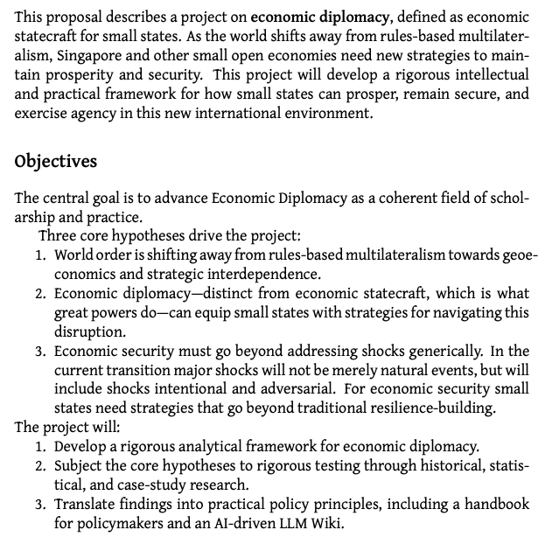
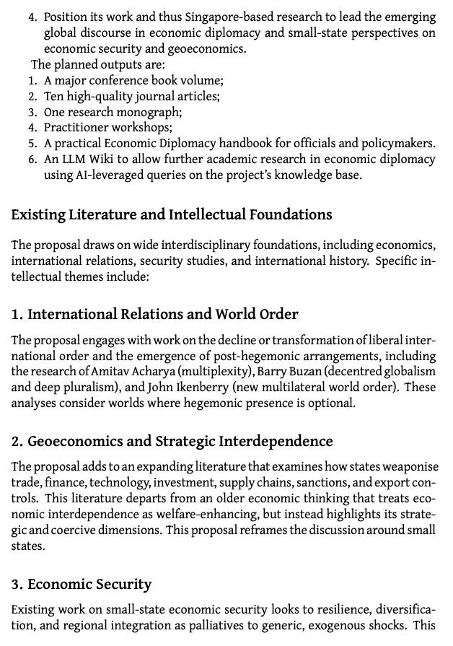
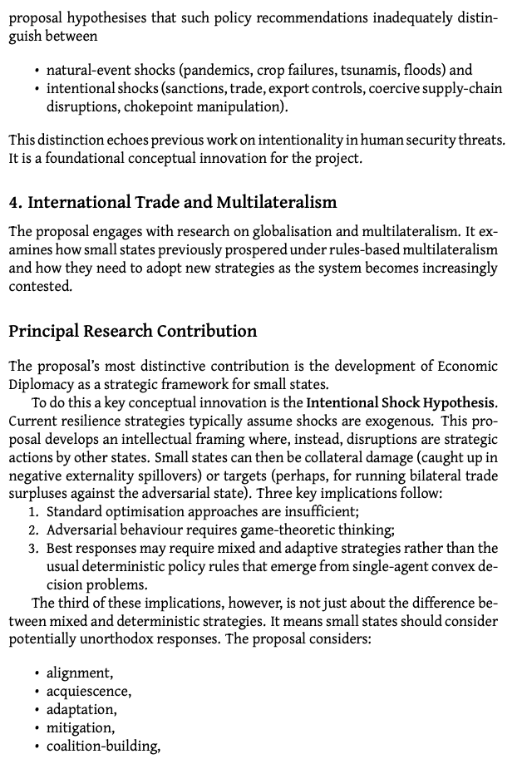
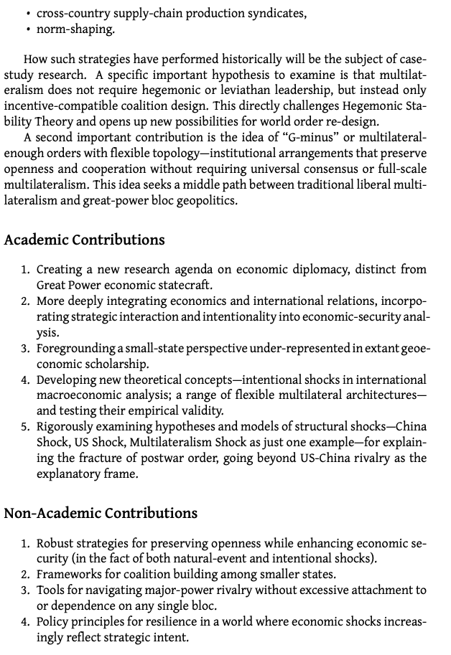
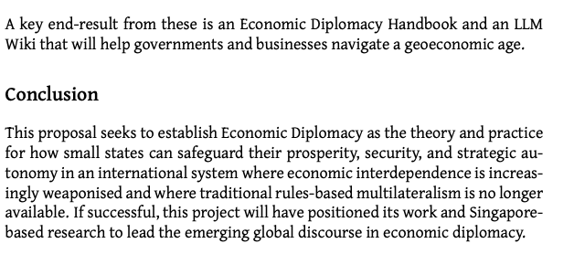

8. PROJECT DELIVERABLES AND DESIRED OUTCOMES

Please provide full details of the deliverables and desired outcomes from project in no more than 2 pages (Arial font size 12, single line spacing, 1-inch margins). Please refer to Annex B of the RFP Document for further guidelines on completing this section.

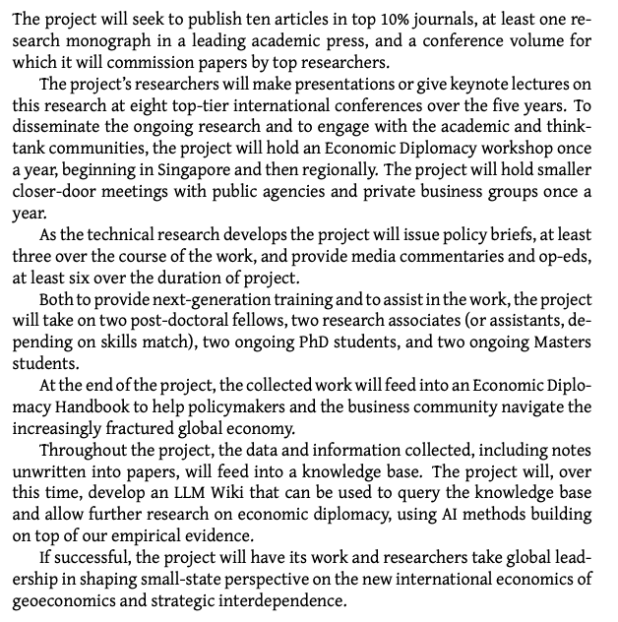

9. PROJECT IMPLEMENTATION SCHEDULE (GANTT CHART FORMAT)

The proposed schedule will be used for assessment and evaluation of the project. Satisfactory progress is required for continued disbursements of funds. Projects are expected to commence operation no later than six months from the award of the project.
Quarters  A. Project  Implementation Schedule  (no more than 300 characters) |  |  |  |  |  |  |  |  |  |  |  |  | For Type B and Type C Proposals Only
 | Year 1 |  |  |  | Year 2 |  |  |  | Year 3 |  |  |  | Year 4 |  |  |  | Year 5
 | Q1 | Q2 | Q3 | Q4 | Q1 | Q2 | Q3 | Q4 | Q1 | Q2 | Q3 | Q4 | Q1 | Q2 | Q3 | Q4 | Q1 | Q2 | Q3 | Q4

10. Proposed Budget & justification

You are advised to consult the Office of Research (ORE) when preparing the budget to ensure that it is in line with your university’s HR and finance guidelines. Sufficient details and justifications should be provided for each request and items in the budget must be directly relevant to the proposed project. Please refer to Annex of Enclosure 1 and Annex B of the RFP Document for the list of non-fundable items and further guidelines on budget preparation.

Please note that the duration of funding is capped at three years for projects in the ‘Type A’ Category and five years for projects in the ‘Type B’ and ‘Type C’ category.

Overall Proposed Budget
 |  |  |  | For Type B and Type C proposals only
Category | Year 1($) | Year 2($) | Year 3($) | Year 4($) | Year 5($) | Total ($)
EOM (excluding Research Scholarships)
EOM (Research Scholarships)
Equipment
OOE
Overseas Travel
Indirect costs
Grand Total ($)

EOM (excluding Research Scholarships)

 |  |  |  |  |  | For Type B and Type C proposals only
Staff Category | No. | Cost per head($) | Year 1($) | Year 2($) | Year 3($) | Year 4($) | Year 5($) | Total ($)

Research Fellow

Research Assistant

Student Assistant

Others (please state)

Sub-total

EOM (Research Scholarships)

Research scholarships may be spent on postgraduate stipend and tuition support. Costs should be based on the standard stipend rates and tuition fees that apply in the host institution. Research scholarship funding is ring-fenced and cannot be transferred to other categories. Research scholarships do not qualify for IRC.

 |  |  |  |  |  | For Type B and Type C proposals only
Staff Category | No. | Cost per head($) | Year 1($) | Year 2($) | Year 3($) | Year 4($) | Year 5($) | Total ($)

Research Scholar

Details and justifications for proposed EOM budget

- Research Fellows/ Postdoctoral Fellows: $858,000 (Years 2 to 4)

A total budget of $858,000 is requested to support two Research Fellows/Postdoctoral Fellows over Years 2 to 4 ($143,000 × 2 fellows × 3 years).

The Research Fellows/Postdoctoral Fellows will work closely with the PI and Co-PI as junior research colleagues, contributing to the project's research design, data collection, analysis, publications, and other research activities. Where appropriate, they will be encouraged to further develop and align their recent PhD research with the themes and objectives of this project.

The appointments will also serve a strong capacity-building function. Throughout the project, the PI and Co-PI will provide mentorship, research training, and professional development opportunities to strengthen the Fellows' research capabilities and support their transition to independent academic careers, including progression to junior faculty positions upon completion of the project.

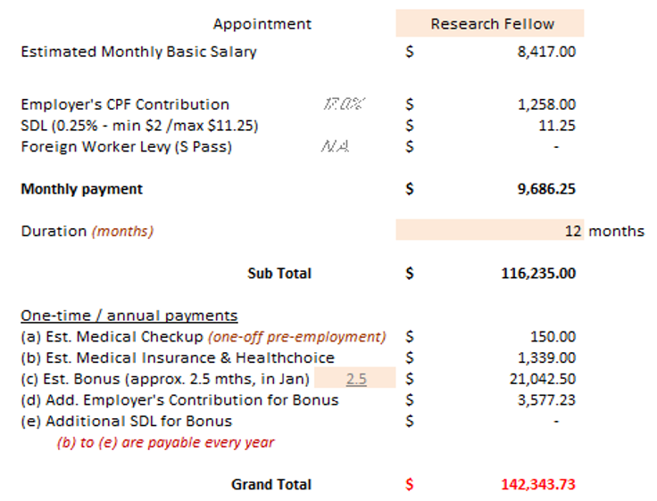

Please justify the manpower request, describing the specific role performed by each individual and their contribution to the project (no more than 1000 words for each individual)

- Senior/Research Associates: $896,000 (Years 2 to 5)

A total budget of $896,000 is requested to support two Senior/Research Associates over Years 2 to 5 ($112,000 × 2 associates × 4 years).

The Senior/Research Associates will have prior experience as research assistants and will work closely with PI, Co-PI, and Postdoctoral Fellows throughout the project. They will support key research activities, including conducting literature reviews, data analysis, background and routine writing.
In addition, they will play major roles in organising the project's workshops.

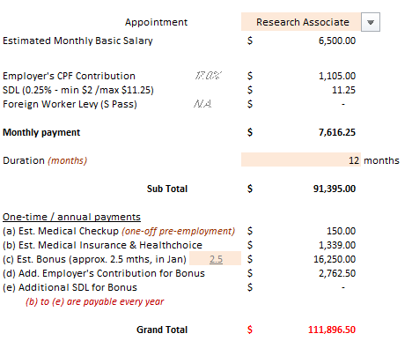

- Research Assistants: $1,140,000 (Years 2 to 5)

A total budget of $1,140,000 is requested to support three Research Assistants over Years 2 to 5 ($95,000 × 3 assistants × 4 years).
The Research Assistants will work closely with PI, Co-PIs, and individual collaborators on specific sub-projects throughout the project.
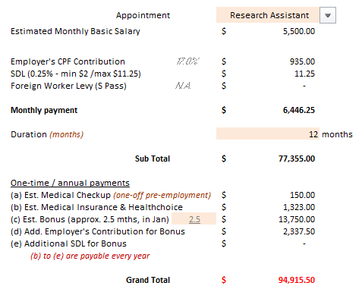

- Student Assistants (Part-time): $40,000 (Years 2 to 5)

The project will hire four part-time Student Assistants from Years 2 to 5 to provide on-demand work at LKYSPP including information retrieval, copy-editing, proof-reading, and helping the Research Associates in the project workshops.

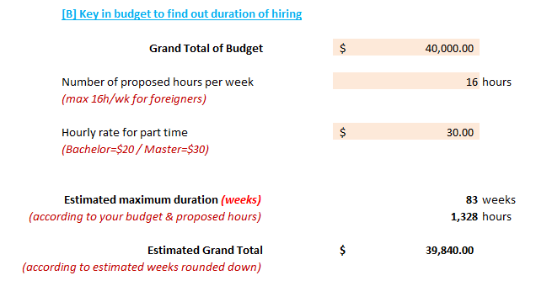

Please include justification (no more than 200 words) for the number of research scholars and briefly describe the scope of their research.

Equipment
Please include GST, where applicable.
 |  |  |  |  |  | For Type B and Type C proposals only
Item | No. | Cost per item($) | Year 1($) | Year 2($) | Year 3($) | Year 4($) | Year 5($) | Total ($)

New Lab Equipment (to append vendor’s written quotations)

Item (Quotation No.)
Notebooks | 8 | 3,000 | 24,000 |  |  |  |  | 24,000
Local LLM-capable desktop | 1 | 12,000 | 12,000 |  |  |  |  | 12,000
Specialised data and LLM subscription | 1 | 80,000 |  | 20,000 | 20,000 | 20,000 | 20,000 | 80,000
Subtotal |  |  | 36,000 | 20,000 | 20,000 | 20,000 | 20,000 | 116,000

Details and justifications for proposed equipment budget

The requirement for each piece of equipment requested should be adequately justified (no more than 1000 words per item). Please state if similar equipment exists in the PI or co-PIs’ labs or in the PI’s department/school and justify why new equipment is required for the project. Written quotations for ALL equipment requested should be appended.
Notebooks: $24,000 is requested to procure notebook computers for the Postdoctoral Fellows, Research Associates, and Research LLM-capable desktop: $12,000 is requested to acquire a high-performance desktop workstation for the Principal Investigator (PI). The workstation will support computationally intensive statistical analyses and natural language processing tasks, including the secure deployment and use of local large language models (LLMs).
Specialised data and LLM subscription: $80,000 is requested for subscriptions to specialised datasets, databases, and LLM services required for the project.

OOE
Please include GST, where applicable.

 |  |  |  | For Type B and Type C proposals only
Item*  (Indicate Quotation No., if applicable) | Year 1($) | Year 2($) | Year 3($) | Year 4($) | Year 5($) | Total ($)
Workshop |  | 100,000 |  | 100,000 |  | 200,000
Visiting Professors/Research Visitors |  | 60,000 | 60,000 | 60,000 | 60,000 | 240,000
Local travel | 2,000 | 2,000 | 2,000 | 2,000 | 2,000 | 10,000
Publication expenses |  |  |  |  | 12,000 | 12,000
Subtotal | 2,000 | 162,000 | 62,000 | 162,000 | 74,000 | 462,000
* Note:
1. Please indicate the budget requirement for each line item clearly. An aggregate budget for each category is not acceptable. Overhead charges and contingency funds are not allowed. Please refer to Annex of Enclosure 1 for the guidelines for non-fundable items.
2. Materials & Consumables - please provide a breakdown of items and costing and to append quotations only for items that constitute a significant proportion (e.g. >5%) of the total budget of OOE.

Details and justifications for proposed OOE budget

All items listed under OOE should be appropriately justified (no more than 1000 words for each) and supported with relevant documents. Consumables to be used for the project should be appropriately categorized and costed. Written quotations should be appended for items that constitute a significant proportion (e.g. >5%) of the total budget of OOE.

Costs for engaging visiting professors and experts (e.g. honorarium, costs of travel) are categorised under OOE. Proposed visiting professors should be identified and their intended contribution to the project supported in writing. The duration of the visit(s) should be stated clearly.

A breakdown of the “Others” category such as maintenance of equipment, publications, local conference, local travel, training & safety-related expenses etc. should be provided.

- Workshops: $200,000

A total budget of $200,000 is requested to organise two 3-day workshops in Years 2 and 4 ($100,000 per workshop). Each workshop will bring together approximately 20 participants, including authors and discussants, with about half of the participants travelling from abroad.

The budget will cover airfare, accommodation, per diem, local transportation, withholding tax (where applicable), catering, and other workshop-related expenses, estimated at 20 participants @$5K each*2

- Workshop 1: Will focus on …
- Workshop 2: Will focus on …

- Visiting Professors/Research Visitors: $240,000

A total of $240,000 is requested to support two Visiting Professors/Research Visitors over Years 2 to 5. We have identified two distinguished scholars (to include names?) to contribute to the project.

The budget will cover an honorarium (based on one-month per year, pro-rated for shorter visits), business-class airfare, accommodation. The estimated cost is $30,000 per visitor per year, for two visitors over four years ($30,000 × 2 × 4 = $240,000).

- Local Transportation: $10,000 ($2,000 per year for Years 1 to 5) budgeted for local travel expenses for meetings within Singapore.

- Publication Expenses: $12,000 is requested in Year 5 to support publication-related expenses, including map preparation, image licensing, production costs, and article processing charges for open-access publications where appropriate.

Overseas Travel
Include overseas conference travel and overseas travel for purposes directly related to the research project.

 |  |  |  | For Type B and Type C proposals only
Item  (Indicate Quotation No., if applicable) | Year 1 ($) | Year 2 ($) | Year 3 ($) | Year 4($) | Year 5($) | Total ($)
Overseas conference | 60,000 | 60,000 | 60,000 | 60,000 | 60,000 | 300,000
Regional elite interviews, case-study research, fieldwork | 30,000 | 30,000 | 30,000 | 30,000 |  | 120,000
Subtotal | 90,000 | 90,000 | 90,000 | 90,000 | 60,000 | 420,000

Details and justifications for proposed overseas travel budget

Expenditure for overseas conferences and travel should be in accordance with the university’s guidelines.
We propose a total travel budget of $420,000, comprising $60,000 per year (Years 1–5) for overseas conference attendance and $30,000 per year (Years 1–4) for travel related to regional elite interviews, case study research, and fieldwork.
The overseas conference funding will enable team members to present key research findings at leading international conferences, particularly in the United States, United Kingdom, Germany (or other transatlantic).
The cost estimate covers airfare, accommodation, conference registration fees, per diem, and other related travel expenses.

11a. DETAILS OF RESEARCH PROPOSAL

Give a description of the research in no more than 15 pages (for Type A proposals) and 20 pages (for Type B and Type C proposals), adhering to the following formatting: Arial font size 12, single line spacing, 1-inch margins. Attach this detailed proposal to the end of this application form. Information SHOULD include:
- Vision and rationale of the project/programme
- Research plan
- Data collection plan
- Potential impact
- Research team and organisational structure
- Equipment and infrastructure
- Financial plan and support
- Ethics and risks

Explanations of each of these points are detailed in Annex B of the RFP Document. Information provided should be sufficiently self-contained for an assessment of the proposal without further reference to other materials. Please include references cited at the end of the detailed proposal. References do not count as part of the 15-page or 20-page limit.

11b. Declaration of Ethics Consideration

Where applicable, the PI has to obtain full Ethics Approval and any other research-related approvals (such as risk assessments) from the relevant authorities before the SSHR-TG account is activated by the host institutions’ Office of Finance.
Please tick, where appropriate, if your study involves the following:

Human subject
Use of Human Tissues or Cells
Animal Experimentation
Use of Animal Tissues or Cells
Requirement for containment (BSL 2 and above)
Other ethical approval (please specify)

A copy of the ethics approval is attached:

Yes No

12. Declaration of Other Funding Support

The Principal Investigator and Co-Principal Investigator(s) should detail the grants awarded in the last 5 years, including those currently held or submitted for consideration by other funding agencies. Please note that parallel submissions are not allowed – i.e. applicants should not send similar versions or part(s) of the current SSHR-TG proposal application to other agencies or grant schemes for funding concurrently.

PI: [name]
Grant/s Applied  (Pending Approval)  Please add records, if any | S/N | Status:  PI, Co-PI, Collaborator  (please indicate one) | Project Title | Funding Agency/ies  Please list co-funding Grantors, if applicable | Amount Requested  (S$) |  | Proposed Duration of Award  (No. of Years)
 |  |  |  |  | AcRF | Non-AcRF
 |  |  |  | TOTAL

Grant/s Awarded  (Current)  Please add records, if any | S/N | Status:  PI, Co-PI, Collaborator  (please indicate one) | Project Title  (Project ID / Account No.) | Funding Agency/ies  Please list co-funding Grantors, if applicable | Amount Awarded  (S$) |  | Duration of Award  (MM-YY to MM-YY) | % of time PI is involved in each grant
 |  |  |  |  | AcRF | Non-AcRF
 |  |  |  | TOTAL

Grant/s Awarded  (Completed) –  Last 3 grants completed  Please add records, if any | S/N | Status:  PI, Co-PI, Collaborator  (please indicate one) | Project Title  (Project ID / Account No.) | Funding Agency/ies  Please list co-funding Grantors, if applicable | Amount Awarded  (S$) |  | Duration of Award  (MM-YY to MM-YY)
 |  |  |  |  | AcRF | Non-AcRF
 |  |  |  | TOTAL

Co-I: [name]
Grant/s Applied  (Pending Approval)  Please add records, if any | S/N | Status:  PI, Co-PI, Collaborator  (please indicate one) | Project Title | Funding Agency/ies  Please list co-funding Grantors, if applicable | Amount Requested  (S$) |  | Proposed Duration of Award  (No. of Years)
 |  |  |  |  | AcRF | Non-AcRF
 |  |  |  | TOTAL

Grant/s Awarded  (Current)  Please add records, if any | S/N | Status:  PI, Co-PI, Collaborator  (please indicate one) | Project Title  (Project ID / Account No.) | Funding Agency/ies  Please list co-funding Grantors, if applicable | Amount Awarded  (S$) |  | Duration of Award  (MM-YY to MM-YY) | % of time PI is involved in each grant
 |  |  |  |  | AcRF | Non-AcRF
 |  |  |  | TOTAL

Grant/s Awarded  (Completed) –  Last 3 grants completed  Please add records, if any | S/N | Status:  PI, Co-PI, Collaborator  (please indicate one) | Project Title  (Project ID / Account No.) | Funding Agency/ies  Please list co-funding Grantors, if applicable | Amount Awarded  (S$) |  | Duration of Award  (MM-YY to MM-YY)
 |  |  |  |  | AcRF | Non-AcRF
 |  |  |  | TOTAL

13. Suggested Names of EXTERNAL Reviewers

PIs should nominate suggested external reviewers. External Reviewers should be experts in the field who are able to provide an independent and credible assessment of the research proposal. In general, reviewers should be at least Assistant Professors or equivalent. Doctoral students should not be nominated as external reviewers. Prior consent should be obtained from suggested external reviewers before nomination. PIs should also disclose their relationship and past collaborations with the external reviewers, if any. The Expert Panel may choose not to engage the suggested external reviewers.

S/N | Salutation | Name of Reviewer | Institution and Designation | Details of contacts  (Please provide mailing address,  e-mail address, tel and fax numbers) | Research interest / Expertise | Relationship to PI/co-PI
1
2
3
4
5

The application should not be sent to the following reviewers:

S/N | Salutation | Last Name | First Name | Institution | Reason (No more than 200 characters)
1
2
3
4
5

14. UNDERTAKING by PRINCIPAL INVESTIGATOR, Co-Principal Investigator(S) and ALL COLLABORATORS
In signing the Grant Application, the Principal Investigator, all Co-Principal Investigator(s) and all collaborators UNDERTAKE, on any Grant Award, to:

- ensure that a proposal with similar research aims has not been awarded research funding either by MOE or another funding agency;
- ensure that MOE’s funding is acknowledged in all publications;
- ensure that a copy of all publications arising from research wholly or partly funded by MOE will be submitted to MOE;
- ensure that all data generated from research funded by the SSR Thematic Grant should be made available to user communities at the earliest feasible opportunity, subject to restrictions related to confidentiality and intellectual property.
- co-operate with MOE to inculcate interest in research among all students; and
- grant the Singapore Government and public sector agencies a non-exclusive, non-transferable, perpetual, irrevocable, worldwide, royalty-free right and licence to use, modify, reproduce and distribute the IP created from Thematic Grant for non-commercial, R&D and/or educational purposes.
------------------------------------------------------
Name and Signature of Principal Investigator
Date:

-----------------------------------------------
Name and Signature of Co-Investigator (please add if necessary)
Date:
-----------------------------------------------  Name and Signature of Collaborator*  Date: | -----------------------------------------------  Name and Signature of Collaborator*  Date:
-----------------------------------------------  Name and Signature of Collaborator*  Date: | -----------------------------------------------  Name and Signature of Collaborator*  Date:

* Faxed signatures are acceptable.

15. UNDERTAKING by the HOST INSTITUTION
In signing the Grant Application, the Host Institution UNDERTAKES, on any Grant Award, to:
- support and agree to this proposal being carried out in the institution;
- check with appropriate human resource personnel, who have access to reliable sources for proper verification, to ensure that the applicants meet the eligibility criteria cited in the grant call document and Administrative Guidelines & Policies;
- ensure that all necessary licenses and approvals have been obtained or are being sought;
- ensure that the funds provided are used for the appropriate purposes;
- ensure that all budget requests are in accordance with the university's prevailing HR policies and financial guidelines;
- provide the Singapore Government and public sector agencies with data and statistics of indicators pertaining to the research activity when requested; and
- grant the Singapore Government and public sector agencies a non-exclusive, non-transferable, perpetual, irrevocable, worldwide, royalty-free right and licence to use, modify, reproduce and distribute the IP created from Thematic Grant for non-commercial, R&D and/or educational purposes.

Comments:

------------------------------------------------------ -------------------
Name and Signature of Director of Research* Date

* If the Principal Investigator is the Director of Research, UNDERTAKING by the Director’s Reporting officer is required.

------------------------------------------------------ -------------------
Name, Designation and Signature Date

ANNEX A
Letters of Commitment
(Required for PI, Co-PIs and Collaborators)

Letters should present the following information (no more than 1 page):

Identification: The opening paragraph of the letter should identify the name of the PI/co-PI/collaborator, and to state the exact role in the project (i.e. as (i) the PI; (ii) a Co-PI; or (iii) a collaborator). For PIs and Co-PIs, it should also declare that he/she is currently under full-time employment in the Host Institution.

Roles and Responsibilities: The letter should clearly state the role and responsibilities of the aforementioned person in the proposed project. It should list the appropriate skills and/or resources that he/she will bring to the proposed project, and explain how he/she intend to fulfil his/her commitment to the project. In particular, prior experience in managing similar research projects and/or relevant work in the field should be listed.

For Co-PIs and collaborators, list out prior research collaboration experience with the PI.

Authorisation: Letters should be properly authorised by the aforementioned person with his/her signature.

Authorisation: Letters should be properly authorised by the aforementioned person with his/her signature.

Indirect cost is supported at a flat rate of 30% of the total qualifying direct costs, less EOM (Research Scholarships) and must be budgeted within the overall cap of Type A grant ($1M), Type B and Type C grant ($10M).
Funding for research scholarship under the SSHR-TG is applicable only to National University of Singapore (NUS), Nanyang Technological University (NTU), Singapore Management University (SMU), Singapore Institute of Technology (SIT) (Industrial Masters’ and Industrial Doctorate only) and Singapore University of Technology & Design (SUTD), and duration of funding is capped at the project duration.
This refers also to grants funded by agencies other than MOE.
Repeat for each Co-Investigator
PIs/co-PIs should disclose their relationship and past collaborations with the external reviewers, if any.

