集美大学计算机工程学院实验报告

课程名称： Java程序设计 | 班级：计算2011 | 实验成绩：
实验编号： | 姓名：施旭轩 | 实验日期：2024.5.16
实验名称：教师管理系统 | 学号：201822121062 | 实验地点：

一、目的（本次实验所涉及并要求掌握的知识点）
1．熟悉java web开发环境
2．初步掌握利用框架进行web开发的基本方法

二、实验内容与设计思想（设计思路、主要代码结构、主要代码段的文字分析、输出结果截图）
本次实验的目标是开发一个教师管理系统，需要制作登录界面、主页面、教师信息浏览页以及对教师信息的增、删、改操作。以下是系统框架示例图：
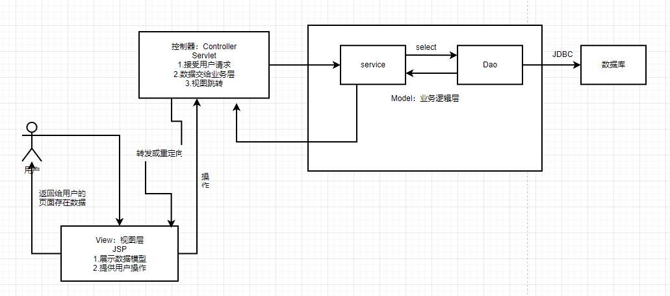

我使用的技术是jsp+servlet+JDBC，页面设计使用html+css+js。系统设计了dao层、model层、util层以及servlet进行数据库连接操作和数据处理。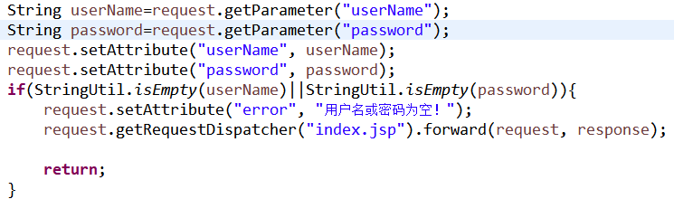
登录页面的设计代码：
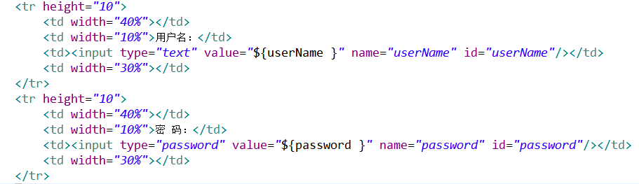
当进行登录操作时，通过servlet处理数据：

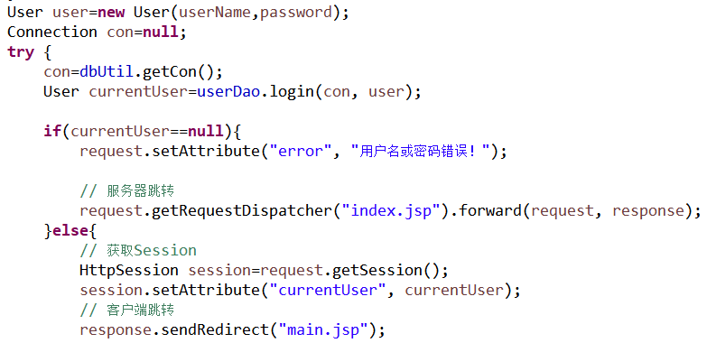
使用dopost提交数据，如果账号或密码输入为空，显示“用户名或密码为空”则跳转回登录页面，如果账号密码不为空，但不正确的话则显示“用户名或密码错误”，正确的话经过Session验证并跳转主页面

以下是登录界面的输出结果如图：
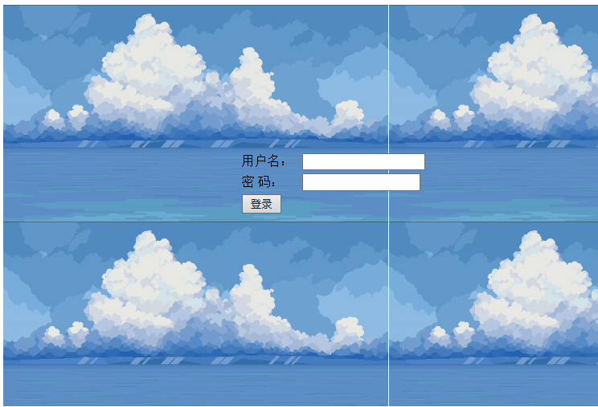
当账号或密码为空时提示“用户名或密码为空！”。
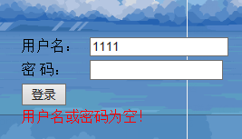
当账密错误时提示“用户名或密码错误！”
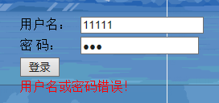
成功登录系统时进入主界面：
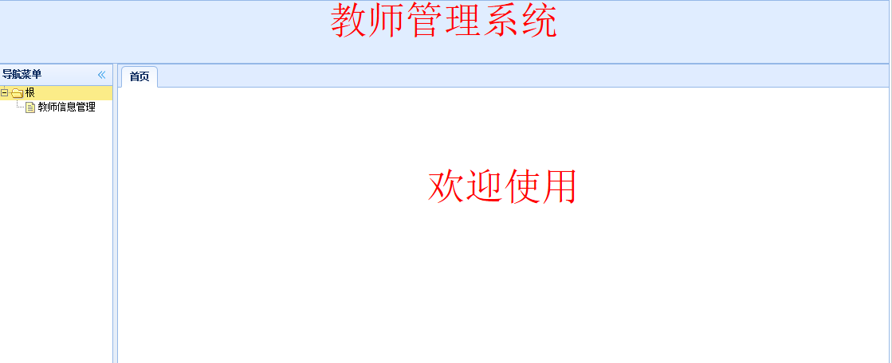

教师信息浏览页代码：
用表格显示教师的信息
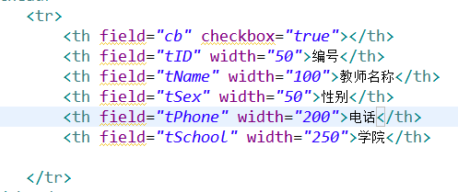
添加和修改教师信息的代码：
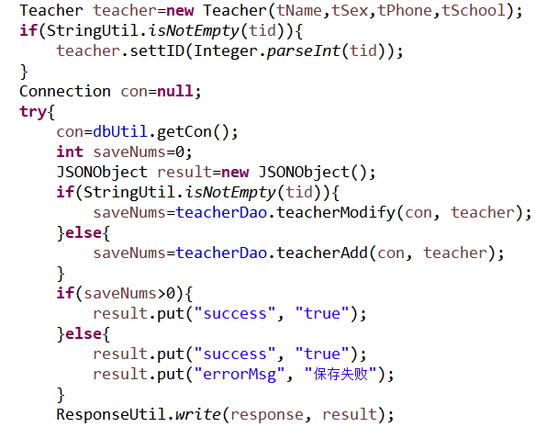
如果教师信息的id不为空，则可以修改教师的信息，否则进入添加教师信息。

DAO层数据库操作添加和修改的代码：
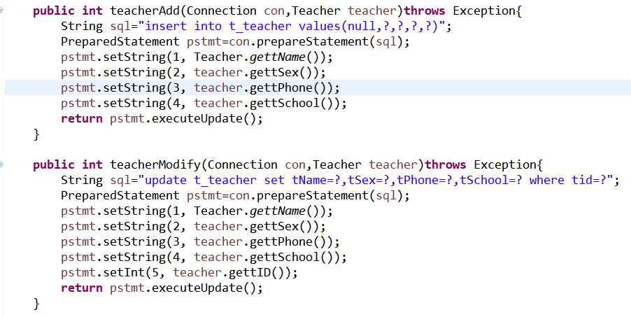

删除教师信息的代码：
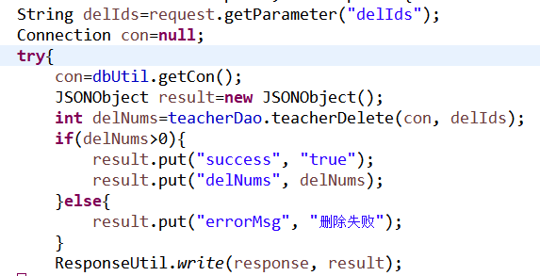
DAO层数据库操作删除的代码：
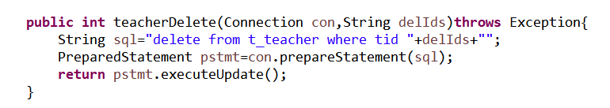

以下是教师页面的输出结果：
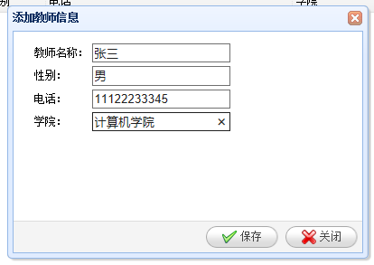
添加成功时的提示：
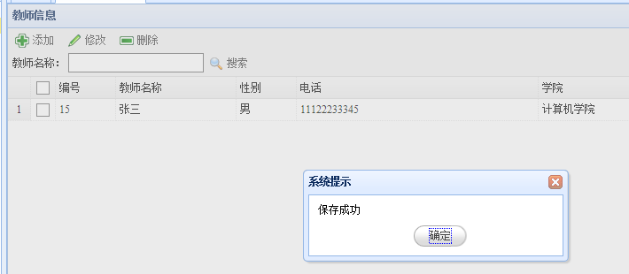

修改教师信息：
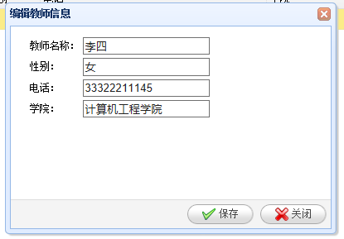
修改成功后：
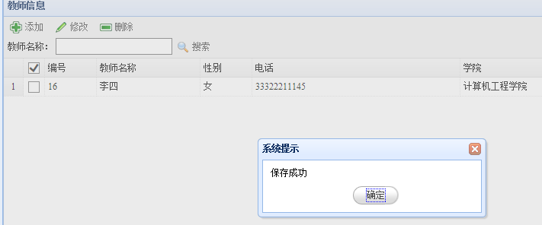

当要删除教师信息时
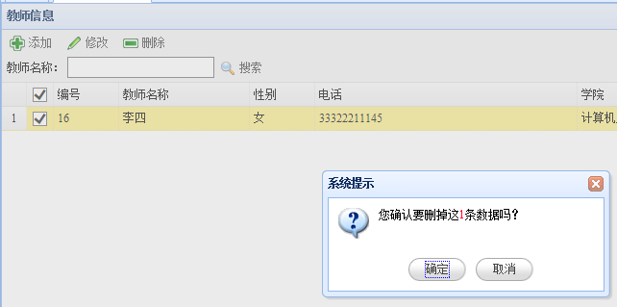

删除成功后提示：
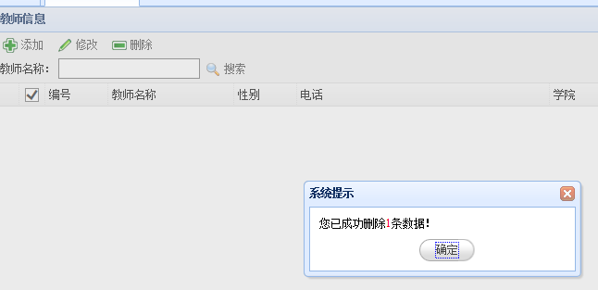

三、实验使用环境（本次实验所使用的平台和相关软件）
Win10、eclipse、jdk1.8、tomcat8.5.100、easyUI

四、实验小结（实验中遇到的问题及解决过程、实验中产生的错误及原因分析、实验体会和收获）
本次实验遇到了许多的问题，首先是配置开发环境时，tomcat的连接问题和版本问题令我困扰，servlet的配置也屡屡出错，也因此了解注解配置和web.xml手动配置的差别，以及开始对相应的jar包构建路径的错误操作也让我多花了不少时间埋头寻找错误的解决方法。
在学习和实验的过程中，慢慢理解了javaee的各种框架和具体意义，开发同样的web项目管理系统也有许多不同的方法，感谢这门课加深了我对java开发的理解。

五、参考文献（书籍、网址链接等）
【学生信息管理系统jsp&sevlet】 https://www.bilibili.com/video/BV1VE411v7GX/?p=4&share_source=copy_web&vd_source=1dfdc1115061f7f72bee9ca4d8efe240

六、源代码附件（完整的程序源代码，注意排版紧凑，字体、字间距选择小一点的）
Index.jsp
<%@ page language="java" contentType="text/html; charset=UTF-8"
pageEncoding="UTF-8"%>
<!DOCTYPE html PUBLIC "-//W3C//DTD HTML 4.01 Transitional//EN" "http://www.w3.org/TR/html4/loose.dtd">
<html>
<head>
<meta http-equiv="Content-Type" content="text/html; charset=UTF-8">
<title>教师管理系统</title>
</script>
</head>
<body>

<div align="center" style="padding-top: 50px;">
<form action="login" method="post">
<table width="740" height="500" background="images/login.png" >
<tr height="180">
<td colspan="4"></td>
</tr>
<tr height="10">
<td width="40%"></td>
<td width="10%">用户名：</td>
<td><input type="text" value="${userName }" name="userName" id="userName"/></td>
<td width="30%"></td>
</tr>
<tr height="10">
<td width="40%"></td>
<td width="10%">密 码：</td>
<td><input type="password" value="${password }" name="password" id="password"/></td>
<td width="30%"></td>
</tr>
<tr height="10">
<td width="40%"></td>
<td width="10%"><input type="submit" value="登录"/></td>
<td width="30%"></td>
</tr>
<tr height="10">
<td width="40%"></td>
<td colspan="3">
<font color="red">${error }</font>
</td>
</tr>
<tr >
<td></td>
</tr>
</table>
</form>
</div>
</body>
</html>
Main.jsp
<%@ page language="java" contentType="text/html; charset=UTF-8"
pageEncoding="UTF-8"%>
<!DOCTYPE html PUBLIC "-//W3C//DTD HTML 4.01 Transitional//EN" "http://www.w3.org/TR/html4/loose.dtd">
<html>
<head>
<meta http-equiv="Content-Type" content="text/html; charset=ISO-8859-1">
<title>教师管理系统主页</title>

<link rel="stylesheet" type="text/css" href="jquery-easyui-1.3.3/themes/default/easyui.css">
<link rel="stylesheet" type="text/css" href="jquery-easyui-1.3.3/themes/icon.css">
<script type="text/javascript" src="jquery-easyui-1.3.3/jquery.min.js"></script>
<script type="text/javascript" src="jquery-easyui-1.3.3/jquery.easyui.min.js"></script>
<script type="text/javascript" src="jquery-easyui-1.3.3/locale/easyui-lang-zh_CN.js"></script>
<script type="text/javascript">
$(function(){
// 数据
var treeData=[{
text:"根",
children:[{
text:"教师信息管理",
attributes:{
url:"teacherInfoManage.jsp"
}
}]
}];
// 实例化树菜单
$("#tree").tree({
data:treeData,
lines:true,
onClick:function(node){
if(node.attributes){
openTab(node.text,node.attributes.url);
}
}
});
// 新增Tab
function openTab(text,url){
if($("#tabs").tabs('exists',text)){
$("#tabs").tabs('select',text);
}else{
var content="<iframe frameborder='0' scrolling='auto' style='width:100%;height:100%' src="+url+"></iframe>";
$("#tabs").tabs('add',{
title:text,
closable:true,
content:content
});
}
}
});
</script>
</head>
<body class="easyui-layout">
<div region = "north" style = "height:80px; background-color: #E0EDFF"><div align="center"><font color="red" size="10">教师管理系统</font></div></div>
<div region = "center">
<div class="easyui-tabs" fit="true" border="false" id="tabs">
<div title="首页">
<div align="center" style="padding-top: 100px;"><font color="red" size="10">欢迎使用</font></div>
</div>
</div>
</div>
<div region = "west" style = "width:150px;" title="导航菜单" split="true">
<ul id="tree"></ul>
</div>
</body>
</html>

teacherInfoManage.jsp
<%@ page language="java" contentType="text/html; charset=UTF-8"
pageEncoding="UTF-8"%>
<!DOCTYPE html PUBLIC "-//W3C//DTD HTML 4.01 Transitional//EN" "http://www.w3.org/TR/html4/loose.dtd">
<html>
<head>
<meta http-equiv="Content-Type" content="text/html; charset=UTF-8">
<title>教师信息管理</title>
<link rel="stylesheet" type="text/css" href="jquery-easyui-1.3.3/themes/default/easyui.css">
<link rel="stylesheet" type="text/css" href="jquery-easyui-1.3.3/themes/icon.css">
<script type="text/javascript" src="jquery-easyui-1.3.3/jquery.min.js"></script>
<script type="text/javascript" src="jquery-easyui-1.3.3/jquery.easyui.min.js"></script>
<script type="text/javascript" src="jquery-easyui-1.3.3/locale/easyui-lang-zh_CN.js"></script>
<script type="text/javascript">
var url;
function searchTeacher(){

$('#dt').datagrid('load',{
tName:$('#s_tName').val()
});
}
function deleteTeacher(){

var selectedRows=$("#dt").datagrid('getSelections');
if(selectedRows.length==0){
$.messager.alert("系统提示","请选择要删除的数据！");
return;
}
var strIds=[];
for(var i=0;i<selectedRows.length;i++){
strIds.push(selectedRows[i].id);
}
var ids=strIds.join(",");
$.messager.confirm("系统提示","您确认要删掉这<font color=red>"+selectedRows.length+"</font>条数据吗？",function(r){
if(r){

$.post("teacherDelete",{delIds:ids},function(result){
alert("yes");
if(result.success){
$.messager.alert("系统提示","您已成功删除<font color=red>"+result.delNums+"</font>条数据！");

$("#dt").datagrid("reload");
}else{
$.messager.alert('系统提示',result.errorMsg);
}
},"json");
}
});

}
function openTeacherAddDialog(){
$("#dlg").dialog("open").dialog("setTitle","添加教师信息");
url="teacherSave";
}
function openTeacherModifyDialog(){
var selectedRows=$("#dt").datagrid('getSelections');
if(selectedRows.length!=1){
$.messager.alert("系统提示","请选择一条要编辑的数据！");
return;
}
var row=selectedRows[0];
$("#dlg").dialog("open").dialog("setTitle","编辑教师信息");
$("#fm").form("load",row);
url="teacherSave?id="+row.id;
}
function closeTeacherDialog(){
$("#dlg").dialog("close");
resetValue();
}
function resetValue(){
$("#tName").val("");
$("#tSex").val("");
$("#tPhone").val("");
$("#tSchool").val("");
}
function saveTeacher(){
$("#fm").form("submit",{
url:url,
onSubmit:function(){
return $(this).form("validate");
},
success:function(result){
if(result.errorMsg){
$.messager.alert("系统提示",result.errorMsg);
return;
}else{
$.messager.alert("系统提示","保存成功");
resetValue();
$("#dlg").dialog("close");
$("#dt").datagrid("reload");
}
}
});
}
</script>
</head>
<body>
<table id="dt" title="教师信息" class="easyui-datagrid" fitColumns="true"
pagination="true" rownumbers="true" url="teacherList" fit="true" toolbar="#tb">
<thead>
<tr>
<th field="cb" checkbox="true"></th>
<th field="tID" width="50">编号</th>
<th field="tName" width="100">教师名称</th>
<th field="tSex" width="50">性别</th>
<th field="tPhone" width="200">电话</th>
<th field="tSchool" width="250">学院</th>

</tr>
</thead>
</table>
<div id="tb">
<div>
<a href="javascript:openTeacherAddDialog()" class="easyui-linkbutton" iconCls="icon-add" plain="true">添加</a>
<a href="javascript:openTeacherModifyDialog()" class="easyui-linkbutton" iconCls="icon-edit" plain="true">修改</a>
<a href="javascript:deleteTeacher()" class="easyui-linkbutton" iconCls="icon-remove" plain="true">删除</a>
</div>
<div>&nbsp;教师名称：&nbsp;<input type="text" name="s_tName" id="s_tName"/><a href="javascript:searchTeacher()" class="easyui-linkbutton" iconCls="icon-search" plain="true">搜索</a></div>
</div>

<div id="dlg" class="easyui-dialog" style="width: 400px;height: 280px;padding: 10px 20px"
closed="true" buttons="#dlg-buttons">
<form id="fm" method = "post">
<table>
<tr>
<td>教师名称：</td>
<td><input type="text" name="tName" id="tName" class="easyui-validatebox" required="true"/></td>
</tr>
<tr>
<td>性别：</td>
<td><input type="text" name="tSex" id="tSex" class="easyui-validatebox" required="true"/></td>
</tr>
<tr>
<td>电话：</td>
<td><input type="text" name="tPhone" id="tPhone" class="easyui-validatebox" required="true"/></td>
</tr>
<tr>
<td>学院：</td>
<td><input type="text" name="tSchool" id="tSchool" class="easyui-validatebox" required="true"/></td>
</tr>
</table>
</form>
</div>
<div id="dlg-buttons">
<a href="javascript:saveTeacher()" class="easyui-linkbutton" iconCls="icon-ok">保存</a>
<a href="javascript:closeTeacherDialog()" class="easyui-linkbutton" iconCls="icon-cancel">关闭</a>
</div>
</body>
</html>

TeacherDao.java
package dao;
import java.sql.Connection;
import java.sql.PreparedStatement;
import java.sql.ResultSet;
import model.PageBean;
import model.Teacher;
import util.StringUtil;
public class TeacherDao {
public ResultSet teacherList(Connection con,PageBean pageBean, Teacher teacher)throws Exception{
StringBuffer sb=new StringBuffer("select * from t_teacher");
if(StringUtil.isNotEmpty(Teacher.gettName())){
sb.append(" and tName like '%"+Teacher.gettName()+"%'");
}
if(pageBean!=null){
sb.append(" limit "+pageBean.getStart()+","+pageBean.getRows());
}
PreparedStatement pstmt=con.prepareStatement(sb.toString().replaceFirst("and", "where"));
return pstmt.executeQuery();
}
public int teacherCount(Connection con)throws Exception{
String sql="select count(*) as total from t_teacher";
PreparedStatement pstmt=con.prepareStatement(sql);
ResultSet rs=pstmt.executeQuery();
if(rs.next()){
return rs.getInt("total");
}else{
return 0;
}
}
public int teacherDelete(Connection con,String delIds)throws Exception{
String sql="delete from t_teacher where tid "+delIds+"";
PreparedStatement pstmt=con.prepareStatement(sql);
return pstmt.executeUpdate();
}
public int teacherAdd(Connection con,Teacher teacher)throws Exception{
String sql="insert into t_teacher values(null,?,?,?,?)";
PreparedStatement pstmt=con.prepareStatement(sql);
pstmt.setString(1, Teacher.gettName());
pstmt.setString(2, teacher.gettSex());
pstmt.setString(3, teacher.gettPhone());
pstmt.setString(4, teacher.gettSchool());
return pstmt.executeUpdate();
}
public int teacherModify(Connection con,Teacher teacher)throws Exception{
String sql="update t_teacher set tName=?,tSex=?,tPhone=?,tSchool=? where tid=?";
PreparedStatement pstmt=con.prepareStatement(sql);
pstmt.setString(1, Teacher.gettName());
pstmt.setString(2, teacher.gettSex());
pstmt.setString(3, teacher.gettPhone());
pstmt.setString(4, teacher.gettSchool());
pstmt.setInt(5, teacher.gettID());
return pstmt.executeUpdate();
}
}

UserDao.java
package dao;
import java.sql.Connection;
import java.sql.PreparedStatement;
import java.sql.ResultSet;
import model.User;
public class UserDao {

/**
* 登录验证
* @param con
* @param user
* @return
* @throws Exception
*/
public User login(Connection con,User user) throws Exception{
User resultUser=null;
String sql="select * from t_user where userName=? and password=?";
PreparedStatement pstmt=con.prepareStatement(sql);
pstmt.setString(1, user.getUserName());
pstmt.setString(2, user.getPassword());
ResultSet rs=pstmt.executeQuery();
if(rs.next()){
resultUser=new User();
resultUser.setUserName(rs.getString("userName"));
resultUser.setPassword(rs.getString("password"));
}
return resultUser;
}
}

User.java
package model;
public class User {
private int id;
private String userName;
private String password;

public User() {
super();
// TODO Auto-generated constructor stub
}

public User(String userName, String password) {
super();
this.userName = userName;
this.password = password;
}
public int getId() {
return id;
}
public void setId(int id) {
this.id = id;
}
public String getUserName() {
return userName;
}
public void setUserName(String userName) {
this.userName = userName;
}
public String getPassword() {
return password;
}
public void setPassword(String password) {
this.password = password;
}
}

Teacher.java

package model;
public class Teacher {
private int tID;
private static String tName;
private String tSex;
private String tPhone;
private String tSchool;
public Teacher() {
super();
}
public Teacher(String tName,String tSex,String tPhone,String tSchool) {

super();
Teacher.tName = tName;
this.tSex = tSex;
this.tPhone = tPhone;
this.tSchool = tSchool;

}
public int gettID() {
return tID;
}
public void settID(int tID) {
this.tID = tID;
}
public static String gettName() {
return tName;
}
public void settName(String tName) {
Teacher.tName = tName;
}
public String gettSex() {
return tSex;
}
public void settSex(String tSex) {
this.tSex = tSex;
}
public String gettPhone() {
return tPhone;
}
public void settPhone(String tPhone) {
this.tPhone = tPhone;
}
public String gettSchool() {
return tSchool;
}
public void settSchool(String tSchool) {
this.tSchool = tSchool;
}
}

PageBean.java

package model;
public class PageBean {
private int page; // 第几页
private int rows; // 每页记录数
private int start; // 起始页
public PageBean(int page, int rows) {
super();
this.page = page;
this.rows = rows;
}
public int getPage() {
return page;
}
public void setPage(int page) {
this.page = page;
}
public int getRows() {
return rows;
}
public void setRows(int rows) {
this.rows = rows;
}
public int getStart() {
return (page-1)*rows;
}
}

DBUtil.java

package util;
import java.sql.Connection;
import java.sql.DriverManager;
public class DbUtil {
private String dbUrl="jdbc:mysql://localhost:3306/db_teacherInfo";
private String dbUserName="root";
private String dbPassword="123456";
private String jdbcName="com.mysql.cj.jdbc.Driver";

/**
* 获取数据库连接
* @return
* @throws Exception
*/
public Connection getCon() throws Exception{
Class.forName(jdbcName);
Connection con=DriverManager.getConnection(dbUrl,dbUserName,dbPassword);
return con;
}

/**
* 关闭数据库连接
* @param con
* @throws Exception
*/
public void closeCon(Connection con) throws Exception{
if(con!=null){
con.close();
}
}

public static void main(String[] args) {
DbUtil dbUtil=new DbUtil();
try {
dbUtil.getCon();
System.out.println("数据库连接成功");
} catch (Exception e) {
// TODO Auto-generated catch block
e.printStackTrace();
}
}
}

JsonUtil.java
package util;
import java.sql.ResultSet;
import java.sql.ResultSetMetaData;
import net.sf.json.JSONArray;
import net.sf.json.JSONObject;

public class JsonUtil {

public static JSONArray formatRsToJsonArray(ResultSet rs)throws Exception{
ResultSetMetaData md=rs.getMetaData();
int num=md.getColumnCount();
JSONArray array=new JSONArray();
while(rs.next()){
JSONObject mapOfColValues=new JSONObject();
for(int i=1;i<=num;i++){
mapOfColValues.put(md.getColumnName(i), rs.getObject(i));
}
array.add(mapOfColValues);
}
return array;
}

}

ResponseUtil.java

package util;
import java.io.PrintWriter;
import javax.servlet.http.HttpServletResponse;
import net.sf.json.JSONObject;
public class ResponseUtil {
public static void write(HttpServletResponse response,JSONObject jsonObject)throws Exception{
response.setContentType("text/html;charset=utf-8");
PrintWriter out=response.getWriter();
out.println(jsonObject.toString());
out.flush();
out.close();
}
}

StringUtil.java

package util;

public class StringUtil {

public static boolean isEmpty(String str){
if("".equals(str)|| str==null){
return true;
}else{
return false;
}
}

public static boolean isNotEmpty(String str){
if(!"".equals(str)&&str!=null){
return true;
}else{
return false;
}
}
}

LoginServlet.java

package servlet;

import java.io.IOException;
import java.sql.Connection;

import javax.servlet.ServletException;
import javax.servlet.annotation.WebServlet;
import javax.servlet.http.HttpServlet;
import javax.servlet.http.HttpServletRequest;
import javax.servlet.http.HttpServletResponse;
import javax.servlet.http.HttpSession;

import dao.UserDao;
import model.User;
import util.DbUtil;
import util.StringUtil;

/**
* Servlet implementation class MyServlet
*/
@WebServlet("/LoginServlet")
public class LoginServlet extends HttpServlet {

DbUtil dbUtil=new DbUtil();
UserDao userDao=new UserDao();

private static final long serialVersionUID = 1L;

/**
* @see HttpServlet#doGet(HttpServletRequest request, HttpServletResponse response)
*/
@Override
protected void doGet(HttpServletRequest request, HttpServletResponse response) throws ServletException, IOException {
// TODO Auto-generated method stub
//response.getWriter().append("Served at: ").append(request.getContextPath());

this.doPost(request, response);

}

/**
* @see HttpServlet#doPost(HttpServletRequest request, HttpServletResponse response)
*/
@Override
protected void doPost(HttpServletRequest request, HttpServletResponse response) throws ServletException, IOException {
// TODO Auto-generated method stub
//doGet(request, response);
String userName=request.getParameter("userName");
String password=request.getParameter("password");
request.setAttribute("userName", userName);
request.setAttribute("password", password);
if(StringUtil.isEmpty(userName)||StringUtil.isEmpty(password)){
request.setAttribute("error", "用户名或密码为空！");
request.getRequestDispatcher("index.jsp").forward(request, response);

return;
}
User user=new User(userName,password);
Connection con=null;
try {
con=dbUtil.getCon();
User currentUser=userDao.login(con, user);

if(currentUser==null){
request.setAttribute("error", "用户名或密码错误！");

// 服务器跳转
request.getRequestDispatcher("index.jsp").forward(request, response);
}else{
// 获取Session
HttpSession session=request.getSession();
session.setAttribute("currentUser", currentUser);
// 客户端跳转
response.sendRedirect("main.jsp");

}
} catch (Exception e) {
// TODO Auto-generated catch block
e.printStackTrace();
}finally{
try {
dbUtil.closeCon(con);
} catch (Exception e) {
// TODO Auto-generated catch block
e.printStackTrace();
}
}
}
}

TeacherListServlet.java

package servlet;
import java.io.IOException;
import java.sql.Connection;
import javax.servlet.ServletException;
import javax.servlet.annotation.WebServlet;
import javax.servlet.http.HttpServlet;
import javax.servlet.http.HttpServletRequest;
import javax.servlet.http.HttpServletResponse;
import net.sf.json.JSONArray;
import net.sf.json.JSONObject;
import dao.TeacherDao;
import model.Teacher;
import model.PageBean;
import util.DbUtil;
import util.JsonUtil;
import util.ResponseUtil;
@WebServlet("/TeacherListServlet")
public class TeacherListServlet extends HttpServlet{
DbUtil dbUtil=new DbUtil();
TeacherDao TeacherDao=new TeacherDao();
private static final long serialVersionUID = 1L;
@Override
protected void doGet(HttpServletRequest request, HttpServletResponse response)
throws ServletException, IOException {
this.doPost(request, response);
}
@Override
protected void doPost(HttpServletRequest request, HttpServletResponse response)
throws ServletException, IOException {
String page=request.getParameter("page");
String rows=request.getParameter("rows");
String teacherName=request.getParameter("tName");
if(teacherName==null){
teacherName="";
}
Teacher teacher=new Teacher();
PageBean pageBean=new PageBean(Integer.parseInt(page),Integer.parseInt(rows));
Connection con=null;
try{
con=dbUtil.getCon();
JSONObject result=new JSONObject();
JSONArray jsonArray=JsonUtil.formatRsToJsonArray(TeacherDao.teacherList(con, pageBean, teacher));
int total=TeacherDao.teacherCount(con);
result.put("rows", jsonArray);
result.put("total", total);
ResponseUtil.write(response, result);
}catch(Exception e){
e.printStackTrace();
}finally{
try {
dbUtil.closeCon(con);
} catch (Exception e) {
// TODO Auto-generated catch block
e.printStackTrace();
}
}
}
}

TeacherDeleteServlet.java

package servlet;
import java.io.IOException;
import java.sql.Connection;
import javax.servlet.ServletException;
import javax.servlet.http.HttpServlet;
import javax.servlet.http.HttpServletRequest;
import javax.servlet.http.HttpServletResponse;
import javax.servlet.Servlet;
import net.sf.json.JSONArray;
import net.sf.json.JSONObject;
import dao.TeacherDao;
import model.Teacher;
import model.PageBean;
import util.DbUtil;
import util.JsonUtil;
import util.ResponseUtil;
public class TeacherDeleteServlet extends HttpServlet{
DbUtil dbUtil=new DbUtil();
TeacherDao teacherDao=new TeacherDao();
private static final long serialVersionUID = 1L;
protected void doGet(HttpServletRequest request, HttpServletResponse response)
throws ServletException, IOException {
this.doPost(request, response);
}
protected void doPost(HttpServletRequest request, HttpServletResponse response)
throws ServletException, IOException {
String delIds=request.getParameter("delIds");
Connection con=null;
try{
con=dbUtil.getCon();
JSONObject result=new JSONObject();
int delNums=teacherDao.teacherDelete(con, delIds);
if(delNums>0){
result.put("success", "true");
result.put("delNums", delNums);
}else{
result.put("errorMsg", "删除失败");
}
ResponseUtil.write(response, result);
}catch(Exception e){
e.printStackTrace();
}finally{
try {
dbUtil.closeCon(con);
} catch (Exception e) {
// TODO Auto-generated catch block
e.printStackTrace();
}
}
}
}

TeacherSaveServlet.java

package servlet;
import java.io.IOException;
import java.sql.Connection;
import javax.servlet.ServletException;
import javax.servlet.annotation.WebServlet;
import javax.servlet.http.HttpServlet;
import javax.servlet.http.HttpServletRequest;
import javax.servlet.http.HttpServletResponse;
import net.sf.json.JSONArray;
import net.sf.json.JSONObject;
import dao.TeacherDao;
import model.Teacher;
import model.PageBean;
import util.DbUtil;
import util.JsonUtil;
import util.ResponseUtil;
import util.StringUtil;
@WebServlet("/TeacherSaveServlet")
public class TeacherSaveServlet extends HttpServlet{
private static final long serialVersionUID = 1L;
DbUtil dbUtil=new DbUtil();
TeacherDao teacherDao=new TeacherDao();
@Override
protected void doGet(HttpServletRequest request, HttpServletResponse response)
throws ServletException, IOException {
this.doPost(request, response);
}
@Override
protected void doPost(HttpServletRequest request, HttpServletResponse response)
throws ServletException, IOException {
request.setCharacterEncoding("utf-8");
String tName=request.getParameter("tName");
String tSex=request.getParameter("tSex");
String tPhone=request.getParameter("tPhone");
String tSchool=request.getParameter("tSchool");
String tid=request.getParameter("tID");
Teacher teacher=new Teacher(tName,tSex,tPhone,tSchool);
if(StringUtil.isNotEmpty(tid)){
teacher.settID(Integer.parseInt(tid));
}
Connection con=null;
try{
con=dbUtil.getCon();
int saveNums=0;
JSONObject result=new JSONObject();
if(StringUtil.isNotEmpty(tid)){
saveNums=teacherDao.teacherModify(con, teacher);
}else{
saveNums=teacherDao.teacherAdd(con, teacher);
}
if(saveNums>0){
result.put("success", "true");
}else{
result.put("success", "true");
result.put("errorMsg", "保存失败");
}
ResponseUtil.write(response, result);
}catch(Exception e){
e.printStackTrace();
}finally{
try {
dbUtil.closeCon(con);
} catch (Exception e) {
// TODO Auto-generated catch block
e.printStackTrace();
}
}
}
}

Web.xml

<?xml version="1.0" encoding="UTF-8"?>
<web-app xmlns:xsi="http://www.w3.org/2001/XMLSchema-instance" xmlns="http://java.sun.com/xml/ns/javaee" xsi:schemaLocation="http://java.sun.com/xml/ns/javaee http://java.sun.com/xml/ns/javaee/web-app_3_0.xsd" id="WebApp_ID" version="3.0">
<display-name>teacherManegementSystem</display-name>
<welcome-file-list>
<welcome-file>index.html</welcome-file>
<welcome-file>index.htm</welcome-file>
<welcome-file>index.jsp</welcome-file>
<welcome-file>default.html</welcome-file>
<welcome-file>default.htm</welcome-file>
<welcome-file>default.jsp</welcome-file>
</welcome-file-list>
<servlet>
<servlet-name>loginServlet</servlet-name>
<servlet-class>servlet.LoginServlet</servlet-class>
</servlet>
<servlet>
<servlet-name>teacherListServlet</servlet-name>
<servlet-class>servlet.TeacherListServlet</servlet-class>
</servlet>
<servlet>
<servlet-name>teacherDeleteServlet</servlet-name>
<servlet-class>servlet.TeacherDeleteServlet</servlet-class>
</servlet>
<servlet>
<servlet-name>teacherSaveServlet</servlet-name>
<servlet-class>servlet.TeacherSaveServlet</servlet-class>
</servlet>
<servlet-mapping>
<servlet-name>loginServlet</servlet-name>
<url-pattern>/login</url-pattern>
</servlet-mapping>
<servlet-mapping>
<servlet-name>teacherListServlet</servlet-name>
<url-pattern>/teacherList</url-pattern>
</servlet-mapping>
<servlet-mapping>
<servlet-name>teacherDeleteServlet</servlet-name>
<url-pattern>/teacherDelete</url-pattern>
</servlet-mapping>
<servlet-mapping>
<servlet-name>teacherSaveServlet</servlet-name>
<url-pattern>/teacherSave</url-pattern>
</servlet-mapping>

</web-app>

