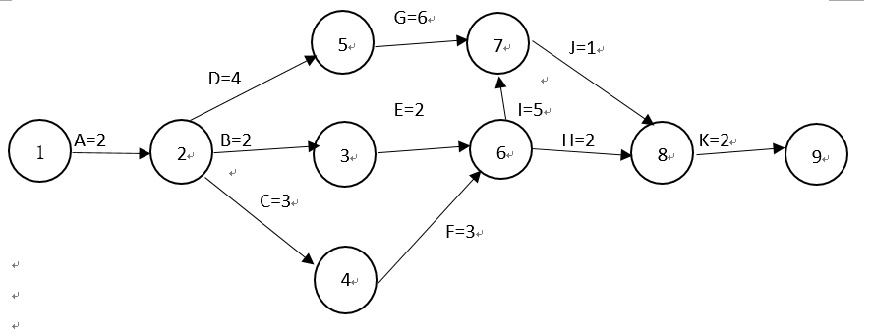

Path 1: A-D-G-J-K Length=15

Path 2: A-B-E-H-K Length=10

Path 3: A-B-E-I-J-K Length=14

Path 4: A-C-F-H-K Length=12

Path 5: A-C-F-I-J-K Length=16

Path A-C-F-I-J-K is the critical path for this project,is 16 days.

完成项目最短时间为16天

F

E

G

A

Start

C

B

D

H

J

K

I

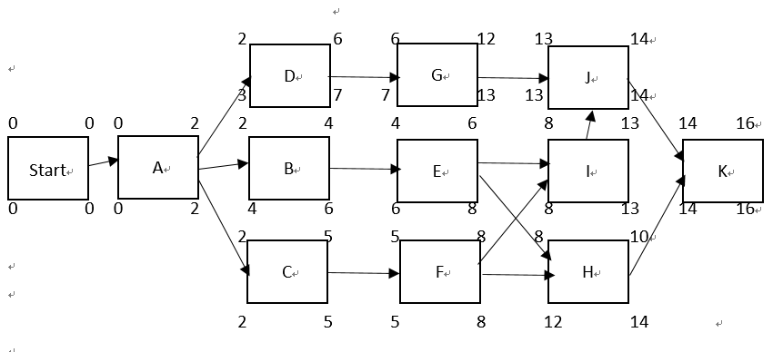

B的自由浮动时间是2天，总浮动时间是2天

F的自由浮动时间是4天，总浮动时间是0天

J的自由浮动时间是0天，总浮动时间是0天

6.

