Jacob Stout

2/24/2023

PostgresSQL & AWS Connection Information

For our project, we will be using PostgresSQL as the back-end. We want to create a database instance in AWS so that we are all able to connect to PostgresSQL, and have a cloud-based save for easy access. This is important because we do not need to maintain a database server. AWS allows for automated backups, options to scale up, etc. In essence, it is an important tool to host the database of our web application.

AWS needs access to our Postgres database to make direct modifications in the database. The tables of the database may require changes. It is not possible to have shell access via AWS RDS, so there are different ways to connect. We can connect using pgAdmin or via psql. Both require a separate download of an application to do this task.

For this demonstration, we are going to use pgAdmin. Make sure to download PostgreSQL in advance before going to these steps – but if you are not working on the backend, you can download pgAdmin separately as you do not need PostgreSQL to connect to the database.

Make sure that pgAgent is downloaded.

Once pgAgent is downloaded, open the application.

1. Here is the information we need:
2. Endpoint: database-2.cheiebzedtfg.us-east-1.rds.amazonaws.com
3. Port: 5432
4. Choose add server from the file menu. (Or Register Server)
5. In the new server registration dialog box, enter the DB instance endpoint (see step 2) in the host box.
6. The username is postgres and the password is seniorproject.
7. 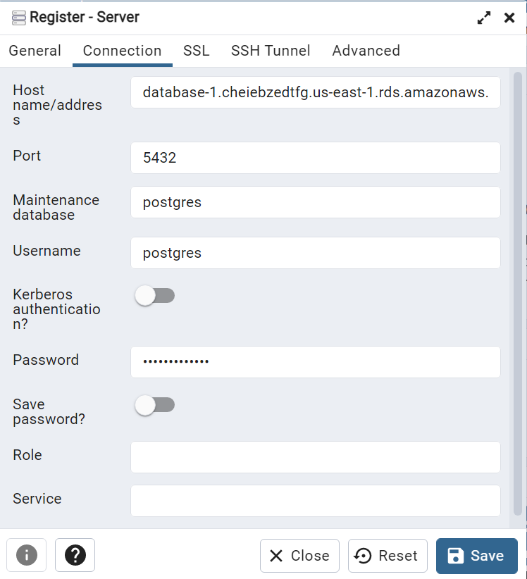
8. Choose Save
9. In the Object browser, expand **Server Groups.** Choose the server and then the database name that should be listed.
10. From here, you can choose the plugin icon and choose PSQL Console. The psql command window opens for our database.
11. \q closes this window.