**1. The output of the provided pair of images:**

After running main.m, the output is generated.

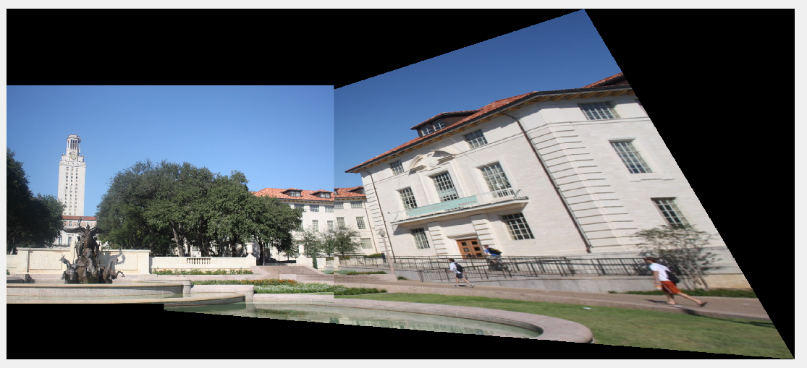

Named “output1.png” in file.

**2.**

**The two self-chosen images:**

1.jpg

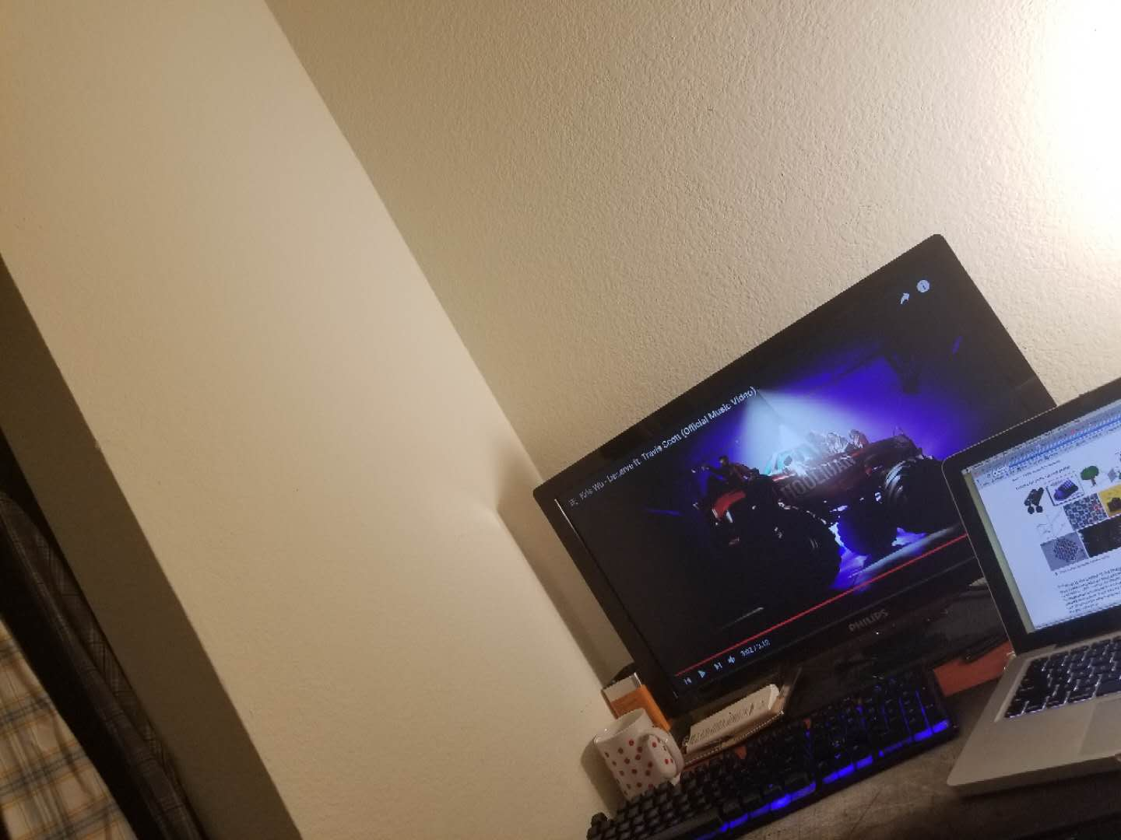

2.jpg

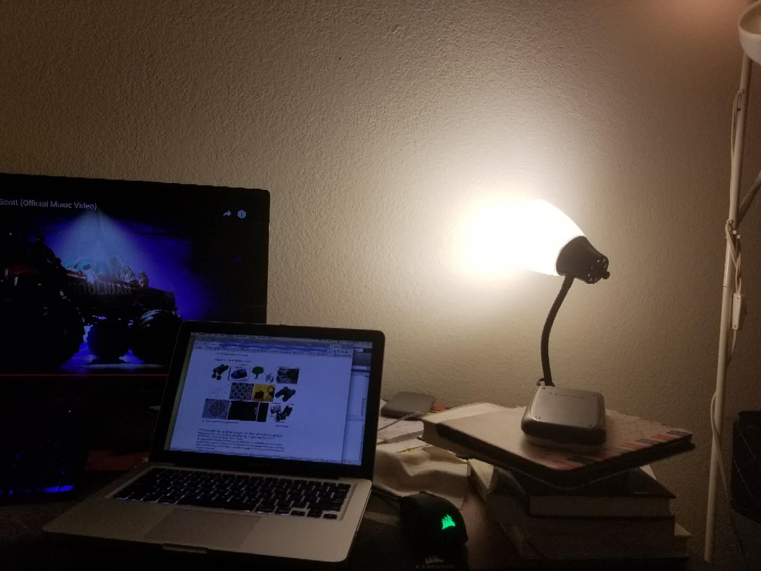

**The output of the self-chosen pair of images:**

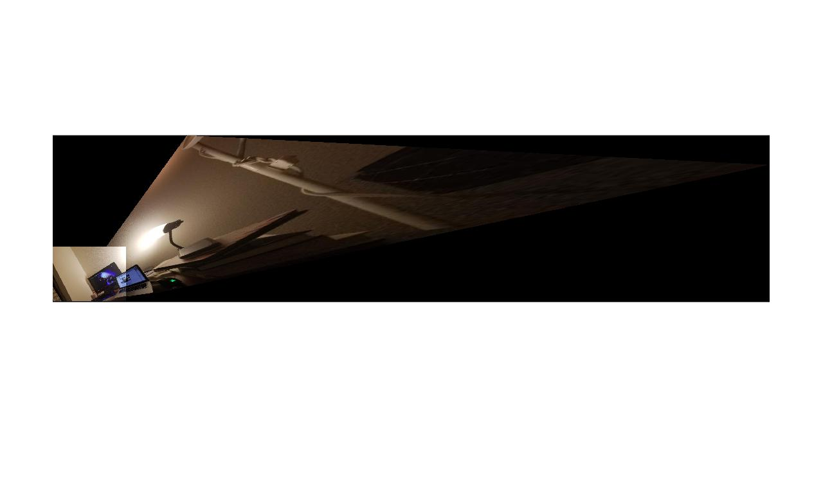

Output is named “output2.jpg” in file.

**3. The output of billboard.**

Input images:

board.jpg

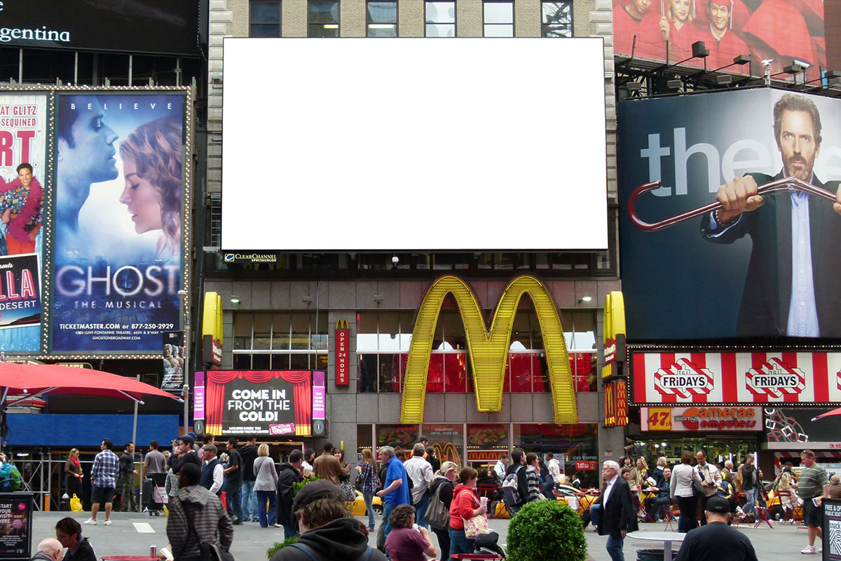

trump.png

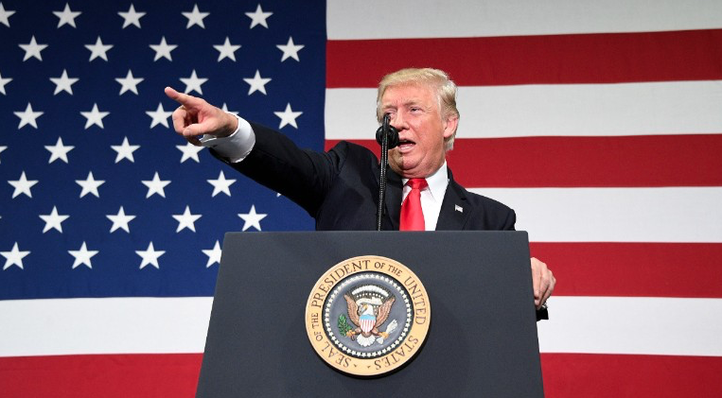

After running billboard.m, get output “output3.jpg” in file.

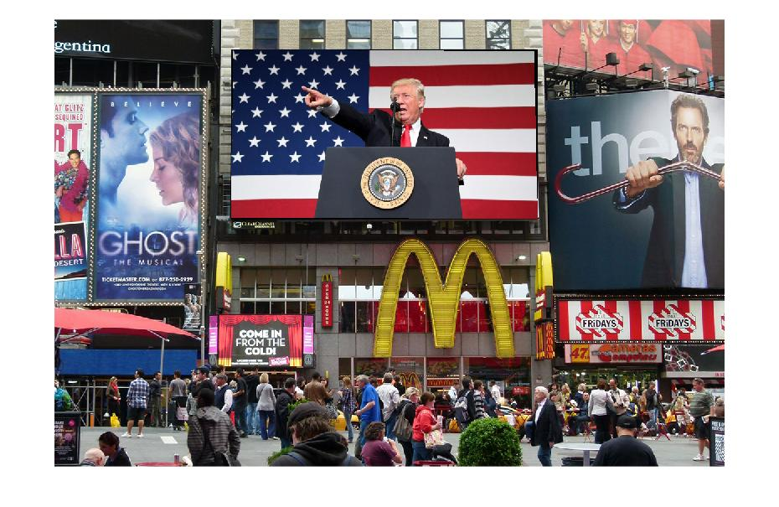

**Extra Credit 1:**

With input images as uttower1.jpg and uttower2, running extra1.m

Outputs are as following:

temp1.jpg

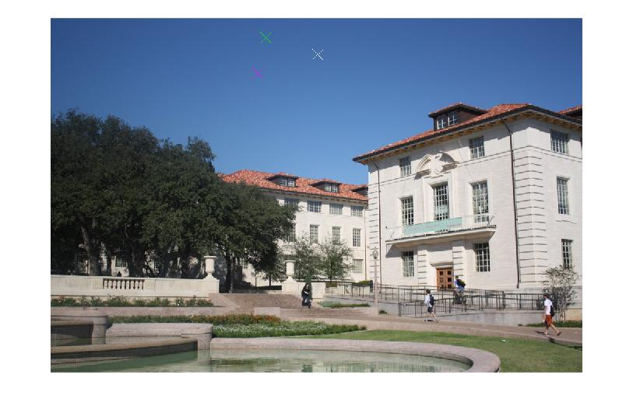

temp2 .jpg

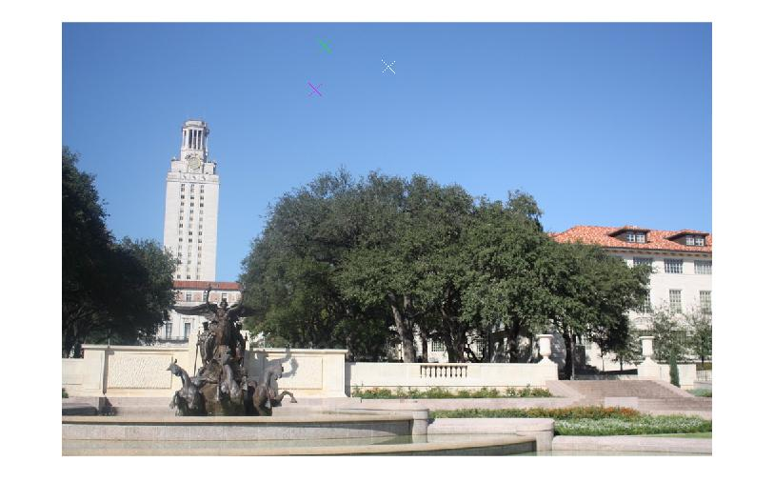

The marks have same color are the top 3 pairs of corresponding interest points. I have to say it works pretty well since from a human eyes’ perspective it seems impossible to pick these 3 pairs of points for image matching.

**Extra Credit 3:**

Running extra3.m,

The input image floor.jpg in file:

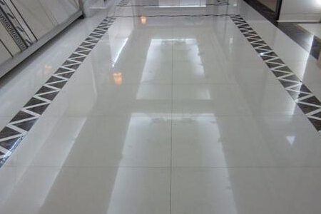

The output image “extra3ouput.jpg” after running extra3.m:

