

Corporate Site - Company
Test Plan

Version <1.0>

Revision History
Date | Version | Description | Author
12/1 | 1.0 | Initial Version | Danny Rosen

Table of Contents
Overview
Introduction
Definitions, Acronyms and Abbreviations
References
Testing Environment
Setup Information (general Pre-conditions)
Section
Company - http://buddymedia.com/company - Test Cases
Content verification test
Scenario
Table content verification Test
Scenario
Table Cell Randomization Test
Scenario
Company - About Us: http://buddymedia.com/company - Test Cases
Timeline controls test
Scenario
Timeline display test
Scenario
“About Us” content verification
Scenario
Company - Awards: http://buddymedia.com/company/awards - Test Cases
Banner content verification test
Scenario
Page content verification test
Scenario
Company - Culture: http://buddymedia.com/company/awards - Test Cases
Banner content verification test
Scenario
Page content verification test
Scenario

Overview

Introduction
  - The purpose of this document is to provide configuration instructions and test guidance with regards to the ‘Company’ section of the Buddy Media website.

Definitions, Acronyms and Abbreviations
  - Cell - Pertaining to image squares on the /company page. IE: Each square is a “cell”

References
  - This subsection should provide a complete list of all documents referenced elsewhere in the Test Cases.

Testing Environment
The following operating systems & browser combinations will be tested:
Operating System | Browser
Mac Osx (10.6.8) | Firefox (Stable)  Safari (Stable)  Chrome (Stable)
Windows XP | Internet Explorer (7)  Internet Explorer (8)
Windows 7 | Internet Explorer (9)

Setup Information (general Pre-conditions)

Git setup:
- Login to dev.buddymedia.com
- Change directory to your webserver root e.g. > cd ~/www/Corp-Site
- Reset and lose any changes > git reset –hard
- Checkout master > git check out master
- Pull any changes from master > git pull origin master
- Checkout the branch you want to test e.g. > git checkout –b <bug|fea>-<fogbugz number>
- Pull down changes for the new branch > git pull origin <bug|fea>-<fogbugz number>
- Navigate your browser to the appropriate URL

Section

Company - http://buddymedia.com/company - Test Cases

Content verification test
  - The goal of this test is to confirm that the content on the page is as expected

Scenario
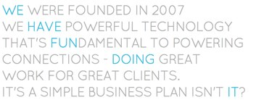
The above image should exist below the navigation bar and above the image cells

Table content verification Test
  - The images on the bottom of the page exist as a 4x2 table. Each cell in this table contains an image, a link call out and a color. The color and call out links are static. This test defines how they should appear.
  - Cell #’s start at the top left corner with the value of 1 and increment by one when going to the right. After the first row is completed the second row’s bottom left corner cell contains the value of 5 and increments by one when going to the right.

Scenario

Cell # | Color | Call out | Link URL | Sign Off
1 |  | Become a Buddy Find out how > | http://buddymedia.com/careers
2 |  | Company Culture Learn More > | http://buddymedia.com/company/culture
3
4 |  | What We’re All About Find Out > | http://buddymedia.com/company/about-us
5 |  | Feelin’ The Love Our Awards > | http://buddymedia.com/company/awards
6
7 |  | The Team Meet Them > | http://buddymedia.com/company/team
8 |  | Where To Find Us Our Locations > | http://buddymedia.com/company/locations

Table Cell Randomization Test
  - The images on the bottom of the page exist as a 4x2 table. Each cell in this table contains an image. Each image has the ability to randomly change. This test looks to confirm the images randomize.

Scenario

Case | Expected Result | Sign Off
Page is loaded. | Table contains a 4x2 table.  Table’s cell contents contains 8 different photos in each cell
Page is reloaded | Table contains a 4x2 table.  Table’s cell contents contains 8 different photos in each cell. >= 1 of these photos should be different
Page is reloaded | Table contains a 4x2 table.  Table’s cell contents contains 8 different photos in each cell. >= 1 of these photos should be different

Company - About Us: http://buddymedia.com/company - Test Cases

Timeline controls test
  - The goal of this test is to confirm that the control in the timeline accurately function

Scenario

Case | Expected Result | Sign Off
Do not hover over right-most green arow | Slider should not slide
Do not hover over left-most green arow | Slider should not slide
Pre-condition: “Jan” of the “2007” year is viewable on the left side of the slider.  Mouse pointer is over “July” in the “2007” year.  Move mouse pointer to the right until it is above the “D” in the “December” “2007” year. | Once mouse pointer is above “D” in “December” slider should slide to the right.  Slide should continue until “December 2011” is displayed
Pre-condition: “Jan” of the “2007” year is viewable on the left side of the slider.  Continue to move mouse pointer to the right of the slider. | A crosshair should appear.  As tester continues to move crosshair to the right the slide speed should increase  Slide should continue until “December 2011” is displayed
Pre-condition: “Dec” of the “2011” year is viewable on the left side of the slider.  Mouse pointer is over “July” in the “2011” year.  Move mouse pointer to the left until it is above the “B” in the “Feb” “2011” year. | Once mouse pointer is above “B” in “Feb” slider should slide to the left.  Slide should continue until “Jan” of the “2007” year is displayed
Pre-condition: “Dec” of the “2011” year is viewable on the left side of the slider.  Continue to move mouse pointer to the left of the slider. | A crosshair should appear.  As tester continues to move crosshair to the left the slide speed should increase  Slide should continue until “Jan” of the “2007” year is displayed
Pre-condition: “Jan” of the “2007” year is viewable on the left side of the slider.  Hold a click on the right-most green arrow for 2 seconds. | Slider should slide to the right at an fast speed  After click is released slider should slide at a slower speed
Pre-condition: “Dec” of the “2011” year is viewable on the left side of the slider.  Hold a click on the left-most green arrow for 2 seconds. | Slider should slide to the left at an fast speed  After click is released slider should slide at a slower speed

Timeline display test
  - The goal of this test is to confirm that the display of the timeline

Scenario
Assure the timeline displays the following images (Note: These images are not stitched together. However their content if stitched together should be what the slider displays):
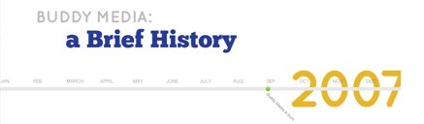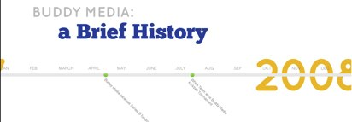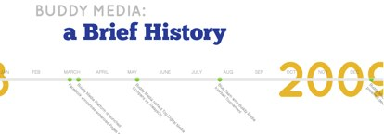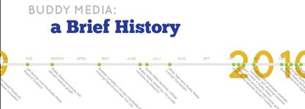

“About Us” content verification
  - The goal of this test is to confirm that the display of the content is accurate

Scenario
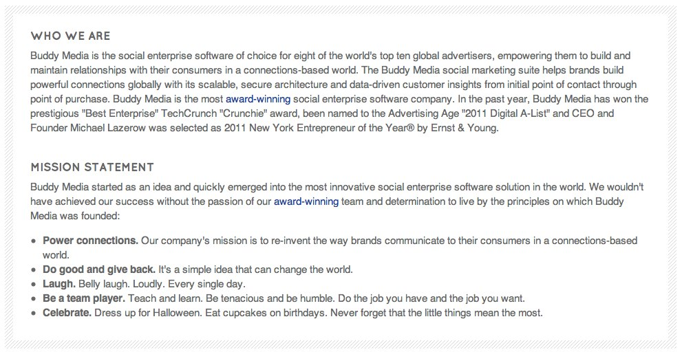

Content | Link | Sign Off
“award-winning” | http://buddymedia.com/company/awards


Content | Link | Sign Off
“Check out our awards page > “ | http://buddymedia.com/company/awards

Content | Link | Sign Off
“< Locations” | http://buddymedia.com/company/locations
“Awards >” | http://buddymedia.com/company/awards

Company - Awards: http://buddymedia.com/company/awards - Test Cases

Banner content verification test
  - The goal of this test is to confirm that the banner displays as designed

Scenario
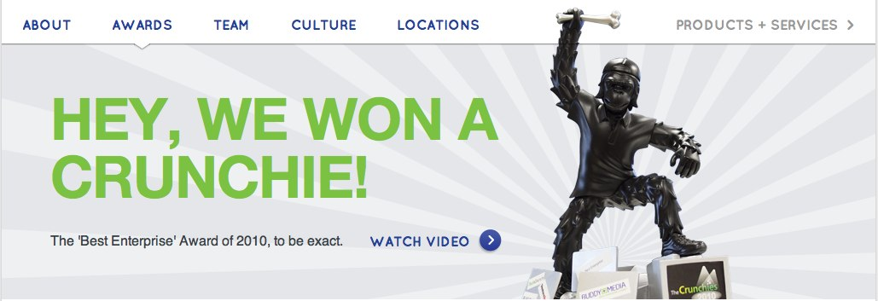

Content | Link | Sign Off
“Watch Video >” | https://www.facebook.com/video/video.php?v=568191932313

Page content verification test
  - The goal of this test is to confirm that the page content displays as designed

Scenario
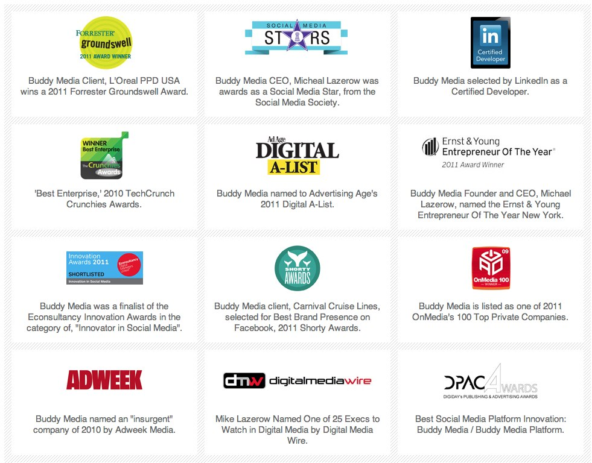
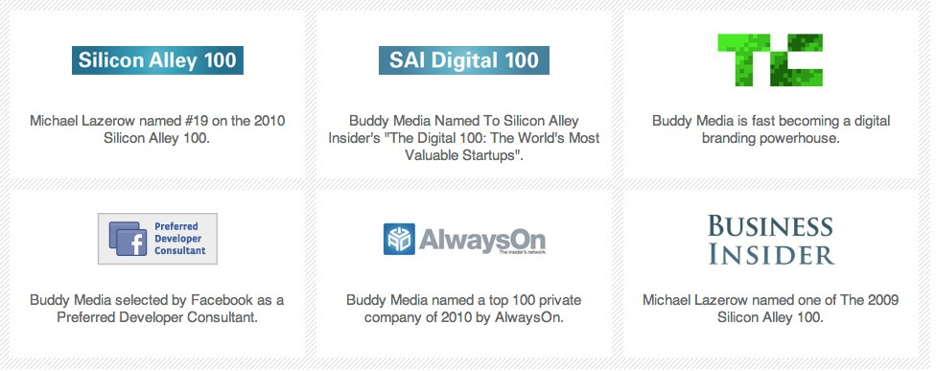



Content | Link | Sign Off
“Meet our team >” | http://buddymedia.com/company/team

Content | Link | Sign Off
“< About” | http://buddymedia.com/company/about-us
“Team>” | http://buddymedia.com/company/team

Company - Culture: http://buddymedia.com/company/awards - Test Cases

Banner content verification test
  - The goal of this test is to confirm that the banner displays as designed

Scenario

On click of the video button, the video should play.

Content | Link | Sign Off
Become a Buddy > | http://buddymedia.com/careers

Page content verification test
  - The goal of this test is to confirm that the page displays as designed

Scenario
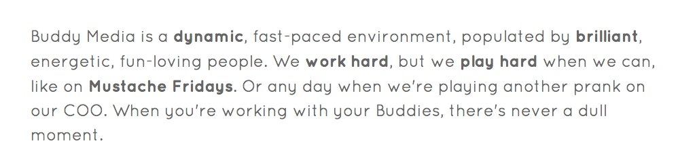
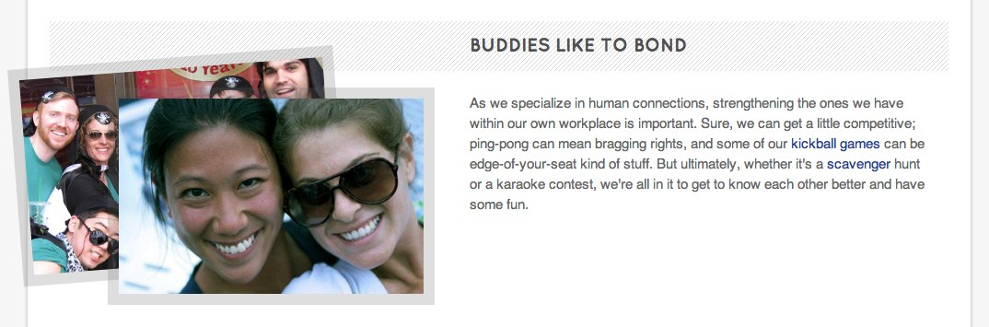

Content | Link | Sign Off
Kickball games | https://www.facebook.com/video/video.php?v=10100513766215189
Scavenger | https://www.facebook.com/media/set/?set=a.10150332048907139.389073.40373497138&type=1

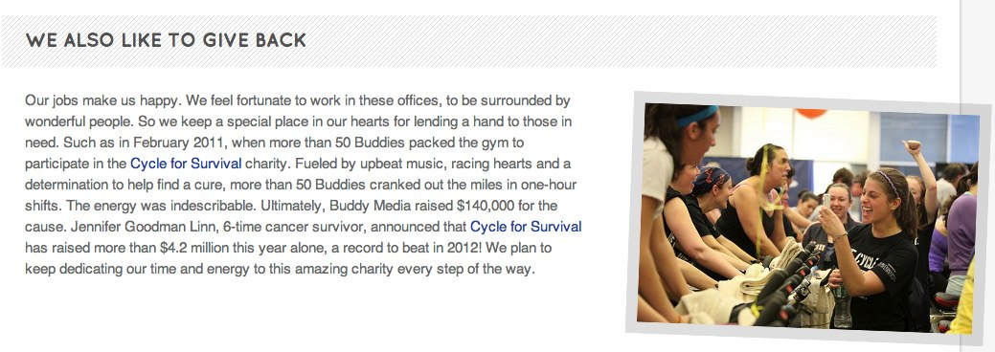

Content | Link | Sign Off
“Cycle for Survival” | https://www.facebook.com/media/set/?set=a.10150186123247139.342974.40373497138&type=1
“Cycle for Survival”(2) | http://mskcc.convio.net/site/PageServer?pagename=cfs_home

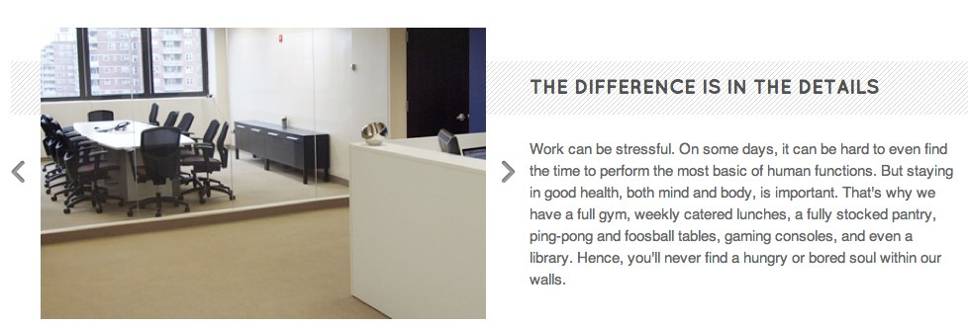



Content | Link | Sign Off
“Buddy Media University” | http://buddymedia.com/services/buddy-media-university
“Products” | http://buddymedia.com/products



Content | Link | Sign Off
“Browse Careers >” | http://buddymedia.com/careers

Content | Link | Sign Off
“< Team” | http://buddymedia.com/careers
“Locations >” | http://buddymedia.com/company/locations

