

Corporate Site - Home Page
Test Plan

Version <1.0>

Revision History
Date | Version | Description | Author | Sign off
11/28/2011 | 1.0 | Initial Version | Danny Rosen
11/30/2011 | 1.1 | Added and modified content | “”
12/2/2011 | 1.2 | Added sign off element to tables | “”

Table of Contents
Overview
Introduction
Definitions, Acronyms and Abbreviations
References
Testing Environment
Setup Information (general Pre-conditions)
Home Page
Test Cases for: http://www.buddymedia.com
Banner Controls Test
Scenario
Middle Banner Controls Test
Scenario
Social Hover Tests
Scenario
Top Banner Content Verification
Scenario
Middle Banner Content Verification
Scenario
“The Newsroom” Content Verification
Scenario

Overview

Introduction
  - The purpose of this document is to provide configuration instructions and test guidance with regards to the ‘Home Page’ section of the Buddy Media website.

Definitions, Acronyms and Abbreviations
  - Pagination - Arrows and dots that control what “page” is displayed in the banner.

References
  - This subsection should provide a complete list of all documents referenced elsewhere in the Test Cases.

Testing Environment
The following operating systems & browser combinations will be tested:
Operating System | Browser
Mac Osx (10.6.8) | Firefox (Stable)  Safari (Stable)  Chrome (Stable)
Windows XP | Internet Explorer (7)  Internet Explorer (8)
Windows 7 | Internet Explorer (9)

Setup Information (general Pre-conditions)

Git setup:
- Login to dev.buddymedia.com
- Change directory to your webserver root e.g. > cd ~/www/Corp-Site
- Reset and lose any changes > git reset –hard
- Checkout master > git check out master
- Pull any changes from master > git pull origin master
- Checkout the branch you want to test e.g. > git checkout –b <bug|fea>-<fogbugz number>
- Pull down changes for the new branch > git pull origin <bug|fea>-<fogbugz number>
- Navigate your browser to the appropriate URL

Home Page

Test Cases for: http://www.buddymedia.com

Banner Controls Test
  - This test is to assure the controls on the home page function as expected.

Scenario

Case | Expected result | sign off
Click pagination arrow on right side of banner | Banner should execute a slide animation.  Banner image should change.  Current pagination dot should turn gray.  Next pagination dot in series should turn blue.
Click pagination arrow on left side of banner | Banner should execute a slide animation.  Banner image should change.  Current pagination dot should turn gray.  Previous pagination dot in series should turn blue.
Select a random pagination dot | Banner should execute a slide animation.  Banner image should change.  Current pagination dot should turn gray.  Clicked pagination dot in series should turn blue.
Pre-condition: Left most pagination dot in series is selected  Click pagination arrow on the left side of the banner | Banner should execute a slide animation skipping all images in series  Banner image should change.  Current pagination dot should turn gray.  Right most pagination dot in series should turn blue
Pre-condition: Right most pagination dot in series is selected  Click pagination arrow on the right side of the banner | Banner should execute a slide animation skipping all images in series  Banner image should change.  Current pagination dot should turn gray.  Left most pagination dot in series should turn blue
Pre-condition: Left most pagination dot is selected  Click left most pagination dot | The URL should read: http://buddymedia.com/#1
Each dot after the left most pagination dot should add an additional value to the url:  Click the 2nd most pagination dot | The URL should read: http://buddymedia.com/#2
Each dot after the left most pagination dot should add an additional value to the url:  Click the 3rd most pagination dot | The URL should read: http://buddymedia.com/#3
Each dot after the left most pagination dot should add an additional value to the url:  Click the 4th most pagination dot | The URL should read: http://buddymedia.com/#4
Each dot after the left most pagination dot should add an additional value to the url:  Click the 5th most pagination dot | The URL should read: http://buddymedia.com/#5

Middle Banner Controls Test
  - This test is to assure the controls on the home page function as expected.

Scenario

Case | Expected result | Sign off
Pre-condition: What we offer is selected  Click “What We Offer” | Nothing should change
Pre-condition: What we offer is selected  Click “How it works” | Banner should execute a slide animation.  Banner image should change.  Current indicator should change to “How it works”.  “What we offer” should lose background and look like “Who Uses it.”.
Pre-condition: What we offer is selected  Click “Who uses it” | Banner should execute a slide animation.  Banner image should change.  Current indicator should change to “Who Uses it”.  “What we offer” should lose background and look like “How it works.”.
All items in the series should function as above. | Banner should execute a slide animation skipping all images in series  Banner image should change.  Current selected menu item should lose background  Clicked menu item should lose background

Social Hover Tests
  - This test is to assure the controls on the home page function as expected.

Scenario

Case | Expected Result | Sign off
Hover over each social link | Assure an underline displays for each

Top Banner Content Verification
  - This test is to assure the contents on the home page banner is as expected.

Scenario
The following banner images should exist:
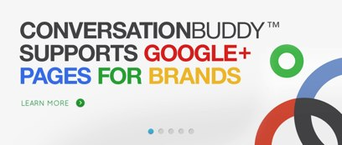

Pagination position | “Learn More” link url | Sign off
1 | http://buddymedia.com/products/conversationbuddy/google-plus

Pagination position | “Learn More” link url | Sign off
2 | http://buddymedia.com/products

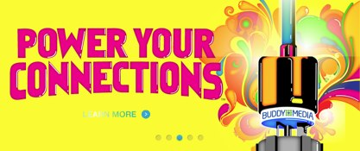
Pagination position | “Learn More” link url | Interactivity Case | Interactivity Result | Sign off
3 | http://buddymedia.com/products | Mouse over “Learn More” | “Learn More” should provide a horizontal, sweeping glow animation
 |  | Mouse over Plug | Plug should animate, displaying a push down / plug in motion.

Pagination position | “Learn More” link url | Sign off
4 | http://buddymedia.com/resources/events


Pagination position | “Download White Paper” link url | Sign off
5 | http://forms.buddymedia.com/whitepaper-form_guide-to-social-commerce-power-connections-to-generate-revenue.html

Middle Banner Content Verification
  - This test is to assure the contents on the home page banner is as expected.

Scenario
The following middle banner images should exist:

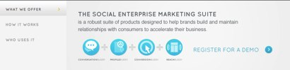

Pagination position | “Register for a demo” link url | Sign off
1 | http://forms.buddymedia.com/demo-form.html
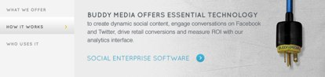
Pagination position | “Social Enterprise Software” link url | Sign off
2 | http://buddymedia.com/products
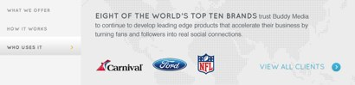
Pagination position | “View All Clients” link url | Sign off
3 | http://buddymedia.com/clients

“The Newsroom” Content Verification
  - This test is to assure the contents on the home page banner is as expected.

Scenario
The newsroom section should look like below (Note: These items will eventually become dynamic)
