

Corporate Site - Products
Test Plan

Version <1.0>

Revision History
Date | Version | Description | Author
11/29/2011 | 1.0 | Initial version | Danny Rosen

Table of Contents
Overview
Introduction
Definitions, Acronyms and Abbreviations
References
Testing Environment
Setup Information (general Pre-conditions)
Products
All Products - Test Cases
The Billboard Content Verification
Scenario
The Products Content Verification
Scenario
Product Features Content Verification
Scenario
Internal Ad Content Verification
Scenario
ConversationBuddy - Test Cases
The Billboard Content Verification
Scenario
Product Usage Content Verification
Scenario
Product Features Content Verification
Scenario
Internal Ad Content Verification
Scenario
Product Navigation Content Verification
Scenario
ProfileBuddy - Test Cases
The Billboard Content Verification
Scenario
Product Usage Content Verification
Scenario
Product Features Content Verification
Scenario
Internal Ad Content Verification
Scenario
Product Navigation Content Verification
Scenario
ConversionBuddy - Test Cases
The Billboard Content Verification
Scenario
Product Usage Content Verification
Scenario
Product Features Content Verification
Scenario
Internal Ad Content Verification
Scenario
Product Navigation Content Verification
Scenario
ReachBuddy - Test Cases
The Billboard Content Verification
Scenario
Product Usage Content Verification
Scenario
ReachBuddy Demo Functional Verification
Scenario
Product Features Content Verification
Scenario
Internal Ad Content Verification
Scenario
Product Navigation Content Verification
Scenario
Analytics - Test Cases
The Billboard Content Verification
Scenario
Product Usage Content Verification
Scenario
Product Features Content Verification
Scenario
Internal Ad Content Verification
Scenario
Product Navigation Content Verification
Scenario
Dashboard - Test Cases
The Billboard Content Verification
Scenario
Product Usage Content Verification
Scenario
Product Features Content Verification
Scenario
Internal Ad Content Verification
Scenario
Product Navigation Content Verification
Scenario

Overview

Introduction
  - The purpose of this document is to provide configuration instructions and test guidance with regards to the ‘Section’ section of the Buddy Media website.

Definitions, Acronyms and Abbreviations
  - N/a

References
  - N/a

Testing Environment
The following operating systems & browser combinations will be tested:
Operating System | Browser
Mac Osx (10.6.8) | Firefox (Stable)  Safari (Stable)  Chrome (Stable)
Windows XP | Internet Explorer (7)  Internet Explorer (8)
Windows 7 | Internet Explorer (9)

Setup Information (general Pre-conditions)

Git setup:
- Login to dev.buddymedia.com
- Change directory to your webserver root e.g. > cd ~/www/Corp-Site
- Reset and lose any changes > git reset –hard
- Checkout master > git check out master
- Pull any changes from master > git pull origin master
- Checkout the branch you want to test e.g. > git checkout –b <bug|fea>-<fogbugz number>
- Pull down changes for the new branch > git pull origin <bug|fea>-<fogbugz number>
- Navigate your browser to the appropriate URL

Products

All Products - Test Cases

The Billboard Content Verification
  - This test is to assure the contents in The Billboard are as expected.

Scenario
The Billboard section should look like below:
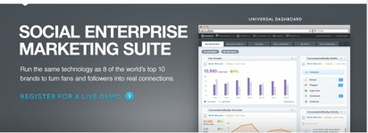
“Register for a live demo” link to http://forms.buddymedia.com/demo-form.html

The Products Content Verification
  - This test is to assure the contents in The Products are as expected.

Scenario
The Products section should look like below:
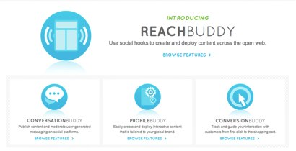
“ReachBuddy - Browse Features >” link to http://buddymedia.com/products/reachbuddy
“ConversationBuddy - Browse Features >” link to http://buddymedia.com/products/conversationbuddy
“ProfileBuddy - Browse Features >” link to http://buddymedia.com/products/profilebuddy
“ConversionBuddy - Browse Features >” link to http://buddymedia.com/products/conversionbuddy

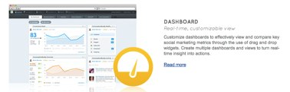
“Dashboard - Read Now” link to http://buddymedia.com/products/dashboard

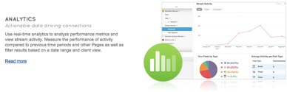
“Analytics - Read Now” link to http://buddymedia.com/products/analytics

Product Features Content Verification

Scenario
Product Features section should look like below:
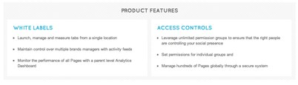

Internal Ad Content Verification

Scenario
Internal Ad section should look like below:

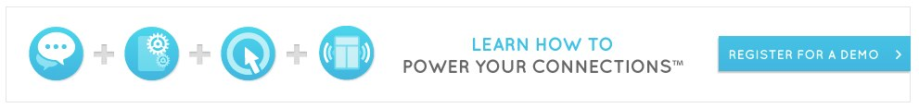
“Register for a demo” link to http://forms.buddymedia.com/demo-form.html

ConversationBuddy - Test Cases

The Billboard Content Verification
  - This test is to assure the contents in The Billboard are as expected.

Scenario
The Billboard section should look like below:
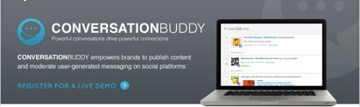
“Register for a live demo” link to http://forms.buddymedia.com/demo-form.html

Product Usage Content Verification
  - This test is to assure the contents in Product Usage are as expected.

Scenario
Product Usage section should look like below:
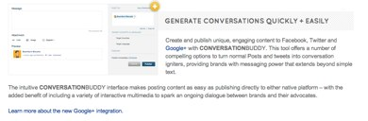
“Learn more about the new Google+ integration.” link to http://www.buddymedia.com/products/conversationbuddy/google-plus
On click of 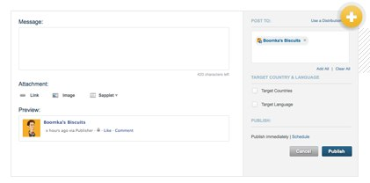image should expand into large lightbox. Lightbox can be exited by pressing escape or clicking X

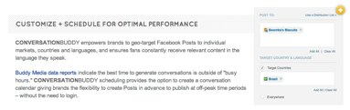
“Buddy Media data reports” link to http://forms.buddymedia.com/whitepaper-form_review-strategies-for-effective-facebook-wall-posts_retail.html
On click of 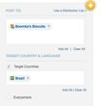image should expand into large lightbox. Lightbox can be exited by pressing escape or clicking X

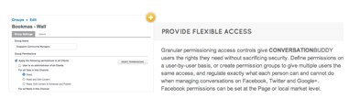
On click of 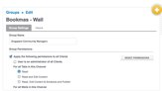image should expand into large lightbox. Lightbox can be exited by pressing escape or clicking X

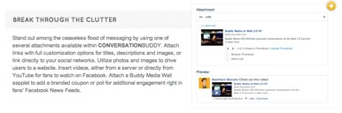
On click of 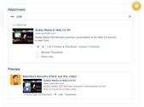image should expand into large lightbox. Lightbox can be exited by pressing escape or clicking X

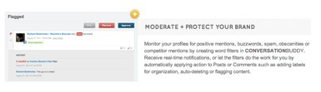
On click of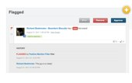image should expand into large lightbox. Lightbox can be exited by pressing escape or clicking X

Product Features Content Verification
  - This test is to assure the contents in Product Features are as expected.

Scenario
Product Features section should look like below:
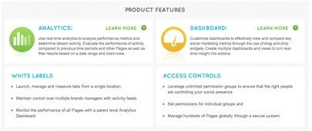
“Analytics - Learn More” - link to http://buddymedia.com/products/analytics
“Dashboard - Learn More” - link to http://buddymedia.com/products/dashboard

Internal Ad Content Verification

Scenario
Internal Ad section should look like below:

“Register for a demo” link to http://forms.buddymedia.com/demo-form.html

Product Navigation Content Verification

Scenario
Product Navigation section should look like below:

“< Dashboard” link to http://buddymedia.com/products/dashboard
“ProfileBuddy >” link to http://buddymedia.com/products/profilebuddy

ProfileBuddy - Test Cases

The Billboard Content Verification
  - This test is to assure the contents in The Billboard are as expected.

Scenario
The Billboard section should look like below:

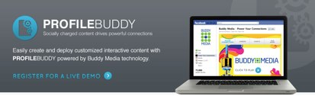
“Register for a live demo > “ link to http://forms.buddymedia.com/demo-form.html

Product Usage Content Verification
  - This test is to assure the contents in Product Usage are as expected.

Scenario
Product Usage section should look like below:

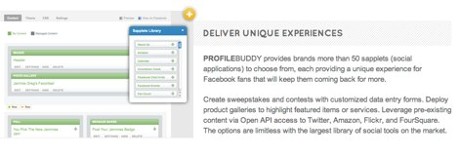
On click of 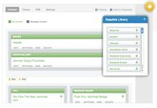image should expand into large lightbox. Lightbox can be exited by pressing escape or clicking X

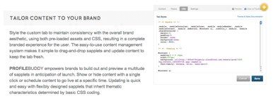
On click of 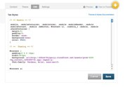image should expand into large lightbox. Lightbox can be exited by pressing escape or clicking X

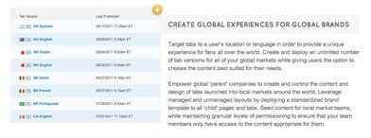
On click of 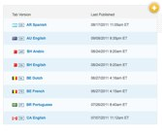image should expand into large lightbox. Lightbox can be exited by pressing escape or clicking X

Product Features Content Verification
  - This test is to assure the contents in Product Features are as expected.

Scenario
Product Features section should look like below:
“Analytics - Learn More” - link to http://buddymedia.com/products/analytics
“Dashboard - Learn More” - link to http://buddymedia.com/products/dashboard

Internal Ad Content Verification

Scenario
Internal Ad section should look like below:

“Register for a demo” link to http://forms.buddymedia.com/demo-form.html

Product Navigation Content Verification

Scenario
Product Navigation section should look like below:

“< ConversationBuddy” link to http://buddymedia.com/products/dashboard
“ConversionBuddy >” link to http://buddymedia.com/products/profilebuddy

ConversionBuddy - Test Cases

The Billboard Content Verification
  - This test is to assure the contents in The Billboard are as expected.

Scenario
The Billboard section should look like below:
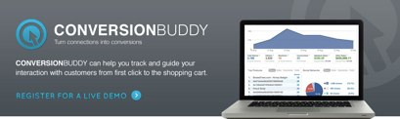
“Register for a live demo > “ link to http://forms.buddymedia.com/demo-form.html

Product Usage Content Verification
  - This test is to assure the contents in Product Usage are as expected.

Scenario
Product Usage section should look like below:

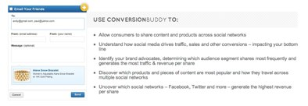
On click of image 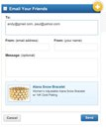should expand into large lightbox. Lightbox can be exited by pressing escape or clicking X

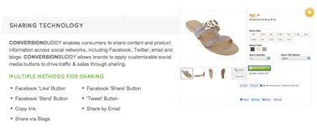
On click of image 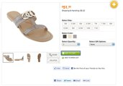 should expand into large lightbox. Lightbox can be exited by pressing escape or clicking X

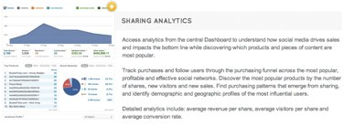
On click of 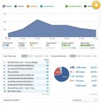image should expand into large lightbox. Lightbox can be exited by pressing escape or clicking X

Product Features Content Verification
  - This test is to assure the contents in Product Features are as expected.

Scenario
Product Features section should look like below:
“Analytics - Learn More” - link to http://buddymedia.com/products/analytics
“Dashboard - Learn More” - link to http://buddymedia.com/products/dashboard

Internal Ad Content Verification

Scenario
Internal Ad section should look like below:

“Register for a demo” link to http://forms.buddymedia.com/demo-form.html

Product Navigation Content Verification

Scenario
Product Navigation section should look like below:

“< ProfileBuddy” link to http://buddymedia.com/products/profilebuddy
“ReachBuddy >” link to http://buddymedia.com/products/reachbuddy

ReachBuddy - Test Cases

The Billboard Content Verification
  - This test is to assure the contents in The Billboard are as expected.

Scenario
The Billboard section should look like below:

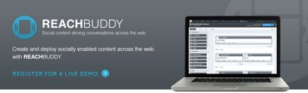
“Register for a live demo > “ link to http://forms.buddymedia.com/demo-form.html

Product Usage Content Verification
  - This test is to assure the contents in Product Usage are as expected.

Scenario
Product Usage section should look like below:

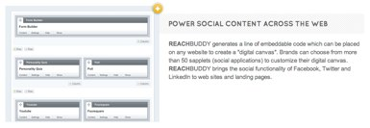
On click of image 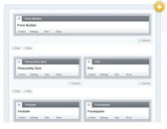should expand into large lightbox. Lightbox can be exited by pressing escape or clicking X

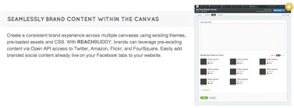
On click of 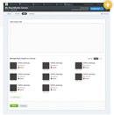image should expand into large lightbox. Lightbox can be exited by pressing escape or clicking X

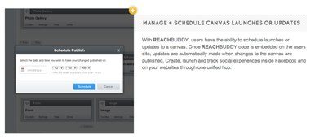
On click of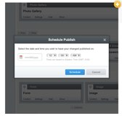 image should expand into large lightbox. Lightbox can be exited by pressing escape or clicking X

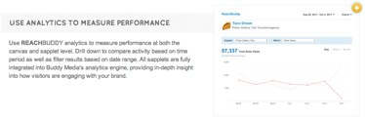
On click of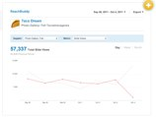 image should expand into large lightbox. Lightbox can be exited by pressing escape or clicking X

ReachBuddy Demo Functional Verification
  - This test is to assure the ReachBuddy sapplet functions as expected.

Scenario
ReachBuddy Demo section should look like below:
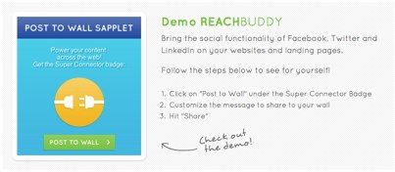

Case | Expected Result
Pre-Condition: User is logged into Facebook  Click “Post to Wall” | Post to your wall share window is displayed
Click Share | Tester’s Facebook timeline should now have a “badge” from the Reachbuddy sapplet. Displayed below: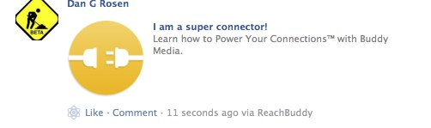

Product Features Content Verification
  - This test is to assure the contents in Product Features are as expected.

Scenario
Product Features section should look like below:
“Analytics - Learn More” - link to http://buddymedia.com/products/analytics
“Dashboard - Learn More” - link to http://buddymedia.com/products/dashboard

Internal Ad Content Verification

Scenario
Internal Ad section should look like below:

“Register for a demo” link to http://forms.buddymedia.com/demo-form.html

Product Navigation Content Verification

Scenario

Product Navigation section should look like below:

“< ConversationBuddy” link to http://buddymedia.com/products/conversionbuddy
“Analytics >” link to http://buddymedia.com/products/analytics

Analytics - Test Cases

The Billboard Content Verification
  - This test is to assure the contents in The Billboard are as expected.

Scenario
The Billboard section should look like below:

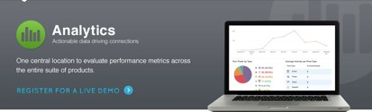
“Register for a live demo > “ link to http://forms.buddymedia.com/demo-form.html

Product Usage Content Verification
  - This test is to assure the contents in Product Usage are as expected.

Scenario
Product Usage section should look like below:

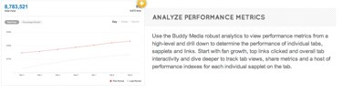
On click of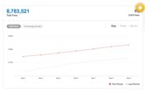image should expand into large lightbox. Lightbox can be exited by pressing escape or clicking X
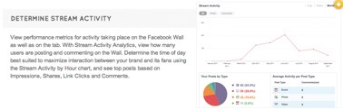
On click of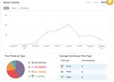image should expand into large lightbox. Lightbox can be exited by pressing escape or clicking X

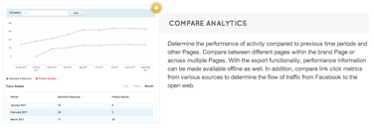
On click of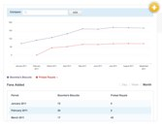image should expandinto large lightbox. Lightbox can be exited by pressing escape or clicking X

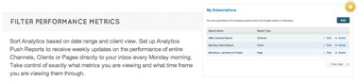
On click of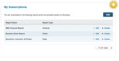image should expandinto large lightbox. Lightbox can be exited by pressing escape or clicking X

Product Features Content Verification
  - This test is to assure the contents in Product Features are as expected.

Scenario
Product Features section should look like below:
“Analytics - Learn More” - link to http://buddymedia.com/products/analytics
“Dashboard - Learn More” - link to http://buddymedia.com/products/dashboard

Internal Ad Content Verification

Scenario
Internal Ad section should look like below:

“Register for a demo” link to http://forms.buddymedia.com/demo-form.html

Product Navigation Content Verification

Scenario

Product Navigation section should look like below:

“< ReachBuddy” link to http://buddymedia.com/products/reachbuddy
“Dashboard >” link to http://buddymedia.com/products/dashboard

Dashboard - Test Cases

The Billboard Content Verification
  - This test is to assure the contents in The Billboard are as expected.

Scenario
The Billboard section should look like below:
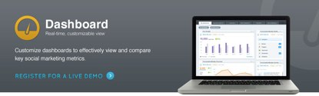

“Register for a live demo > “ link to http://forms.buddymedia.com/demo-form.html

Product Usage Content Verification
  - This test is to assure the contents in Product Usage are as expected.

Scenario
Product Usage section should look like below:

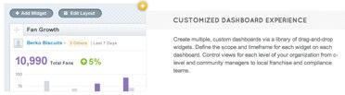
On click of 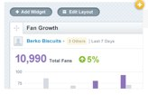image should expand into large lightbox. Lightbox can be exited by pressing escape or clicking X

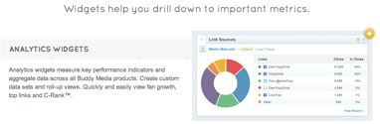
On click of 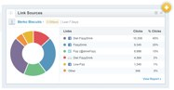image should expand into large lightbox. Lightbox can be exited by pressing escape or clicking X

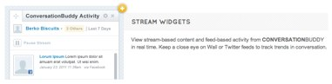
On click of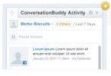image should expand into large lightbox. Lightbox can be exited by pressing escape or clicking X

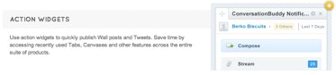
On click of 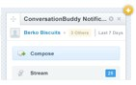image should expand into large lightbox. Lightbox can be exited by pressing escape or clicking X

Product Features Content Verification
  - This test is to assure the contents in Product Features are as expected.

Scenario
Product Features section should look like below:
“Analytics - Learn More” - link to http://buddymedia.com/products/analytics
“Dashboard - Learn More” - link to http://buddymedia.com/products/dashboard

Internal Ad Content Verification

Scenario
Internal Ad section should look like below:

“Register for a demo” link to http://forms.buddymedia.com/demo-form.html

Product Navigation Content Verification

Scenario

Product Navigation section should look like below:

“< Analytcs” link to http://buddymedia.com/products/analytics
“Dashboard >” link to http://buddymedia.com/products/conversationbuddy

