Enterprise application architecture

Continuous Assessment 2

Daniel Buckley

X00109141

## Tested On

|  |  |
| --- | --- |
| OS | Linux Fedora 64-bit |
| Virtual Disk Memory | 19.25 GB |
| Actual Disk Memory | 7.48 GB |
| CPU’s | 1 |

## Visualisations in R

### Ui Vs N

Ui stands for Utilisation. I calculated this from the output of my results.dat as it produced the percentage of idle time. To get the utilisation percentage I had to inverse this number. I completed this by subtracting 100 from the idle percentage. I then divided by 100 which gave me a number between 0 and 1.

I wrote a piece of code in R to show what happens to the CPU when sessions increase on it. This graph can be seen below:

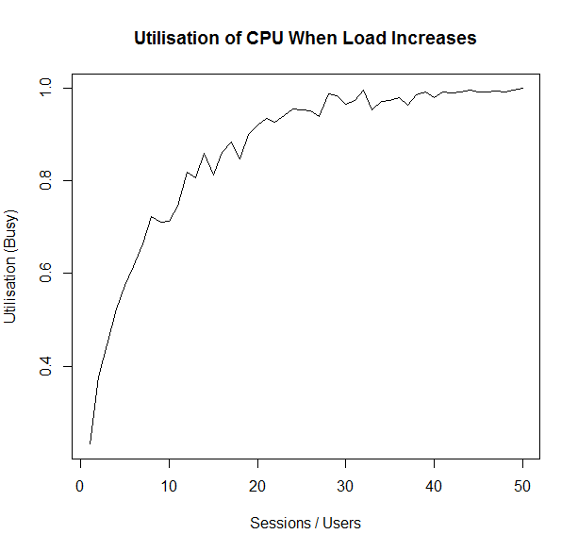

As sessions / users increase on the CPU, it becomes saturated and the idle time declines. When enough sessions / users are on the CPU, the CPU hits 100% utilisation which means it can’t handle any more requests on it.



### Di Vs N

Di stands for Service Demand. Service Demand is the amount of time a single transaction requires on a specific resource. To find this I calculated Di = Ui / X0. This gave me the following line chart:

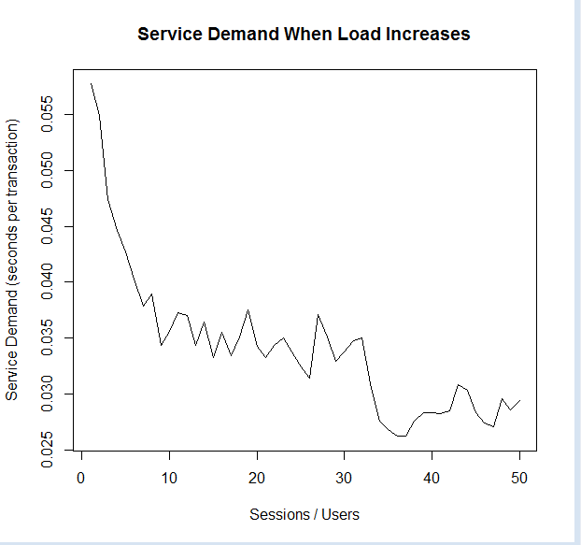

From this graph, I can see that when the number of sessions / users are on the CPU, the Service Demand decreases i.e. the seconds per transaction becomes lower.



### X0 Vs N

X0 is the throughput of the system. This was calculated as X0 = C0 / T. C0 is the completed transactions on the CPU while T is the time the system was monitored for. This produced a line graph which can be seen below:

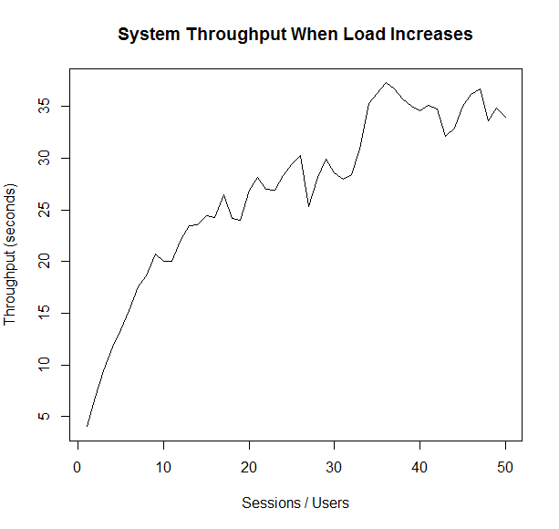

So, when the number of sessions / users rise so does the throughput of the system as more work is being completed by each user, therefore increasing the throughput and giving us the above result.



### R Vs N

R is the residence time of a transaction in the system. R is calculated as R = N / X0. This results in the below line chart:

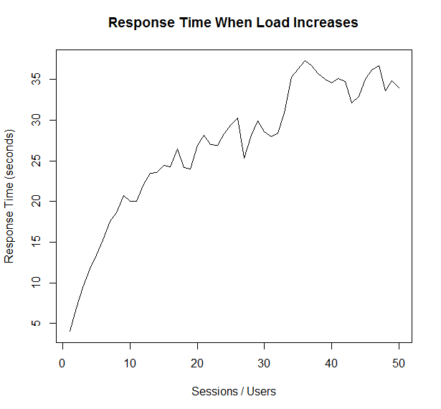

When the number of sessions / users starts increasing so does the response time meaning that transactions take a longer time to complete in the system.

