Niger Delta Gas Infrastructure Expansion (NDGIE) Project
PROJECT EXECUTION STRATEGY — ASSESS (EARLY) STAGE

Owner: Nigerian National Petroleum Company Ltd (NNPCL)
Operator: DeltaGas JV (NNPCL 60%, Seaway Energy 25%, PetroNova 15%)
Date: October 2025
Version: Rev 0

――――――――――――――――――――――――――――――――――――――――


Revision History
Rev. | Date | Description of Change | Prepared By | Reviewed By | Approved By
0 | Oct 2025 | Initial Issue (Assess Stage Draft) | PMC Team | Project Director | Steering Committee
1 | TBD | Final for Review | PMC Team | NNPCL Representative | DeltaGas JV Board

Table of Contents
Revision History 2
1. Executive Summary 5
Lifecycle Roadmap 5
2. Project Background and Objectives 5
3. Scope Definition 5
Integrated Block Flow Diagram 6
4. Execution Philosophy and Strategy 6
Execution Hierarchy (Vision → Field) 7
5. Governance and Assurance (Overview) 7
Governance Org Chart 7
6. Contracting and Procurement Strategy 8
Contracting Strategy Flow 8
7. HSSE and Sustainability 8
Bowtie (Major Accident Hazard) – Placeholder 9
8. Risk & Opportunity Management 9
Risk Heat Map 10
9. Security Management Plan 10
10. Schedule and Milestones 10
High-level Gantt Timeline 11
11. Cost Estimation & Project Controls 11
12. Change Management 12
Change Workflow 12
13. Quality Assurance & Technical Integrity 12
14. Stakeholder Engagement Plan 12
Stakeholder Influence–Interest Matrix 13
15. Information Management & Communication 13
16. Transition to Define (FEED) Stage 13
Appendices 14
A. Detailed Risk Register (Top 20) 14
B. Assess-Stage Deliverables List 15
C. Glossary & Abbreviations 15

1. Executive Summary
1.1 Purpose and Strategic Intent
The Niger Delta Gas Infrastructure Expansion (NDGIE) program is a national-scale initiative to monetize stranded associated and non-associated gas, cut routine flaring, and deliver reliable domestic energy to Nigeria’s industrial corridors. In the Assess Stage, NDGIE will confirm technical and commercial viability, define the execution and contracting model, de-risk environmental and stakeholder interfaces, and secure Gate-2 approval to mobilize FEED in Q3 2026.
The project directly supports the Decade of Gas and the Energy Transition Plan (ETP 2060) by converting otherwise flared gas into pipeline-spec gas for industry and power, as well as LPG/NGL and condensate products for local markets
1.2 Strategic Rationale and Value Proposition
- Decarbonization & Compliance: Monetizes gas currently flared, avoiding ~4.0 MtCO₂e/year and aligning with IFC/FMEnv expectations.
- Industrial Growth & Reliability: Delivers up to 500 MW of firm power to industrial hubs, improving grid stability and enabling manufacturing/logistics expansion.
- Petrochemical Feedstock & Cooking Fuel: Supplies LPG/NGL and stabilized condensate to domestic markets, supporting petrochem/value-add chains and cleaner household fuels.
- Local Content & Jobs: Target ≥60% Nigerian Content by man-hours and ≥40% by value; creates 3,000+ direct and 10,000+ indirect jobs with structured skills transfer.

Lifecycle Roadmap
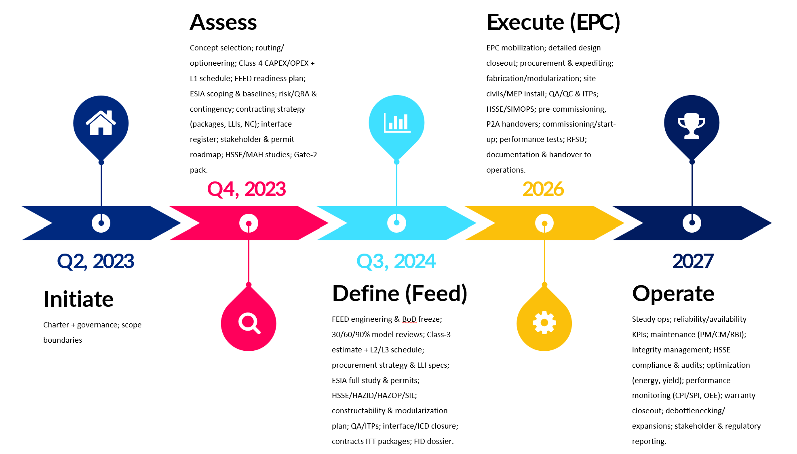

2. Project Background and Objectives
Nigeria’s Decade of Gas and the Energy Transition Plan (ETP 2060) set the context for monetizing gas, reducing flaring, and supporting industrialization. NDGIE responds to this mandate by integrating gas gathering, processing, power generation, and export infrastructure. The JV structure (NNPCL 60%, Seaway Energy 25%, PetroNova 15%) aligns national priorities with private investment. Objectives include safe delivery, schedule certainty, competitive cost, and robust environmental and social stewardship across sensitive wetland and community corridors.
▣ Project Objectives
1) Monetize 1.2 BCF/D of gas for domestic and export markets; 2) Deliver 500 MW embedded power for industrial clusters; 3) Achieve Train 8 expansion; 4) Maximize Nigerian content (≥60%); 5) Meet IFC and Nigerian ESIA standards; 6) De-risk interfaces via a PMC-led, multi-EPC model.

3. Scope Definition
Component | Description | Key Quantities
Gas Gathering | 350 km, 36” trunkline interlinking six hubs; pigging stations; block valves | 1.2 BCF/D throughput
Processing & Fractionation | Central Gas Complex (inlet separation, dehydration, NGL recovery, fractionation) | 1.2 BCF/D; C2/C3+ products
Power Generation | Two 250 MW open/combined-cycle gas turbines; black-start and redundancy | 500 MW total
Export | Bonny Terminal revamp, jetty upgrades, new LNG Train 8 | ~6 mtpa incremental
Utilities & Infrastructure | Eight compressor stations; 40 km of 132 kV lines; laydown areas and camps | 8 stations; 40 km
Scope boundaries (battery limits) and interfaces are explicitly defined to avoid overlap between EPC packages. Wetland crossings will employ HDD where feasible; pre-assembly and modularization will reduce field exposure. Tie-ins to existing assets will be planned during low-demand windows and aligned with stakeholder shutdown calendars.

Integrated Block Flow Diagram
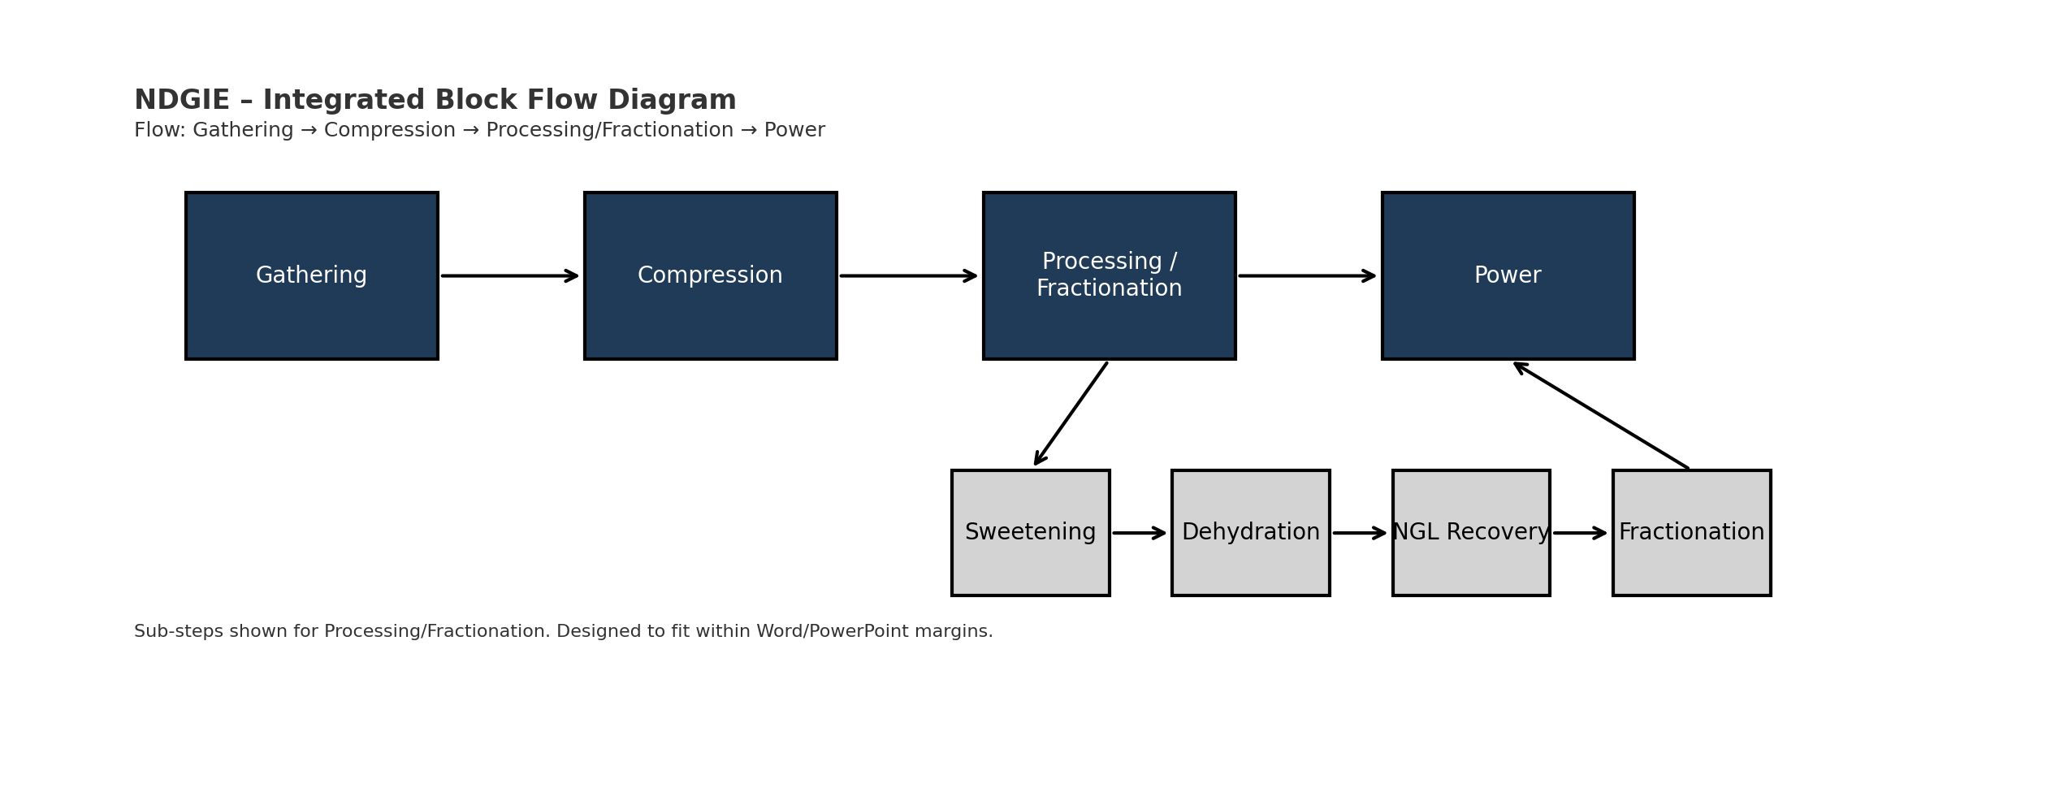

4. Execution Philosophy and Strategy
The project adopts a PMC-led, multi-EPC model to enable competitive tension and clear accountability. A data-centric engineering approach underpins design maturity, with model-based reviews, clash detection, and constructability assessments held at each maturity checkpoint. Modularization of skids (dehydration, compression, utility racks) reduces workfront congestion in swamp terrain and shortens the critical path. Early works (temporary access, logistics bases, power and water) are front-loaded to de-risk construction mobilization. Commissioning follows a systemization strategy aligned with subsystem MC/SC handovers and punch categorization (A/B/C).
▣ Key Principles
• Goal Zero HSSE;
• Single-source-of-truth data;
• Robust interface management;
• Early works & modularization;
• Predictable commissioning & handover.

Execution Hierarchy (Vision → Field)
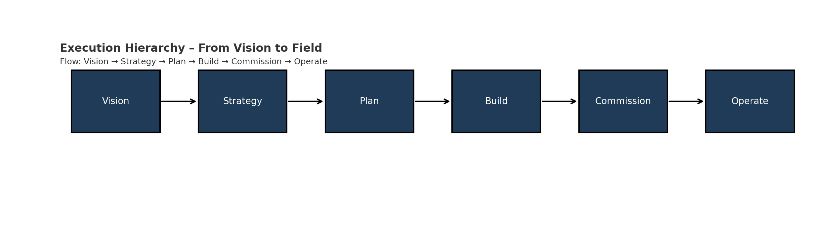

5. Governance and Assurance (Overview)
Governance operates at three tiers: (1) Steering Committee for strategy and approvals; (2) Project Management Committee for tactical alignment; (3) PMC-led execution teams for day-to-day delivery. Technical Assurance embeds independent reviews at concept selection, FEED readiness, HAZID/ENVID close-out, and contracting milestones. Escalation thresholds for change and claims are codified in the PEP and Contracting Plan.

Governance Org Chart
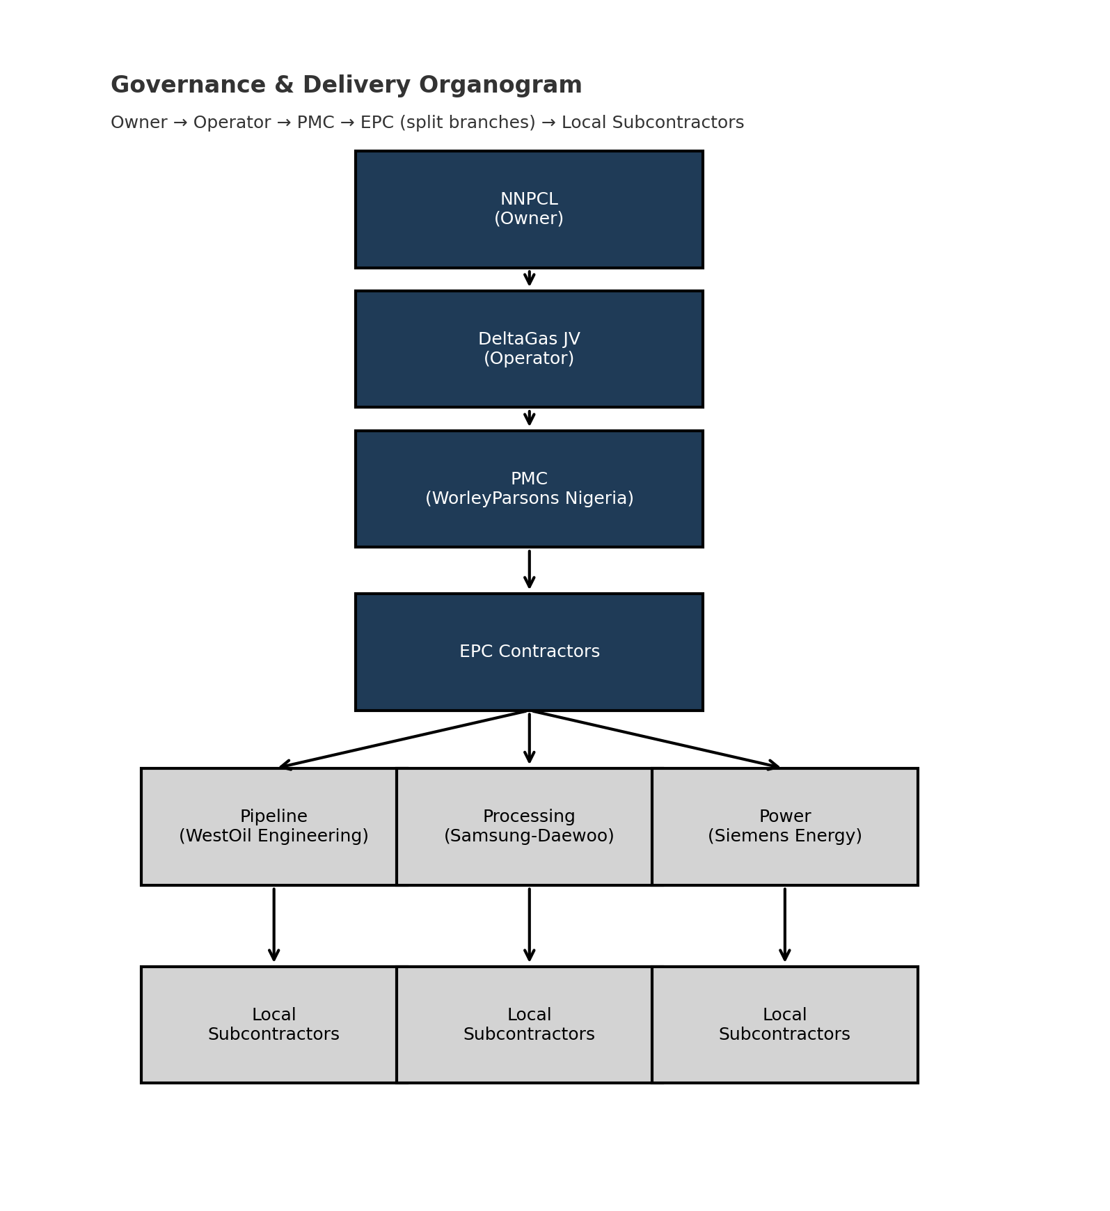

6. Contracting and Procurement Strategy
Contract packaging is structured to reduce interfaces while preserving competition: Package A (Pipeline LSTK), Package B (Processing EPC), Package C (Power & Utilities EPC), and a reimbursable PMC. Selection is based on capability, Nigerian content, HSE performance, and financial strength. Long-lead items (compressors, turbines, cryogenic exchangers) are pre-identified; technical prequalification begins during Assess to compress FEED-to-EPC transition. E-procurement supports transparent bidding and vendor development.
Package | Scope | Contract Type | Tender Launch (Indicative)
A | 350 km 36” trunkline incl. stations & HDD crossings | LSTK | Q3 2026
B | Gas Processing Complex incl. utilities & offsites | EPC | Q4 2026
C | Power Plants (2x250 MW) & 132 kV grid works | EPC | Q1 2027
PMC | Integrated Project Management Consultancy | Reimbursable w/ KPIs | Q1 2026
▣ Local Content Plan
Target ≥60% Nigerian content via local fabrication yards (spools, pipe supports), training programs, and vendor qualification. Adopt ‘make where feasible, import where necessary’ to balance cost and schedule.

Contracting Strategy Flow
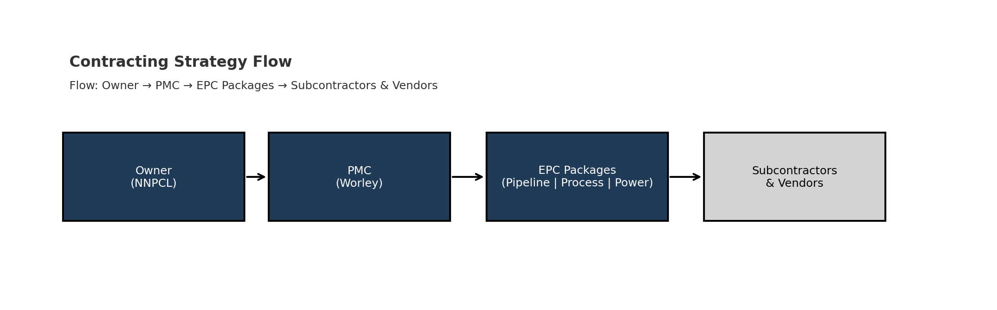

7. HSSE and Sustainability
HSSE commitment is codified through project-specific Lifesaving Rules, permit-to-work discipline, and leadership site engagement (MSE). The ESIA roadmap aligns with Nigerian EIA Act and IFC Performance Standards: scoping, baseline surveys, impact assessment, and management plans (EMP, SMP, WMP, BMP). Sustainability priorities include flare reduction, energy efficiency, water stewardship, and biodiversity protection in mangrove/wetland habitats.
HSSE ‘Golden Rules’: Comply with procedures; Intervene on unsafe acts; Respect the environment.

Bowtie (Major Accident Hazard) – Placeholder
⬚⬚⬚ EDITABLE GRAPHIC PLACEHOLDER ⬚⬚⬚
Loss of containment at compressor station – barriers & escalation controls

8. Risk & Opportunity Management
Risk management follows ISO 31000. A living risk register captures threats and opportunities with owners, actions, and due dates. Quantitative risk analysis (QRA) informs contingency. Opportunities include modularization savings, local fabrication, and early power revenues.
Risk ID | Description | Likelihood | Impact | Mitigation
R-001 | ROW acquisition delays | High | High | Community MoUs; compensation framework; early survey permits
R-002 | ESIA approval delay | Medium | High | NESREA/NUPRC pre-engagement; complete baseline early
R-003 | Security incidents (Niger Delta) | High | High | 24/7 marine patrols; vetted escorts; journey management
R-004 | Cost escalation & forex risk | High | Medium | Benchmarking; VE; forex hedging; framework agreements
R-005 | Contractor performance variance | Medium | High | Performance KPIs; earned value; incentive/LDs structure

Risk Heat Map
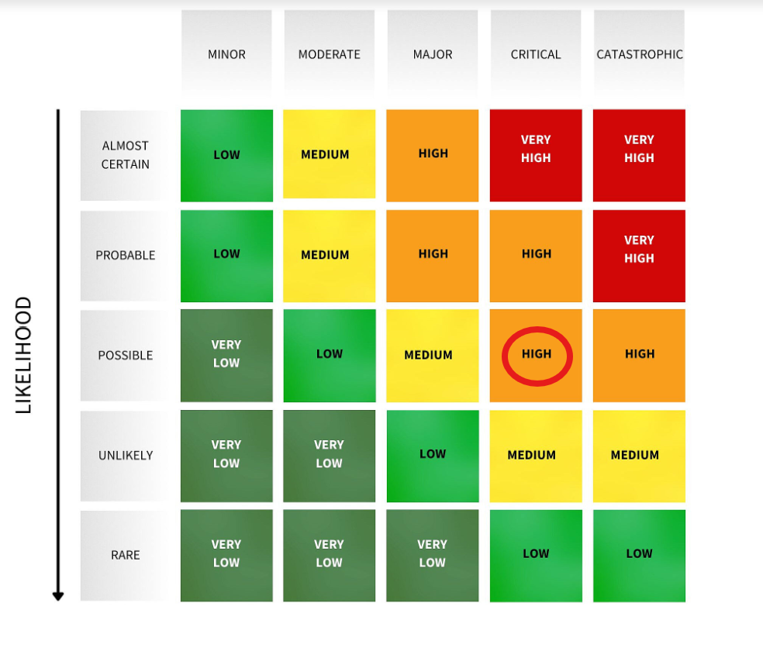

9. Security Management Plan
Security is risk-based and community-sensitive. Measures include vetted security providers, coordination with civil authorities, monitored marine routes, and geofenced journey management. A grievance mechanism supports community relations, minimizing disruptions to ROW works.

10. Schedule and Milestones
The Level-1 schedule defines phase gates and critical path: Concept Selection (Q2 2026), FEED kickoff (Q3 2026), EPC tendering (Q1 2027), FID (Q4 2027), Construction start (Q1 2028), Mechanical Completion (Q4 2030), and RFSU (Q2 2031). Front-end activities focus on early works, permitting, and long-lead procurement to compress overall duration.
Milestone | Start Date | Finish Date | Phase
Concept Selection Approved | Q3 2025 | Q2 2026 | Assess
FEED Kick-off |  | Q3 2026 | Define
EPC Tendering | Q4 2026 | Q1 2027 | Define
FID | Q2 2027 | Q4 2027 | Define
Procurement of LLI | Q1 2028 | Q3 2028 | Execute
Construction | Q2 2028 | Q4 2030 | Execute
Mechanical Completion |  | Q4 2030 | Execute
Commissioning & RFSU | Q1 2031 | Q2 2031 | Operate

High-level Gantt Timeline
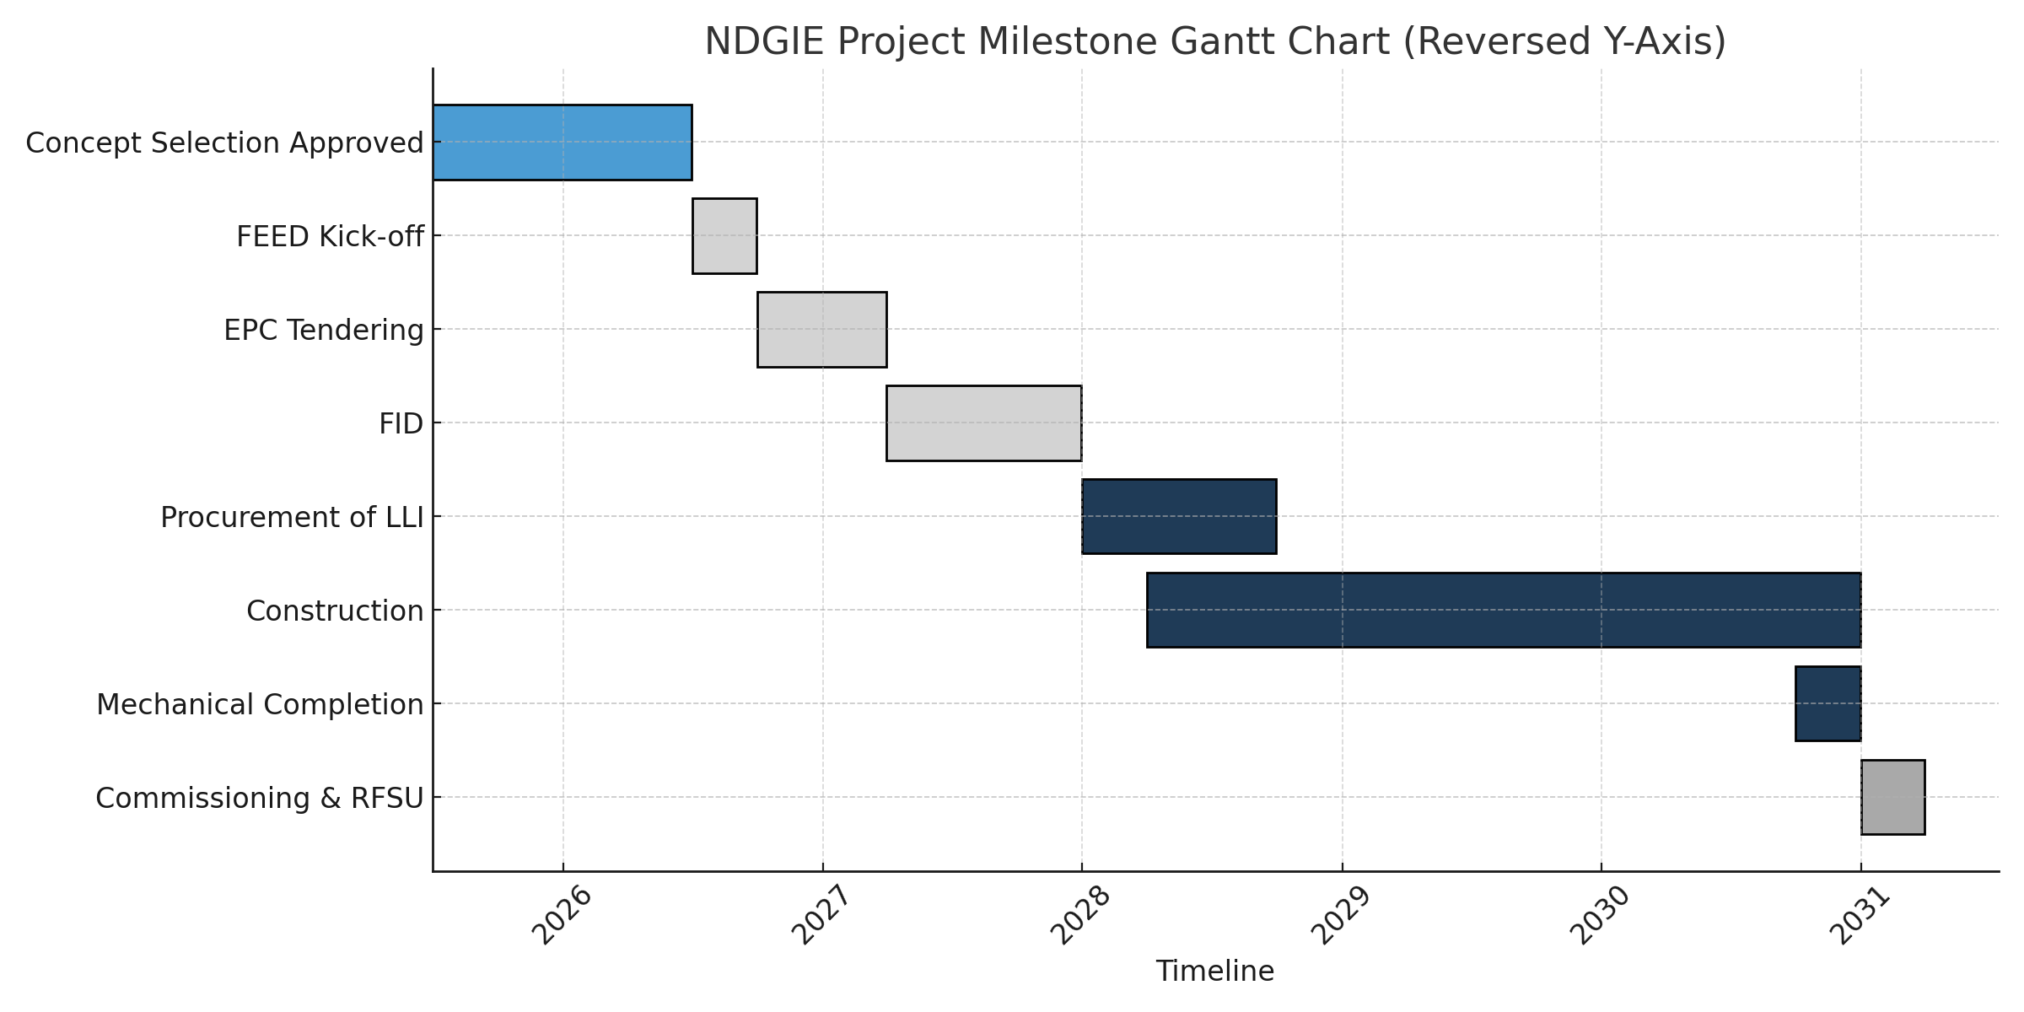

11. Cost Estimation & Project Controls
A Class 4 estimate will be developed using analogous benchmarks and quantity-based factored models. Cost breakdown structure (CBS) aligns with WBS and contracts. Contingency is based on risk analysis and maturity. Project Controls integrates cost, schedule, and risk using EVMS to track CPI/SPI and forecast EAC.
CBS Level | Element | Basis | Notes
L1 | Pipeline | Benchmark length/diameter factors | Includes HDD premiums; swamp logistics
L1 | Processing Complex | Major equipment + installation factors | Early modularization uplift then site reduction
L1 | Power Plants | OEM budgetary quotes | Balance-of-plant factored costs
L1 | Export & Utilities | Historical norms | Jetty/terminal revamp allowances
▣ Controls Toolkit
• EVMS (CPI/SPI);
• Change control workflow;
• Risk-adjusted forecast;
• Monthly cost/schedule report;
• Dashboard KPIs.

12. Change Management
Change is controlled through a single intake (PCR), impact assessment (cost/schedule/HSSE), and approval thresholds (PMC, PMT, Steering Committee). Trends are tracked to anticipate budget movements. Contract changes follow predefined clauses for variations and claims.

Change Workflow
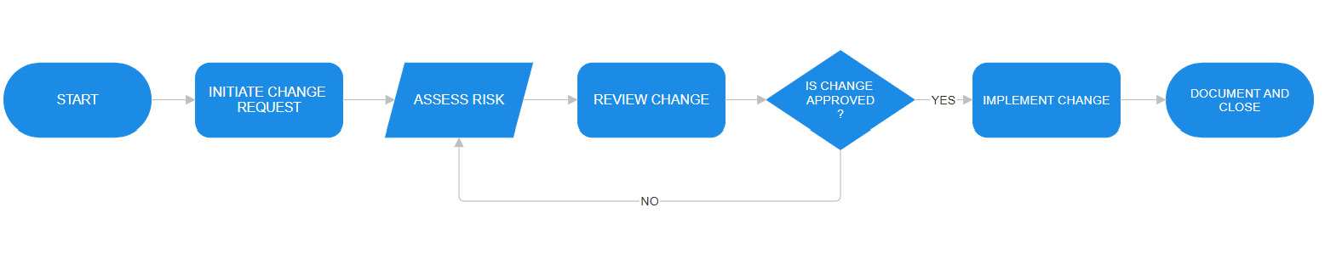

13. Quality Assurance & Technical Integrity
Quality aligns with ISO 9001. ITPs define hold/witness points for critical activities (welding, NDT, coatings, hydrotests). Vendor surveillance ensures equipment conformity. Technical integrity checks verify design safeguards, relief systems, and operability before MC/SC.
Discipline | Key QA Controls | Assurance Evidence
Pipeline | WPS/PQR, weld maps, RT/UT/PAUT, coating holiday tests | ITPs, NCR logs, hydrotest packs
Process Plant | Equipment FAT/SAT, loop checks, calibration | QC dossiers, punch lists
Power | OEM acceptance tests, performance runs | OEM certificates, run logs

14. Stakeholder Engagement Plan
Stakeholders include NUPRC/NESREA, state/local governments, host communities, partners, contractors, and financiers. A mapping exercise ranks influence and interest, informing engagement tactics: MoUs, grievance redress, capacity building, and transparent communication.
Category | Stakeholder | Interest | Influence | Strategy
Regulatory | NUPRC, NESREA | High | High | Permit tracker; early reviews
Community | Host/Transit communities | High | Medium | MoUs; local hiring; CSR projects
Partners | Seaway, PetroNova | High | High | Weekly JV reviews; clear RACI
Contractors | PMC/EPCs | Medium | High | Interface protocols; KPIs
Financial | ECAs/banks | High | Medium | Term sheets; ESG reporting

Stakeholder Influence–Interest Matrix
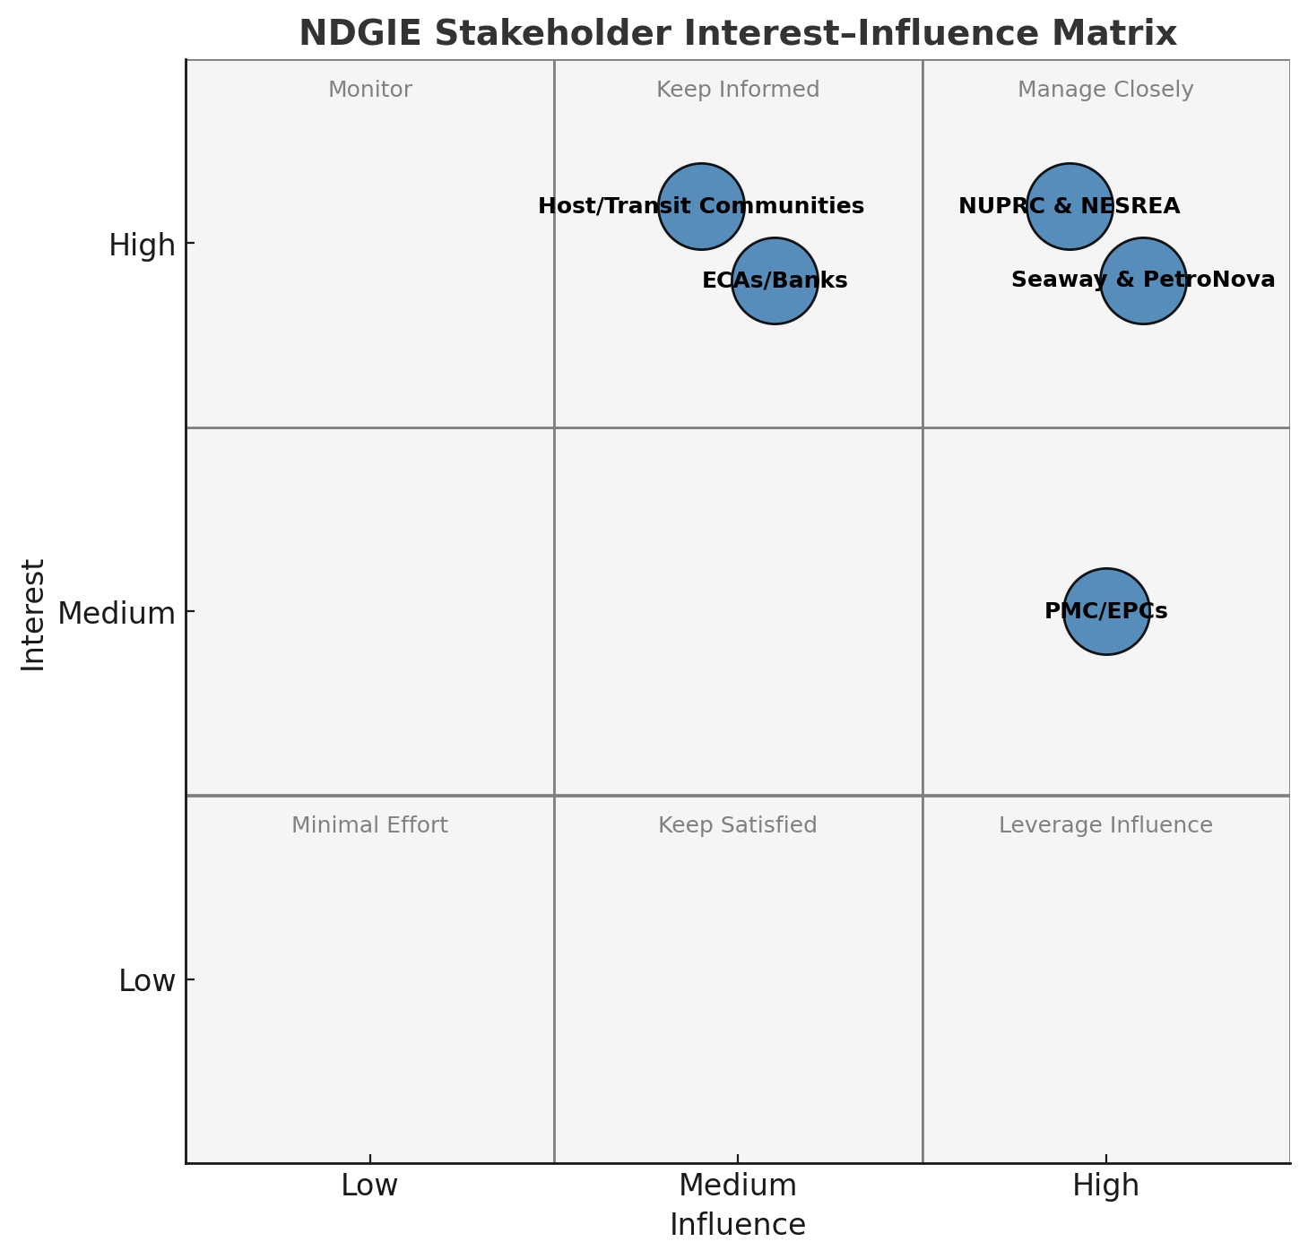

15. Information Management & Communication
A cloud-based EDMS governs document numbering, revisions, and transmittals. Communication follows a RACI-informed cadence: daily site briefs, weekly progress meetings, monthly Steering reviews, and quarterly assurance. Data governance ensures tag consistency, 3D model versioning, and cybersecurity for shared environments.

16. Transition to Define (FEED) Stage
FEED entry requires Concept Selection approval, BoD maturity, Class 4 estimate/schedule, ESIA scoping approval, and an endorsed contracting plan. A readiness checklist assigns deliverable owners and due dates, with a Gate-2 pack prepared for Steering endorsement.
Gate-2 Item | Owner | Status
Concept Selection Report | PMC | In progress
Basis of Design (BoD) | Engineering | Drafting
Class 4 Cost Estimate | Estimating | Benchmarking
L1 Schedule | Planning | Logic developed
ESIA Scoping Approval | HSSE | Engaging regulators
Contracting Strategy | Contracts | Draft ready

Appendices

A. Detailed Risk Register (Top 20)
ID | Risk Description | Category | Impact | Likelihood | Risk Rating | Mitigation Measures
R1 | Delay in Right-of-Way acquisition across swamps | Land & Community | High | Likely | High | Early community engagement, alternative routing studies, secure government support
R2 | Security threats in the Niger Delta region | Security | High | Likely | High | 24/7 marine and ground patrols, MOU with local vigilante groups, embed security advisor
R3 | Interface misalignment between EPC packages | Execution | High | Possible | Medium-High | Strong PMC coordination, interface registers, 4D schedule integration
R4 | Gas feedstock shortfall from producing hubs | Supply/Technical | High | Unlikely | Medium | Diversify gas sources, tie-in phased commissioning, contractual production guarantees
R5 | Environmental impact during pipeline construction | Environmental | Medium | Likely | Medium | Full EIA compliance, HDD under water crossings, environmental monitoring plan
R6 | Cost overrun due to inflation or scope creep | Commercial | High | Possible | Medium-High | Fixed-price EPC contracts, strong cost control governance
R7 | Low local content performance by contractors | Regulatory | Medium | Possible | Medium | Enforce NCMB regulations, set KPIs in contract, embed local compliance reporting
R8 | Delay in Regulator approvals (e.g., NUPRC, NESREA) | Regulatory | Medium | Possible | Medium | Pre-submission engagement, regulator workshops, early documentation readiness
R9 | Power plant interconnection delays (132 kV line) | Technical | Medium | Unlikely | Low | Parallel permit application, engage grid operator early, phased energization plan
R10 | LNG terminal tie-in interface risks | Infrastructure | High | Unlikely | Medium | Detailed interface schedule, dedicated tie-in coordination team

B. Assess-Stage Deliverables List
Deliverable | Owner | Due
Concept Selection Report | PMC | Q2 2026
BoD | PMC/Engineering | Q2 2026
Class 4 Estimate | Estimating | Q2 2026
L1 Schedule | Planning | Q2 2026
HSSE Scoping Report | HSSE | Q2 2026
Stakeholder Plan | CSR & Legal | Q2 2026
FID Readiness Roadmap | Project Controls | Q2 2026

C. Glossary & Abbreviations
BoD – Basis of Design; CSR – Corporate Social Responsibility; EDMS – Electronic Document Management System; ENVID – Environmental Identification; EPC – Engineering, Procurement, and Construction; ESIA – Environmental and Social Impact Assessment; FEED – Front-End Engineering Design; FID – Final Investment Decision; HAZID – Hazard Identification; HDD – Horizontal Directional Drilling; HSSE – Health, Safety, Security, Environment; IFC – International Finance Corporation; JV – Joint Venture; LSTK – Lump Sum Turnkey; NESREA – National Environmental Standards and Regulations Enforcement Agency; NUPRC – Nigerian Upstream Petroleum Regulatory Commission; PMC – Project Management Consultancy; ROW – Right of Way; RFSU – Ready for Start-Up; WBS – Work Breakdown Structure.

