as eukaryotes. In contrast, cells of organisms known as prokaryotes do not contain organelles and are generally smaller than eukaryotic cells. However, all cells share strong similarities in biochemical function.

The molecules of cells
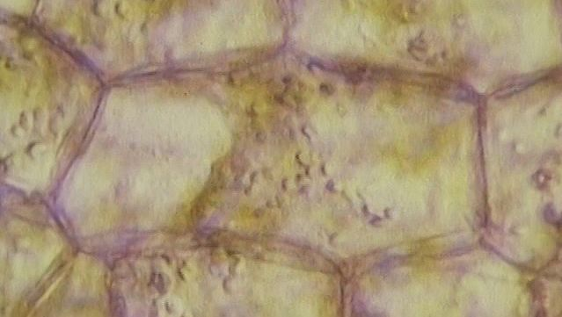
The function of the cell membrane in biology explainedCells ingest molecules through their plasma membranes.
See all videos for this article
Cells contain a special collection of molecules that are enclosed by a membrane. These molecules give cells the ability to grow and reproduce. The overall process of cellular reproduction occurs in two steps: cell growth and cell division. During cell growth, the cell ingests certain molecules from its surroundings by selectively carrying them through its cell membrane. Once inside the cell, these molecules are subjected to the action of highly specialized, large, elaborately folded molecules called enzymes. Enzymes act as catalysts by binding to ingested molecules and regulating the rate at which they are chemically altered. These chemical alterations make the molecules more useful to the cell. Unlike the ingested molecules, catalysts are not chemically altered themselves during the reaction, allowing one catalyst to regulate a specific chemical reaction in many molecules.

Access for the whole family!
Bundle Britannica Premium and Kids for the ultimate resource destination.
Biological catalysts create chains of reactions. In other words, a molecule chemically transformed by one catalyst serves as the starting material, or substrate, of a second catalyst and so on. In this way, catalysts use the small molecules brought into the cell from the outside environment to create increasingly complex reaction products. These products are used for cell growth and the replication of genetic material. Once the genetic material has been copied and there are sufficient molecules to support cell division, the cell divides to create two daughter cells. Through many such cycles of cell growth and division, each parent cell can give rise to millions of daughter cells, in the process converting large amounts of inanimate matter into biologically active molecules.

The structure of biological molecules
Cells are largely composed of compounds that contain carbon. The study of how carbon atoms interact with other atoms in molecular compounds forms the basis of the field of organic chemistry and plays a large role in understanding the basic functions of cells. Because carbon atoms can form stable bonds with four other atoms, they are uniquely suited for the construction of complex molecules. These complex molecules are typically made up of chains and rings that contain hydrogen, oxygen, and nitrogen atoms, as well as carbon atoms. These molecules may consist of anywhere from 10 to millions of atoms linked together in specific arrays. Most, but not all, of the carbon-containing molecules in cells are built up from members of one of four different families of small organic molecules: sugars, amino acids, nucleotides, and fatty acids. Each of these families contains a group of molecules that resemble one another in both structure and function. In addition to other important functions, these molecules are used to build large macromolecules. For example, the sugars can be linked to form polysaccharides such as starch and glycogen, the amino acids can be linked to form proteins, the nucleotides can be linked to form the DNA (deoxyribonucleic acid) and RNA (ribonucleic acid) of chromosomes, and the fatty acids can be linked to form the lipids of all cell membranes.
Approximate chemical composition of a typical mammalian cell
component | percent of total cell weight
water | 70
inorganic ions (sodium, potassium, magnesium, calcium, chloride, etc.) | 1
miscellaneous small metabolites | 3
proteins | 18
RNA | 1.1
DNA | 0.25
phospholipids and other lipids | 5
polysaccharides | 2
Aside from water, which forms 70 percent of a cell’s mass, a cell is composed mostly of macromolecules. By far the largest portion of macromolecules are the proteins. An average-sized protein macromolecule contains a string of about 400 amino acid molecules. Each amino acid has a different side chain of atoms that interact with the atoms of side chains of other amino acids. These interactions are very specific and cause the entire protein molecule to fold into a compact globular form. In theory, nearly an infinite variety of proteins can be formed, each with a different sequence of amino acids. However, nearly all these proteins would fail to fold in the unique ways required to form efficient functional surfaces and would therefore be useless to the cell. The proteins present in cells of modern animals and humans are products of a long evolutionary history, during which the ancestor proteins were naturally selected for their ability to fold into specific three-dimensional forms with unique functional surfaces useful for cell survival.
Most of the catalytic macromolecules in cells are enzymes. The majority of enzymes are proteins. Key to the catalytic property of an enzyme is its tendency to undergo a change in its shape when it binds to its substrate, thus bringing together reactive groups on substrate molecules. Some enzymes are macromolecules of RNA, called ribozymes. Ribozymes consist of linear chains of nucleotides that fold in specific ways to form unique surfaces, similar to the ways in which proteins fold. As with proteins, the specific sequence of nucleotide subunits in an RNA chain gives each macromolecule a unique character. RNA molecules are much less frequently used as catalysts in cells than are protein molecules, presumably because proteins, with the greater variety of amino acid side chains, are more diverse and capable of complex shape changes. However, RNA molecules are thought to have preceded protein molecules during evolution and to have catalyzed most of the chemical reactions required before cells could evolve (see below The evolution of cells).

Coupled chemical reactions
Cells must obey the laws of chemistry and thermodynamics. When two molecules react with each other inside a cell, their atoms are rearranged, forming different molecules as reaction products and releasing or consuming energy in the process. Overall, chemical reactions occur only in one direction; that is, the final reaction product molecules cannot spontaneously react, in a reversal of the original process, to reform the original molecules. This directionality of chemical reactions is explained by the fact that molecules only change from states of higher free energy to states of lower free energy. Free energy is the ability to perform work (in this case, the “work” is the rearrangement of atoms in the chemical reaction). When work is performed, some free energy is used and lost, with the result that the process ends at lower free energy. To use a familiar mechanical analogy, water at the top of a hill has the ability to perform the “work” of flowing downhill (i.e., it has high free energy), but, once it has flowed downhill, it cannot flow back up (i.e., it is in a state of low free energy). However, through another work process—that of a pump, for example—the water can be returned to the top of the hill, thereby recovering its ability to flow downhill. In thermodynamic terms, the free energy of the water has been increased by energy from an outside source (i.e., the pump). In the same way, the product molecules of a chemical reaction in a cell cannot reverse the reaction and return to their original state unless energy is supplied by coupling the process to another chemical reaction.
All catalysts, including enzymes, accelerate chemical reactions without affecting their direction. To return to the mechanical analogy, enzymes cannot make water flow uphill, although they can provide specific pathways for a downhill flow. Yet most of the chemical reactions that the cell needs to synthesize new molecules necessary for its growth require an uphill flow. In other words, the reactions require more energy than their starting molecules can provide.
Cells use a single strategy over and over again in order to get around the limitations of chemistry: they use the energy from an energy-releasing chemical reaction to drive an energy-absorbing reaction that would otherwise not occur. A useful mechanical analogy might be a mill wheel driven by the water in a stream. The water, in order to flow downhill, is forced to flow past the blades of the wheel, causing the wheel to turn. In this way, part of the energy from the moving stream is harnessed to move a mill wheel, which may be linked to a winch. As the winch turns, it can be used to pull a heavy load uphill. Thus, the energy-absorbing (but useful) uphill movement of a load can be driven by coupling it directly to the energy-releasing flow of water.
In cells, enzymes play the role of mill wheels by coupling energy-releasing reactions with energy-absorbing reactions. As discussed below, in cells the most important energy-releasing reaction serving a role similar to that of the flowing stream is the hydrolysis of adenosine triphosphate (ATP). In turn, the production of ATP molecules in the cells is an energy-absorbing reaction that is driven by being coupled to the energy-releasing breakdown of sugar molecules. In retracing this chain of reactions, it is necessary first to understand the source of the sugar molecules.

Photosynthesis: the beginning of the food chain
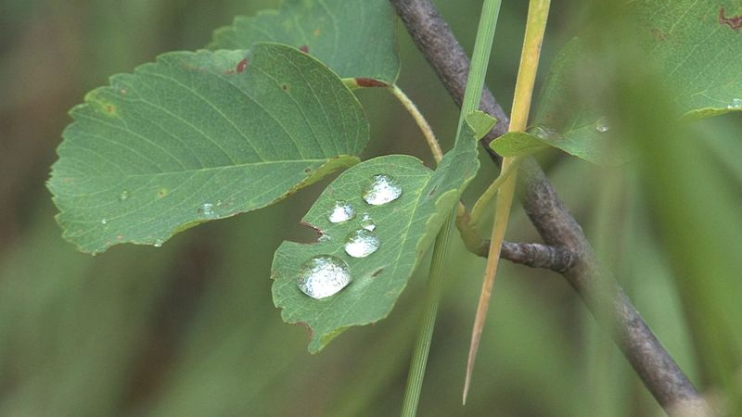
The process of photosynthesis in plants explainedThe location, importance, and mechanisms of photosynthesis. Study the roles of chloroplasts, chlorophyll, grana, thylakoid membranes, and stroma in photosynthesis.
See all videos for this article
Sugar molecules are produced by the process of photosynthesis in plants and certain bacteria. These organisms lie at the base of the food chain, in that animals and other nonphotosynthesizing organisms depend on them for a constant supply of life-supporting organic molecules. Humans, for example, obtain these molecules by eating plants or other organisms that have previously eaten food derived from photosynthesizing organisms.

Britannica Quiz
Biology Bonanza

Plants and photosynthetic bacteria are unique in their ability to convert the freely available electromagnetic energy in sunlight into chemical bond energy, the energy that holds atoms together in molecules and is transferred or released in chemical reactions. The process of photosynthesis can be summarized by the following equation:(solar) energy + CO₂ + H₂O → sugar molecules + O₂.
The energy-absorbing photosynthetic reaction is the reverse of the energy-releasing oxidative decomposition of sugar molecules. During photosynthesis, chlorophyll molecules absorb energy from sunlight and use it to fuel the production of simple sugars and other carbohydrates. The resulting abundance of sugar molecules and related biological products makes possible the existence of nonphotosynthesizing life on Earth.

ATP: fueling chemical reactions

How does ATP provide energy to cells?Adenosine triphosphate, or ATP, is the primary carrier of energy in cells. The water-mediated reaction known as hydrolysis releases energy from the chemical bonds in ATP to fuel cellular processes.
See all videos for this article
Certain enzymes catalyze the breakdown of organic foodstuffs. Once sugars are transported into cells, they either serve as building blocks in the form of amino acids for proteins and fatty acids for lipids or are subjected to metabolic pathways to provide the cell with ATP. ATP, the common carrier of energy inside the cell, is made from adenosine diphosphate (ADP) and inorganic phosphate (P_{i}). Stored in the chemical bond holding the terminal phosphate compound onto the ATP molecule is the energy derived from the breakdown of sugars. The removal of the terminal phosphate, through the water-mediated reaction called hydrolysis, releases this energy, which in turn fuels a large number of crucial energy-absorbing reactions in the cell. Hydrolysis can be summarized as follows:ATP +H₂O → ADP + P_{i}+ energy.
The formation of ATP is the reverse of this equation, requiring the addition of energy. The central cellular pathway of ATP synthesis begins with glycolysis, a form of fermentation in which the sugar glucose is transformed into other sugars in a series of nine enzymatic reactions, each successive reaction involving an intermediate sugar containing phosphate. In the process, the six-carbon glucose is converted into two molecules of the three-carbon pyruvic acid. Some of the energy released through glycolysis of each glucose molecule is captured in the formation of two ATP molecules.
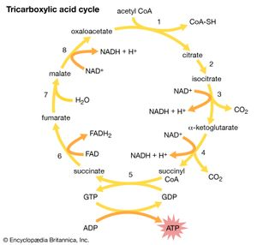
Tricarboxylic acid cycleThe eight-step tricarboxylic acid cycle.
The second stage in the metabolism of sugars is a set of interrelated reactions called the tricarboxylic acid cycle. This cycle takes the three-carbon pyruvic acid produced in glycolysis and uses its carbon atoms to form carbon dioxide (CO₂) while transferring its hydrogen atoms to special carrier molecules, where they are held in high-energy linkage.
In the third and last stage in the breakdown of sugars, oxidative phosphorylation, the high-energy hydrogen atoms are first separated into protons and high-energy electrons. The electrons are then passed from one electron carrier to another by means of an electron-transport chain. Each electron carrier in the chain has an increasing affinity for electrons, with the final electron acceptor being molecular oxygen (O₂). As separated electrons and protons, the hydrogen atoms are transferred to O₂ to form water. This reaction releases a large amount of energy, which drives the synthesis of a large number of ATP molecules from ADP and P_{i}. (For further discussion of the electron-transport chain, see below Metabolic functions.)
Most of the cell’s ATP is produced when the products of glycolysis are oxidized completely by a combination of the tricarboxylic acid cycle and oxidative phosphorylation. The process of glycolysis alone produces relatively small amounts of ATP. Glycolysis is an anaerobic reaction; that is, it can occur even in the absence of oxygen. The tricarboxylic acid cycle and oxidative phosphorylation, on the other hand, require oxygen. Glycolysis forms the basis of anaerobic fermentation, and it presumably was a major source of ATP for early life on Earth, when very little oxygen was available in the atmosphere. Eventually, however, bacteria evolved that were able to carry out photosynthesis. Photosynthesis liberated these bacteria from a dependence on the metabolism of organic materials that had accumulated from natural processes, and it also released oxygen into the atmosphere. Over a prolonged period of time, the concentration of molecular oxygen increased until it became freely available in the atmosphere. The aerobic tricarboxylic acid cycle and oxidative phosphorylation then evolved, and the resulting aerobic cells made much more efficient use of foodstuffs than their anaerobic ancestors, because they could convert much larger amounts of chemical bond energy into ATP.

The genetic information of cells
Cells can thus be seen as a self-replicating network of catalytic macromolecules engaged in a carefully balanced series of energy conversions that drive biosynthesis and cell movement. But energy alone is not enough to make self-reproduction possible; the cell must contain detailed instructions that dictate exactly how that energy is to be used. These instructions are analogous to the blueprints that a builder uses to construct a house; in the case of cells, however, the blueprints themselves must be duplicated along with the cell before it divides, so that each daughter cell can retain the instructions that it needs for its own replication. These instructions constitute the cell’s heredity.

DNA: the genetic material
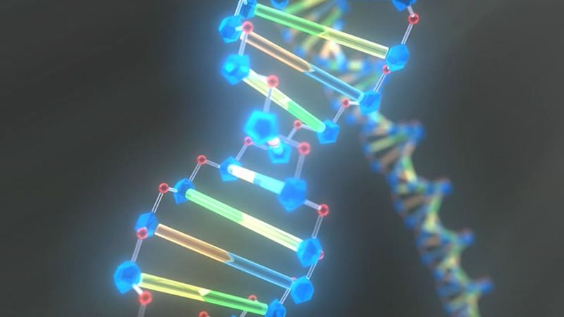
Study DNA's double helix structure to learn how the organic chemical determines an organism's traitsJames Watson and Francis Crick revolutionized the study of genetics when they discovered the structure of DNA.
See all videos for this article
During the early 19th century, it became widely accepted that all living organisms are composed of cells arising only from the growth and division of other cells. The improvement of the microscope then led to an era during which many biologists made intensive observations of the microscopic structure of cells. By 1885 a substantial amount of indirect evidence indicated that chromosomes—dark-staining threads in the cell nucleus—carried the information for cell heredity. It was later shown that chromosomes are about half DNA and half protein by weight.
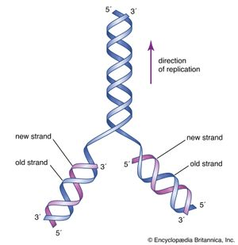
DNA structureThe initial proposal of the structure of DNA by James Watson and Francis Crick was accompanied by a suggestion on the means of replication.
The revolutionary discovery suggesting that DNA molecules could provide the information for their own replication came in 1953, when American geneticist and biophysicist James Watson and British biophysicist Francis Crick proposed a model for the structure of the double-stranded DNA molecule (called the DNA double helix). In this model, each strand serves as a template in the synthesis of a complementary strand. Subsequent research confirmed the Watson and Crick model of DNA replication and showed that DNA carries the genetic information for reproduction of the entire cell.
All of the genetic information in a cell was initially thought to be confined to the DNA in the chromosomes of the cell nucleus. Later discoveries identified small amounts of additional genetic information present in the DNA of much smaller chromosomes located in two types of organelles in the cytoplasm. These organelles are the mitochondria in animal cells and the mitochondria and chloroplasts in plant cells. The special chromosomes carry the information coding for a few of the many proteins and RNA molecules needed by the organelles. They also hint at the evolutionary origin of these organelles, which are thought to have originated as free-living bacteria that were taken up by other organisms in the process of symbiosis.

RNA: replicated from DNA
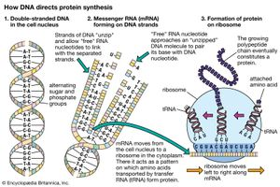
Messenger RNA; translationMolecular genetics emerged from the realization that DNA and RNA constitute the genetic material of all living organisms. (1) DNA, located in the cell nucleus, is made up of nucleotides that contain the bases adenine (A), thymine (T), guanine (G), and cytosine (C). (2) RNA, which contains uracil (U) instead of thymine, transports the genetic code to protein-synthesizing sites in the cell. (3) Messenger RNA (mRNA) then carries the genetic information to ribosomes in the cell cytoplasm that translate the genetic information into molecules of protein.
It is possible for RNA to replicate itself by mechanisms related to those used by DNA, even though it has a single-stranded instead of a double-stranded structure. In early cells RNA is thought to have replicated itself in this way. However, all of the RNA in present-day cells is synthesized by special enzymes that construct a single-stranded RNA chain by using one strand of the DNA helix as a template. Although RNA molecules are synthesized in the cell nucleus, where the DNA is located, most of them are transported to the cytoplasm before they carry out their functions.
The RNA molecules in cells have two main roles. Some, the ribozymes, fold up in ways that allow them to serve as catalysts for specific chemical reactions. Others serve as messenger RNA, which provides templates specifying the synthesis of proteins. Ribosomes, tiny protein-synthesizing machines located in the cytoplasm, “read” the messenger RNA molecules and “translate” them into proteins by using the genetic code. In this translation, the sequence of nucleotides in the messenger RNA chain is decoded three nucleotides at a time, and each nucleotide triplet (called a codon) specifies a particular amino acid. Thus, a nucleotide sequence in the DNA specifies a protein provided that a messenger RNA molecule is produced from that DNA sequence. Each region of the DNA sequence specifying a protein in this way is called a gene.

More From Britannica
human disease: Abnormal growth of cells

By the above mechanisms, DNA molecules catalyze not only their own duplication but also dictate the structures of all protein molecules. A single human cell contains about 10,000 different proteins produced by the expression of 10,000 different genes. Actually, a set of human chromosomes is thought to contain DNA with enough information to express between 30,000 and 100,000 proteins, but most of these proteins seem to be made only in specialized types of cells and are therefore not present throughout the body. (For further discussion, see below The nucleus.)

The organization of cells

Intracellular communication
A cell with its many different DNA, RNA, and protein molecules is quite different from a test tube containing the same components. When a cell is dissolved in a test tube, thousands of different types of molecules randomly mix together. In the living cell, however, these components are kept in specific places, reflecting the high degree of organization essential for the growth and division of the cell. Maintaining this internal organization requires a continuous input of energy, because spontaneous chemical reactions always create disorganization. Thus, much of the energy released by ATP hydrolysis fuels processes that organize macromolecules inside the cell.
When a eukaryotic cell is examined at high magnification in an electron microscope, it becomes apparent that specific membrane-bound organelles divide the interior into a variety of subcompartments. Although not detectable in the electron microscope, it is clear from biochemical assays that each organelle contains a different set of macromolecules. This biochemical segregation reflects the functional specialization of each compartment. Thus, the mitochondria, which produce most of the cell’s ATP, contain all of the enzymes needed to carry out the tricarboxylic acid cycle and oxidative phosphorylation. Similarly, the degradative enzymes needed for the intracellular digestion of unwanted macromolecules are confined to the lysosomes.
The relative volumes occupied by some cellular compartments in a typical liver cell
cellular compartment | percent of total cell volume | approximate number per cell
cytosol | 54 | 1
mitochondrion | 22 | 1,700
endoplasmic reticulum plus Golgi apparatus | 15 | 1
nucleus | 6 | 1
lysosome | 1 | 300
It is clear from this functional segregation that the many different proteins specified by the genes in the cell nucleus must be transported to the compartment where they will be used. Not surprisingly, the cell contains an extensive membrane-bound system devoted to maintaining just this intracellular order. The system serves as a post office, guaranteeing the proper routing of newly synthesized macromolecules to their proper destinations.
All proteins are synthesized on ribosomes located in the cytosol. As soon as the first portion of the amino acid sequence of a protein emerges from the ribosome, it is inspected for the presence of a short “endoplasmic reticulum (ER) signal sequence.” Those ribosomes making proteins with such a sequence are transported to the surface of the ER membrane, where they complete their synthesis; the proteins made on these ribosomes are immediately transferred through the ER membrane to the inside of the ER compartment. Proteins lacking the ER signal sequence remain in the cytosol and are released from the ribosomes when their synthesis is completed. This chemical decision process places some newly completed protein chains in the cytosol and others within an extensive membrane-bounded compartment in the cytoplasm, representing the first step in intracellular protein sorting.
The newly made proteins in both cell compartments are then sorted further according to additional signal sequences that they contain. Some of the proteins in the cytosol remain there, while others go to the surface of mitochondria or (in plant cells) chloroplasts, where they are transferred through the membranes into the organelles. Subsignals on each of these proteins then designate exactly where in the organelle the protein belongs. The proteins initially sorted into the ER have an even wider range of destinations. Some of them remain in the ER, where they function as part of the organelle. Most enter transport vesicles and pass to the Golgi apparatus, separate membrane-bounded organelles that contain at least three subcompartments. Some of the proteins are retained in the subcompartments of the Golgi, where they are utilized for functions peculiar to that organelle. Most eventually enter vesicles that leave the Golgi for other cellular destinations such as the cell membrane, lysosomes, or special secretory vesicles. (For further discussion, see below Internal membranes.)

Intercellular communication
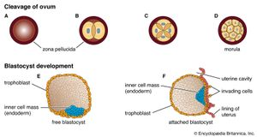
Early stages of human developmentThe ovum contains a small collection of cells in the early stages of human development. As cells divide (A–D), they are separated into different regions of the ovum. Each region of the ovum transmits a unique set of chemical signals to nearby cells. Thus, the signals detected by one cell differ from those detected by its neighbor cells. In this process, known as cell determination, cells are individually programmed to direct them toward development into different cell types.
Formation of a multicellular organism starts with a small collection of similar cells in an embryo and proceeds by continuous cell division and specialization to produce an entire community of cooperating cells, each with its own role in the life of the organism. Through cell cooperation, the organism becomes much more than the sum of its component parts.
A fertilized egg multiplies and produces a whole family of daughter cells, each of which adopts a structure and function according to its position in the entire assembly. All of the daughter cells contain the same chromosomes and therefore the same genetic information. Despite this common inheritance, different types of cells behave differently and have different structures. In order for this to be the case, they must express different sets of genes, so that they produce different proteins despite their identical embryological ancestors.
During the development of an embryo, it is not sufficient for all the cell types found in the fully developed individual simply to be created. Each cell type must form in the right place at the right time and in the correct proportion; otherwise, there would be a jumble of randomly assorted cells in no way resembling an organism. The orderly development of an organism depends on a process called cell determination, in which initially identical cells become committed to different pathways of development. A fundamental part of cell determination is the ability of cells to detect different chemicals within different regions of the embryo. The chemical signals detected by one cell may be different from the signals detected by its neighbor cells. The signals that a cell detects activate a set of genes that tell the cell to differentiate in ways appropriate for its position within the embryo. The set of genes activated in one cell differs from the set of genes activated in the cells around it. The process of cell determination requires an elaborate system of cell-to-cell communication in early embryos.
Bruce M. Alberts

The cell membrane
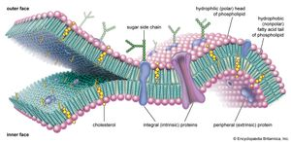
Molecular view of the cell membraneIntrinsic proteins penetrate and bind tightly to the lipid bilayer, which is made up largely of phospholipids and cholesterol and which typically is between 4 and 10 nanometers (nm; 1 nm = 10⁻⁹ metre) in thickness. Extrinsic proteins are loosely bound to the hydrophilic (polar) surfaces, which face the watery medium both inside and outside the cell. Some intrinsic proteins present sugar side chains on the cell's outer surface.
A thin membrane, typically between 4 and 10 nanometers (nm; 1 nm = 10⁻⁹ metre) in thickness, surrounds every living cell, delimiting the cell from the environment around it. Enclosed by this cell membrane (also known as the plasma membrane) are the cell’s constituents, often large, water-soluble, highly charged molecules such as proteins, nucleic acids, carbohydrates, and substances involved in cellular metabolism. Outside the cell, in the surrounding water-based environment, are ions, acids, and alkalis that are toxic to the cell, as well as nutrients that the cell must absorb in order to live and grow. The cell membrane, therefore, has two functions: first, to be a barrier keeping the constituents of the cell in and unwanted substances out and, second, to be a gate allowing transport into the cell of essential nutrients and movement from the cell of waste products.

Chemical composition and membrane structure
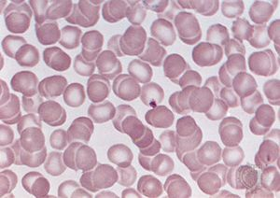
Red blood cellsHuman red blood cells (erythrocytes).
Most current knowledge about the biochemical constituents of cell membranes originates in studies of red blood cells. The chief advantage of these cells for experimental purposes is that they may be obtained easily in large amounts and that they have no internal membranous organelles to interfere with study of their cell membranes. Careful studies of these and other cell types have shown that all membranes are composed of proteins and fatty-acid-based lipids. Membranes actively involved in metabolism contain a higher proportion of protein; thus, the membrane of the mitochondrion, the most rapidly metabolizing organelle of the cell, contains as much as 75 percent protein, while the membrane of the Schwann cell, which forms an insulating sheath around many nerve cells, has as little as 20 percent protein.

Membrane lipids
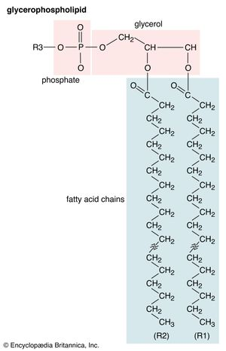
Glycerophospholipid structureGeneral structural formula of a glycerophospholipid. The composition of the specific molecule depends on the chemical group (designated R3 in the diagram) linked to the phosphate and glycerol “head” and also on the lengths of the fatty acid “tails” (R1 and R2).
Membrane lipids are principally of two types, phospholipids and sterols (generally cholesterol). Both types share the defining characteristic of lipids—they dissolve readily in organic solvents—but in addition they both have a region that is attracted to and soluble in water. This “amphiphilic” property (having a dual attraction; i.e., containing both a lipid-soluble and a water-soluble region) is basic to the role of lipids as building blocks of cellular membranes. Phospholipid molecules have a head (often of glycerol) to which are attached two long fatty acid chains that look much like tails. These tails are repelled by water and dissolve readily in organic solvents, giving the molecule its lipid character. To another part of the head is attached a phosphoryl group with a negative electrical charge; to this group in turn is attached another group with a positive or neutral charge. This portion of the phospholipid dissolves in water, thereby completing the molecule’s amphiphilic character. In contrast, sterols have a complex hydrocarbon ring structure as the lipid-soluble region and a hydroxyl grouping as the water-soluble region.
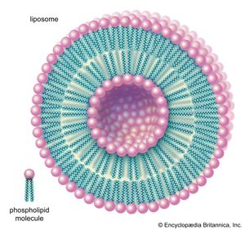
LiposomePhospholipids can be used to form artificial structures called liposomes, which are double-walled hollow spheres useful for encapsulating other molecules such as pharmaceutical drugs.
When dry phospholipids, or a mixture of such phospholipids and cholesterol, are immersed in water under laboratory conditions, they spontaneously form globular structures called liposomes. Investigation of the liposomes shows them to be made of concentric spheres, one sphere inside of another and each forming half of a bilayered wall. A bilayer is composed of two sheets of phospholipid molecules with all of the molecules of each sheet aligned in the same direction. In a water medium, the phospholipids of the two sheets align so that their water-repellent, lipid-soluble tails are turned and loosely bonded to the tails of the molecules on the other sheet. The water-soluble heads turn outward into the water, to which they are chemically attracted. In this way, the two sheets form a fluid, sandwichlike structure, with the fatty acid chains in the middle mingling in an organic medium while sealing out the water medium.

