FACILITIES DESK
A Campus Work Order Tracking System
Closing the facility-maintenance reporting gap on university campuses
Prepared by: [Danquah Joel]
Student ID: [Your Student ID]
Course / Module: [Computer Science]
Institution: [Kumasi Technical University]
Date: 19 July 2026
Tip: replace the bracketed fields above before submitting. In Word, open the Navigation Pane (View → Navigation Pane) to jump between sections.

1. Executive Summary
University campuses run on hundreds of small physical systems — lights, taps, chairs, routers, air conditioners — that quietly fail every day. Right now, most campuses have no dedicated channel for reporting these failures. A student mentions a broken tap to a friend, a leaking pipe gets flagged in a WhatsApp group, a flickering light in a lab goes unmentioned entirely. None of it reaches the people who can fix it, and none of it is tracked.
Facilities Desk is a lightweight web application that gives a campus a single place to report a facility issue, follow its progress, and — for the facilities team — manage a queue of work orders with clear ownership and status. This document describes the problem, the prototype built to solve it, its architecture, and the roadmap for turning it into a production system.
The problem was chosen deliberately because it is common, invisible, and unglamorous — the kind of issue that rarely gets attention in a hackathon or assignment, precisely because it doesn't look urgent until a minor fault becomes an expensive or unsafe one.

2. Problem Statement

2.1 What happens today
On most campuses, a facility issue is reported one of three ways: told to a friend, mentioned in a class or hostel group chat, or reported verbally to whichever staff member happens to be nearby. None of these create a record. There is no ticket number, no owner, and no way for the reporter — or anyone else — to check whether it was ever addressed.

2.2 Why it stays overlooked
- It isn't dramatic. Unlike safety incidents or academic issues, a broken chair or a slow drain rarely feels urgent enough to escalate, so it's absorbed as background noise.
- It's assumed to be “someone else's job.” Students see it as a facilities-department problem, not something a piece of software could fix, so it's rarely the subject of a student-built app.
- There's no data trail. Because reports aren't logged anywhere, the university has no way to see that, say, the same lab's air conditioning has failed four times this term — information that would justify a repair budget instead of a fourth patch job.

2.3 The cost of leaving it unsolved
- Minor faults become major ones: a loose handrail left unreported becomes a fall risk; a dripping tap becomes a water-damage repair.
- Trust erodes. Students stop reporting issues once they conclude nothing happens when they do.
- Facilities teams triage blind, working off memory and word-of-mouth rather than a prioritized, visible queue.

3. Objectives
- Give students and staff one obvious place to report a facility issue in under a minute.
- Make status visible: every report should show whether it's been seen, is being worked on, or is resolved — and by when.
- Give the facilities team a manageable, filterable queue instead of a pile of verbal reports.
- Surface patterns — the buildings and categories generating the most tickets — so maintenance spending can be planned, not just reactive.
- Keep the barrier to reporting low: no account creation required, and anonymous reporting supported for sensitive situations.

4. Target Users & Stakeholders
Stakeholder | Role in the system
Students | File reports; track the status of issues that affect them (shared or personal spaces).
Lecturers & staff | File reports, particularly for labs, offices, and shared teaching spaces.
Facilities management team | Triage incoming reports, update status, and record how each issue was resolved.
University administration | Use the dashboard's trends to plan maintenance budgets and staffing.

5. System Overview & Core Features
The prototype is organized around three views: filing a report, browsing the live work order board, and a facilities-facing analytics dashboard.
Feature | What it does | Primary user
File a work order | A structured form captures category, urgency, building, room, and description in under a minute. Reporting can be anonymous. | Student / Staff
Automatic ticket numbering | Every report receives a unique, sequential ticket ID (e.g. WO-0013) the instant it's filed. | System
Filterable work order board | Tickets can be searched and filtered by category, building, status, or urgency, and sorted by recency or urgency. | Student / Staff
Four-stage status lifecycle | Open → Acknowledged → In Progress → Resolved, each timestamped, with a resolution note captured at close-out. | Facilities staff
Role-based views | A visible role toggle switches between a Student view (report and track) and a Facilities Staff view (report, track, and update status). | Both
Live analytics dashboard | Real-time counts, average resolution time, and the most-reported category and building, backed by two charts. | Facilities / Admin

6. System Architecture
The prototype runs entirely in the browser, using in-memory JavaScript state seeded with sample tickets so the workflow is visible immediately. No backend or database is required to demonstrate it. The diagram below also sketches the production architecture this prototype is designed to grow into.
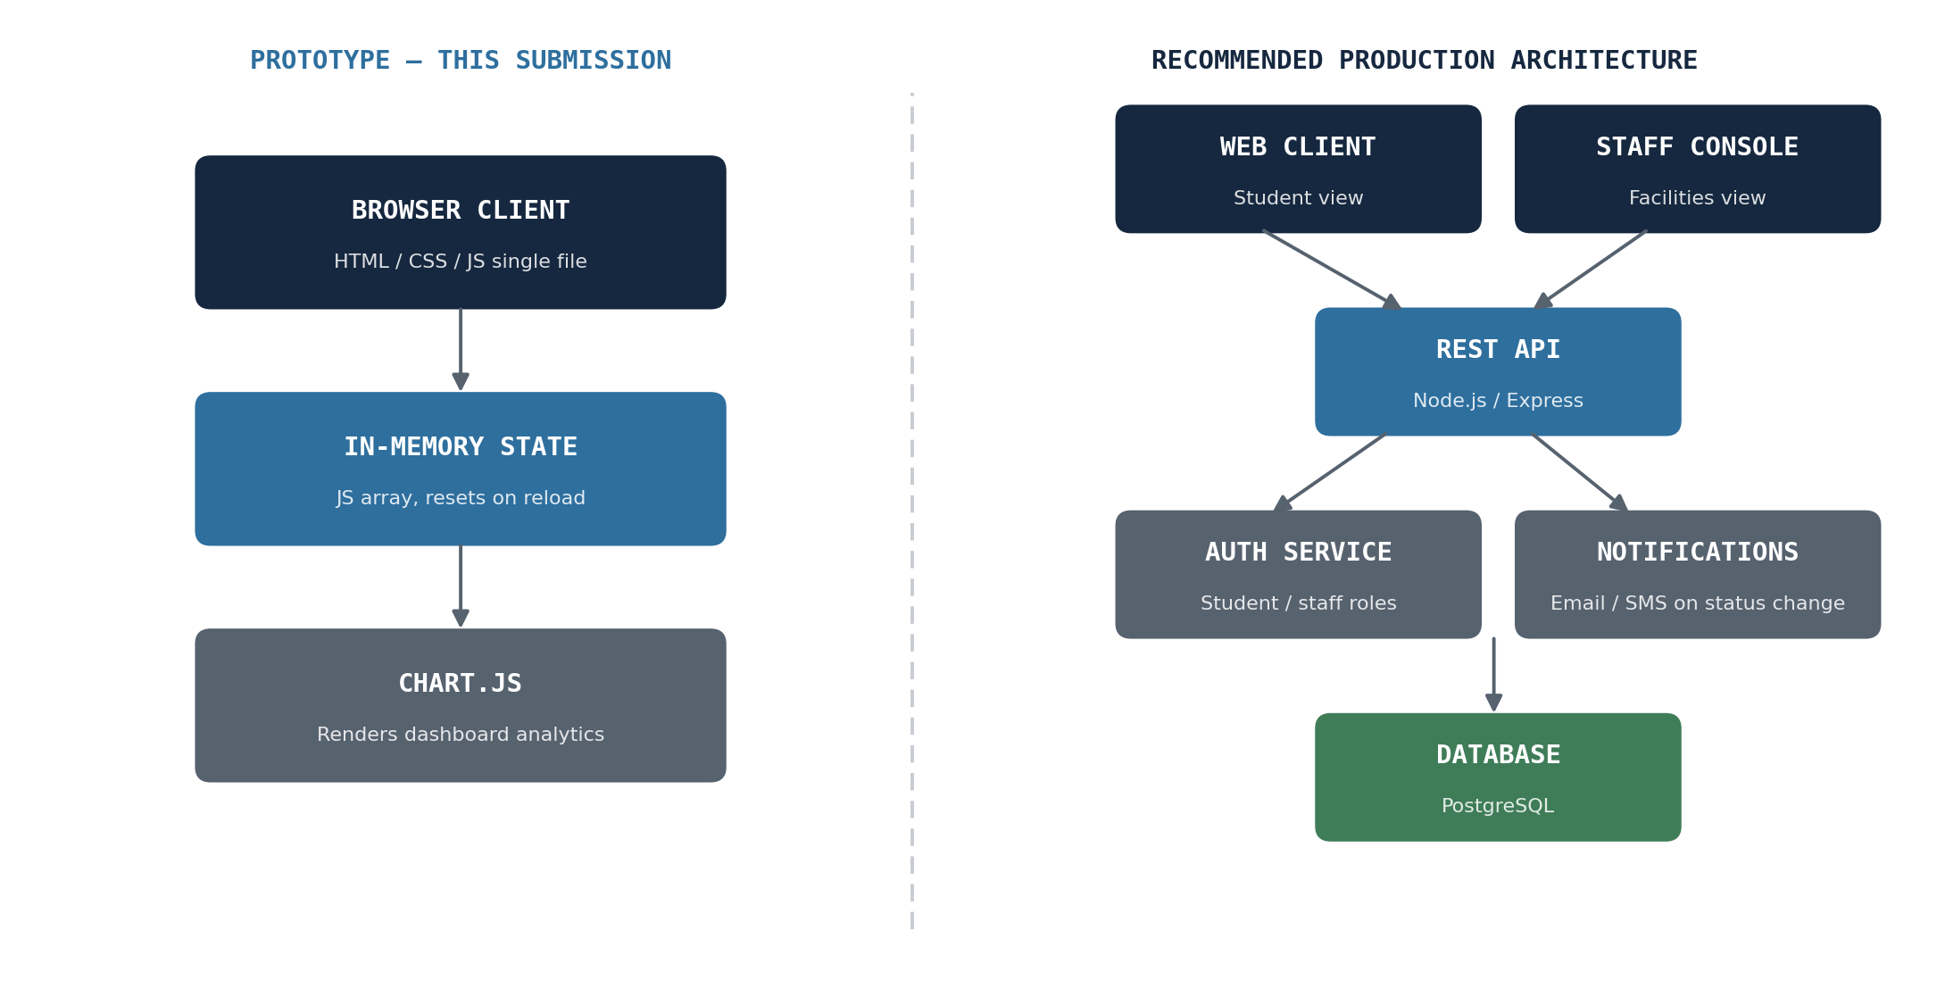
Figure 1. Prototype architecture (left) versus the recommended production architecture (right).
In production, the browser client would talk to a REST API backed by a relational database, with a dedicated authentication service handling student/staff login and a notification service emailing or texting reporters when their ticket's status changes.

7. User Roles & Permissions
Capability | Student | Facilities Staff
File a work order | Yes | Yes
View all tickets | Yes | Yes
Change a ticket's status | No | Yes
Add a resolution note | No | Yes
View the analytics dashboard | Yes | Yes
The prototype simulates this with a visible role toggle rather than a login, so the permission difference can be demonstrated instantly without setting up test accounts.

8. Work Order Status Flow
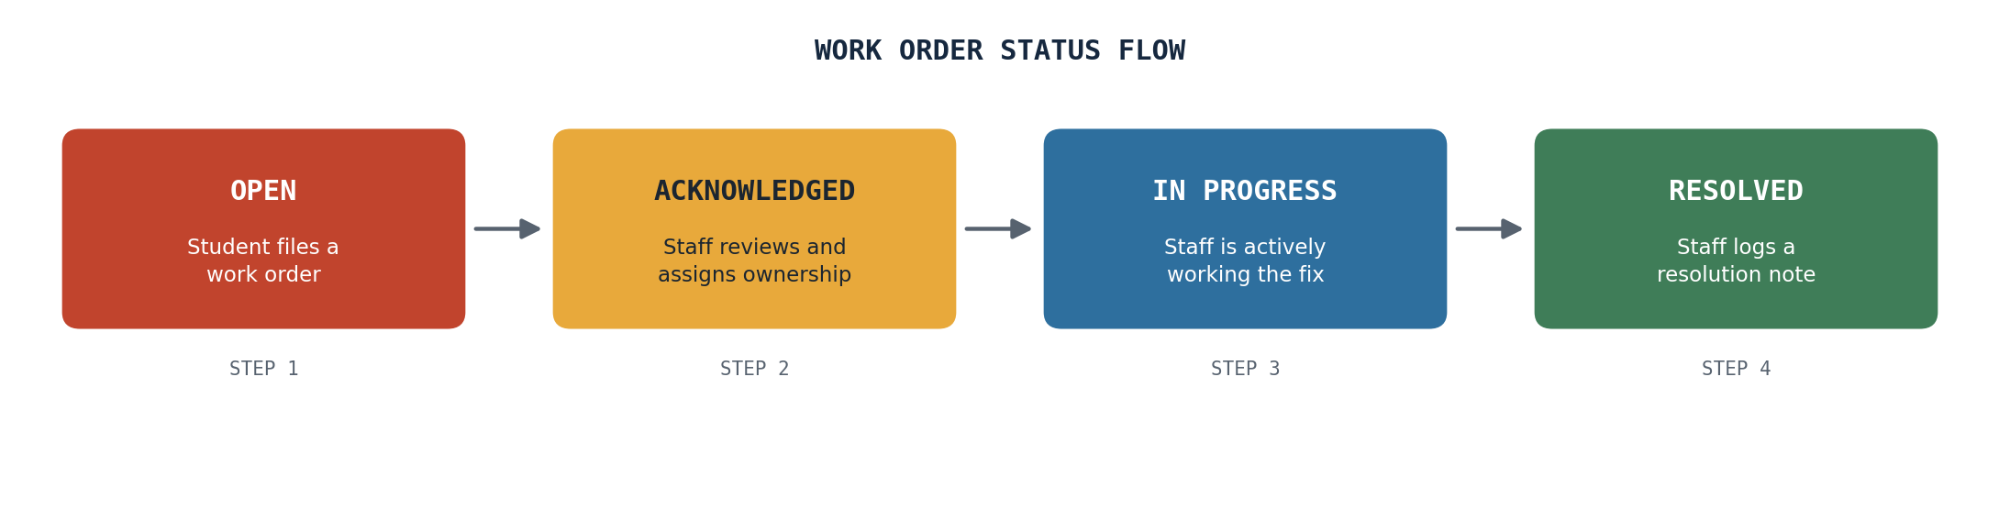
Figure 2. Every ticket moves through the same four stages, each timestamped for accountability.
Because each stage is timestamped, the dashboard can compute how long tickets spend open before resolution — the single most useful number for a facilities manager deciding where to add staff or budget.

9. Data Model
Each report is stored as a single issue record with the following fields:
Field | Type | Notes
id | String | Auto-generated, e.g. WO-0013
category | Enum | Electrical, Plumbing, Furniture, IT & Wi-Fi, HVAC, Structural, Cleaning, Other
building / room | String | Free-text location
description | String | The reporter's account of the issue
urgency | Enum | Low, Medium, High
reporter | String or null | Null when reported anonymously
status | Enum | Open, Acknowledged, In Progress, Resolved
reportedDate | Date | Set automatically at submission
resolvedDate | Date or null | Set automatically when marked Resolved
resolutionNote | String or null | Captured from staff when resolving

10. Technology Stack
Layer | In this prototype | Recommended for production
Frontend | HTML5, CSS3, vanilla JavaScript in one portable file | React or Vue, for a larger codebase
Charts | Chart.js, loaded from a CDN | Chart.js or Recharts
Data storage | In-browser memory only (resets on refresh) | PostgreSQL or MySQL behind a REST API
Backend | None — logic runs entirely client-side | Node.js / Express (or Django, Laravel)
Authentication | A visible role toggle, for demonstration | Institutional single sign-on or student/staff ID login
Hosting | Open the file directly in any browser | University server, or Render / Vercel / Netlify

11. How to Run the Prototype
- Open facilities-desk.html in any modern browser (Chrome, Edge, Firefox, Safari) — no installation or server required.
- An internet connection is only needed the first time, to load the page fonts and the Chart.js library from their CDNs.
- Use the Student / Facilities Staff toggle in the top-right to demonstrate the permission difference.
- Because data lives only in browser memory for this prototype, refreshing the page resets it to the seeded sample tickets — this is a deliberate scope choice, not a bug, and is addressed in Section 10 above.

12. Suggested Presentation Flow
A short script for walking an audience through the prototype live:
- Open on the Report tab. State the problem in one sentence: facility issues get mentioned, not tracked.
- File a real work order live — e.g. a broken projector in a named room — and point out the instant ticket number.
- Switch to Work Orders. Filter by High urgency to show triage at a glance.
- Switch role to Facilities Staff, open a ticket, advance its status, and add a resolution note.
- Switch to Dashboard and show the charts update immediately — this is the data the university didn't have before.
- Close with the architecture diagram (Section 6) to show this is a prototype with a clear path to production, not a dead end.

13. Future Enhancements
- A real backend and database, so tickets persist across sessions and devices.
- Login via institutional student/staff ID or single sign-on, replacing the demo role toggle.
- Photo attachments on reports — a picture of a broken fixture speeds up triage significantly.
- Automatic email or SMS notifications when a tracked ticket changes status.
- Escalation rules — a High-urgency ticket untouched after 48 hours is automatically flagged to a supervisor.
- A building-level heatmap view, to make recurring-problem hotspots obvious at a glance.
- A mobile-first Progressive Web App version, since most reports happen on the way past the problem, on a phone.

14. Limitations of This Prototype
- No persistent backend: data resets on page refresh. This was a deliberate scope decision to focus the available time on workflow and interface design, described fully in Section 6.
- No real authentication: the Student / Facilities Staff toggle simulates the permission difference a production login system would enforce.
- No file or photo attachments yet — listed under Future Enhancements.
- Sample tickets are seeded for demonstration; in real use, the board would start empty.

15. Conclusion
Facilities Desk targets a problem every campus already has and almost nobody tracks. It doesn't require new hardware, sensors, or budget to pilot — only a shared habit of logging what's broken instead of just mentioning it. The prototype in this submission demonstrates the full reporting-to-resolution workflow end to end, and this document lays out exactly what would need to be added — authentication, persistence, and notifications — to take it from a class assignment to a tool a real facilities department could run on.

