From Source to SQL

560+ transcriptions of Jude into 1 database

Dirk Roorda
2012-11-13
version 1.0

- Introduction 1
- Source 1
- Step 1: to UNICODE 1
- Step 2: layered markup, anchored by position 1
- Step 3: sql import file of layered markup 1
- Next steps 1
  - Exercise: nomina sacra 1
  - Collation 1

Introduction
This document describes the generated content of the dataset urn:nbn:nl:ui:13-qxf4-1v containing 560+ manuscript transcriptions of the New Testament epistle of Jude. It describes the source and successive stages of conversion into a file that can be loaded into a MySQL database. We motivate the choice of data model as well.

Source
The transcription sources have been produced by the contributor of this dataset, Dr. Tommy Wasserman, who wrote the monograph The Epistle of Jude: Its Text and Transmission. ConBNT 43. Stockholm: Almqvist & Wiksell International, 2006. They are transcriptions from microfilm of all the Greek manuscripts that contain passages of the epistle of Jude. Tommy offered his own version of these transcriptions -as is- to Dr. Jan Krans and me for exploratory purposes. They came in the form of text files in a non-standard encoding. Due to the software that was originally used (Collate 2.0), the greek text was represented in Symbol Greek, not UNICODE. That is absolutely fine when using Collate 2.0, but not very interoperable with UNICODE-aware applications. So we converted all greek text to real UNICODE greek. Here is a screenshot.
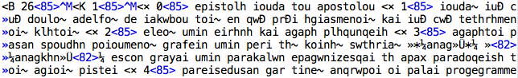
These files are not included in this dataset.
In his book, Tommy has provided a list of the provenance of the original manuscripts, containing the year of creation and the places where they lie stored now. This list, in plain text , tab-delimited, is also included in the dataset. See screenshot.
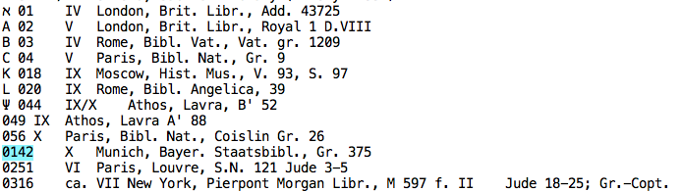

Step 1: to UNICODE
The first step by Jan and I was to transform the original files into one file in UNICODE, with real unicode greek characters. We treated comments carefully, in order not to greekify texts that were after all latin. We detected all markup, checked it, and rewrote it as XML tags. The result is the file transcriptions.txt in this dataset. Here is a screenshot.
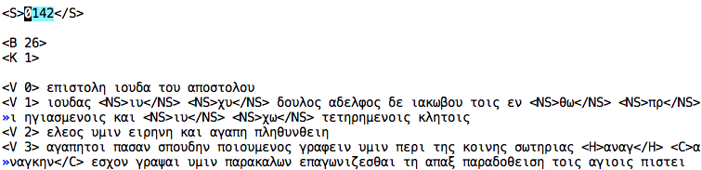
The source code of this conversion plus a complete log and a summary of the activities of this script has been added to the dataset: see the folder conversion and in there the files transform.pl and transform.log and summary.log.

Step 2: layered markup, anchored by position
The next step was to split the material in layers. Every passage has a source layer, containing the primary text. Every character in the source layer has a fixed character position, a number.
Everything else goes into other layers: markup layers, comment layers and nomina sacra layers.
Material in other layers have character positions that correspond to the character positions in the source layer.
At the same time, we merged the provenance information into the transcription data.
A visual representation of the result is contained in the file graphpaper.txt, in this dataset.
Here is a screenshot.
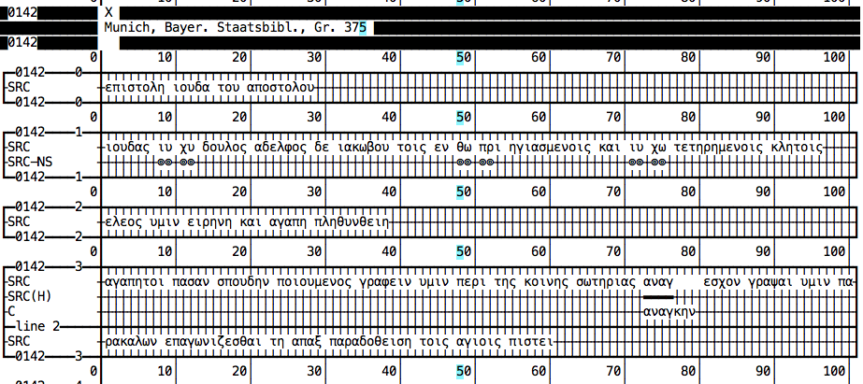

A numerical representation has also been generated, (not present in the dataset), but here is a screenshot for the sake of exposition.
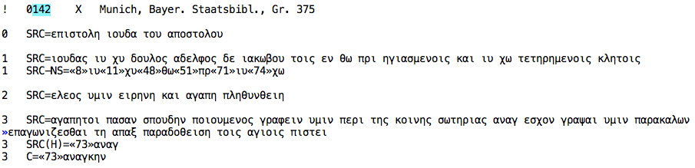

Step 3: sql import file of layered markup
The final step has been to transform the numerical representation into a real database model.
The text has been divided into passages (verses). The contribution of every source (manuscript) to a passage consists of a set of layers.
Each layer contains characters at certain positions. The complete datamodel is shown in the screenshot next.
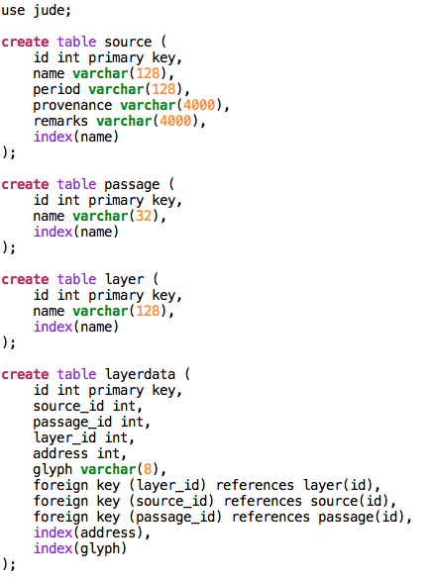
So every single character in every single manuscript occupies a layerdata record. This layerdata record contains also the address (position) of the character (relative to the character positions in the source layer).
Moreover, the layerdata record is linked to the corresponding source record, passage record, and layer record.
Below is a screenshot of a small fragment of the layers.sql file, which is included in the dataset.
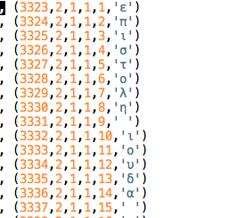

Next steps
So far for the contents of this dataset. The question is: what can you do with it?

Exercise: nomina sacra
A first exercise is to get all nomina sacra of the main text. The following sql query will do the trick:

use jude;

select
layerdata.address,
layerdata.glyph,
source.name,
passage.name
from
layerdata inner join source
on layerdata.source_id = source.id
inner join passage
on layerdata.passage_id = passage.id
inner join layer
on layerdata.layer_id = layer.id
where
layer.name = 'SRC-NS'
order by
passage.id,
source.name,
layerdata.address
;

and the initial part of the result is:
address | glyph | name | name
8 | ι | 142 | 1
9 | υ | 142 | 1
11 | χ | 142 | 1
12 | υ | 142 | 1
48 | θ | 142 | 1
49 | ω | 142 | 1
51 | π | 142 | 1
52 | ρ | 142 | 1
71 | ι | 142 | 1
72 | υ | 142 | 1
74 | χ | 142 | 1
75 | ω | 142 | 1
8 | χ | 49 | 1
9 | υ | 49 | 1
11 | ι | 49 | 1
12 | υ | 49 | 1
48 | θ | 49 | 1
49 | ω | 49 | 1
51 | π | 49 | 1
52 | ρ | 49 | 1
71 | ι | 49 | 1
72 | υ | 49 | 1
74 | χ | 49 | 1
75 | ω | 49 | 1
8 | ι | 56 | 1
9 | υ | 56 | 1
11 | χ | 56 | 1
12 | υ | 56 | 1
48 | θ | 56 | 1
49 | ω | 56 | 1
51 | π | 56 | 1
52 | ρ | 56 | 1
71 | ι | 56 | 1
72 | υ | 56 | 1
74 | χ | 56 | 1
75 | ω | 56 | 1

Collation
The following task could very well be: use modern collation software (such as CollateX) to collate the source layer. Based on the collation results build a table that links character positions in one source to character positions in another source.
This will yield an enormous web of interrelated character positions. If this web is stored as a new database table as well, then we have a starting point to build convenient visualizations of all the material that is relevant to a researcher of the passages of Jude.

