**Instructions for Materials Studio 2025**

1. Location of the Workstation (**pmi-versalabdct**): IAC Room 027D

2. Open Materials Studio (click the icon from the taskbar)



3. Select either “**Create a new project**” or “**Open an existing project**“ (please save all projects under your own folder). The UI of MS 2025 looks like the following:

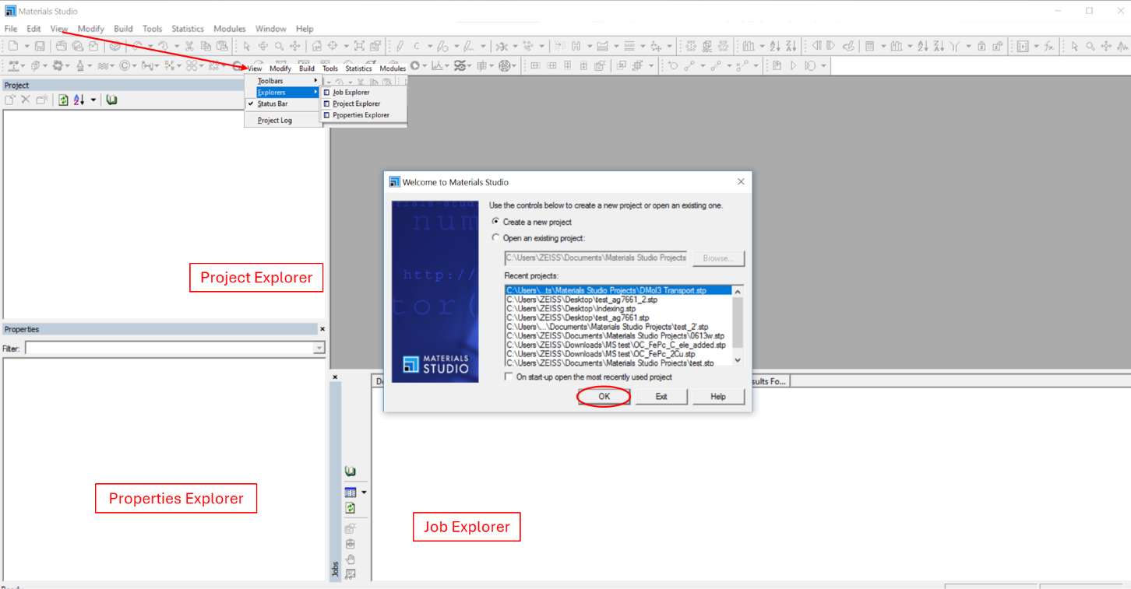

Sometimes, users may accidentally close a window (or Explorer) and then aren’t sure how to bring it back. In that case, go to **View** 🡪 **Explorers** to open or close specific windows.

Also, the latest MS tutorials (MS_tutorials_2025.pdf) is available on the desktop:

5. Before you start:

Since this Workstation is publicly accessible, ALWAYS reset all settings before use as you won’t know what changes previous users made. To do this, go to “**Tools** 🡪 **Settings Organizer** 🡪 select your project name 🡪 click “**Reset**”

6. Depending on what kind of calculation you want to run, find the corresponding chapter and follow it step by step. Once you are familiar with the software, you can build your own models.

**Common Q&A (continuously updated with new questions):**

Q1: Where can I find the sketching tool? How can I create a molecule from scratch?

A1: First, go to **File** 🡪 **New** 🡪 double-click **3D Atomistic 🡪** the sketching tool is on the toolbar

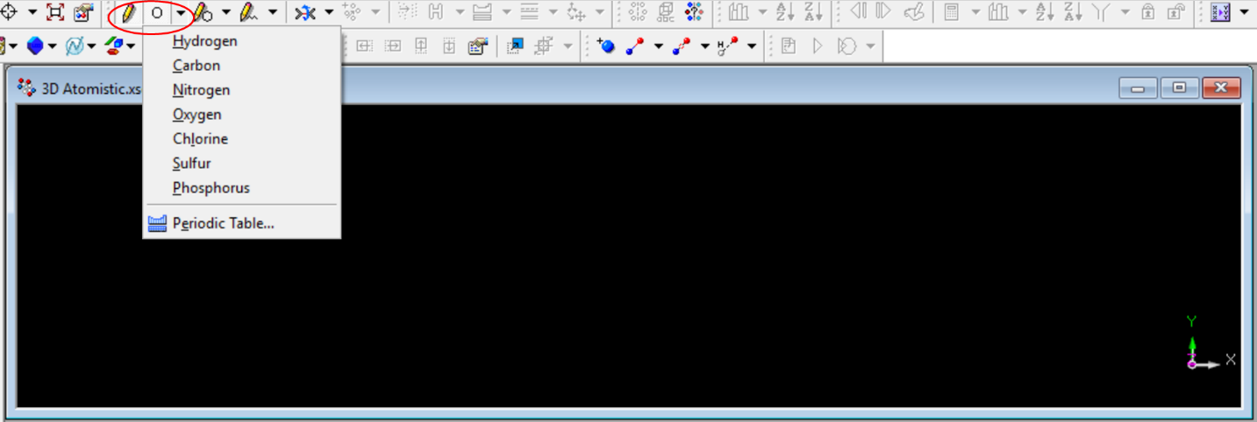

Common elements are listed here. You can also add any element you like by clicking “**periodic table**.”

To add an atom (e.g., sulfur), select “Sulfur” from the list, left-click in the “3D Atomistic.xsd*” window, and then right-click or press “Esc” to confirm. Here, the “+” symbol indicates the S atom.

To build a molecule (e.g., SO2), manually add two O atoms bonded to S. Select “Oxygen” from the list, left-click near the S atom, then left-click on S to form the bond.

Next, add the second O atom on the opposite side:

Apparently, the two S=O bonds are not equivalent. This is normal. We will address this in a later step.

Next, select the “3D Viewer Selection Mode,”

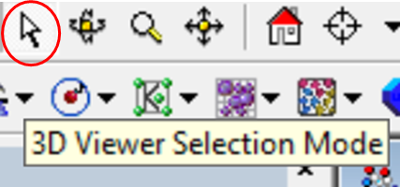

Since SO2 has double bonds, click the middle of one bond, manually change the bond order from 1 to 2, and set the bond type from single to double.

Now, let’s make the structure look better. Simply click “**Clean**.”

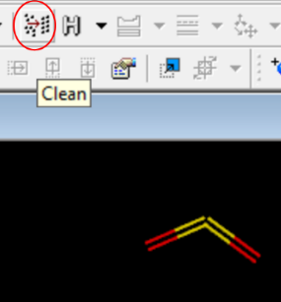

Finally, to optimize the structure, select **Module** 🡪 **Forcite** 🡪 **Calculation** from the menu bar to open the Forcite Calculation dialog. On the **Setup** tab, change the *task* to **Geometry Optimization** and the *Quality* to **Fine**. Select the **Energy** tab and change the *Forcefield* to **COMPASSIII**. Click **Run**.

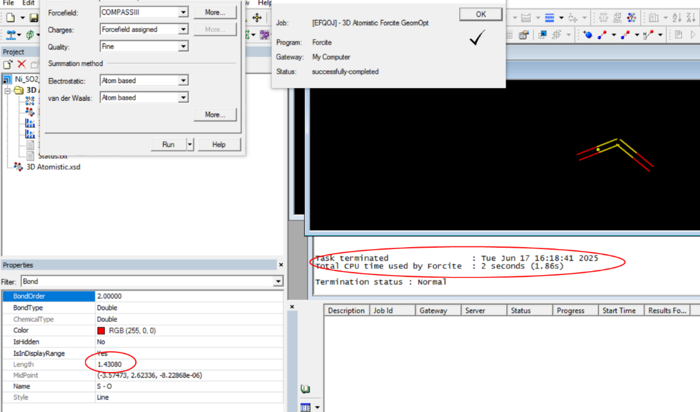

Here, the calculated bond length is 1.43080 Å, in good agreement with the experimental value of 1.43 Å.

Finally, if you don’t like the display style, right-click in the structure window, and select **Display Style**, then you canchoose any style you like, e.g., **Ball and stick**:

Q2: The tutorial mentions “ensure xxx is the active document” and “make xxx the active document” many times, what do they mean? What should I do?

A2: Simply left click the document.

Q3: Where are the example documents? I cannot find them.

A3: C:\Program Files (x86)\BIOVIA\Materials Studio 25.1\share

Q4: How can I request more cores/processors to speed up my calculations?

A4: Parallel calculations may not always be available. If they are, go to **Job Control**, adjust the # of cores. For this specific workstation, the maximum # of cores you can request is 20. However, for small jobs (e.g., optimizing a small molecule), using more cores can sometimes slow down the calculations.

Q5: I noticed that MS’s default diffraction data format is .xcd, which differs from the format of the data I collected at IAC (.raw). How should I convert my data so that MS can read it correctly?

A5: MS can directly read the .raw format and will automatically convert it to .xcd. See below:

