**Read Me**

**Project Overview**

This database project is designed to manage and store information related to sports teams, players, stadiums, and games. The system tracks details for each team, player, stadium, and game, ensuring that unique identifiers are used for efficient data management and retrieval.

**Teams**

Each team in the database is uniquely identified. The database stores the following attributes for each team:

- Team Name

- City

- Coach's Name

**Players**

Players are assigned unique identifiers in the database. The following attributes are stored for each player:

- Full Name

- Position

- Date of Birth

- Team Association (Each player belongs to one specific team)

**Stadiums**

The database tracks various stadiums, each with a unique identifier. The following attributes are stored for each stadium:

- Stadium Name

- Capacity

- Location

**Games**

Games are organized with unique game IDs. The database stores the following information for each game:

- Game Date

- Scores for both participating teams

- Teams that participated in the game

- Associated Stadium (Each game is played in a specific stadium)

**Testing the Project**

To test the project, follow these steps and business rules to ensure the database runs correctly and data is properly stored and retrieved. By following the business rules, you can verify that the database is functioning as it should be.

Query 1:

**-- Who are the players on the MD soccer team?**

SELECT playerId AS "Player ID",

playerName AS "Player Name"

FROM Player

WHERE teamId = '1';

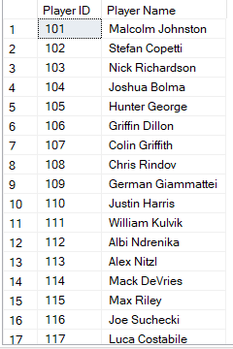

Query 2:

**-- Which games took place in a specific stadium?**

SELECT gameId AS "Game ID",

gameDate AS "Game Date",

teamId1 AS "Team 1 ID",

teamId2 AS "Team 2 ID"

FROM Game

WHERE stadiumId = '003';

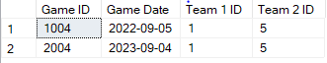

Query 3:

**-- What was the score of a particular game?**

SELECT gameScore1 AS "Team 1 Score",

gameScore2 AS "Team 2 Score"

FROM Game

WHERE gameId = '1001';



Query 4:

**-- Which teams are assigned to a specific coach?**

SELECT teamName AS "Team Name",

teamCity AS "Team City"

FROM Team

WHERE teamCoach = 'Tim O Donohue';



Query 5:

**-- What games were played in stadiums with a capacity exceeding 5000?**

SELECT gameId AS "Game ID",

gameDate AS "Game Date",

teamId1 AS "Team 1 ID",

teamId2 AS "Team 2 ID"

FROM Game

WHERE stadiumId IN (

SELECT stadiumId

FROM Stadium

WHERE stadiumCapacity > 5000

);

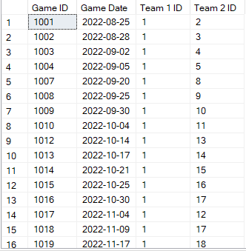

Query 6:

**-- What is the highest scoring game in a specific stadium?**

SELECT TOP 1 gameId AS "Game ID",

gameDate AS "Game Date",

(gameScore1 + gameScore2) AS "Total Score"

FROM Game

WHERE stadiumId = (

SELECT stadiumId

FROM Stadium

WHERE stadiumName = 'Ludwig Field'

)

ORDER BY (gameScore1 + gameScore2) DESC;



**Data Source**

*UMD Soccer Team Data*. University of Maryland Athletics. (n.d.). https://umterps.com/sports/mens-soccer/schedule