

**Manual**

**DoubleClue Developer’s Guide (Android)**

**Version: 2.1.0**

**Contents**

1. About this Guide 3

2. Introduction 3

2.1 App-GUI 3

2.2 SDK-Library 4

3. Requirements 4

4. Distribution File and Artifacts 4

5. DCEM Files 4

5.1 “TrustStore.pem” 5

5.2 “SdkConfig.as” 5

6. Creating the DoubleClue Android App Step by Step 6

6.1 Creating a new Android Studio Project 6

6.2 Changes in the Module “app build.gradle” 8

6.3 Changes in the Project “build.gradle” 9

6.4 Creating a new Android Studio Project 9

6.5 Starting the App 9

7. DoubleClue SDK-API 9

7.1 Initialization 9

8. Setting up Push Notifications 10

# About this Guide

This guide is intended for Android app developers to build the DoubleClue App in a few steps.

A good understanding of Android Studio and Gradle as well as JAVA knowhow is required.

# Introduction

Android is one of the client platforms supported by DoubleClue. With the DoubleClue Android App, the user will be able to register at and login to DoubleClue Enterprise Management (DCEM). After login the user can receive messages and send back signed message responses.

The DoubleClue App consists of two main parts:

* App-GUI
* DoubleClue SoftwareDevelopmentKit (SDK) Library

**App GUI**

Open Source

**DoubleClue SDK-Library**

(Security & Communication)

**DC SDK-API**

## App-GUI

The App-GUI is the Android App itself with all user interfaces and GUI navigations. This is a paradigm of a typical DoubleClue App which is delivered in source files. You are free to change the sources according to your needs after signing the DoubleClue License agreement.

## SDK-Library

The SDK-Library is responsible for all cryptography and communication security with DCEM. The library is delivered in “**.aar**” format. The interface between the App-GUI and the SDK-Library is the DoubleClue SDK-API.

Please see chapter 7. DoubleClue SDK-API for more details.

# Requirements

* Java 1.8.xx
* Android Studio Version 3.0 or higher

# Distribution File and Artifacts

The distribution file “**DoubleClueAndroid.zip**” contains the following files and folders:

* Folder: “**src**”  
  This folder contains the complete source structure for the App-GUI.
* File: “**LibDCSdk-release.aar**”  
  This is the DoubleClue SDK library which needs to be included into your app.
* File: “**DC_Dev_Guide_Android.pdf**”  
  This is the documentation on hand.
* File: “**google-services.json**”  
  This file is just an example. You have to register at Google Firebase Push Notification services and replace this file with your own “google-services.json” file. Please see chapter 8. Setting up Push Notifications for more details.

# DCEM Files

In order to create a secure connection to DCEM, you will need two files from the DCEM installation, “**SdkConfig.as**” and “**TrustStore.pem**”. These files have to be copied into the folder “**src/main/assets**”.

## “TrustStore.pem”

This file contains the DCEM Root-Trust X.509 certificates in PEM format. These are required to establish a secure SSL/TLS connection to DCEM or the DCEM Load Balancer. If SSL/TLS is terminated at the Load Balancer, you have to retrieve the file from the Load Balancer, else you need to download this file from DCEM (main menu “System”, sub menu “KeyStores”, button “Download as PEM”).

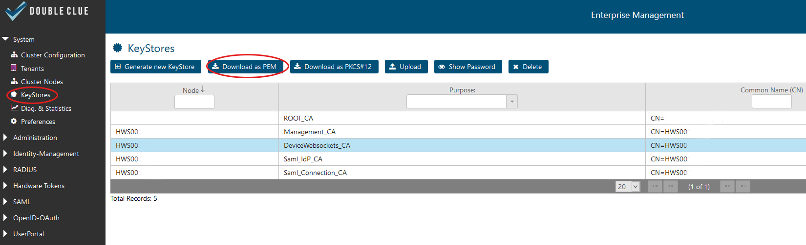

For more information please have a look at the DCEM Manual (“**DCEM_Manual_EN.pdf**”) or ask your DCEM administrator.

## “SdkConfig.as”

C:\Users\maike.behnsen\Desktop\Grafiken\caution-sign.pngThis file contains several secure pieces of information which are required to establish a trust connection to your DCEM installation: the Server URL, the public-Key of the trust DCEM and other secure information.

The file is signed and any changes made in it will corrupt the file contents.

Note: DoubleClue uses an extra X.509 trust certificate infrastructure between SDK-Clients and DCEM, which is independent from the SSL/TLS certificates.

The file has to be downloaded from DCEM (main menu “App-Management”, sub menu “Versions”, button “Generate SDK-Configuration”).

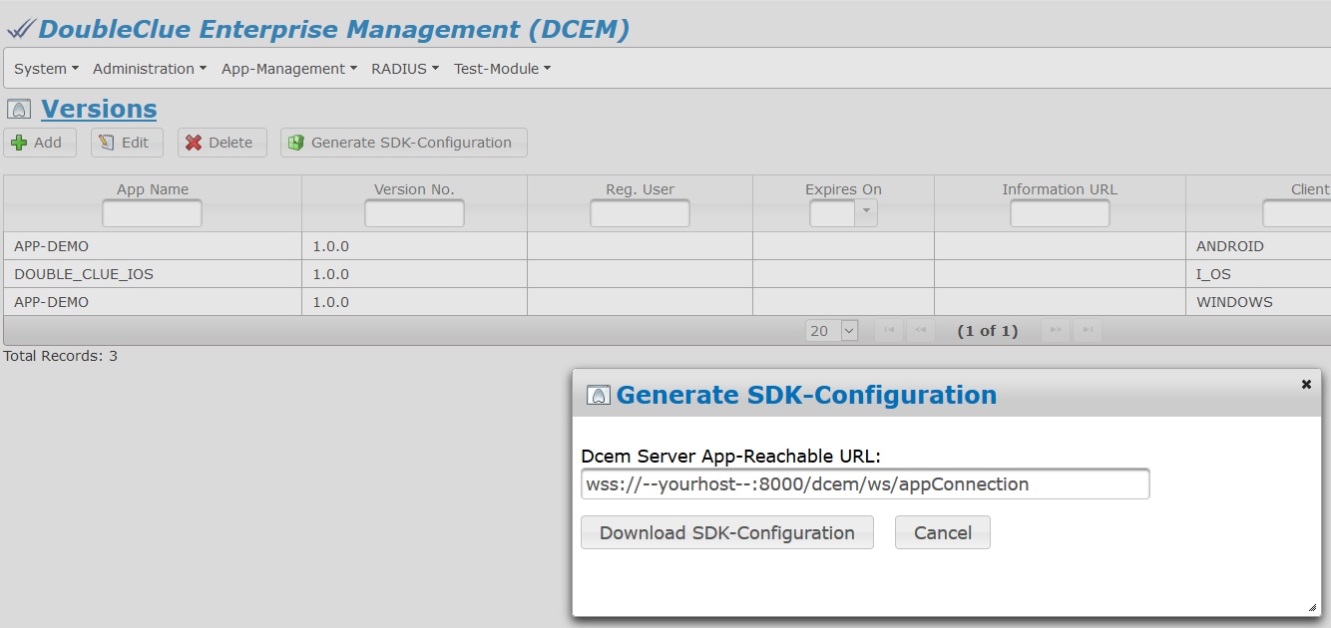

For more information please have a look at the DCEM Manual (“**DCEM_Manual_EN.pdf**”) or ask your DCEM administrator.

# Creating the DoubleClue Android App Step by Step

## Creating a new Android Studio Project

Note: The standard package name is: “**com.doubleclue**”

C:\Users\maike.behnsen\Desktop\Grafiken\caution-sign.pngIf you need to change the package name, you will need to change the JAVA package name in all sources files as well.

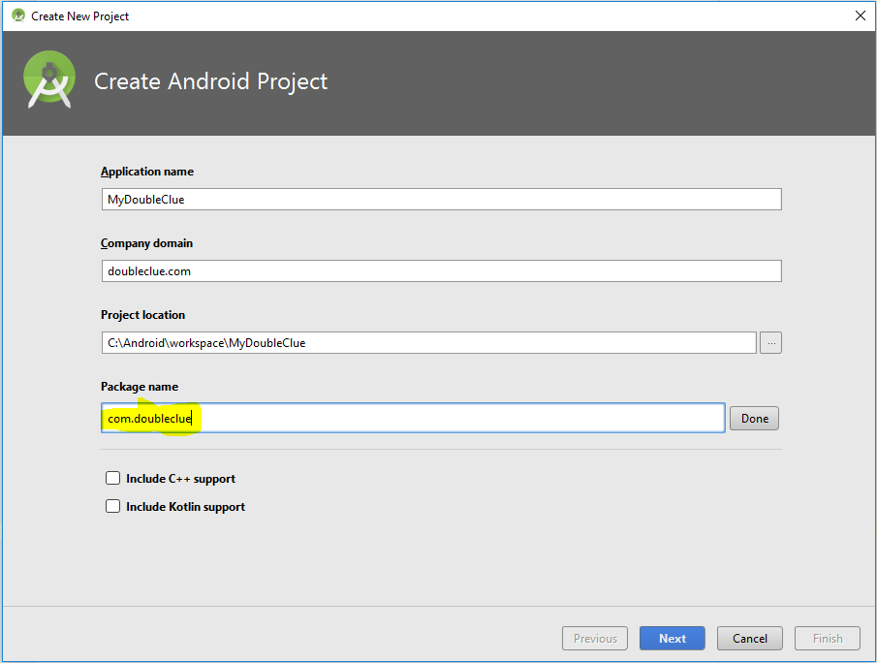

Set the API version to API 19: Android 4.4 (KitKat)

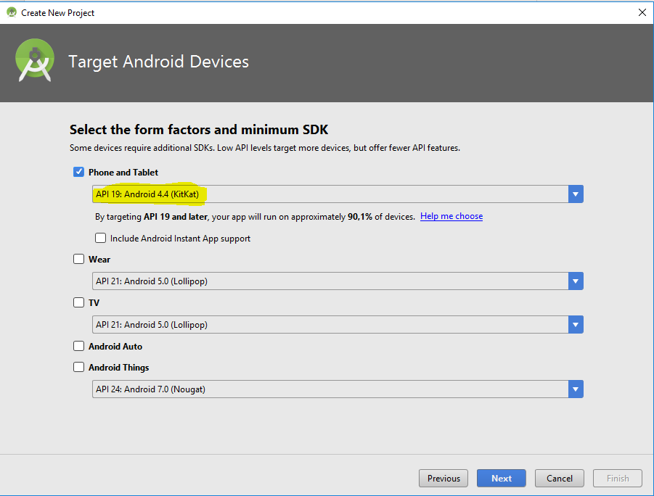

For “*Layout*” just select “*Empty Activity*”. This will create the project and with the next steps the default sources will be overwritten.

1. Replace the folder “**src**” from the Android Studio project directory with the “**src**” folder from the DoubleClue delivery package.

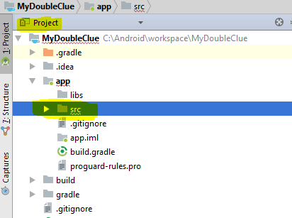

1. Open the “*File-Menu*” and from there the window “*Project Structure*”:
2. Click on “+” in the upper left corner in order to add a module library.
3. Select “**Import JAR/.AAR Package**”.
4. As “*File name*” choose the “**LibDcSdk-release.aar**” file from the DoubleClue delivery package and click on “*Finish*”.

Now click on “*App-Dependencies*” and on the upper right “+ *Module dependency*”  
and choose “**:LibDcSdk-release**”:

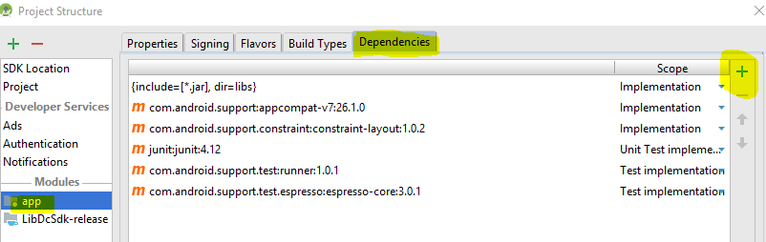

## Changes in the Module “app build.gradle”

Add the following entries in the section “*Dependencies*”:

compile **'com.android.support:appcompat-v7:26.1.0'**compile **'com.android.support:multidex:1.0.2'**compile **'com.android.support:design:26.1.0'**compile **'com.google.android.gms:play-services:11.4.2'**compile **'com.android.support:support-v4:26.1.0'**compile **'com.google.firebase:firebase-messaging:11.4.2'**

At the end of the file, add

apply **plugin**: **'com.google.gms.google-services'**

The App version must have three subversions *Major.Minor.Service*.   
Change the parameter “**versionName**“ to “**1.0.0**”.

Add the following lines in the section “*DefaultConfig*”:  
  
vectorDrawables.useSupportLibrary = **true**multiDexEnabled = **true**

Add the line below at the end of the file:

apply **plugin**: **'com.google.gms.google-services'**

## Changes in the Project “build.gradle”

In the file “*Project: build.gradle*” and add the line below in the section “*Dependencies*”:

classpath **'com.google.gms:google-services:3.1.0'**

## 6.4 Creating a new Android Studio Project

Copy the file “**google-services.json**” from the DoubleClue delivery package to the directory “**app**”. This file has to be replaced if you intend to use Push Notifications from Google Firebase.

Please see chapter 8. Setting up Push Notifications for more details.

## 6.5 Starting the App

The app installation is complete.

Now you can start the app in a simulator or with a device. After the start, the Activation view will be displayed. To activate the device you will need the registered DoubleClue user login ID, an activation code and the user password.

Please contact your DCEM administrator for more information.

# DoubleClue SDK-API

This is an overview about the interface between the DoubleClue GUI and the DoubleClue Library.

You can find a detailed JAVA-Doc for the DoubleClue SDK-API in the DCEM installation directory:

..**DcemInstallation\doc\AppDcSDK**

## Initialization

The first step is to get an instance of the “**AppSdkImpl**”:

1. AppSdkImpl appSdkImpl = AppSdkImpl.getInstance();
2. AppSdkListnerImpl appSdkListnerImpl = new AppSdkListnerImpl(this);
3. *appSdkImpl*.initialize(new AsVersion(*APP_NAME*, BuildConfig.*VERSION_NAME*), appSdkListnerImpl, appProperties, sdkConfig, keyStoreBytes);
4. *appSdkImpl*.getActivatedUsers();

# Setting up Push Notifications

DCEM has the ability to send Push Notifications to Android devices. DCEM sends Push Notifications to all user devices when it receives a message and all devices are in offline mode. The DoubleClue App and DCEM use ***firebase.google.com*** as their Push Notification provider.

In order to receive a Push Notification you have to create a Firebase project first.

If no app with Firebase exists as yet, create a new Firebase project for the app.

Add the app and in doing so store the package name and the SHA1 value as well.

* The SHA1 value is the unique computer identification number which you will find in Android Studio.
* The file “**google-service.json**” is created automatically when the app is added.

Import the file “**LibDcSdk.aar**”, which you will find in the project structure of your project, into the folder “**app**”.

Download the file “**google-service.json**” and save it in the Android project folder.

Download the configuration file for Push Notifications from Google Firebase and implement it according to the instructions from Google.

Login to DCEM. Insert the server key of the Firebase project into the field “*Firebase Cloud Messaging Key*” (main menu “App-Management”, sub menu “Preferences”).

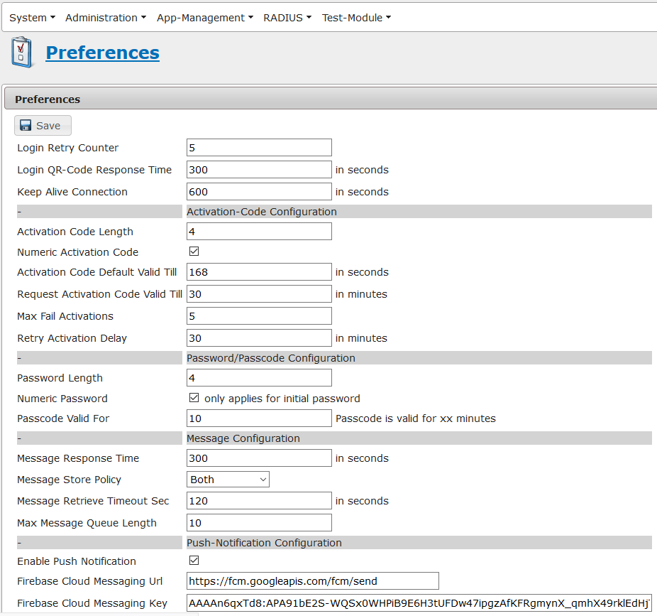

For more information please have a look at the DCEM Manual (“**DCEM_Manual_EN.pdf**”) or ask your DCEM administrator.