

**Manual**

**PortalDemo**

**Installation & Functionalities**

**Version: 2.1.1**

Contents

1. Introduction 3

2. Installation & Launch 3

2.1 Hardware Requirements 3

2.2 Installation of PortalDemo 3

2.3 Configuration 4

3. Functionalities of PortalDemo 5

3.1 Calling up PortalDemo 5

3.2 Installation of the DoubleClue App 5

3.3 Registration as a DoubleClue User 5

3.4 Activation of the DoubleClue App 7

3.5 Login to PortalDemo 8

3.5.1 Login with Transaction Message 8

3.5.2 QR Code Login 9

3.5.3 Offline Login with Passcode 10

3.5.4 Offline Login with RADIUS 12

3.6 Example for Money Transfer 13

# Introduction

DoubleClue PortalDemo is a software for testing purposes with which you can test some functions of the product DoubleClue without having implemented the software in your client portal beforehand.

PortalDemo is a JAVA Web Application based on Tomcat Version 8.

It communicates with DoubleClue Enterprise Management (DCEM) by using REST-Web Services.

The library “**LibRestDcClient**”, which is integrated into PortalDemo, will do the REST-Web Services implementation and offers a JAVA API to PortalDemo.

**LibRest**

**DcClient**

**PortalDemo**

**DCEM**

# Installation & Launch

## Hardware Requirements

* RAM: Minimum of 2 GB
* Hard Drive: Minimum of 5 GB

## Installation of PortalDemo

In order to run PortalDemo, you need to set up, install and start DCEM beforehand (see DCEM Manual: “**DCEM_Manual_EN.pdf**”).

PortalDemo is installed together with the installation of DCEM. If you do not use the DoubleClue Windows Installer or if you use a Linux operating system, do the following:

1. Go to the delivered DCEM software package and open the folder “**bat**” if you use a Windows operating system or the folder “**sh**” if you use a Linux operating system in the delivered DCEM software package.
2. Start PortalDemo as a service by executing the file “**installPortalDemoService.bat**” or “**installPortalDemoService.sh**”.

If you want to run PortalDemo as an application, execute the file “**runPortalDemoApplication.bat**” or “**runPortalDemoApplication.sh**”.

Before being able to use PortalDemo, you have to configure it. See next chapter.

## Configuration

You can make the configuration via the following URL:

**http://localhost:--Port--/PortalDemo/portalConfig.xhtml**

“--Port--”: By default, “8080” is set as the port of a REST-Web Services connection.

Host REST-Web Services URL:

**https:// *--DCEM host name/IP--* : --Port-- /dcem/restApi/as**

Operator:

Determine the operator who should have access to PortalDemo via the REST-WebServices interface.

C:\Users\maike.behnsen\Desktop\Grafiken\caution-sign.pngBy default, at the installation of DCEM an operator “RestServicesOperator” is created which has privileges to access the “restWebServices”.

After installation this operator has the same password as the DCEM “SuperAdmin”.

Instead of the proposed operator you can create a new operator in DCEM as well.

Operator Password:

Set a password for the REST-Web Services operator.

Connection Timeout:

Specify after how many seconds of inactivity the user will be logged out of PortalDemo.

RADIUS

If you intend to test RADIUS authentication, please configure the RADIUS settings and create a RADIUS-NAS Client in DCEM.

PortalDemo is now ready for use.

The configuration has to be made only once. It is solely available in English.

# Functionalities of PortalDemo

## Calling up PortalDemo

Open your browser and enter the following URL:

**http://localhost:8080/PortalDemo**

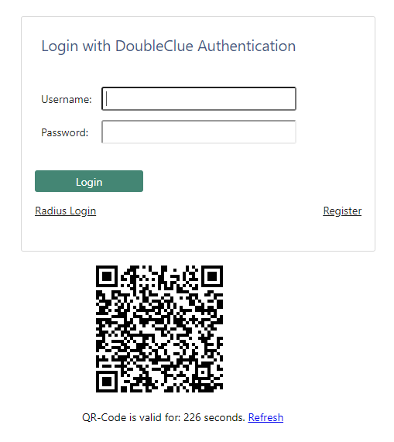

## Installation of the DoubleClue App

The DoubleClue App is the app component of PortalDemo. It can be used on the smart device of your choice (smartphone, tablet, notebook). The DoubleClue App is needed to confirm for example login attempts or transactions.

It is available for Android (from version 5.0 onwards), iOS and Windows.

To install DoubleClue App, download it from your Google Play Store / Appstore or, in case of the Windows Desktop Application, from [www.doubleclue.com](http://www.doubleclue.com).

## Registration as a DoubleClue User

Before you can use PortalDemo, you need to register as a DoubleClue user.

1. Open PortalDemo (see chapter 3.1 Calling up PortalDemo) and click on “Register”.

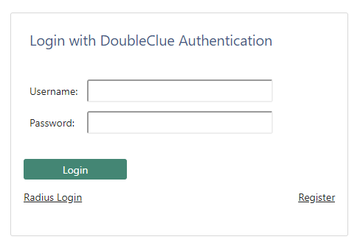

1. Enter your user name, your full name, your password which you will need for logging in to the DoubleClue App and your email address and/or mobile phone number depending on the way in which you would like to receive your Activation Code.

C:\Users\maike.behnsen\Desktop\Grafiken\caution-sign.png

In order to use SMS or Email messaging services, you need to configure them in DCEM first.

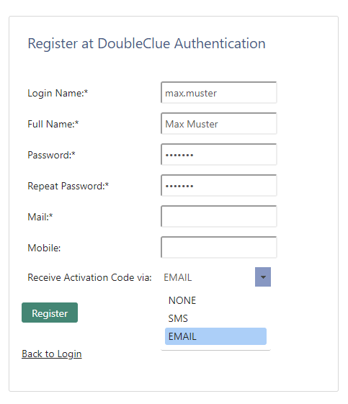

1. Click on the button “Register”.

The Activation Code for the DoubleClue App is now shown to you at the top of the page.

Or you will receive your Activation Code for the DoubleClue App via SMS / e-mail, here an example:

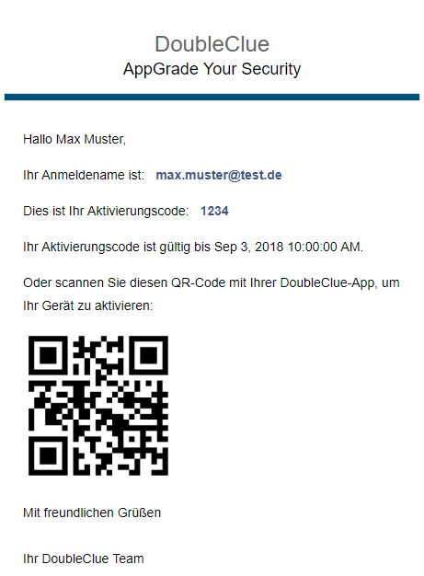

Hello Max Muster,

Your Login ID is:

This is your Activation Code:

Your Activation Code is valid till Sep 3, 2018 10:00:00 AM.

Or scan this QR Code with your DoubleClue App to activate your device:

Cleverly Secures Identities

## Activation of the DoubleClue App

1. Open your DoubleClue App and enter your user name and your Activation Code either manually in the respective fields, or scan the QR Code from your Activation e-mail.
2. Click on the button “Activate” to conclude the activation process.

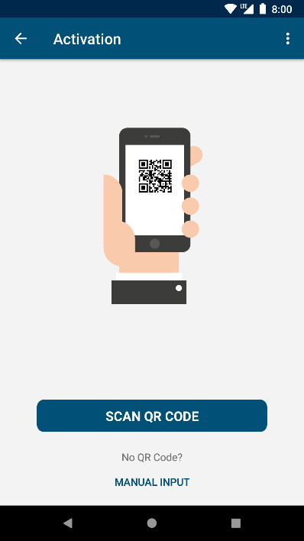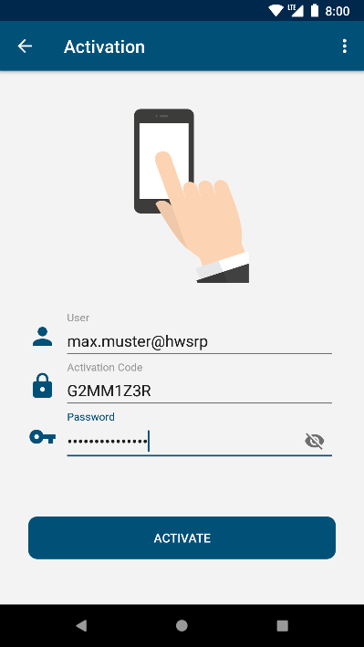

Your mobile device is now activated for the DoubleClue authentication process and your registration at PortalDemo has been successful.

## Login to PortalDemo

Here you are shown some examples for secure logins to a client portal via Multi-Factor Authentication (MFA) with the DoubleClue App.

### Login with Transaction Message

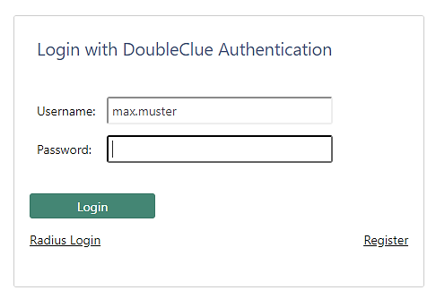

Secure login to a client portal by means of a digitally signed secure message.

1. Open DoubleClue PortalDemo.
2. Enter your user name and password and click on the button “Login”.
3. A window will pop up that shows the different authentication methods available to you. Select “Transaction Message”.

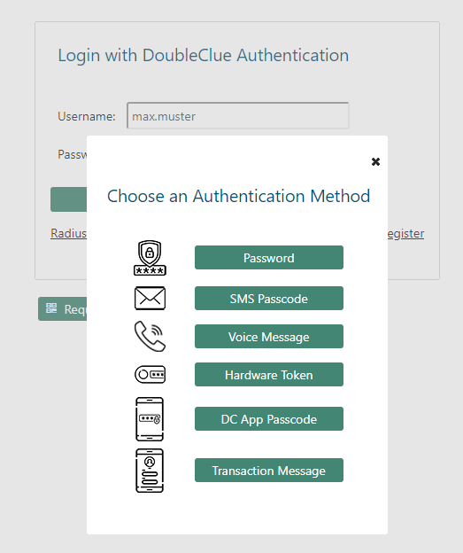

1. Open your DoubleClue App. Log in with your user name and password.

Now confirm the shown Transaction Message to successfully log in to PortalDemo.

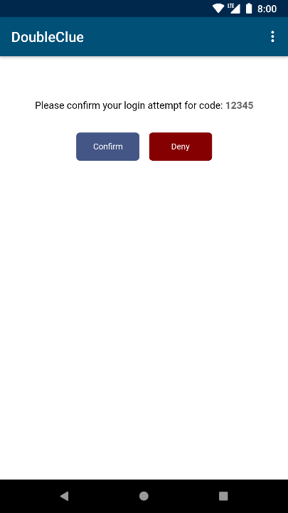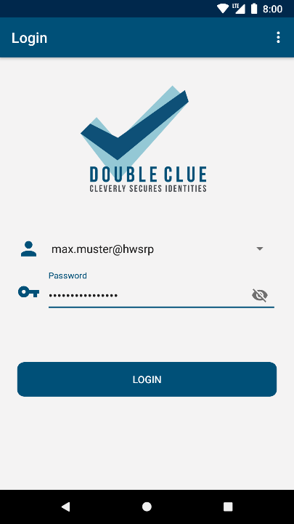

### QR Code Login

Secure login to a client portal by means of a QR Code scan.

1. Open PortalDemo.

Here you can already see the QR Code which you need to scan with your DoubleClue App.

C:\Users\maike.behnsen\Desktop\Grafiken\caution-sign.png Please note: The QR Code is only valid for a certain period of time. If it has expired, just click on “Request New QR Code”.

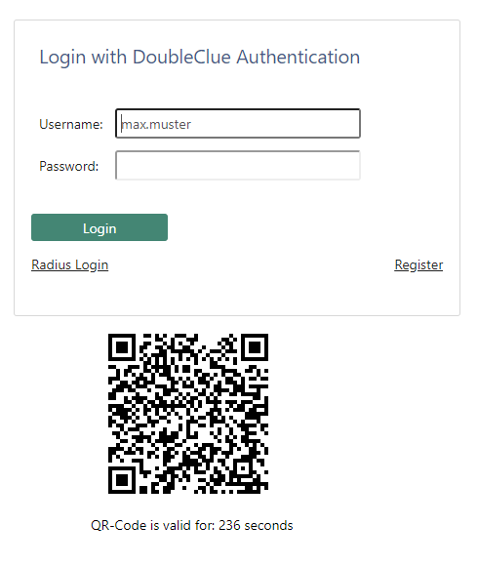

1. Log in to your DoubleClue App.

Click on the button “QR Code Login” and scan the QR Code which is shown to you in PortalDemo.

### Offline Login with Passcode

Secure login to a client portal by means of an offline message on your smart device. This alternative is useful if it is not possible to establish a connection to the internet via the DoubleClue App.

* Logic: At an offline login, the user’s login ID will be verified. If there is no user with this name or if no user name is given, an offline login is not possible.
* Validity of the Passcode: As a time limit has to be set for the validity of the Passcode, the clocks of DCEM and the mobile device of the end user have to be synchronous. Otherwise it might be possible that the login time has run out before the user has been able to act.

1. Open PortalDemo.
2. Enter your user name and password and click on the button “Login”.

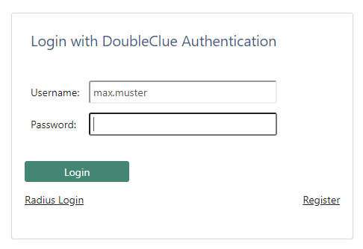

1. A window will pop up that shows you the different authentication methods available to you. Select “DC App Passcode”.



1. Open your DoubleClue App and click on the three dots in the upper-right corner, then select “Offline Login”.

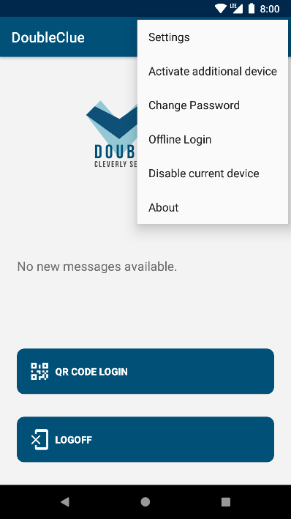

You will get a six-figure passcode that has to be entered into the PortalDemo login form in order to be logged in successfully.

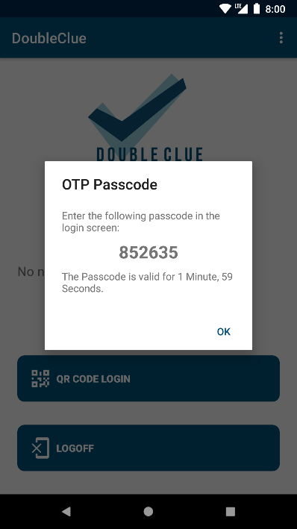

1. Enter the Offline Passcode in the respective field in PortalDemo.

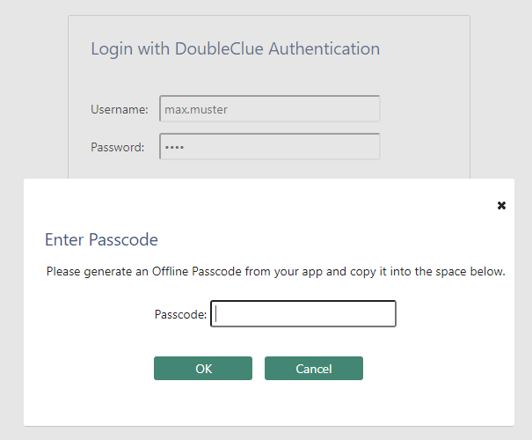

### Offline Login with RADIUS

In order to be able to do an offline login with a RADIUS connection, the offline login has to be allowed in the RADIUS settings of DCEM first.

1. Call up PortalDemo.

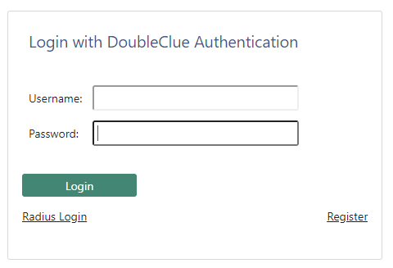

Choose “Radius Login”.

1. A new screen will appear. Enter your user name and password in the following way:

**#passcode#password**

The passcode is created with your DoubleClue App (see chapter 3.4.3 Offline Login with Passcode).

Then click on the button “Login” to successfully log in to PortalDemo.

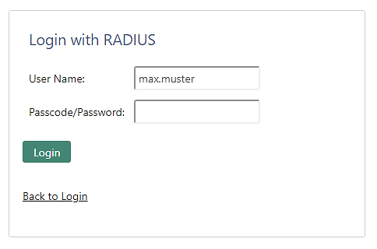

e.g. #123456#test

## Example for Money Transfer

This is an example how a secure transaction is done. A Transaction is sent to the end user who confirms and therefore digitally signs it:

1. Log in to PortalDemo.

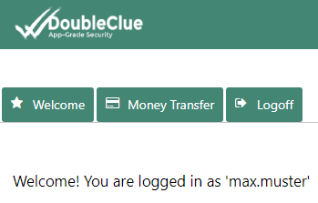

1. Click on the tab “Money Transfer” in the navigation bar in the upper left corner.
2. Enter your exemplary money transfer details and click on the button “Send”.

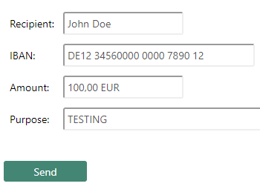

A window will pop up that tells you to confirm your money transfer request using your DoubleClue App.

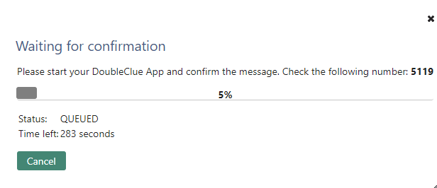

1. Log in to your DoubleClue App and confirm your money transfer request.

