The Phytoplankton Community Response to California Lightning Fires in the Monterey Bay
Dante Capone ¹; Patrick Daniel²; Raphael Kudela^{2,} Andrew Barton^{1,} Mati Kahru¹ Moira Décima¹
¹Scripps Institution of Oceanography, University of California San Diego, ²University of California, Santa Cruz

Abstract

Introduction
In the fall of 2020, California experienced some of the largest fires in state history.
The Western US has experienced an increase in wildfires driven by anthropogenic climate change, natural climate variability and human alterations to land and fire regimes (Abatzoglou and Williams, 2016). Climate models project an increase in the frequency of extreme fires related to temperature-driven aridity and temporal shifts in precipitation (Goss et al., 2020; Swain, 2021). California has been struck particularly hard, with a fivefold increase in the amount of burned area from 1972-2018 (Williams et al., 2019). Recent wildfires have had adverse effects on human health and increased economic costs (Leibel et al., 2020; Aguilera et al., 2021; Liao and Kousky, 2021). Post-fire debris flows can also impact the watershed, geomorphology and biogeochemistry of the local ecosystems (Addison and Oommen, 2020; Uzun et al., 2020).
In terrestrial and freshwater ecosystems, wildfires have been shown to increase net productivity, alter biogeochemistry, reduce the availability of photosynthetically-active radiation (PAR) and UV-B, and influence community structure (Klose, Cooper and Bennett, 2015; Scordo et al., 2021, 2022). Wildfires can restructure aquatic communities through both top-down and bottom-up effects, impacting multiple trophic levels (Cooper et al., 2015). Smoke has been shown to release epi-pelagic phytoplankton from photoinhibition, leading to increased primary productivity and biomass-specific photosynthetic rates (Urmy et al., 2016; Scordo et al., 2022). Smoke also impacts higher trophic levels through reductions in zooplankton vertical migration magnitudes (Urmy et al., 2016; Scordo et al., 2022). Alterations to physiography enhance post-fire runoff, which can extirpate higher order consumers such as trout, releasing invertebrate consumers from predation and resulting in a trophic cascade (Larsen et al., 2009; Cooper et al., 2015).
Leachate from wildfire ash can exhibit both fertilizing and eco-toxic effects on organisms depending on its composition. Ash can increase phytoplankton biomass over short timescales (Netshituni et al., 2022). Variable ecotoxic effects have been observed on invertebrate zooplankton depending on the ash source (Silva et al., 2015; Harper et al., 2019). Silva et al (2015) found no significant immobilization of the zooplankton Daphnia magna after acute (48hr) exposure to eucalyptus derived wildfire ash (Australian), whereas Harper et al (2019) found the opposite for ash from Australia, the US, and Canada, attributing the response to high values of pH, conductivity, NO3⁻, Cl⁻, Hg and SO4²⁻.
The timescales of these wildfire effects can vary from days (e.g. change in biogeochemistry and incident solar radiation), to weeks and months (e.g. post-fire runoff), to even years (e.g. differential abundances and growth rates of fish and nutrient retention) (Bixby et al., 2015; Diemer et al., 2015; Rosenberger et al., 2015; Urmy et al., 2016). Long-term monitoring programs have been developed in wildfire-prone regions which has allowed these disturbances to be placed in the context of historical variability. However, the monitoring of marine ecosystems in proximity to wildfire-prone regions is rare and more challenging. One reason for the paucity of observations is the logistical and financial barriers that impede the collection of oceanographic data. Research cruises take months to years to plan and demand structured timelines, whereas wildfires occur unpredictably. Furthermore, the frequency of research cruises is rarely greater than monthly (e.g. CalCOFI, Plumes and Blooms, HOT, BATS), which poses a challenge for placing a wildfire event within context of comparable historical variability.
Recent work has circumvented this challenge by leveraging remote sensing data (including satellite chlorophyll-a and aerosol reanalysis), in-situ time series and monitoring programs (e.g. BGC-Argo, Aeronet) located near wildfire events to link anomalous phytoplankton blooms with wildfire aerosol deposition. Weis et al (2022) found that pyrogenic aerosols fertilized the Southern Ocean by relieving iron stress and facilitated a large enough bloom that persisted 9 months, sustained by recycling and additional aerosol inputs (Weiss et al., 2022). During the same event Tang et al (2021) linked the bloom to both higher primary production and export production (Tang et al., 2021). While the promise of remote sensing-based analyses are promising and replicable, overestimation of satellite chlorophyll-a during wildfire events underscores the need for more in situ sampling (Kramer, Bisson and Mitchell, 2023).
The magnitude of phytoplankton response observed in the Southern Ocean was attributed to iron-fertilization in an iron-stressed region, however in non-iron-limited regions wildfires may still facilitate a bloom by alleviating other forms of nutrient limitation. For example, Ardyna et al (2022) found that deposition of nitrogen-rich wildfires contributed significantly to an amplified phytoplankton bloom in the arctic during summer 2014 (Ardyna et al., 2022). Although similar “megafires” have become frequent in California, few studies link these events to local marine biogeochemistry and ecosystem dynamics. Fortunately, the US West Coast maintains one of the most extensive coastal observing networks in the world including a network shore stations, gliders, buoys, cruises, and remote sensing.
Though often physically and biologically distinct from oceanic environments, the coastal ocean provides a more accessible interface for continuous monitoring. In the CCE, the Southern and Central California Ocean Observing System (SCCOOS & CeNCOOS respectively) are regions within the U.S. Integrated Ocean Observing System (IOOS) that collect and openly provide real-time, in-situ biological, chemical, and physical observations. This network includes vessels, gliders, buoys and moorings, but also fixed shore stations operated by institutions ranging from Humboldt in the north to San Diego in the south. Beyond chemical sensors, the shore stations maintain weekly sampling and characterization of the phytoplankton community as a part of the California Harmful Algal Bloom Monitoring and Alert Program (CalHABMAP).
These data are a valuable publicly available and underutilized resource when synthesizing ecosystem responses to high-frequency disturbance on the California coast. Previous work using shore station time-series data from Monterey Bay analyzed phytoplankton community composition from both weekly HAB water quality sampling and an Imaging Flow Cytobot (IFCB) to understand drivers in dinoflagellate blooms (Fischer et al., 2020). Fischer et al. found that two major anomalous shifts from the typical diatom-dominated system to enhanced dinoflagellate abundance were linked to a strongly negative North Pacific Gyre Oscillation, increased river discharge and variable interactions with upwelling.
Interannual climate phenomena with known impacts on biogeochemistry of the CCE such as El Niño/La Niña may be linked to wildfire events. Fire-related climate anomalies have been shown to follow a 5-7 year oscillation, with extreme fire years preceded by a La Niña event, followed by a winter with less precipitation and snow, and finally increased dry season temperatures, drought and wildfire vulnerability (Son et al., 2021). Wildfire events may then occur due to higher-frequency intensifications of offshore downslope winds such as the Santa Ana (Southern California) and Diablo (Northern California) winds (Abatzoglou et al., 2021). These offshore winds may also transport dust which has been shown to have a mixed impact on chlorophyll-a ranging from no effect to fertilization (Sosa-Avalos et al., 2005; Álvarez et al., 2020). Due to the complexity of interactions and connectivity in the terrestrial-atmosphere-ocean system, high-resolution data on the many potential drivers of biogeochemistry (interannual climate variability, upwelling, winds, and freshwater runoff) are required to reject alternative hypotheses.
Here we leverage the multiple datastreams available in around the Monterey Bay to analyze the impact of the SCU Lightning Complex fires (August-October 2020) on biogeochemistry of the coastal ocean. First, we scale responses of satellite chlorophyll-a to wildfire emissions measured as black carbon aerosols. Next, I will analyze whether in-situ biogeochemical data collected at coastal monitoring stations correlates with anomalies in wildfire aerosol emissions and whether responses are coherent in space and time. Finally, I will focus on the Santa Clara Unit (SCU) Lightning Complex Fires near Monterey Bay in August-October 2020 and utilize shore-station biogeochemistry, ground-based aerosols, and phytoplankton (community composition and abundance quantified through both images and microscopy) to examine whether wildfire alters biological community composition and structure. We explore alternative hypotheses to potential biogeochemical responses including interannual climate variability, upwelling, winds, and freshwater runoff.
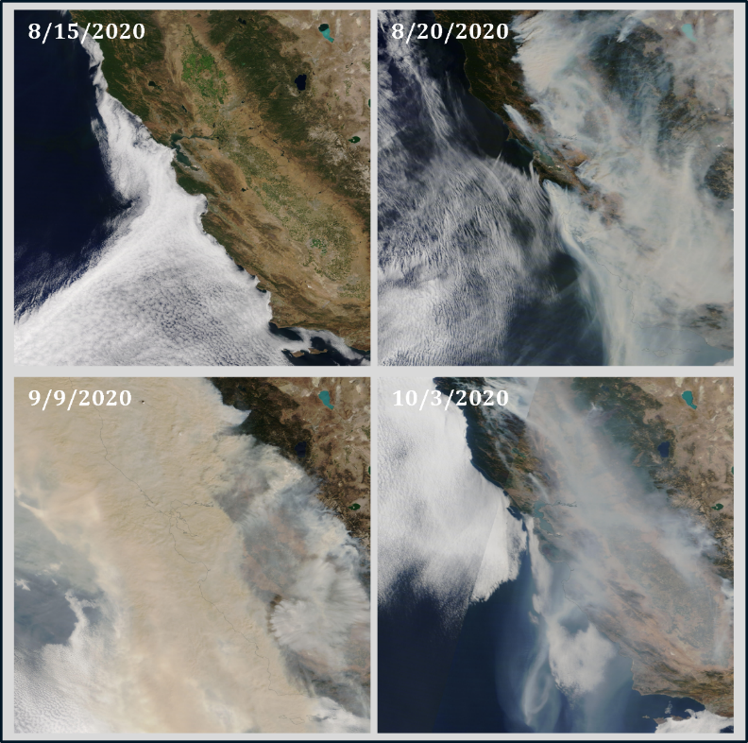
Figure 1. Evolution of the SCU Lightning Complex fire over the Santa Cruz/Monterey region from August-October 2020. (Source: https://worldview.earthdata.nasa.gov/)

Methods

Data Acquisition and Descriptions
We leveraged data from a multitude of locations, organizations, and instruments, each with its gaps in sampling, sampling frequencies, availability ranges and distances from the shore or surf zone. We provide more comprehensive descriptions of each data stream, its limitations, and pre-processing required for analysis below.

Plankton and Biogeochemical
Ocean Color
Ocean Color data were downloaded for the Monterey Bay region (37, 112) from https://spg-satdata.ucsd.edu/MBay/MBay.htm. These data are a produced as a composite of multiple satellite measurements. A thorough explanation of the product is detailed in (). Limitations to these satellite data include potential overestimation of chlorophyll-a and colored dissolved organic matter during a wildfire event (Kramer, Bisson and Mitchell, 2023).

Shore Stations
The shore station network consists of a suite of fixed, Eulerian sensors that measure (at minimum) temperature, salinity, chlorophyll-a, and water level all along the California coast (Figure 2). Many of the shore stations have records of automated sensor data that date back to the late 2000’s-early 2010’s and continue to the present day. Some shore stations sample off of piers that extend beyond the surf zone (e.g. Scripps Pier) whereas others collect water from a flow-through system (e.g. Bodega Marine Lab).

Imaging Flow Cytobots
The California Imaging Flow Cytobot Network (CA IFCB Network) maintains 12 in-situ instruments to measure phytoplankton community composition, taxa-specific abundance and biovolume. The IFCB continuously images plankton and particles (<10 to 150 μm) in approximately 5mL sample volumes every 20min. The Santa Cruz Municipal Wharf (SCMW) IFCB has been collecting data since 8/20/2015, with a handful of gaps. The instrument and image data are maintained by the Kudela Lab at the University of California, Santa Cruz. A convolutional neural network (CNN) is used to classify images into one of 54 distinct classes (). Classes are assigned probabilistically in the penultimate layer of the CNN and here we assumed classes with an assigned probability of >0.85 to be true.
Each class can be used to produce time series of cell abundances (cells/L) or cell biovolumes (ug C/L). We computed daily maximum metrics of abundance and biovolume for each phytoplankton class and normalized by the sample volume to yield a concentration of cells or carbon.

The specifics of the classifier are detailed in Fischer et al. (2020) and data for each sample are available on the IFCB dashboard (http://akashiwo.oceandatacenter.ucsc.edu:8000/dashboard).
The Harmful Algal Bloom Monitoring and Alert Program
The California Harmful Algal Bloom Monitoring and Alert Program (Cal HABMAP) is a sampling program within the Shore Stations network and founded in 2008 that collects weekly phytoplankton and water quality data at nine locations along the California coast (Figure 2). The program was formed as a collaborative effort for the interests of researchers, managers and stakeholders to monitor blooms of harmful species of phytoplankton. Taxonomic groups are identified through microscopy and include Alexandrium, Cochlodinium, Dinophysis spp., Gonyaulax, Lingulodinium, Prorocentrum spp., Pseudo-nitzschia delicatissima-size class, Pseudo-nitzschia seriata-size class, Phaeocystis, total diatoms, and total dinoflagellates. Most stations sample weekly in the morning, with day of week varying between sites. Potential limitations to these data include sub-sampling extrapolations and taxonomic expertise.

Wildfire Aerosol Data
MERRA-2 Black Carbon aerosol
Daily, 0.5×0.65◦ resolved black-carbon aerosol data will be obtained from the Modern-Era Retrospective Analysis for Research and Applications, Version 2 (MERRA-2) for 1980-2022 (Gelaro et al., 2017) as a proxy for wildfire emissions. Reanalysis involves the combination of disparate historical observations with a data-assimilating forecast model to produce a regularly-gridded dataset including observed and derived variables (Gelaro et al., 2017). The model utilizes biomass burning emission data from the Tropospheric Chemical Composition, version 2 (RETRO-2;(Schultz et al., 2008)), the Global Fire Emissions Database, version 3.1 (GFED-3.1; van der Irf et al. 2006), and the Quick Fire Emission Dataset, version 2.4r6 (QFED-2.4.r6;). Previous studies have found MERRA-2 black carbon data to reliably match ground-based measurements (Qin et al., 2019; Cao et al., 2021).
Aeronet Aerosol Optical Depth
The Aeronet (AErosol RObotic NETwork) is a global ground-based remote sensing aerosol network established by NASA and PHOTONS (PHOtométrie pmy le Traitement Opérationnel de Normalisation Satellitaire, https://aeronet.gsfc.nasa.gov/new_web/index.html). Sun photometer measurements of solar radiation provide information to calculate the columnar aerosol optical depth (AOD) and validate satellite based AOD. The spectral deconvolution algorithm is applied to the AOD data to derive coarse and fine-mode optical depths at 500 nm. Here I will use Level 1.5-2.0 data which are automatically cloud cleared and quality assured (Level 1.5 and 2.0) with pre-field and post-field calibration applied (Level 2.0). Aeronet sensors are available at the following locations proximal to shore stations: Trinidad Head (2005-present), Monterey (2002-present), UCSB (2002-present), USC (2011-present), and La Jolla (2000-2007,2010-2013,2019-present).
Airnow PM 2.5 Air Quality Data
Daily air quality data is available on Airnow.gov and includes measurements of ozone, and PM 2.5. Monitoring stations in Santa Cruz County are located in

Indices and Meausurement for Alternative Hypotheses
To reject alternative hypotheses of physical forcing driving changes in coastal biogeochemistry I can examine relevant indices and measurements. To test for the influence of upwelling, I will use the Biologically Effective Upwelling Transport Index (BEUTI) (https://mjacox.com/upwelling-indices) which provides daily or monthly estimates of vertical nitrate flux near the coast (Jacox et al., 2018). Wind forcing will be determined through wind speed and direction measured from NDBC buoy 46042 (https://www.ndbc.noaa.gov/station_page.php?station=46042&unit=E ). I will use stream gauge data from USGS as a proxy for freshwater discharge for the San Lorenzo River in Santa Cruz (https://waterdata.usgs.gov/monitoring-location/11161000). To examine coincidence of fires with interannual climate phenomena, I will use the Multivariate ENSO Index which is computed from the 1st EOF of anomalies in sea level pressure, sea surface temperature, surface zonal and meridional winds, and outgoing longwave radiation (https://psl.noaa.gov/enso/mei).

Time Series and Statistical Analysis
The analysis and statistics for this work were conducted using MATLAB R2023b-2024b and Rstudio. We used cross-correlation between wildfire and alternative physical driver metrics and phytoplankton chlorophyll-a or group abundances to test the strength of the relationship and associated lag between the time series. We used daily-averaged values of each variable with the climatological median removed to cross-correlate anomalies of each signal. For Aeronet AOD data, we used linear interpolation with the MATLAB ‘fillmissing’ function to ensure that the time series had no gaps prior to cross-correlation.
We selected phyoplankton groups which displayed a correlation coefficient of >0.6 for subsequent analysis. For each phytoplankton group, we found the lag that produced the maximum correlation between the time series.
To determine whether the phytoplankton community structure changed in response to the wildfires, we used lags from taxa-fire correlations to compute a Bray-Curtis dissimilarity index. The mode lag for the phytoplankton taxa that displayed the strongest responses to fire was 8 days, so the Bray-Curtis index was calculated between communities 8 days apart for the entire time series. A probability-density function (PDF) for this dissimilarity index was constructed for the entire time-series using kernel density. We determined which points within the fire period fell into the extremes of the distribution (top 10%).
Following examination of the change in community composition, we explored how the abundance and biovolume of the responding taxa during the fire period compared with the climatological averages. We produced PDFs for the fire period (August-October) for the year of the fire, 2020, and compared these distributions with the those for the same fall window using the full time series. We used a two-sided Kolmogorov-Smirnov test to determine whether there was a significant difference (where p-values >0.05) in the distributions.

Tests of Alternative Drivers
The complex dynamics of the Monterey Bay and multitude of forcings that have been shown to impact phytoplankton production locally demanded that we explore alternative drivers of phytoplankton anomalies during the fire period. We used drivers explored in Fischer et al. (2020) as a basis for this analysis.
Furthermore, previous work at the SCMW has shown that this sampling point may not always be representative of the Monterey Bay as a whole ().

Deposition and HYSPLIT Models
Although no in-situ measurements of a wildfire tracer (e.g. dissolved black carbon, iron, etc) were measured during fall 2020, deposition and aerosol back-tracking models can be used to determine whether wildfire aerosols would have been present at the ocean surface of the SCMW. We used NOAA’s HYSPLIT model to produce daily back trajectories for the SCMW during the fire period. We also ran forward trajectories on the source wildfires to confirm the altitude and fate of fire aerosols.

Results
Wildfire Aerosols over the Monterey Bay
We characterized climatologies for wildfire aerosols using Aeronet AOD, MERRA-2 black carbon surface mass, and PM 2.5. We found that wildfires during the period of available data resulted in orders of magnitude increase in aerosol measurements when compared to the historical averages (). Although other factors such as anthropogenic emissions can influence wildfire aerosol metrics used here, we find that the anomalies observed during the fire are large enough to yield fluctuations related to these signals insignificant.
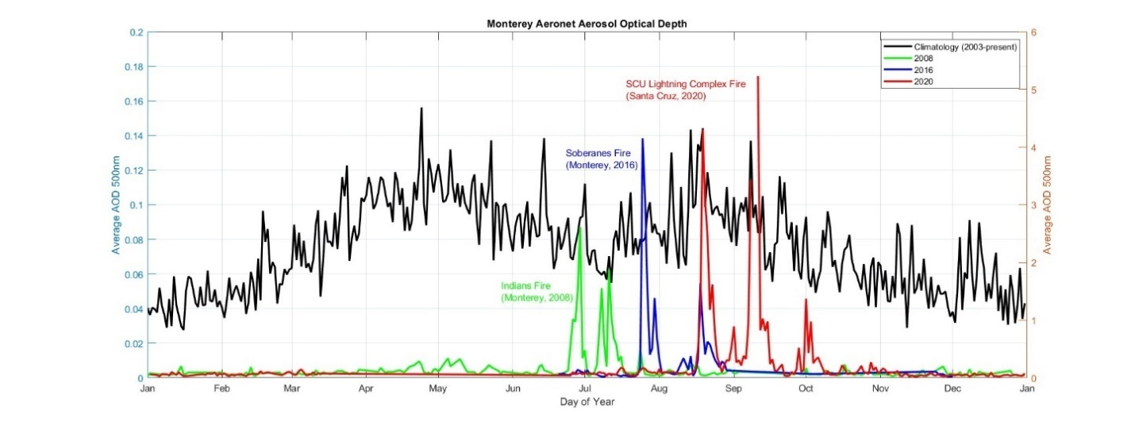
Figure 2. Climatology and selected fire years for Monterey Bay aerosol data.The left axis displays the climatological average range for AOD and the right axis is scaled for the years where large wildfires were observed.
Between August 2020 and October 2020 two of the largest wildfires in California state history produced thick smoke plumes above the Monterey Bay. The first fire occurred in the Santa Cruz Mountains (lat, lon) only xx km away from the SCMW. The second set of fires were much larger in extent, but occurred much further away: approximately xxkm from SCMW. In both cases a large anomaly was observed in measurements of wildfire aerosols including the Monterey Aeronet station’s aerosol optical depth, MERRA-2 black carbon surface mass concentration. Similarity between the signals produced between selected data streams for wildfire reinforce the strength of the magnitude of the observed fire event.
However, our analysis of smoke plume transport and the locally monitored PM 2.5 data displayed divergence with AOD and BCMASS where the first, local fire produced significantly more detectable particles at the ground level. This finding illustrates the importance of maintaining multiple independent and synergistic proxies for wildfire in the atmosphere when attempting to relate it to other ground-based Eulerian observations.
Regional Response of Chlorophyll-a
Satellite chlorophyll-a
An Anomalous Community Composition
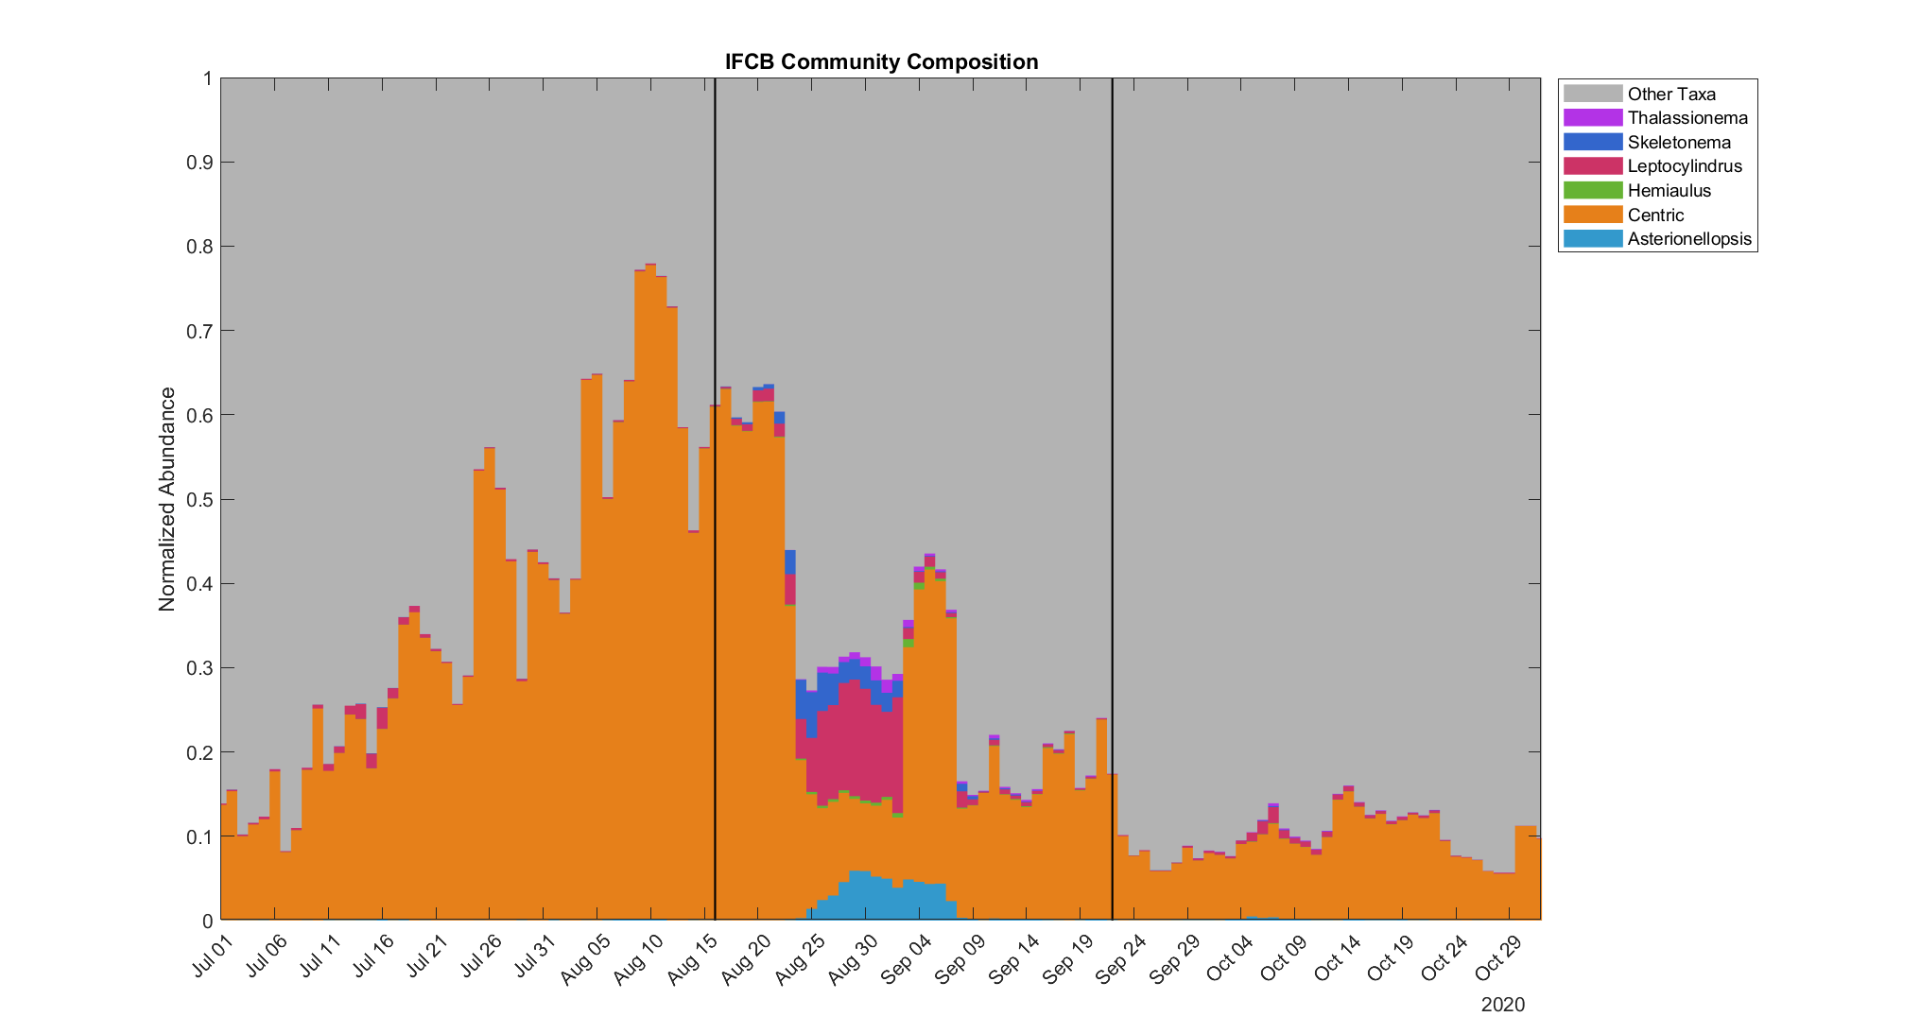
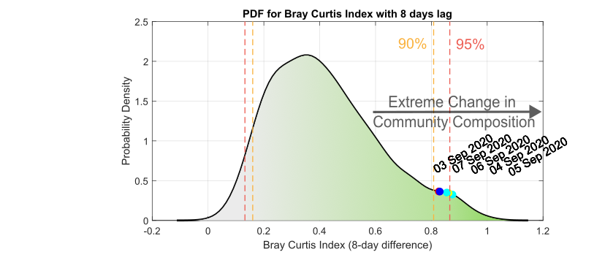
Bloom of Particular Phytoplankton Groups
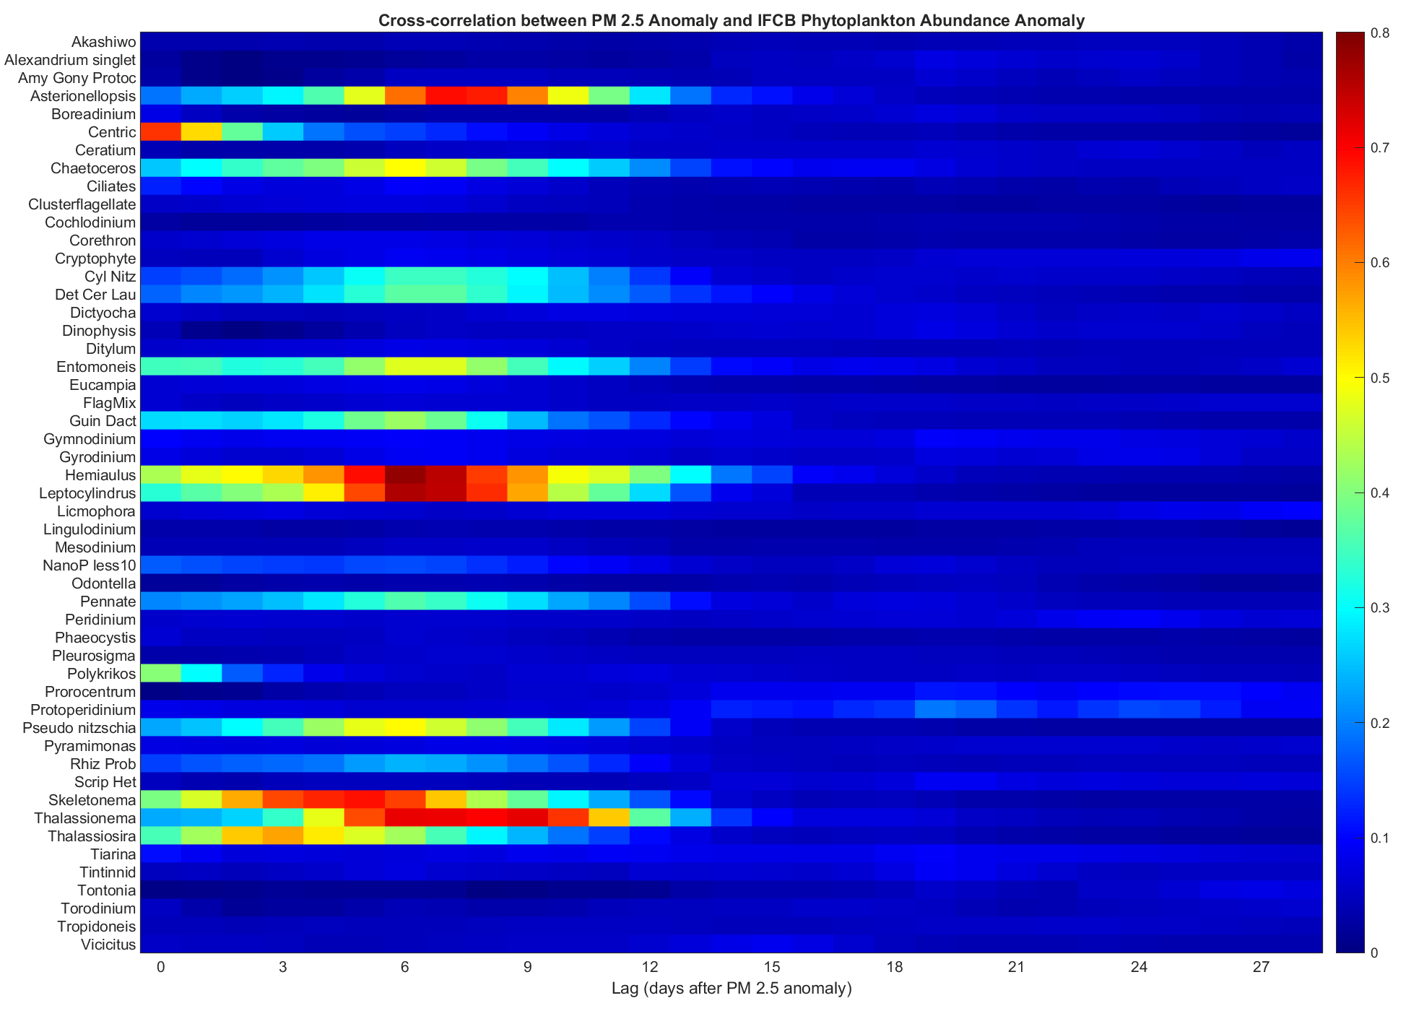
Figure 3. Heatmap of cross-correlation coefficients between IFCB phytoplankton classes and ground-based PM 2.5 observations at different lags following the start of the wildfire aerosol anomaly.
Correlations between wildfire aerosols and phytoplankton taxa revealed 6 diatom groups with strong (C >0.6), positive relationships to the fires (Figure 2).

Discussion

References

Supplementary

Datastream | Organization | Data Type | Locations | Data availability | Temporal Resolution | Spatial Resolution | Variables
Shore Stations | CalOOS | Eulerian environmental sensors | Scripps Pier, Santa Monica Pier, Stearns Wharf, Newport Beach, Moss Landing, Morro Bay, Humboldt, Trinidad, Bodgea, Hog Island Oyster Co, Fort Point, Carquinez, Exploratorium, SLO | 2005-present, 2008-present, 2013-present, 2015-present, 2018-present | continuous | Eulerian, California coastline | CO2, chlorophyll-a, conductivity, fluorescence, nitrate, dissolved oxygen,  oxygen saturation, pH, radiative flux: beam attenuation coefficient, salinity, temperature  transmissivity, water level
Buoys | NDBC, BML | Eulerian environmental sensors | Bodega, Tomales Bay, coastally ubiquitous (NDBC) | 2004-2018, 2013-present | continuous | fixed locations | chlorophyll-a, conductivity, salinity, density, temperature, turbidity, wind speed
IFCB | CalOOS | Image-based phytoplankton taxonomic abundances, biovolumes | Hog Island , Bodega Pier, San Francisco Bay (Pier 17)*, Santa Cruz Municipal Wharf**, Monterey Bay (Power Buoy), Stearns Wharf , Newport Beach Pier, Del Mar Mooring, Scripps Pier | 2021/2022-present, *2018-present, **2015-present | continuous | Eulerian, California coastline | phytoplankton community composition, abundance, & biovolume
Cal HABMAP | CalOOS | Phytoplankton group counts | Scripps Pier, Santa Monica Pier, Stearns Wharf, Newport Pier, Trinidad, Bodega Marine Lab Intake, Cal Poly Pier, Santa Cruz Wharf, Monterey Wharf | 2008-present, 2022-present, 2005-present | weekly | Eulerian, California coastline | Akashiwo, Alexandrium, Cochlodinium, Dinophysis spp., Gonyaulax, Lingulodinium, Prorocentrum spp., Pseudo-nitzschia delicatissima, Pseudo-nitzschia seriata, Phaeocystis, tot diatoms, tot dinoflagellates
MODIS-Aqua Level 2 Ocean Color | NASA | Satellite chlorophyll-a | Global | 2002-present | daily, weekly | 1km | chlorophyll-a, particulate backscattering coefficient (bbp at 443nm)
Aeronet | NASA | Ground-based aerosol optical index | Trinidad Head, Monterey, UCSB, USC, La Jolla | 2005-present | continuous | Eulerian, California coastline | aerosol optical depth (340-1640nm)
MERRA-2 | NASA | Aerosol reanalysis | Global | 1980-present | Daily | 0.5×0.65◦ globally | black carbon aerosols, dust aerosols
Table 1. Summary of Observational Data Streams for Analysis.

