Exploring Patterns in Zooplankton Diversity Across an Environmental Gradient Using a Modified Metabarcoding-Morphological Approach
Co-authors: Hannah Budroe, Ramon Gallego, Stephanie Matthews, Michelle Nixon, Jeff Bowman, Moira Décima

Introduction
Marine zooplankton are a functionally and taxonomically diverse group, with pivotal roles in trophic transfer of primary production, biogeochemical cycling, and as indicators of environmental variability. Zooplankton biomass and diversity metrics have been deemed essential ocean variables (EOV’s) for monitoring ecosystem health by the Global Ocean Observing System. Due to non-linear responses to climate forcing, zooplankton may hold the potential to reveal information about climate change impacts on marine ecosystems that physical environmental variables do not (Taylor, Allen and Clark, 2002)
A wealth of research in the CCE has established the importance of the ecological functions zooplankton provide through top-down regulation of phytoplankton growth and contribution to carbon export. Seasonal and interannual changes in productivity due to upwelling and large-scale climate events such as El Niño have been shown to alter zooplankton community composition and dynamics, coherent across both the Southern and Central CCE (Lavaniegos and Ohman, 2007; Lilly and Ohman, 2018). These disturbances propagate throughout food webs, altering the flow of energy and carbon and can persist for several years (Lavaniegos and Ohman, 2007; Décima, Landry and Popp, 2013). Zooplankton may exhibit species or taxon-specific responses to climate events in the CCE, for instance calanoid copepod species do not respond consistently to El Niño events (Rebstock, 2002; Lilly and Ohman, 2018). Zooplankton exhibit a diversity of life history strategies which dictate the timescales of forcing to which they respond (Di Lorenzo and Ohman, 2013). Although few zooplankton time series are collected at a sufficient frequency to be able to resolve seasonal variability on annual timescales, longer time series and comparative measurements between adjacent years have shown seasonal shifts in community composition (Brinton and Townsend, 2003, 2003)
In addition to temporal variability, the CCE exhibits a strong cross-shore gradient in environmental properties such as temperature, nutrients and chlorophyll-a fluorescence associated with upwelling (Hayward and Venrick, 1998). Rykaczewski and Checkley (2008) found a logarithmic relationship between upwelling velocity and the slope of the normalized biomass size spectrum of net-collected zooplankton, with higher upwelling velocities (associated with nearshore environments) corresponding with flatter size-spectrum slopes. Powell and Ohman (2015) surveyed 154 fronts using glider acoustics and net tows and found similar cross-shore trends in zooplankton size, with the offshore community dominated by copepods and the nearshore community by euphausiids. Most recently, James et al (2022) applied self-organizing maps to an extensive spatial and temporal dataset of 16S and 18S rRNA microbial community composition to identify onshore and offshore clusterings of different taxonomic groupings in the CCE. They found a general decrease in cross-shore alpha diversity for most taxonomic groups with the exception of diatoms which followed the opposite trend. Previous studies based on bulk phytoplankton metrics (chlorophyll-a and phycoerythrin) have found that nitracline depth (not temperature) is the primary driver of phytoplankton communities (Collier and Palenik, 2003), and DNA-based metrics of the microbial community find that composition is also primarily driven by the depth of the nitracline (James et al., 2022).
Recent studies have begun to implement these molecular approaches to study zooplankton community composition in the CCE. Pitz et al (2020) investigated how the zooplankton community changed in association with alongshore biogeographic breaks and discontinuities in environmental properties. Their results corroborated historical trends in copepod and euphausiid diversity and revealed taxonomic groups such as parasites that are rarely detected by traditional approaches. While collection of molecular samples (primarily eDNA) is beginning to be integrated into regular sampling in the CCE (such as through the CalCOFI NCOG program), there remains a need to compare these approaches to historical data and generate workflows for integration and interpretation.
DNA metabarcoding is a relatively recent technique in the field of zooplankton ecology and involves the large-scale taxonomic identification of a mixed community through the amplification of a particular ‘barcode’ region of DNA, which is typically the mitochondrial cytochrome c oxidase subunit I gene (COI) (Bucklin et al., 2016). Compared to traditional morphological identification approaches such as microscopy and imaging, DNA metabarcoding may be cheaper, faster and requires significantly less taxonomic expertise, in particular with decreasing sequencing and bioinformatic costs. Despite its advantages, multiple challenges remain in mitigating biases in sub-sampling, primer choice, PCR amplification, and sequencing (Matthews et al. 2021). While primer bias can influence community composition in early PCR cycles, in later PCR cycles non-primer bias (determined by taxon-specific amplification efficiencies) has been shown to have significant effects on composition, even in mixtures of only two species (Suzuki and Giovannoni, 1996).
Several strategies have been proposed to mitigate PCR bias including: the construction of mock communities, conducting a variable PCR cycle experiment for samples of an unknown composition, modeling the results of sequencing with an independent observation of community composition and abundance (e.g. imaging or microscopy), or attaching molecular identifiers to source molecules and tracking them through amplification (Shelton et al., 2023). Mock community calibration requires vouchers of extracted DNA from supposed taxa present in the sample, which can pose a challenge when dealing with samples of unknown composition in which many taxa are present or in regions where historical data are sparse (Shelton et al., 2023). Additional bias emerges when working with mixed-tissue samples of whole-organisms: the relative abundances of DNA can bias towards the larger species which have more biomass, and consequent gene copies (Carvalho, 2022; Jungbluth et al., 2022). Jungbluth et al (2022) employed quantitative PCR (qPCR) and found a strong, empirical log-log linear relationship between the biomass of copepod nauplii and the number of copies of the COI gene across five orders of magnitude. However, some taxa such as ciliates have been shown to contain DNA copies numbers that vary drastically at the species level and do not correlate with genome size (Wang et al., 2017). Despite these challenges, implementation of additional processing steps between sample collection and data analysis can assist in producing ecological data that constrains the semi-quantitative nature of these methods.
Technologies such as the Zooscan- an image-analysis system designed for morphological-based identification of preserved zooplankton samples are extremely valuable in producing quantitative abundance, size and biomass data, but remain limited in taxonomic resolution (Gorsky et al., 2010). Thus, as an independent measure of community composition, they can only verify DNA-based results to the taxonomic level of the classified image dataset. Continued adoption of Zooscan and imaging technologies in collaboration with taxonomic experts will be required to improve the quality of plankton image databases such as Ecotaxa.
Here I use a size structured, dual-marker DNA metabarcoding approach to analyze how zooplankton community composition and structure vary across a cross-shore environmental gradient in the CCE. I use 3 size classes of mesozooplankton (0.2-0.5mm, 0.5-1mm, and 1-2 mm) with barcodes from two different genes (COI and 18S) to examine changes in diversity and composition (total and by size) across a large gradient o. Furthermore, I implement a novel method to address methodological biases of DNA metabarcoding introduced through PCR, assess the limitations of this method, and compare the results with traditional (raw or normalized reads) and independent (Zooscan imaging) measures of abundance. This constitutes the first study that recovers absolute zooplankton DNA concentrations (for a subset of the present taxa), thus establishing a key step in the broader application of DNA metabarcoding to investigations of metazoan zooplankton dynamics in marine systems.
- What environmental variables are correlated with zooplankton community composition and diversity?
- Which taxa show significant relationships with environmental variables and are these relationships consistent across size?
- Which taxa contribute most to differences between and across physical and biological clusters?

- Are trends in taxonomic abundance and diversity consistent across PCR-bias mitigated data, raw read abundances, and morphological based imaging methods (Zooscan)?

Materials and Methods
Oceanographic Zooplankton Sampling/Processing
Zooplankton net tow samples were collected during three quasi-Lagrangian experiments termed ‘Cycles’ between July 21st and August 7th, 2021, with a Bongo net (0.71-m diameter frame, 202-µm mesh nets and cod ends) towed obliquely between the surface and ~200m depth (300m wire out). The net was towed with a wire angle of 45° at a ship speed of 1-2 knots and was recovered at 30 m min⁻¹. Sampling depths Ire logged with a temperature-depth recorder and volume filtered through the net was measured using a calibrated General Oceanics Flow meter. The starboard side of the Bongo net was split quantitatively, and 3/8ths of the total sample was size-fractionated using a set of sieves (mesh sizes 5mm, 2mm, 1mm, 0.5mm, 0.2mm), was rinsed using filtered seawater onto a 47 mm-diameter, 0.2mm Nitex mesh filter, was placed in a petri and was flash frozen for metabarcoding or other analyses on land.
Cycle 1 and Cycle 2 both tracked cool, salty, dense upwelled water off Point Sur. Cycle 3 was initiated about 800 km offshore near the western boundary of the CCE and provided an ecological and biogeochemical endmember. Additionally, P2107 conducted 2 transects between August 7th and August 11th, 2021. First, an east-West transect spanning the CCE (referred to as CT1) and an alongshore transect (CT2) which included 8 stations extending north-south from San Simeon to the Point Arguello. CT1 spanned a vast range of environmental conditions whereas CT2 sampled alongshore. Excluding CT1, I selected a subset of the stations sampled within each sampling event to examine metabarcoding community composition. For C1-C3 we sequenced a pair of day-night tows and for CT2 we selected 3 of the 8 stations.

DNA Metabarcoding, Bioinformatics, PCR Calibration Experiment
We used two of the most common DNA barcodes for marine zooplankton: the hypervariable V4 region of the 18S ribosomal RNA marker (Zhan et al. 2013) and the mitochondrial cytochrome c oxidase subunit I gene (COI) (Leray et al. 2013) to resolve zooplankton community composition. The 3 smallest size fractions of zooplankton samples collected above were subsampled to ⅛ of filter, the tissue was homogenized, and DNA was extracted using the OMEGA E.Z.N.A. Insect Kit or Mollusc Kit following manufacturer protocols, with the specific kit being selected based on visual inspection of zooplankton community composition. Elutions were conducted in duplicate, and DNA concentrations were assessed by Qubit. For each sample, the barcode regions were amplified in triplicate using a 2-step PCR. Amplified products were pooled equimolarly and were sequenced on an Illumina MiSeq with 300bp PE VX chemistry. Taxonomy was assigned to ASVs for both the COI and 18S marker, using the MetaZooGene database augmented with sequences obtained from local CCE zooplankton voucher specimens, to maximize identification of the zooplankton taxa targeted with the metazoan primers. MetaZooGene global databases and taxonomy files were downloaded on 3 May 2022. Sequences with mismatches between NCBI taxonomic identities and mothur taxonomic identities were removed, and the remaining at each marker were trimmed to the targeting amplicon region using virtual PCR from the insect R package, then were supplemented with sequences obtained from sanger sequencing of positively identified voucher specimens. The combined MetaZooGene and voucher sequences for each marker were used to train amplicon-specific classifiers in QIIME2, with the default parameters of the sk-learn algorithm. ASVs were assigned taxonomy, keeping all classifications with >80% confidence.

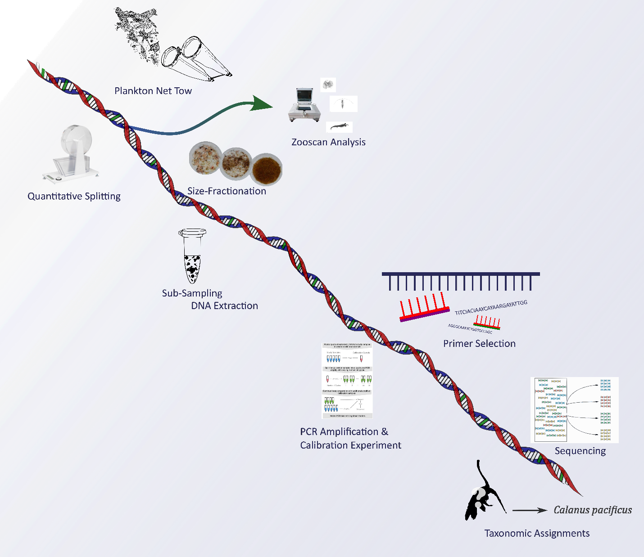
Figure 13. Schematic showing pipeline for DNA metabarcoding of marine zooplankton. The process follows: plankton net tow, quantitative splitting, Zooscan analysis, size fractionation, sub-sampling and DNA extraction, primer selection, PCR amplification and calibration experiment, sequencing, and taxonomic assignments.
In addition to this more widely implemented metabarcoding pipeline, we included an additional variable PCR experiment that attempts to mitigate PCR-bias in our results. We followed the methodology proposed by Silverman et al. (2021) and combined a calibration experiment with Bayesian Multinomial Logistic-Normal Models using the R package fido (Figure 14). The log-ratio linear models implemented by fido can account for mixtures of more than two taxa with different amplification efficiencies and have been shown to fit PCR-bias of microbiome data. These models incorporate the “competition to be counted” in which counting more of one type of thing means there are fewer resources available to count other types of things (Silverman et al., 2022). Compared to other quantitative metabarcoding approaches such as mock communities, the variable PCR method doesn’t depend on a priori knowledge of a sample’s community composition. Instead, we included a calibration experiment in which study samples are pooled into a “calibration sample”. This calibration sample ideally contains sequences from every organism in the study.
Next, the calibration sample was split into aliquots which were amplified with PCR at varying cycles. Each of these varying cycle samples was amplified, barcoded and sequenced in accordance with protocols followed for all other environmental samples. Finally, log-linear models were used to fit the data and determine the PCR-bias corrected DNA concentrations present in the sample at cycle 0.
Although this method addresses the significant bias introduced through PCR, it is limited in several ways. First, the approach of pooling all sub-samples of all samples may miss rare taxa and can only apply to taxa present in all the calibration samples. Another challenge that must be overcome in working towards quantitative metabarcoding of marine metazoans is accounting for gene copy number. Previous work has found that different taxonomic groups possess different numbers of copies for gene markers (Prokopowich, Gregory and Crease, 2003; Wang et al., 2017). Future work remains to determine taxon-specific gene copy numbers if metabarcoding methods hope to produce quantitative measures of abundance and biomass.
For this study, we created pooled samples and amplified them at 3 different PCR cycle numbers (20, 24, and 28) to calculate an ASV-specific amplification efficiency and initial, PCR-bias mitigated relative abundance. We aliquoted 10 µL of DNA into 4 different pooled samples, 3 pools contained different subsets of the total samples (determined by placement in the 96-Ill plate) and one pool contained an aliquot from every sample in the study. Unfortunately, due to PCR failure for the 20-cycle amplification for the COI pools, the model fits for COI ASV’s Were limited to 24 and 28 cycle pools in fitting the fido model.
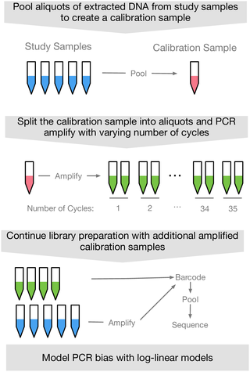
Figure 14. Variable PCR Experiment Workflow (Silverman et al. 2021)
Dataset Pre-processing
Even after generating ASVs, metabarcoding data poses many opportunities for choice of resolution and specificity when analyzing communities. First, we amplified both the COI and 18S marker regions. COI provides better species identification for the metazoan mesozooplankton taxa of interest but misses key groups such as pelagic tunicates. In contrast, 18S has a wider coverage and is able to capture more taxa but sacrifices specificity due to its lower mutation rate, which limits its ability to discriminate beyond the level of genus or family. Previous work has combined COI and 18S data to account for differences in coverage, however we did not include this approach for these analyses (Steffani et al, 2018).
Prior to quality filtering, we recovered 4941 ASVs for COI containing 2180 unique sequences (Table 2). For 18S we recovered 6918 sequences with 1188 distinct ASVs. We compared taxonomic designations made through BLAST with the Metazoogene database (Bucklin et al., 2021). Based on the coverage, resolution and relevant filtering to metazoan zooplankton taxa of interest we proceeded my analysis with Metazoogene assignations. Weseparately conducted manual filtering of taxonomic assignments from BLAST to remove holoplanktonic and non-zooplankton taxa, however we concluded that Metazoogene assignments were standardized and more specific.
 | Total # unique ASVs | Kingdom | Phylum | Class | Order | Family | Genus | Species
mtCOI BLAST | 2180 | 1 | 23 | 36 | 68 | 108 | 139 | 153
18S rRNA BLAST | 1188 | 1 | 15 | 19 | 35 | 50 | 47 | 46
mtCOI (Metazoogene) | 1501 | 1 | 10 | 19 | 33 | 68 | 88 | 101
18S rRNA (Metazoogene) | 1130 | 1 | 15 | 18 | 35 | 48 | 45 | 44
Table 2. The number of ASV’s identified to primary taxonomic levels for COI and 18S using BLAST and Metazoogene.
Metabarcoding is limited by taxon-specific amplification biases and masking the detection of rare species (Shelton et al., 2023). Data transformations such as normalization to a median number of read counts can alleviate some of the bias in raw reads, but methods to estimate true proportions of species in a sample that can be correlated to biomass at the species level remain in development. Here I include analysis of relative read abundance (RRA), read abundance normalized by the median number of read counts, and my PCR-bias corrected relative abundances (only for particular ASVs).

Additional Pre-processing for fido & Use in Modeling Against Environmental Properties
Prior to the implementation of the R package fido we applied additional filtering to examine only abundant and widespread ASV’s that met a specific criterion. Previous work using fido modeled human gut microbiome data and was analyzed at the genus level and genera that were not seen in at least 30% of samples with at least 3 counts were amalgamated together into a category called “other” for analysis (Silverman et al., 2021). Due to the environmental nature of my samples and the fact that samples are not collected evenly across environments, we applied a modified approach.
First, we selected only ASVs that appeared in all replicates of my variable PCR experiment to ensure that an amplification efficiency could be adequately calculated for each ASV. Next, we constructed an Empirical Cumulative Density Function (ECDF) of the count sums across all environmental samples and set a threshold of 0.9 to examine only ASV’s in the top 10% of the ECDF distribution. Remaining ASV’s that did not meet my criteria were pooled into an ‘other’ category. Separate analyses based on size class was necessary for this step, as larger taxa were abundant in different subsets of samples than smaller taxa and contained distinct biological communities.
In addition to its suitability for modeling PCR bias, fido can be used to construct Bayesian Multinomial Logistic Normal relationships between ASVs and environmental variables. we applied the previously described criteria to examine which environmental properties (Table S1) displayed significant relationships with ASVs. Resulting mean centered-log ratio values that did not contain 0 in the 95% confidence interval were deemed significant.

Zooscan Sample Processing and Analysis
Formalin-preserved samples were size fractionated (>1000 µm & 200-1000 µm) and quantitatively sub-sampled to approximately 1500 individuals, which were distributed into the Zooscan imaging tray. A complete image was taken, the background was removed, and individual plankton vignettes were extracted into regions of interest (ROI’s) using ImageJ. Touching plankton were manually separated by the user, then re-processed. Processed samples and metadata were uploaded to Ecotaxa-a web application where users upload and host images of individual plankton and particles, classify them using taxonomic annotation and machine learning algorithms and export processed ecological datasets.
We followed this workflow for formalin-preserved zooplankton samples from the port side net of the oblique bongo tows from which my size-fractionated DNA tissue samples were collected. Due to limitations in taxonomic expertise, we identified images into 35 taxonomic categories, multiples, and an additional 4 non-living categories. We used feret diameter from each image and length-carbon relationships to calculate carbon-biomass for each organism (Lavaniegos and Ohman, 2007). Taxon abundance and carbon biomass were standardized for aliquot volumes and the filtered volume of seawater measured by the flow meter during the net tow.

Physical Environmental Analysis
The CCE-LTER process cruises are interdisciplinary efforts and generate a range of physical, chemical and biological data. Here, we use the physical and chemical data to 1) determine the environmental clustering within my study, 2) compare these results to biological distributions, and 3) model relationships between environmental factors and the abundance of particular taxa.
We collected downcast data from CTD casts associated with each net tow and merged these with nutrient data measured from Niskin bottles including NO3, NO2, PO4, and SIL. We used surface-averaged (top 20m) values for nutrient bottle measurements and CTD data including potential temperature, density, fluorescence, salinity, and oxygen saturation (Table 3 S1). Additionally we calculated the mixed layer depth (where a difference in 0.125 density change occurs), nitracline depth (defined as the depth where nitrate concentration exceeds 1 µM), hypoxic depth (defined as the depth at which oxygen concentration first drops below 2mL/L or the minimum oxygen depth if greater than 2 mL/L for the entire cast), the chlorophyll-a fluorescence maximum depth and fluorescence value, beam transmissometry maximum depth, distance from shore, and the 1% PAR depth (if a night cast we used the nearest daytime cast) (Table 3 S1). Nutrient data were not collected during T2, so we used the R package missMDA (version 1.18) function imputePCA to impute the missing values (Josse, 2016) with the 1st principal component as determined by the estim_ncpPCA function from missMDA.
Next, we performed a principal components analysis (PCA) on the complete metadata table. We used the R package pvclust to perform hierarchical clustering with an averaging agglomerative clustering algorithm and a correlation distance bootstrapped 10000 times to examine which samples were most similar in PCA-space. We took clusters with an approximately unbiased (AU) probability value (p-value) of >0.95 to be significant. Figure 17 shows the results of the hierarchical clustering of environmental metadata with a red box drawn around the significant clusters.

Results
4.4.1 Physical Environmental Clusterings
Principal component analysis explained 68% of the variance: PC1 accounted for 58% and PC2 for 10% of the variance. Temperature, density, nitrite, chlorophyll-a fluorescence, nitrate, the depth of the chlorophyll-a maximum, distance from shore, salinity, longitude, and phosphate contributed significantly to PC1 (Figure 16). Euphotic zone (1% PAR depth), oxygen saturation, fluorescence at the chlorophyll-a maximum, PO₄, silica, and the mixed layer depth contributed significantly to PC2 (Figure 16). Distance from shore showed a positive correlation with temperature, chlorophyll-a maximum depth, and nitracline depth and a negative correlation with density, nitrite, chlorophyll-a fluorescence, and nitrate (Figure 15). This cross shore gradient in biogeochemical properties aligns with historical expectations of Hayward and Venrick (1998). Hierarchical clustering of stations based on physical environmental properties resulted in two significant clusters: an onshore cluster (including Cycles 1 and 2, the alongshore transect (CT2) and the 2 stations of the cross-shore transect (CT1-7 and 8) and an offshore cluster (Cycle 3 and CT1-1-6) (Figure 17).
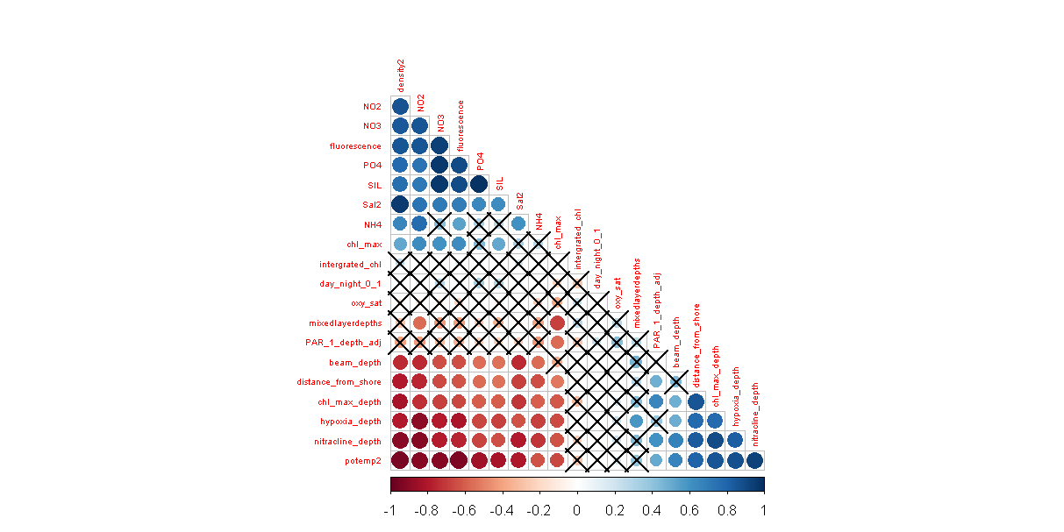
Figure 15. Correlation matrix of environmental variables used in cluster analysis. Matrix positions marked with ‘X’ indicate a nonsignificant correlation.
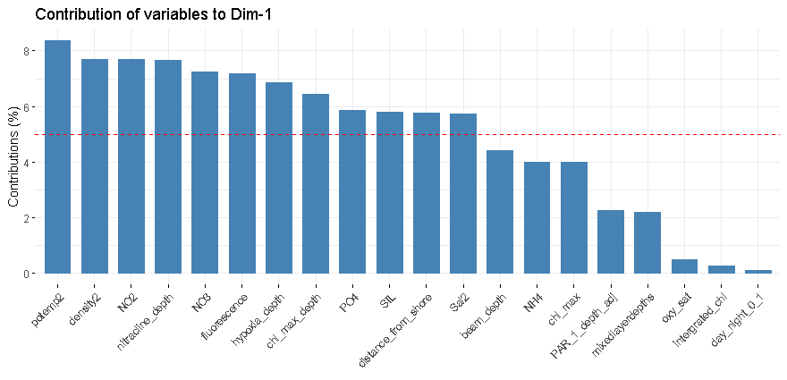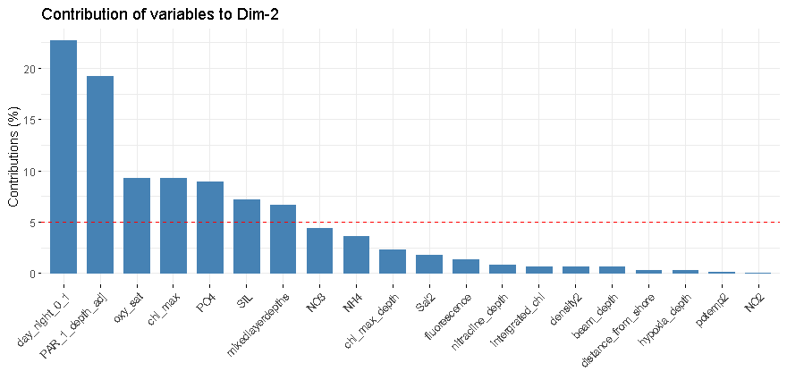
Figure 16. Contribution of environmental variables to PC1 (upper) and PC2 (lower). We consider variables contributing >5% to the PC to be significant (delineated by the red dashed line).

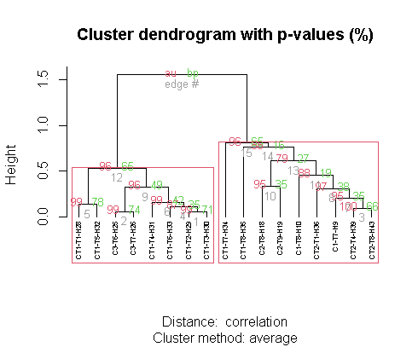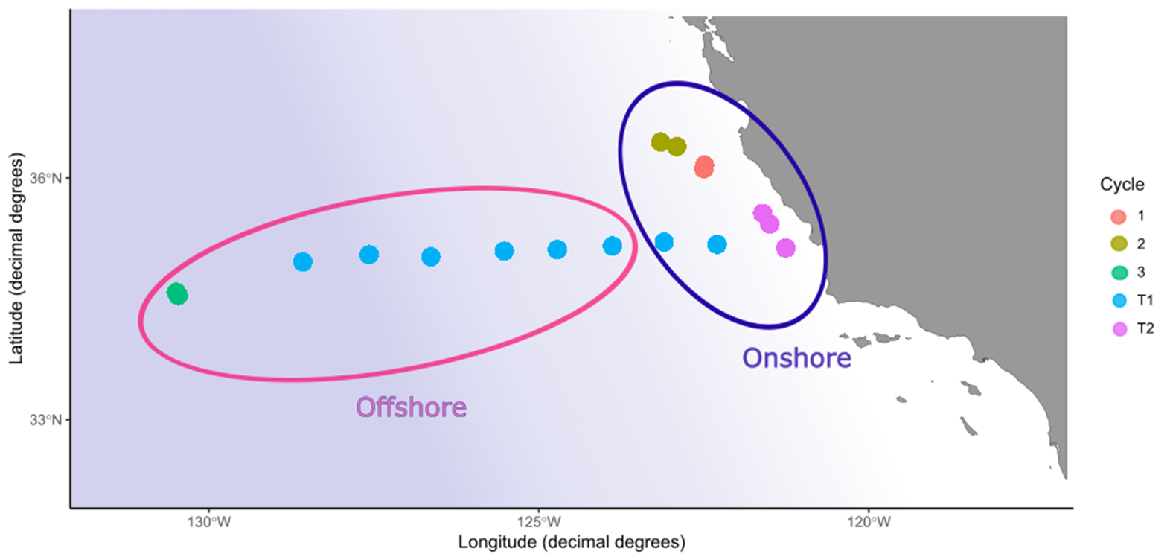
Figure 17. Upper: Hierarchical clustering of environmental sampling stations based on physical and chemical measurements in Table S1. Approximately unbiased p-values (au) are in red and bootstrap probability (bp) is in green. Red ellipses delineate the largest significant clusters. Lower: Map of sampling sites for P2107. Point color is associated with the cycle or transect and ellipses show the onshore and offshore resulting from hierarchical clustering analysis.
4.4.2 Comparison of Zooplankton with Physical Environmental Properties
Shannon Diversity (H’) (calculated using both COI and 18S) of the full community (all sizes) was significantly correlated with PC1 (R²=0.33, p=0.02 for COI and R²=0.32, p=0.02 for 18S) (Figure 18). When separating by size fraction, only 18S was significant although a similar pattern could be observed for COI. H’ of the smallest size fraction (0.2-0.5mm) was not significantly correlated with PC1. For the intermediate size-fraction (0.5-1mm) there was a significant negative correlation with PC1 for 18S (R²=0.26, p=0.04). The largest size fraction (1-2mm) displayed the opposite relationship for both gene markers with a positive correlation but this was not statistically significant (Figure 19).
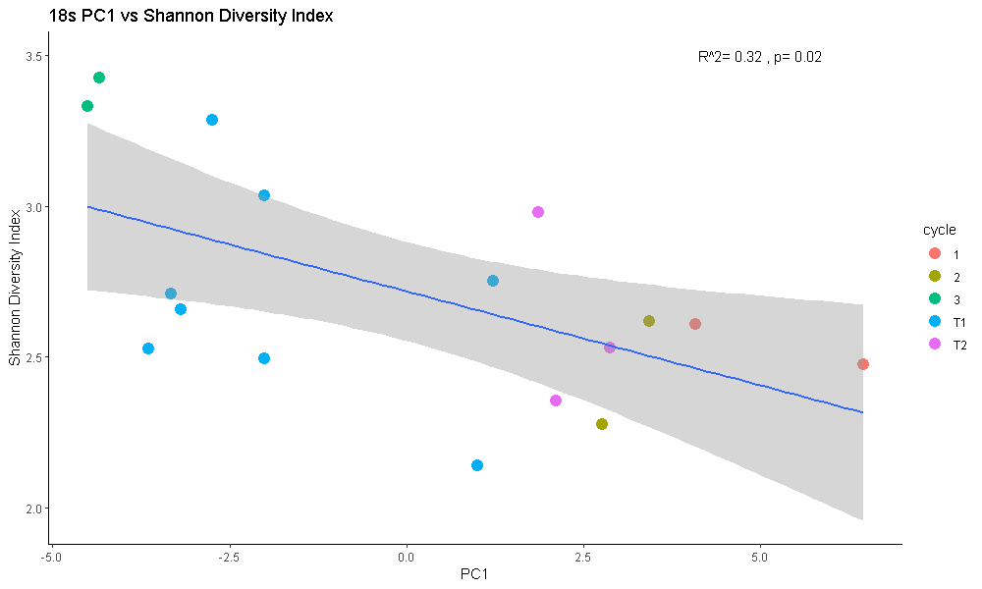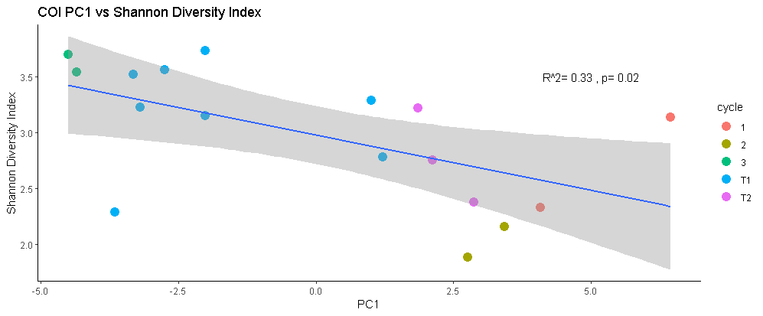
Figure 18. Linear regressions of Shannon Diversity Index for aggregated samples vs. PC1 for 18S (upper) and COI (lower).
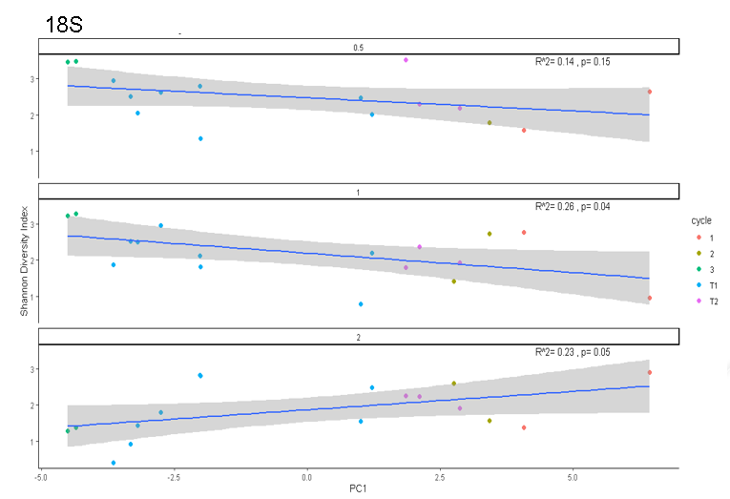
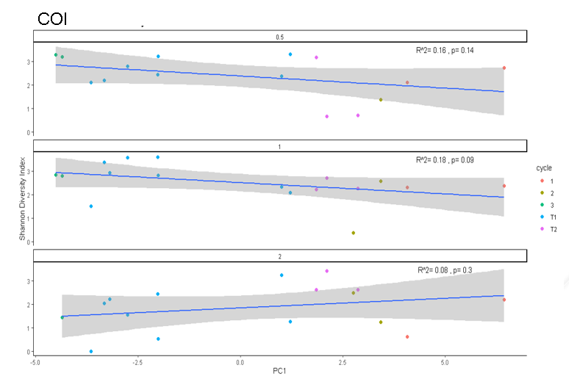
Figure 19. Linear regressions of Shannon Diversity Index for size-fractionated samples vs. PC1 for 18S (upper) and COI (lower). Sizes are listed from top to bottom as 0.2-0.5 mm, 0.5-1 mm and 1-2 mm.

4.4.3 Zooplankton Taxon and Size-specific relationships with Environmental Properties
After the pre-processing for fido the ASVs associated with 3 groups for COI (Euphausia pacifica, calanoid copepods, and Rosacea cymbiformes) and 2 groups for 18S (euphausiids and calanoids) produced significant relationships with PC1 (Figure 20, Figure S1). For COI, the results indicate that many taxa differ in their relationship with environmental properties between size classes. Calanus pacificus ASV 1 showed a well-conserved relationship across the 3 size classes (Figure 20). C. pacificus had many ASVs assigned for COI, and none of the modeled relationships align consistently. This variability in ASV could arise due to sequencing errors or limitations of the taxonomic database that does not include similar species and thus assigned them all to C. pacificus. Ctenocalanus vanus ASVs were highly conserved across its two sizes (0.2-0.5 mm and 0.5-1 mm) and their negative mean centered log-ratio value indicates that this organism is strongly linked with the offshore environment. The largest size siphonophore was strongly linked with the onshore environment, whereas its smaller size classes had less of a clear association. Smaller E. pacifica were significantly related to positive onshore PC1 values and the largest size class was not significantly associated with either grouping (Figure 20).
We also found many taxa with strong relationships to nutrients: NO₃, PO₄, NO₂, and NH₃ and chlorophyll-a fluorescence (not shown). Next steps in this analysis will be to examine how these relationships change after running the models for PCR bias-corrected abundances.

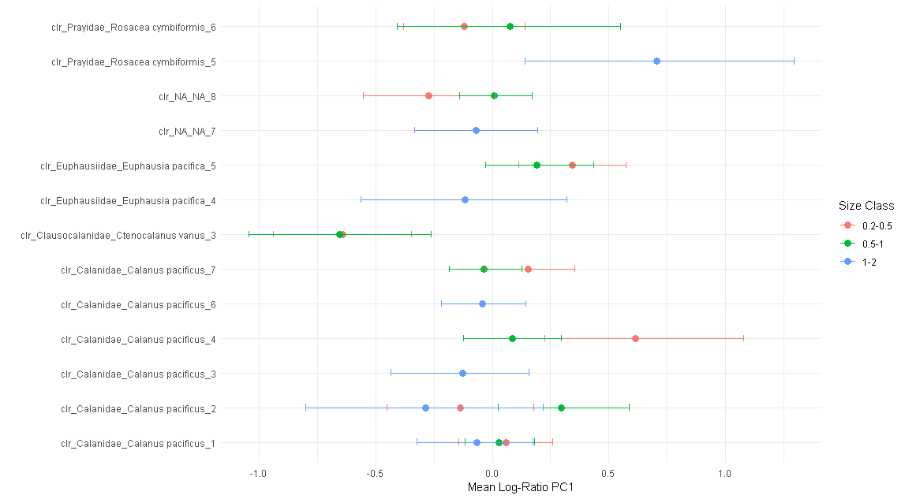
Figure 20. Fido model showing centered log-ratio values for ASVs and PC1. Color is associated with size fraction (red=0.2-0.5mm, green=0.5-1mm, blue=1-2mm) and error bars are the 95% confidence interval. Note: not all ASVs in the plot passed the pre-processing criteria or appeared in each size fraction (e.g. Calanus_pacificus_6 for 0.2-0.5 and 1-2mm).
4.4.4 Onshore and Offshore Zooplankton Taxa
Normalized read-based species abundances indicated C. pacificus E. pacifica were the dominant species onshore Figure 21). Other notable taxa included the siphonorphores R. cymbiformes and Nanomia bijuga, Metridia pacifica (also abundant in 18S-figure not shown) and Ct. vanus. In the offshore, read abundances were more evenly distributed across a diversity of calanoid copepods, although E. pacifica was also relatively abundant (Figure 21).
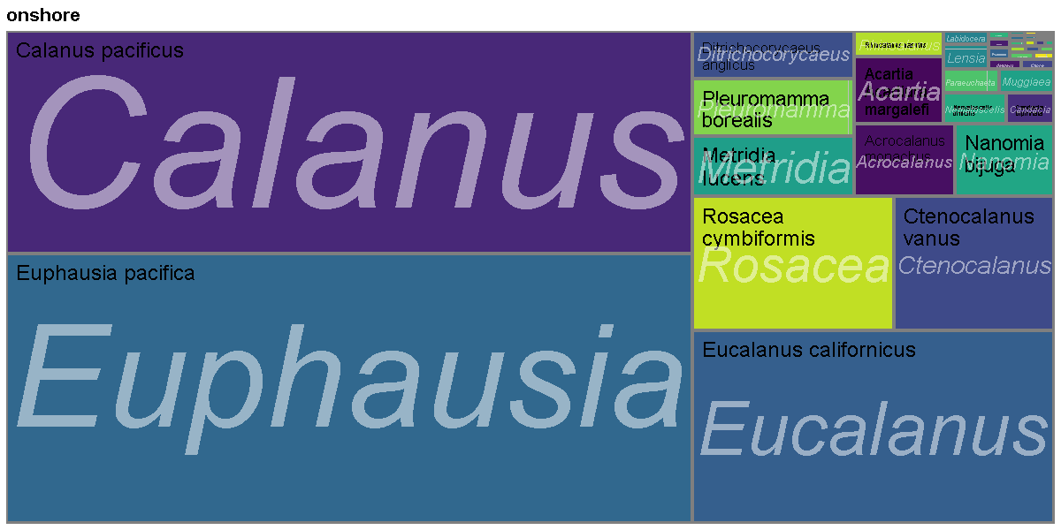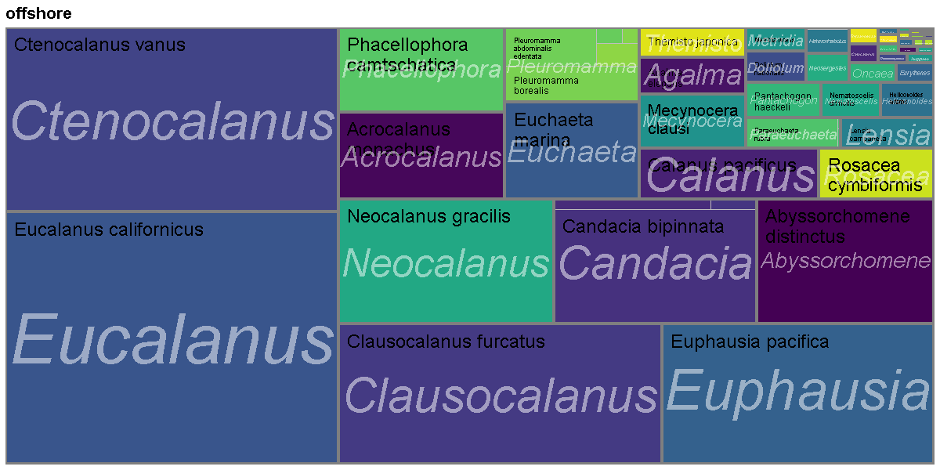
Figure 21. Treemaps of onshore (upper) and offshore (lower) taxa for COI. The size of each rectangle scales with read abundance normalized to the median. Plots comprised of total read abundances from each physically determined cluster.
In parallel with fido, we examined onshore and offshore taxa using the DESEQ2 package. Differences in sequence abundance between onshore and offshore break (not shown here) revealed a handful of taxa significantly more abundant in each of these environments. The onshore region displayed elevated abundances of calanoid copepods including Eucalanus californicus, Ditrichocorycaeus anglicus and C. pacificus as well as the siphonophore Muggiaea atlantica. E. californicus and C. pacificus are both omnivorous whereas D. anglicus is carnivorous. Muggiaea atlantica is a cosmopolitan calycophoran siphonophore that preys on copepods, and is common in shallow waters. Offshore was defined by greater abundances of the siphonophore Agalma elegans and an amphipod that was identified Abyssorchomene distinctus. However, since this species of amphipod has previously been reported only in waters >2000m in the South West Pacific, this likely represents a mis-identification related to database limitations. Agalma elegans is documented from the CCE though little is known about its ecology. Other noteworthy taxa distributions include doliolids as characteristically offshore, identified with COI. Cnidaria were found in both onshore and offshore environments, with 3 species in each (siphonophore, trachymedusa and scyphozoan offshore, and 3 siphonophore species onshore). Chaetognaths appeared in both environments though were not identified to the level of species.
Notably, some species had multiple ASVs that were characteristically associated with either onshore or offshore environments, such as E. californicus, Pleuromamma borealis and Heterorhadbus papilger. Other species had multiple ASVs but they aggregated (as expected) by environment: C. pacificus, Acartia margalefi and E. pacifica onshore, and Candacia bipinnata, Euchaeta rimana (identified here as Euchaeta marina which likely represents a misidentification) and Clausocalanus furcatus offshore.

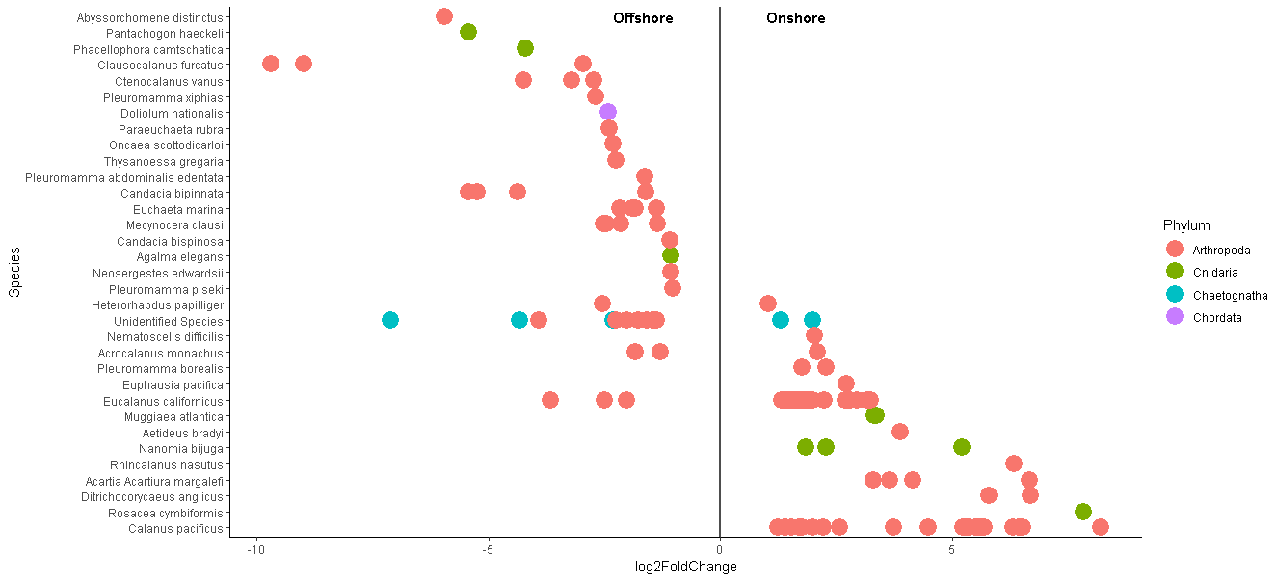

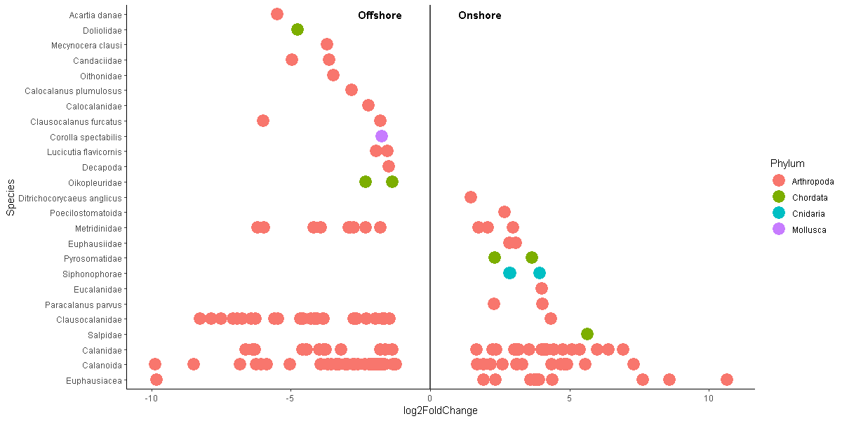
Figure 22. Upper: DESEQ2 results from aggregated sample and size fractions for COI. Lower: DESEQ2 results for 18s. ASVs not identified to the level of species are assigned family or order.

4.4.4 Variable PCR Experiment, Zooscan, and Comparison of Estimates of Zooplankton Abundance
The results of the variable PCR experiment yielded the first estimates of amplification efficiency for marine zooplankton. These results will focus on the 18S dataset as 18S had fewer taxa that met the filtering criteria (46 versus 8) (Figure 23, Figure 29 S2). Each size fraction included ASVs from C. pacificus, E. pacifica, and R. cymbiformes, with Ct. vanus only in the two smaller sizes (Figure 23).
Amplification efficiencies among sizes and species were variable. In the 0.2-0.5mm size fraction, C. pacificus and R. cymbiformes had negative amplification efficiencies, while Ct. vanus and E. pacifica showed positive efficiencies. In the 0.5-1 mm size fraction, R. cymbiformes and Ct. vanus had negative amplification efficiencies, E. pacifica had positive amplification efficiencies, and the multiple C. pacificus ASVs had mixed signs. Finally, in the 1-2 mm size class only E. pacifica had a positive amplification efficiency, whereas R. cymbiformes and C. pacificus were negative or near zero. Across all size classes, ‘Other’ had the largest and most positive amplification efficiency (Figure 23). The high amplification efficiency of the ‘Other’ category indicates that many of the abundant ASVs are overwhelmed by amplification of rarer ASVs competing for the number of reads. The consistently positive amplification efficiency of E. pacifica for the COI gene marker is notable, indicating this taxon is be overrepresented in reads in our metabarcoding data. Given the reported net-avoidance biases for euphausiids (Brinton 1967), these results underscore the need to consider bias and error propagation along all steps of the metabarcoding pipeline.
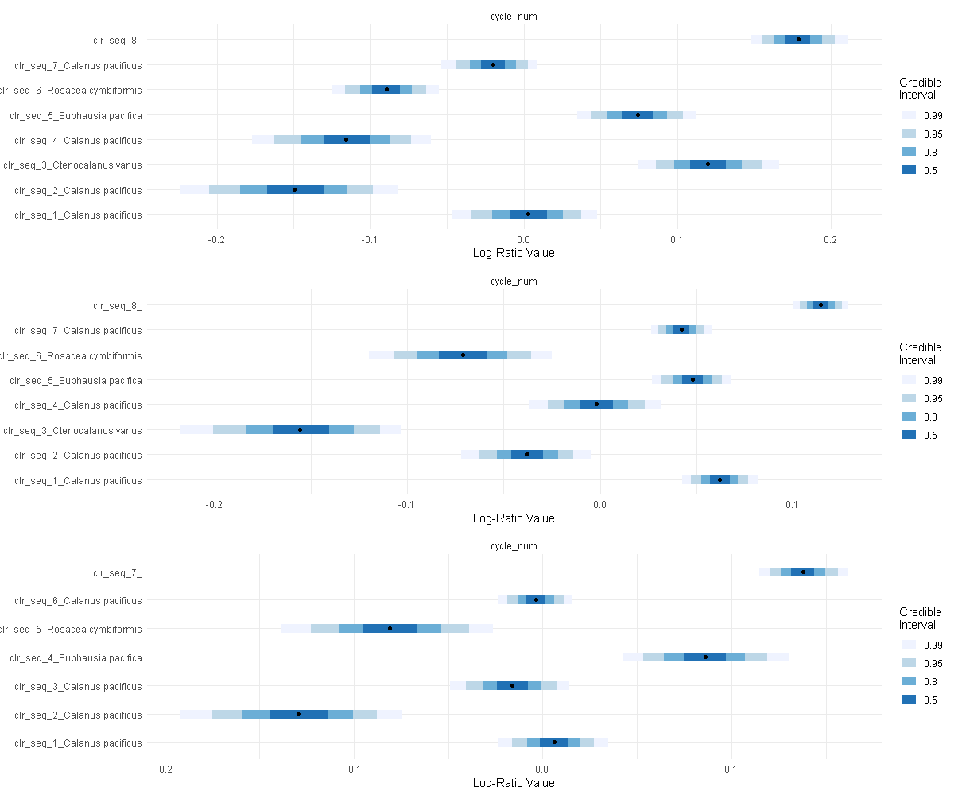
Figure 23. Estimates of amplification efficiency in centered log-ratio values for COI taxa. Upper is 0.2-0.5 mm taxa, middle is 0.5-1 mm and lower is 1-2 mm taxa. Credible intervals are displayed based on color-scale on the right.

As of the writing of this proposal, the Zooscan dataset has not been completely classified, thus the focus will be only on the validated samples which comprise ~50% of the total image count of 145,572. Figure 24 shows the relative abundance (as a proportion of individuals m⁻³ for all ‘living’ images) of calanoid copepods for each station. Zooscan imaging shows the relative abundance of calanoids is highest along the coast at Cycle 2 and in the smaller two size fractions (70-75% total abundance). The relative abundances between the two smaller size fractions are similar, whereas the 1-2 mm size class declines offshore with a minimum of 0.5% of the total sample.
Based on the relative read abundance from calanoid copepod taxa amalgamated for 18S (see Figure 29 (S1) for taxon included), calanoid copepods occurred uniformly across the sampling region (Figure 24). While relative read-abundance shows greater dominance of calanoid copepods compared to Zooscan-based relative abundances, there is notable agreement between both methods in the decline in copepod abundance in the intermediate sampling sites for the cross-shore transect. Specifically, the 3rd and 4th most offshore transect points were characterized by strong minima in the largest size class of calanoid copepods (1-2 mm) (Figure 24). The PCR bias mitigated data shows differences compared to the relative abundances of the ASVs of calanoid copepods (Figure 24). Future work will include an in-depth analysis of the drivers of these differences between the methods, and a parallel analysis for COI.

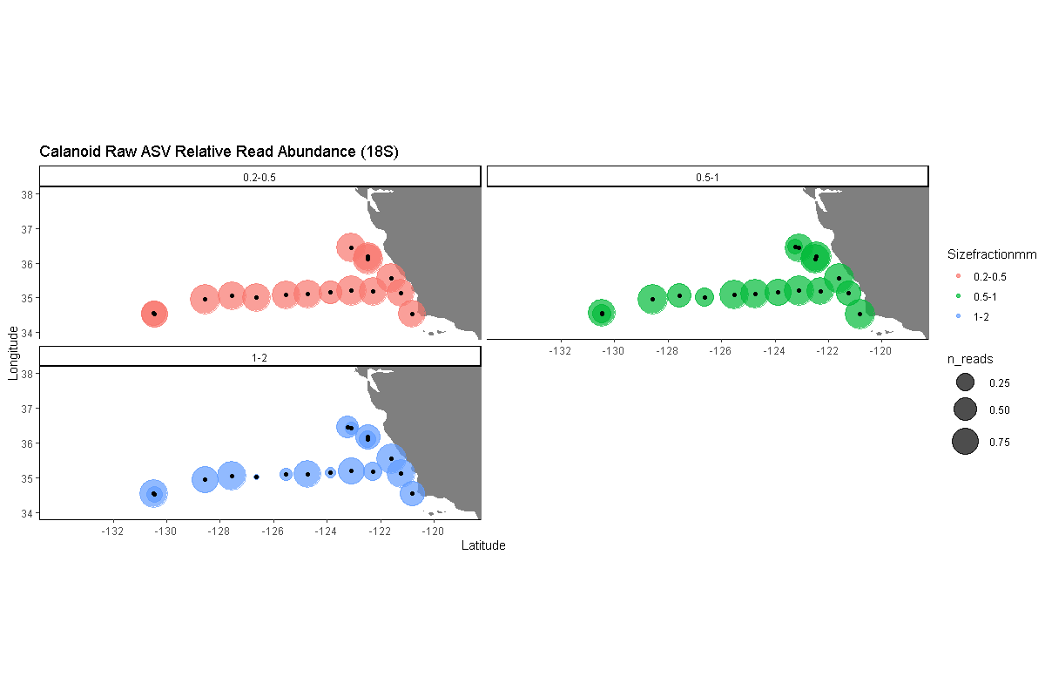

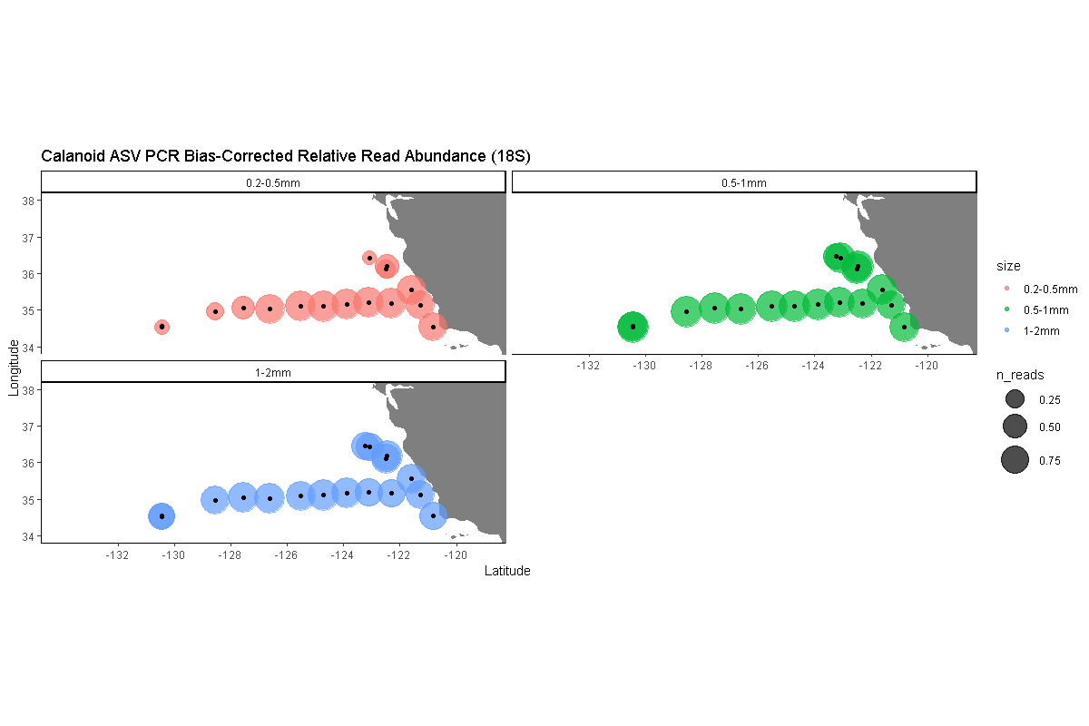
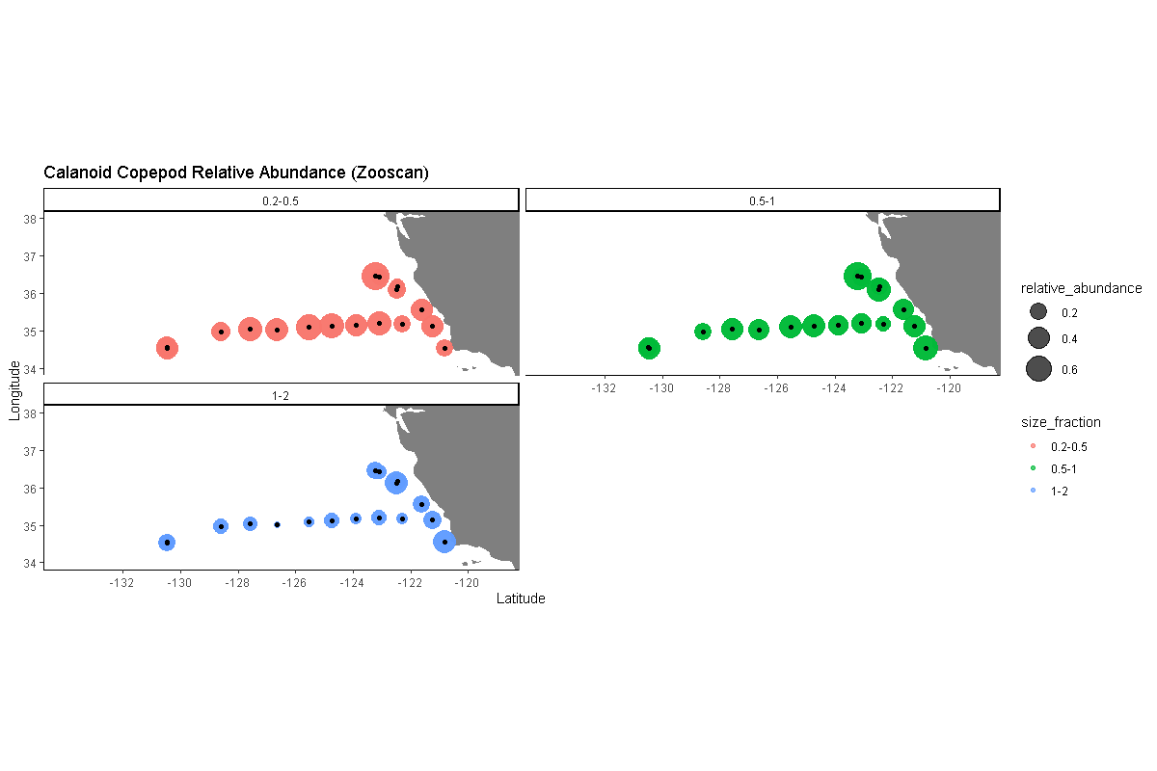
Figure 24. Distribution maps for calanoid copepods using relative read abundance (RRA) normalized to median counts, PCR-bias mitigated relative abundance (middle), and Zooscan pipeline (bottom). The Zooscan data include all calanoid taxa, whereas the relative read abundance PCR-bias mitigated data only includes those meeting the criteria outline in section 4.3.

Discussion
As molecular methods become more widely adopted, it is important to not only compare results of modern diversity surveys with morphological assessments on replicates but also to place them in the context of historical distributions. (Pitz et al., 2020) began this process by comparing alongshore DNA metabarcoding-identified species distributions with copepod and euphausiid taxa documented and enumerated by the CalCOFI program. Determining whether historically documented taxa are detected by metabarcoding further aids in constraining innate biases in this method and illustrates how these independent assessments may be complementary. I will examine distributions of selected taxa detected in our dataset (those that met the fido filtering criteria) and compare them with distributions and occurrences presented in the CalCOFI atlas and other literature sources. Finally, I will determine the environmental habitat and biogeographic ranges of the most consistently detected species within the dataset. These results will aid the interpretation of current and future programs that incorporate DNA metabarcoding as a monitoring tool to determine biological responses to environmental perturbations.

Acknowledgements

References

Supplemental

Working Outline

- Characterize physical, chemical and biological environment
  - Correlations+basic EDA
  - PCA, clustering
- Diversity across environment
  - Remake PC1 vs. shannon for sizes
- Relationships between taxa and environment
  - DESEQ2, fido
- Biomass estimates for PCR-bias mitigated taxa
  - Pool by size
- Methods comparison for calanoid copepods
  - Zooscan data

