Group Name: Crab Rave
Armando Tenorio
Group Activity for 3/23/2021
Part I:
- For Alessandro’s Concept:
  - I liked:
    - That the player gets random, but predictable, power-ups from bosses.
    - That there is a lot of emphasis on movement and physics.
    - That the difficulty increases when the player gets a power-up.
  - I disliked:
    - The general plot behind the game (not that it’s bad, but I just don’t like the genre in general).
- For Dante’s Concept:
  - I liked:
    - That the protagonist is a crab.
    - How silly the plot is.
    - The player’s POV since the player only sees 2 floating crab claws for attacking/interacting.
    - The Crabmania diffculty.
    - The crab skins.
  - I disliked:
    - Nothing.

Part II:
1. We could change Dante’s POV into my POV where the player can see the front part of their shell with the crab claws to their sides. This can bring in a little immersion for players since they players can visualize a body now. Basically, the players will feel more involved with the main idea of attacking and evading Walmart employees to save the other crabs.
2. Wacky physics could make Alessandro’s game more exciting since the player has to learn and master unconventional movement. I guess it will add a charm to Alessandro’s game since it’s going to be a difficult movement-based game that doesn’t take itself seriously.
3. We can also implement item/tool usage in Dante’s game as a way to make puzzles. For example, we can place bottles of glue around the store so that players can pick them up and throw them at the employees so that their movement is slowed for a while.
Part III:
(We picked Dante’s concept, so I’m going to use his In-Class Activity as a response.)
Premise
- The Crabs are trying to free their brethren from the Wal-Mart crab tank.
Character
- A random Wal-Mart employee is trying to do their job to get their paycheck.
Actions & Consequences
- Wal-Mart employees can tie your claws to stop you from attacking for a couple of seconds.

Part II:
High level: Objectives & conflicts
- What is the player’s goal, and what do they need to do to achieve it?
The crab must free all of its brethren that have been captured inside of Wal-Mart. This must be accomplished without being captured itself.

- What are the most significant obstacles/conflicts to the player succeeding?
Wal-Mart employees are at the front of the defense (with their minimum wage), fending off the crab. Employees have zip ties and traps to capture the crab along the path.

More specific: The key system dynamics
- What is the most important player action? The most common?
The player must navigate the crab to avoid the employees while getting the crab to its goal which is the crab tank. The player must be responding to both the employees and to any physical obstacles that may show up.

- Under what different circumstances does the player perform that action?
The player will have a relatively easy time moving to the store’s entrance, but there will be more employees guarding the spots closer to the crab tank. Additionally, more physical obstacles will appear the deeper the player gets into the store.

- How does the environment respond to that action, and what are the possible outcomes?
The environment will be mostly static, but some of the items (like carts) can be moved to block the player’s advancement.

Commit to a specific idea
- List 2-3 player experiences that will make the game fun and interesting. Be specific and player-focused!
Player experience 1: The thrill and excitement of freeing your fellow crabs as you avoid the Wal-Mart employees.
Player experience 2: The Wal-Mart employees will be looking for a rogue crab to capture the Player which will cause a Game Over or restart the level from the beginning.
Player experience 3: After the Player has completed the game or finished a level, it unlocks a new difficulty called Crabmania or introduces new mechanics/levels.
Part III:
As an individual, repeat Part II in your own separate document. You can choose any of the other merged concepts that came up in your group, or a new one you come up with on your own. Put the three ideas (premise, character, actions & consequences) at the top of the document.

Go into more detail than you did in the class activity. Answer the questions above (1-6) with a short paragraph or longer bullet list as appropriate.

In addition:
- Draw out a sequence of screenshot sketches showing what a player would see during those critical gameplay experiences from question 6. Pay attention to what information is on screen (environment or UI elements).
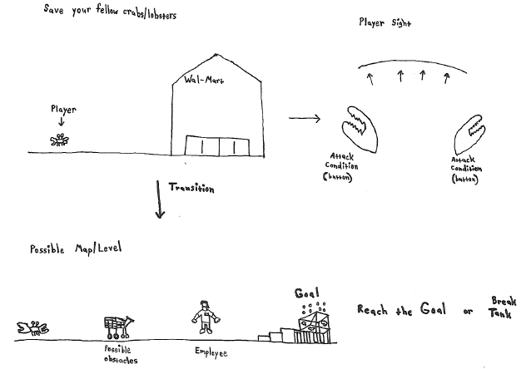

- Write a 1-2 paragraph description that “sells” this concept to potential players. Try to capture what makes it uniquely interesting. Describe at least the premise, aesthetic, core gameplay and how you win or lose.
The game will an FPS where the player controls a crab that is trying to free its fellow brethren from the Wal-Mart crab tank while avoiding many obstacles and the employees. The player movement control will be based on (wacky physics), to where the player can move and attack like a crab. The player controlling the crab can move throughout the level interacting with obstacles (like a cart) or attack the employees if they try to capture the player. Once the player reaches the end goal (Wal-Mart crab tank), then the level is complete. With each level completed, unlocks a newer/harder difficulty called “Crabmania” for those that want a challenge. Once the game is finished, the player will be able to unlock new crab skins (Ex: color variations/exotic/rainbow) for completing the game and for completing the game on the harder difficulties.
The premise of the game is a crab trying to free their brethren from the Wal-Mart crab tank. The aesthetic of the game will either be in 2D or 3D, with some props to give it more of a visual appeal of each level according to its design. The core gameplay mechanics of the game will involve the player controlling the crab that is trying to reach the end goal of freeing its fellow brethren from the Wal-Mart crab tank while at the same time avoiding the employees or obstacles that may come your way. For the player to win the game, they must be able to free their fellow brethren from the Wal-Mart crab tank without getting caught by the employees. However, if the player does get caught, then they would have to fight off the employee in order to escape, otherwise the game will end causing the player to lose.

