Team Activity: Game Design
Get together in your team channel. Create a shared document to work with. Building on the discussion that started last class, start filling out the game design document for your final game project. Submit your document by committing it to the Documents folder in your repo as design_doc_v1.

As before, answer the questions with a short paragraph or longer bullet list as appropriate (and embed images for the screenshot sketches).

High level: Objectives & conflicts
1) What is the player’s goal, and what do they need to do to achieve it?

The player is trying to free the other crabs from the Walmart lobster tank. The player has to either avoid or fight past the Walmart employees, reach the lobster tank, and find a way to open it for the other crabs to get out.

2) What are the most significant obstacles/conflicts to the player succeeding?

The most important obstacles are the employees because they are able to capture the player if they collide with the player, which will lead to a game-over. A common obstacle will be the environment in the form of store shelves, shopping carts, and displays. They will physically block the player’s movement unless the player works around them or moves them out of the way.

More specific: The key system dynamics
3) What is the most important player action? The most common?

The most important player actions are either avoiding the employees or fighting the employees because the player doesn’t want to get a game-over. The most common player action is working around or with the environment since the player can interact with the environment to make new paths or block the employees’ movements by blocking out paths.

4) Under what different circumstances does the player perform that action?
The circumstances that can trigger these types of actions is when either the employee finds the player or has some suspicions that the player is around. This type of mechanic has been implemented in the game where there are two AIs, one that knows where the player is at all times and seeker ai that locates the player through vague hints of the map ai.

5) How does the environment respond to that action, and what are the possible outcomes?
So how the environment responds to the hiding and seek between the player and the employees is on how the suspicion level of the employee is consistently raised or decreased based on time. Like a sneaking mechanic where if the employee sees you without hiding, they will pursuit until the player “hides” which will prompt the suspicion meter.

Commit to a specific idea
6) List 2-3 player experiences that will make the game fun and interesting. Be specific and playerfocused!
- I feel like the game can be fun if there is a combat mechanic like some crabs picking up items such as knives, pan, plates and etc,
- The Sneaking Mechanic would make the game fun by playing a game of hide and seek based on a meter of proximity or visibility between the player and the employee
- Another experience would be character creation in which the player would enjoy cosmetics items on their character that would make it funny, epic or both. This can be gained by how much they win in a game. (Or loot boxes, just kidding, microtransactions suck).

7) Draw out a sequence of screenshot sketches showing what a player would see during those critical gameplay experiences from question 6. Pay attention to what information is on screen (environment or UI elements).
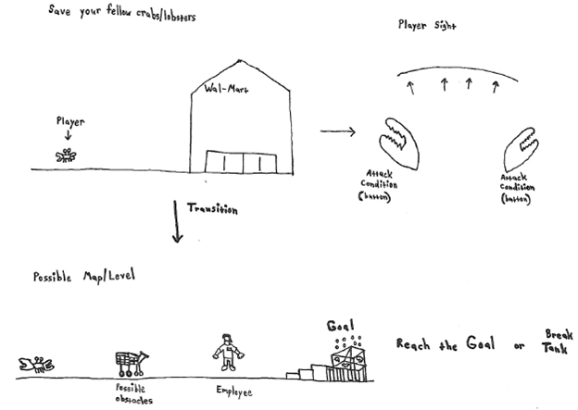

8) Write a 1-2 paragraph description that “sells” this concept to potential players. Try to capture what makes it uniquely interesting. Describe at least the premise, aesthetic, core gameplay and how you win or lose.

The game will an FPS where the player controls a crab that is trying to free its fellow brethren from the Wal-Mart crab tank while avoiding many obstacles and the employees. The player movement control will be based on (wacky physics), to where the player can move and attack like a crab. The player controlling the crab can move throughout the level interacting with obstacles (like a cart) or attack the employees if they try to capture the player. Once the player reaches the end goal (Wal-Mart crab tank), then the level is complete. With each level completed, unlocks a newer/harder difficulty called “Crabmania” for those that want a challenge. Once the game is finished, the player will be able to unlock new crab skins (Ex: color variations/exotic/rainbow) for completing the game and for completing the game on the harder difficulties.

The premise of the game is a crab trying to free their brethren from the Wal-Mart crab tank. The aesthetic of the game will either be in 2D or 3D, with some props to give it more of a visual appeal of each level according to its design. The core gameplay mechanics of the game will involve the player controlling the crab that is trying to reach the end goal of freeing its fellow brethren from the Wal-Mart crab tank while at the same time avoiding the employees or obstacles that may come your way. For the player to win the game, they must be able to free their fellow brethren from the Wal-Mart crab tank without getting caught by the employees. However, if the player does get caught, then they would have to fight off the employee in order to escape, otherwise the game will end causing the player to lose.

