Team Activity: Game Design Refinement
Get together in your final project channel. Each individual create a document to take notes for this activity that you will turn in. In your new team repo, create a folder called “Documents” and a sub-folder called “Refinement”. Commit all your notes files into that sub-folder.

Part I, Critique
Go around the channel and share the concept you brought from last class. Read the description, experiences and explain the storyboards. Everyone else respond (very briefly!) with one thing that really interests you, one thing you don’t like, and one open question.
Everyone write down your own notes (likes, don’t likes, questions) for each concept that is shared.
From Armando Tenorio’s concept
Likes:
- The idea of disarming the bomb with crab hands or using the pliers while holding onto them with the crab hands.
- The wacky physics that could make the game more enjoyable.
- Clues to help the Player determine which wire to cut or not cut.
- An interactive environment with various objects (chairs, lamps, boxes, etc.).
Dislikes:
- Nothing
Questions:
- The time limit for how long it will take the bomb to go off if the Player (crab) can’t handle the physics.
- Will there be complex bombs to defuse or a mixture of randomly generated bombs for the Player?

From Alessandro Abarca’s concept
Likes:
- The idea of the protagonist having multiple actions/interactive skills as they unlock overtime
- Obstacles/Enemies for the protagonist that prevent progression
- “Punishment Mode” (Enemies get stronger as Player progresses [reaches max level])
Dislikes:
- Puzzles and Minigames may be difficult to implement in an FPS game
Questions:
- The idea of boss fights could make the game very exciting or very difficult depending on how its implemented

Part II, Compare and contrast
Go around the channel one at a time doing this exercise:
- Take what you think is the most unique and interesting part of your game concept
- Transplant it into one of the other concepts
- Describe the resulting game in a few sentences (theme, objective, conflict, dynamics)
- Together, discuss player experiences in that imagined game
Everyone write down the sentences you came up with in step (3) in your notes to turn in.
- The Player is a crab in an FPS game to where they have crab hands which can used for combat or for interacting with the environment.
- I could implement this idea with Alessandro’s idea of the main protagonist having multiple powers in which the crab can hold multiple dangerous weapons (melee, guns, etc.) or have various powers.
- The theme of the FPS game would be based off of a crab fighting to free its fellow brethren against an enemy (Wal-Mart employee, Alessandro: rat militia [or another mob]). The objective is for the player to progress throughout game without dying and to free their fellow crab brethren. The conflict that may arise throughout the game will be various obstacles and enemies that will try to kill or slow down the Player from progressing. The dynamics or physics of the game will be wacky in a sense to where its enjoyable and smooth for gameplay.
*Many ideas throughout the group could be interchangeable between one another. I could implement Armando’s idea of disarming a bomb within the time limit instead of having the crab tank. Meanwhile, Alessandro’s idea of the main protagonist having powers could be implemented within my game idea or Armando’s.*

Part III, Commit to a Direction (Cited: Dante Vela Activity_P3-HW)
Over the course of this week, you are going to create your team game design document (in the same format as the last homework). Things will change as you go, but at this moment you need to commit to a relatively specific direction. As a team, talk through the design document questions below. You don’t have to finalize details or write it down right now, but you need to have some general agreement. On Thursday, you’ll start writing it down and really committing to the details.

High level: Objectives & conflicts
- What is the player’s goal, and what do they need to do to achieve it?
The crab must free all of its brethren that have been captured inside of Wal-Mart. This must be accomplished without being captured itself.

- What are the most significant obstacles/conflicts to the player succeeding?
Wal-Mart employees are at the front of the defense (with their minimum wage), fending off the crab. Employees have zip ties and traps to capture the crab along the path.

More specific: The key system dynamics
- What is the most important player action? The most common?
The player must navigate the crab to avoid the employees while getting the crab to its goal which is the crab tank. The player must be responding to both the employees and to any physical obstacles that may show up.

- Under what different circumstances does the player perform that action?
The player will have a relatively easy time moving to the store’s entrance, but there will be more employees guarding the spots closer to the crab tank. Additionally, more physical obstacles will appear the deeper the player gets into the store.

- How does the environment respond to that action, and what are the possible outcomes?
The environment will be mostly static, but some of the items (like carts) can be moved to block the player’s advancement.

Commit to a specific idea
- List 2-3 player experiences that will make the game fun and interesting. Be specific and playerfocused!
Player experience 1: The thrill and excitement of freeing your fellow crabs as you avoid the Wal-Mart employees.
Player experience 2: The Wal-Mart employees will be looking for a rogue crab to capture the Player which will cause a Game Over or restart the level from the beginning.
Player experience 3: After the Player has completed the game or finished a level, it unlocks a new difficulty called Crabmania or introduces new mechanics/levels.

- Draw out a sequence of screenshot sketches showing what a player would see during those critical gameplay experiences from question 6. Pay attention to what information is on screen (environment or UI elements).
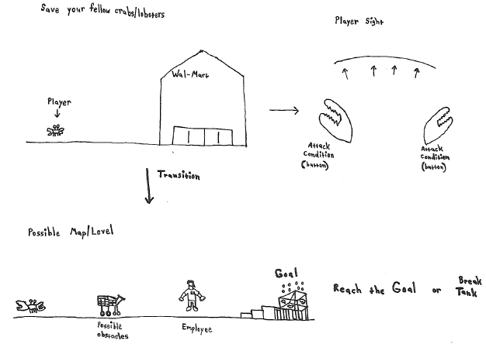

- Write a 1-2 paragraph description that “sells” this concept to potential players. Try to capture what makes it uniquely interesting. Describe at least the premise, aesthetic, core gameplay and how you win or lose.
The game will an FPS where the player controls a crab that is trying to free its fellow brethren from the Wal-Mart crab tank while avoiding many obstacles and the employees. The player movement control will be based on (wacky physics), to where the player can move and attack like a crab. The player controlling the crab can move throughout the level interacting with obstacles (like a cart) or attack the employees if they try to capture the player. Once the player reaches the end goal (Wal-Mart crab tank), then the level is complete. With each level completed, unlocks a newer/harder difficulty called “Crabmania” for those that want a challenge. Once the game is finished, the player will be able to unlock new crab skins (Ex: color variations/exotic/rainbow) for completing the game and for completing the game on the harder difficulties.

The premise of the game is a crab trying to free their brethren from the Wal-Mart crab tank. The aesthetic of the game will either be in 2D or 3D, with some props to give it more of a visual appeal of each level according to its design. The core gameplay mechanics of the game will involve the player controlling the crab that is trying to reach the end goal of freeing its fellow brethren from the Wal-Mart crab tank while at the same time avoiding the employees or obstacles that may come your way. For the player to win the game, they must be able to free their fellow brethren from the Wal-Mart crab tank without getting caught by the employees. However, if the player does get caught, then they would have to fight off the employee in order to escape, otherwise the game will end causing the player to lose.

