|  |  |
| --- | --- |
| STUDENT ID | NAMES |
| 20127369 | Lê Quốc Trung |
| 20127400 | Phan Gia Huy |
| 20127437 | Dương Đức Anh |
| 20127673 | Trương Gia Huy |

Working progess: 100%

Data structures:

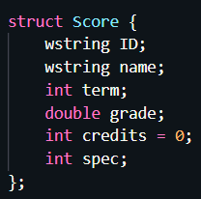

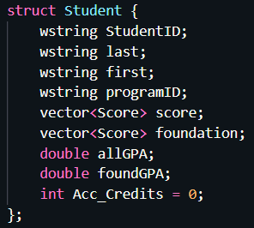

Algorithms (step-by-step):

1. File and struct handling:

* Read Grading file (Grading.csv) into struct<Student> GradeList (ReadStudent_Grading)

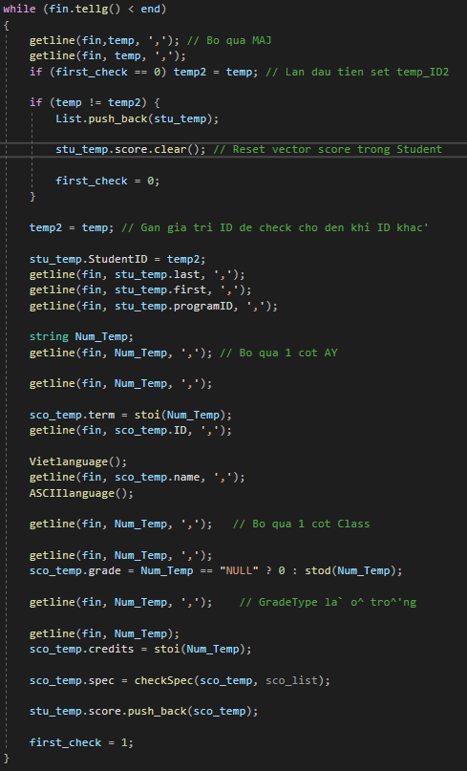

* Sort Grading file by ID and delete duplicated students (void sort(vector<Student>& bar))
  + Convert StudentID into integer and merge sort

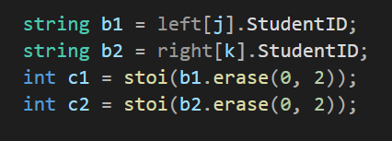

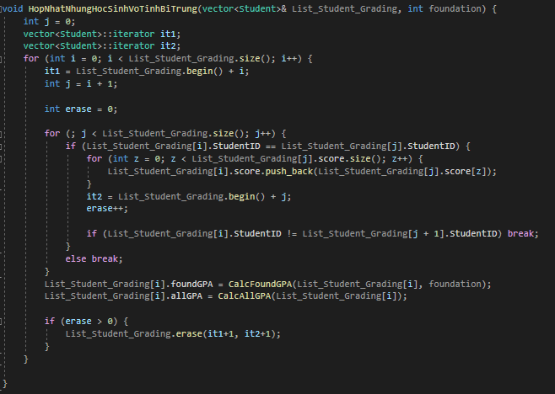

* Read Interest file (Interests.csv) (ReadStudent_Interest)

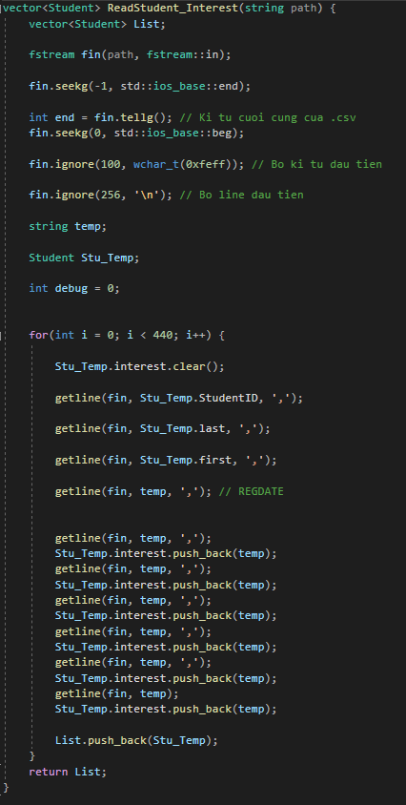

* Sort Interests file by ID (void sort(vector<Student>& bar))
* Add interests into GradeList

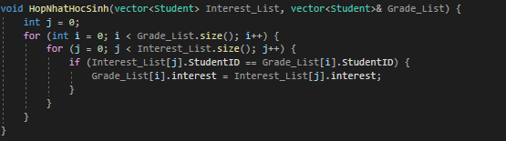

* Delete student that don’t have interests

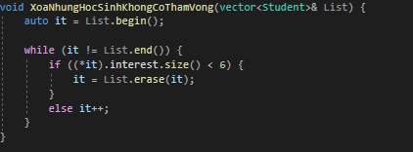

* Calculate GPAFound, GPA_All and credits

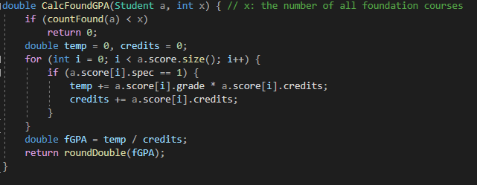

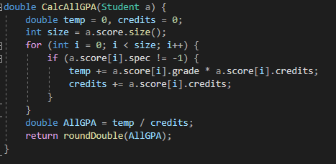

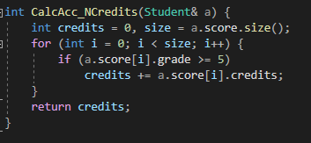

* Sort GradeList by GPAFound

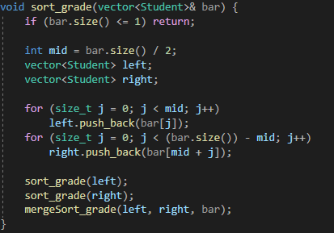

* Add students to Majors: Loop through the GradeList and in descending order for each student, we iterate the interests, if the major’s quota is greater than 0 then we set the flag Chosen to student’s interest index and Selected to the shorten form of the major.

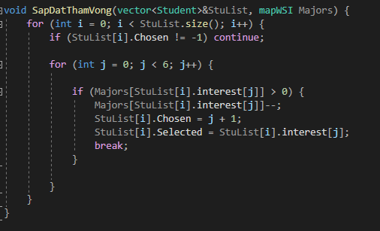

1. Command Line and Arguments handling:

* Command 1: Output Result.csv

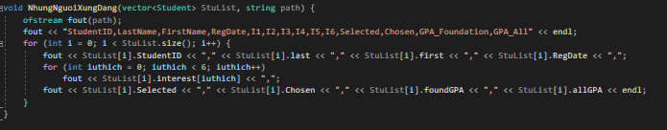

* Command 2: Search into the GradeList sequentially by ID and get the student’s information

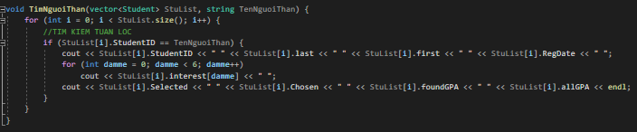

* Command 3: Loop through the GradeList, compare each student’s selected which the given major and output it into Major.csv

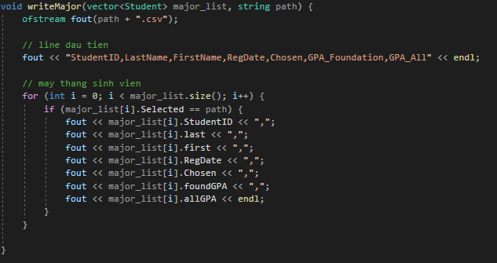

Reference: https://codereview.stackexchange.com/questions/167680/merge-sort-implementation-with-vectors