**Data Structures and Algorithms**

**Lab Manual**



**Name:** Muhaddis Muhammad Afzal

**Roll No:** BSE-22F-106

**Semester:** Third

**Program:** BS Software Engineering

**Course:** Data Structure & Algorithms

**Instructor:** M.Ameen Chajro

**Lab 1**

**Anaconda Distribution Installment:**

* First you have to visit the official website of Anaconda Distribution.
* Download it for your OS like Windows, Mac etc.



* Open the downloaded setup and complete the installation.



**Setting up IDE for Python:**

* Open Anaconda Navigation and install Jupyter Notebook.
* Open Jupyter Notebook and create new folder.

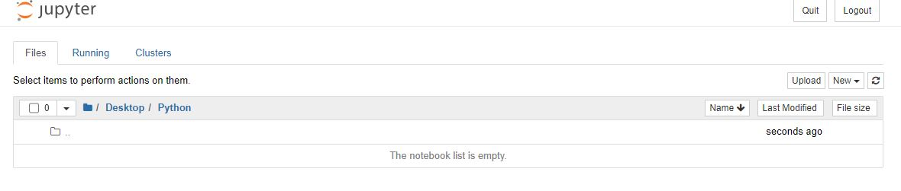

**Install Packages:**

* Open Anaconda Powershell Prompt.
* Write pip install matplotlib.

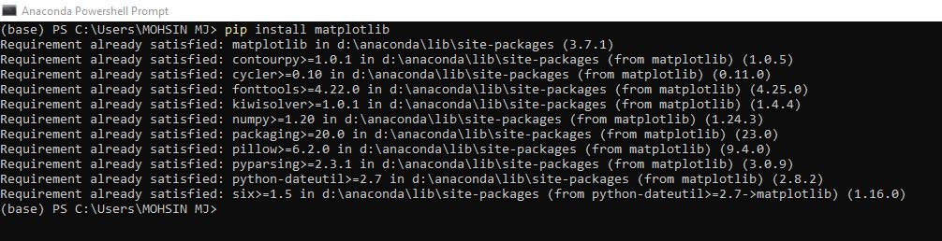

**Create your First Project:**

* 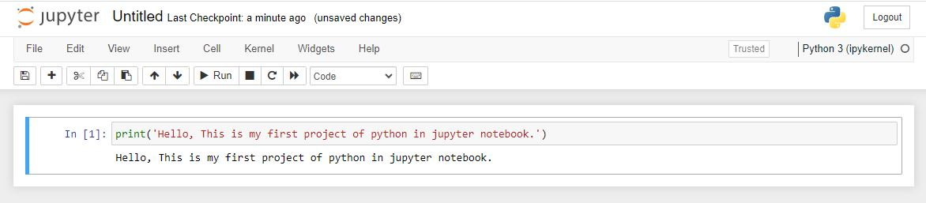Open Jupyter Notebook and write your code in python.

**Lab 2**

**Question 1:**

* Perform all arithmetic operations using assignment operators for current semester courses. Addition between three courses. Total marks of current semester.
* With the help of arithmetic operations describe which number is even and odd form following: **101, 500, 204.**

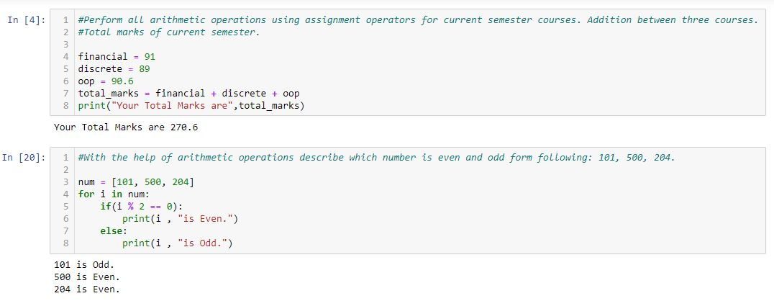

**Question 2:**

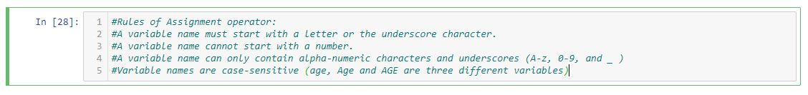Define Rules of Assignment operators.

**Question 3:**

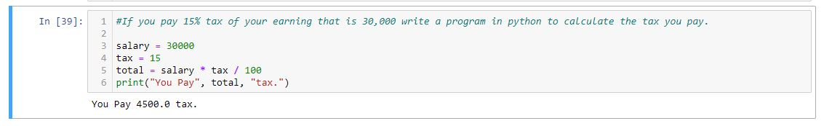If you pay 15% tax of your earning that is 30,000 write a program in python to calculate the tax you pay.

**Question 4:**

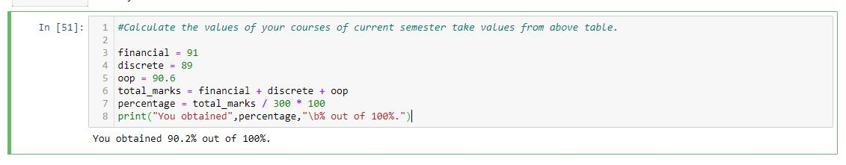Calculate the values of your courses of current semester take values from above table.

**Question 5:**

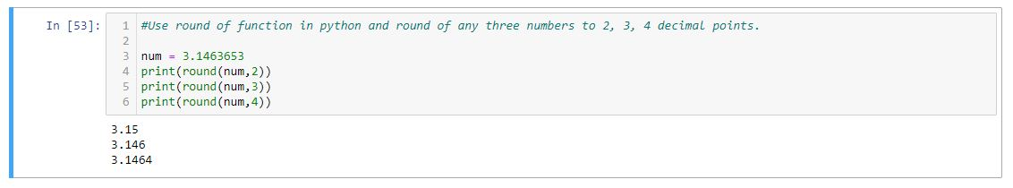Use round of function in python and round of any three numbers to 2, 3, 4 decimal points.

**Question 6:**

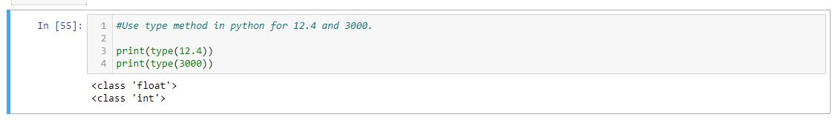Use type method in python for 12.4 and 3000.

**Question 7:**

Convert 6.0 to 6.

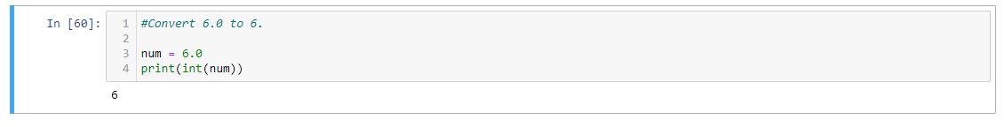

**Lab 3**

**Question 1:**

Use string slicing to grab the word 'thin' from inside 'thinktank'.

**Program:**

word = 'thinktank'

print(word[0:4])

**Output:**

thin

**Question 2:**

Use indexing value of your class id to grab character from the string.

**Program:**

class_id = 'BSE-22F-106'

print(class_id[10])

**Output:**

6

**Question 3:**

Store ABC in a variable and perform following operations.

**Program:**

alphabets = 'ABCDEFGHIJKLMNOPQRSTUVWXYZ'

**Question 4:**

Print all strings.

**Program:**

print(alphabets)

**Output:**

ABCDEFGHIJKLMNOPQRSTUVWXYZ

**Question 5:**

Grab alternate letters from ABC.

**Program:**

print(alphabets[::2])

**Output:**

ACEGIKMOQSUWY

**Question 6:**

Reverse your string.

**Program:**

print(alphabets[::-1])

**Output:**

ZYXWVUTSRQPONMLKJIHGFEDCBA

**Question 7:**

Grab 8 letters from the string and start from the letter which is the first letter of your name.

**Program:**

print(alphabets[12:20])

**Output:**

MNOPQRST

**Question 8 & 9:**

Write the code in python to generate following output using string logic.

abbcccddddeeee

**Program:**

print('a' + 'b'*2 + 'c'*3 + 'd'*4 + 'e'*4)

**Output:**

abbcccddddeeee

**Question 10:**

10.Apply the .format method on semester courses

Name of one course

Name of three courses

**Program:**

dsa = 'Data Structures & Algorithms'

stats = 'Probability & Statistics'

sre = 'Software Requirement Engineering'

print('One Course = {}'.format(dsa))

print('Three Courses are: {}, {}, {}.'.format(dsa,stats,sre))

**Output:**

One Course = Data Structures & Algorithms

Three Courses are: Data Structures & Algorithms, Probability & Statistics, Software Requirement Engineering.

**Question 11:**

Write intro about you , convert into list structure and then grab all words excluding 1st and last word, from your introduction.

**Program:**

my_intro = "My name is Muhaddis I completed my matriculation from Nasra Secondary School and Intermediate from St Patrick's College and recently doing BS Software Engineering in Sindh Madressatul Islam University."

my_intro2 = my_intro.split()

print(my_intro2[1:-1])

**Output:**

['name', 'is', 'Muhaddis', 'I', 'completed', 'my', 'matriculation', 'from', 'Nasra', 'Secondary', 'School', 'and', 'Intermediate', 'from', 'St', "Patrick's", 'College', 'and', 'recently', 'doing', 'BS', 'Software', 'Engineering', 'in', 'Sindh', 'Madressatul', 'Islam']

**Question 12:**

Name of six courses randomly and arrange them in alphabetical order using indexing in .format method.

**Program:**

dsa = 'Data Structures & Algorithms'

stats = 'Probability & Statistics'

sre = 'Software Requirement Engineering'

pf = 'Programming Fundamentals'

ds = 'Discrete Structures'

phy = 'Physics'

print('Courses:\n{0}, {1}, {2}, {3}, {4}, {5}.'.format(dsa,ds,phy,stats,pf,sre))

**Output:**

Courses:

Data Structures & Algorithms, Discrete Structures, Physics, Probability & Statistics, Programming Fundamentals, Software Requirement Engineering.

**Question 13:**

Assign the key words to all semester courses and call them using .format method

**Program:**

print('Courses:\n{dsa}, {stats}, {pf}, {phy}, {ds}, {sre}.'.format(dsa = 'Data Structures & Algorithms',stats = 'Probability & Statistics',sre = 'Software Requirement Engineering'

,pf = 'Programming Fundamentals',ds = 'Discrete Structures',phy = 'Physics'))

**Output:**

Courses:

Data Structures & Algorithms, Probability & Statistics, Programming Fundamentals, Physics, Discrete Structures, Software Requirement Engineering.

**Question 14:**

Apply float formatting method on following numbers with precision of 4

#a.200.340982589

#b.40/66611

#c.1.534854395

**Program:**

a = 200.340982589

b = 40/66611

c = 1.534854395

print('{:.4f}'.format(a))

print('{:.4f}'.format(b))

print('{:.4f}'.format(c))

**Output:**

200.3410

0.0006

1.5349

**Lab 4**

**Question 1:**

Create a list of your current semester courses..

**Program:**

sem_courses = ['DSA','Probability & Statistics','HCI','HRM','Software Requirement Engineering']

print(sem_courses)

**Output:**

['DSA', 'Probability & Statistics', 'HCI', 'HRM', 'Software Requirement Engineering']

**Question 2:**

Add course Python in the end of semester courses list.

**Program:**

sem_courses.append('Python')

print(sem_courses)

**Output:**

['DSA', 'Probability & Statistics', 'HCI', 'HRM', 'Software Requirement Engineering', 'Python']

**Question 3:**

Create an empty list with the name my_course.

**Program:**

my_course = list()

print(my_course)

**Output:**

[]

**Question 4:**

Extend my_course list with the semester courses list.

**Program:**

my_course.extend(sem_courses)

print(my_course)

**Output:**

['DSA', 'Probability & Statistics', 'HCI', 'HRM', 'Software Requirement Engineering', 'Python']

**Question 5:**

Insert “Programming” at index 2 in the my_course list.

**Program:**

my_course.insert(2,'Programming')

print(my_course)

**Output:**

['DSA', 'Probability & Statistics', 'Programming', 'HCI', 'HRM', 'Software Requirement Engineering', 'Python']

**Question 6:**

Remove element at index 1.

**Program:**

my_course.remove('Probability & Statistics')

print(my_course)

**Output:**

['DSA', 'Programming', 'HCI', 'HRM', 'Software Requirement Engineering', 'Python']

**Question 7:**

Add “Math1” to index 1.

**Program:**

my_course.insert(1,'Math1')

print(my_course)

**Output:**

['DSA', 'Math1', 'Programming', 'HCI', 'HRM', 'Software Requirement Engineering', 'Python']

**Question 8:**

Sort all courses in ascending order.

**Program:**

my_course.sort()

print(my_course)

**Output:**

['DSA', 'HCI', 'HRM', 'Math1', 'Programming', 'Python', 'Software Requirement Engineering']

**Lab 5**

**Question 1:**

Create the set of two semester courses using add method.

**Program:**

course_1 = 'Data Structure and Algorithms'

course_2 = 'Probability and Statistics'

courses = set()

courses.add(course_1)

courses.add(course_2)

print(courses)

**Output:**

{'Probability and Statistics', 'Data Structure and Algorithms'}

**Question 2:**

Remove the course data structure from the set.

**Program:**

courses.remove(course_1)

courses.remove(course_2)

print(courses)

**Output:**

set()

**Question 3:**

Create a list of 10 even numbers in python and convert it into tuple.

**Program:**

even_num = [2,4,6,8,10,12,14,16,18,20]

print(tuple(even_num))

**Output:**

(2, 4, 6, 8, 10, 12, 14, 16, 18, 20)

**Question 4:**

Write a program in python with the help of a dictionary data structure that stores 10 words along with their meaning.

Perform following operations.

1. Only grab the words from the dictionary data structure.

2. Only grab the meaning from the dictionary data structure.

3. Exchange 5th word and replace with other word.

4. Grab both words and meaning from the dictionary data structure.

**Program:**

words_meaning = {'Absence':'The lack or unavailability of something or someone',

'Approval':'Having a positive opinion of something or someone',

'Answer':'The response or receipt to a phone call, question, or letter',

'Attention':'Noticing or recognizing something of interest',

'Amount':'A mass or a collection of something',

'Borrow':'To take something with the intention of returning it after a period of time',

'Ban':'An act prohibited by social pressure or law',

'Characteristic':'referring to features that are typical to the person, place, or thing',

'Chip':'a small and thin piece of a larger item',

'Cease':'to eventually stop existing'}

print("Words:")

for key,course in words_meaning.items():

print(f"{key}")

print("\nMeanings:")

for key,course in words_meaning.items():

print(f"{course}")

print("\nChanging 5th Word:")

for key,course in words_meaning.items():

if key == 'Amount':

key = 'Subconscious'

course = "of or concerning the part of the mind of which one is not fully aware but which influences one's actions and feelings"

print(f"{key}: {course}")

**Output:**

Words:

Absence

Approval

Answer

Attention

Amount

Borrow

Ban

Characteristic

Chip

Cease

Meanings:

The lack or unavailability of something or someone

Having a positive opinion of something or someone

The response or receipt to a phone call, question, or letter

Noticing or recognizing something of interest

A mass or a collection of something

To take something with the intention of returning it after a period of time

An act prohibited by social pressure or law

referring to features that are typical to the person, place, or thing

a small and thin piece of a larger item

to eventually stop existing

Changing 5th Word:

Absence: The lack or unavailability of something or someone

Approval: Having a positive opinion of something or someone

Answer: The response or receipt to a phone call, question, or letter

Attention: Noticing or recognizing something of interest

Subconscious: of or concerning the part of the mind of which one is not fully aware but which influences one's actions and feelings

Borrow: To take something with the intention of returning it after a period of time

Ban: An act prohibited by social pressure or law

Characteristic: referring to features that are typical to the person, place, or thing

Chip: a small and thin piece of a larger item

Cease:to eventually stop existing

**Question 5:**

Write a program in python with the help of a dictionary data structure that stores the courses of current semester and assign a number key to each course perform above operations.

**Program:**

courses_dict = {'1':"DSA",

'2':"Probability",

'3':"HRM",

'4':"HCI",

'5':"Software Requirement Engineering"}

print("Keys:")

for key,course in courses_dict.items():

print(f"{key}")

print("\nCourses:")

for key,course in courses_dict.items():

print(f"{course}")

print("\nChanging 5th Word:")

courses_dict['5'] = 'PF'

for key,course in courses_dict.items():

print(f"{key}: {course}")

**Output:**

Keys:

1

2

3

4

5

Courses:

DSA

Probability

HRM

HCI

Software Requirement Engineering

Changing 5th Word:

1: DSA

2: Probability

3: HRM

4: HCI

5: PF

**Question 6:**

Write a program in python with the help of a dictionary data structure that stores the names of 10 students of your class and perform above operations.

**Program:**

students_dict = {'1':"Muhaddis",

'2':"Ahmed",

'3':"Aamir",

'4':"Haroon",

'5':"Hafeez",

'6':"Noman",

'7':"Sibghat",

'8':"Yameen",

'9':"Zohaib",

'10':"Raheel"}

print("Keys:")

for key,course in students_dict.items():

print(f"{key}")

print("\nStudents:")

for key,course in students_dict.items():

print(f"{course}")

print("\nChanging 5th Word:")

students_dict['5'] = 'Ahsan'

for key,course in students_dict.items():

print(f"{key}: {course}")

**Output:**

Keys:

1

2

3

4

5

6

7

8

9

10

Students:

Muhaddis

Ahmed

Aamir

Haroon

Hafeez

Noman

Sibghat

Yameen

Zohaib

Raheel

Changing 5th Word:

1: Muhaddis

2: Ahmed

3: Aamir

4: Haroon

5: Ahsan

6: Noman

7: Sibghat

8: Yameen

9: Zohaib

10: Raheel

**Question 7:**

Create a tuple of 10 elements with data ypes string, integer and float.

**Program:**

data_tuple = ('Hello','Hey',2,5,2,3.14,6.6,2,'End','Last')

print(data_tuple)

**Output:**

('Hello', 'Hey', 2, 5, 2, 3.14, 6.6, 2, 'End', 'Last')

**Question 8:**

apply count and index method on the tuple created above.

**Program:**

print(data_tuple.index('End')) #returns the index of given parameter.

print(data_tuple.count(2)) #returns the occurance of given parameter.

**Output:**

8

3

**Question 9:**

Write a code in python which makes tuple mutable.

**Program:**

mutable_tuple = [('Hello'),('Hey'),('Greeting')] #tuple inside a list makes it mutable.

mutable_tuple.append(('Wishes'))

print(mutable_tuple)

**Output:**

['Hello', 'Hey', 'Greeting', 'Wishes']

**Question 10:**

Apply Concatenation by adding 100 after your class id.

**Program:**

class_id = 'BSE-22F-106'

print(class_id + '100')

**Output:**

BSE-22F-106100

**Lab 6**

**Question 1:**

With the help of following operators, write script in python and use the boolean logic, True or False on integers and string data and do 10 tasks

**Program:**

print(6<5)

print(40 == 40)

print(3 < 5)

print(5 > 3)

print('b' == 'c')

print(25!=25)

print(100<=100)

print(50>=20)

print('Muhaddis' == 'muhaddis')

print('Muhaddis' != 'muhaddis')

**Output:**

False

True

True

True

False

False

True

True

False

True

**Lab 7**

**Question 1:**

Write a text file with your name and it should have atleast 20 sentences.

Open the file usiing read methods.

**Program:**

intro_file = open('intro.txt')

print(intro_file.read())

intro_file.readlines()

**Output:**

Meet Muhaddis, a determined and ambitious student who is currently pursuing his Bachelor's degree.

Muhaddis's educational journey is characterized by his unwavering passion for learning and his commitment to personal and academic growth.

As he embarks on this exciting phase of his life, he finds himself on the cusp of new opportunities and challenges.

Muhaddis's pursuit of a Bachelor's degree reflects his desire to expand his knowledge, develop critical thinking skills, and gain a deeper understanding of his chosen field.

He is a dedicated and inquisitive learner who is always eager to explore new horizons. Starting his Bachelor's degree program, Muhaddis is excited to delve into a specific area of study that aligns with his interests and career aspirations.

His chosen major resonates with him on a personal level, and he is eager to immerse himself in the subject matter. Muhaddis's commitment to academic excellence is evident in his diligence and hard work.

He understands that a Bachelor's degree is not just a certificate but a journey of self-discovery and intellectual growth. He is ready to embrace the academic challenges that come his way.

In addition to his academic pursuits, Muhaddis is a well-rounded student who values extracurricular activities.

He is keen on joining clubs and organizations, which will allow him to connect with like-minded peers and develop leadership skills. Throughout his Bachelor's degree program, Muhaddis plans to engage in research opportunities and internships, aiming to gain practical experience in his chosen field.

He believes that a combination of academic knowledge and real-world experience is the key to success in his future career. Muhaddis is excited about the prospect of being mentored by experienced professors who will guide him through the complexities of his chosen discipline. He values the wisdom and guidance that seasoned educators can provide.

Furthermore, Muhaddis is eager to make lasting friendships and connections with his fellow students. He recognizes the importance of a supportive network, both academically and personally. As he embarks on his Bachelor's degree journey, Muhaddis is aware of the need for time management and organization.

He is determined to strike a balance between his academic commitments, personal life, and self-care.

Muhaddis understands that his Bachelor's degree is a stepping stone to his long-term goals.

He envisions a bright future in which his education will empower him to make a meaningful impact on society and contribute to his field of study. In conclusion, Muhaddis is a dedicated and enthusiastic student, ready to make the most of his Bachelor's degree experience.

With his unwavering commitment to learning, a strong work ethic, and a passion for his chosen field, he is poised to excel in his academic pursuits and emerge as a well-rounded, knowledgeable individual ready to tackle the challenges of the future.

[]

**Lab 8**

**Question 1:**

Use your name as variable and write code in python to use if,elif and else statements. execute every statement one by one by changing the name in the variable you have defined.

**Program:**

name = "Muhaddis"

if name == "Ali":

print("Name not matched.")

elif name == "Hamza":

print("Name not matched.")

else:

print("Name Matched.")

**Output:**

Name Matched.

**Question 2:**

Write a program in python which defines if the K-electric units equal to 200 you will not pay taxes else you have to pay full payment.

**Program:**

KE_units = int(input())

if KE_units == 200:

print("You will not pay taxes.")

else:

print("You have to pay full payment.")

**Output:**

200

You will not pay taxes.

**Question 3:**

Write a program in python with help of if,elif and else statement.

Use loc for location in variable name location can be any string

If location is different run different from loc then run elif

If loc is different in if and elif statement then run else statement

**Program:**

location = input("Enter the location: ")

if location == "home":

print("You are at home. Welcome!")

elif location == "work":

print("You are at work. Good to see you!")

else:

print(f"You are at {location}. Enjoy your time!")

**Output:**

Enter the location: home

You are at home. Welcome!

**Lab 9**

**Question 1:**

1.Iterate any 10 even ids along with names of your class fellows from the list using for loop in python.

Sample data: Even IDs and corresponding names

**Program:**

class_fellows_data = {

102: "Mirza",

104: "Haroon",

106: "Muhaddis",

108: "Ibrahim",

110: "Noman",

112: "Ahmed",

114: "Shahzaib",

116: "Tabish",

118: "Shehryar",

120: "Zuhaib"

}

# Iterate over even IDs and names using a for loop

for student_id, student_name in class_fellows_data.items():

if student_id % 2 == 0:

print(f"ID: {student_id}, Name: {student_name}")

**Output:**

ID: 102, Name: Mirza

ID: 104, Name: Haroon

ID: 106, Name: Muhaddis

ID: 108, Name: Ibrahim

ID: 110, Name: Noman

ID: 112, Name: Ahmed

ID: 114, Name: Shahzaib

ID: 116, Name: Tabish

ID: 118, Name: Shehryar

ID: 120, Name: Zuhaib

**Question 2:**

Write a code in python to print odd and even ids of your class fellows from the list of 12.

**Program:**

class_fellow_ids = [101, 102, 103, 104, 105, 106, 107, 108, 109, 110, 111, 112]

print("Odd IDs:")

for student_id in class_fellow_ids:

if student_id % 2 != 0:

print(student_id)

print("\nEven IDs:")

for student_id in class_fellow_ids:

if student_id % 2 == 0:

print(student_id)

**Output:**

Odd IDs:

101

103

105

107

109

111

Even IDs:

102

104

106

108

110

112

**Question 3:**

Create the list of tuples of 12 numbers and each tuple has three values in it, apply a for loop and extract the last value of each tuple.

**Program:**

numbers = [(1,2,3), (4,5,6), (7,8,9), (10,11,12)]

for num in numbers:

print(num[2])

**Output:**

3

6

9

12

**Question 4:**

Create the dictionary of your current semester courses and marks. Apply for loop in python for following conditions.

**Program:**

Sem_marks = {'FA': 91, 'DS': 89, 'SE': 70.5, 'OOP': 90.6, 'ISL': 68, 'ENG': 76}

#Grab key and values of dictionary

print("Printing Keys and Values.")

for subjects,marks in Sem_marks.items():

print(f"{subjects}: {marks}")

#Grab on values from the dictionary

print("\nPrinting Values")

for subjects,marks in Sem_marks.items():

print(f"{marks}")

**Output:**

Printing Keys and Values.

FA: 91

DS: 89

SE: 70.5

OOP: 90.6

ISL: 68

ENG: 76

Printing Values

91

89

70.5

90.6

68

76

**Lab 10**

**Question 1:**

Apply break on while loop consider the value of variable x is 12 and break the while loop at 20.

**Program:**

x = 12

while True:

if x == 20:

break

print(x)

x=x+1

**Output:**

12

13

14

15

16

17

18

19

**Question 2:**

Apply the for loop on string of your name and break it in the middle.

**Program:**

name = "Muhaddis"

for i in name:

print(i)

if i == "a":

break

**Output:**

M

u

h

a

**Question 3:**

Apply the continue keyword using for loop on the string ‘data structure and algorithms’ continue when it finds the letter a in the string so meaning that in output there will be no letter a.

**Program:**

text = "data structure and algorithms"

for i in text:

if i == "a":

continue

print(i)

**Output:**

d

t

s

t

r

u

c

t

u

r

e

n

d

l

g

o

r

i

t

h

m

s

**Lab 11**

**Question 1:**

Generate the sequence of numbers starting from your class id/number till 30 using the range function in python.

**Program:**

for i in range(106,136):

print(i)

**Output:**

106

107

108

109

110

111

112

113

114

115

116

117

118

119

120

121

122

123

124

125

126

127

128

129

130

131

132

133

134

135

**Question 2:**

With the help of range function generate the sequence of even and odd numbers starting from your class id/roll number till 31.

**Program:**

print("\nEven Number:")

for i in range(106,137,2):

print(i)

print("\nOdd Number:")

for i in range(107,137,2):

print(i)

**Output:**

Even Number:

106

108

110

112

114

116

118

120

122

124

126

128

130

132

134

136

Odd Number:

107

109

111

113

115

117

119

121

123

125

127

129

131

133

135

**Question 3:**

Generate a list of data with the help of range function.

**Program:**

data = []

for i in range(10):

data.append(i)

print(data)

**Output:**

[0, 1, 2, 3, 4, 5, 6, 7, 8, 9]

**Question 4:**

Write a code in python assign index values to letters from A to Z

**Program:**

import string

letters = dict()

for index, letter in enumerate(string.ascii_lowercase):

letters[letter] = index + 1

print(letters['z'])

**Output:**

26

**Question 5:**

Write names of your any 10 courses which you have studied shuffle it five times using python.

**Program:**

from random import shuffle

courses_studied = ['DSA', 'DS', 'PF', 'FA', 'Physics', 'Calculus', 'English', 'Presentation Skills', 'OOP', 'Probability']

for i in range(5):

shuffle(courses_studied)

print(courses_studied)

**Output:**

['PF', 'FA', 'Calculus', 'OOP', 'Probability', 'English', 'Physics', 'DS', 'Presentation Skills', 'DSA']

['PF', 'Calculus', 'Physics', 'Probability', 'OOP', 'DSA', 'DS', 'Presentation Skills', 'FA', 'English']

['Presentation Skills', 'FA', 'English', 'Probability', 'Physics', 'PF', 'DS', 'DSA', 'Calculus', 'OOP']

['FA', 'Physics', 'DSA', 'OOP', 'English', 'Presentation Skills', 'PF', 'Calculus', 'DS', 'Probability']

['DSA', 'Presentation Skills', 'DS', 'FA', 'Calculus', 'Probability', 'English', 'OOP', 'Physics', 'PF']

**Question 6:**

Write a code in python and grab random numbers for committee members which are 10 in number to avoid the repetition.

**Program:**

import random

def generate_committee_members(num_members):

committee_members = random.sample(range(1, 101), num_members)

return committee_members

num_committee_members = 10

committee = generate_committee_members(num_committee_members)

print("Committee Members:", committee)

**Output:**

Committee Members: [49, 83, 91, 32, 5, 40, 13, 76, 47, 15]

**Question 7:**

Design a calculator in python which takes three numbers as input from the user and form following operations

#Additions

#Subtraction

#Multiplication

#Division

#When you run the program it should give you the result of all above operations at once.

**Program:**

def calculator(num1, num2, num3):

# Addition

addition_result = num1 + num2 + num3

# Subtraction

subtraction_result = num1 - num2 - num3

# Multiplication

multiplication_result = num1 * num2 * num3

# Division (checking for division by zero)

division_result = "Undefined" if num2 == 0 or num3 == 0 else num1 / num2 / num3

return addition_result, subtraction_result, multiplication_result, division_result

# Get input from the user

num1 = float(input("Enter the first number: "))

num2 = float(input("Enter the second number: "))

num3 = float(input("Enter the third number: "))

# Perform calculations

results = calculator(num1, num2, num3)

# Display the results

print(f"Addition Result: {results[0]}")

print(f"Subtraction Result: {results[1]}")

print(f"Multiplication Result: {results[2]}")

print(f"Division Result: {results[3]}")

**Output:**

Enter the first number: 2

Enter the second number: 3

Enter the third number: 4

Addition Result: 9.0

Subtraction Result: -5.0

Multiplication Result: 24.0

Division Result: 0.16666666666666666

**Lab 12**

**Question 1:**

Write an introduction of your course and append that introduction text into the list by using for loop and list comprehension.

**Program:**

print("Using For Loop:")

course_intro = "Welcome to the Introduction to Python Programming course! This course is designed for beginners who want to learn the fundamentals of Python programming."

course_modules = ["Module 1: Getting Started with Python",

"Module 2: Variables and Data Types",

"Module 3: Control Flow and Loops",

"Module 4: Functions and Modules",

"Module 5: File Handling in Python"]

for i in range(len(course_modules)):

course_modules[i] = course_intro + " " + course_modules[i]

for module in course_modules:

print(module)

#Using list comprehension

print("\nUsing List Comprehension:")

course_intro = "Welcome to the Introduction to Python Programming course! This course is designed for beginners who want to learn the fundamentals of Python programming."

course_modules = ["Module 1: Getting Started with Python",

"Module 2: Variables and Data Types",

"Module 3: Control Flow and Loops",

"Module 4: Functions and Modules",

"Module 5: File Handling in Python"]

course_modules = [course_intro + " " + module for module in course_modules]

for module in course_modules:

print(module)

**Output:**

Using For Loop:

Welcome to the Introduction to Python Programming course! This course is designed for beginners who want to learn the fundamentals of Python programming. Module 1: Getting Started with Python

Welcome to the Introduction to Python Programming course! This course is designed for beginners who want to learn the fundamentals of Python programming. Module 2: Variables and Data Types

Welcome to the Introduction to Python Programming course! This course is designed for beginners who want to learn the fundamentals of Python programming. Module 3: Control Flow and Loops

Welcome to the Introduction to Python Programming course! This course is designed for beginners who want to learn the fundamentals of Python programming. Module 4: Functions and Modules

Welcome to the Introduction to Python Programming course! This course is designed for beginners who want to learn the fundamentals of Python programming. Module 5: File Handling in Python

Using List Comprehension:

Welcome to the Introduction to Python Programming course! This course is designed for beginners who want to learn the fundamentals of Python programming. Module 1: Getting Started with Python

Welcome to the Introduction to Python Programming course! This course is designed for beginners who want to learn the fundamentals of Python programming. Module 2: Variables and Data Types

Welcome to the Introduction to Python Programming course! This course is designed for beginners who want to learn the fundamentals of Python programming. Module 3: Control Flow and Loops

Welcome to the Introduction to Python Programming course! This course is designed for beginners who want to learn the fundamentals of Python programming. Module 4: Functions and Modules

Welcome to the Introduction to Python Programming course! This course is designed for beginners who want to learn the fundamentals of Python programming. Module 5: File Handling in Python

**Question 2:**

Use the range function inside list comprehension print even numbers only.

**Program:**

even_numbers = [num for num in range(2, 21) if num % 2 == 0]

print("Even Numbers:", even_numbers)

**Output:**

Even Numbers: [2, 4, 6, 8, 10, 12, 14, 16, 18, 20]

**Question 3:**

Use two for loops multiply 2,3,4,5,6 with your previous semester courses marks.

**Program:**

Sem_marks = {'FA': 91, 'DS': 89, 'SE': 70.5, 'OOP': 90.6, 'ISL': 68, 'ENG': 76}

multipliers = [2, 3, 4, 5, 6]

result_matrix = {course: [mark * multiplier for multiplier in multipliers] for course, mark in Sem_marks.items()}

for course, marks in result_matrix.items():

print(f"{course} Marks:", Sem_marks[course])

print("Multiplied Marks:", marks)

**Output:**

FA Marks: 91

Multiplied Marks: [182, 273, 364, 455, 546]

DS Marks: 89

Multiplied Marks: [178, 267, 356, 445, 534]

SE Marks: 70.5

Multiplied Marks: [141.0, 211.5, 282.0, 352.5, 423.0]

OOP Marks: 90.6

Multiplied Marks: [181.2, 271.79999999999995, 362.4, 453.0, 543.5999999999999]

ISL Marks: 68

Multiplied Marks: [136, 204, 272, 340, 408]

ENG Marks: 76

Multiplied Marks: [152, 228, 304, 380, 456]

**Lab 13**

**Question 1:**

Write a function that returns a string.

**Program:**

def one_line_function():

my_string = "This is a one-line function using print and return keywords."

print(my_string)

return my_string

my_string = one_line_function()

print("Value of my_string:", my_string)

**Output:**

This is a one-line function using print and return keywords.

Value of my_string: This is a one-line function using print and return keywords.

**Question 2:**

Write a single function in python to perform following arithmetic operations on any two numbers and

#gives the result of all oprations

#Aditions

#Multiplication

#Division

#Subtraction

**Program:**

def perform_operations(num1, num2):

addition_result = num1 + num2

subtraction_result = num1 - num2

multiplication_result = num1 * num2

division_result = "Undefined" if num2 == 0 else num1 / num2

results = {

"Addition": addition_result,

"Subtraction": subtraction_result,

"Multiplication": multiplication_result,

"Division": division_result

}

return results

number1 = float(input("Enter the first number: "))

number2 = float(input("Enter the second number: "))

results_dict = perform_operations(number1, number2)

for operation, result in results_dict.items():

print(f"{operation} Result: {result}")

**Output:**

Enter the first number: 5

Enter the second number: 3

Addition Result: 8.0

Subtraction Result: 2.0

Multiplication Result: 15.0

Division Result: 1.6666666666666667

**Question 3:**

Write a function in python and pass four string arguments to it like, your name, name of any three courses of your current semester.

**Program:**

def print_semester_info(name, course1, course2, course3):

print(f"Hello, {name}! Here are the courses in your current semester:")

print(f"1. {course1}")

print(f"2. {course2}")

print(f"3. {course3}")

your_name = input("Enter your name: ")

course_name1 = input("Enter the name of the first course: ")

course_name2 = input("Enter the name of the second course: ")

course_name3 = input("Enter the name of the third course: ")

print_semester_info(your_name, course_name1, course_name2, course_name3)

**Output:**

Enter your name: Muhaddis

Enter the name of the first course: PF

Enter the name of the second course: OOP

Enter the name of the third course: DSA

Hello, Muhaddis! Here are the courses in your current semester:

1. PF

2. OOP

3. DSA

**Lab 14**

**Question 1:**

Write a function in python which extracts the list of odd numbers from the list data given by user which is starting from 1 to 15.

**Program:**

def extract_odd_numbers(user_list):

odd_numbers = [num for num in user_list if num % 2 != 0]

return odd_numbers

user_list = [int(input(f"Enter number {i + 1} (1 to 15): ")) for i in range(15)]

odd_numbers_list = extract_odd_numbers(user_list)

print("Original List:", user_list)

print("Odd Numbers List:", odd_numbers_list)

**Output:**

Enter number 1 (1 to 15): 2

Enter number 2 (1 to 15): 22

Enter number 3 (1 to 15): 3

Enter number 4 (1 to 15): 33

Enter number 5 (1 to 15): 4

Enter number 6 (1 to 15): 44

Enter number 7 (1 to 15): 5

Enter number 8 (1 to 15): 55

Enter number 9 (1 to 15): 6

Enter number 10 (1 to 15): 6

Enter number 11 (1 to 15): 66

Enter number 12 (1 to 15): 7

Enter number 13 (1 to 15): 77

Enter number 14 (1 to 15): 8

Enter number 15 (1 to 15): 88

Original List: [2, 22, 3, 33, 4, 44, 5, 55, 6, 6, 66, 7, 77, 8, 88]

Odd Numbers List: [3, 33, 5, 55, 7, 77]