The Correlation between Elevation and Probability of Death in High Altitude Mountaineering on Everest: Simulation vs. Statistical Model

Daniel Foster

San Diego State University

Abstract

This paper will explore the correlation between the elevation and probability of death for high altitude mountaineers on Everest. An attempt will be made to create a simulation, based on rough historical data, to determine a mean height at which mountaineers and their sherpas die. A probability model will then be applied to try to determine a rough picture of the effect of this particular mountain on the people who climb it. An existing statistical model, created and researched in *Mortality on Mount Everest (2008)*, will be used as a research source to compare the simulation to, as well as a source of valuable information for construction of the simulation. It explores various factors on expeditions and classic alpine ascents which may lead to fatal consequences. This study will be the basis of all facts and stances taken in this paper.

*Keywords: mountaineering, Everest, mortality*

1. **Introduction/Discussion**

The highest peaks in the world, with their mystical names and everlasting allure, are both beautiful and dangerous. And although Everest is not the most deadly, nor the hardest, it is certainly the most storied and the most coveted. Just as the master poacher desires to bag that perfect moose, the skilled mountaineer has his eyes set on the summit of Mount Everest, the tallest mountain in the world. Eight-thousand meter peaks have a very important distinction, they include a foray into the death-zone, an area where the human body slowly dies; the brain swells, the lungs fill with fluid, the body struggles with every step and every breath. With the use of supplemental oxygen, these peaks have become more accessible, and with the introduction of expensive expeditions, these climbs have become easier, but also more controversial. But one fact has remained, Everest always has the last word.

The dream of climbing Everest is immediately juxtaposed with the realization that one may perish trying to do so. Peril is imminent. Avalanches, falling, sickness, frostbite, weather, crevasses, seracs, mistakes, altitude. As a result, studies have been conducted to analyze how people die on Everest. *Mortality on Mount Everest (2008)*, written by Paul Firth, and with statistical analysis by Hui Zheng, is widely considered as one of the best analyses of death at high altitude. It looks at the years between 1921 and 2006, and a combination of 8030 climbers and 6108 sherpas:

*“This study examined the patterns of deaths over an 86 year period on Mount Everest (1921-2006). The mortality above base camp was 1.3% (table 2*[*⇑*](http://www.bmj.com.libproxy.sdsu.edu/content/337/bmj.a2654#T2)*). Most sherpas were killed in incidents on the lower slopes, whereas most climbers died above 8000 m. Climbers typically died during descent from the summit, often developing cognitive impairment and ataxia, symptoms of high altitude cerebral oedema. Profound fatigue, late summit times, and the tendency to fall behind companions were common early features of non-survivors.”*

And although 1.3% sounds like a nominal number, this totals over 140 casualties. But where do these casualties occur? Does it matter whether these are experienced western mountaineers or sherpas/porters from Nepal/Pakistan? This study examines the causes for these deaths, but one step further may analyze exactly where they take their last step, and where the most dangerous place is on this mountain.

Another study, conducted by Collete Wiseman in *Physical and Medical Characteristics of Successful and Unsuccessful Summiteers of Mount Everest in 2003*, examines one year on Everest and the deaths that occurred that year:

*“Supplemental oxygen use and no personal history of AMS are clearly correlated with successful summiting. In addition, we have found suggestions that variables such as reports of gastrointestinal illness, other illness, medication use. and previous experience may be correlated with success, but a larger sample size is needed to yield meaningful results. Future research focusing on such issues will, we hope, elicit answers to these interesting questions.”*

It brings some notable insight into the importance of supplemental oxygen at high altitudes, as well as the effects that HAPE(high altitude pulmonary edema) have on all climbers.

Certainly a closer look at the effects of altitude on Everest deaths would be an interesting piece to the puzzle. This paper will look into this issue, and attempt to make some interesting conclusions/findings on this subject.

1. **Hypothesis**

Elevation will definitely have an effect on death, although possibly not as large as I would have first thought. Many people (sherpas in particular) perish low on the mountain, in the Khumbu Icefall because of avalanches and earthquakes. I think ultimately though, that of the people that die on the mountain, the mean height will be somewhere in the 6000-7000 meter range. I would guess that a linear model would best describe this data, although it may be skewed heavily towards either the high or low elevation.

1. **Data/Statistics/Findings/Insight**

**Source Code:**

*\*Source code and project file have been included for viewing in Google Drive format.*

*Link:* https://drive.google.com/file/d/0B-p1mO3l3z95UXBodjNnRVVZZDQ/view?usp=sharing

using System;

using System.Collections.Generic;

using System.Linq;

using System.Text;

using System.Threading.Tasks;

namespace EE300Project

{

class Program

{

static void Main(string[] args)

{

String[] death_list = Properties.Resources.EverestDeathList.Split((char[])null, StringSplitOptions.RemoveEmptyEntries);

int n = 0;

int total = 0;

int no_heights = 21;

int[] histogram = new int[] { 0, 0, 0, 0, 0 };

int median = 0;

double mean = 0;

double variance = 0;

double sd = 0;

foreach (string s in death_list)

{

++n;

total += int.Parse(s);

if (int.Parse(s) < 5000)

++histogram[0];

if ((int.Parse(s) >= 5000) && (int.Parse(s) < 6000))

++histogram[1];

if ((int.Parse(s) >= 6000) && (int.Parse(s) < 7000))

++histogram[2];

if ((int.Parse(s) >= 7000) && (int.Parse(s) < 8000))

++histogram[3];

if (int.Parse(s) >= 8000)

++histogram[4];

}

Console.WriteLine("Deaths of all Climbers on Mount Everest vs. Elevation of Death");

Console.WriteLine("The following calculations describe this population.");

Console.WriteLine("n is equal to: {0}", n);

Console.WriteLine("unbiased n value(total known deaths): {0}", n + no_heights);

Console.WriteLine();

mean = (double)total / n;

Console.WriteLine("The mean height is: {0}", mean);

List<int> heights = new List<int>();

foreach(string s in death_list)

{

heights.Add(int.Parse(s));

if(double.Parse(s) >= mean)

variance += Math.Pow((double.Parse(s) - mean), 2);

else if(mean > double.Parse(s))

variance += Math.Pow((mean - double.Parse(s)), 2);

}

variance = variance / n;

Console.WriteLine("The variance is: {0}", variance);

sd = Math.Sqrt(variance);

Console.WriteLine("The standard deviation is: {0}", sd);

heights.Sort();

median = heights.ElementAt(n / 2);

Console.WriteLine("The median is: {0}", median);

Console.WriteLine();

Console.WriteLine("Histogram values: {0}, {1}, {2}, {3}, {4}", histogram[0], histogram[1], histogram[2], histogram[3], histogram[4]);

Console.WriteLine();

Console.WriteLine("The following examples are based off standardizing the random variable. They represent z-score values.");

//Probability of death at 5000m and 8000m using normal approximation.

double test1 = 5000;

double test2 = 8000;

test1 = (test1 - mean) / sd;

test2 = (test2 - mean) / sd;

Console.WriteLine("The probability of death below 5000m is: {0}", test1);

Console.WriteLine("The probability of death above 8000m is: {0}", test2);

//Probability of death on the Lhotse face.(7800m ~ 8500m)

double bound1 = 7800;

double bound2 = 8500;

bound1 = (bound1 - mean) / sd;

bound2 = (bound2 - mean) / sd;

Console.WriteLine("The probability of dying on the Lhotse face is: {0} - {1}", bound1, bound2);

//Probability of dying in the Khumbu Icefall.(5300m ~ 5900m)

double bound3 = 5300;

double bound4 = 5900;

bound3 = (bound3 - mean) / sd;

bound4 = (bound4 - mean) / sd;

Console.WriteLine("The probability of dying in the Khumbu Icefall is: {0} - {1}", bound3, bound4);

Console.ReadLine();

}

}

}

**Output:**

Deaths of All Climbers on Mount Everest vs. Elevation of Death

The following calculations describe this population.

n is equal to: 262

unbiased n value(total known deaths): 283

The mean height is: 7148.41 m

The variance is: 1607932.94 m^2

The standard deviation is: 1268.04 m

The median is: 7500 m

Histogram values: 2, 76, 22, 73, 89

The following examples are based off standardizing the random variable. They represent z-score values.

The probability of death below 5000m: -1.69

The probability of death above 8000m: 0.67

The probability of dying on the Lhotse face is: 0.51 – 1.07

The probability of dying in the Khumbu Icefall is: -1.46 - -0.98

**Analysis:**

The preceding information was found in two ways:

* creating a resource of all recorded deaths on Everest, this list included the heights at which the people were pronounced dead, or where they were believed to have died
* a coding effort which includes traversing the list to make calculations based on a standard normal distribution

Notable information not included in the above coding effort:

* the list encompasses *all* recorded deaths from 1922-present, so this analysis will be on a population, not a sample
* the list’s integrity is backed by research done by the *Himalayan Database*
* there were 21 unrecorded heights on the death list, the death toll(recorded history) 283, but the 262 value was used for the purpose of this analysis
* 110 of the 283 recorded deaths were climbers of Nepalese (also known as sherpa) descent, an astounding 38.87%
* the total amount of climbers to have attempted the climb is unknown, but it is estimated that ~1200-1500 climbers have attempted an Everest summit; this would leave the death rate at near ~10% (Moore, *Weather and Death on Mount Everest*)
* all values have been recorded in meters
* route, experience, nationality, expedition style, etc. have not been considered

The mean height, 7,148 meters is a bit surprising. Even with the recent earthquakes in Nepal that have caused many deaths at very low altitudes, this height is still very high. In fact, this height is higher than the tallest mountain South America, Aconcagua. It stands at 6,961 meters.

The variance and standard deviation are high, suggesting a diverse data set. Usually this would be worrying, but in this case, as the data is bounded between ~4,500 meters and ~8,850 meters, the variance is expected.

The median is at 7,500 meters. This location lies on the Lhotse face. Although not as dangerous as many other places on the mountain, it is also viewed as the midpoint of the difficult part of the climb. This makes sense. Deaths at high altitude because of danger, sickness, weather, etc. even out with deaths near the base of Everest in the Khumbu Icefall because of avalanches and glacier travel. The median is higher than the mean, insinuating that the distribution is skewed left with a majority of the data at lower elevation, as expected.

A histogram is included, split up into 1,000 meter elevation gains starting at Base Camp and ending at the summit. The results of this graph are as expected. It does not follow the shape of a mountain with increasing slope over time. The amount of deaths near base camp or in the Khumbu Icefall is nearly as high as the number of deaths over 8,000 meters in the death zone.

The coding effort also describes z-scores for many different probability scenarios. Of interest are:

* The probability of death below 5000m: -1.69 z-score = .05 = 5% probability
* The probability of death above 8000m: 0.67 z-score = 1 - .75 = .25 = 25% probability
* The probability of dying on the Lhotse face is: 0.51 – 1.07 z-score = .86 - .70 = .16 = 16% probability
* The probability of dying in the Khumbu Icefall is: -1.46 - -0.98 z-score = .16 - .07 = .09 = 9% probability

This data is very interesting, but also explains that 25% of climbers die above the death zone according to the normal distribution approximation. Similarly, on the Lhotse face, which we earlier designated as the median location of the distribution, holds nearly 16% of deaths, despite the fact that that location isn’t particularly hazardous. The Khumbu Icefall, which is widely considered to be the most dangerous location on the entire mountain, only accounted for 9% of the total deaths, despite the fact that recent summers (Nepalese earthquakes in 2015 and 2016) have seen an inordinate amount of deaths caused by earthquake related falls and avalanches in that region.

**Insight:**

G.W.K Moore, in *Weather and Death on Mount Everest: An Analysis of the Into Thin Air Storm*, describes why data in conventional studies may be skewed. They only look at dramatic instances of death at high altitude:

*“This outbreak of high impact weather resulted in the largest number of fatalities (8) to occur near the summit of Everest during a single event. In the ensuing years, a passionate and wide-ranging debate has been ongoing in an attempt to understand the factors that contributed to this tragedy. Curiously absent has been a quantitative discussion of the meteorological conditions that gave rise to this storm and the storm's impact on the climbers' physiology.”*

Curiously enough, the widely researched 1999 disaster was one such case which doesn’t follow this data sets findings.

Nick Heil goes one step further in *Mount Everest Suffers from too Many Climbers and Deteriorating Conditions*. He describes one of the major causes of death at high altitude, summit fever:

*“It's nearly impossible to reverse course, a pressure that only intensifies the closer teams get to the top.”*

Although summit fever causes death he also explains that:

*“Something else may be happening, too. The proliferation of communication technology now commonplace on remote expeditions has taken Everest voyeurism to new heights. Photos, video, podcasts, lengthy written dispatches, 3D graphics, and GPS tracking tools flood websites each spring, beaming reports from the mountain, practically in real time. Far from serving as cautionary tales, warning wannabes from the dangerous slopes, these extreme reality shows only bolster the peak's mystique, prestige, and appeal. Climbing Everest has long been a spectacle; now it's a spectator sport, with no shortage of willing participants.”*

Dangers abound on Everest at 8,848 meters.

Lastly I would like to comment on the data found in *Mortality on Mount Everest*, as it is one of the leading statistical analyses on Everest deaths in the modern era. The problem with the distribution suggested in that analysis, however, is that it only look at a small subset of the total data available. While it does a good job of considering cause of death and climber scenario, it doesn’t accurately depict death at elevation on Everest.

For example, the Khumbu Icefall on Everest is extremely dangerous, almost more so than being above the death zone; so why does that analysis not include a comment about that distinction? I have included an important graph and table from that study in the “Tables and Graphs” section of this paper. I believe it sheds some light on some aspects of Everest death that I have not explored personally in this paper.

1. **Tables and Graphs**

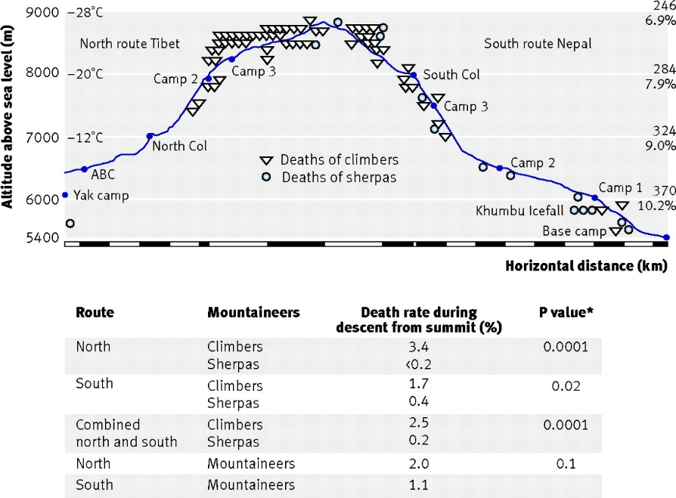

(taken from Firth, *Mortality on Mount Everest*)

1. **Conclusions**

This statistical analysis has shed light on exactly where mountaineers/Sherpas/climbers die on Mount Everest. The histogram has revealed information that the correlation between height on the mountain and death is not as high as some may have thought. Two prominent locations, the death zone and the Khumbu Icefall, are shown to be almost equally dangerous, even though they are more than 3,000 meters apart in elevation.

This analysis, along with the data from other scholarly studies, has shown that altitude only really becomes a factor in the death zone. In other words, elevation does not play as big a part as some may think. The dangers really come from uncontrollable circumstances such as weather, body conditions, mountain conditions, mistakes at high altitude, and simple lack of experience.

My hypothesis has been proven correct. Perhaps if I had more time or more resources I could do a more in depth study looking at the many factors such as experience, expedition style, or nationality on the death rates while climbing Mount Everest. However, for the scope of this paper, I felt I came to a pertinent conclusion that is both substantial in its practicality and significant in its brevity.

**Closing Statement:** There is an unsubstantial correlation between elevation and death on Mount Everest.

References

* An effort has been made to conform to the APA style guide for this paper.

Firth, P. G., Zheng, H., Windsor, J. S., Sutherland, A. I., Imray, C. H., Moore, G. W. K., . . . Salisbury, R. A. (2008). Mortality on mount everest, 1921-2006: Descriptive study. *BMJ : British Medical Journal (Online), 337* doi:http://dx.doi.org.libproxy.sdsu.edu/10.1136/bmj.a2654

Heil, N. (2012, May 23). Mount everest suffers from too many climbers and deteriorating conditions. *The Daily Beast* Retrieved from http://libproxy.sdsu.edu/login?url=http://search.proquest.com.libproxy.sdsu.edu/docview/1648398429?accountid=13758

"List of People Who Died Climbing Mount Everest." Wikipedia. Wikimedia Foundation, n.d. Web. 06 Nov. 2016. **(not scholarly, but will use as spreadsheet data for personal modeling for comparison with statistical data)**

Moore, G. W. K., & Semple, J. L. (2006). WEATHER AND DEATH ON MOUNT EVEREST: An analysis of the into thin air storm. *Bulletin of the American Meteorological Society, 87*(4), 465-480,405. Retrieved from http://libproxy.sdsu.edu/login?url=http://search.proquest.com.libproxy.sdsu.edu/docview/232610803?accountid=13758

Wiseman, C., Freer, L., & Hung, E. (2006). Physical and medical characteristics of successful and unsuccessful summiteers of mount everest in 2003. *Wilderness & Environmental Medicine, 17*(2), 103-8. Retrieved from <http://libproxy.sdsu.edu/login?url=http://search.proquest.com.libproxy.sdsu.edu/docview/213637402?accountid=13758>

*\*Have also used general knowledge obtained from Wikipedia articles on mountaineering, Everest, etc.*