Predicting Medical Insurance Charges Using Supervised Machine Learning Techniques
Introduction
Rising healthcare costs have made accurate medical insurance pricing increasingly important for both insurers and policyholders. Understanding how demographic and lifestyle factors influence insurance charges enables better risk assessment and fairer premium estimation. This study applies machine learning techniques to analyse a medical insurance dataset containing information such as age, gender, body mass index (BMI), smoking status, number of dependents, residential region and no-claims bonus. The primary objective is to develop predictive models that estimate individual medical insurance charges based on these attributes. Through systematic data preparation, exploratory analysis, feature selection and model evaluation. This work aims to identify effective modelling approaches and assess their predictive reliability using robust validation techniques.
Dataset Description
The dataset used in this study consists of 1,338 observations and eight attributes, representing individual medical insurance beneficiaries. The variables include demographic information such as age and gender, health-related indicators including body mass index (BMI) and smoking status, household information in the form of number of dependents, residential region, no-claims bonus percentage and the target variable, medical insurance charges. The dataset contains a mix of numerical and categorical features requiring appropriate preprocessing before modelling. An initial inspection revealed the presence of missing values in several columns, including BMI, gender, number of children and charges which necessitated data cleaning. The target variable, charges, is continuous and exhibits a wide range of values, making it suitable for regression-based machine learning approaches. Overall, the dataset provides sufficient variability and relevant features to support meaningful predictive analysis.
Data Preparation and EDA
Prior to modelling, the dataset is systematically prepared to ensure data quality and consistency. Missing numerical values in BMI, number of children and insurance charges are handled using median imputation due to skewness and sensitivity to outliers while missing categorical values such as gender are imputed using the mode. Data types are corrected where necessary and categorical text fields are standardised to ensure consistency during encoding.
Exploratory Data Analysis (EDA) revealed that insurance charges are right-skewed, with a small proportion of individuals incurring significantly higher costs. Smoking status showed a strong association with higher charges while BMI and age exhibited positive relationships with insurance costs, particularly at higher values. Regional and gender-based differences are comparatively modest. These insights informed feature engineering and model selection, emphasising the importance of lifestyle and health-related factors in predicting insurance charges.
Conceptual Choice of Machine Learning Approach
The choice of machine learning approach depends on the nature of the problem and the availability of labelled data. In this dataset, the target variable, medical insurance charges is a known and continuous value which making supervised learning the most appropriate approach. Supervised learning algorithms are designed to learn patterns from historical data where the outcome is already defined which allowing accurate predictions for new observations.
Among supervised learning tasks, regression is more suitable than classification, as insurance charges represent a continuous range rather than discrete categories. While unsupervised learning techniques such as clustering can be used to identify customer segments, they do not directly optimise the prediction of insurance costs and are therefore not selected as the primary modelling approach. Consequently, this study focuses on supervised regression models to estimate insurance charges, ensuring that predictive performance can be objectively evaluated using established statistical metrics.
Feature Selection
Categorical variables such as gender, smoking status and residential region are encoded using one-hot encoding to enable numerical representation without introducing artificial order. Numerical features including age, BMI, number of children and no-claims bonus are standardised to prevent scale dominance during model training. Feature engineering is applied by introducing an interaction term between age and smoking status to capture compounded health risk effects.
Feature selection is conducted using Random Forest feature importance, identifying smoking-related variables, age and BMI as the most influential predictors, consistent with findings from exploratory analysis. Two regression models are developed, Linear Regression as a baseline and Random Forest Regression to model non-linear relationships. Hyperparameter tuning for Random Forest is performed using GridSearchCV to optimise predictive performance and reduce overfitting.
Model Evaluation and Validation
Model performance is evaluated using a robust validation strategy to ensure reliability and generalisability of the results. Both regression models are trained and tested using three distinct train–test splits: 80/20, 70/30 and 60/40. This approach assesses model sensitivity to the amount of training data and helps identify potential overfitting or underfitting. Performance is measured using the coefficient of determination (R²) which indicates the proportion of variance in insurance charges explained by the model and the root mean squared error (RMSE) which quantifies average prediction error in monetary terms.
To further strengthen the evaluation, K-fold cross-validation with five folds is applied to both models. This method ensures that each observation is used for both training and testing, reducing dependency on a single data split. The mean and standard deviation of R² across folds are calculated to assess average predictive performance and model stability.
The results demonstrated that Random Forest consistently outperformed Linear Regression across all splits, achieving higher R² values and lower RMSE scores. Cross-validation results also indicated lower variability for Random Forest, suggesting improved generalisation and robustness compared to the linear baseline.
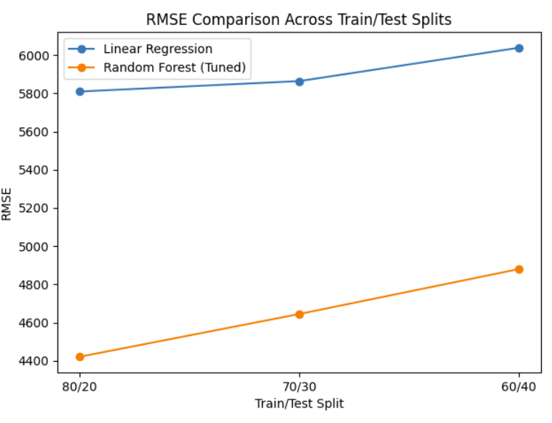
Comparison of Modelling Outcomes
The comparative analysis reveals clear performance differences between the two regression models. Linear Regression showed moderate predictive accuracy across all train–test splits with performance decreasing as the training data size is reduced. This limitation reflects the model’s linear assumptions which restrict its ability to capture complex relationships among predictors. In contrast, Random Forest consistently achieved higher R² values and lower RMSE scores across all splits, demonstrating superior predictive accuracy. Cross-validation results reinforced this finding with Random Forest exhibiting higher mean R² and lower variability indicating greater stability and stronger generalisation. While both models benefited from preprocessing and feature engineering, Random Forest is better suited to modelling the non-linear effects of factors such as smoking status, age and BMI.
Conclusion and Future Work
This study applied supervised machine learning techniques to predict medical insurance charges using demographic and lifestyle data. Following systematic data preparation, exploratory analysis, feature selection and model evaluation, Random Forest Regression emerged as the most effective approach. The use of multiple train–test splits and K-fold cross-validation confirmed the robustness and reliability of the model. However, the analysis is limited by the available feature set and lack of external data. Future work could incorporate additional predictors, explore advanced ensemble models such as gradient boosting and apply unsupervised methods for customer segmentation to further enhance predictive insights.
References
Breiman, L. (2001) ‘Random forests’, Machine Learning, 45(1), pp. 5–32. https://doi.org/10.1023/A:1010933404324
Pedregosa, F., Varoquaux, G., Gramfort, A., Michel, V., Thirion, B., Grisel, O., Blondel, M., Prettenhofer, P., Weiss, R., Dubourg, V., Vanderplas, J., Passos, A., Cournapeau, D., Brucher, M., Perrot, M. and Duchesnay, É. (2011) ‘Scikit-learn: Machine learning in Python’, Journal of Machine Learning Research, 12, pp. 2825–2830.

