 |  | Eco Audit Report
Product name |  |  |  | Cross Laminated Timber
Country of manufacture |  | World

Country of use |  |  |  | World
Product life (years) |  |  |  | 20
Summary:

 |  | 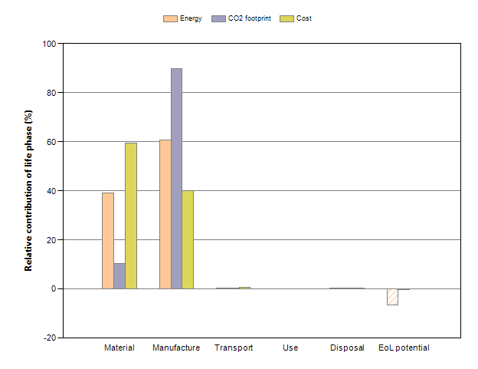
 |  |  | Energy details |  | CO2 footprint details |  | Cost details
Phase | Energy  (MJ) | Energy  (%) | CO2 footprint  (kg) | CO2 footprint  (%) | Cost  (GBP) | Cost  (%)
Material | 2.82e+03 | 39.2 | 94.5 | 10.2 | 226 | 59.3
Manufacture | 4.36e+03 | 60.6 | 829 | 89.7 | 153 | 40.1
Transport | 8.36 | 0.1 | 0.602 | 0.1 | 2.22 | 0.581
Use | 0 | 0.0 | 0 | 0.0 | 0 | 0
Disposal | 3.1 | 0.0 | 0.217 | 0.0 | 0.053 | 0.0139
Total (for first life) | 7.2e+03 | 100 | 924 | 100 | 382 | 100
End of life potential | -474 |  | -1.61

Eco Audit Report


Summary

Energy Analysis

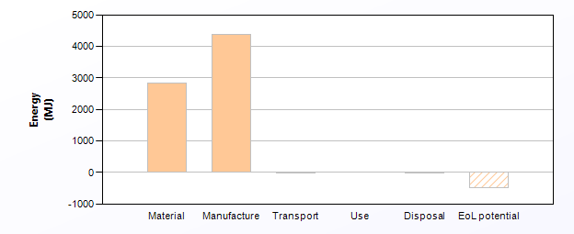
 | Energy (MJ/year)
Equivalent annual environmental burden (averaged over 20 year product life): | 360

Detailed breakdown of individual life phases

Material: |  | Summary
Component | Material | Recycled content*  (%) | Part mass  (kg) | Qty. | Total mass processed**  (kg) | Energy  (MJ) | %
Timber | Pau marfim (t) | Virgin (0%) | 5 | 1 | 5.6 | 6.1e+02 | 21.5
laminate | Epoxy/Aramid, PCB laminate | Virgin (0%) | 6 | 1 | 6 | 2.2e+03 | 78.5
Total |  |  |  | 2 | 12 | 2.8e+03 | 100

*Typical: Includes 'recycle fraction in current supply'

**Where applicable, includes material mass removed by secondary processes

***User-defined material

 | Manufacture: |  |  | Summary
Component | Process | % Removed | Amount processed |  | Energy  (MJ) | %
Timber | Cutting and trimming | 10 | 0.56 | kg | 0.17 | 0.0
laminate | Resin transfer molding (RTM) | - | 6 | kg | 77 | 1.8
Pressing | Adhesives, cold curing | - | 4.3e+02 | m^2 | 4.3e+03 | 98.2
Total |  |  |  |  | 4.4e+03 | 100

Transport: |  |  | Summary
Breakdown by transport stage

Stage name | Transport type | Distance  (km) | Energy  (MJ) | %
road | 55 tonne (8 axle) truck | 1e+03 | 7.8 | 93.4
ship | Ocean freight | 2.8e+02 | 0.55 | 6.6
Total |  | 1.3e+03 | 8.4 | 100

Breakdown by components

Component | Mass  (kg) | Energy  (MJ) | %
Timber | 5 | 3.8 | 45.5
laminate | 6 | 4.6 | 54.5
Total | 11 | 8.4 | 100

Use: |  |  | Summary
 | Relative contribution of static and mobile modes
Mode | Energy  (MJ) | %
Static | 0
Mobile | 0
Total | 0 | 100

Disposal: | Summary
Component | End of life option | % recovered | Energy  (MJ) | %
Timber | Re-manufacture | 80.0 | 1 | 32.3
laminate | Downcycle | 50.0 | 2.1 | 67.7
Total |  |  | 3.1 | 100

EoL potential:

Component | End of life option | % recovered | Energy  (MJ) | %
Timber | Re-manufacture | 80.0 | -4.7e+02 | 100.0
laminate | Downcycle | 50.0 | 0 | 0.0
Total |  |  | -4.7e+02 | 100

Notes: | Summary

Eco Audit Report


Summary

CO2 Footprint Analysis

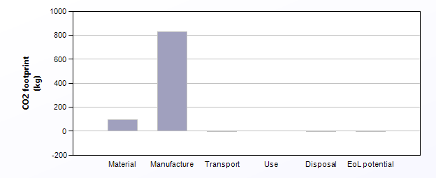
 | CO2 (kg/year)
Equivalent annual environmental burden (averaged over 20 year product life): | 46.2

Detailed breakdown of individual life phases

Material: |  | Summary
Component | Material | Recycled content*  (%) | Part mass  (kg) | Qty. | Total mass processed**  (kg) | CO2 footprint  (kg) | %
Timber | Pau marfim (t) | Virgin (0%) | 5 | 1 | 5.6 | 3.1 | 3.2
laminate | Epoxy/Aramid, PCB laminate | Virgin (0%) | 6 | 1 | 6 | 91 | 96.8
Total |  |  |  | 2 | 12 | 94 | 100

*Typical: Includes 'recycle fraction in current supply'

**Where applicable, includes material mass removed by secondary processes

***User-defined material

 | Manufacture: |  |  | Summary
Component | Process | % Removed | Amount processed |  | CO2 footprint  (kg) | %
Timber | Cutting and trimming | 10 | 0.56 | kg | 0.013 | 0.0
laminate | Resin transfer molding (RTM) | - | 6 | kg | 6.2 | 0.7
Pressing | Adhesives, cold curing | - | 4.3e+02 | m^2 | 8.2e+02 | 99.3
Total |  |  |  |  | 8.3e+02 | 100

Transport: |  |  | Summary
Breakdown by transport stage

Stage name | Transport type | Distance  (km) | CO2 footprint  (kg) | %
road | 55 tonne (8 axle) truck | 1e+03 | 0.56 | 93.4
ship | Ocean freight | 2.8e+02 | 0.04 | 6.6
Total |  | 1.3e+03 | 0.6 | 100

Breakdown by components

Component | Mass  (kg) | CO2 footprint  (kg) | %
Timber | 5 | 0.27 | 45.5
laminate | 6 | 0.33 | 54.5
Total | 11 | 0.6 | 100

Use: |  |  | Summary
 | Relative contribution of static and mobile modes
Mode | CO2 footprint  (kg) | %
Static | 0
Mobile | 0
Total | 0 | 100

Disposal: | Summary
Component | End of life option | % recovered | CO2 footprint  (kg) | %
Timber | Re-manufacture | 80.0 | 0.07 | 32.3
laminate | Downcycle | 50.0 | 0.15 | 67.7
Total |  |  | 0.22 | 100

EoL potential:

Component | End of life option | % recovered | CO2 footprint  (kg) | %
Timber | Re-manufacture | 80.0 | -1.6 | 100.0
laminate | Downcycle | 50.0 | 0 | 0.0
Total |  |  | -1.6 | 100

Notes: | Summary

Eco Audit Report


Summary

Cost Analysis

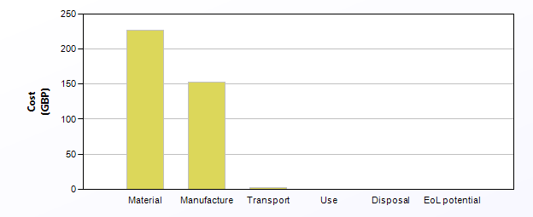
 | Cost (GBP/year)
Equivalent annual environmental burden (averaged over 20 year product life): | 19.1

Detailed breakdown of individual life phases

Material: |  | Summary
Component | Material | Recycled content*  (%) | Part mass  (kg) | Qty. | Total mass processed**  (kg) | Cost  (GBP) | %
Timber | Pau marfim (t) | Virgin (0%) | 5 | 1 | 5.6 | 35 | 15.6
laminate | Epoxy/Aramid, PCB laminate | Virgin (0%) | 6 | 1 | 6 | 1.9e+02 | 84.4
Total |  |  |  | 2 | 12 | 2.3e+02 | 100

*Typical: Includes 'recycle fraction in current supply'

**Where applicable, includes material mass removed by secondary processes

***User-defined material

 | Manufacture: |  |  |  |  |  | Summary
Country of manufacture |  |  |  | World
Component | Process | Length (m) | % Removed | Amount processed |  | Cost  (GBP) | %
Timber | Cutting and trimming | - | 10 | 0.56 | kg | 0.0011 | 0.0
laminate | Resin transfer molding (RTM) | - | - | 6 | kg | 21 | 14.0
Pressing | Adhesives, cold curing | - | - | 4.3e+02 | m^2 | 1.3e+02 | 86.0
Total |  |  |  |  |  | 1.5e+02 | 100

Transport: |  | Summary
Package dimensions

Height (m) | Width (m) | Depth (m)
0.1 | 0.2 | 0.4

Breakdown by transport stage

Stage name | Transport type | Distance  (km) | Cost  (GBP) | %
road | 55 tonne (8 axle) truck | 1e+03 | 1.1 | 49.9
ship | Ocean freight | 2.8e+02 | 1.1 | 50.1
Total |  | 1.3e+03 | 2.2 | 100

Breakdown by components

Component | Mass  (kg) | Cost  (GBP) | %
Timber | 5 | 1 | 45.5
laminate | 6 | 1.2 | 54.5
Total | 11 | 2.2 | 100

Use: |  |  | Summary
 | Relative contribution of static and mobile modes
Mode | Cost  (GBP) | %
Static | 0
Mobile | 0
Total | 0 | 100

Disposal: | Summary
Component | End of life option | % recovered | Cost  (GBP) | %
Timber | Re-manufacture | 80.0 | 0.024 | 45.5
laminate | Downcycle | 50.0 | 0.029 | 54.5
Total |  |  | 0.053 | 100

Notes: | Summary

 |  | Eco Audit Report
Product name |  |  |  | Hempcrete
Country of manufacture |  | World

Country of use |  |  |  | United Kingdom
Product life (years) |  |  |  | 100
Summary:

 |  | 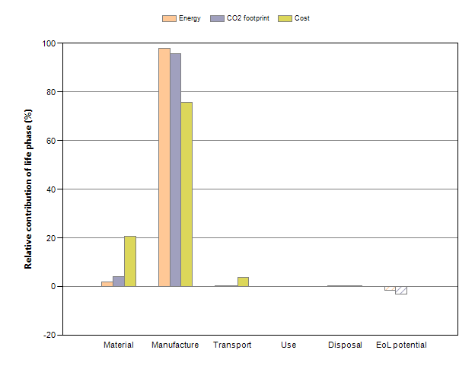
 |  |  | Energy details |  | CO2 footprint details |  | Cost details
Phase | Energy  (MJ) | Energy  (%) | CO2 footprint  (kg) | CO2 footprint  (%) | Cost  (GBP) | Cost  (%)
Material | 57.5 | 2.0 | 9.2 | 4.1 | 4.96 | 20.6
Manufacture | 2.85e+03 | 97.9 | 214 | 95.8 | 18.2 | 75.7
Transport | 1.86 | 0.1 | 0.134 | 0.1 | 0.871 | 3.62
Use | 0 | 0.0 | 0 | 0.0 | 0 | 0
Disposal | 0.92 | 0.0 | 0.0644 | 0.0 | 0.0222 | 0.0921
Total (for first life) | 2.91e+03 | 100 | 223 | 100 | 24.1 | 100
End of life potential | -43.2 |  | -6.9

Eco Audit Report


Summary

Energy Analysis

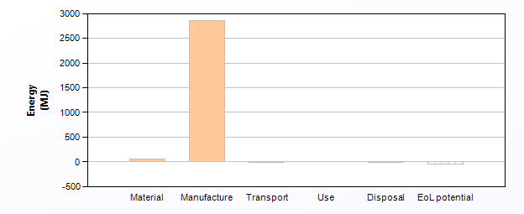
 | Energy (MJ/year)
Equivalent annual environmental burden (averaged over 100 year product life): | 29.1

Detailed breakdown of individual life phases

Material: |  | Summary
Component | Material | Recycled content*  (%) | Part mass  (kg) | Qty. | Total mass processed**  (kg) | Energy  (MJ) | %
Hempcrete block | Hemp fiber | Virgin (0%) | 4.6 | 1 | 5.8 | 58 | 100.0
Total |  |  |  | 1 | 5.8 | 58 | 100

*Typical: Includes 'recycle fraction in current supply'

**Where applicable, includes material mass removed by secondary processes

***User-defined material

 | Manufacture: |  |  | Summary
Component | Process | % Removed | Amount processed |  | Energy  (MJ) | %
Hempcrete block | Cutting and trimming | 20 | 1.2 | kg | 0.35 | 0.0
Hydraulic pressing | Construction | - | 2.9e+04 | kg | 2.9e+03 | 100.0
Total |  |  |  |  | 2.9e+03 | 100

Transport: |  |  | Summary
Breakdown by transport stage

Stage name | Transport type | Distance  (km) | Energy  (MJ) | %
ship | Ocean freight | 2.8e+02 | 0.23 | 12.4
land | 55 tonne (8 axle) truck | 5e+02 | 1.6 | 87.6
Total |  | 7.8e+02 | 1.9 | 100

Breakdown by components

Component | Mass  (kg) | Energy  (MJ) | %
Hempcrete block | 4.6 | 1.9 | 100.0
Total | 4.6 | 1.9 | 100

Use: |  |  | Summary
 | Relative contribution of static and mobile modes
Mode | Energy  (MJ) | %
Static | 0
Mobile | 0
Total | 0 | 100

Disposal: | Summary
Component | End of life option | % recovered | Energy  (MJ) | %
Hempcrete block | Reuse | 75.0 | 0.92 | 100.0
Total |  |  | 0.92 | 100

EoL potential:

Component | End of life option | % recovered | Energy  (MJ) | %
Hempcrete block | Reuse | 75.0 | -43 | 100.0
Total |  |  | -43 | 100

Notes: | Summary

Eco Audit Report


Summary

CO2 Footprint Analysis

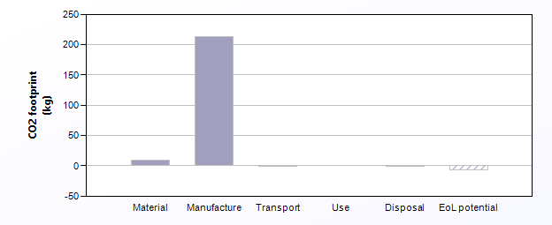
 | CO2 (kg/year)
Equivalent annual environmental burden (averaged over 100 year product life): | 2.23

Detailed breakdown of individual life phases

Material: |  | Summary
Component | Material | Recycled content*  (%) | Part mass  (kg) | Qty. | Total mass processed**  (kg) | CO2 footprint  (kg) | %
Hempcrete block | Hemp fiber | Virgin (0%) | 4.6 | 1 | 5.8 | 9.2 | 100.0
Total |  |  |  | 1 | 5.8 | 9.2 | 100

*Typical: Includes 'recycle fraction in current supply'

**Where applicable, includes material mass removed by secondary processes

***User-defined material

 | Manufacture: |  |  | Summary
Component | Process | % Removed | Amount processed |  | CO2 footprint  (kg) | %
Hempcrete block | Cutting and trimming | 20 | 1.2 | kg | 0.026 | 0.0
Hydraulic pressing | Construction | - | 2.9e+04 | kg | 2.1e+02 | 100.0
Total |  |  |  |  | 2.1e+02 | 100

Transport: |  |  | Summary
Breakdown by transport stage

Stage name | Transport type | Distance  (km) | CO2 footprint  (kg) | %
ship | Ocean freight | 2.8e+02 | 0.017 | 12.4
land | 55 tonne (8 axle) truck | 5e+02 | 0.12 | 87.6
Total |  | 7.8e+02 | 0.13 | 100

Breakdown by components

Component | Mass  (kg) | CO2 footprint  (kg) | %
Hempcrete block | 4.6 | 0.13 | 100.0
Total | 4.6 | 0.13 | 100

Use: |  |  | Summary
 | Relative contribution of static and mobile modes
Mode | CO2 footprint  (kg) | %
Static | 0
Mobile | 0
Total | 0 | 100

Disposal: | Summary
Component | End of life option | % recovered | CO2 footprint  (kg) | %
Hempcrete block | Reuse | 75.0 | 0.064 | 100.0
Total |  |  | 0.064 | 100

EoL potential:

Component | End of life option | % recovered | CO2 footprint  (kg) | %
Hempcrete block | Reuse | 75.0 | -6.9 | 100.0
Total |  |  | -6.9 | 100

Notes: | Summary

Eco Audit Report


Summary

Cost Analysis

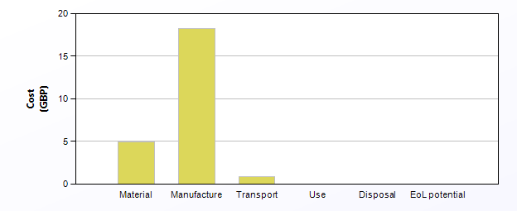
 | Cost (GBP/year)
Equivalent annual environmental burden (averaged over 100 year product life): | 0.241

Detailed breakdown of individual life phases

Material: |  | Summary
Component | Material | Recycled content*  (%) | Part mass  (kg) | Qty. | Total mass processed**  (kg) | Cost  (GBP) | %
Hempcrete block | Hemp fiber | Virgin (0%) | 4.6 | 1 | 5.8 | 5 | 100.0
Total |  |  |  | 1 | 5.8 | 5 | 100

*Typical: Includes 'recycle fraction in current supply'

**Where applicable, includes material mass removed by secondary processes

***User-defined material

 | Manufacture: |  |  |  |  |  | Summary
Country of manufacture |  |  |  | World
Component | Process | Length (m) | % Removed | Amount processed |  | Cost  (GBP) | %
Hempcrete block | Cutting and trimming | - | 20 | 1.2 | kg | 0.0022 | 0.0
Hydraulic pressing | Construction | - | - | 2.9e+04 | kg | 18 | 100.0
Total |  |  |  |  |  | 18 | 100

Transport: |  | Summary
Package dimensions

Height (m) | Width (m) | Depth (m)
0.6 | 0.2 | 0.2

Breakdown by transport stage

Stage name | Transport type | Distance  (km) | Cost  (GBP) | %
ship | Ocean freight | 2.8e+02 | 0.46 | 53.3
land | 55 tonne (8 axle) truck | 5e+02 | 0.41 | 46.7
Total |  | 7.8e+02 | 0.87 | 100

Breakdown by components

Component | Mass  (kg) | Cost  (GBP) | %
Hempcrete block | 4.6 | 0.87 | 100.0
Total | 4.6 | 0.87 | 100

Use: |  |  | Summary
 | Relative contribution of static and mobile modes
Mode | Cost  (GBP) | %
Static | 0
Mobile | 0
Total | 0 | 100

Disposal: | Summary
Component | End of life option | % recovered | Cost  (GBP) | %
Hempcrete block | Reuse | 75.0 | 0.022 | 100.0
Total |  |  | 0.022 | 100

Notes: | Summary

