Project Proposal & Scope of Work
Project Title: Emergency Blood Donor Matching System.
Team Name: Team 1
Course Name: Foundation Project
Members:
- Daniel Gakumba Ntwali
- Teta Butera Nelly
- Dianah Shimwa Gasasira
- Ariane Itetero
- Peter Mfitumukiza
- Melyssa Mbayire
Mission: Our mission is to improve emergency blood availability in Rwanda by developing a reliable, secure, and real-time digital system that connects hospitals with compatible nearby voluntary donors through geospatial matching and automated sms alerts, with the aim of reducing response time and preventing avoidable deaths.

ABSTRACT
Access to safe and sufficient blood remains a major healthcare challenge in Rwanda, where demand frequently exceeds supply.

Table Of Contents
Contents
List Of Tables 5
List Of Figures 6
List Of Acronyms 7
Chapter One: Introduction 8
1. Background 8
2. Problem Statement 8
3. Objectives 8
4. Research Questions 8
5. Project Scope 8
6. Significance and Justification 8
7. Ethical Considerations 8
8. Research Timeline 8
9. Feasibility, Innovation, Risk & Evaluation Plan 8
Chapter Two: Literature Review 9
1. Introduction 9
2. Review of Existing Systems 9
3. Identified Research Gap 9
4. Summary and Conclusion 9
Chapter Three: System Analysis & Design 10
1. Research Design & Development Model 10
2. System Architecture 10
3. UML Diagrams 10
4. Database Design 10
5. Development Tools 10
6. Team Members & Contributions 10
7. References 10
Appendix A 11

Chapter One: Introduction

Background
Access to safe and sufficient blood is a critical part of healthcare systems worldwide, especially during emergencies such as surgeries, war, and maternal complications. The World Health Organization emphasizes that low and middle-income countries continue to face major challenges in maintaining adequate blood supplies, which increases the risk of preventable deaths during emergencies (World Health Organization, 2023). In sub-Saharan Africa, blood shortages remain a persistent healthcare concern due to limitations in donor mobilization and emergency response systems.
In Rwanda, national blood services are overseen by the Rwanda Biomedical Centre (RBC), which manages blood collection and distribution through centralized blood bank operations. Community initiatives such as the Intwari Club 25 program, Rwanda Red Cross campaigns, and partnerships with platforms like Irembo have helped promote voluntary blood donation (Rwanda Biomedical Centre, 2024; Rwanda Red Cross, 2024; Irembo, 2024). Despite these efforts, blood supply still falls below demand. The RBC Annual Report (2024) indicates that approximately 86,812 units of blood were collected, compared to an estimated national need of around 130,000 units per year, showing a significant supply gap of almost ⅓ of the demand required by the World Health Organization (WHO).
Beyond collection levels, timely access to blood during emergencies remains a major challenge. Maternal health studies in Rwanda highlight that obstetric haemorrhage (excessive bleeding during pregnancy, delivery or shortly after giving birth) is among the leading causes of maternal mortality and near-miss cases, where rapid transfusion is essential for survival (Benimana et al., 2018; Rulisa et al., 2021). The United Nations Population Fund (2025) further emphasizes that improving access to emergency blood transfusion is critical for reducing maternal deaths. These findings show that the issue is not only about blood availability but also about how quickly compatible donors can be identified and mobilized.
Globally, digital platforms such as BLOODR and BloodConnect demonstrate the potential of technology in improving donor engagement and communication (Tatikonda & El-Ocla, 2017; BloodConnect, 2025). However, many existing systems lack real-time geospatial matching and structured donor availability tracking, limiting their effectiveness in emergency situations. This creates an opportunity to develop a solution tailored to Rwanda’s healthcare context, capable of connecting hospitals with eligible nearby donors quickly and efficiently.

Problem Statement
The provision of safe blood is a major healthcare issue within sub-Saharan Africa. Blood collection levels in Rwanda are lower than recommended levels, showing that there is still a gap in supply and rapid responses to emergencies. The issue is not just limited to collection; timely delivery during critical emergencies, including postpartum haemorrhage, trauma, and surgical complications, is crucial to patient survival. Maternal mortality remains a concern, with obstetric haemorrhage accounting for a substantial proportion of direct maternal deaths, emphasizing the urgent need for rapid transfusions (United Nations Population Fund [UNFPA], 2025).
Rwanda has come a long way through centralized blood banks operations that connect all the districts through Blood Bank Management System (BBMS). This system is efficient because it manages stocks of blood, appointments with the donors and also facilitates transfers between hospitals. Voluntary donations are promoted through local programs, including Intwari Club 25 program and community blood donation events at the Rwanda Red Cross and Irembo. Nevertheless, these mechanisms and websites lack real-time and hospital-confirmed donor alerts, which restrict quick countermeasures during crises (Rwanda Biomedical Centre, 2024; Rwanda Red Cross, 2024; Irembo, 2024).
On the international level, solutions such as BLOODR and BloodConnect provide donor notification and matching mobile and web-based solutions. Although these systems show the possibility of technology in donor engagement and real-time notifications, they are not always precise with regards to geographical filtering, structured management of donor availability and connection with national blood supply chains. In addition, they are designed with a high level of connectivity, which can be a hindrance in rural or low-bandwidth areas (Tatikonda & El-Ocla, 2017; BloodConnect, n.d.).
An analysis of existing systems reveals three main gaps:
Table 1: Gap Analysis of Existing Systems
Gap | Explanation
Lack of real-time emergency donor activation | Current systems do not directly connect verified hospital requests with eligible nearby donors during emergencies (Tatikonda & El-Ocla, 2017; BloodConnect, n.d.).
Focus on inventory and scheduling rather than dynamic matching | Systems primarily manage blood stock and appointments but fail to support geospatial emergency matching.
Absence of structured donor availability management | Platforms do not differentiate temporarily ineligible donors or track real-time availability for urgent requests.

Objectives
To build HemoLink Rwanda, a web-based system for matching emergency blood requests with nearby willing donors. Right now, Rwanda lacks any automated way to find compatible donors close to a hospital in real time and alert them by SMS. HemoLink Rwanda aims to cut down how long it takes hospitals to secure blood, get more voluntary donors actively participating, and ultimately improve how emergency transfusion cases are handled across the country.

Specific Objectives

The following SMART specific objectives break down the overall aim of the project:
- By the end of Week 1, we aim to have carried out a thorough literature review covering digital blood donor management platforms, geospatial matching techniques, and notification alerts driven health interventions. Alongside this, gather requirements from simulated hospital staff and donor participants.
- By the end of Week 5, to have designed and built the full working system. This includes a donor registration portal, a geospatial matching engine, a hospital-facing dashboard for blood requests, Notification alerting system, a blood inventory tracker, and an admin panel.
- By Week 7, put the system through rigorous testing — both standard functional tests and simulated emergency scenarios. Four main metrics will define success: SMS alerts dispatched in under 60 seconds, 95% blood-type match accuracy, 99% system uptime, and at least 70% donor confirmation rate during controlled test runs.

Research Questions

Project Scope
For the pilot, the geographic focus will be on Kigali City, specifically Gasabo and Kicukiro districts. This bounded scope is chosen to ensure realistic feasibility within the project's seven-weeks timeline. Kigali works well because its population density provides a realistic pool of donors to register, and enough hospitals and health centers sit within those two districts to serve as meaningful test sites.

Project Scope (Inclusions):
- A registration portal where donors sign up with their name, blood type (all eight groups: A+, A-, B+, B-, AB+, AB-, O+, O-), phone number, GPS location, and whether they are currently available to donate.
- Geospatial matching engine that filters and ranks registered donors by blood type compatibility and distance from a requesting hospital using the Haversine formula.
- Automated notification alerts via SMS to dispatch targeted blood request alerts to matched donors within 60 seconds of a hospital request submission.
- A hospital dashboard where authorized facilities submit urgent blood requests, set priority levels, track which donors have responded, and check current inventory.
- Blood inventory tracking module for hospitals to log and monitor current stock levels per blood type.
- An admin panel (intended for staff at organizations like RBC) covering donor data management, hospital account oversight, activity monitoring, and usage reports.
- A responsive web interface usable on both desktop and mobile browsers.

Project Scope (Exclusions):
- No native iOS or Android app from this phase.
- Physical blood logistics, transportation coordination, or cold-chain management hardware integration.
- Integration with Rwanda's national Electronic Health Records (EHR) system, DHIS2, or any external hospital information systems.
- Payment processing, donor incentive schemes, or financial transaction management.
- Deployment or testing beyond Gasabo and Kicukiro districts in this phase.
- Multi-language support beyond English and Kinyarwanda in the initial release.

Deliverables:
- Fully functional HemoLink Rwanda web application deployed in a staging environment.
- Project Proposal document (this document).
- System design documentation including ERD, UML diagrams, and architecture diagrams.
- Test report documenting functional, performance, and security testing results.
- Final project report and oral presentation.

Significance and Justification
People die waiting for blood. When a hospital realizes it does not have enough of a particular blood type on hand, the clock starts. Every hour spent making phone calls and hoping a compatible donor shows up is an hour the patient may not have.Maternal hemorrhage kills an estimated 830 women per day worldwide (WHO, 2023) making this especially urgent. If a system can locate a compatible donor five minutes away and text them immediately, that changes the equation entirely for cases like these in Rwanda.

With HemoLink Rwanda, the aim is to bring average alert dispatch time down from what currently takes hours to under a minute, and to improve response rates by only contacting donors who are actually nearby and have the right blood type.

Beyond the clinical side, there is a social dimension. HemoLink Rwanda gives ordinary citizens a concrete way to contribute to emergency healthcare. Instead of vague appeals for blood donation, a person gets a text saying their specific blood type is needed at a hospital ten minutes from where they are. That kind of personal relevance is what turns a one-time donor into someone who stays registered long-term.

Ethical Considerations
The Emergency Blood donor matching system is concerned with the sensitive personal or medical-related information; therefore,e the ethical standards must be ensured highly.
- Confidentiality of information and Privacy.
The system will collect the details of the donors, such as the names, the phone numbers, location coordinates, and blood types of the donors. All sensitive information is to be kept in a safe location, encrypted when necessary, and against unauthorized access.
- Informed Consent
They need their permission (opt-in) to be reached out to through use of SMS notifications before contacting the donors. Consent status (consent sms) will be stored in the system to ensure that ethical communication is achieved.
- Data Security
Hashes (administrators) of passwords should be safe. It will be a role-based system to make sure that information is not misused.
- Responsible Use of Location Data.
The matching of the donors will be done based on geographic coordinates (latitude/longitude), which will not be applied to follow the donor movements.
- Non-Discrimination
It will be able to match its system to the donors according to blood compatibility, availability, and proximity, but not according to gender, ethnicity, religion, or socioeconomic background.
- Transparency
Hospitals and the donors should be informed of the manner in which their data would be used and stored.

Research Timeline

Feasibility, Innovation, Risk & Evaluation Plan

Feasibility Analysis

Technical Feasibility
Some of the technologies that are widely applied in the system are PostgreSQL and existing web frameworks. Integration with SMS could be achieved using a series of communication APIs that are available. The hardware requirement is not complex and average.

Operational Feasibility
Already, hospitals have blood request processes in place, and as such, a digital matching system would make things work more efficiently rather than a reworkflow overhaul. The donors register it on a basic form.

Economic Feasibility
It is an open-source-based system, which reduces the development cost. An SMS notification is comparatively inexpensive and can be simplified by means of bulk pricing.

Time Feasibility
The system can be developed according to phases:
- Phase 1: DB and backend setup.
- Phase 2: Frontend interface.
- Phase 3: Implementation and testing.
It will require 7 weeks to build a prototype (depending on the level of functionality).

Risk Assessment Table
Risk | Likelihood | Impact | Mitigation Strategy
Data breach | Medium | High | Use encryption, secure authentication, and restricted access
SMS delivery failure | Medium | Medium | Use a reliable SMS provider and a retry mechanism
Incorrect donor matching | Low | High | Implement strict validation rules and testing
System downtime | Medium | High | Use reliable hosting and regular backups
Low donor response rate | Medium | High | Awareness campaigns and reminder notifications
Outdated inventory data | Medium | Medium | Require hospitals to update stock regularly
Unauthorized system access | Low | High | Role-based access control and strong password policies

Evaluation Plan
The system will be validated based on its effectiveness, performance, and usability.

Performance Metrics
- Average time to attend to a blood request
- Effective donor matching
- Donor response rate
- SMS delivery success rate

User Evaluation
- Hospital employee feedback
- Reactions of registered donors
- Usability testing surveys

System Testing
- Backend functional testing
- Application and database integration testing
- Both emergency demand and stress testing are high

Continuous Improvement
- Regular performance appraisals
- Quarterly security checks
- User-based system updates

Chapter Two: Literature Review

Overview of the Problem
Blood shortages remain a major public health concern globally and across Sub-Saharan Africa. The World Health Organization recommends a minimum of 10 blood units per 1,000 population, yet many African countries collect significantly less (Barro et al., 2018; Weimer et al., 2018).
In Rwanda, 126,837 units of blood were delivered in 2024 against a demand of 127,198 units (Rwanda Biomedical Centre [RBC], 2024). Although national supply appears nearly balanced, emergency situations such as activation of the Massive Blood Transfusion Protocol (MBTP) expose coordination delays. According to Rwanda’s National Directives on the Rational Use of Blood, MBTP is triggered during life-threatening blood loss requiring rapid multi-unit transfusion (Ministry of Health, 2018). In such cases, response time directly affects survival.
These findings justify the need for improved emergency coordination mechanisms in Rwanda’s blood donation system.

Review of Existing Systems

SMS in Health Systems
Evidence shows that SMS-based health interventions improve engagement and response rates, particularly in low-resource settings (Weimer et al., 2018). SMS platforms are:
- Low-cost
- Internet-independent
- Compatible with basic feature phones
In Rwanda:
- 58,688 donors are registered (RBC, 2024)
- 42.46% of donations come from Regular Blood Donors (RBC, 2024)
- 46.1% of donors are aged 18–25 (RBC, 2024)
- Mobilization relies on 1,807 Blood Donor Representatives (manual coordination) (RBC, 2024)
While community-based outreach is effective, manual systems may delay emergency response. Research on blood safety systems in Sub-Saharan Africa emphasizes the importance of stronger coordination mechanisms to improve responsiveness (Barro et al., 2018).
Therefore, automated SMS alerts could enhance donor mobilization during critical events.

Geospatial Health Systems
Geospatial tools improve healthcare efficiency by matching resources based on proximity and need. Studies across African health systems show that geospatial data improves service targeting and delivery efficiency (Mogojwe & Mogojwe, 2024).
In Rwanda:
- Karongi (-7.2%) and Ruhengeri (-2.8%) experienced declines in active collection sites due to transport challenges (RBC, 2024).
- Zipline drones handled 56% of blood deliveries in 2024 (RBC, 2024).
Although blood delivery logistics are technologically optimized, donor mobilization remains manual. Integrating geospatial matching with SMS alerts would enable rapid identification and notification of the nearest compatible donors during MBTP activation.
This aligns with evidence that spatial targeting improves healthcare response efficiency (Mogojwe & Mogojwe, 2024).

Existing Systems and Limitations

System | Description | Strengths | Limitations | Relevance to our solution
BloodConnect (South Africa) | A youth-driven blood donor recruitment platform that uses SMS and digital campaigns to encourage voluntary donations. | • Strong SMS-based communication  • Engages young donors effectively  • Community awareness focus | • No real-time geolocation matching  • Focuses on campaigns rather than emergency alerts | Shows that SMS improves donor engagement but lacks targeted emergency matching.
eBloodBank (India model) | A digital blood bank directory system allowing users to search available blood by type and location. | • Centralized digital database  • Searchable blood type system  • Improves transparency | • Limited automated alert system  • Not optimized for rural/low-internet areas | Demonstrates importance of centralized databases but needs stronger emergency alert integration.
Rwanda Biomedical Centre (RBC system – Rwanda)  Intwari Club 25 | National blood service coordinating collection and distribution across Rwanda. | • Government-backed credibility  • Organized collection infrastructure  • Established medical standards | • Limited direct donor-to-patient matching(0.61% in 2024) (RBC, 2024)  • Emergency response may not be SMS-based or location-targeted | Strong medical oversight but lacks dynamic digital donor matching features.
GiveBlood (UK Campaign Model) | A digital donor registration and awareness system encouraging citizens to book donation appointments. | • Easy donor registration  • Structured scheduling system  • Public awareness campaigns | • Internet-dependent  • Not built for rapid emergency matching | Highlights structured donor registration but not emergency geospatial targeting.
Brief Version
System | Strengths | Limitations
BloodConnect | Strong youth engagement | Not emergency-focused
e-BloodBank | Real-time inventory tracking | Internet-dependent
Intwari Club 25 | Structured donor network | Limited national contribution (0.61% in 2024) (RBC, 2024)
GiveBlood | Appointment scheduling | Smartphone-dependent
Most systems emphasize awareness or appointment scheduling rather than real-time emergency mobilization. Many depend on smartphones or stable internet, limiting accessibility in rural areas.

Identified Research Gap
The literature identifies three main gaps:
- Limited SMS-first systems tailored for feature-phone users
- Continued reliance on manual donor mobilization during emergencies
- Lack of integration between donor mobilization and proximity-based targeting

Summary and Conclusion
Existing research supports SMS-based engagement (Weimer et al., 2018) and highlights coordination challenges in Sub-Saharan Africa (Barro et al., 2018). However, no integrated system combines:
- SMS-based emergency alerts
- Blood type matching
- Geospatial proximity targeting
Therefore, there is a need for a low-cost, SMS-integrated, geospatial Emergency Blood Donor Matching System designed for Rwanda’s infrastructure and demographic context.

Chapter Three: System Analysis & Design
Introduction
In this part, we will present the research approach, system design, and technical architecture of our project. The system development methodology is Agile, implemented through 7-week sprint cycles. We selected this approach because it accommodates iterative refinement, enables regular feedback integration, and ensures that working software is delivered incrementally rather than only at the end of the project. The development tools and frameworks were selected based on open-source availability, team competency, and documented suitability, and documented suitability for the project’s technical requirements.

Research Design & Development Model
HemoLink project follows the Agile Software Development methodology. We will divide tasks into 6 which will be done in 7 weeks. Task 1 will be requirements analysis and database design; Task 2 donor registration module; Task 3 will be building geospatial matching engine plus the MTN integration for the SMS; Task 4 will be for hospital dashboard; Task 5 will deliver admin panel and inventory model; Lastly; Testing, QA, and deployment will be completed.

Agile Development Model

Sprint | Weeks | Task / Module | Key Deliverables
Sprint 1 | Week 1 | Requirements Analysis & Database Design | ER Diagram, DB Schema, Requirements Doc
Sprint 2 | Week 2 | Donor Registration Module | Registration API, Auth System, Donor UI
Sprint 3 | Weeks 3-4 | Matching Engine + MTN SMS Integration | Matching Engine, SMS Alert System, MTN API
Sprint 4 | Week 5 | Hospital Dashboard | Hospital Dashboard
Sprint 5 | Week 6 | Admin Panel & Inventory Model | Admin Panel, Inventory Alerts
Sprint 6 | Week 7 | Testing, QA & Deployment | Report, Deployment, User Manual

System Architecture
HemoLink employs three main layers: React.js based presentation layer, Node.js/Express application layer that handles business logic and integrations, and a PostgreSQL Data Layer. We will use an external SMS gateway (MTN Rwanda API) which is in the application layer.
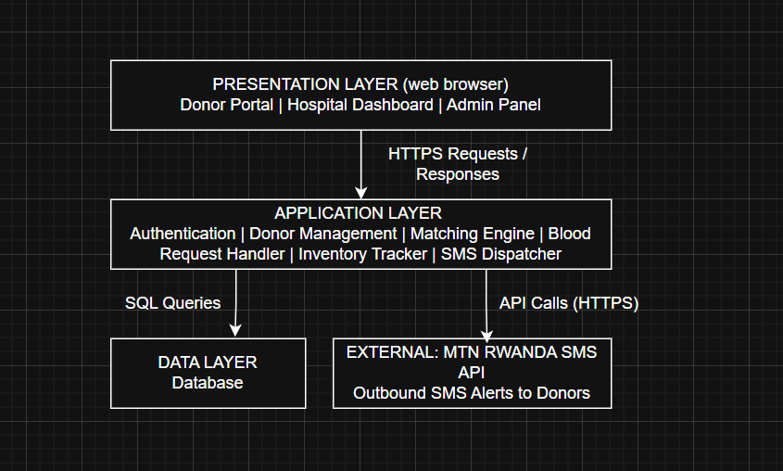

UML DIAGRAMS
- Use Case Diagram
This diagram shows the primary actors in this project and how they will interact with the system functionalities. The stakeholders are: Donor, Hospital Staff, System Administrator, and the external MTN SMS Gateway.

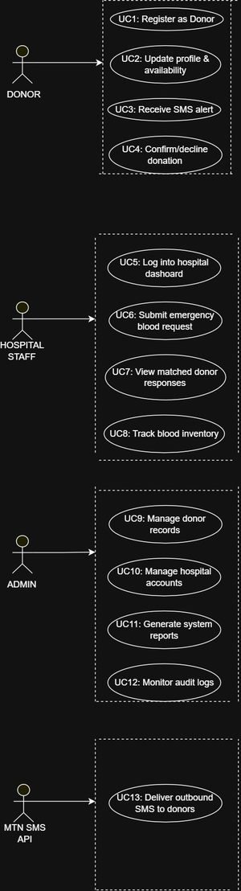
- Class Diagram
This diagram shows the primary entities (tables), attributes, methods and inter-class relationships.
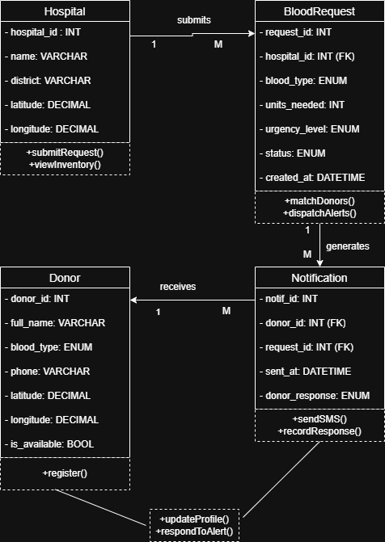

Database Design

4.1 Database System
The system will use PostgreSQL as the relational database management system (RDBMS).

Justification:
- Strong support for relational integrity (primary and foreign keys)
- Reliable and scalable
- Supports geographic coordinates (latitude/longitude)
- Open-source and cost-effective
- Compatible with modern backend frameworks

4.2 Entity-Relationship Diagram (ERD)
Figure 4: Entity Relationship Diagram of the Emergency Blood Donor Matching System
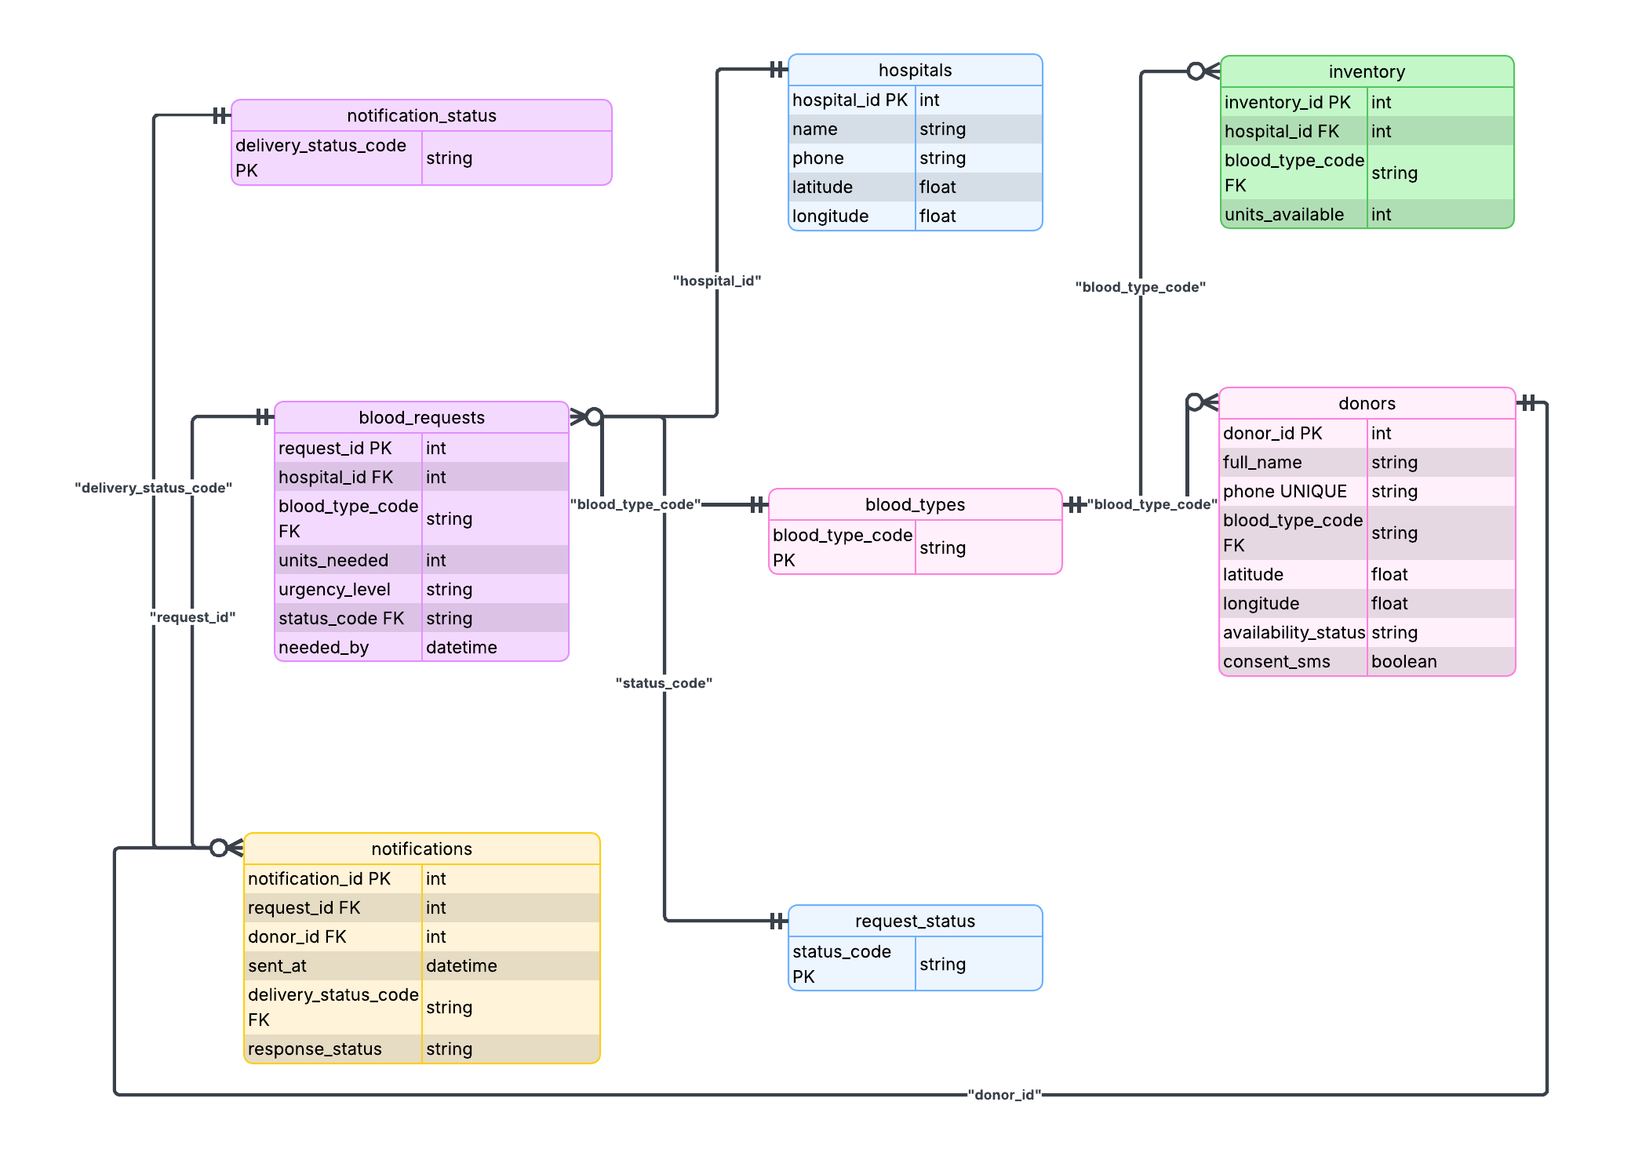

Relationship Summary:
- One Hospital can create many Blood_Requests.
- One Hospital can have many Inventory records.
- One Blood_Type can be linked to many Donors, Blood_Requests, and Inventory entries.
- One Blood_Request can generate many Notifications.
- One Donor can receive many Notifications.
- Lookup tables manage standardized values.

4.3 Database Tables Description

1. Table: donors

Columns Description
Column Name | Data Type | Key | Purpose
donor_id | SERIAL | PK | Unique donor identifier
full_name | VARCHAR(100) | — | Donor’s full name
phone | VARCHAR(20) | — | Donor’s contact number
blood_type_code | VARCHAR(5) | FK → blood_types | Donor blood group
latitude | DECIMAL(9,6) | — | Donor location latitude
longitude | DECIMAL(9,6) | — | Donor location longitude
availability_status | VARCHAR(20) | — | Availability (Available/Unavailable)
consent_sms | BOOLEAN | — | Indicates if the donor agreed to SMS notifications

Sample Data
donor_id | full_name | phone | blood_type_code | latitude | longitude | availability_status | consent_sms
1 | Jean Claude | 0788123456 | O+ | -1.9441 | 30.0619 | Available | TRUE
2 | Marie Uwase | 0788765432 | A- | -1.9500 | 30.0580 | Unavailable | TRUE

2. Table: hospitals
Column Name | Data Type | Key | Purpose
hospital_id | SERIAL | PK | Unique hospital identifier
name | VARCHAR(150) | — | Hospital name
phone | VARCHAR(20) | — | Hospital contact number
latitude | DECIMAL(9,6) | — | Hospital latitude
longitude | DECIMAL(9,6) | — | Hospital longitude

Sample Data
hospital_id | name | phone | latitude | longitude
1 | Kigali University Teaching Hospital | 0788000000 | -1.9536 | 30.0605
2 | King Faisal Hospital | 0788111111 | -1.9365 | 30.0900

3. Table: blood_requests

Column Name | Data Type | Key | Purpose
request_id | SERIAL | PK | Unique request ID
hospital_id | INT | FK → hospitals | Hospital making request
blood_type_code | VARCHAR(5) | FK → blood_types | Required blood type
units_needed | INT | — | Number of units required
urgency_level | VARCHAR(20) | — | Urgency (Low/Medium/High/Critical)
status_code | VARCHAR(20) | FK → request_status | Current request status
needed_by | TIMESTAMP | — | Deadline for blood

Sample Data
request_id | hospital_id | blood_type_code | units_needed | urgency_level | status_code | needed_by
1 | 1 | O+ | 3 | Critical | Pending | 2026-02-23 18:00:00

4. Table: notifications

Columns Description
Column Name | Data Type | Key | Purpose
notification_id | SERIAL | PK | Unique notification ID
request_id | INT | FK → blood_requests | Related blood request
donor_id | INT | FK → donors | Notified donor
sent_at | TIMESTAMP | — | Date/time sent
delivery_status_code | VARCHAR(20) | FK → notification_status | Delivery state
response_status | VARCHAR(20) | — | Donor response (Accepted/Declined/No Response)

Sample Data
notification_id | request_id | donor_id | sent_at | delivery_status_code | response_status
1 | 1 | 1 | 2026-02-22 10:30:00 | Delivered | Accepted

5. Table: inventory

Columns Description
Column Name | Data Type | Key | Purpose
inventory_id | SERIAL | PK | Unique inventory record
hospital_id | INT | FK → hospitals | Hospital
blood_type_code | VARCHAR(5) | FK → blood_types | Blood type
units_available | INT | — | Current available units

Sample Data
inventory_id | hospital_id | blood_type_code | units_available
1 | 1 | O+ | 2
2 | 1 | A+ | 5

Lookup Tables

6. Table: blood_types
Column Name | Data Type | Key | Purpose
blood_type_code | VARCHAR(5) | PK | Blood type identifier
description | VARCHAR(50) | — | Description

Sample Data
blood_type_code | description
O+ | O Positive
A- | A Negative

7. Table: request_status
Column Name | Data Type | Key | Purpose
status_code | VARCHAR(20) | PK | Request status code
description | VARCHAR(50) | — | Status meaning

Sample Data
status_code | description
Pending | Awaiting donor response
Fulfilled | Request completed
Cancelled | Request cancelled

8. Table: notification_status
Column Name | Data Type | Key | Purpose
delivery_status_code | VARCHAR(20) | PK | Delivery status
description | VARCHAR(50) | — | Meaning

Sample Data
delivery_status_code | description
Sent | Message sent
Delivered | Successfully delivered
Failed | Delivery failed

Development Tools

Team Members & Contributions
- Daniel Gakumba Ntwali – Project Manager & Presentation Lead: Overall project coordination, proposal integration, PowerPoint creation, design consistency, storytelling flow, final edits.
- Melyssa Ingabe Mbayire – System Analyst & QA: Problem statement research, Rwanda statistics, comparison of existing systems, identifying software gap, APA citations.
- Mfitumukiza Peter – Lead Backend Developer: Main objective and SMART objectives, project scope definition, significance & justification.
- Teta Butera Nelly – DevOps & Documentation: Literature review, existing system analysis, APA references, DevOps setup, documentation integration, version control.
- Dianah Gasasira Shimwa – UI/UX and Frontend Developer: Development methodology (Agile), system architecture diagram, UML diagrams (Use Case and Class), system explanation.
- Ariane Itetero – Database Architect: ERD design, database tables, development tools justification, ethical considerations, feasibility analysis, risk assessment, evaluation plan, team participation tracking.

References
Benimana, C., Small, M., & Rulisa, S. (2018). Preventability of maternal near miss and mortality in Rwanda: A case series from the University Teaching Hospital of Kigali (CHUK). PLOS ONE, 13(6), e0195711. https://doi.org/10.1371/journal.pone.0195711
Gondwe, A., et al. (2025). Facilitators of and barriers to blood donation among voluntary non-remunerated blood donors in sub-Saharan Africa: A scoping review. Vox Sanguinis. https://pubmed.ncbi.nlm.nih.gov/40107721
Rwanda Biomedical Centre. (2024). Annual report 2024: Blood Transfusion Division. Ministry of Health, Government of Rwanda. https://www.rbc.gov.rw/fileadmin/user_upload/report_2024/Services_Department_Blood_Transfusion_Division_ANNUAL_REPORT_2024.pdf
Rulisa, S., Ntihinyurwa, P., Ntirushwa, D., Wong, A., & Olufolabi, A. (2021). Causes of maternal mortality in Rwanda, 2017–2019. Obstetrics & Gynecology, 138(4), 552–556. https://pubmed.ncbi.nlm.nih.gov/34623066
United Nations Population Fund (UNFPA). (2025). Maternal health in Rwanda. https://rwanda.unfpa.org/en/topics/maternal-health
World Health Organization. (2023). Blood safety and availability (Fact sheet). https://www.who.int/news-room/fact-sheets/detail/blood-safety-and-availability
BloodConnect. (2025). BloodConnect: Overview & features. https://bloodconnect.net/
Irembo. (2024, June 21). Irembo partners with Rwanda Biomedical Center (RBC) for free blood donation drive. https://irembo.com/2024/06/irembo-partners-with-rwanda-biomedical-center-rbc-unite-for-free-blood-donation-drive/
Rwanda Biomedical Centre. (2024). Blood Transfusion Division Annual Report 2024. https://www.rbc.gov.rw/
Rwanda Red Cross. (2024). Blood donation and community engagement programmes. https://www.redcross.org.rw/
Tatikonda, V. K., & El-Ocla, H. (2017). BLOODR: Blood donor and requester mobile application. mHealth, 3, 40. https://doi.org/10.21037/mhealth.2017.08.08
United Nations Population Fund. (2025). Maternal health in Rwanda. https://rwanda.unfpa.org/en/topics/maternal-health
World Health Organization. (2024). Blood safety. https://www.afro.who.int/health-topics/blood-safety

Appendix A
BSE Team Task Sheet_[EWD_Database Design and Implementation_Cohort 1_Team1]

A1. Project Overview
Project Title: HemoLink Rwanda – Emergency Blood Donor Matching System
Course: Foundations Project
Team Name: Team 1
This appendix documents team organization, role allocation, individual contributions, and collaboration records to demonstrate equal participation and accountability throughout the development of the project proposal.

A2. Team Work Allocation Strategy
The team divided responsibilities according to the grading rubric to ensure that each member owned specific deliverables linked to assessment criteria. This approach ensured balanced workload distribution and clear accountability.
The rubric areas covered include:
- Abstract
- Background & Problem Statement
- Objectives, Scope & Significance
- Literature Review
- System Analysis & Design
- Team Organization & Contributions
- Ethics, Feasibility & Risk
- Formatting & Presentation
Each member was assigned ownership of specific sections to maximize efficiency and quality.

A3. Team Members and Individual Contributions

1. Daniel Gakumba Ntwali — Project Manager & Presentation Lead
Main Responsibilities:
- Overall project coordination
- Proposal integration and final review
- Document formatting and structure
- PowerPoint creation and design consistency
Proposal Contributions:
- Cover page preparation
- Abstract finalization
- Background section refinement
- Final editing and formatting
- Integration of all chapters into one document
Presentation Contributions:
- Designed entire slide deck
- Managed storytelling flow
- Ensured visual consistency
- Final presentation edits
Rubric Coverage:
- Abstract
- Formatting & Presentation
- Team Organization

2. Melyssa Mbayire — Problem Statement & Research Lead
Main Responsibilities:
- Development of problem statement section
- Research evidence and statistics
Proposal Contributions:
- Problem Statement (Section 1.2)
- Rwanda blood supply statistics
- Comparison of existing systems
- Identification of system gaps
- Academic citations (APA style)
Rubric Coverage:
- Background & Problem Statement

3. Peter Mfitumukiza — Objectives, Scope & Significance Lead
Main Responsibilities:
- Define project goals and realistic scope
Proposal Contributions:
- Main objective definition
- SMART specific objectives
- Project scope (inclusions & exclusions)
- Deliverables list
- Significance and justification section
Rubric Coverage:
- Objectives, Scope & Significance

4. Teta Butera Nelly — Literature Review & References Lead
Main Responsibilities:
- Research and analysis of existing systems
Proposal Contributions:
- Literature review introduction
- Analysis of systems:
  - BloodConnect
  - e-Bloodbank
  - Rwanda Biomedical Centre system
  - GiveBlood
- Strengths and weaknesses comparison
- Research gap identification
- Reference list (APA formatting)
Rubric Coverage:
- Literature Review

5. Dianah Shimwa Gasasira — System Analysis & Technical Design Lead
Main Responsibilities:
- Technical architecture and system modeling
Proposal Contributions:
- Agile development methodology
- System architecture design
- UML diagrams:
  - Use Case Diagram
  - Class Diagram
- Technical system explanation
Rubric Coverage:
- System Analysis & Design

6. Ariane Itetero — Database, Ethics & Feasibility Lead
Main Responsibilities:
- Database design and system feasibility
Proposal Contributions:
- ERD design
- Database tables and schema description
- Development tools justification
- Ethical considerations
- Feasibility analysis
- Risk assessment table
- Evaluation plan
- Team participation documentation
Rubric Coverage:
- Ethics, Feasibility & Risk
- Team Organization

A4. Team Integration Process
After individual sections were completed:
- The Project Manager merged all sections into one document.
- Writing style and formatting were standardized.
- APA referencing format was verified.
- Table of contents and page structure were reviewed.
- Final proofreading was conducted collaboratively.
Formatting checks included:
- Times New Roman font
- Size 12 (body text)
- 1.5 line spacing
- Correct heading hierarchy
- Page numbering

A5. Team Meetings & Collaboration Summary
Meeting | Purpose | Key Outcomes
Meeting 1 | Project idea selection | Selected Emergency Blood Donor Matching System
Meeting 2 | Role allocation | Assigned rubric-based responsibilities
Meeting 3 | Research alignment | Confirmed data sources and references
Meeting 4 | System design planning | Finalised architecture and database structure
Meeting 5 | Integration review | Merged sections and reviewed formatting
Meeting 6 | Presentation preparation | Finalized PowerPoint and delivery roles

A6. Contribution Verification
All members contributed directly to the development of the proposal according to assigned responsibilities. Collaboration was maintained through regular communication, shared document editing, and review sessions.

