BookMyHotel.com
Enterprise System Study — Draft Report
Programme Name: | BEng (Hons) Software Engineering
Module Title: | SWE6013 Enterprise System Development
Assessment Title: | Enterprise System Study
Student Number: | 2533971
Marking Tutor: | Ms. Renuka Nyayadhish
Date of Submission: | 14 August 2026
Word Count: | 3055

1. Introduction to Enterprise System Development
Enterprise System Development refers the disciplined design of large-scale information systems to support an organisation's strategic and operational objectives. This report outlines the architectural approach for BookMyHotel.com, a Dubai-based e-commerce platform which centralises room bookings for four hotel chains (Marriott, Hilton, Hyatt, and Four Seasons) into a single customer-facing application. Designing the platform involves the disciplined application of an enterprise architecture framework to determine the manner in which business goals translate into technology decisions, and a software architecture pattern which will keep the system maintainable, secure, and scalable. This section introduces the frameworks/patterns used in the industry, outlines the decisions made for BookMyHotel.com, and their rationale, using the case study.

1.1 Enterprise System Architecture Frameworks
Enterprise Architecture (EA) refers to the description and control of the structure, behaviour, and relationships of an organisation's business processes, information systems, data, and technology so that they act coherently towards strategic objectives. The EA framework provides a standard methodology with common terminology that matches an organisation's IT investment with the goals and controls complexity as an organisation grows.
TOGAF (The Open Group Architecture Framework) is one of the most widely used EA frameworks and is built around the Architecture Development Method (ADM), which is an iterative cycle, from Architecture Vision to Business, Data, Application and Technology Architecture to Migration Planning and Governance. TOGAF is more of a process-driven approach: it establishes how an enterprise architecture should be designed, validated, and evolved, not just what an enterprise looks like.
The Zachman Framework, in contrast, is more of a classification scheme rather than a process. It categorises enterprise artefacts into a 6x6 matrix, which cross-references six questions (What, How, Where, Who, When, Why) with six perspectives (Planner, Owner, Designer, Builder, Sub-contractor, Enterprise). It's a good taxonomy to avoid missing perspectives, but lacks the sequence of steps to create or realise an architecture.

1.2 Software Architecture Patterns
In addition to the enterprise-level framework for an enterprise architecture, a software architecture pattern will determine the internal internal design of the application itself. Four popular patterns were reviewed:
- Model-View-Controller (MVC): This separates an app into the Model (data and business rules), the View (presentation), and the Controller (mediates input, coordinates Model and View) — making testing, maintenance, and parallel development of front-end and backend functions more manageable.
- Client-Server: This breaks a system into a client that makes request requests and renders the interface, and a server which processes requests and manages data — centralises controlling data and security on the server.
- Microservices: This breaks an application into small, independently deployable services that communicate using lightweight protocols. Has excellent scalability but introduces substantial operational and debugging complexities to teams new to distributed systems.
- Layered (N-Tier): This divides a system into horizontal layers (presentation, business logic, data access) which only communicate with the layer beneath them — makes for separation of concerns but can cause unnecessary indirection for smaller systems

1.3 Selection of Architecture Framework and Pattern
This project will use TOGAF, as the enterprise architecture framework, with a hybrid Client-Server and Model-View-Controller (MVC) software architecture pattern for BookMyHotel.com. While both Zachman and Microservices were reviewed, both were rejected in favour of this combination, for the following reasons, which are detailed in Section 1.4.

1.4 Justification
TOGAF was selected over the Zachman methodology because BookMyHotel.com is a green field build which requires the final ability to handle 300+ daily bookings across four hotel chains (this figure expected to increase in future). The Zachman Framework's 6x6 matrix is an excellent tool to catalog what an enterprise architecture needs to include, but doesn't inform on how it should be implemented, sequenced, or governed. Instead, TOGAF provides an iterative, phase-by phase roadmap with the Architecture Development Method (ADM) which encompasses business vision through to implementation and governance — exactly the process-oriented methodology this project requires. TOGAF is also designed to handle the evolution of complex, multi-stakeholder systems that fit a platform that must be scalable to include additional hotel chains and capabilities (such loyalty rewards, analytics dashboards) for without breaking down the existing architecture. Finally, its focus on Business Architecture ensures every technical decision can be traced to a business goal, and keeps features like secure payments and administrative reporting aligned to BookMyHotel.com's commercial aims.
The hybrid Client-Server and MVC pattern was selected over the Microservices approach because while Microservices has excellent scalability, it also introduces distributed-systems complexities (independent deployment, communication, distributed debugging) that are not warranted by a single-team academic project build. This hybrid approach, in contrast, provides a clean separation of concerns — the presentation layer (served using Next.js) as the Client, which only handles the customer-facing experience, routing, and booking process. The backend (built using Laravel) is the Server and natively incorporates MVC — the Model controls database schemas for Hotels, Users, Reservations, and Payments; the Controller handles core business logic (e.g. validation availability, calculating discounts, payment processing using Stripe); and the View renders the JSON returned to the client. Since the client never communicates with the database itself and all requests to routed to the Controller, this architecture reduces the complexity required of the security requirements set for in the case study (e.g. secure payments, role-based authentication). Communication between the Next.js client and the Laravel server is done via standard RESTful APIs to keep the integration simple, but manageable for testing, given the scope and timeline of the project.
2. Requirements Analysis
This section analyses the BookMyHotel.com case study to establish what the system must do (functional requirements) and the qualities it must exhibit (non-functional requirements), before mapping these back to the company's stated business goals and outlining the software and hardware environment selected to deliver them.

2.1 Functional Requirements
The functional requirements below are derived directly from the BookMyHotel.com case study and cover the customer, hotel-staff, and administrative sides of the platform.
- Registration and login: users must register an account before they can make a reservation; unregistered users cannot log in or book.
- Search and filtering: customers can search and filter rooms across the four participating hotel chains (Marriott, Hilton, Hyatt, Four Seasons) by price, services, and room type.
- Rates and availability: the system maintains a calendar of daily room rates broken down by date and room type, together with occupancy and availability.
- Reservation management: customers can view, reserve, and cancel bookings for rooms and ancillary services.
- Ancillary services: customers can browse and reserve additional hotel services such as bar and restaurant, car and motorbike rental, local tour tickets with guides, and spa treatments.
- Promotions: the system supports discount actions created by hotel managers in addition to standard rates and availability.
- Guest reviews: the system aggregates written guest feedback and ratings for each property.
- Contact form: customers can contact BookMyHotel.com directly through a contact form on the site.
- Secure payment: Secure payment: customers can pay for reservations through a secure, PCI-aware payment gateway (Stripe) configured in Test Mode to safely simulate transactions supporting multiple payment methods.
- Hotel administration: admin users can add, edit, and remove hotels and their details, and view reservation details for a specific date.
- Analytics dashboard: admin users can view an aggregated performance overview -- booked room-nights, room revenue, and average daily rate (room revenue divided by room-nights) -- with links through to the underlying reports for each hotel.
- Property management: each hotel has a profile page (the Property record) describing the hotel for the customer-facing interface.

2.2 Non-Functional Requirements
The non-functional requirements describe the qualities the system must exhibit rather than specific features, and are used later in Section 1.4 to justify the choice of architecture and pattern.
- Performance: the platform must comfortably handle the case study's stated average load of approximately 300 room-night reservations a day without degradation to response times.
- Scalability: as BookMyHotel.com intends to add further hotels and services, the architecture must accommodate this growth without requiring the existing system to be redesigned.
- Security: payment data and customer accounts must be protected; card data is handled by Stripe rather than stored directly, and role-based authentication is used to separate customer, hotel-staff, and admin capabilities.
- Reliability and data integrity: the booking and rates data must remain consistent so that two customers cannot be confirmed into the same room for the same dates.
- Usability: the interface must support multiple search options (price, services, rooms) and must be usable by customers with no technical background, consistent with the case study's emphasis on an improved user interface.
- Maintainability: because the platform will keep growing in hotels and services, the codebase must remain straightforward for a small team to extend, which is a key driver behind the architecture and pattern choice discussed in Section 1.
- Availability: as a booking platform trading across time zones (Asia and Europe), the system should remain accessible outside a single region's business hours.

2.3 Mapping Requirements to Business Goals
Table 1 links the requirements identified above back to BookMyHotel.com's stated commercial aims, so that each technical decision can be traced to a business driver, consistent with the Business Architecture emphasis of the TOGAF ADM discussed in Section 1.4.
Business Goal | Requirement(s) Addressed
Single platform across multiple hotel chains | Unified search/reservation across Marriott, Hilton, Hyatt, and Four Seasons; a shared Hotels/Rooms data model rather than one system per chain.
Growth in hotels, services, and booking volume | Scalable hybrid Client-Server/MVC architecture (Section 1.4) and a database schema (Section 4.3) designed to add hotels and room types without structural change.
Customer trust and transparency on cancellations/refunds | Reservation cancellation feature and clear booking-status handling in the Reservations entity.
Customer safety and secure payment | Payment processing delegated to Stripe, role-based authentication, and RESTful API boundaries that stop the client communicating with the database directly (Section 1.4).
Data-driven decision making for the business | Admin Analytics Dashboard reporting booked room-nights, room revenue, and average daily rate.
Attracting and retaining hotel-manager participation | Promotions/discount functionality that lets hotel managers offer their own incentives on the shared platform.
Table 1: Mapping of BookMyHotel.com business goals to system requirements.
The case study also raises sustainability incentives, such as reward points for eco-friendly bookings, as a customer expectation. This has been logged as a candidate future enhancement (Section 8) rather than a current requirement, since the case study does not specify how such a scheme should operate and no reward-point mechanic has been implemented in the current build.

2.4 Software and Hardware
The software environment follows directly from the architecture and pattern justified in Section 1.4: a Next.js client, a Laravel backend implementing MVC, and a relational database, communicating over RESTful APIs and integrating with Stripe for payment.
- Frontend: Next.js (React) -- handles the customer, admin, and hotel-staff interfaces and client-side routing.
- Backend: Laravel (PHP) -- implements the MVC pattern, business logic, and API endpoints consumed by the client.
- Database: MySQL -- a relational database was selected over a NoSQL alternative because bookings, rooms, and payments are naturally tabular and relationship-heavy (Section 4.3), and MySQL is a natural pairing with Laravel's Eloquent ORM.
- Payment gateway: Stripe -- handles card capture and PCI-scope reduction so that BookMyHotel.com does not store card data directly. For the scope of this project, Stripe is implemented using its developer sandbox (Test Mode) with test API keys.
- Hosting: a cloud-hosted virtual server (for example AWS, DigitalOcean, or a comparable provider) running the Laravel application and MySQL database, with the Next.js client deployed to a static/edge hosting service; this keeps hosting costs proportionate to the project's current 300 booking/day scale while leaving room to scale up as BookMyHotel.com grows.
These choices are treated as a starting infrastructure decision for the project rather than a fixed constraint -- if load or feature requirements change materially during development, the hybrid architecture in Section 1.4 is intended to absorb that change without a redesign.
3. Project Plan

3.1 Gantt Chart
The BookMyHotel.com project has a twelve-week timeline spanning from late May to 25 August. This schedule stages the planning (frameworks analysis, requirement analysis, system design) before the implementation (database setup, backend/frontend development, integration), before finally conducting testing, report refinement, and final submission. Figure 1 illustrates the planned task durations and overlapping.
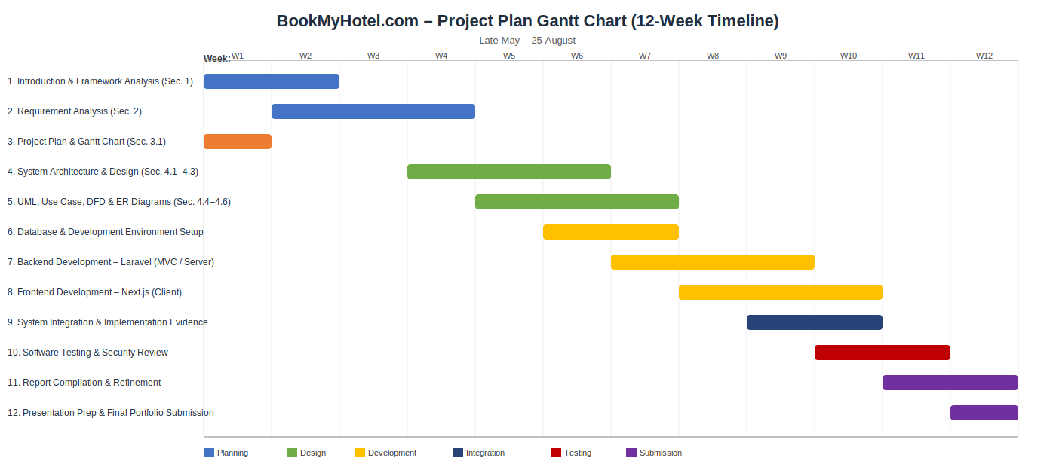
Figure 1: BookMyHotel.com 12-week project Gantt chart.
4. System Design

4.1 System Architecture
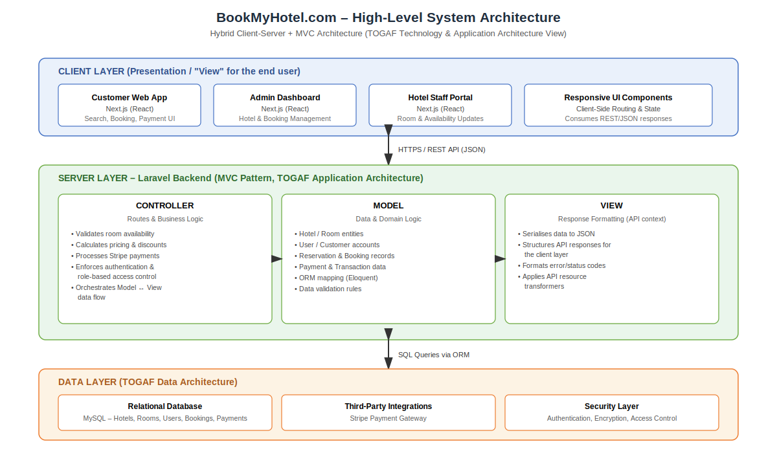
Figure 2: High-level system architecture — hybrid Client-Server + MVC (TOGAF Technology and Application Architecture view).
Architecture means the high-level design of a software system: its key components, their duties, and communication channels between them. For BookMyHotel.com, this includes a Next.js client layer serving the customer, admin, and hotel-staff interfaces; a server layer Laravel server that implements MVC to enforce business logic and security controls; and a data layer containing a relational database and integration with the Stripe payment gateway, as illustrated by Figure 2

4.2 System Design
System design defines the internal functional operation of a system in detail enough to drive an implementation – how components handle data, how modules interact with defined interfaces, and how the data schema is designed. Whereas system architecture focuses on how the systems is structured on the whole system level, system design focuses on the internal behaviour and construction of parts of the system, and will be defined using the Entity-Relationship and Data Flow designs further in this report.

4.3 Database Design -- ER Diagram
Figure 3 illustrates the Entity-Relationship model for BookMyHotel.com, featuring the five core entities identified in Section 2.
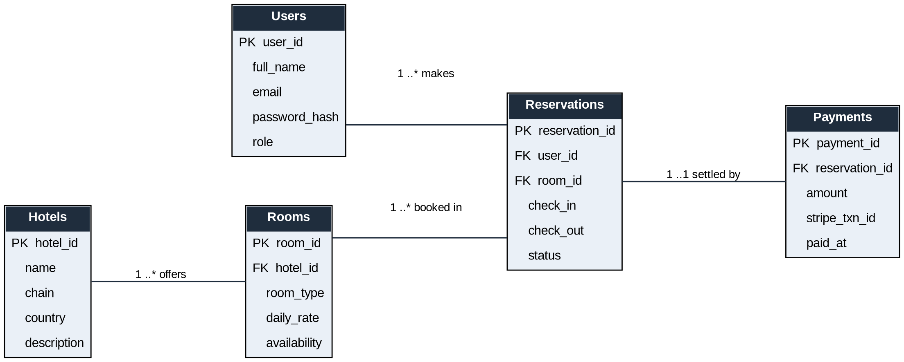
Figure 3: BookMyHotel.com Entity-Relationship diagram.
Hotels are associated with Rooms in a one-to-many relationship, as each of the platforms hotels (e.g., Marriott, Hilton, Hyatt, Four Seasons) lists several types of Rooms with varying rates. The relationship between Users and Reservations is one-to-many, allowing each user to hold multiple reservations for hotels. Each Reservation refers to exactly one Room through a foreign key that is established to permit the checking of the availability of Rooms in each of the selected Hotels during the Reservation booking process. Each Reservation is associated with exactly one Payment record, and each Payment record references the Stripe transaction ID for that particular Reservation rather than storing the actual credit card details from the user. This design avoids keeping any credit card details within the BookMyHotel.com database and significantly reduces the database exposure to the credit card data processing responsibilities. Furthermore, this structure allows for the creation of the Analytics Dashboard for BookMyHotel.com administrators, as the required data for the dashboard (e.g., revenue from each hotel rooms and the average daily rate for each hotel rooms) can be derived from joining the Rooms, Hotels, Reservations, and Payments data within the database.

4.4 Use Case Diagram
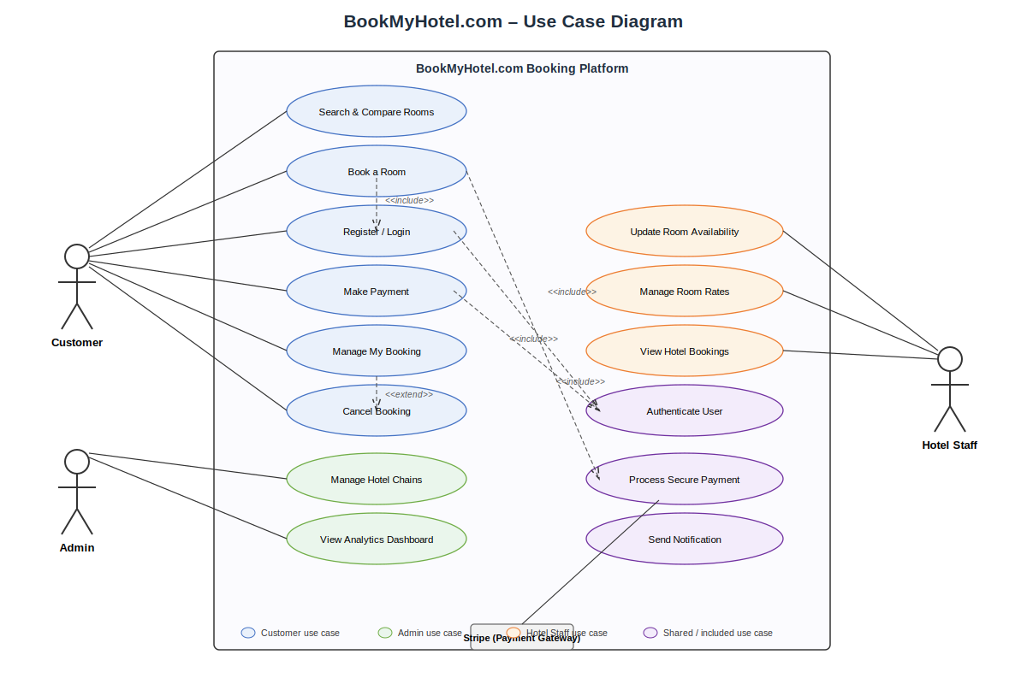
Figure 4: BookMyHotel.com use case diagram.
Figure 4 identifies three main actors – Customer, Admin, Hotel Staff – as well as the the Stripe payment gateway (external, secondary) for BookMyHotel.com. The Customer looks for, reserves rooms, manages reservations, and makes payments; the Admin manages the participating hotel chains and reviews analytics; and Hotel Staff can update room availability and prices, and view relevant bookings. Common processes such asAuthenticate User and Process Secure Payment are <<include>> as being a component of booking and staff-side updates respectively; Cancel Booking is modelled as an <<extend>> of Manage My Booking, since booking a hotel is not a necessary process, but merely an alternative.

4.5 Data Flow Diagrams (DFD)
Figure 5 presents the context-level (Level 0) diagram for BookMyHotel.com. BookMyHotel.com is depicted as a single process in the center of the diagram and is surrounded by its external entities, which consist of the Customer, Hotel Staff, Admin, and the Stripe payment gateway. None of these external entities are connected directly to one another in this level of the diagram; all data flows are connected to the single process.
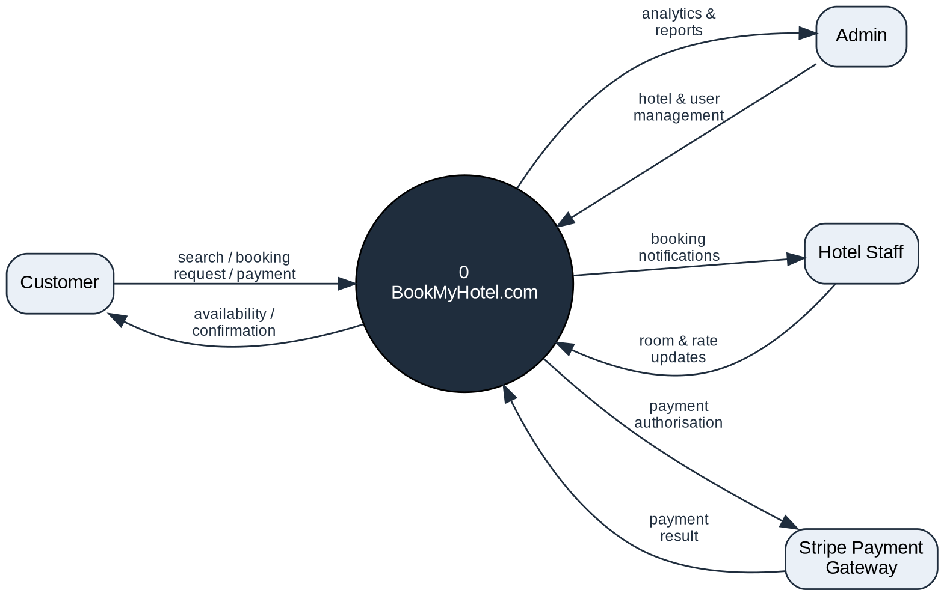
Figure 5: BookMyHotel.com context-level (Level 0) DFD.
Figure 6 illustrates the decomposition of the Level 0 diagram into four processes: Process Search Rooms, Process Reservation, Process Payment, and Process Hotel Data. These four processes interact with three data stores: D1 Room\_File, D2 Booking\_Database, and D3 Payment\_Log. D1 corresponds to the Rooms/Hotels entity of Figure 4, while D2 corresponds to the Reservations entity of Figure 4, and D3 corresponds to the Payments entity of Figure 4. None of the processes communicate with each other without a data flow, and data stores do not appear in the context level diagram; they are only present in the decomposed Level 1 diagram.
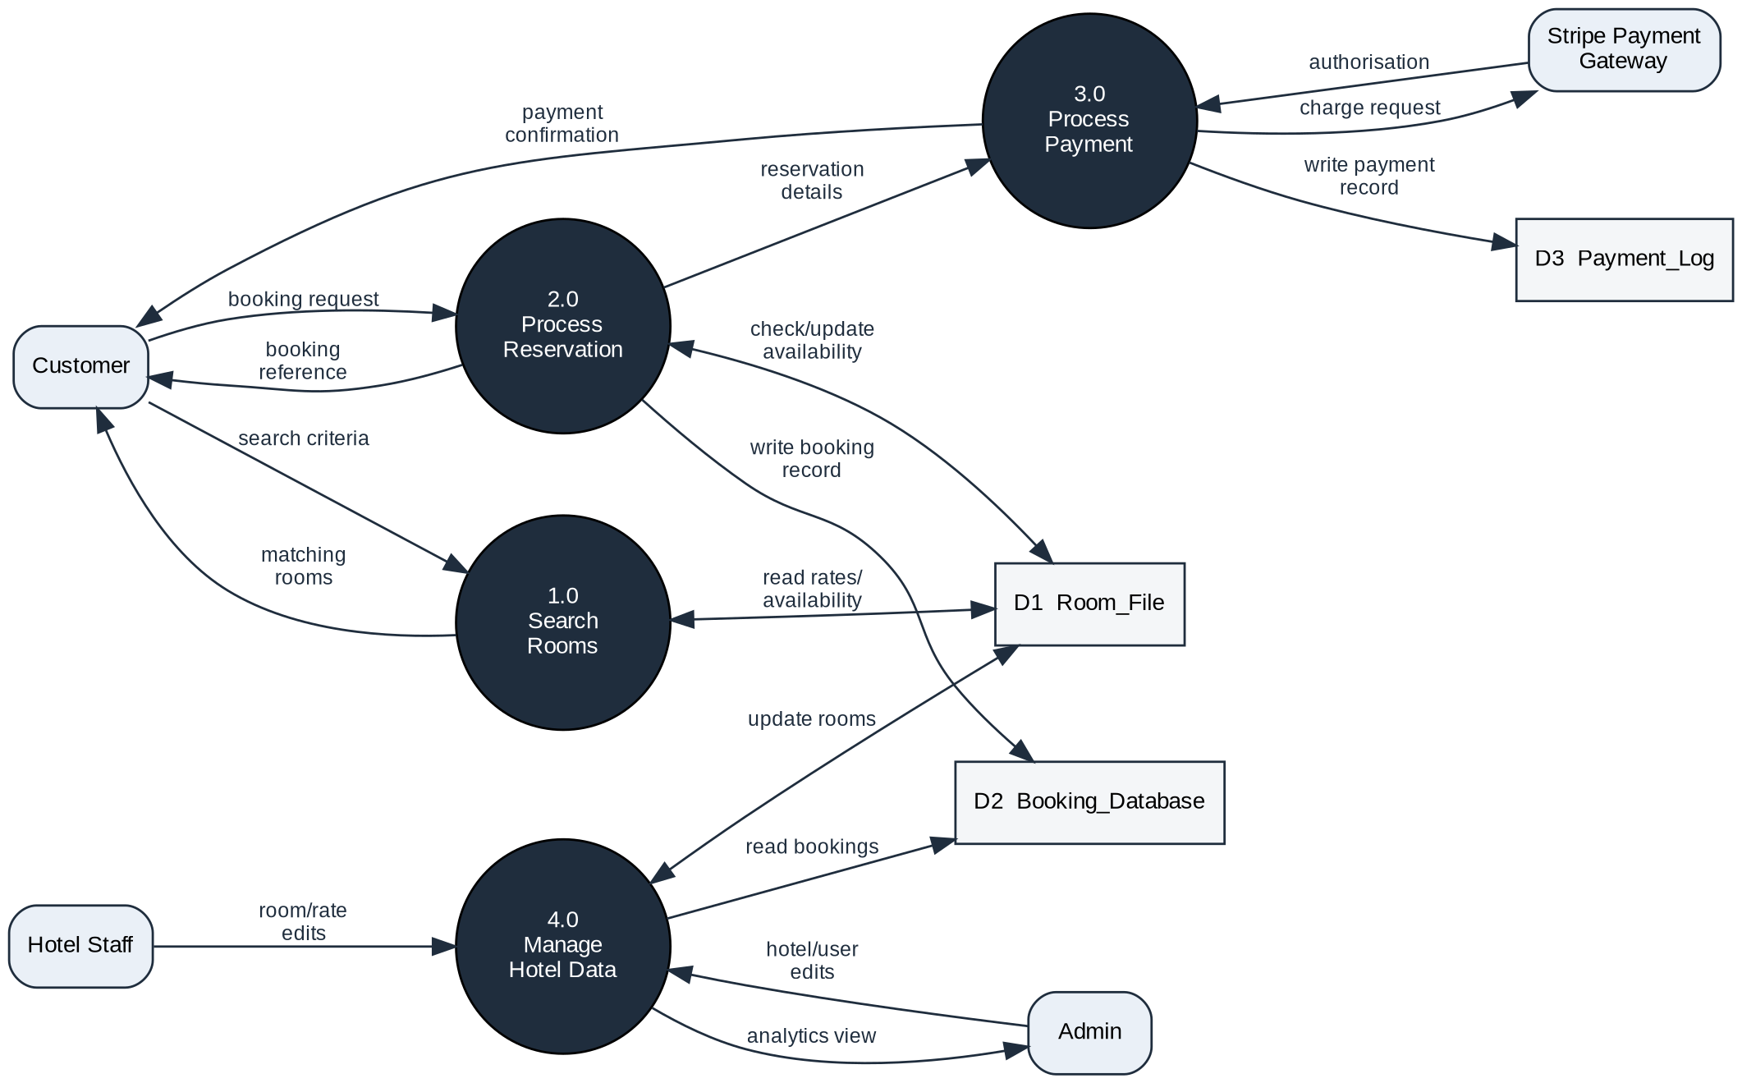
Figure 6: BookMyHotel.com Level 1 DFD.
2.0 The Process Reservation checks and updates room availability in D1 before writing a booking record to D2. The Process Reservation then passes control to 3.0 Process Payment, which uses the Stripe gateway to take payment from the customer and then logs the payment in D3 before sending a confirmation of booking back to the customer. 4.0 The Manage Hotel Data is the behind-the-scenes management of the functions described in 2.1. The Hotel Staff is able to edit room and rate information in D1. The Admin, however, has the ability to manage the hotels and users in the system. In addition, the Admin has the ability to view analytics related to the hotels and users that is generated by reading data from D1 and D2 - this data is what is used to generate the Analytics Dashboard.
References
Sources are listed alphabetically by author surname in Harvard style, in line with the module's referencing requirement of fifteen to twenty sources, including a minimum of three refereed academic journals and five academic books. Full bibliographic details (edition, publisher location, page ranges) should be checked against the library catalogue before final submission.
Bass, L., Clements, P. and Kazman, R. (2012) Software Architecture in Practice. 3rd edn. Boston, MA: Addison-Wesley.
Chen, P.P. (1976) 'The entity-relationship model -- toward a unified view of data', ACM Transactions on Database Systems, 1(1), pp. 9-36.
Connolly, T. and Begg, C. (2015) Database Systems: A Practical Approach to Design, Implementation, and Management. 6th edn. Harlow: Pearson Education.
Fielding, R.T. and Taylor, R.N. (2002) 'Principled design of the modern Web architecture', ACM Transactions on Internet Technology, 2(2), pp. 115-150.
Fowler, M. (2002) Patterns of Enterprise Application Architecture. Boston, MA: Addison-Wesley.
Freeman, A. (2017) Pro ASP.NET Core MVC 2. New York: Apress.
Hevner, A.R., March, S.T., Park, J. and Ram, S. (2004) 'Design science in information systems research', MIS Quarterly, 28(1), pp. 75-105.
Lankhorst, M. (2013) Enterprise Architecture at Work: Modelling, Communication and Analysis. 3rd edn. London: Springer.
Laravel (2024) Laravel Documentation. Available at: https://laravel.com/docs (Accessed: 10 August 2026).
Newman, S. (2015) Building Microservices: Designing Fine-Grained Systems. Sebastopol, CA: O'Reilly Media.
Northwood, C. (2018) The Full Stack Developer. New York: Apress.
OWASP Foundation (2021) OWASP Top Ten. Available at: https://owasp.org/www-project-top-ten/ (Accessed: 10 August 2026).
Rozanski, N. and Woods, E. (2012) Software Systems Architecture: Working with Stakeholders Using Viewpoints and Perspectives. 2nd edn. Upper Saddle River, NJ: Addison-Wesley.
Sommerville, I. (2016) Software Engineering. 10th edn. Harlow: Pearson Education.
Stripe (2024) Stripe API Documentation. Available at: https://stripe.com/docs (Accessed: 10 August 2026).
The Open Group (2022) TOGAF Standard, 10th edn. Reading: The Open Group. Available at: https://www.opengroup.org/togaf (Accessed: 10 August 2026).
Vercel (2024) Next.js Documentation. Available at: https://nextjs.org/docs (Accessed: 10 August 2026).
Zachman, J.A. (1987) 'A framework for information systems architecture', IBM Systems Journal, 26(3), pp. 276-292.

