

SWE6010 Undergraduate Project — Project Proposal
Student Name | Danial Arif
Student Number and Email | daniyalarif2004@gmail.com, +92 370 3130213
Degree Pathway | B.Eng (Software Engineering)
Proposed Project Title | FixMyCity (Smart Community Complaint and Civic Issue Resolution Platform)
Project Background
Background | Local civic issues including damaged roads, water supply failures, electricity outages, ineffective waste disposal, and street safety risks continue to affect many urban areas, especially in developing countries like Pakistan (World Bank, 2022). For many residents, reporting these problems is still a manual and unclear process.  At present, citizens usually submit complaints through phone calls, visits to municipal offices, or public posts on platforms such as Twitter and Facebook. These methods do not maintain a reliable complaint history, provide automated department mapping, or allow users to monitor progress after submission (Afzal and Iqbal, 2021). The process often becomes a dead end. A major issue is the absence of a proper complaint management workflow. Citizens may not know which government department handles a specific problem, causing reports to reach the wrong authority or remain unattended. After submitting a complaint, users commonly receive no confirmation about the assigned department, current status, expected response time, or completed actions. This creates frustration among citizens and leaves local authorities working without a clear data-driven view of high-priority problems affecting their areas (Khan et al., 2020). Many existing e-government solutions only cover limited parts of this workflow. Some systems collect complaints but do not include real-time status tracking. Others are designed for a single department and cannot handle multiple categories such as road maintenance, water supply, electricity faults, and sanitation issues within the same application. In addition, most platforms do not expose useful resolution statistics, making it difficult to understand service performance.  This FixMyCity Project focuses on developing a digital civic complaint management platform where citizens can register issues by uploading descriptions, evidence files, and location information. The system will process complaint data through backend logic, classify incidents according to predefined categories, and map them to the relevant municipal department IDs for handling. It will maintain complaint states from submission to closure, allowing citizens to follow updates while giving authorities a clearer dashboard of reported problems, priorities, and response progress.  The platform acts as a digital connection between residents and local departments. It replaces scattered reporting methods with a trackable workflow built around complaint records, routing rules, and status monitoring.
Aim and Objectives
Aim | The main goal FixMyCity the development of a web/mobile based Smart Community Complaint and Civic Issue Resolution Platform. The system will allow citizens to submit local civic problems with supporting images and location coordinates, while the backend manages complaint records, category-based processing, and authority assignment through defined routing logic. The platform will analyse existing complaint workflows, design the required system architecture, implement the application modules, and evaluate performance through testing. It will maintain complaint states from initial submission to final resolution, giving citizens and the public access to progress updates instead of leaving reports in a data black hole. The system will also help authorities manage incoming issues with better visibility and control.
Objectives | - Existing civic-reporting and e-government platforms will be reviewed to identify gaps in complaint tracking, visibility, and department routing.  - The needs of citizens, authorities, and administrators will be analysed to define the complaint submission and tracking workflow.  - A category-based routing module will map complaints such as roads, water, electricity, sanitation, and safety to the related department records.  - A location-based complaint map with a public city-wide issue density heatmap will be developed to show common problem areas.  - A role-based access system will be implemented for Citizen, Authority, and Admin/Super Admin users with defined permissions.  - A complaint workflow using Pending, In Progress, and Resolved states will be added with a community upvoting feature to highlight urgent issues.
Expected Outcomes and Deliverables
Deliverables | - Project Plan (Gantt chart)  - Interim Research Report  - Software Requirements Specification (SRS)  - Project Presentation (PPT)  - Platform will be developed as a functional web application. It will support citizen complaints through text, images, and geo-location tags, with category-based classification and automatic routing to related departments. The system will include an admin/authority panel, complaint status tracking with notifications, community upvoting for urgent issues, and a public dashboard showing issue density through a heatmap.  - Testing Report  - Final Report (Dissertation)
Research Method and SDLC
Research Method | Mixed Method (Quantitative and Qualitative)
SDLC Model | Agile (Iterative and Incremental Development)
Project Plan | Gantt Chart:  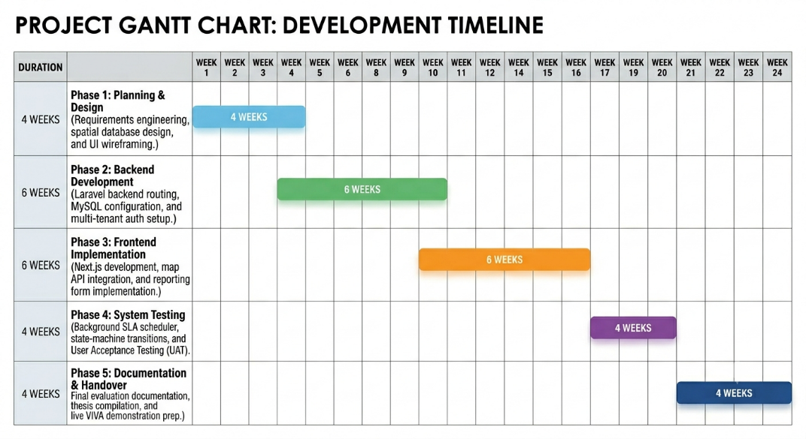
Resource Requirements
Frontend | Next.js, React.js, Redux Toolkit / Context API, Tailwind CSS
Backend | Laravel (PHP) — authentication, role-based access control, complaint routing logic, notification handling
Database | MySQL
Mapping / Geo-location | Leaflet.js or Google Maps API: complaint location tagging and city wide heatmap visualisation
Notifications | Email notifications (SMTP)
Hosting / Deployment | Vercel (frontend), Railway or Render (backend) free-tier services sufficient for development and demonstration
Hardware Requirements | Personal laptop/PC capable of running Node.js, PHP/Laravel, and a local or cloud-hosted MySQL instance, with internet access for map API and notification services. A mobile device for testing the responsive citizen facing interface.
Theories / Models, Key Terms, and Technologies (Nature of Academic Challenge)
Key Terms | - E-Government and civic-technology systems  - Role-Based Access Control (RBAC)  - Geo-location tagging and geospatial data visualisation (heatmaps)  - Complaint routing / workflow state management  - Community-driven prioritisation (upvoting) systems  - Public transparency and accountability in digital government services
References
References | Afzal, S. and Iqbal, M. (2021) Citizen Engagement through Social Media in Local Governance: A Case Study Approach. Online source. URL to be added after literature review.  Khan, A., Hussain, R. and Aslam, S. (2020) E-Government Adoption and Service Delivery Challenges in Developing Countries. Online source. URL to be added after literature review.  Sommerville, I. (2016) Software Engineering. 10th ed. Pearson Education.  World Bank (2022) Urban Service Delivery and Citizen Feedback Mechanisms. Online source. URL to be added after literature review.  These references provide the initial foundation for the study. More verified reviewed sources will be added during the literature review stage.
Supervisor (for supervisor use ONLY) | Dr Nuwan
Supervisor Comments
Supervisor Signature and Date

