 |  | Assignment Cover Sheet |  |  |  |  | 
 | BEng Top-Up
 | Undergraduate Project
 | SWE6010
 | HE6
 | 30 /60
 | Interim Research Report
01-July-2026 | 09-August-2026
Important

Declaration for Use of Generative AI in an Assessment
 |  |  |  |  |  |  |  |  | ☐Yes ☒No
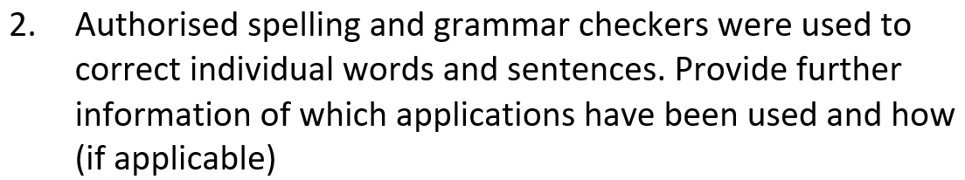 |  |  |  |  | Application |  |  |  | Usage
☐Yes ☒No
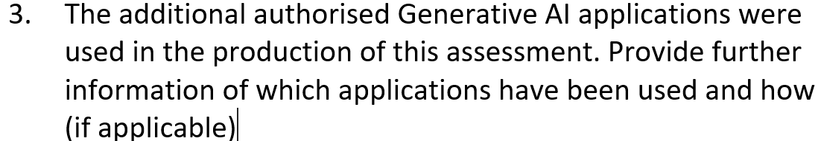 |  |  |  |  | Application |  |  |  | Usage
 |  |  |  |  | Gemini / ChatGPT |  |  |  | For diagrams(idea) and references
☒Yes ☐No |  |  |  |  |  |  |  |  | For diagrams(idea) and references
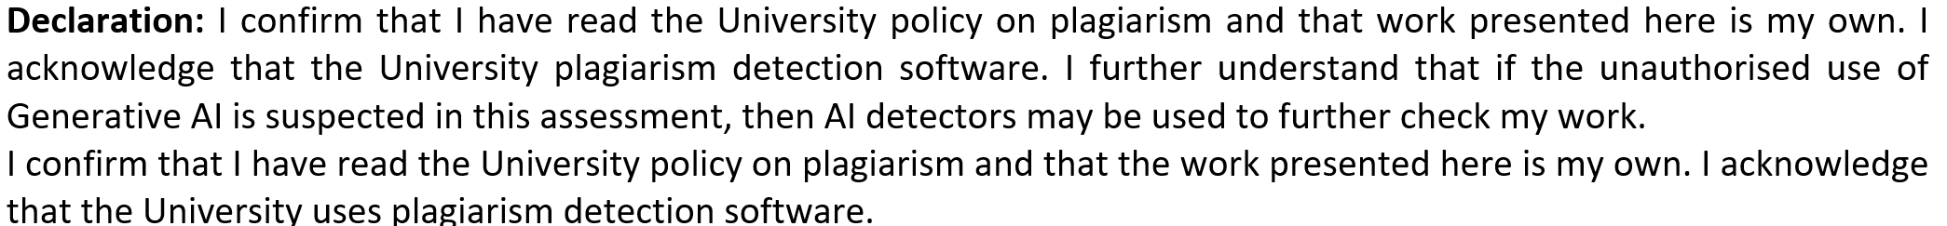
Student Signature: | Danial Arif |  |  |  | Student Number: |  |  | 2533971
Date: | 09-August-2026 |  |  |  | Word Count: |  |  | 7150

FixMyCity
Smart Community Complaint and Civic Issue Resolution Platform
Interim Research Report
Submitted in partial fulfilment of the requirements for the degree of
B.Eng (Hons) Software Engineering
Danial Arif
Student ID: 2533971
Supervisor: Dr Nuwan
Module: SWE6010 - Undergraduate Project
Western International College (WIC)
University of Greater Manchester
2026

Abstract
The rapid growth of Pakistani cities has made it difficult for municipal authorities to handle everyday civic complaints. Today, citizens report issues through phone calls, visits to municipal offices, or social media. None of these methods create a record of the complaint, assign it to the responsible department, or provide any notification that the complaint has been addressed.
This report outlines the research that has been conducted as part of the development of FixMyCity. FixMyCity is a web platform developed to manage civic complaints, using Next.js, Laravel, and MySQL. Users can upload complaints with geo-tagged locations, select the type of issue to ensure it is routed to the appropriate department, track the status of the complaint online against Service Level Agreements, and upvote other complaints to indicate urgency. Additionally, the platform will provide a heat map of where the most complaints are being submitted.
A review of existing civic reporting platforms in both developed and developing countries (FixMyStreet, SeeClickFix) and research on e-government applications reveals that although platforms exist to submit civic complaints, none of them combine automated complaint routing based on issue type, public tracking of complaint resolution times, and geospatial visualization of the issues being reported.
Two surveys were conducted online to gather data regarding the civic issue reporting problem in Pakistani cities. Twenty-two citizens and ten municipal administrators participated in the surveys. The data from the surveys confirmed that most citizens experience civic issues on a daily basis and do not report many of these complaints. Furthermore, the administrators admitted that the current methods for reporting issues are inefficient.
These survey findings informed the design of FixMyCity. The functional and non-functional requirements for the platform and its system design are outlined in Chapter 3, illustrating how FixMyCity addresses the research gap identified by this project.

Acknowledgement
I'd like to extend my gratitude to Ms. Fatima, my module leader, for her guidance and instruction that helped me structure and complete this project. I'd also like to thank Dr. Nuwan for his feedback during the planning stages.
Furthermore, I would like to thank the academic staff at Western International College and the University of Greater Manchester for their support. I would also like to thank the citizens and administrators of the municipalities who responded to the surveys, providing the data that drives the FixMyCity platform. Lastly, I would like to thank my family and friends for their patience and support.
Table of Contents
Abstract 4
Acknowledgement 5
List of Figures 8
List of Tables 10
List of Abbreviations 11
Chapter 1: Introduction 12
1.1 Background of the Study 12
1.2 Problem Statement 13
1.3 Aim of the Project 13
1.4 Objectives 14
1.5 Research Questions 15
1.6 Project Scope 15
Included 15
Excluded 15
1.7 Feasibility Study 16
1.8 Project Plan 16
1.8.1 Work Breakdown 16
1.8.2 Gantt Chart 18
1.8.3 Timeline of Activities 18
Chapter 2: Literature Review 19
2.1 Introduction 19
2.2 Related Research Studies 19
2.2.1 Automated Routing in E-Government 19
2.2.2 Geospatial Heatmapping for Urban Infrastructure 20
2.3 Existing Technologies / Systems 20
2.3.1 General Municipal Web Portals 20
2.3.2 Mobile Civic Reporting Applications 21
2.4 Comparative Analysis 23
2.5 Research Gap 25
2.6 Chapter Summary 25
Chapter 3: Methodology 26
3.1 Introduction 26
3.2 Research Methodology 26
3.3 Research Ethics 27
3.4 Software Development Methodology 27
3.5 Data Collection Methods 28
3.6 Data Analysis Methods 31
3.7 System Requirements 32
3.7.1 Functional Requirements 32
3.7.2 Non-Functional Requirements 33
3.8 System Design 33
References 37

List of Figures
Figure 1.1: Project Gantt Chart Development Timeline 18
Figure 3.1: Citizen Survey — Frequency of Encountering Civic Issues (n = 21) 29
Figure 3.2: Citizen Survey — Current Method of Reporting Civic Issues (n = 20) 29
Figure 3.3: Citizen Survey — Difficulty Identifying the Responsible Department (n = 18) 30
Figure 3.4: Administrator Survey — Department Represented by Respondents (n = 10) 30
Figure 3.5: Administrator Survey — Rated Efficiency of the Current Complaint Routing Process (n = 10) 30
Figure 3.6: Administrator Survey — Reported Barriers to Efficient Complaint Resolution (n = 10) 31
Figure 3.7: System Architecture Diagram — illustrates the Next.js frontend, Laravel backend, and MySQL database, alongside the external mapping and notification services. 33
Figure 3.8: Use Case Diagram — shows the Citizen and Authority actors interacting with the core functions of the FixMyCity platform. 34
Figure 3.9: Entity Relationship Diagram (ERD) — displays the Users, Complaints, Departments, Categories, Status_History, and Upvotes tables with their primary and foreign keys. 35
Figure 3.10: Sequence Diagram — maps the step-by-step communication flow of submitting and routing a complaint from citizen to database. 35
Figure 3.11: Data Flow Diagram (DFD) — Level 0 (Context) — presents the FixMyCity system as a single process exchanging data with the Citizen and Authority actors. 36
Figure 3.12: Data Flow Diagram (DFD) — Level 1 — decomposes the system into the Submit, Route, Track, and Heatmap processes and their associated data stores. 36
Figure 3.13: Data Flow Diagram (DFD) — Level 2 — decomposes the Route Complaint process into category validation, department matching, and SLA deadline assignment. 36

List of Tables
Table 2.1: Comparative Summary of Existing Systems and Related Studies 23

List of Abbreviations
Abbreviation | Meaning
API | Application Programming Interface
DFD | Data Flow Diagram
ERD | Entity Relationship Diagram
ICT | Information and Communication Technology
RBAC | Role-Based Access Control
RE1 | Research Ethics Form 1
SDLC | Software Development Life Cycle
SLA | Service Level Agreement
SMTP | Simple Mail Transfer Protocol
UAT | User Acceptance Testing
UI | User Interface
UML | Unified Modelling Language
VGI | Volunteered Geographic Information
WBS | Work Breakdown Structure

Chapter 1: Introduction

1.1 Background of the Study
Cities throughout Pakistan, along with many developing nations, are growing at a rate that is outpacing their existing municipal infrastructure. The infrastructure that keeps urban areas running each day includes the road systems, waste management services, water distribution systems, and electrical grids. The World Bank (2022) reports that the development of urban areas requires that these essential services be provided reliably to their residents. Municipalities that fail to invest in the modernization of this infrastructure and their management of these systems begin to face a variety of problems that impact the satisfaction of the city’s residents, the spread of informal settlements, and the public health of the area. In Pakistan, the lack of investment in the digital management of municipal systems for the past many years has left most municipal governments dependent on paper systems for managing the operations of their governments. As a result, any issues that arise with municipal services are only identified when problems begin to affect the lives of the citizens of those cities.
The consequences of the current state of communication for reporting issues with physical infrastructure are clear.
Physical infrastructure in cities and communities faces increasing demand from citizens. However, the communication processes used to report issues with this infrastructure exhibit many of the same limitations. Citizens experience damage to infrastructure such as roads, overflowing waste containers, water shortages, and electricity failures. Yet, the methods used to report these issues rarely connect to the workflow within the government. Social media platforms are often utilized for citizens to report these issues, as there are no dedicated systems for reporting them to government operations. The reason for this behaviour, as suggested by Afzal and Iqbal (2021), indicates the limitations of e-government in such processes, rather than the empowerment of the citizens.
When citizens post about an issue with the infrastructure of the city, such post may be shared and commented upon by other citizens. However, there are no processes in place to indicate if the information in the post has been received by the authorities responsible for the issue, if the complaint has been validated with a tracking number, if it has been assigned to the correct department, or what the status of the complaint is. Therefore, though the post may be widely shared among the citizens and the government may be aware of the issue through social media platforms, there are no systems in place to acknowledge and manage the complaint. This disconnect between the reporting of infrastructure issues by citizens and the authorities who manage the issues creates a disconnect between expectations and reality of the government. The need for a reporting system that is dedicated to each department of a government is clearly needed to ensure that citizen issues with infrastructure are managed and monitored appropriately.

1.2 Problem Statement
Even with the proliferation of smartphones throughout Pakistan, there is yet to be established a single system that allows for the recording of civic complaints, the assignment of those complaints to the relevant municipal department, and the tracking of their status throughout the resolution process.
Currently, most civic complaints are communicated to local authorities via various methods - phone calls, papers, social media, and more. The lack of a centralized system to record and track the status of civic complaints limits the ability of local authorities to respond effectively to the issues presented to them. As a result, citizens feel that their local governments are unresponsive to the issues and needs of the citizens. Meanwhile, the local authorities responsible for responding to these complaints are also ill-equipped to perform their roles effectively due to the lack of a centralized system to record civic issues, track their status, and monitor the metrics of their performance.

1.3 Aim of the Project
The aim of this project is to design, develop, and evaluate FixMyCity, a web-based Smart Community Complaint and Civic Issue Resolution Platform. This platform aims to bridge the communication gap between the citizens of a community and their municipal authorities. FixMyCity will implement automated complaint category processing, routing of complaints to the correct municipal department, and allow citizens to view the status of their complaints. These complaints will be stored in a centralized database and categorized according to the issue reported.
Each complaint will also have status transitions recorded that track its movement throughout the complaint resolution process.
This will offer citizens a trackable way in which to report issues in their community and allow the municipal departments to handle these complaints in a structured way.

1.4 Objectives
1. To identify weaknesses in current e-government systems for the reporting of civic complaints, their existing feedback-loop visibility, complaint tracking capabilities, and the communication between citizens and municipal departments will be analyzed. This will help to determine where the accountability of the city for the resolution of the reported complaints is weak.
2. A category-specific state machine will be designed to process each reported civic complaint and determine the appropriate municipal department for which the reported complaint will be sent.
3. A responsive web application will be built so that users can report civic complaints and attach geo-tagged images to their text-based complaints. The web application will be usable on all screen sizes.
4. A public heatmap dashboard will be built alongside an automated system for tracking the resolution of civic complaints by the departments to which they were assigned.
5. The web application will be user-tested to determine its overall usability and the accuracy of the routing of the complaints reported to the departments. The performance of the web application and its automated system for tracking the resolution of civic complaints will be benchmarked.

1.5 Research Questions
- How can an automated state-machine workflow improve the accuracy of complaint routing to municipal authorities?
- To what extent does real-time transparency in complaint tracking increase citizen trust in municipal governance?
- How can geospatial heatmapping help authorities prioritize infrastructure maintenance based on issue density?

1.6 Project Scope

Included
The project will include a Next.js frontend and a Laravel backend. The two parts of the system will work together to manage the submission, processing, and status of civic complaints. The system will also use the Google Maps and Leaflet APIs to allow citizens to mark the location of their complaint on the map.
The users of the system will be separated into two user roles: Citizen accounts and Authority accounts. Access to the system will be restricted based on the role of the user with Role-Based Access Control (RBAC). Furthermore, the system will include Service Level Agreement (SLA) logic that allows the system to track the time it takes to resolve each complaint. The system will display the status of each complaint within its workflow, allowing system administrators to see whether the response times for the system are being met.

Excluded
The scope is clearly defined. The project plan will involve the creation of a web-based application. The creation of a native mobile application to be distributed via app stores is not included in the plan for this project.
The system also will not leverage third-party payment gateways to collect civic fines. All of this will make sure that the scope of the project and the development team is focused exclusively on the creation of the website and its complaint management system.

1.7 Feasibility Study
Technical Feasibility: The system is built using Next.js, Laravel, Leaflet, and the Google Maps API, all of which are mature and widely documented technologies with established development ecosystems. These tools provide the required functionality for complaint management, geospatial visualisation, and backend processing without the need for experimental frameworks or custom infrastructure.
Economic Feasibility: Deployment costs remain low through the use of free-tier hosting services such as Vercel and Render. This approach reduces infrastructure expenses while still providing an environment suitable for production-grade application hosting and testing.
Operational Feasibility: FixMyCity operates entirely through a web browser, removing the need for specialised hardware installations or extensive user training. Citizens can access reporting features through standard internet-enabled devices, while municipal administrators can manage complaints using familiar web-based interfaces.
Environmental Feasibility: The platform supports quicker identification of waste-management problems and improves the routing of reports to the appropriate operational teams. By helping departments plan repair activities more efficiently and optimise repair-crew transport routes, the system can indirectly contribute to lower fuel consumption and reduced carbon emissions.

1.8 Project Plan
The project is scheduled to take 24 weeks of development time, which is split into five sequential phases. Planning and Requirements Gathering, Backend Development, Frontend Development, System Testing, and Project Handover. These phases rely on their predecessors' completion to create an organised progression of requirements, implementation, validation and deployment phases.

1.8.1 Work Breakdown
During the Planning and Requirements Gathering phase, I define the requirements for the system and define the structure of the database. In the Backend Development phase, I define and implement the logic for the system to route complaints to the appropriate departments. In the Frontend Development phase, I define and implement the interface for citizens and authorities to access the backend services. In the System Testing phase, I define the test cases and validate the functionality of the system for both usability and routing accuracy. Finally, during the Handover phase, I provide the system documentation and deliverables to the client for deployment.
The following is the timeline for the project to be completed. The total time allocated for the project is 24 weeks.
- Phase 1: Planning & Design (Weeks 1–4) - The planning and designing phase of the project will include the engineering of requirements for the project and the design of the spatial database for the project as well as the design of the user interface for the system.
- Phase 2: Backend Development (Weeks 5–10) - During this phase of the project, the backend of the system will be developed. This will be done using the framework of Laravel. Additionally, a database for the system will be set up to manage the data of the project as well as implementing multi-tenant authentication within the system.
- Phase 3: Frontend Implementation (Weeks 11–16) - During this phase of the project, the frontend of the system will be developed using the framework of Next.js. Additionally, the map API will be integrated into the system for features such as displaying locations on the map. Finally, a form to allow users to submit reports will also be developed as part of the system.
- Phase 4: System Testing (Weeks 17–20) - The background scheduler of the SLA of the system will be tested. Additionally, the systems state transitions will be tested to ensure that they perform as expected during UAT.
- Phase 5: Documentation & Handover (Weeks 21–24) - During this phase of the project, the system will be evaluated on its functionality and features. Additionally, the project documentation as well as the thesis will be developed. Finally, a live VIVA will be prepared for the project to showcase its capabilities and to demonstrate its features to the evaluators.

1.8.2 Gantt Chart
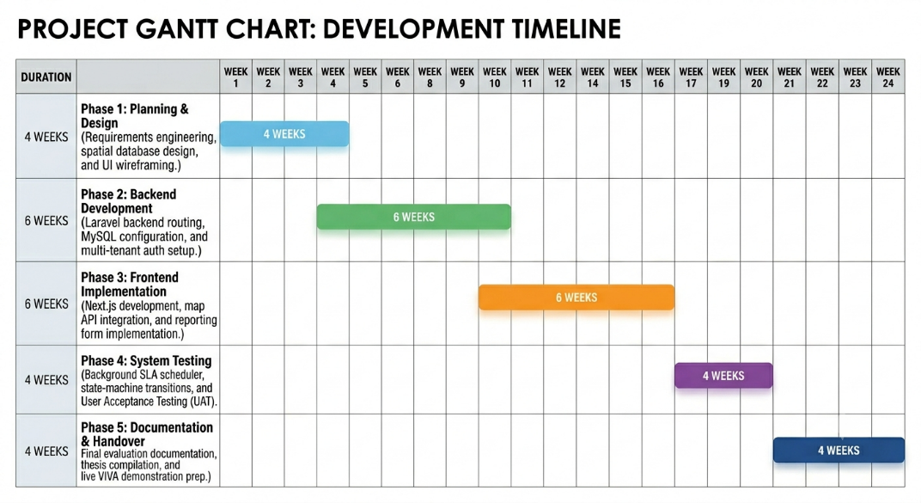
Figure 1.1: Project Gantt Chart Development Timeline

1.8.3 Timeline of Activities
The project will span a total of 24 weeks and be completed over five different phases. The following are the phases and their allocated time:
- Phase 1: Planning & Design (Weeks 1–4)
- Phase 2: Backend Development (Weeks 5–10)
- Phase 3: Frontend Implementation (Weeks 11–16)
- Phase 4: System Testing (Weeks 17–20)
- Phase 5: Documentation & Handover (Weeks 21–24)

Chapter 2: Literature Review

2.1 Introduction
This chapter reviews current civic issue reporting systems and e-government complaint portals, as well as the related academic research. The review will begin by examining municipal portals and mobile civic reporting applications that are currently in operation, then will review the academic literature that relates to the design of e-governance complaint management systems and geospatial heatmapping applications. The chapter will then examine the research gap that is identified in Section 2.4 of this study, which will justify the development of the FixMyCity application that is introduced in Chapter 1 of this study.

2.2 Related Research Studies

2.2.1 Automated Routing in E-Government
Linders (2012) conducted a conceptual synthesis of the literature regarding citizen-coproduction to develop a framework for understanding how citizen complaints are managed. The classification included three types of citizen-coproduction: citizen sourcing, government as a platform, and do-it-yourself government. Most of the citizen coproduction platforms available on the web fell into the citizen sourcing category of Linders' classification. In these systems, citizen complaints are reported to the government, but the classification of these reports to government departments is conducted manually. The report by Linders (2012) identifies this bottleneck as a problem within these systems, but does not propose a solution to automate the management of these reports.
Clark, Brudney, and Jang (2013) performed a quantitative analysis of municipal 311 datasets to identify who reported the complaints and how those complaints were managed. The results of this analysis indicated that it was the number of reports, rather than a automated mechanism for routing these complaints to appropriate departments, that determined which departments received reports and managed them. Additionally, the times for resolving the reports varied by department. Their recommendations to investigate how to manage these complaints better, however, did not propose a technical solution to the issue.

2.2.2 Geospatial Heatmapping for Urban Infrastructure
In their conceptual paper, Roche (2014) argues that spatial data must be tied to geographic coordinates to be visualized and interpreted by city inhabitants. The paper takes a theoretical approach to the subject and makes no mention of any particular city implementation of the proposed concept; instead, it calls for geospatial data and reasoning to be directly integrated into the governance processes of cities (Roche, 2014).
In Kitchin (2014), the author critically examines the growth of real-time city dashboards that are used by smart cities to visually monitor various features of the city. These dashboards include live data that highlights particular infrastructure issues or the number of people in certain parts of the city. Kitchin (2014) argues that these visualizations do not contain any feedback systems that would enable individuals within the city to take action in response to the issues that are visualized. Kitchin (2014) highlights the failure of smart city visualizations to connect to a specific department or action as one of the main limitations of their use in cities today.
Johnson and Sieber (2013) carried out a study in which they reviewed various instances of volunteered geographic information (VGI) in government agencies in the developed world. In their findings, Johnson and Sieber (2013) noted that there are a number of barriers to the successful use of VGI in government agencies. Additionally, the authors suggest that these studies should be extended to the developing world and the urban environments that are found within Pakistan (Johnson and Sieber, 2013).

2.3 Existing Technologies / Systems

2.3.1 General Municipal Web Portals
Many of the municipal governments in existence today, including those in the country of Pakistan, have developed static informational websites that allow citizens to access departmental contact information, download forms, and review public notices. However, none of these websites allow for the submission of complaints by residents of these cities. In a study that analyzed e-government in Pakistan, the academic authors Rehman, Esichaikul and Kamal (2012) indicated that the websites that had been developed by the municipal governments of Pakistan were not able to be reviewed online. Citizens could not submit requests to these governments or review the progress of their complaints once they had been submitted (Rehman, Esichaikul and Kamal, 2012).
Bertot, Jaeger and Grimes (2010) have argued that, for e-government to function in a manner that allows citizens to have control over the services that are provided to them by their governments, the governments must expose process-level data regarding the management of the requests that are received from citizens. However, the municipal websites that were reviewed of the cities in which a sample of the citizens of the country of Pakistan lived were unable to provide this type of data. As a result, there was no way for the citizens of these cities to review how quickly the complaints that they had submitted to these governments had been resolved (Bertot, Jaeger and Grimes, 2010).

2.3.2 Mobile Civic Reporting Applications
FixMyStreet, which was developed by mySociety in the UK, allows the citizens of the country to input their location and describe any issues that need to be reported to the relevant local council. Linders (2012) classifies this type of application as ‘citizen sourcing,’ as the government has the ability to source information from its citizens without returning to each council department to issue status updates to the citizen who reported the issue. While FixMyStreet can improve upon the ability of citizens to report issues to the authorities, it does not have the flexibility in its routing logic to enable the software to be adapted to use by the municipalities of Pakistan due to its focus on the British local government structure (Linders, 2012).
SeeClickFix is another application that is used within the cities of the United States. It allows the citizens of those cities to report non-emergency issues that need to be fixed by the authorities. Linders (2013) performed an analysis of the reports submitted to the 311 system within the cities that Use the SeeClickFix software and discovered that there is an uneven distribution of report submissions between the different parts of the city and the people that reside within those areas. In addition, another limitation of the software is that none of the 311 systems that are linked to the software enforce a Service Level Agreement (SLA) between the citizens of the city and the various departments within the city government (Clark et al., 2013).
Offenhuber (2015) performed a comparative analysis of the cities that utilize the Open311 standard. Open311 is an effort to make the data that is related to reporting issues to the authorities of a city available to third-party applications. However, Offenhuber (2015) found that the ability of other software to access the data that is related to report submissions does not create any accountability within the departments of the city government to address the issues that are reported by citizens within a specific amount of time or within a specific category of issue (Offenhuber, 2015).
The table that follows below presents a summary of the software that has been described above in terms of the problem that each software solution was created to solve, the technologies and methods that each software utilized to provide those solutions, the key findings of each of the software solutions, the limitations of each software solution, and the relation of each of the software solutions to the FixMyCity application that will be discussed next.

2.4 Comparative Analysis
Table 2.1: Comparative Summary of Existing Systems and Related Studies
Ref | Author(s), Year | Title | Problem Addressed | Method/Technology Used | Key Findings | Limitations | Relevance to My Project
1 | mySociety (2007) | FixMyStreet | Fragmented street/infrastructure issue reporting in the UK | Web-based citizen-to-council reporting system | Facilitates the reporting of infrastructure issues to local authorities | Can only route issues to specific councils based on their boundaries | Relevant for the geotagging aspect, but requires city-specific routing logic.
2 | Public Stuff / Berkowitz (2008), analysed by Clark, Brudney and Jang (2013) | SeeClickFix / 311 Integration | Non-emergency civic issue reporting in the USA | Mobile and web-based platforms integrated with local 311 systems | Enables citizens to report issues like potholes directly to the city | Requires the city to have an active 311 backend to process reports | Highlights the need for a system that communicates directly with municipal authorities.
3 | Offenhuber (2015) | Open311-Based Citizen Feedback Systems | Inconsistent citizen feedback formats across city departments | Analysis of Open311 systems across global cities | Allows third-party applications to log citizen feedback in a standardized format | Standardized reporting does not guarantee issue resolution by departments | Provides a schema model for structured data payloads to send to municipal systems.
4 | Rehman, Esichaikul and Kamal (2012) | Factors Influencing E-Government Adoption in Pakistan | Low interactivity of e-government websites in Pakistan | Empirical survey on e-government service adoption in Pakistan | Most e-gov services in Pakistan lack complaint submission or feedback mechanisms | Lacks dedicated tracking identifiers for citizen complaints | Establishes the local gap and confirms the direct need for this project in Pakistan.
5 | Bertot, Jaeger and Grimes (2010) | Using ICTs to Create a Culture of Transparency | Lack of transparency and accountability in e-government services | Literature review on ICT and social media usage for e-government transparency | Transparency increases only when citizens gain visibility into operational data | Most global e-gov platforms display static content without operational transparency | Justifies the inclusion of a Service Level Agreement (SLA) tracking component.
6 | Linders (2012) | From E-Government to We-Government | Manual triage of citizen-submitted complaints. | Conceptual synthesis and typology of citizen coproduction. | Civic apps rely on manual department assignment of complaints. | No proposed automated or rules-based routing system. | Provides theoretical background to the automated routing system in FixMyCity.
7 | Clark, Brudney and Jang (2013) | Coproduction of Government Services and New IT | There is no clear link between complaint volume and department response times. | Analysis of municipal 311 request data. | Complaints volume, not the type of complaints, determines which department handles it. | No standard service level agreements are in place for 311 requests. | Provides a basis for the SLAs within the FixMyCity app.
8 | Kitchin (2014) | The Real-Time City? Big Data and Smart Urbanism | There is a disconnect between smart city data and accountability for actions based on that data. | Review of smart city data visualization dashboards. | The data is presented to the public without a system for accountability. | Smart city data dashboards can become just a layer of information without a feedback mechanism. | Provides theoretical background to the heatmap features in the FixMyCity app, as it will link to actions.
9 | Roche (2014) | Why Does a Smart City Need to Be Spatially Enabled? | There is a lack of integration of spatial capabilities into current smart city governance programs. | Conceptual and theoretical argument for the use of spatial features in smart city programs. | Smart cities need to be spatially enabled for maximum effectiveness. | Theoretical model of spatially enabled smart cities. | Provides a rationale for the geolocating and category-specific heatmapping in the FixMyCity app.
10 | Johnson and Sieber (2013) | Situating the Adoption of VGI by Government | There are some barriers to the implementation of VGI data into government programs. | Review of different case studies of governments attempting to implement VGI data. | There are issues with data quality and government department use of VGI. | The focus of this paper is on developed countries. | Provides a framework for the implementation of FixMyCity in Pakistan.

2.5 Research Gap
Existing civic reporting platforms, from simple municipal portals to the mobile applications that link to the Open311 framework (FixMyStreet, SeeClickFix), allow citizens to submit complaints, but none of the available systems permit the resolution of those issues to be monitored by the public, or the government to fulfill any service level agreements. Furthermore, the literature available on the topic (Linders, 2012; Clark, Brudney & Jang, 2013; Roche, 2014; Kitchin, 2014; Johnson & Sieber, 2013) does not demonstrate the creation of a civic reporting platform that includes category-specific, geospatial monitoring of issues within an urban developing world location, as is intended for the project outlined in Section 1.8 and with relation to Chapter 3. FixMyCity was therefore created over a period of 24 weeks to fill this identified gap.

2.6 Chapter Summary
This chapter reviewed existing municipal web portals, mobile civic reporting applications, and academic literature on e-government routing and geospatial heatmapping. The existing solutions reviewed in this study were able to capture citizen complaints but were unable to effectively track them to ensure they were resolved by the correct government entities. Additionally, there was a lack of existing solutions that combined automated category-specific routing, public SLA tracking, and geospatial heatmapping in the context of a developing urban area such as Pakistan. These findings will be used to define the functional requirements for the FixMyCity application in the following chapter.

Chapter 3: Methodology

3.1 Introduction
This chapter outlines the research methodology used to support the FixMyCity project. It covers the research approach, ethical considerations, the SDLC model chosen to develop the software, the methods used to collect primary data, and how the primary data will be analysed. In addition, it specifies the system requirements (both functional and non-functional), and presents the technical design diagrams of the software architecture that will be developed based on these requirements. All of these sections are combined to provide the foundation for the rest of the project documentation, and clearly demonstrate the traceable line from the research data to the software features that will be developed.

3.2 Research Methodology
This project utilized a mixed-method approach to research, combining both quantitative and qualitative data within a single survey distributed to two distinct groups of respondents. Quantitative data was collected through the use of multiple-choice questions, which allowed for the measurement of the frequency and severity of the issues experienced by citizens within their municipality. Furthermore, quantitative data was used to determine how often citizens utilized the existing methods of reporting issues to the municipality. Qualitative data was collected through the use of open-text questions included at the end of each survey instrument. The use of open-text questions allowed for the collection of data on the frustration experienced by citizens with the current methods of reporting issues to the municipality, and the descriptions of the challenges that municipal administrators faced in addressing those reports. By collecting both quantitative and qualitative data, researchers were able to determine both the frequency with which issues occurred within the municipality and the reasoning behind the citizens and administrators dissatisfaction with the current systems in place.
The two survey instruments that were created for this research project were designed based upon the literature that was reviewed for the study presented in Chapter 2. Each question in the surveys was created to directly address one of the issues that was identified in the literature review. By creating the survey instruments based upon the reviewed literature, it was possible to collect data that was relevant to the FixMyCity project, and to compare the findings of this study to the findings of other studies of e-government systems.

3.3 Research Ethics
As this project involved the collection of data directly from the public and municipal staff, it was necessary to maintain ethical standards throughout the data collection process. The following points summarize the areas of focus for maintaining ethical standards in this project.
Data Privacy: All data was collected anonymously. No information that could personally identify individuals was collected during this study. All data was stored on a password-protected device and only accessible to the project researcher. The data collected was only used for the purpose of this academic study.
User Consent: Prior to collecting data, all participants were informed of the study’s purpose, how their data would be used, and that they had the right to withdraw their data at any point in time. The RE1 Research Ethics form for this project was completed and signed prior to the collection of any data.
Responsible AI Use: The FixMyCity platform does not integrate artificial intelligence or machine learning models into its core operations. Instead, the complaint routing system is managed exclusively by a state machine to ensure that the departments that receive these complaints are predictable. Artificial intelligence was only used to develop the platform itself. The platform was developed using generative AI for tasks like creating boilerplate code, debugging the program, writing its documentation, and creating conceptual diagrams. All AI-generated code was manually checked for accuracy, tested, and verified to ensure there were no errors in its code or design.

3.4 Software Development Methodology
The FixMyCity platform will follow an iterative and incremental development model, also known as the Agile methodology. This model was chosen over a more linear methodology such as Waterfall because of the complex logic required to route complaints between issue categories and municipal departments. This routing logic can be developed and tested during the short development cycles inherent in the Agile model, rather than needing to be finalized prior to the rest of the development process. Furthermore, the continuous integration of the Leaflet.js mapping API with the backend development of the FixMyCity platform allows for the continued development of the mapping features alongside the rest of the backend development. Finally, the iterative nature of the Agile methodology fits with the project timeline of 24 weeks. Over these 24 weeks, the requirements for the platform, the backend, the frontend, and the testing of the platform will be completed in a serial fashion. Within each of the 24 weeks of development, the work on each area of the FixMyCity platform will be completed in shorter cycles of review within the development teams, which allows for the testing and adjustment of the routing logic and map features prior to the completion of the development of the rest of the system, reducing the risk to the project timeline.

3.5 Data Collection Methods
For this project, primary data was collected through two structured online surveys distributed through Google Forms. These surveys targeted two separate user groups of the proposed system. Each survey included closed-ended multiple-choice questions, rating scales for satisfaction and agreement with statements, and a few open-ended questions to elicit detailed responses. The first survey targeted the citizens who report civic issues in the researcher's community to understand their experiences reporting and the satisfaction that they had with the current systems in place. The second survey targeted the administrators within the local government to understand the challenges that they face with the current systems in place for reporting civic issues. The citizen survey collected a total of 22 responses, and the administrator survey collected a total of 10 responses. These surveys were distributed digitally to users within the local community to gather data that was representative of the intended users of the proposed system. The results of both surveys are summarized in the following figures.
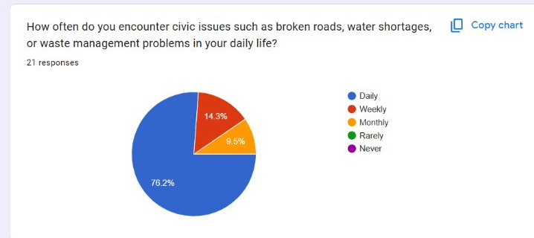
Figure 3.1: Citizen Survey — Frequency of Encountering Civic Issues (n = 21)
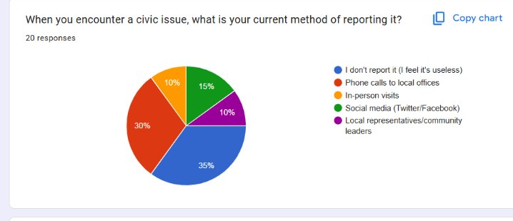
Figure 3.2: Citizen Survey — Current Method of Reporting Civic Issues (n = 20)
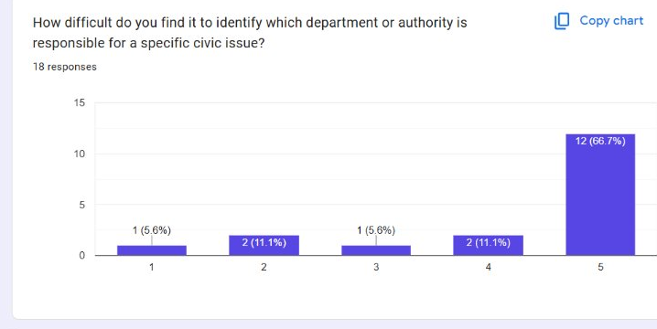
Figure 3.3: Citizen Survey — Difficulty Identifying the Responsible Department (n = 18)

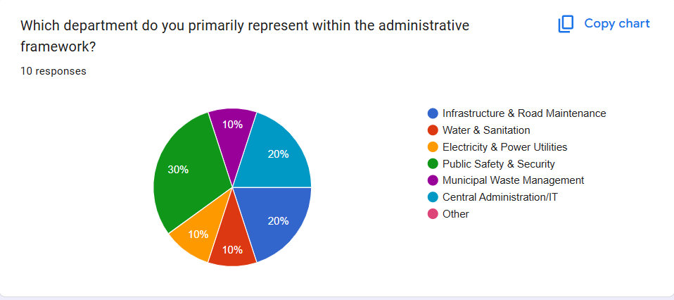
Figure 3.4: Administrator Survey — Department Represented by Respondents (n = 10)

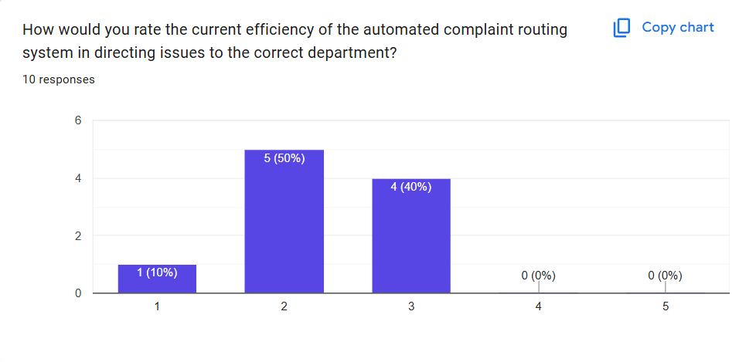
Figure 3.5: Administrator Survey — Rated Efficiency of the Current Complaint Routing Process (n = 10)

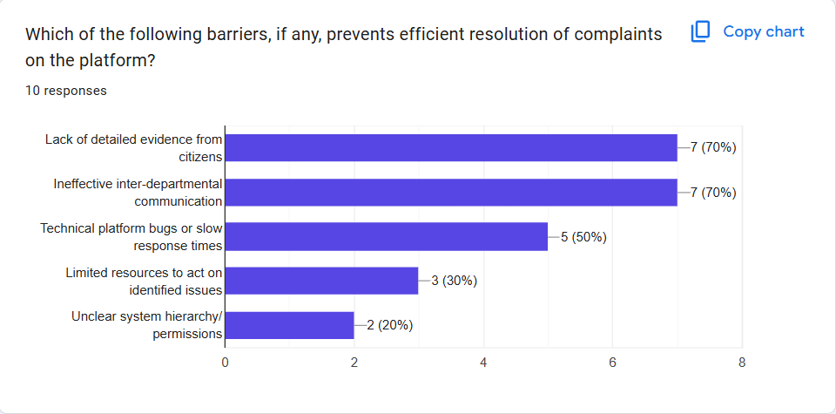
Figure 3.6: Administrator Survey — Reported Barriers to Efficient Complaint Resolution (n = 10)

3.6 Data Analysis Methods
The survey results indicate that the majority of citizens (76.2%) experience civic issues daily, such as broken roads and water shortages. Despite the high frequency of these issues, 35% of respondents do not report issues to the authorities due to a feeling of futility when reporting issues. The remaining respondents utilize a fragmented system of reporting issues, with most using phone calls to local authorities (30%), followed by social media (15%), in-person visits (10%), and local representatives (10%). The lack of clarity regarding which department is responsible for a particular civic issue leads to frustration for 66.7% of citizens, and a maximum level of frustration is expressed by 76.5% of citizens for the lack of tracking of civic issues. However, 75% of citizens would definitely utilize a category-based automated routing system to submit their civic issues, suggesting that the routing feature of FixMyCity is a desired functionality.
When it came to the administration of civic issue complaints, 50% of administrators rated the efficiency of the current manual process of routing complaints as a 2 out of 5, while the other 40% of administrators rated the process as a 3 out of 5. As a result, the administrators identified the key barriers to the effective resolution of civic issue complaints to be the lack of detailed evidence submitted by citizens (70%), ineffective communication between departments (70%), technical limitations of the current platforms (50%), and the limited resources available for administrators to address the complaints (30%). Thus, the findings of the citizen and administrator surveys confirm the existence of the core problems identified in Chapters 1 and 2, including the lack of automated routing and the missing tracking of civic issues. These findings justify the functional requirements of FixMyCity, particularly the automated category-based routing, the provision of detailed and evidence-based citizen complaints, and the improvement of the tracking and visibility of civic issues by departments.

3.7 System Requirements
Here are the functional and non-functional requirements derived from the survey findings in Section 3.6 and the objectives established in Chapter 1.

3.7.1 Functional Requirements
- User Authentication: The system shall allow both citizens and authorities to create accounts, log in, and have permissions established through the Role-Based Access Control (RBAC) system.
- Geo-Tagged Complaints: The system shall allow users to upload images of the problem that the complaints pertain to, as well as the geo-location of that image at the time of the complaint.
- Automated State-Machine Routing: The system shall automatically assign the complaints to the appropriate departments based on the category of the issue that is reported.
- Complaint Status Tracking: The system shall allow citizens who have filed a complaint to view the current status of that complaint in real time.
- Community Upvoting: The system shall allow citizens to vote on existing complaints to signal the urgency of that complaint.
- Heatmap Dashboard: The system shall provide a city-wide heatmap to authorities indicating the density of complaints based on location and type of issue.

3.7.2 Non-Functional Requirements
- Security: All passwords must be encrypted when saved in the Laravel backend database.
- Performance: The Leaflet heatmap feature must load and display within three seconds of the page loading in the browser.
- Usability: The system interface shall be responsive on devices of all sizes (desktops and mobile phones) and accessible to people with disabilities.
- Reliability: The system shall have an uptime of 99% during the duration of the project demonstration and testing period.
- Scalability: The database shall be designed such that it supports the addition of other complaint categories and departments in the future without the need for structural changes to the database schema.

3.8 System Design
The following diagrams translate the functional and non-functional requirements defined in Section 3.7 into the technical design of the FixMyCity platform.
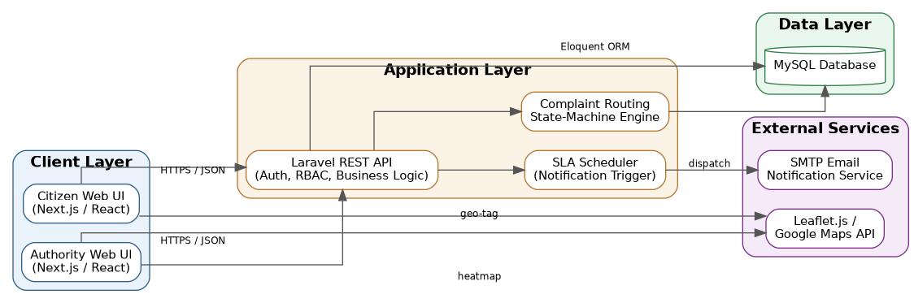
Figure 3.7: System Architecture Diagram — illustrates the Next.js frontend, Laravel backend, and MySQL database, along with external mapping and notification services.
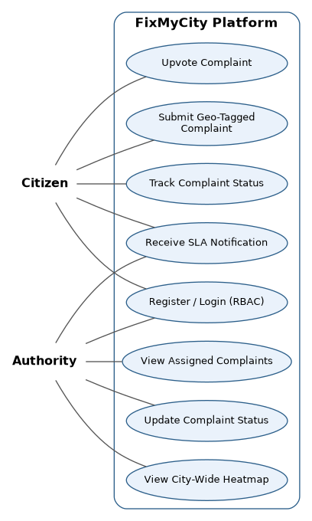
Figure 3.8: Use Case Diagram — demonstrates the actors, citizen and authority, and the various use cases within the FixMyCity platform.
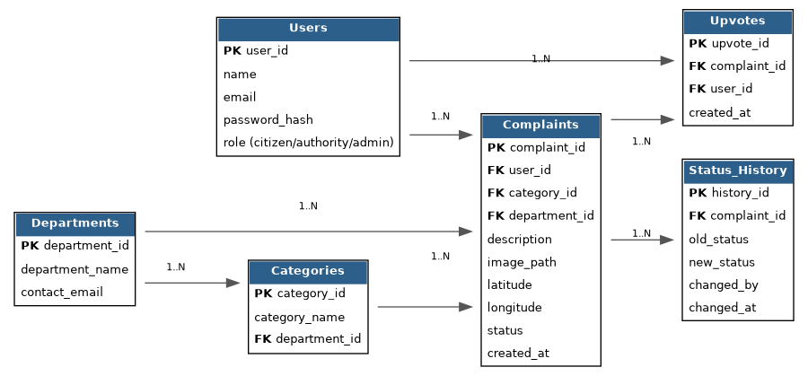
Figure 3.9: Entity Relationship Diagram (ERD) — shows the various entities within the FixMyCity platform, including users, complaints, departments, categories, status history, and upvotes, along with their keys.
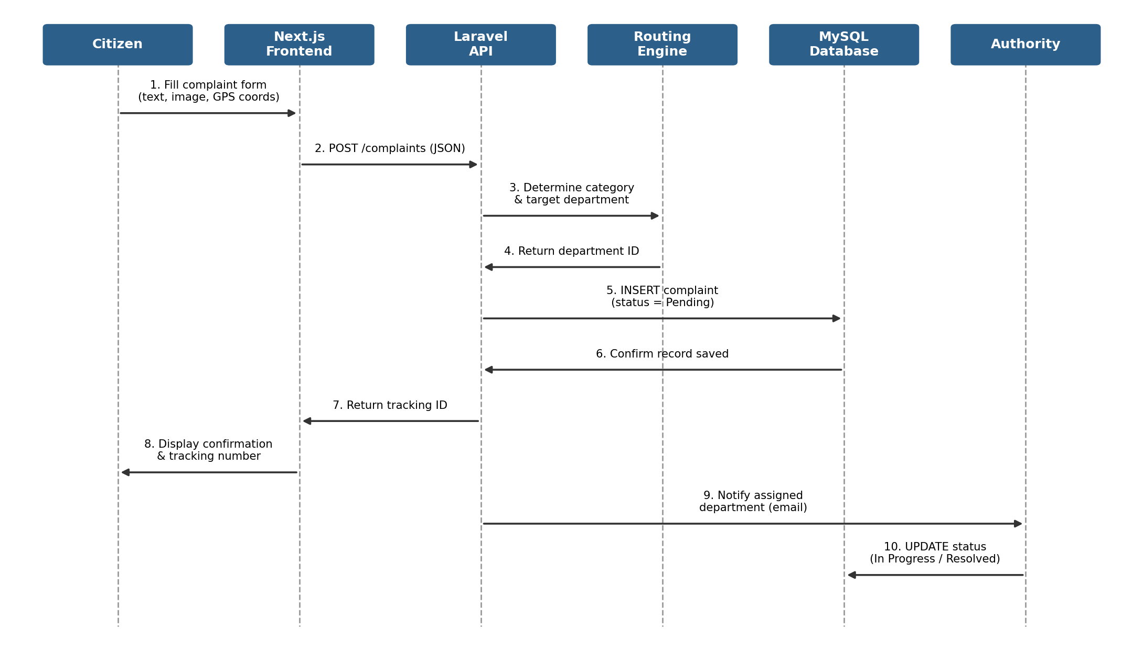
Figure 3.10: Sequence Diagram — diagrams the process of submitting a complaint by the citizen and sending it to the database.
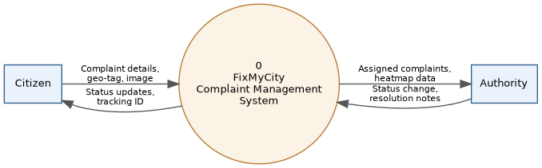
Figure 3.11: Data Flow Diagram (DFD) — Level 0 (Context) — shows the system as a single process interacting with the citizen and the authority.
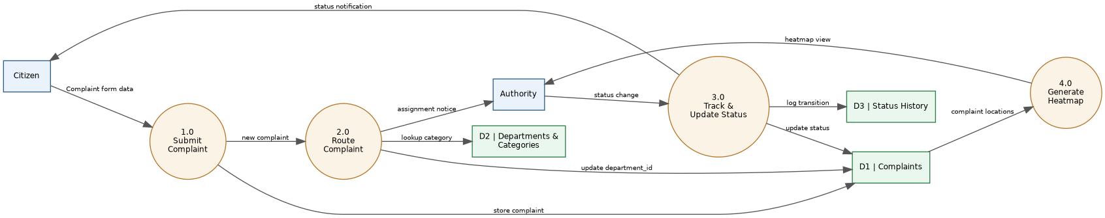
Figure 3.12: Data Flow Diagram (DFD) — Level 1 — demonstrates the processes within the FixMyCity system.
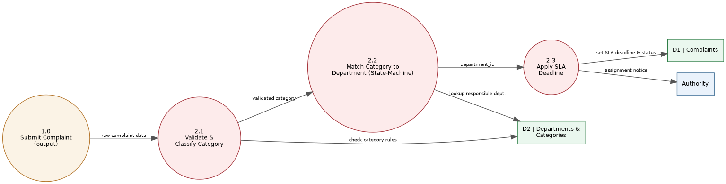
Figure 3.13: Data Flow Diagram (DFD) — Level 2 — shows the decomposition of the route complaint process in the FixMyCity system.

References
Afzal, S. and Iqbal, M. (2021) Citizen Engagement through Social Media in Local Governance: A Case Study Approach. Online source. URL to be added after literature review.
Bertot, J.C., Jaeger, P.T. and Grimes, J.M. (2010) 'Using ICTs to create a culture of transparency: E-government and social media as openness and anti-corruption tools for societies', Government Information Quarterly, 27(3), pp. 264–271.
Clark, B.Y., Brudney, J.L. and Jang, S.G. (2013) 'Coproduction of government services and the new information technology: Investigating the distributional biases', Public Administration Review, 73(5), pp. 687–701.
Johnson, P.A. and Sieber, R.E. (2013) 'Situating the adoption of VGI by government', in Sui, D., Elwood, S. and Goodchild, M. (eds.) Crowdsourcing Geographic Knowledge. Dordrecht: Springer, pp. 65–81.
Kitchin, R. (2014) 'The real-time city? Big data and smart urbanism', GeoJournal, 79(1), pp. 1–14.
Linders, D. (2012) 'From e-government to we-government: Defining a typology for citizen coproduction in the age of social media', Government Information Quarterly, 29(4), pp. 446–454.
Offenhuber, D. (2015) 'Infrastructure legibility – a comparative analysis of Open311-based citizen feedback systems', Cambridge Journal of Regions, Economy and Society, 8(1), pp. 93–112.
Rehman, M., Esichaikul, V. and Kamal, M. (2012) 'Factors influencing e-government adoption in Pakistan', Transforming Government: People, Process and Policy, 6(3), pp. 258–282.
Roche, S. (2014) 'Geographic information science I: Why does a smart city need to be spatially enabled?', Progress in Human Geography, 38(5), pp. 703–711.
World Bank (2022) Urban Service Delivery and Citizen Feedback Mechanisms. Online source. URL to be added after literature review.

