This directory is based on code discussed in the paper, *Inferring lateral tension distribution in wall structures of single cells*. For conceptual understanding, please refer to the paper.

To run this code, all you need is a text file of sample coordinates, generated by Image-J, and MATLAB. An example of the txt file has been provided (see Snakes_caulonema_control.txt). Note that in the example, the first couple lines of the original text file generated from Image-J were removed and the lines with octothorpes from Image-J have also been removed. When you prepare your own input of the txt file, please follow the format of Snakes_caulonema_control.txt.

To begin the process, run the file titled RunFile.m in MATLAB. Then enter the parameter values (listed below in bold face) in the command window. See demonstration and example of the parameter input-format below.

For the **filename**, please enter the name of the file containing the samples. Some users may run into an issue with their settings based on if you need the full path to the file or not. Please be wary of this if troubleshooting. The example input is: **Snakes_caulonema_control.txt**

For the **data sample** **indices contained in the text file**, please reference the first column of the text file, which contains the indices of individual samples. Enter the list of this indices as a matrix. The example input is: **[2:10, 12, 13, 15]**

For the **indices of the samples you would like to use**, enter a matrix of any subset of the indices contained in the text file. The example input is: **[5, 7, 15]**

For the **truncation value**, enter the number of points from the tip in either direction you would like to use for the final averaged outline. Note that this value must be less than each of the “Max TC” values in the plots of the subset selected in the previous step. The example input is **160**.

For the **discretization value ds**, you can compute ds = $\left\lceil \frac{truncation value}{number of segments}\right\rceil$. For example, when the truncation value = 160, and the desired number of segments to discretize the cell outline is 10, we have ds = 16. In the paper, the number of segments were 10 and 20, so ds = 16 and ds=8, respectively. The example input is **16**.

For the **polynomial degree**, enter a number less than or equal to the number of segments. The example value is **9**.

Running the code with the example inputs provided, after inputting the truncation value, you should see the following figure. Note that these images of cell samples are before any rotation or truncation is done:

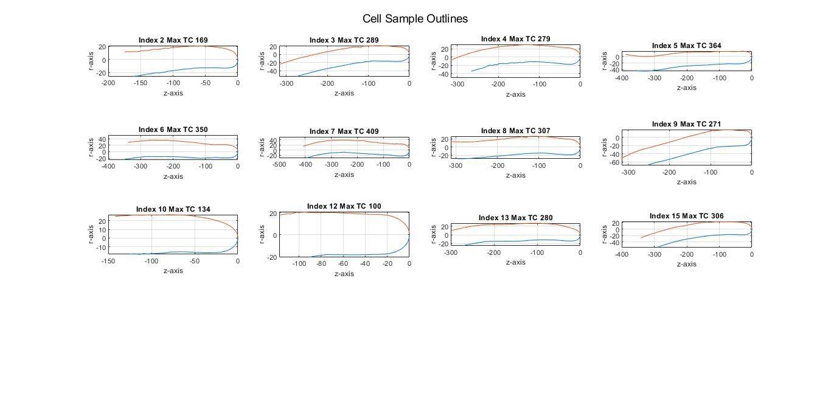

After finishing input, you should see these two figures in addition to the other 3 from before:

