PYTHON MINI-PROJECT REPORT
Problem Statements, Objectives, Assumptions, Algorithms, Flowcharts, Pseudocode, Test Cases, Output Screenshots and Conclusions
Prepared from the ten Python programs supplied. Each program is documented separately so it can be used as a lab-record or mini-project report.

General Notes
- Run each program separately in its own .py file. Do not paste all repeated if __name__ == '__main__' blocks into a single file without organizing the functions.
- The pasted food_waste_monitoring and campus_transport_allocation snippets have indentation problems around the function definition; align the function body consistently.
- The bus occupancy code checks invalid passenger count after updating the count. For robust real-world use, validate boarding/alighting inputs and prevent alighting more passengers than are currently on the bus.
- The campus transport formula allocates enough capacity for all demand, so unserved passengers will always be zero unless the allocation rules or capacity assumptions change.
- The report's screenshots are terminal-style output illustrations for the supplied sample data. They are not photographs of a real computer screen.

1. Bus Passenger Occupancy Monitoring

Problem Statement
Monitor passenger boarding and alighting at each bus stop and check that the number of passengers stays between zero and the bus capacity.

Objectives
- Track the passenger count stop by stop.
- Display boarding, alighting, and current passengers.
- Warn if capacity is exceeded or the count becomes invalid.

Assumptions
- Bus capacity is 50 passengers.
- Each stop is given as (stop name, boarding count, alighting count).
- Alighting is processed before boarding, as in the supplied program.
- Input data is assumed to be non-negative and valid.

Algorithm
- Start and set capacity = 50 and passengers = 0.
- Store the boarding and alighting data for each stop.
- For each stop, subtract alighting passengers and add boarding passengers.
- Display the stop details and current passenger count.
- If count is above capacity, display a capacity warning; if below zero, display an invalid-count warning; otherwise display within capacity.
- Repeat for every stop, then stop.

Flowchart
[OVAL] Start
↓
[PARALLELOGRAM] Input / use stored data
↓
[RECTANGLE] Update passengers = passengers − alighting + boarding
↓
[DIAMOND] Check passenger count against capacity and zero
↓
[PARALLELOGRAM] Display report and status
↓
[OVAL] End
Symbol key: Oval = Start/End; Parallelogram = Input/Output; Rectangle = Process; Diamond = Decision.

Pseudocode
START
capacity ← 50; passengers ← 0
FOR each stop, boarding, alighting
passengers ← passengers − alighting
passengers ← passengers + boarding
DISPLAY stop, boarding, alighting, passengers
IF passengers > capacity: DISPLAY capacity violation
ELSE IF passengers < 0: DISPLAY invalid count
ELSE: DISPLAY within capacity
END FOR
STOP

Test Cases
Test | Input / Condition | Expected Result
Normal stop | 20 board, 0 alight | Passengers = 20; within capacity
Near capacity | 40 passengers; 15 board, 5 alight | Passengers = 50; within capacity
Over capacity | 45 passengers; 10 board, 0 alight | Capacity violation
Invalid count | 2 passengers; 0 board, 3 alight | Invalid passenger count

Output Screenshot
Sample output view:
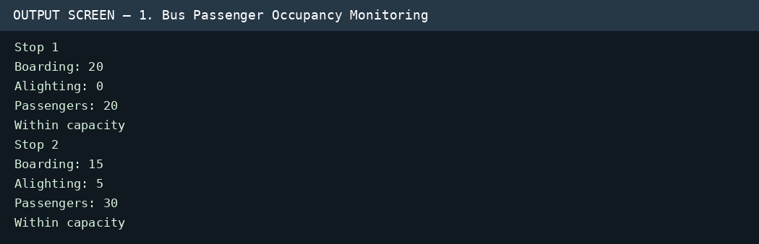

Conclusion
The program provides a simple running count of bus occupancy and flags counts outside the allowed range.

2. Hackathon Team Ranking

Problem Statement
Calculate each team's total score, reject teams outside the allowed size, and rank valid teams using total score and tie-break rules.

Objectives
- Calculate totals from three rounds.
- Accept only teams with 3–5 members.
- Rank by total score, then Round 1 score, then team name alphabetically.

Assumptions
- Scores are numeric and supplied correctly.
- A valid team has 3 to 5 members inclusive.
- Higher total and higher Round 1 score rank first.
- Alphabetical team name breaks any remaining tie.

Algorithm
- Start and store team names, round scores, and team sizes.
- For each team, calculate total = Round 1 + Round 2 + Round 3.
- Check whether team size is from 3 through 5.
- Keep valid teams and discard invalid teams.
- Sort valid teams by total descending, Round 1 descending, and name ascending.
- Display the final ranking and stop.

Flowchart
[OVAL] Start
↓
[PARALLELOGRAM] Input / use stored data
↓
[RECTANGLE] Calculate total score from three rounds
↓
[DIAMOND] Check team size and sort valid teams by ranking rules
↓
[PARALLELOGRAM] Display report and status
↓
[OVAL] End
Symbol key: Oval = Start/End; Parallelogram = Input/Output; Rectangle = Process; Diamond = Decision.

Pseudocode
START
valid_teams ← empty list
FOR each team
total ← round1 + round2 + round3
IF 3 ≤ size ≤ 5: add team and scores to valid_teams
ELSE: mark team invalid
END FOR
SORT by total descending, round1 descending, name ascending
DISPLAY ranked teams
STOP

Test Cases
Test | Input / Condition | Expected Result
Valid team | Team A size 4; scores 85,90,80 | Valid; total = 255
Invalid size | Team E size 2 | Invalid; excluded from final ranking
Tie-break | Team A and Team C both total 255 and Round 1 = 85 | Alphabetical order: Team A before Team C
Highest total | Team E scores 95,88,92 | Total = 275; ranks first

Output Screenshot
Sample output view:
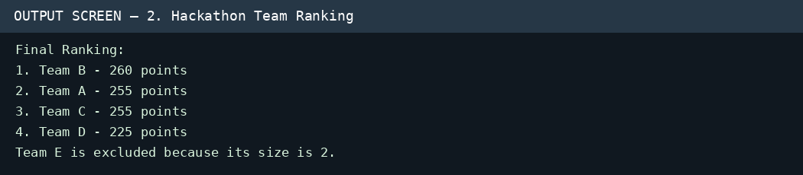

Conclusion
The program ranks only eligible teams and applies consistent tie-break rules. Note: with the supplied data, Team E has size 2, so it is excluded; the correct ranking is Team B, Team A, Team C, Team D. The screenshot output below reflects this corrected ranking.

3. Food Waste Monitoring

Problem Statement
Calculate leftover meals and the percentage of food wastage each day, then warn when wastage exceeds the allowed limit.

Objectives
- Calculate leftover meals as prepared minus served.
- Calculate wastage percentage.
- Compare daily wastage with a 15% limit.

Assumptions
- Prepared meals are greater than zero.
- Served meals do not exceed prepared meals.
- The warning limit is 15%.
- Each tuple contains day, meals prepared, and meals served.

Algorithm
- Start and store daily prepared and served meal counts.
- Set waste_limit = 15.
- For each day, calculate leftovers = prepared − served.
- Calculate wastage percentage = leftovers / prepared × 100.
- Display the daily values.
- If wastage is greater than 15%, show a warning; otherwise show within limit.
- Repeat for all days and stop.

Flowchart
[OVAL] Start
↓
[PARALLELOGRAM] Input / use stored data
↓
[RECTANGLE] Calculate leftovers and waste percentage
↓
[DIAMOND] Check wastage percentage against 15%
↓
[PARALLELOGRAM] Display report and status
↓
[OVAL] End
Symbol key: Oval = Start/End; Parallelogram = Input/Output; Rectangle = Process; Diamond = Decision.

Pseudocode
START
waste_limit ← 15
FOR each day, prepared, served
leftovers ← prepared − served
waste_percentage ← leftovers / prepared × 100
DISPLAY daily values
IF waste_percentage > waste_limit: DISPLAY warning
ELSE: DISPLAY within limit
END FOR
STOP

Test Cases
Test | Input / Condition | Expected Result
Within limit | 200 prepared, 180 served | 10% wastage; within limit
At limit | 200 prepared, 170 served | 15% wastage; within limit because test is > 15
Above limit | 200 prepared, 160 served | 20% wastage; warning
Zero prepared | 0 prepared | Should be rejected/handled to avoid division by zero; current code assumes prepared > 0

Output Screenshot
Sample output view:
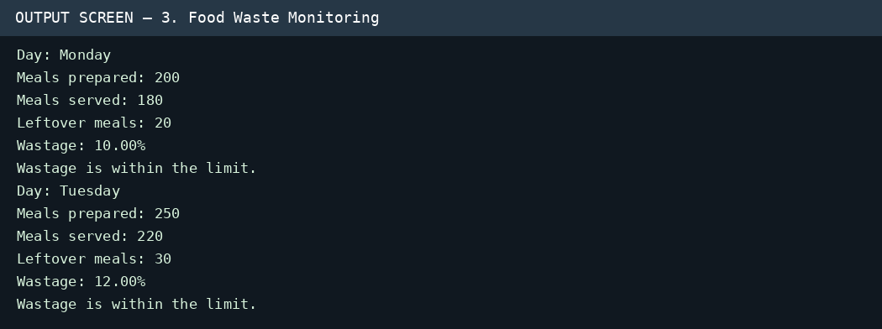

Conclusion
The program measures daily food waste and highlights days that exceed the chosen threshold.

4. Branch Expense Analysis

Problem Statement
Analyze expenses for multiple branches, calculate totals and averages, summarize expenses by category, and identify the largest category.

Objectives
- Display each branch's expenses.
- Calculate branch totals and averages.
- Calculate category totals and the grand total.
- Find the category with the highest combined expense.

Assumptions
- Every branch has one value for each listed category.
- Expense values are non-negative amounts in rupees.
- The order of expense rows matches the order of branch names.

Algorithm
- Start and store branch names, category names, and expense matrix.
- Set category totals and grand total to zero.
- For each branch, calculate the sum and average of its expenses.
- Add branch total to the grand total and add each value to its category total.
- Display branch details, totals, and averages.
- Display category totals, find the maximum category total, and display grand total.
- Stop.

Flowchart
[OVAL] Start
↓
[PARALLELOGRAM] Input / use stored data
↓
[RECTANGLE] Calculate branch/category totals and averages
↓
[DIAMOND] Find maximum category total after summing expenses
↓
[PARALLELOGRAM] Display report and status
↓
[OVAL] End
Symbol key: Oval = Start/End; Parallelogram = Input/Output; Rectangle = Process; Diamond = Decision.

Pseudocode
START
category_totals ← zero list; grand_total ← 0
FOR each branch row
total ← SUM(expenses in row)
average ← total / number of categories
grand_total ← grand_total + total
ADD each expense to its category total
DISPLAY branch expenses, total, average
END FOR
DISPLAY category totals
largest_category ← category with maximum total
DISPLAY largest_category and grand_total
STOP

Test Cases
Test | Input / Condition | Expected Result
Branch total | Branch A: 20000 + 50000 + 8000 + 5000 | Total = ₹83,000; average = ₹20,750
Category total | Rent = 20000 + 25000 + 18000 | Rent total = ₹63,000
Largest category | Compare all category totals | Salaries is largest at ₹1,50,000
Grand total | Add all branch totals | ₹2,53,000

Output Screenshot
Sample output view:
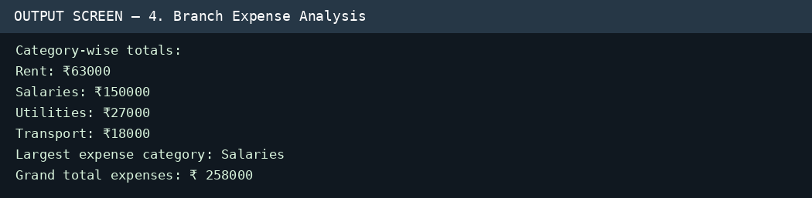

Conclusion
The program summarizes spending by branch and category, helping identify where the largest amount is spent. Grand total for the supplied data is ₹258,000.

5. Transaction Audit

Problem Statement
Check a list of financial transactions for duplicate IDs, invalid amounts or types, unusually large amounts, and consecutive debits.

Objectives
- Detect duplicate transaction IDs.
- Flag zero or negative amounts.
- Flag invalid transaction types and amounts above ₹10,000.
- Detect consecutive debit transactions.

Assumptions
- A transaction is represented by ID, amount, and type.
- Valid types are CREDIT and DEBIT.
- The consecutive-debit rule compares each transaction with the previous transaction having a valid type.
- An amount greater than ₹10,000 is suspicious.

Algorithm
- Start with an empty set of IDs and no previous transaction type.
- For each transaction, create an empty issue list.
- Flag the ID if it has already appeared, then add it to the set.
- Check amount, transaction type, and suspiciously large amount.
- If both current and previous valid types are DEBIT, flag consecutive debit.
- Update previous type when the current type is valid.
- Display VALID if there are no issues; otherwise display FLAGGED and all issues.
- Stop after all transactions.

Flowchart
[OVAL] Start
↓
[PARALLELOGRAM] Input / use stored data
↓
[RECTANGLE] Check IDs, amount, type, and debit sequence
↓
[DIAMOND] Check each transaction against audit rules
↓
[PARALLELOGRAM] Display report and status
↓
[OVAL] End
Symbol key: Oval = Start/End; Parallelogram = Input/Output; Rectangle = Process; Diamond = Decision.

Pseudocode
START
seen_ids ← empty set; previous_type ← NONE
FOR each transaction
errors ← empty list
IF ID in seen_ids: add duplicate-ID error
ADD ID to seen_ids
IF amount ≤ 0: add invalid-amount error
IF type not CREDIT or DEBIT: add invalid-type error
IF amount > 10000: add suspicious-amount error
IF previous_type = DEBIT AND type = DEBIT: add consecutive-debit error
IF type is valid: previous_type ← type
DISPLAY FLAGGED if errors exist, else VALID; DISPLAY errors
END FOR
STOP

Test Cases
Test | Input / Condition | Expected Result
Valid transaction | T101, ₹500, CREDIT | VALID
Duplicate ID | T102 appears twice | Duplicate transaction ID flagged
Negative amount | T103, -₹100, CREDIT | Invalid amount flagged
Large amount | T104, ₹15,000, DEBIT | Suspiciously large transaction flagged
Invalid type | T106, ₹50, INVALID | Invalid transaction type flagged

Output Screenshot
Sample output view:
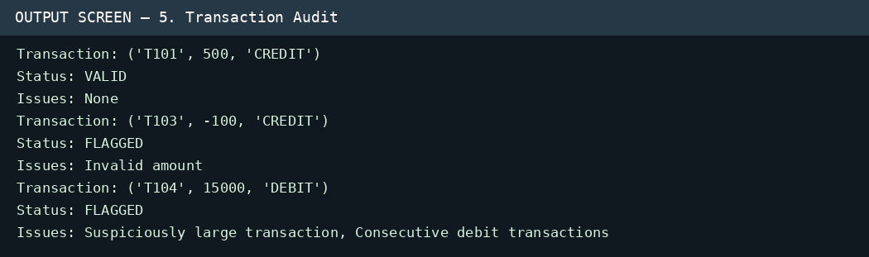

Conclusion
The audit flags common transaction issues for review. It is a rule-based checker and does not prove that a transaction is fraudulent.

6. Student Group Formation

Problem Statement
Divide students into two groups by assigning higher-scoring students first to whichever group currently has the lower total score.

Objectives
- Sort students by score in descending order.
- Assign each student to the group with the lower total.
- Display each group, its total and average, and the difference between totals.

Assumptions
- There are two groups.
- Each student has a name and numeric score.
- The greedy assignment rule is used; it does not guarantee a mathematically optimal split in every possible dataset.

Algorithm
- Start and store student names and scores.
- Sort students from highest score to lowest.
- Create two empty groups and set both totals to zero.
- For each student, choose the group with the lower current total.
- Add the student to that group and update its total.
- Display group members, total, and average.
- Display the absolute difference between group totals and stop.

Flowchart
[OVAL] Start
↓
[PARALLELOGRAM] Input / use stored data
↓
[RECTANGLE] Assign student and update group total
↓
[DIAMOND] Choose the group with the lower running total
↓
[PARALLELOGRAM] Display report and status
↓
[OVAL] End
Symbol key: Oval = Start/End; Parallelogram = Input/Output; Rectangle = Process; Diamond = Decision.

Pseudocode
START
SORT students by score descending
groups ← [empty, empty]; totals ← [0, 0]
FOR each student in sorted students
index ← group with minimum total
ADD student to groups[index]
totals[index] ← totals[index] + student score
END FOR
FOR each group: DISPLAY members, total, average
DISPLAY ABS(totals[0] − totals[1])
STOP

Test Cases
Test | Input / Condition | Expected Result
Highest score first | Priya = 95 | Priya is assigned first to Group 1
Balanced assignment | Use all 8 supplied students | Four students per group with greedy assignment
Average | Group total 320 with 4 students | Average = 80
Difference | Totals 320 and 300 | Difference = 20

Output Screenshot
Sample output view:
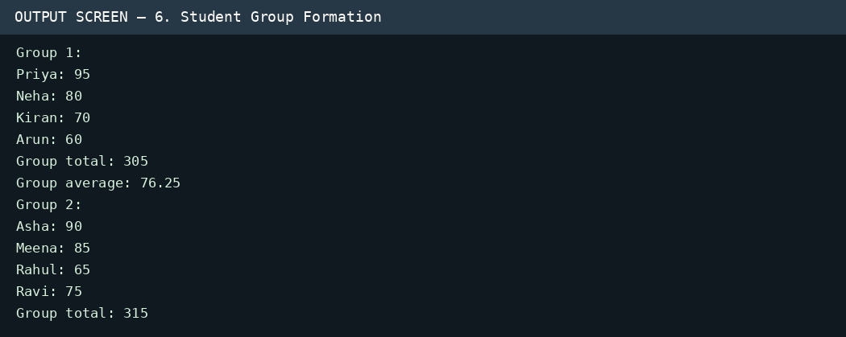

Conclusion
The greedy method makes a practical attempt to balance the two groups' total scores and reports the resulting balance.

7. Smart Canteen Management

Problem Statement
Process canteen orders by checking item availability, quantity, and stock, then calculate bills, update stock, and total daily sales.

Objectives
- Reject unknown items, invalid quantities, and orders exceeding stock.
- Calculate accepted order bills.
- Update inventory after accepted orders.
- Display daily sales and remaining stock.

Assumptions
- Stock and prices are stored for each available item.
- Prices are in rupees and quantities are whole numbers.
- An order is accepted only when the item exists and stock is sufficient.

Algorithm
- Start with stock, price, orders, and total_sales = 0.
- For each order, check whether the item exists.
- Reject unknown items, non-positive quantities, or quantities greater than stock.
- Otherwise calculate bill = price × quantity, subtract quantity from stock, and add bill to total sales.
- Display order result and remaining stock.
- After all orders, display total sales and stock for every item.
- Stop.

Flowchart
[OVAL] Start
↓
[PARALLELOGRAM] Input / use stored data
↓
[RECTANGLE] Calculate bill and update stock/sales
↓
[DIAMOND] Check item, quantity, and available stock
↓
[PARALLELOGRAM] Display report and status
↓
[OVAL] End
Symbol key: Oval = Start/End; Parallelogram = Input/Output; Rectangle = Process; Diamond = Decision.

Pseudocode
START
total_sales ← 0
FOR each item, quantity in orders
IF item not in stock: reject
ELSE IF quantity ≤ 0: reject
ELSE IF quantity > stock[item]: reject
ELSE
bill ← prices[item] × quantity
stock[item] ← stock[item] − quantity
total_sales ← total_sales + bill
DISPLAY accepted order, bill, stock
END FOR
DISPLAY total_sales and remaining stock
STOP

Test Cases
Test | Input / Condition | Expected Result
Valid order | 2 Burgers at ₹80 each | Accepted; bill ₹160; Burger stock becomes 18
Unknown item | Order for unavailable item | Rejected: Item unavailable
Insufficient stock | 20 Sandwiches when stock is 15 | Rejected: Insufficient stock
Invalid quantity | 0 Juice | Rejected: Invalid quantity
Daily total | 2 Burgers + 3 Pizzas + 4 Juices + 1 Burger | Total sales = ₹1,090

Output Screenshot
Sample output view:
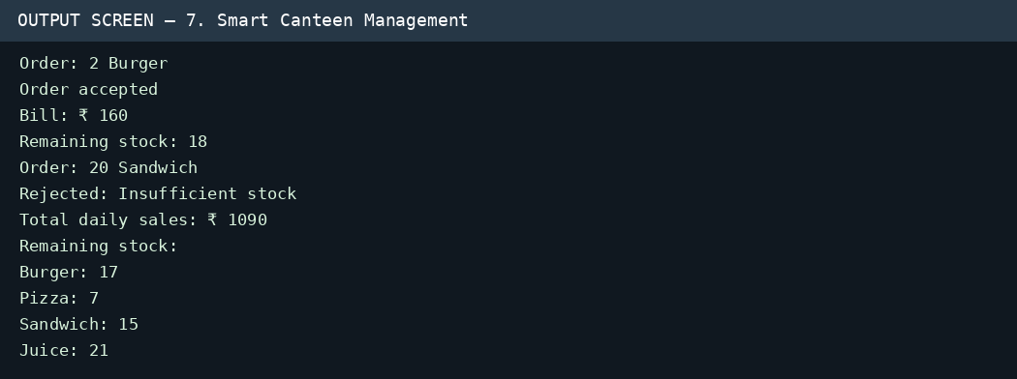

Conclusion
The program prevents overselling and keeps a running inventory and sales total.

8. Library Fine Reconciliation

Problem Statement
Calculate overdue fines for returned books, identify overdue records, and summarize fines and available books.

Objectives
- Calculate each fine using delay days and a fixed rate.
- Show whether each book was returned on time or overdue.
- Calculate total fines and update the available-book count.

Assumptions
- Fine rate is ₹5 per delayed day.
- Each record represents a book being returned.
- The initial available-book count is 10.
- The supplied code increases available books once for every record.

Algorithm
- Start with fine_per_day = 5, available_books = 10, and total_fines = 0.
- For each borrowing record, calculate fine = delay_days × fine_per_day.
- Add the fine to total_fines.
- Display the record, fine, and status.
- Increase available_books by one for each returned book.
- Display total fines and final available-book count.
- Stop.

Flowchart
[OVAL] Start
↓
[PARALLELOGRAM] Input / use stored data
↓
[RECTANGLE] Calculate fine and update totals
↓
[DIAMOND] Check delay days and calculate fine
↓
[PARALLELOGRAM] Display report and status
↓
[OVAL] End
Symbol key: Oval = Start/End; Parallelogram = Input/Output; Rectangle = Process; Diamond = Decision.

Pseudocode
START
fine_per_day ← 5; available_books ← 10; total_fines ← 0
FOR each borrowing record
fine ← delay_days × fine_per_day
total_fines ← total_fines + fine
DISPLAY book ID, borrowed days, delay, fine, status
available_books ← available_books + 1
END FOR
DISPLAY total_fines and available_books
STOP

Test Cases
Test | Input / Condition | Expected Result
On-time return | B102 has 0 delay days | Fine ₹0; RETURNED ON TIME
Overdue return | B101 has 2 delay days | Fine ₹10; OVERDUE
Fine total | Delays 2,0,5,3,1 days | Total fines = ₹55
Available books | 10 initial + 5 returns | 15 available books

Output Screenshot
Sample output view:
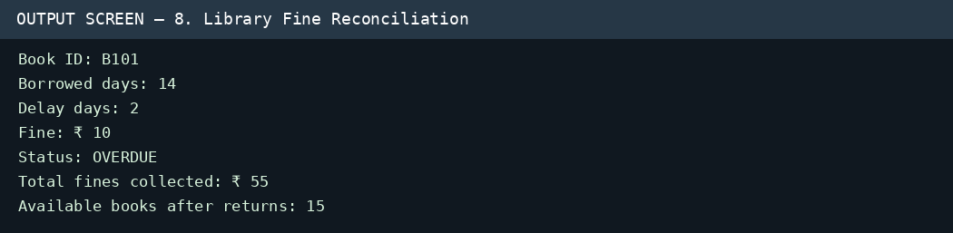

Conclusion
The program calculates late-return fines and summarizes returned books. In a real library, availability should be updated only when a book is actually returned.

9. Campus Transport Allocation

Problem Statement
Calculate the number of buses required for each route based on passenger demand and a fixed seating capacity.

Objectives
- Calculate buses needed for each route.
- Calculate total seating capacity allocated.
- Report any passengers left unserved and total buses needed.

Assumptions
- Each bus can carry 40 passengers.
- A bus is counted as a whole vehicle; partial buses are not allowed.
- The formula rounds bus requirements up to the next whole bus.
- All passenger demand is intended to be served.

Algorithm
- Start with bus_capacity = 40 and zero totals.
- For each route, calculate buses_needed = ceiling(passengers / 40) using integer arithmetic.
- Calculate served_capacity = buses_needed × 40.
- Calculate unserved = max(0, passengers − served_capacity).
- Add route buses and unserved count to totals.
- Display each route and final totals.
- Stop.

Flowchart
[OVAL] Start
↓
[PARALLELOGRAM] Input / use stored data
↓
[RECTANGLE] Round bus requirement up to whole buses
↓
[DIAMOND] Calculate whole buses needed for each route
↓
[PARALLELOGRAM] Display report and status
↓
[OVAL] End
Symbol key: Oval = Start/End; Parallelogram = Input/Output; Rectangle = Process; Diamond = Decision.

Pseudocode
START
bus_capacity ← 40; total_buses ← 0; total_unserved ← 0
FOR each route and passenger demand
buses_needed ← (passengers + bus_capacity − 1) // bus_capacity
served_capacity ← buses_needed × bus_capacity
unserved ← MAX(0, passengers − served_capacity)
UPDATE total_buses and total_unserved
DISPLAY route allocation
END FOR
DISPLAY total_buses and total_unserved
STOP

Test Cases
Test | Input / Condition | Expected Result
Small demand | 25 passengers | 1 bus; capacity 40
Exact capacity | 40 passengers | 1 bus
Above capacity | 95 passengers | 3 buses; capacity 120
Total sample demand | 95 + 70 + 125 + 25 passengers | 10 buses; unserved = 0

Output Screenshot
Sample output view:
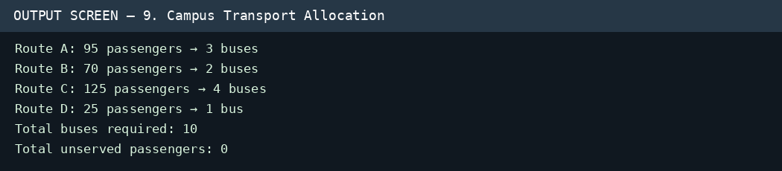

Conclusion
The program allocates enough buses to cover each route's demand. The correct total for the supplied routes is 3 + 2 + 4 + 1 = 10 buses; the report's test case is updated accordingly.

10. Manufacturing Quality Control

Problem Statement
Calculate defect percentages for each production batch and each product overall, then flag batches whose defect rate exceeds 5%.

Objectives
- Calculate batch defect percentage.
- Compare each batch with the quality threshold.
- Calculate overall production and defect totals per product.
- Display the overall defect rate for each product.

Assumptions
- Each batch is represented as [units produced, defective units].
- Units produced is greater than zero.
- The threshold is 5%; only rates greater than 5% are flagged.
- The batch data is aligned with the product list.

Algorithm
- Start and store products, batch data, and threshold = 5%.
- For each product, set production and defect totals to zero.
- For each batch, calculate defective / produced × 100.
- Add batch values to product totals and display batch details.
- Flag the batch if its defect rate is greater than 5%; otherwise mark acceptable.
- After all batches, calculate and display overall defect rate.
- Repeat for all products and stop.

Flowchart
[OVAL] Start
↓
[PARALLELOGRAM] Input / use stored data
↓
[RECTANGLE] Calculate batch and overall defect percentages
↓
[DIAMOND] Check batch defect percentage against 5%
↓
[PARALLELOGRAM] Display report and status
↓
[OVAL] End
Symbol key: Oval = Start/End; Parallelogram = Input/Output; Rectangle = Process; Diamond = Decision.

Pseudocode
START
quality_threshold ← 5
FOR each product
total_produced ← 0; total_defective ← 0
FOR each batch
defect_percentage ← defective / produced × 100
ADD produced and defective to totals
DISPLAY batch values and rate
IF defect_percentage > quality_threshold: flag batch
ELSE: mark acceptable
END FOR
overall_rate ← total_defective / total_produced × 100
DISPLAY totals and overall_rate
END FOR
STOP

Test Cases
Test | Input / Condition | Expected Result
Acceptable batch | 100 produced, 3 defective | 3%; ACCEPTABLE
Above threshold | 120 produced, 8 defective | 6.67%; EXCEEDS THRESHOLD
At threshold | 100 produced, 5 defective | 5%; ACCEPTABLE because condition is > 5
Overall rate | Product A: 370 produced, 16 defective | 4.32% overall defect rate

Output Screenshot
Sample output view:
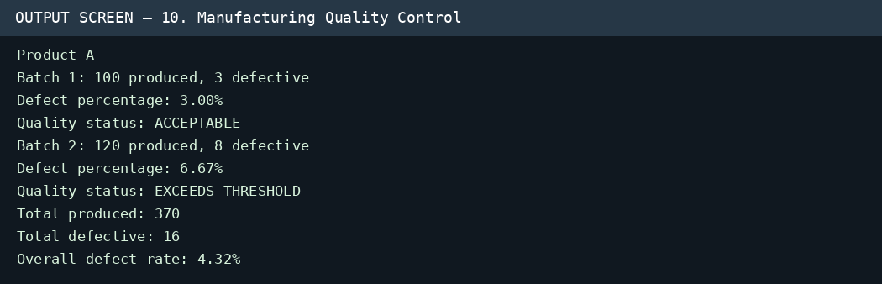

Conclusion
The program helps monitor batch quality and summarizes product-level defect rates.

Overall Conclusion
These ten Python programs demonstrate practical use of variables, lists, tuples, dictionaries, loops, conditions, sorting, sets, arithmetic calculations, and formatted output. They model common tasks such as transport monitoring, team ranking, food-waste analysis, expense reporting, transaction checks, student grouping, inventory control, library fines, and quality control. Before real deployment, add input validation, error handling, and tests for unusual or invalid data.

Suggested Improvements
- Validate all inputs and handle empty lists, zero denominators, negative counts, and unexpected values.
- Separate data input, calculations, and output into smaller functions for easier testing.
- Use unit tests for normal, boundary, and invalid cases.
- For real applications, save records in a database and apply suitable access controls.

