**DEVELOPMENT PART - 1**

1. **Data Collection**:

Obtain the transaction data. This data typically consists of records of items purchased in each transaction, such as sales receipts or online shopping carts.

1. **Data Loading:**

Start by loading the transaction dataset into your chosen data analysis tool (e.g., Python with Pandas). The dataset should include transaction IDs and the items purchased in each transaction.

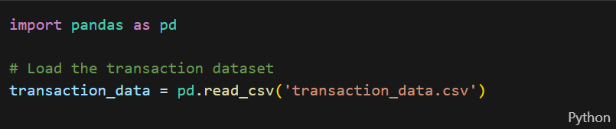

1. **Exploratory Data Analysis (EDA)**:

Conduct EDA to understand your data better. Explore the first few rows and the structure of the data.

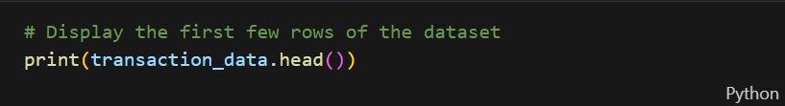

1. **Data Preprocessing**:

Depending on the dataset, you may need to preprocess the data. Common preprocessing steps include:

* + Handling missing values (if any).
  + Removing duplicates.
  + Data transformation (if needed).

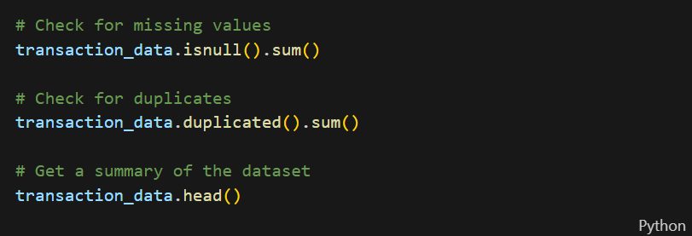

1. **Transaction Data Transformation**:

Transform the data into a transaction format, where each row represents a transaction, and the items bought in that transaction are listed.



1. **One-Hot Encoding**:

Perform one-hot encoding to convert items into binary columns. Each column represents an item, and a '1' in a column indicates that the item was purchased in the transaction, while '0' indicates it was not.

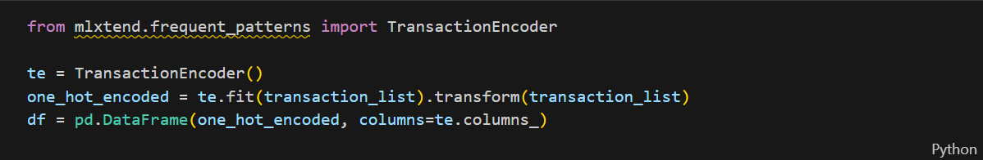

1. **Association Analysis**:

With the preprocessed data, you can perform association analysis to find itemsets that are frequently bought together. This can be done using algorithms like Apriori or FP-growth.

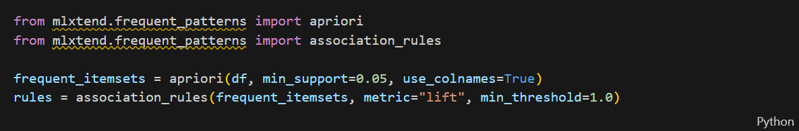

1. **Interpretation and Itemset Suggestions**:

Analyze the generated association rules to provide itemset suggestions for the retailer. These suggestions can be used to improve customer engagement and identify customer behaviour.

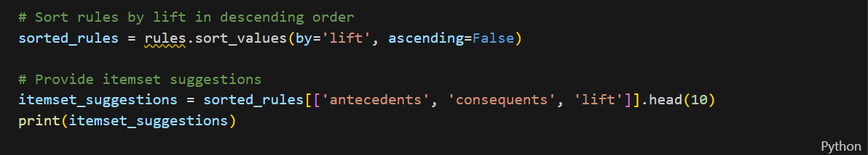

1. **Visualization and Reporting**:

You can visualize the generated itemset suggestions and patterns using charts or graphs to help the retailer understand and act on the insights.

1. **Implementation**:

Finally, work with the retailer to implement these suggestions, potentially by offering product bundles or targeted promotions based on the association rules.

By following these steps, you can use association analysis to provide itemset suggestions to the retailer, ultimately helping them improve customer engagement and understand customer behavior better.